Massachusetts Department of Conservation and Recreation

Bureau of Forest Fire Control and Forestry

Forest Management Proposal

Name: Goodale-Chipman Lots

Date Posted: March 2, 2020

End of Comment Period: April 16, 2020

Region: North

Recreation District: Metro-West

Forest Management District: Northeast

State Forest: Marlborough-Sudbury

Closest Road: White Pond and Concord Roads

Town Hudson and Marlboro, MA

Contact Information: Mike Waterman
25 Shattuck Street
Lowell, MA 01852
978-937-2092 ext 109
Michael.J.Waterman@state.ma.us

Overview:

The Goodale-Chipman Lots were selected for a forest management project in order to build upon previous forestry projects conducted by the Commonwealth of Massachusetts Bureau of Forestry. The proposed project is located off White Pond and Concord Roads in the Marlboro-Sudbury State Forest in the Town of Hudson and City of Marlborough respectively (Topographical Maps 1,2 and 3).

The Goodale-Chipman lots were selected as a proposed forestry project at this time because:
- Red pine (Pinus resinosa) located in forest stands are susceptible to fungal and insect pathogens that cause rapid mortality.
- Access to the State Forest is excellent.
- Regeneration established in the red and white pine (Pinus strobus) plantation during previous treatments is ready to be released to grow into the forest canopy.
- Forest stands will benefit by thinning poor quality, low vigor trees.
- To provide the ecosystem services that Woodlands provide as directed by the Forest Futures Visioning Process (2010) and subsequent Management Guidelines (2012). Examples include:
- Sustainable production of renewable wood products for the local forest products industry.
- Sequestration of carbon through the production of solid wood products, retention of woody material of all sizes, retention of large legacy trees in reserve areas, and an energetically regenerating forest of native species.
- Creation of diverse habitats that benefit native wildlife and build forest resilience to stressors.

The major objectives for this project are:
- Remove red pine susceptible to the fungal pathogen diplodia blight (Diplodia pinea), and red pine scale (Matsucoccus resinosae), releasing white pine and native hardwood species established during previous silvicultural treatments.
- Use even aged management techniques to release established regeneration thus increasing species and age diversity within project areas.
- Thin forest stands to increase vigor and stimulate tree regeneration.
- Remove dead trees along forest roads and trails to protect public safety
- Continue to monitor and remove populations of invasive plants.
- Increase the vertical and horizontal structure of forest stands to benefit local wildlife.
- Provide food sources for native wildlife.
- Demonstrate Best Management Practices (BMP’s) that protect water and soil resources.

Project Area Description:

The proposed project area consists of the Goodale Lot, 3 stands ± 103 acres and the Chipman Lot, 1 stand ± 10 acres that are even aged ( ± 85 years old). These lots were purchased by the Commonwealth as abandoned agricultural lands and were planted as part of the Civilian Conservation Corps (Goodale Stand 1) or reverted to forested conditions naturally (all other stands).

The tree species present in the project areas include: white pine and red pine, along with hardwood trees consisting of red oak (Quercus rubra), black oak (Quercus velutina), white oak (Quercus alba), black birch (Betula lenta), white birch (Betula papyrifera), gray birch (Betula populifolia), black cherry (Prunus serotina), and red maple (Acer rubrum). Occasionally observed trees found in and around the project areas consist of species such as pitch pine (Pinus rigida), big tooth aspen (Populous grandidentata), and shagbark hickory (Carya ovata). Some American chestnut (Castanea dentata) sprouts and saplings were also noted in the project area

The understory of the stands consists of: low bush blueberry (Vaccinium angustifolium), sheep laurel (Kalmia angustifolia), high bush blueberry (Vaccinium corymbosum), partridge berry (Mitchella repens), Canada mayflower (Maianthemum canadense), dewberry (Rubus flagellaris), huckleberry (Gaylussacia sp.) along with various ferns, shrubs, and grasses. Some invasive glossy buckthorn (Frangula alnus) plants were noted in the southern portion of the Goodale Lot.

DCR Management Guidelines state the forest stands will be classed and considered for silvicultural treatments that generally fit their productivity, structural complexity (or potential thereof), and diversity. Analyzing the site productivity and complexity using geographic information system (GIS) data layers of prime forest soils, potential vegetation complexity, late successional potential, forest diversity, early successional potential, continuous forest inventory (CFI) site index, and CFI stand structure imply low to moderate productivity of these forest stands. Forests with this type of productivity levels lend themselves to more even aged silvicultural systems (e.g. shelterwoods).

Topography:

Elevations range from approximately 190 to 250 feet, with the terrain best described as rolling with a north and north-east aspect.

Soils:

The soils in the project area are typical of this area of Middlesex County and are of the glacial outwash and glacial till types. The soils are of a sandy-loamy nature (Windsor series) with many stones and boulders present in the project area (Paxton series) and are generally well to excessively drained. Soil productivity is generally poor to moderate with site index rating of 57 (Windsor series) for white pine respectively.

Previous Silvicultural Treatments:

The red and white pine plantation (Goodale Stand 1, ± 37 acres) was harvested in the winter of 2015-16 as part of a shelterwood regeneration system. Previous silvicultural treatments have established an excellent cohort of white pine, oak and other hardwood seedlings under the red pine and white pine overstory ready for release within this stand.

The majority of the overstory trees located within Goodale Stand 2 (±52 acres) are pole sized to sawlog size with some larger specimens in the stand (>18” DBH). Previous silvicultural treatments in this stand were limited to small home fuelwood projects conducted during the 1980’s removing small trees along the main forest trails.

Goodale Stand 3 was treated during the 2015-16 harvest with a commercial thinning. Trees in the dominant and co-dominant canopy positions were thinned targeting trees with poor form, damaged crowns or low-quality, low vigor specimens in the intermediate and suppressed canopy positions.

Chipman Stand 1 was treated with a commercial firewood harvest in 1987 removing damaged and suppressed hardwood tress. No other treatments have been conducted on this site since that treatment.

Aesthetic, Recreation, Wetlands, Cultural, Rare Species and Wildlife Considerations:

Aesthetic:
As outlined in the Management Guidelines Document, forest management activities will be designed to promote native vegetation, retain large diameter trees, promote species diversity and provide a safe experience for users. Legal recreational users of the State Forest will be given proper consideration during project implementation by marking trees for removal on one side within 50 feet of trails and roads to minimize aesthetic impacts. Slash will be kept low (< 2 feet), away from trails, and run over or otherwise treated to promote rapid decomposition and a light appearance. All slash will be treated to comply with current Massachusetts Slash Law regulations. Landing areas will be seeded at the cessation of operations to rapidly re-vegetate disturbed areas.

Recreation:

Walking, mountain biking, and hunting are the most prevalent activities in the Goodale and Chipman Lots. The few trails that are located within the Goodale Lot are utilized by abutting neighbors for the most part as there are no dedicated parking areas for constituents to use. The southern boundary of the Chipman Lot abuts Concord Road that leads into the “Desert Natural Area”. This road is utilized by many visitors as there is a vast network of trails and a dedicated parking area. The project areas will be closed to the public during operational hours and activities will be timed seasonally to minimize impacts to recreational users as much as possible.

Wetlands:

Located within the Goodale project area is a bog and shrub swamp near Main Street, two potential non certified vernal pools along the main forest road, and another wetland located in the south-east portion of the project area. There is a small wetland complex along the south-west portion of the Chipman Lot. There are no stream or wetland crossings within project areas.

A 50 foot no cut buffer from wetland resources and potential vernal pools will provide protection to these valuable areas. All resource areas will be mapped, flagged, and painted in the field in accordance with filing a MGL Chapter 132 Forest Cutting Plan for this project with the Massachusetts DCR Service Forestry Program along with simultaneous filing of the cutting plan with the local conservation commission. The Massachusetts Forestry BMP’s are required by law to mitigate any impact.

Cultural Resources:

Located within and around the project area are the remains of a few stone walls that document previous land use history. The walls are discontinuous and there is ample room for equipment to access the site without disturbance. No other cultural resources were located during field reconnaissance. All resources discovered during stand examination will be mapped and documented to protect their historical significance and consultation with the Office of Cultural Resources will take place prior to preparing a written prescription for the project.

Rare and Endangered Species:

Review of the Massachusetts Natural Heritage and Endangered Species Priority Habitat GIS data layer of the project area shows that the Chipman Lot is in a priority habitat for rare and endangered species. The Chipman Lot is part of the larger Desert Natural Area, however, since it is such a small parcel no effort will be made to restore this area to scrub oak or pitch pine as is being done on larger acreages east of the Chipman Lot. Because this lot is in a priority habitat it will be subject to NHESP review when a Forest Cutting Plan is written for the project.

The Goodale lot is not located in a priority habitat according to GIS data.

Wildlife:
There is evidence of deer feeding and traveling within the project areas. Other animal species that have been noted in the area are; turkeys, chipmunk, squirrel, pileated woodpecker and a variety of other avian species. Anticipated impacts by these animals on regeneration should be minimal as opening up the forest canopy will allow grasses, forbs and other forms of browse to become more plentiful.

As per the 2012 Management Guidelines large sawlog size trees (18 inch diameter at breast height (DBH)) with wildlife cavities, live snags and known nest trees shall be retained. Large mast producing species will be retained and released where possible to provide food to native species. Fine and course woody material will be retained in forest stands to provide habitat and cover to wildlife.

The proposed project will provide positive benefits to native wildlife by increasing plant species diversity and vertical structure of the forest. Coarse woody material (minimum 256 cubic feet per acre) on the forest floor and retention of snags will benefit invertebrates, amphibians, and small mammal species that depend on them. Retention and releasing of mast trees (oak, cherries, etc.) will benefit numerous bird and mammal species that utilize these sources of food as part of their diet as canopies of these species expand and produce more mast. The proposed project will have positive benefits to wildlife, however, the planned silvicultural treatments will provide little habitat to species that require substantial patches of early successional habitat.

Sale Layout and Harvesting Limitations:

Project Access:

Access to the project areas will be off White Pond and Concord Roads. Existing woods roads will be used to haul forest products out of the project areas.

Skid Roads and Trails:

Within project stands existing skid trails will be reused wherever possible taking care to avoid sensitive areas, steep slopes and minimize aesthetic impacts. Equipment skid trails will be laid out prior to harvesting operations with flagging and paint.

Landings:

Landings that were used during previous harvests will be utilized again (see detail maps). At project completion landing areas will be seeded to mitigate aesthetic impacts.

Equipment Limitations:

A cut-to-length logging system employing a harvester and forwarder will be utilized to harvest the forest stands. This system of operation processes trees at the stump retaining woody material throughout the site providing nutrient retention desirable for the types of soils found in the project areas. Forwarding processed trees out of the project area will minimize soil disturbance because logs are carried out on the machine, and not skidded along the ground. Soil compaction is minimized since the equipment is working on a mat of woody material. Log landings are small and highly organized into different products to be trucked to market.

Excluded Areas:

No harvesting will be allowed in filter strips or wetlands.

Erosion and Sedimentation:

Operations will be seasonally restricted to dry or frozen times of year to minimize impacts to the project area. Operations during “spring breakup” will not be allowed in order to prevent any soil rutting. At close of operations all skid trails will be stabilized as required in the latest edition of the Massachusetts Forestry Best Management Practices Manual. Landings and will be seeded and straw mulched at cessation of operations.

In Kind Services:

It is anticipated that in kind services will be in the form of access gates to prevent unauthorized access along with typical stone and gravel installation for truck access improvements.

Silviculture:

Primary and Secondary Goals for all Stands:

The primary goals for stands within the project areas are to establish and release regeneration within forest stands. Secondary goals are to provide habitat and food for native wildlife species. A third goal is to improve access for fire control and forestry.

Silvicultural Methods:

Goodale Stand 1 will be treated as the final cut of a shelterwood with reserves silvicultural system. Red pine will be targeted for removal from this stand. Select white pine, pitch pine, and hardwood trees will be reserved for legacy and wildlife benefits.

Goodale Stand 2 and Chipman Stand 1 will be treated using a commerical thinning. Trees in the dominant and co-dominant canopy positions will be thinned targeting trees with poor form, damaged crowns or low-quality, low vigor specimens in the intermediate and suppressed canopy positions within the stands. Larger diameter individuals will be targeted for retention to provide food and habitat for wildlife and provide a seed bank for the future forest. Thinning these trees will improve their ability to withstand stressors and improve the sawtimber quality of the remaining trees.

Goodale Stand 3 will be weeded of undesirable advanced regeneration (suppressed, leaning, poor form, etc.) improving conditions for desirable oak and white pine saplings already established. This weeding will be done in house with DCR forestry staff.

All stands will be inventoried for invasive plants. Invasive plants will be treated mechanically (i.e. pulling or mowing) or selective herbicide treatment by qualified applicators with appropriate permitting and notifications.

Desired Future Conditions:

The desired future condition from these forest stands is to release and encourage vigorous regeneration of white pine and native hardwood species, remove red pine trees susceptible to pathogens, and to increase species diversity. A healthy forest of native tree and shrub species that provides habitat and food for native wildlife is also a highly desirable future condition.

Anticipated Future Treatments:

All stands will be monitored for invasive plants. Small populations of these plants can be easily controlled with follow up treatments either mechanically or with herbicide applications. Monitoring of regeneration response in all stands will be conducted within several years after harvest to quantify success.

Future treatments may include weeding and cleaning (Goodale Stand 1) of released regeneration. Other stands will be re-evaluated within 10 years to determine steps necessary to initiate the regeneration process using either a shelterwood or irregular shelterwood silvicultural systems.

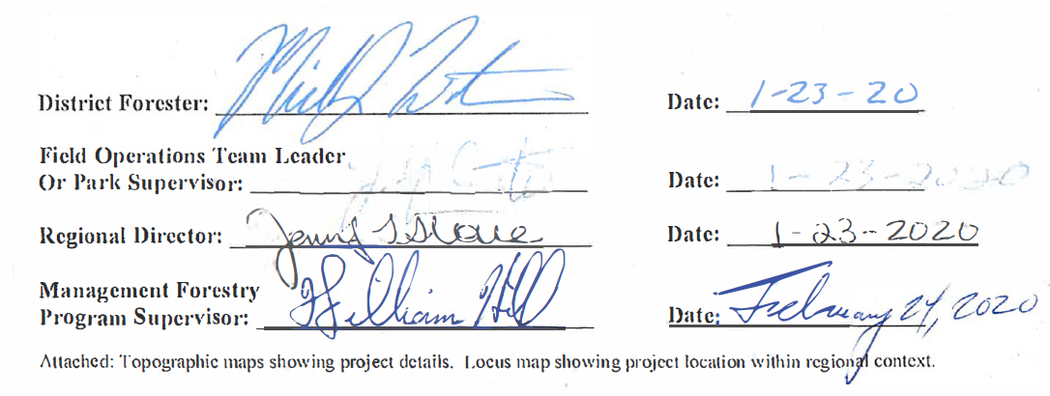

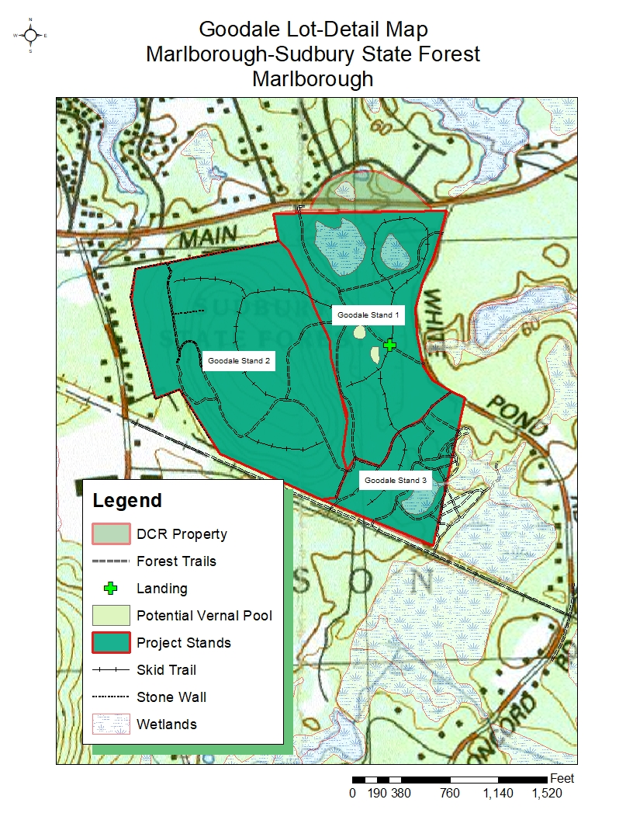

Topographical Detail Map-1

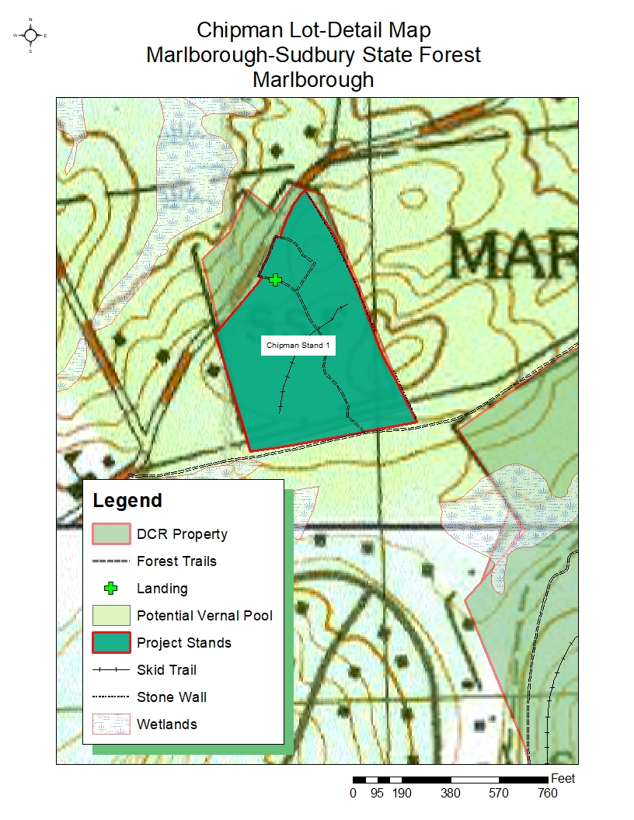
Topographical Detail Map-2

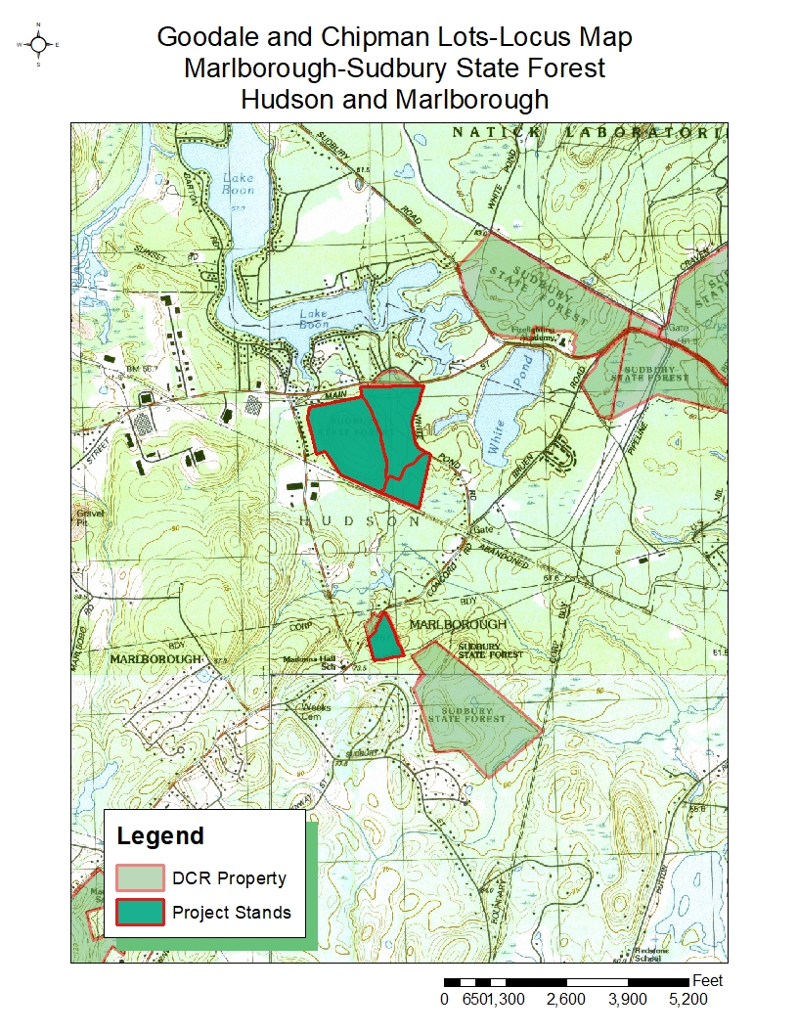Topographical Detail Map-3

