**INDOOR AIR QUALITY ASSESSMENT**

**Goodrich Academy**

**111 Goodrich Street**

**Fitchburg, MA**

Front view of Goodrich Academy, Fitchburg

Prepared by:

Massachusetts Department of Public Health

Bureau of Environmental Health

Indoor Air Quality Program

February 2020

# Background

|  |  |
| --- | --- |
| Building: | Goodrich Academy (GA) |
| Address: | 111 Goodrich Street, Fitchburg, MA |
| Assessment Requested by: | Robert Michael Jokela, Superintendent, Fitchburg Public Schools |
| Reason for Request: | General Indoor Air Quality (IAQ) |
| Date of Assessment: | September 13, 2019 |
| Massachusetts Department of Public Health/Bureau of Environmental Health (MDPH/BEH) Staff Conducting Assessment: | Michael Feeney, Director, IAQ Program |
| Building Description: | The GA is a brick building complex. The original building was constructed in 1891. |
| Windows: | Windows are openable |

# Methods

Please refer to the IAQ Manual for methods, sampling procedures, and interpretation of results (MDPH, 2015).

**IAQ Testing Results**

The following is a summary of indoor air testing results (Table 1):

* ***Carbon dioxide levels*** were below the MDPH guideline of 800 parts per million (ppm) in all the locations assessed, however the building was mostly empty. Based on the condition of the ventilation system, carbon dioxide levels would be expected to be higher with full occupancy. This is explained further in the **Ventilation** section of this report.
* ***Temperature*** was within the recommended range of 70°F to 78°F the day of assessment. Note it is difficult to control temperature to maintain comfort without operating the mechanical ventilation systems as designed.
* ***Relative humidity*** was within or close to the recommended range of 40 to 60% the day of assessment.
* ***Carbon monoxide*** levels were non-detectable (ND) in all areas tested.
* ***Fine particulate matter (PM2.5)***concentrations measured were below the national ambient air quality standard (NAAQS) limit of 35 μg/m3 in all areas tested.

# Discussion

## Ventilation

A heating, ventilating and air conditioning (HVAC) system has several functions. First it provides heating and, if equipped, cooling. Second, it is a source of fresh air. Finally, an HVAC system will dilute and remove normally occurring indoor environmental pollutants by not only introducing fresh air, but by filtering the airstream and ejecting stale air to the outdoors via exhaust ventilation. Even if an HVAC system is operating as designed, point sources of respiratory irritation may exist and cause symptoms in sensitive individuals.

The building has two types of ventilation systems. Fresh air was originally provided by an air handling unit (AHU) located in a large room in the basement (Picture 1). The deactivated AHU used a motor to power a large fan using a fan belt, which was found removed at the time of the assessment. The amount of fresh air drawn into the AHU room is controlled by a door/window which was found sealed. When the system was functioning as designed, fresh air would be mixed in this room prior to being drawn into the heating elements via the air handler. Ductwork connects this AHU to air diffusers (Picture 2) throughout the building.

Some classrooms are equipped with unit ventilators (univents) (Picture 3). Univents draw air from the outdoors through a fresh air intake located on the exterior wall of the building and return air from the room through an air intake located at the base of the unit. Fresh and return air are mixed, filtered, heated or cooled and provided to rooms through an air diffuser located in the top of the unit ([Figure 1](https://www.mass.gov/doc/unit-ventilator-univent-0/download)). In some rooms items were on top or in front of univents, which can interfere with air circulation. Exhaust ventilation is provided by wall-mounted air shafts (Picture 4). Without proper supply and exhaust ventilation, common indoor air pollutants can build up and lead to IAQ/comfort complaints.

MDPH staff received numerous complaints concerning heat control in this building. The lack of heat control is in part due to the condition of the mechanical ventilation system. In addition, the location of thermostats likely contributes to poor temperature control. In order to provide adequate thermal comfort, thermostats are typically located near exhaust vents to measure temperature in a room. However, some thermostats in the GA were located on exterior walls over radiators or exposed heating pipes (Picture 5). In this configuration, the thermostats would measure heat from radiators and heating pipes and deactivate the heating before rooms are comfortable. In addition, as shown in Picture 5, some thermostats are located on exterior walls near windows. Since the building was constructed in 1891, the exterior walls were constructed without insulation. Without insulation, exterior walls are subject to seasonal temperature extremes (e.g., cold in winter, warm in summer). Thermostats attached to a chilled wall will unnecessarily call for heat, leading to overheating.

The building appears to be originally designed to provide comfort in warm weather by opening windows and using cross-ventilation. The building was likely originally equipped with windows on opposing exterior walls along with hinged windows (called transoms, Picture 6) located above the doors between classrooms and the hallways. A transom enables the classroom doors to be closed while maintaining a pathway for airflow. This design allows for airflow to enter an open window, pass through a classroom, pass through the open transom, enter the hallway, pass through the opposing open classroom transom, into the opposing classroom and exit the building on the leeward side (opposite the windward side) ([Figure 2](https://www.mass.gov/doc/open-transoms-figure-0/download)). With all windows and transoms open, airflow can be maintained in a building regardless of the direction of the wind. The system fails if the windows or transoms are closed ([Figure 3](https://www.mass.gov/doc/closed-transoms-figure-0/download)). All transoms in the building were found to be sealed, which prevents cross-ventilation as originally designed.

In order to have proper ventilation with a mechanical supply and exhaust system, these systems must be balanced to provide an adequate amount of fresh air to the interior of a room while removing stale air from the room. It is recommended that existing ventilation systems be re-balanced every five years to ensure adequate air systems function (SMACNA, 1994). In its current condition, the HVAC system cannot be balanced.

With regard to HVAC system function, according to the American Society of Heating, Refrigeration and Air-Conditioning Engineers (ASHRAE), the service life for a unit heater, hot water or steam is 20 years, assuming routine maintenance of the equipment (ASHRAE, 1991). Despite attempts to maintain the univents (e.g., oiling bearings, changing filters regularly), the operational lifespan of this equipment has been exceeded in all areas of the GA. Maintaining the balance of fresh to exhaust air will become more difficult as the equipment ages and as replacement parts become increasingly difficult to obtain.

## Microbial/Moisture Concerns

Given that the building does not possess a means to chill air during hot, humid weather, areas in the basement may be prone to condensation. This phenomenon was likely exacerbated during the weather conditions experienced in New England during the summer of 2018:

The New England area experienced an unprecedented period of extended hot, humid weather. According to the Washington Post, “[d]ata…show[s]…cities in the Northeast have witnessed such humidity levels for record-challenging duration...[i]ncluding Albany, Boston, Burlington Portland and Providence” during the summer of 2018 (WP, 2018). “Boston and nearby locations… [saw]…historic numbers of those warm nights with low temperatures at or above 70 degrees…Providence and Blue Hill Observatory have already broken their annual records” (WP, 2018).

Since the building was originally constructed in 1891, it is highly unlikely that the floor has either insulation or a vapor barrier. Therefore, the floor likely has a temperature similar the material beneath the floor (e.g., soil, sand, rock ledge, rock fill). If the temperature of the floor is below or equal to the dew point, the floor will begin to accumulate condensation.

The key to managing condensation is understanding dew point. Condensation is the collection of moisture on a surface at or below the dew point. The dew point is the temperature that air must reach for saturation to occur. If a building material/component has a temperature below the dew point, condensation will accumulate on that material. Over time, condensation can collect and form water droplets. With a floor chilled through contact with soil/rock, and the infiltration of unconditioned hot, humid air during the warmer months, condensation on the floor is likely. This will then moisten materials that are on the floor, including furniture, carpeting and stored materials.

In addition, the presence of high relative humidity (>70%) alone for a significantly long period, can also cause water damage to susceptible materials. If these materials are porous, carbon-containing items (e.g., gypsum wallboard, carpeting, cloth, paper, and cardboard), mold can grow (ASHRAE, 1989).

It is recommended that porous material be dried with fans and heating within *24 to 48 hours of becoming wet* (US EPA, 2008, ACGIH, 1989). If porous materials are not dried within this time frame, mold growth may occur. Water-damaged porous materials cannot be adequately cleaned to remove mold growth.

The basement level of the building contains significant amounts of materials that can support mold growth if exposed to moisture. In addition, a number of conditions exist that may increase relative humidity/moisture conditions in the basement, including the poor condition of the ventilation system. It is highly recommended that materials that can support mold growth be removed from this area. Porous materials such as paper, cardboard, cloth and leather can all become mold colonized if repeatedly exposed to moisture. Conditions conducive to mold growth may result in an indoor environment that could adversely affect the health of occupants with respiratory disease such as asthma.

## Other Conditions

Carpeting on the first and second floors was found stained or rippling (Pictures 7 and 8; Table 1). This carpeting is likely past its service life. The service life of carpeting in schools is approximately 10-11 years (IICRC, 2002). Aging carpet can produce fibers that can be irritating to the respiratory system. In addition, tears or lifting carpet can create tripping hazards. Carpeting should be cleaned annually or semi-annually in soiled high traffic areas as per the recommendations of the Institute of Inspection, Cleaning, and Restoration Certification (IICRC, 2012).

One classroom has a 3D printer which did not appear to have any dedicated exhaust ventilation equipment. An odor was noted in this room that originated from the area of the 3D printer. The National Institute of Occupational Safety and Health (NIOSH), provides the following research information concerning the use of 3D printers:

[I]nvestigators found that a desktop 3D printer emitted smaller particles than those from laser printers that use plastic toner and far greater amounts of certain chemicals linked to asthma. In what they believe is the first discovery of its kind, the investigators also found that 3D printers emit chemicals that combine to form new compounds, including a chemical linked to asthma [and] suggest the need to take precautions to reduce emissions from desktop 3D printers in the home and office… [It is important to use] controls to reduce emissions from desktop 3D printers in non-industrial settings. To reduce emissions, the investigators recommend five specific steps:

1. Always use the manufacturer’s supplied controls (full enclosure appears more effective at controlling emissions than a cover).
2. Use the printer in a well-ventilated place, and directly ventilate the printer.
3. Maintain a distance from the printer to minimize breathing in emitted particles, and choose a low-emitting printer and filament when possible.
4. Turn off the printer if the printer nozzle jams, and allow it to ventilate before removing the cover.
5. Use engineering measures first, such as manufacturer-supplied equipment and proper ventilation, then use materials with lower emissions. Finally, wear protective equipment, such as respirators. (NIOSH, 2016).

Implementation of these control measures would reduce odors and any associated irritation due to this equipment.

Also of note was the presence of peeling paint in the second floor hallway. IAQ staff recommends repairing peeling paint. Identifying the age and lead contents of the paint is necessary to manage, clean and dispose of paint in accordance with applicable state and Federal regulations.

Finally, note that EPA conducted a National School Radon Survey in which it discovered nearly one in five schools had “…at least one frequently occupied ground contact room with short-term radon levels above 4 [picocuries per liter] pCi/L” (US EPA, 1993). The BEH/IAQ Program therefore recommends that every school be tested for radon, and that this testing be conducted during the heating season while school is in session in a manner consistent with USEPA radon testing guidelines. Radon measurement specialists and other information can be found at www.nrsb.org and <http://aarst-nrpp.com/wp>, with additional information at: <http://www.mass.gov/eohhs/gov/departments/dph/programs/environmental-health/exposure-topics/iaq/radon>.

# Conclusions/Recommendations

The conditions related to IAQ problems at the GA raise a number of issues. The general building conditions/design, maintenance, and the condition of HVAC equipment, if considered individually, present conditions that could degrade IAQ and are typically found in buildings of this age. When combined, these conditions can serve to further degrade IAQ. Some of these conditions can be remedied by actions of building occupants. Other remediation efforts will require alteration to the building structure and equipment. For these reasons, a two-phase approach is recommended. The first consists of **short-term** measures to improve air quality and the second consists of **long-term** measures that will require planning and resources to adequately address overall IAQ concerns.

## Short-term measures:

1. Operate existing HVAC components to the extent possible when school is occupied to provide fresh air and exhaust.
2. Use openable windows to provide fresh air during temperate weather. Ensure windows are closed tightly at the end of each day and during heavy rain.
3. Consider removing water-damaged, musty, or worn carpeting. Replace with non-porous materials if possible. Before removal, please assess whether carpeting is adhered to asbestos-containing floor tile. If so, please remove carpet in a manner consistent with Massachusetts Asbestos laws and regulations.
4. Operate dehumidifiers during hot, humid weather to reduce relative humidity in basement areas. Ensure all dehumidifiers are emptied, cleaned and maintained regularly to prevent spills and odors.
5. Avoid storing porous materials on floors, particularly in the lower level. Examine existing materials for water damage and odors and replace as needed.
6. Ensure all sinks in the lower level have wet drain traps throughout the summer break. Run faucets at least twice a week to maintain the airtight seal of the trap.
7. Repair peeling paint is an appropriate manner in conformance with all state and Federal regulations and requirements as needed if paint contains lead.
8. After consulting with a ventilation engineer, examine the feasibility of changing filters in operating HVAC units at least twice a year with Minimum Efficiency Reporting Value (MERV) 8 (or higher) filters. Clean HVAC and univent cabinets of debris and dust when filters are changed.
9. Consider implementing NIOSH 3D printer recommendations.
10. For buildings in New England, periods of low relative humidity during the winter are often unavoidable. Therefore, scrupulous cleaning practices should be adopted to minimize common indoor air contaminants whose irritant effects can be enhanced when the relative humidity is low. To control for dusts, a high efficiency particulate arrestance (HEPA) filter equipped vacuum cleaner in conjunction with wet wiping of all surfaces is recommended. Avoid the use of feather dusters. Drinking water during the day can help ease some symptoms associated with a dry environment (throat and sinus irritations).
11. Clean carpeting annually or semi-annually in soiled high traffic areas as per the recommendations of the Institute of Inspection, Cleaning and Restoration Certification (IICRC 2012).
12. For more information on mold refer to “Mold Remediation in Schools and Commercial Buildings” published by the US Environmental Protection Agency (US EPA, 2008). <http://www.epa.gov/mold/mold-remediation-schools-and-commercial-buildings-guide>.
13. In not done so already, the school should be tested for radon by a certified radon measurement specialist during the heating season when school is in session. Radon measurement specialists and other information can be found at: [www.nrsb.org](http://www.nrsb.org/), and <http://aarst-nrpp.com/wp>.
14. Consider adopting the US EPA (2000) document, “Tools for Schools”, as an instrument for maintaining a good IAQ environment in the building. This document is available at: <http://www.epa.gov/iaq/schools/index.html>.
15. Refer to resource manual and other related IAQ documents located on the MDPH’s website for further building-wide evaluations and advice on maintaining public buildings. These documents are available at: <http://mass.gov/dph/iaq>.

## Long-term Recommendations:

1. Consideration should be given to replace HVAC units/components as they become past their service life. If not conducted already, consider contacting an HVAC engineering firm for an assessment of the ventilation system’s components and control systems (e.g., controls, air intake louvers, thermostats). Based on the age, physical deterioration, and availability of parts for ventilation components, such an evaluation is necessary to determine the operability and feasibility of repairing/replacing the equipment.
2. In order to better control heating in the building, relocating thermostats to interior walls to give appropriate air temperature measurements in highly recommended.

# REFERENCES

ACGIH. 1989. Guidelines for the Assessment of Bioaerosols in the Indoor Environment. American Conference of Governmental Industrial Hygienists, Cincinnati, OH.

ASHRAE. 1989. Ventilation for Acceptable Indoor Air Quality. American Society of Heating, Refrigeration and Air Conditioning Engineers. ANSI/ASHRAE 62-1989.

ASHRAE. 1991. ASHRAE Applications Handbook, Chapter 33 “Owning and Operating Costs”. American Society of Heating, Refrigeration and Air Conditioning Engineers, Atlanta, GA.

IICRC. 2002. Institute of Inspection, Cleaning and Restoration Certification. A Life-Cycle Cost Analysis for Floor Coverings in School Facilities.

IICRC. 2012. Institute of Inspection, Cleaning and Restoration Certification. Carpet Cleaning: FAQ.

MDPH. 2015. Massachusetts Department of Public Health. “Indoor Air Quality Manual: Chapters I-III”. Available at: <http://www.mass.gov/eohhs/gov/departments/dph/programs/environmental-health/exposure-topics/iaq/iaq-manual/>.

NIOSH. 2016. Control Measures Critical for 3D Printers. NIOSH Research Rounds. National Institute for Occupational Safety and Health, Cincinnati, OH. Volume 1, Number 12 (June 2016). <https://www.cdc.gov/niosh/research-rounds/resroundsv1n12.html>

SMACNA. 1994. HVAC Systems Commissioning Manual. 1st ed. Sheet Metal and Air Conditioning Contractors’ National Association, Inc., Chantilly, VA.

US EPA. 1993. Radon Measurement in Schools, Revised Edition. Office of Air and Radiation, Office of Radiation and Indoor Air, Indoor Environments Division (6609J). EPA 402-R-92-014.

US EPA. 2000. Tools for Schools. Office of Air and Radiation, Office of Radiation and Indoor Air, Indoor Environments Division (6609J). EPA 402-K-95-001, Second Edition. <http://www.epa.gov/iaq/schools/tools4s2.html>.

US EPA. 2008. “Mold Remediation in Schools and Commercial Buildings”. Office of Air and Radiation, Indoor Environments Division, Washington, DC. EPA 402-K-01-001. September 2008. Available at: <http://www.epa.gov/mold/mold-remediation-schools-and-commercial-buildings-guide>.

WP. 2018. ‘It’s been relentless’: Smothering summer humidity in the Northeast has crushed records. Washington Post, Washington, DC. <https://www.washingtonpost.com/news/capital-weather-gang/wp/2018/08/30/its-been-relentless-smothering-summer-humidity-in-the-northeast-has-crushed-records/>

**Picture 1**

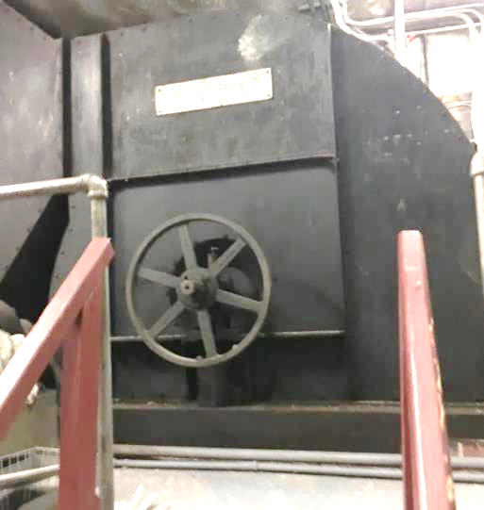

**Abandoned HVAC system equipment in the basement**

**Picture 2**

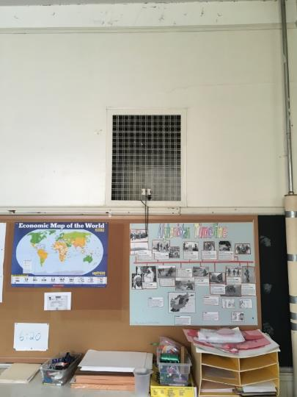

**Original fresh air supply vent**

**Picture 3**

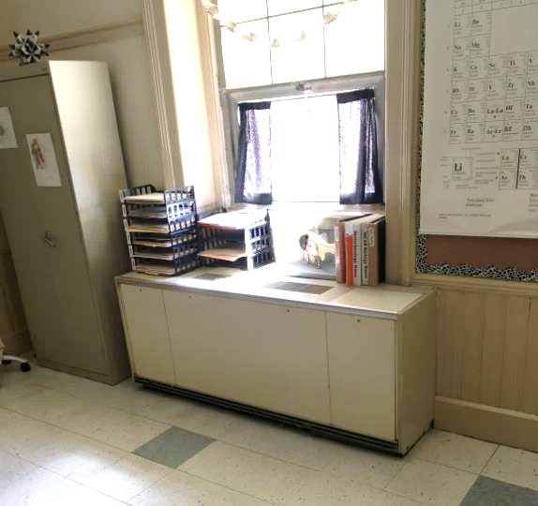

**Unit ventilator (univent)**

**Picture 4**

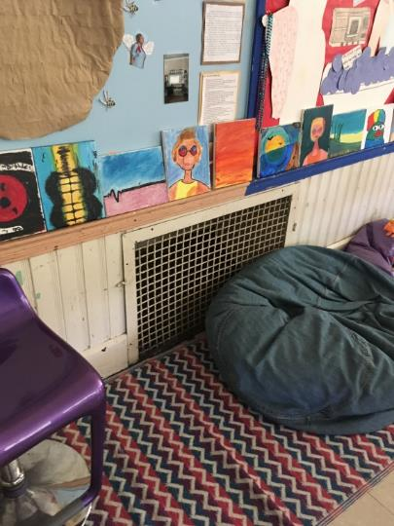

**Exhaust vent**

**Picture 5**

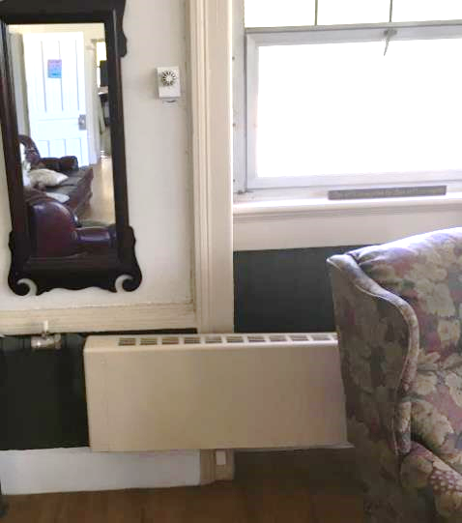

**Thermostat on exterior wall with window and above radiator**

**Picture 6**

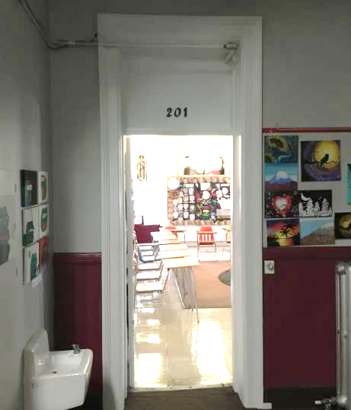

**Area that appears to be a sealed/replaced transom over hallway door**

**Picture 7**

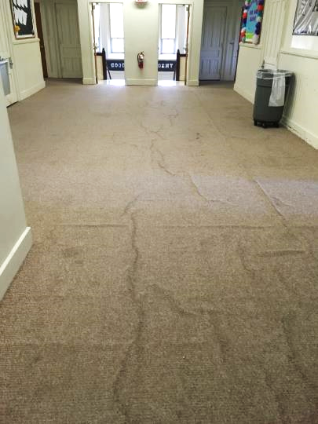

**Rippled carpeting**

**Picture 8**

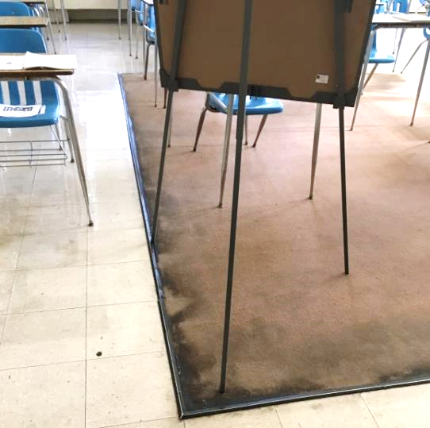

**Discolored carpeting**

| Location | **Carbon**  **Dioxide**  **(ppm)** | **Carbon Monoxide**  **(ppm)** | **Temp**  **(°F)** | **Relative**  **Humidity**  **(%)** | **PM2.5**  **(µg/m**3**)** | **Occupants**  **in Room** | **Windows**  **Openable** | **Ventilation** | | **Remarks** |
| --- | --- | --- | --- | --- | --- | --- | --- | --- | --- | --- |
| **Supply** | **Exhaust** |
| Background (outdoors) | 370 | ND | 68 | 39 | 6 |  |  |  |  |  |
| 202 | 485 | ND | 71 | 50 | 3 | 4 | Y | N | N |  |
| 201 | 460 | ND | 71 | 48 | 4 | 0 | Y | N | N |  |
| 203 | 490 | ND | 72 | 48 | 4 | 3 | Y | Y | N | Computer, 3D printer |
| 204 | 465 | ND | 72 | 48 | 4 | 1 | Y | N | N |  |
| Office | 454 | ND | 73 | 45 | 4 | 0 | N | N | N |  |
| 303 | 455 | ND | 73 | 41 | 5 | 1 | Y | N | N |  |
| 302 | 451 | ND | 76 | 41 | 4 | 1 | Y | N | N | Carpet |
| 301 | 459 | ND | 74 | 42 | 5 | 1 | Y | N | N |  |
| 304 | 425 | ND | 74 | 39 | 4 | 0 | Y | N | N |  |
| 2nd floor hallway |  |  |  |  |  |  |  |  |  | Rippled carpet, peeling paint |
| Computer room | 453 | ND | 72 | 44 | 6 | 0 | Y | N | N | Carpet-odor, upholstered furniture,  window-mounted air conditioner |
| Office 1 | 638 | ND | 71 | 50 | 6 | 1 | Y | N | N |  |
| Office 2 | 530 | ND | 70 | 49 | 5 | 0 | N | N | N |  |