Mold Investigation

Governor Winthrop Nursing Center
142 Pleasant Street
Winthrop, Massachusetts

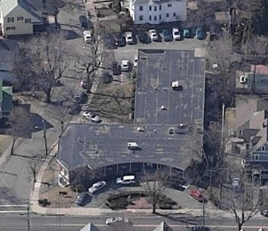

Prepared by:
Massachusetts Department of Public Health
Center for Environmental Health
Emergency Response/Indoor Air Quality Program
January 2007

Background/Introduction
At the request of Mr. Paul Dreyer, Associate Commissioner of the Massachusetts Department of Public Health (MDPH), Center for Quality Assurance and Control (CQAC), the MDPH, Center for Environmental Health (CEH) provided assistance and consultation regarding indoor air quality concerns at the Governor Winthrop Nursing Center (GWNC) located at 142 Pleasant Street, Winthrop, Massachusetts. Concerns of microbial growth and water-damaged materials and their potential impact on the health of patients prompted the request.
On December 29, 2006, a visit was made to this building by Mr. Cory Holmes and Ms. Sharon Lee, Environmental Analysts in CEH’s Emergency Response/Indoor Air Quality (ER/IAQ) Program. Mr. Holmes and Ms. Lee were accompanied by John G. Albert, Landmark Health Solutions and Kevin Cogan, Administrator, GWNC.
The GWNC is a two-story brick nursing facility that provides care for the elderly. Windows are openable throughout the building. Three ground floor areas were brought to the attention of CEH staff: shower room # 4, shower room # 3 and the central supply room. At the time of the CEH assessment, the remediation firm Interstate Restoration Group (IRG) had conducted remediation activities in shower room # 4. According to Mr. Cogan, IRG was scheduled to complete remediation in the other areas within the next several weeks.
Mr. Holmes recommended to Mr. Cogan and Mr. Albert that any remediation of water-damaged/mold contaminated materials be done in a manner consistent with recommendations in “Mold Remediation in Schools and Commercial Buildings” published by the US Environmental Protection Agency (US EPA, 2001). Adherence to these recommendations will serve to protect patients and employees. A copy of this document was provided to Mr. Albert at the time of the visit. Due to the sensitive nature of the population, Mr. Holmes emphasized the importance of implementing preventive measures (e.g., isolation and pressurization) in areas planned for remediation to reduce/eliminate any possible migration of mold, spores, construction dust and other materials that might result in environmental exposures to the patient population.

Methods
CEH staff performed a visual inspection of building materials for water damage and/or microbial growth. CEH staff also collected tape samples on building materials and surfaces for subsequent mold analysis. In accordance with sample collection methods developed previously in collaboration with the Harvard School of Public Health Microbiology Department, tape samples were taken by applying clear adhesive tape to the sample surface, mounting the tape onto microscope slides, and sealing the slides in plastic zip lock bags. Results from tape samples are listed in Table 1.

Microbial/Moisture Concerns
Exposure to mold and related particulates can result in irritant symptoms, particularly in sensitive individuals (i.e. those with pre-existing conditions such as allergies, asthma and respiratory disease). At the time of the CEH assessment, severe water damage to wooden walls and visible mold growth was observed in the central supply room (Picture 1). Visible mold growth was also observed on water-damaged gypsum wallboard (GW) in shower room # 3 (Picture 2):
In order for building materials to support mold growth, a source of water exposure is necessary (e.g., roof/plumbing leaks). Identification and elimination of water moistening building materials is necessary to control mold growth. The main source of moisture in the central supply room is condensation stemming from the large, walk-in refrigerator in the kitchen that is located adjacent to the central supply room. CEH staff examined the refrigerator and found that the casing had a number of breaches, resulting in ice dams (Picture 3). Several areas inside the refrigerator were damaged and/or corroded (Pictures 4 and 5). The front wall of the refrigerator was severely corroded. Light from within the refrigerator could be observed and cold drafts were escaping into the kitchen (Picture 6). Unless the refrigerator is replaced, new materials that may be housed in the central supply room are likely to be damaged again.
The US Environmental Protection Agency (US EPA) and the American Conference of Governmental Industrial Hygienists (ACGIH) recommend that porous materials be dried with fans and heating within 24 to 48 hours of becoming wet (US EPA, 2001; ACGIH, 1989). If not dried within this time frame, mold growth may occur. Once mold has colonized porous materials, they are difficult to clean and should be removed.

Test Results
A total of seven tape samples of various building materials (i.e., gypsum wallboard, wooden walls, pipe insulation and vinyl) were taken. Visible mold growth was observed in some areas, and the presence of growth was confirmed by microscopic analysis in three of the seven samples taken (Table 1). As discussed, exposure to mold and related particulates can result in irritant symptoms, particularly in sensitive individuals (i.e., those with pre-existing conditions such as allergies, asthma and respiratory disease).

TABLE 1
Results of Tape Samples, Governor Winthrop Nursing Center
Samples Taken December 29, 2006

Room | Location in Room | Fungal Growth
Shower Room # 4 | Right bottom corner, wooden frame near floor | None
Shower Room # 4, (storage side) | Interior wall, wooden frame near floor | None
Shower Room # 4, (storage side) | Pipe insulation | None
Shower Room # 4  (storage side) | Gypsum wallboard | None
Central Supply Room | Water-damaged wood wall (surface) | Fonsecaea sp.
Central Supply Room | Exposed vapor barrier behind water-damaged wooden interior wall | Oidiodendron sp.
Shower Room #3 | Water-damaged gypsum wallboard ceiling (rear left corner) | Stachybotrys chartarum

Conclusions/Recommendations
In order to prevent potential mold and related spore movement and to reduce contaminant migration to adjacent areas during remediation, the recommendations outlined below should be implemented. The majority of steps recommended should be taken on any remediation/ renovation project within a public building or building that the public may enter.
- Continue with plans to complete mold remediation. Remediation activities should be conducted in a manner consistent with recommendations in “Mold Remediation in Schools and Commercial Buildings” published by the US Environmental Protection Agency (US EPA, 2001). This document can be downloaded from the US EPA website: http://www.epa.gov/iaq/molds/mold_remediation.html.
- Implement containment measures, which are critical to preventing the spread of dust and mold spores beyond the immediate area(s) of remediation. Once work is completed, ensure that the area is thoroughly cleaned and disinfected with an appropriate antimicrobial prior to reoccupancy. Dust and particulates generated from renovations should be vacuumed with a high efficiency particulate arrestance (HEPA) filtered vacuum cleaner.
- Ensure that among other remediation/containment measures, the general mechanical ventilation system is deactivated and/or sealed (i.e., supply and return vents) in areas of remediation.
- If possible, relocate susceptible persons and those with pre-existing medical conditions (e.g., hypersensitivity, respiratory disease/asthma) furthest away from areas of renovation.
- Implement prudent housekeeping and work site practices to minimize exposure to renovation pollutants. Consider enhancing existing staff resources to accommodate the increase in dirt and dust accumulation related to construction/renovation activities. To control for dusts, a HEPA equipped vacuum cleaner in conjunction with wet wiping/mopping of all surfaces is recommended.
- Seal remediation area(s) with a temporary impermeable barrier (e.g., plastic sheeting) as part of remediation activities. Ensure barrier is as airtight as possible by sealing edges and frames securely with duct tape. Inspect for drafts and/or light penetration to ensure that the barrier is airtight.
- Use local exhaust ventilation and isolation techniques to control remediation pollutants. Precautions should be taken to avoid the re-entrainment of these materials into occupied areas of the building.
- Establish communications between all parties involved with remediation efforts, including patients and other building occupants, to prevent potential IAQ problems and address related concerns.
- Develop a notification system for building occupants to report remediation-related odors and/or issues to the building administrator. Have these concerns relayed to the contractor and/or contact person in a manner that allows for a timely remediation of any problems.

Other Recommendations to Prevent the Reoccurrence of Mold Growth
- Replace refrigerator to prevent a reoccurrence of water damage to materials surrounding the unit.

References
ACGIH. 1989. Guidelines for the Assessment of Bioaerosols in the Indoor Environment. American Conference of Governmental Industrial Hygienists, Cincinnati, OH.

US EPA. 2001. Mold Remediation in Schools and Commercial Buildings. US Environmental Protection Agency, Office of Air and Radiation, Indoor Environments Division, Washington, DC. EPA 402-K-01-001. March 2001.

Picture 1

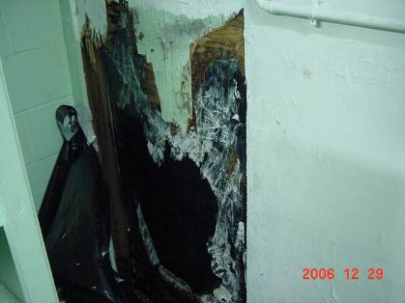

Visible Mold Growth on Water-damaged Wood and Vinyl Vapor Barrier in Central Supply Room

Picture 2

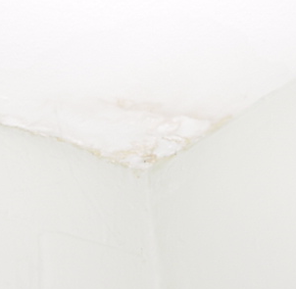

Visible Mold Growth on Water-damaged Gypsum Wallboard Ceiling in Shower Room # 3

Picture 3

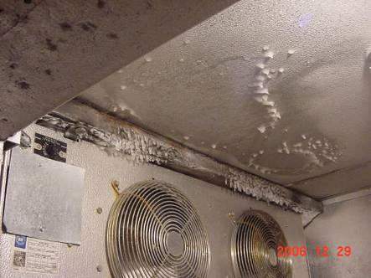

Ice Build-Up inside Refrigerator

Picture 4

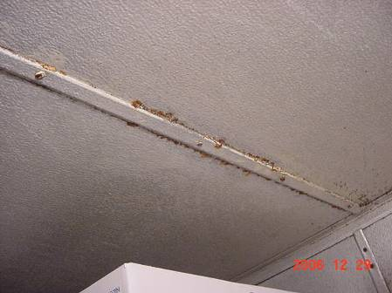

Corrosion along Top Seam of Refrigerator

Picture 5

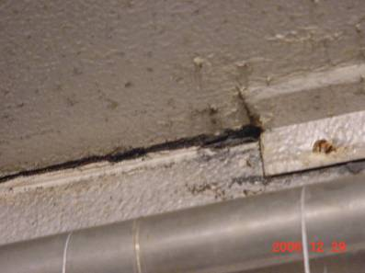

Corrosion of Metal Refrigerator Casing

Picture 6

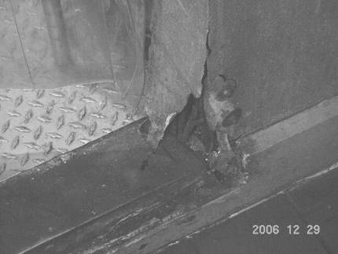

Severe Corrosion of Metal Refrigerator Casing where Light Could be Seen Penetrating and Cold Drafts were Detected

