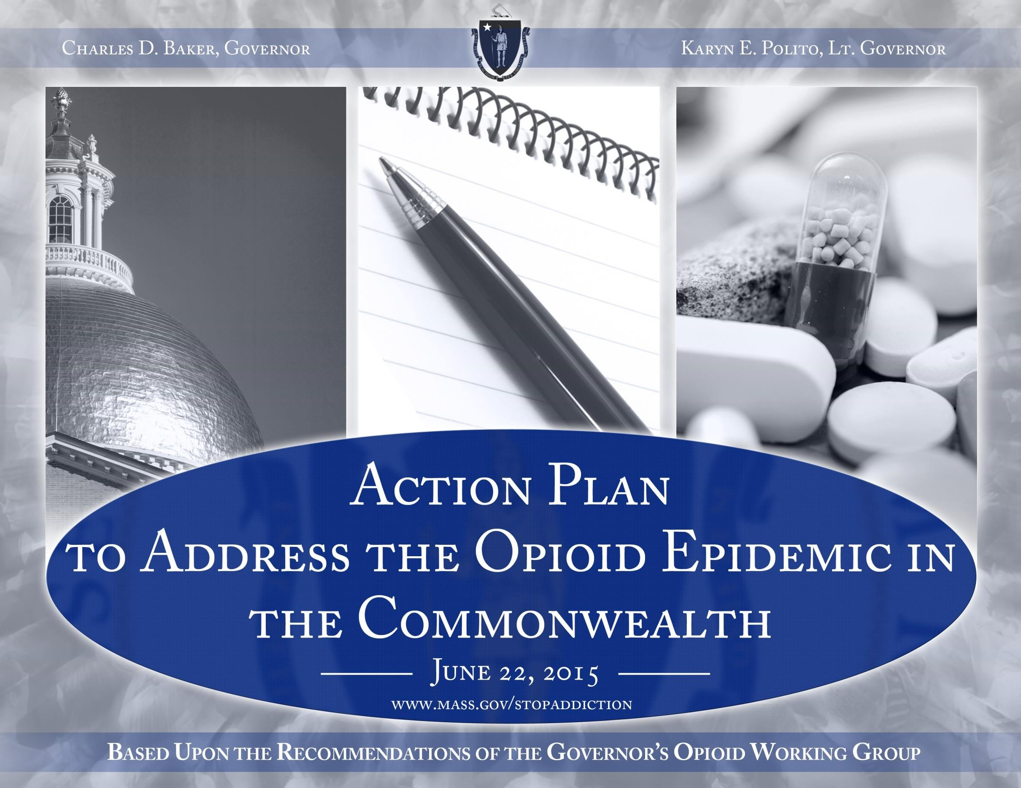

1

2

Scope of the problem: We are in the midst of an epidemic. We have acknowledged and attempted to mitigate the harms associated with opioids for a decade. Nevertheless, we are seeing alarming rates of opioid related overdoses and opioid related deaths. Over the past decade, more than 6,600 members of our community have died because of opioids, and behind those deaths are thousands of hospital stays, emergency department visits, and unquantifiable human suffering inflicted upon individuals, families and our communities.

Governor’s Working Group: An 18 member expert panel, chaired by Marylou Sudders, Secretary of the Executive
Office of Health and Human Services (EOHHS)

Goals: Reduce the magnitude and severity of harm related to opioid misuse and addiction and decrease opioid overdose deaths in the Commonwealth

Objective: Produce actionable recommendations to address the opioid epidemic in the Commonwealth

Activities:
• Hosted 4 listening sessions in Boston, Worcester, Greenfield, and Plymouth
• Held 11 in person meetings
• Examined documents and recommendations from more than 150 organizations
• Heard from more than 1,100 individuals from across the Commonwealth
• Reviewed academic research, government reports, and reports of previous task forces and commissions
• Submitted more than 65 actionable recommendations to Governor Baker on June 12, 2015

2

Public Awareness
Prevention Initiatives
• Create a public awareness campaign focused on reframing addiction as a medical disease

3
• Foster public-private partnerships to leverage public awareness activities
• Promote drug take-back days
• Partner with a chain pharmacy to pilot a drug-take-back program in the Commonwealth

Education – Parents and Students
• Educate parents, students, and faculty about the risks of opioid use and misuse during mandatory athletic meetings
• Provide state funding for evidence-based opioid prevention programs in schools
• Develop targeted educational materials for parents about the risks of opioid use and misuse

Prescriber Practices
• Mandate prescriber education as a condition of licensure by working with boards of registration to enforce continuing education requirements related to: effective pain management; identification of patients at high risk for a SUD; and counseling patients on the side effects, addictive nature, and proper storage and disposal of prescription medications
• Appoint an addiction specialist to the Board of Registration in Medicine, Board of Registration in Nursing, Board of Registration of
Physician Assistants, and Board of Registration in Dentistry
• Appoint members to the drug formulary commission and commence the first meeting prior to August 1
• Outreach to prenatal and postpartum care providers to increase training about screening, intervention, and care for women with a substance use disorder (SUD)
• Increase and improve educational offerings about safe prescribing practices by engaging in private-public partnerships
• Encourage the American College of Graduate Medical Education to adopt requirements for pain management and substance use
disorder education for all medical and residency programs, through a partnership with federal leaders

3

Prescription Monitoring Program
Intervention Initiatives
• Improve the prescription monitoring program (PMP)

4

• Ensure data compatibility of the PMP with other states, Memorandum of understanding with other states required

• Require PMP data to be submitted within 24 hours by pharmacies, Legislation required

Data
• Require timely reporting of overdose death data to the public

• Amend Department of Public Health regulations to require that emergency medical service providers report opioid overdose data

• Utilize overdose reports to identify geographical hot spots for targeted intervention and alert law enforcement, public health entities, community coalitions, and the public

Other Intervention Action Items
• Develop and distribute educational materials for prescribers to increase co-prescribing of naloxone with opioid prescriptions

• Implement a training program about neonatal abstinence syndrome and addiction for Department of Children and Families’ staff

• Promote the Good Samaritan law

• Amend the civil commitment statute, section 12 of chapter 123 of the General Laws, to allow for the involuntary transport and
assessment of an individual with a substance use disorder (SUD), Legislation required

• Improve affordability of naloxone through bulk purchasing, Legislation required

4

MassHealth
Treatment Initiatives
• Develop a statewide database of available treatment services, accessible by phone and internet

5
• Expand mobile emergency service programs to support individuals with a substance use disorder (SUD) in crisis
• Provide case management services to MassHealth fee-for-service members who have a SUD
• Remove fail-first requirements for medication-assisted treatment and ensure naltrexone is categorized as a pharmacy benefit within all MassHealth plans
• Review SUD treatment prior authorization policies across MassHealth to ensure consistency and remove barriers to treatment
• Enroll uninsured patients receiving acute treatment services or clinical stabilization services in MassHealth or other insurance

Department of Public Health
• (Pilot) Create walk-in access to a trained clinician in community-based outpatient provider settings who can provide an emergent/urgent addiction assessment and direct referral to the appropriate level of care
• (Pilot) Make recovery coaches available in emergency departments and hot spots
• Increase the number of office-based opioid treatment programs in community health centers
• Integrate medication-assisted treatment into the clinical stabilization services (CSS) care setting
• Add 100 new treatment beds by July 2016 and expand access to patient navigators

5

6

Treatment Initiatives

Department of Corrections
• Bulk purchase opioid agonist and naltrexone therapies for correctional facilities
• Improve SUD treatment services for men and women committed under section 35 of chapter 123 of the General Laws: transfer
women from the correctional facility at MCI-Framingham to a new facility run by the Executive Office of Health and Human Services (EOHHS) and develop a feasibility plan to transfer responsibility for the Massachusetts Alcohol and Substance Abuse Center at Bridgewater to EOHHS, Legislation required
• Increase treatment beds and ensure a continuum of care for patients who are civilly committed under section 35

Division of Insurance
• Review existing Division of Insurance bulletins regarding parity oversight and enforcement
• Issue guidance on the implementation of the substance use disorder recovery law before October 1, 2015

Group Insurance Commission
• Ensure that all Group Insurance Commission (GIC) plans provide coverage for naltrexone, naloxone, buprenorphine, and methadone
• Review GIC insurance plans, removing fail-first policies and prior authorization protocols that may impede access to treatment

Partnering with Federal Leaders
• Change Drug Enforcement Agency (DEA) rules to permit medical residents to prescribe buprenorphine under an institutional DEA
registration number, through a partnership with federal leaders
• Change federal law and regulations to increase access to buprenorphine by: increasing the cap - the number of patients a physician can treat with buprenorphine - or removing it entirely; and permitting nurse practitioners and physician assistants to prescribe buprenorphine, through a partnership with federal leaders

6

7

Recovery Support Initiatives

Department of Public Health
• Enforce and strengthen the requirement that all licensed addiction treatment programs accept patients who are on methadone or buprenorphine medication

• Implement a process to certify alcohol and drug-free housing to increase accountability and credibility

• Establish revised rates for residential recovery homes, effective July 1, 2015

• Leverage community coalitions to address the opioid epidemic

• Open Recovery High School in Worcester

Executive Office of Health and Human Services
• Create a consistent public behavioral health policy through a review of all DPH and DMH licensing regulations for outpatient primary care clinics, outpatient mental health clinics, and BSAS programs removing all barriers to integration

• Ensure MassHealth coverage is reinstated on an accelerated basis for individuals upon release from incarceration

• Establish a single point of accountability for addiction and recovery policy within the Executive Office of Health and Human
Services

• Amend the composition of the Interagency Council on Substance Abuse, Legislation required

• Report publicly on the progress and challenges of implementing the working group’s recommendations

• Increase federal support for substance use prevention, intervention, treatment, and recovery efforts uniquely tailored for our
Veterans, through a partnership with federal leaders

7

