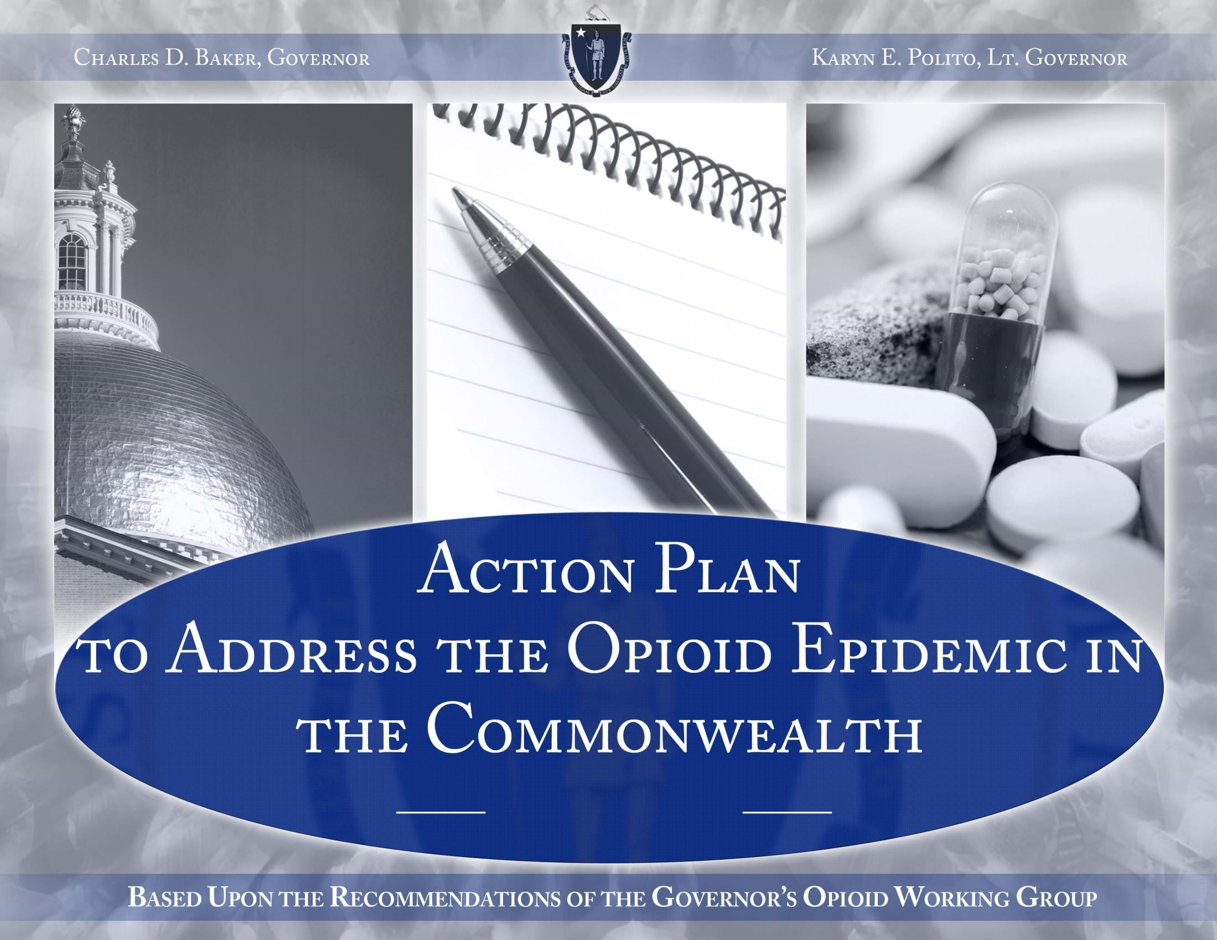

1

Prevention

• July 17, 2015, Governor Baker filed the supplemental budget requesting $27.8 Million to address the opioid crisis, $5 Million of which is for prevention education initiatives. The
budget was signed into law on November 2, 2015.
• July 22, 2015, DPH sponsored a free training program, “Effectively Preventing
Prescription Drug Misuse and Other Drugs,” for 138 participants to become certified in
providing evidence-based substance use prevention curricula. Participants included school
nurses, staff from school-based health centers, and other school personnel.
• July 22, 2015, Massachusetts Hospital Association published a screening tool packet for evaluating patients with a SUD, which supplements their guidelines for Emergency
Department Opioid Management and the Emergency Department Opioid Management
Patient Information Sheet.

2

Prevention

• August 4 & 11, 2015, Participants who attended the July 22 DPH training attended an additional day of training to become certified to teach either the “Botvin LifeSkills” or “All Stars” evidence-based drug prevention program.
• August 6, 2015, Drug Formulary Commission held its first meeting.
• August 19, 2015, Massachusetts Medical Society published opioid therapy and physician
communication guidelines and established FREE CME webinars on their website related to
pain management and safely prescribing opioids.
• August 28, 2015, DPH posted targeted educational materials for parents about the risks of opioid use and misuse on their clearinghouse website.
• September 26, 2015, National Drug take-back day, more than 133 sites throughout the
Commonwealth participated collecting prescription drugs that are no longer needed.

3

Prevention

• October 15, 2015, Governor Baker filed (H. 3817), An Act relative to substance use treatment, education, and prevention, which increases continuing education requirements for practitioners, reduces first-time prescriptions for opioids to 72 hours, ends the practice of admitting women to MCI-Framingham, establishes a 72-hour involuntary assessment period, increases utilization of the prescription monitoring program, and requires the education of athletes and their parents about the dangers of opioid use and misuse.
• October 27, 2015, Governor Baker and Mayor Martin J. Walsh sent a joint letter to members of the Massachusetts State Legislature asking for swift action on H.3817, An Act
Relative to Substance Use Treatment, Education and Prevention.
• October 28 & 29, 2015, DPH sponsored a free training program for school nurses and
other school personnel to become certified in providing evidence-based substance use
prevention curricula.

4

Prevention

• November, 2015, DCF/BSAS trainings on neonatal abstinence syndrome and addiction commenced.
• November, 2015, Governor Baker announced a statewide media campaign with the
bold goal of making Massachusetts a “#StateWithoutStigMA” - 46 billboards promoting the
“State without Stigma” campaign went up on highways in cities and towns throughout the
state.
• December 21, 2015, DPH and the Massachusetts Interscholastic Athletic Association
began a collaboration to develop educational materials for parents and coaches of students
who participate in school sport activities.
• February and March 2016, additional “Botvin LifeSkills Trainings” scheduled for school nurses and other school personnel to become certified in providing evidence-based
substance use prevention curricula.

5

Intervention

• July 17, 2015, Chapter 46 of the acts of 2015 was signed into Law by Governor Baker.
• Section 48 authorizes the bulk purchasing trust fund, which will improve the
affordability of Narcan for cities and towns.
• Section 89 requires PMP data to be submitted within 24 hours.
• August 4, 2015, DPH issued the August quarterly report for overdose death data to
the public.
• August 31, 2015, Attorney General Maura Healey negotiated an agreement with
Amphastar for $325,000 to help offset the costs of Narcan. The payment was deposited
into the Commonwealth’s Municipal Naloxone Bulk Purchase Trust Fund.
• September 23, 2015, DPH issued a letter to all pharmacies reaffirming their
responsibility to distribute the Opioid Prescription Drug Fact Sheet, developed by DPH,
with each Schedule II and III narcotic medication that is dispensed.

6

Intervention

• September 25, 2015, DPH Commissioner Bharel issued a letter to all prescribers encouraging the co-prescription of naloxone when an opioid is prescribed.
• October, 2015, DPH issued the October quarterly report for overdose death data to the public.
• October 23, 2015, BSAS posted RFR to create a pilot program allowing walk-in access to a trained clinician, in community-based outpatient provider settings, who can provide an emergent/urgent addiction assessment and direct referral to the appropriate level of care.
• November, 2015, DPH issued guidance to cities and towns about how to utilize the
Commonwealth’s Municipal Naloxone Bulk Purchase Trust Fund.

7

Intervention

• December 7, 2015, DPH promulgated regulation 105 CMR 700.012 which requires pharmacies to submit data on the dispensing of a controlled substance to the Prescription Monitoring Program on the next business day.
• December 10, 2015, DPH announced that medical residents/interns can access the
Massachusetts Online Prescription Monitoring Program.
• December 16, 2015, Health Policy Commission announced its plan to commit
$3,500,000 to improve the care of patients with neonatal abstinence syndrome.

8

Intervention

• December 22, 2015, DPH awarded a contract to Appriss, Inc. to develop and
implement the new Prescription Monitoring Program, which will include:
• An improved user-friendly interface and faster access to reports;
• Interoperability with other states’ online PMP systems, preventing duplicate
prescribing between states;
• Integration to link with Commonwealth health providers’ electronic medical record
systems to ensure safe prescribing;
• Efficient onboarding for users including prescribers, delegates, residents and interns
and pharmacies and dispensers.

9

Treatment

• June 17, 2015, 10 new adult residential recovery home beds opened in Westborough.
• June 17, 2015, 2 additional Clinical Stabilization Service beds opened in Fall River.
• July 1, 2015, MassHealth implemented protocols to ensure that eligible individuals have MassHealth coverage upon release from incarceration.
• July 10, 2015, DPH issued an alert to all licensed and contracted substance use treatment service providers and stakeholders reinforcing and strengthening the requirement that all licensed addiction treatment programs MUST accept patients who are receiving medication assisted treatment (MAT).
• July 17, 2015, Governor Baker filed a $27.8 Million supplemental budget requesting:
$5.8 Million to transfer women committed under section 35 of chapter 123 of the
General Laws from MCI-Framingham to Taunton State Hospital for treatment; and $3
Million for MassHealth to expand services for individuals with a SUD, which was signed
into law on November 2, 2015.

10

Treatment

• July 20, 2015, MassHealth implements protocols to fast-track MassHealth enrollment
of DPH clients receiving detoxification services who do not have insurance.
• July 31, 2015, Division of Insurance, in coordination with DPH and DMH, issued guidance on the implementation of the substance use disorder recovery law, chapter
258 of the acts of 2014.
• August 5, 2015, BSAS met with the Massachusetts League of Community Health
Centers to encourage doctors to obtain DEA waivers that allow for the prescribing of
buprenorphine.
• August 12, 2015, DPH announced a 3-year, $3 million grant from the federal
Substance Abuse and Mental Health Services Administration (SAMHSA) to expand the
availability of Medication Assisted Treatment (MAT) for pregnant women with opioid
use disorders in Massachusetts, and to improve linkages with comprehensive services
for recovery support for women currently receiving MAT.

11

Treatment

• August 20, 2015, MassHealth and DPH commit to the development and implementation of a statewide database of available treatment services, available via helpline and website. This project will be phased in:
• December 31, 2015, inventory of available acute treatment service (ATS) beds,
clinical stabilization service beds (CSS), transitional support service (TSS) beds, Level
IV detoxification beds, and methadone treatment available via the helpline and
website.
• January 31, 2016, inventory of available Structured Outpatient Addiction Programs,
Intensive Outpatient Programs, and Residential Rehabilitation beds will be available
via the helpline and website.
• February 28, 2016, inventory of primary care providers who prescribe Medication
Assisted Treatment (MAT) and agree to be listed in the database will be available via
the helpline and website.

12

Treatment

• August 31, 2015, Celticare removed prior authorization requirements for Suboxone, as a result of a MassHealth review of SUD treatment prior authorization policies across
MassHealth to ensure consistency and to remove barriers to treatment.
• August 31, 2015, 125 new beds licensed by the Department of Mental Health added
in Dartmouth.
• September 1, 2015, 11 additional detoxification (level 3.7 medically monitored)
service beds opened in Plymouth; 8 additional clinical stabilization service beds opened
in Plymouth.
• September 4, 2015, MassHealth notified all MCO’s to remove prior authorization
requirements for certain substance use treatment services, effective October 1, 2015.

13

Treatment

• September 11, 2015, 23 additional adult residential recovery home beds opened in
Westborough.
• September 17, 2015, Federal Health and Human Services (HHS) Secretary Burwell announced that HHS will revise the regulations related to the prescribing of
buprenorphine to treat opioid dependence. The regulation change will increase the
number of patients that a doctor can treat with buprenorphine.
• October 1, 2015, 15 additional adult residential recovery home beds opened in
Lowell.
• October, 2015, 22 adult residential recovery home beds opened in Boston.
• November, 2015, MassHealth issued policy guidance to its contracted health plans to reduce barriers to SUD treatment and to ensure uniform access to Medication
Assisted Treatment (MAT), to be followed by contract amendments.

14

Treatment

• November 2, 2015, BSAS posted an RFR to increase the number of office-based
opioid treatment programs in community health centers.
• November 9, 2015, Baker-Polito Administration, in partnership with the deans of
the Commonwealth’s four medical schools and the Massachusetts Medical Society
released a pioneering set of medical education core competencies for the prevention
and management of prescription drug misuse to ensure that 3,000 enrolled medical
students across the Commonwealth receive enhanced training in primary, secondary,
and tertiary prevention strategies regarding prescription drug misuse.
• November 14, 2015, Mass League of Community Health Centers held a conference titled Meeting the Challenges of Complex Patients with Chronic Pain or Addiction. Over
70 providers attended the conference, which included workshops led by physicians who prescribe Suboxone.
• November 18, 2015, 20 new Clinical Stabilization Service (CSS) beds opened in
Haverhill.

15

Treatment

• December 10, 2015, 23 new detoxification (level 3.7 medically monitored) service
beds opened in Haverhill.
• December 29, 2015, DPH posted an RFR to pilot Recovery Coaches in the
Emergency Department. Recovery coaches will work with individuals with a substance
use disorder in the emergency department to engage the person in treatment.
• January 5, 2016, DPH announced $466,450 in grants awarded to four healthcare organizations to improve treatment for youth and young adults with substance use
disorders and/or co-occurring substance use and mental health disorders.
• January 6, 2016, DPH announced $700,000 in grants awarded to 31 municipalities to
support the carrying and administering of naloxone by Police and Fire Departments.
• January 7, 2016, DPH announced $6.8 million in grants awarded to 16 communities to implement evidence-based prevention programs, policies, and practices to reduce
prescription drug misuse among persons aged 12 to 25 years old.

16

Treatment

• January 7, 2016, 24 ATS beds opened in Boston
• January 11, 2016, 28 new dedicated section 35 treatment beds for women will open at Shattuck.
• February, 2016, 32 new ATS and 32 new CSS beds are scheduled to open in
Greenfield.
• February 2016, 15 new dedicated section 35 treatment beds for women will open at
Taunton State Hospital.
• Spring 2016, MassHealth will ensure that Outpatient Treatment Programs that dispense methadone have the ability to bill MassHealth for Buprenorphine and
Naltrexone. This will expand access to MAT throughout the Commonwealth.

17

Recovery

• July 17, 2015, Governor Baker filed a $27.8 Million supplemental budget, requesting
$14 Million to increase rates paid to recovery homes for individuals with a substance use
disorder, which was signed into law on November 2, 2015.
• September 8, 2015, The Recovery High School in Worcester opened for 2015/2016 school year.
• October 1, 2015, DPH awarded two contracts for the implementation of the voluntary sober home certification process by Winter, 2016.
• October 16, 2015, daily rate paid to recovery homes for individuals with a substance use disorder raised from $75 per day to $100.08 per day; rate will be paid retroactively to July 1, 2015.

18

Recovery

• October to December 2015, DPH trains residential treatment providers on Best
Practices
• October 30th, 52 Individuals Registered
• November 13th, 51 Individuals Registered
• December 18th, 44 Individuals Registered
• January 2016, Recovery Home Collaborative in collaboration with the Mass
Association of Sober Houses will begin to certify sober homes.

19

