BACKGROUND

MOLD/ODOR ASSESSMENT

Gracy House
Rowe Community Center
Zoar Road
Rowe, Massachusetts

Prepared by:
Massachusetts Department of Public Health
Bureau of Environmental Health
Indoor Air Quality Program
November 2018
Building: | Gracy House  Rowe Community Center
Address: | Zoar Road, Rowe, MA
Assessment Coordinated via: | Janice Boudreau, Executive Secretary, Town of Rowe
Reason for Request: | Mold odor and water damage
Date of Assessment: | October 12, 2018
Massachusetts Department of Public Health/Bureau of Environmental Health (MDPH/BEH) Staff Conducting Assessment: | Michael Feeney, Director, IAQ Program
Date Building Constructed: | 1837 with renovations in 2000s
Building Description: | Originally a wood, two-story residence with an unfinished cellar. The first floor had a laminate flooring system installed. Window frames were replaced and plastic was installed over the dirt floor cellar.

IAQ Testing Results
Please refer to the IAQ Manual for methods, sampling procedures, and interpretation of results (MDPH, 2015). The following is a summary of testing results.
- Moisture Measurements in all laminate flooring on the first floor showed that it was moistened at the time of assessment.
- Temperature was below the recommended range of 70°F to 78°F at the time of assessment.
- Relative humidity was above the recommended range of 40 to 60% in areas tested at the time of the assessment and higher (+ 24 -33%) than outdoors measurements.

Background and Discussion
The BEH/IAQ Program was asked to examine Gracy House due to mold odor and possible water damage from high relative humidity during the hot, humid weather during the summer months of 2018.

Microbial/Moisture Concerns
The Boston area experienced an unprecedented period of extended hot, humid weather. According to the Washington Post, “[d]ata…show[s]…cities in the Northeast have witnessed such humidity levels for record-challenging duration...[i]ncluding Albany, Boston, Burlington Portland and Providence” during the summer of 2018 (WP, 2018). “Boston and nearby locations… [saw]…historic numbers of those warm nights with low temperatures at or above 70 degrees…Providence and Blue Hill Observatory have already broken their annual records” (WP, 2018). If a building does not have either adequate exhaust ventilation and/or air chilling capacity to remove/reduce relative humidity from outside air, then hot, moist air can be introduced into a building and linger to increase occupant discomfort as well as possibly moisten materials that may lead to mold growth.
As noted previously, relative humidity measurements were 24 -33% higher indoors than compared to outdoor measurements the day of this assessment. These relative humidity measurements indicate that little if any air exchange exists in the building and a significant water source exists within the building. The lack of air exchange can be attributed to a number of renovations that were made to weatherize the building, including: installation of energy-efficient windows (Picture 1), sealing of all basement windows (Picture 2), sealing the bulkhead access to the cellar with silver foil insulation (Picture 3), installation of soffit vents (Picture 4) with likely installation of fiberglass batting on the attic floor, and installing plastic on the dirt floor cellar (Picture 5). If water sources exist in the building, especially in combination with the high outdoor relative humidity experienced in New England during the 2018 summer, the resultant high indoor humidity can then moisten building components and contents. Several potential sources of water vapor to the building interior were observed, including:
- A lack of gutters and downspouts (Picture 6) which can lead to water penetrating the building envelope;
- A damaged bulkhead door (Picture 7), which could allow water into the basement;
- A well in the basement (Picture 8) which can be a source of moisture if not properly closed off.
During the assessment, a distinct mold odor was detected on the first floor of the building. The source of this odor was traced to the cellar, which had a distinct musty odor from moistened soil. The cellar has a dirt floor which if moistened, can support mold growth. The cellar door is not airtight. Odors from the cellar can be drawn to the first floor via the stack effect. The stack effect occurs when heated air rises, creating upward air movement which can draw particulates, odors and moisture up from a lower level.
Adding to the water load along the foundation is the lack of gutters and downspouts. Downspouts should empty at least five feet from the foundation to prevent water from entering the building. Over time, these conditions can undermine the integrity of the building envelope and provide a means of water entry into the building via capillary action through concrete and masonry (Lstiburek & Brennan, 2001).
The first floor consists of plywood covered with tongue-in-groove laminate flooring (Picture 9), which is not designed for use in a high moisture environment. According to one manufacturer, their “flooring should not be installed over any ﬂoor with a sump pump or in a room with a ﬂoor drain” (Pergo, unknown). Laminate flooring is usually manufactured using particle board plank with a laminate applied to the surface to give the appearance of natural wood. Due to its design, water vapor cannot readily pass through the material to escape from the space below the floor. This results in the floor beams, under-flooring and laminate to be chronically exposed to moisture. This in turn, may cause the flooring to be colonized with mold.
At the time of assessment, the basement appeared dry, however the surface of floor beams appear to be spotted with mold colonies, indicating chronic moisture exposure (Picture 10). In order for building materials to support mold growth, a source of water exposure is necessary. Building materials with increased moisture content over normal concentrations may indicate the presence or potential of mold growth.
BEH/IAQ staff conducted moisture sampling of the laminate floor, which was found to be moistened. Moisture content of materials may increase or decrease depending on building and weather conditions. In addition, a water-damaged carpet was noted on the threshold of the attic stair (Picture 11).
The United States Environmental Protection Agency (US EPA) and the American Conference of Governmental Industrial Hygienists (ACGIH) recommend that porous materials be dried with fans and heating within 24 to 48 hours of becoming wet (US EPA, 2008; ACGIH, 1989). If porous materials are not dried within this time frame, mold growth may occur. Once mold has colonized porous materials, they are difficult to clean and should be removed and discarded.

Conclusions/Recommendations
The conditions observed at the Gracy House are complicated. Water readily enters the building’s basement, resulting in chronic moistening of materials in the cellar and laminate floor, which is the likely source of reported odors in the building. Due to various conditions involving the building envelope, it is also likely that long-term issues exist involving the restoration of means to vent moisture from the basement.
Short-term and long-term recommendations are provided to address the conditions described in this assessment and to improve IAQ. The short-term recommendations can be implemented as soon as practicable. Long-term measures are more complex and will require planning and resources to adequately address overall IAQ concerns within the building.

Short-term Recommendations
- Remove all porous material from the cellar in a manner consistent with recommendations made in “Mold Remediation in Schools and Commercial Buildings” published by the US EPA (2008). This document can be downloaded from the US EPA website at: http://www.epa.gov/mold/mold_remediation.html.
- Remove carpet from cellar stair threshold.
- Consider removing the laminate flooring and replace with a water impermeable surface e.g., floor tile.
- Open upper-story windows during hot, humid weather to create cross ventilation to vent water vapor.
- Repair bulkhead door.
- Consider removing insulation blocking the bulkhead door to allow for water vapor venting.
- Consider installing openable windows for the cellar to open during hot, humid weather to create cross ventilation.
- Refer to resource manual and other related indoor air quality documents located on the MDPH’s website for further building-wide evaluations and advice on maintaining public buildings. These documents are available at http://mass.gov/dph/iaq.

Long-term Recommendations
- Consider installing gutters and downspouts to direct rainwater at least a distance of five feet away from the foundation.
- Consult a building engineer as to the best method for preventing or minimizing water penetration through the foundation.
- Consider installing a mechanical exhaust vent and necessary ductwork to vent the cellar to draw odors and eject water vapor from the building if needed.

References
ACGIH. 1989. Guidelines for the Assessment of Bioaerosols in the Indoor Environment. American Conference of Governmental Industrial Hygienists, Cincinnati, OH.
ASHRAE. 1989. Ventilation for Acceptable Indoor Air Quality. American Society of Heating, Refrigeration and Air Conditioning Engineers. ANSI/ASHRAE 62-1989.
Lstiburek, J. & Brennan, T. 2001. Read This Before You Design, Build or Renovate. Building Science Corporation, Westford, MA. U.S. Department of Housing and Urban Development, Region I, Boston, MA
Pergo. Unknown. Pergo Installation Essentials Guide for Laminate Flooring. http://sweets.construction.com/swts_content_files/151611/375951.pdf.
US EPA. 2008. Mold Remediation in Schools and Commercial Buildings. US Environmental Protection Agency, Office of Air and Radiation, Indoor Environments Division, Washington, D.C. EPA 402-K-01-001. http://www.epa.gov/mold/mold-remediation-schools-and-commercial-buildings-guide.

Picture 1
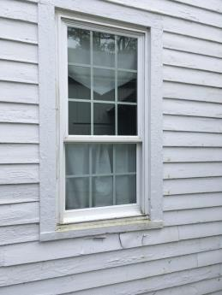
Energy-efficient windows
Picture 2
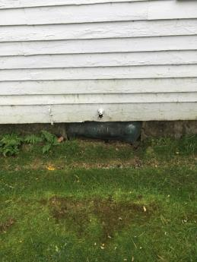
Sealed basement windows
Picture 3
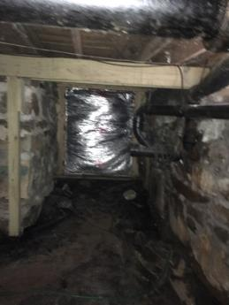
Silver foil insulation sealing off bulkhead from cellar
Picture 4
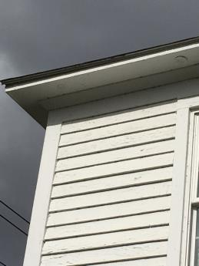
Soffit vents installed to prevent ice dams in attic
Picture 5
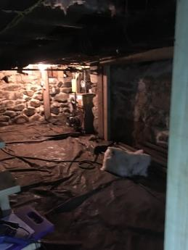
Plastic on cellar floor
Picture 6
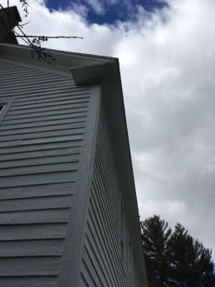
Roof edge without gutter/downspout
Picture 7
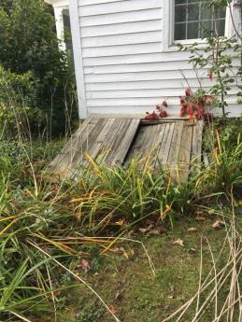
Damaged bulkhead doors
Picture 8
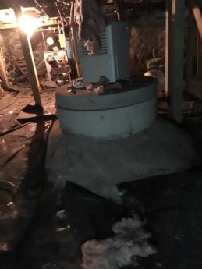
Sealed well head in cellar
Picture 9
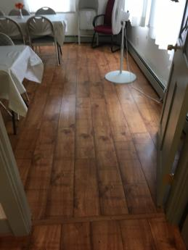
Laminate flooring
Picture 10
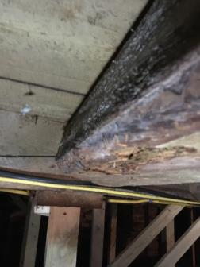
Mold colonization on surface of floor beams
Picture 11
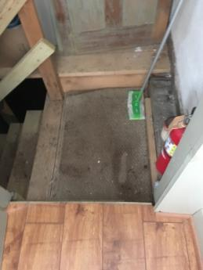
Water-damaged carpet on cellar stair threshold

