The Commonwealth of Massachusetts
Executive Office of Health and Human Services
Department of Public Health
Bureau of Infectious Disease and Laboratory Sciences
305 South Street, Jamaica Plain, MA 02130

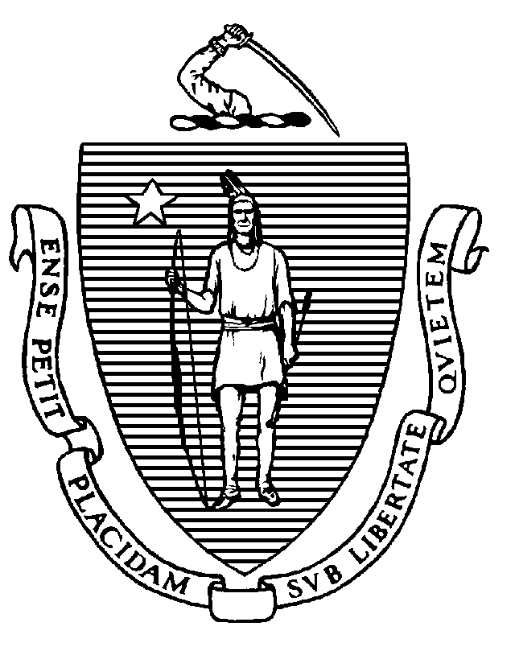
Immunization Division
Tel: (617) 983-6800
Fax: (617) 983-6840
www.mass.gov/dph/imm

MARYLOU SUDDERS
Secretary
MARGRET R. COOKE Commissioner

Tel: 617-624-6000
www.mass.gov/dph

CHARLES D. BAKER
Governor
KARYN E. POLITO
Lieutenant Governor

To: Principals of Public Schools
Principals of Private Schools
From: Jeffrey C. Riley, Commissioner
Department of Elementary and Secondary Education
Pejman Talebian, MA, MPH, Director
Immunization Division, Department of Public Health
Re: 2022-2023 Grade 11 Immunization Survey
Date: September 2022

The annual public and private school Grade 11 Immunization Survey is conducted by the Massachusetts Department of Public Health (MDPH) Immunization Division. The purpose of this survey is to identify children entering eleventh grade who are not protected against vaccine-preventable diseases and to ensure that they are properly immunized according to state requirements. These data are publicly available on the Immunization Division website.

School Immunization Requirements
The following immunizations are required for students entering grades 11-12:
- 2 doses of MMR vaccine
- 3 doses of hepatitis B vaccine
- 2 doses of varicella vaccine
- 4 doses of polio vaccine
- 1 dose of Tdap vaccine following a complete DTaP series
- 2 doses of MenACWY or 1 dose if given on or after the 16th birthday

Recommended Vaccines
- 1 dose of influenza vaccine for the current influenza season administered before December 31st
- COVID-19 vaccine primary series and booster for those who are eligible
- 2 or 3 doses of HPV vaccine depending on age vaccine series was started

Please see the MDPH document, Massachusetts School Immunization Requirements 2022-2023 for additional details (https://www.mass.gov/doc/immunization-requirements-for-school-entry-0/download).

Every Student Succeeds Act. Please note that unimmunized or partially immunized homeless children and children in foster care cannot be denied entry to public school if they do not have immunization records. The federal Every Student Succeeds Act states that if a homeless or foster care child or youth arrives lacking immunizations or medical records, the parent/guardian should be referred to the district's Homeless Education Liaison/foster care point of contact, who has the responsibility to obtain relevant academic records and immunizations or medical records and to ensure that homeless/foster care students are attending school while the records are obtained. The student must be enrolled and permitted to attend public school in the interim. If you have any questions about the Every Student Succeeds Act, please contact the Department of Elementary and Secondary Education (DESE) at (781) 338-3700 or compliance@doe.mass.edu.

Massachusetts Immunization Information System (MIIS) and Survey Deadline
School nurses are encouraged to optimize the use of the MIIS to compile student records while completing the school survey. The survey itself is conducted only through the MIIS. School administrators must register their schools/districts to obtain access to the MIIS. Further information regarding the MIIS can be found at https://www.miisresourcecenter.com/.

The standard immunization survey for Grade 11 is due January 27, 2023. Influenza vaccination information will be collected in a second section – the “flu survey” – of the standard immunization survey, which can be completed at the same time or subsequent to completion of the standard immunization survey. The flu survey is also due January 27, 2023.

Please report the number of students with medical and religious exemptions to each vaccine on the survey. This helps us determine patterns in exemptions, which could potentially lead to disease outbreaks and to develop appropriate educational materials. We also ask you to report the total number of students with any exemptions and the number of students with an exemption that have no documented vaccines (who are unimmunized).

Meningococcal Vaccine and Residential Schools
In addition to the school immunization requirements referenced above, residential schools in Massachusetts are subject to legislation (MGL Ch. 76, s.15D), which requires full-time students in Grades 9-12 to be vaccinated with MenACWY if they will be living in a dormitory or other congregate housing licensed by the school. The requirement also applies to residential students in Grades Pre-K through 8 if the school combines these grades in the same school as students in Grades 9-12. Residential students must provide documentation of having received a dose of MenACWY unless they qualify for a medical or religious exemption. (Meningococcal B vaccines are not required and do not fulfill this requirement.)

These residential students must be given the document entitled Information about Meningococcal Disease, Meningococcal Vaccines, Vaccination Requirements and the Waiver for Students at Colleges and Residential Schools found on the mass.gov website (https://www.mass.gov/lists/meningitis-vaccination-requirements). Guardians of students under age 18 may choose to sign this document, which waives the requirement after learning about the risks and benefits of the vaccine.

Adult Staff Guidelines
There are no immunization requirements for teachers and other staff. However, MDPH recommends that teachers and staff remain up-to-date on their vaccinations to avoid possible exclusion from school during an outbreak of a vaccine-preventable disease. The document titled Adult Occupational Immunizations: Massachusetts Recommendations and Requirements outlines the vaccine recommendations for adults. This document can be found on our website (https://www.mass.gov/doc/adult-occupational-immunizations-massachusetts-recommendations-and-requirements).

Immunization Survey Results
In 2021-2022, the immunization records of 52,417 eleventh grade students from 611 schools were reviewed. As seen in the table below, these students have high vaccination rates from most antigens. Immunization rates by school for schools reporting 30 or more students are available on the Immunization Division webpage (https://www.mass.gov/info-details/school-immunizations).

Results from the Immunization Survey of Students Entering Grade 11
School Year | No. of Records Reviewed | 2 MMR | 3 Hep B | Immunity to chickenpox¹ | Tdap | 1 MenACWY² | Medical Exemptions | Religious Exemptions
2021-22 | 52,417 | 95.5% | 94.5% | 95.3% | 93.9% | 70.7% | 0.26% | 0.76%
2020-21 | 56,357 | 98.3% | 97.4% | 98.1% | 97.9% | 73.1% | 0.40% | 0.92%

¹Immunity to chickenpox disease includes children who have a documented physician-certified reliable history of chickenpox disease or 2 doses of varicella vaccine.
²MenACWY administered on or after the 16th birthday

While the rate of religious exemptions has remained relatively steady in recent years, we encourage schools to review their policies and practices regarding exemptions, including the recommendation to have families renew these annually. The resources below are available to help with communication with parents lacking vaccine confidence:
- Personal belief exemptions for vaccination put people at risk. Examine the evidence for yourself http://www.immunize.org/catg.d/p2069.pdf.
- What if you don’t immunize your child? http://www.immunize.org/catg.d/p4017.pdf
- Childhood vaccine information for parents and caregivers – a page of resources
https://www.mass.gov/info-details/childhood-vaccine-information-for-parents-and-caregivers

Massachusetts school immunization requirements have been very effective in preventing the outbreak of vaccine-preventable diseases. Continued enforcement of the immunization requirements is essential to the health of our community.

Your efforts in completing this survey contribute to protecting our children from vaccine-preventable diseases. Please use the survey worksheets and instructions to help complete the survey accurately. Please retain copies of the survey and worksheets to facilitate follow-up on children and staff not fully immunized. You may be chosen for a randomized audit of immunization records or be called to review your records by MDPH Immunization Division staff. If you have any questions, please contact the MDPH Data Assessment Unit by email at immassessmentunit@mass.gov.

