The Commonwealth of Massachusetts
Executive Office of Health and Human Services
Department of Public Health
Bureau of Infectious Disease and Laboratory Sciences
305 South Street, Jamaica Plain, MA 02130
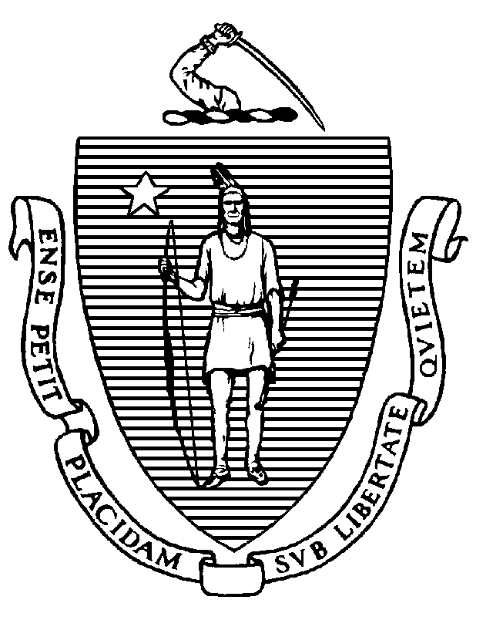
Immunization Division
Tel: (617) 983-6800
Fax: (617) 983-6840
www.mass.gov/dph/imm

KATHLEEN E. WALSH
Secretary
ROBERT GOLDSTEIN, MD, PhD Commissioner

Tel: 617-624-6000
www.mass.gov/dph

MAURA T. HEALEY
Governor
KIMBERLEY DRISCOLL
Lieutenant Governor

To: Principals of Public Schools
Principals of Private Schools

From: Jeffrey C. Riley, Commissioner
Department of Elementary and Secondary Education

Pejman Talebian, MA, MPH, Director
Immunization Division, Department of Public Health

Re: 2023-2024 Grade 7 Immunization Survey

Date: September 2023

The annual public and private school Grade 7 Immunization Survey is conducted by the Massachusetts Department of Public Health (MDPH) Immunization Division. The purpose of this survey is to identify children entering seventh grade who are not protected against vaccine-preventable diseases and to ensure that they are properly immunized according to state requirements. These data are publicly available on the Immunization Division website.

School Immunization Requirements
The following immunizations are required for students entering grades 7 through 10:
- 2 doses of MMR vaccine
- 3 doses of hepatitis B vaccine
- 2 doses of varicella vaccine
- 4 doses of polio vaccine
- 1 dose of Tdap vaccine following complete DTaP series
- 1 dose of MenACWY for all students

Recommended Vaccines
- 1 dose of influenza vaccine for the current influenza season
- 1 dose of updated COVID-19 vaccine
- 2 or 3 doses of HPV vaccine depending on the age the vaccine series was started

Please see the MDPH document, Massachusetts School Immunization Requirements 2023-2024 for additional details:
(https://www.mass.gov/doc/immunization-requirements-for-school-entry-0/download).

Every Student Succeeds Act
Please note that unimmunized or partially immunized homeless children and children in foster care cannot be denied entry to public school if they do not have immunization records. The federal Every Student Succeeds Act states that if a homeless or foster care child or youth arrives lacking immunizations or medical records, the parent/guardian should be referred to the district's Homeless Education Liaison/foster care point of contact, who has the responsibility to obtain relevant academic records and immunizations or medical records and to ensure that homeless/foster care students are attending school while the records are obtained. The student must be enrolled and permitted to attend public school in the interim. If you have any questions about the Every Student Succeeds Act, please contact the Department of Elementary and Secondary Education (DESE) at (781) 338-3700 or compliance@doe.mass.edu.

Massachusetts Immunization Information System (MIIS) and Survey Deadline
School nurses are encouraged to use the MIIS to search student immunization records (if needed) while completing the school survey. The survey itself is conducted only through the MIIS. School administrators must register their schools/districts to obtain access to the MIIS. Further information regarding the MIIS can be found here: (https://www.miisresourcecenter.com/)

The standard immunization survey for Grade 7 is due January 26, 2024. In previous years, influenza vaccination information was collected in a second section – the “flu survey” – of the standard immunization survey. This section has been discontinued and influenza data will not be collected this year.

Please report the number of students with medical and religious exemptions to each vaccine on the survey. This helps us determine patterns in exemptions, which could potentially lead to disease outbreaks, and develop appropriate educational materials. We also ask you to report the total number of students with any exemptions and the number of students with an exemption who have no documented vaccines (who are unimmunized).

Meningococcal Vaccine and Residential Schools
In addition to the school immunization requirements referenced above, residential schools in Massachusetts are subject to legislation (MGL Ch. 76, s.15D), which requires full-time students in Grades 9-12 to be vaccinated with MenACWY if they will be living in a dormitory or other congregate housing licensed by the school. The requirement also applies to residential students in Grades Pre-K through 8 if the school combines these grades in the same school as students in Grades 9-12. Residential students must provide documentation of having received a dose of MenACWY unless they qualify for a medical or religious exemption. (Meningococcal B vaccines are not required and do not fulfill this requirement.)

Adult Staff Guidelines
There are no immunization requirements for teachers and other staff. However, MDPH recommends that teachers and staff remain up-to-date on their vaccinations to avoid possible exclusion from school during an outbreak of a vaccine-preventable disease. The document titled Adult Occupational Immunizations: Massachusetts Recommendations and Requirements outlines the vaccine recommendations for adults. This document can be found on our website: (https://www.mass.gov/doc/adult-occupational-immunizations-massachusetts-recommendations-and-requirements).

Immunization Survey Results
In 2022-2023, the immunization records of 70,709 seventh-grade students from 969 schools were reviewed. As seen in the table below, a comparison of survey results from the previous school year illustrates continued high vaccination rates among seventh-grade students for most antigens. Immunization rates by school for schools reporting 30 or more children are available on the Immunization Division webpage:
(https://www.mass.gov/info-details/school-immunizations).

Results from the Immunization Survey of Students Entering Grade 7
School Year | No. of Records Reviewed | 2 MMR | 3  Hep B | Immunity to chickenpox¹ | Tdap | 1 MenACWY | Medical Exemptions | Religious Exemptions
2022-23 | 70,709 | 98.2% | 98.1% | 97.8% | 93.2% | 92.4% | 0.14% | 1.06%
2021-22 | 69,894 | 98.1% | 97.8% | 97.7% | 92.4% | 91.1% | 0.22% | 0.98%
2020-21 | 72,973 | 98.4% | 98.3% | 98.1% | 91.3% | 90.3% | 0.23% | 1.03%
¹Immunity to chickenpox disease includes children who have a documented physician-certified reliable history of chickenpox disease or 2 doses of varicella vaccine.

While the rate of religious exemptions has remained relatively steady in recent years, we encourage schools to review their policies and practices regarding exemptions, including the recommendation to have families renew these annually. The resources below are available to help with communication with parents lacking vaccine confidence:
- Personal belief exemptions for vaccination put people at risk. Examine the evidence for yourself - http://www.immunize.org/catg.d/p2069.pdf
- What if you don’t immunize your child? - http://www.immunize.org/catg.d/p4017.pdf
- Childhood vaccine information for parents and caregivers – a page of resources - https://www.mass.gov/info-details/childhood-vaccine-information-for-parents-and-caregivers

Massachusetts school immunization requirements have been very effective in preventing the outbreak of vaccine-preventable diseases. Continued enforcement of the immunization requirements is essential to the health of our children.

Your efforts in completing this survey contribute to protecting our children from vaccine-preventable diseases. If needed, use the survey worksheets and instructions to complete the survey accurately. Please retain copies of the survey and worksheets to facilitate follow-up on children and staff not fully immunized. You may be chosen for a randomized audit of immunization records or be called to review your records by MDPH Immunization Division staff. If you have any questions, please contact the MDPH Data Assessment Unit by email at immassessmentunit@mass.gov.

