INDOOR AIR QUALITY ASSESSMENT
Grafton Elementary School
105 Millbury Street
Grafton, Massachusetts

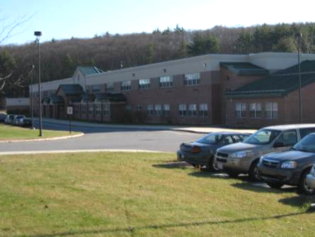

Prepared by:
Massachusetts Department of Public Health
Bureau of Environmental Health
Indoor Air Quality Program
January 2010

Background/Introduction
In response to a referral by the Massachusetts Division of Occupational Safety (DOS), the Massachusetts Department of Public Health (MDPH), Bureau of Environmental Health (BEH) provided assistance and consultation regarding indoor air quality concerns at the Grafton Elementary School (GES), 105 Millbury Street, Grafton, Massachusetts. Symptoms reported included Vertigo, light headedness, headaches, sinus infections and nausea that occupants thought may be related to operation of the mechanical ventilation system on the first floor of the building.
On November 17, 2009, Cory Holmes and James Tobin, Environmental Analysts/Inspectors in BEH’s Indoor Air Quality (IAQ) Program visited the GES to conduct an assessment. During the assessment, BEH staff were accompanied by Anthony LeMay, Director of Buildings and Grounds, Grafton Public Schools (GPS).
The GES is a two-story building brick building that was constructed in 2002. The GES contains general classrooms, computer labs, media center, gymnasium, music rooms, art rooms, specialty rooms and office space. Windows are openable throughout the building.

Method
Air tests for carbon dioxide, temperature, relative humidity and carbon monoxide were conducted with the TSI, Q-Trak, IAQ Monitor, Model 7565. Air tests for airborne particle matter with a diameter less than 2.5 micrometers were taken with the TSI, DUSTTRAK™ Aerosol Monitor Model 8520. BEH staff also performed a visual inspection of building materials for water damage and/or microbial growth.

Results
The school houses approximately 740 students in grades 3 – 5 with approximately 80 staff members. Tests were taken during normal school operations and results appear in Table 1.

Discussion

Ventilation
It can be seen from Table 1 that carbon dioxide levels were below 800 parts per million (ppm) in 45 of 60 areas, indicating adequate air exchange in the majority of the building at the time of the assessment. It is important to note, however, that several areas had open windows or were empty/sparsely populated, both of which can greatly reduce carbon dioxide levels. Carbon dioxide levels would be expected to increase with higher occupancy and windows closed.
Fresh air is supplied to most classrooms by unit ventilators (univent) systems (Picture 1). A univent draws air from the outdoors through a fresh air intake located on the exterior wall of the building (Picture 2). Return air from the classroom is drawn through an air intake located at the base of the unit (Figure 1). Fresh and return air are mixed, filtered, heated and provided to classrooms through an air diffuser located in the top of the unit. Univents were found deactivated in several areas (Table 1); therefore, no means to provide mechanical ventilation to these classrooms was available at the time of the assessment. In several cases, univents were found obstructed by furniture and other items on top of air diffusers and/or in front of return vents along the bottom front of the units (Pictures 3 and 4). In order for univents to provide fresh air as designed, intakes/returns must remain free of obstructions. Importantly, these units must remain “on” and be allowed to operate while rooms are occupied.
Exhaust ventilation in classrooms is provided by grilled ceiling vents ducted to rooftop motors (Picture 5). Exhaust vents in the music rooms were reportedly deactivated due to noise. In one wing, Mr. LeMay reported that the exhaust vents were not functioning and that parts were on order to repair (Table 1). In several classrooms, exhaust vents are located near hallway doors (Picture 5). When these classroom doors are open, exhaust vents will tend to draw air from both the hallway and the classroom, reducing the effectiveness of the exhaust vents to remove common environmental pollutants. As with univents, in order to function properly, exhaust vents must be activated and allowed to operate while rooms are occupied. Without adequate supply and exhaust ventilation, excess heat and environmental pollutants can build up and lead to indoor air/comfort complaints.
Mechanical ventilation in interior rooms and common areas (e.g., gymnasium) is provided by rooftop or ceiling-mounted air-handling units (AHUs). Fresh air is distributed via ceiling-mounted air diffusers and ducted back to AHUs via ceiling or wall-mounted return vents. The AHU in the gymnasium was deactivated at the time of the assessment; therefore, there was no means of mechanical air exchange. As with univents, AHUs should be activated and allowed to operate continuously during occupied periods.
To maximize air exchange, the MDPH recommends that both supply and exhaust ventilation operate continuously during periods of school occupancy. In order to have proper ventilation with a mechanical supply and exhaust system, the systems must be balanced to provide an adequate amount of fresh air to the interior of a room while removing stale air from the room. It is recommended that heating, ventilation and air conditioning (HVAC) systems be re-balanced every five years to ensure adequate air systems function (SMACNA, 1994). The date of the last balancing of these systems was not available at the time of the assessment.
The Massachusetts Building Code requires a minimum ventilation rate of 15 cubic feet per minute (cfm) per occupant of fresh outside air or have openable windows in each room (SBBRS, 1997; BOCA, 1993). The ventilation must be on at all times that the room is occupied. Providing adequate fresh air ventilation with open windows and maintaining the temperature in the comfort range during the cold weather season is impractical. Mechanical ventilation is usually required to provide adequate fresh air ventilation.
Carbon dioxide is not a problem in and of itself. It is used as an indicator of the adequacy of the fresh air ventilation. As carbon dioxide levels rise, it indicates that the ventilating system is malfunctioning or the design occupancy of the room is being exceeded. When this happens, a buildup of common indoor air pollutants can occur, leading to discomfort or health complaints. The Occupational Safety and Health Administration (OSHA) standard for carbon dioxide is 5,000 parts per million parts of air (ppm). Workers may be exposed to this level for 40 hours/week, based on a time-weighted average (OSHA, 1997).
The MDPH uses a guideline of 800 ppm for publicly occupied buildings. A guideline of 600 ppm or less is preferred in schools due to the fact that the majority of occupants are young and considered to be a more sensitive population in the evaluation of environmental health status. Inadequate ventilation and/or elevated temperatures are major causes of complaints such as respiratory, eye, nose and throat irritation, lethargy and headaches. For more information concerning carbon dioxide, consult Appendix A.

Temperature and Relative Humidity
Temperature measurements in the school ranged from 70° F to 77° F, which were within the MDPH recommended range in all areas surveyed (Table 1). The MDPH recommends that indoor air temperatures be maintained in a range of 70° F to 78° F in order to provide for the comfort of building occupants. In many cases concerning indoor air quality, fluctuations of temperature in occupied spaces are typically experienced, even in a building with an adequate fresh air supply.
Relative humidity measurements in the building ranged from 16 to 35 percent at the time of the assessment, all of which were below the MDPH recommended comfort range (Table 1). The MDPH recommends a comfort range of 40 to 60 percent for indoor air relative humidity. Relative humidity levels in the building would be expected to drop during the winter months due to heating. The sensation of dryness and irritation is common in a low relative humidity environment. Low relative humidity is a very common problem during the heating season in the northeast part of the United States.

Microbial/Moisture Concerns
In order for building materials to support mold growth, a source of water exposure is necessary. Identification and elimination of the source of water moistening building materials is necessary to control mold growth. Occupants in the media center expressed concerns related to mold growth from previous roof leaks above ceiling tiles in both the office and the main areas of the media center. BEH staff removed ceiling tiles in these areas to examine conditions above the ceiling plenum. At the time of the assessment, all areas appeared dry and no mold growth and/or associated odors were observed/detected. However, BEH staff found water damaged ceiling tiles in several other areas of the building (Table 1). Water damaged ceiling tiles can provide a source of mold and should be replaced after a leak is discovered and repaired.
The US Environmental Protection Agency (US EPA) and the American Conference of Governmental Industrial Hygienists (ACGIH) recommend that porous materials be dried with fans and heating within 24 to 48 hours of becoming wet (US EPA, 2001; ACGIH, 1989). If not dried within this time frame, mold growth may occur. Once mold has colonized porous materials, they are difficult to clean and should be removed/discarded.
Plants were observed in several areas (Table 1). Plants should be properly maintained and equipped with drip pans. Plants should also be located away from ventilation sources to prevent aerosolization of dirt, pollen or mold (Picture 6). Finally, they should not be placed on porous materials, since water damage to porous materials may lead to microbial growth.
Missing/damaged flashing was observed beneath a window at the rear of the school (Picture 7). Flashing around windows is designed to collect water and drain it away from the interior of the building. The flashing should be repaired to prevent water infiltration and damage to interior building components.

Carbon Monoxide and Particulate Matter
Indoor air quality can be negatively influenced by the presence of respiratory irritants, such as products of combustion. The process of combustion produces a number of pollutants. Common combustion emissions include carbon monoxide, carbon dioxide, water vapor and smoke (fine airborne particle material). Of these materials, exposure to carbon monoxide and particulate matter with a diameter of 2.5 micrometers (μm) or less (PM2.5) can produce immediate, acute health effects upon exposure. To determine whether combustion products were present in the school environment, BEH staff obtained measurements for carbon monoxide and PM2.5.
Carbon monoxide is a by-product of incomplete combustion of organic matter (e.g., gasoline, wood and tobacco). Exposure to carbon monoxide can produce immediate and acute health affects. Several air quality standards have been established to address carbon monoxide and prevent symptoms from exposure to these substances. The MDPH established a corrective action level concerning carbon monoxide in ice skating rinks that use fossil-fueled ice resurfacing equipment. If an operator of an indoor ice rink measures a carbon monoxide level over 30 ppm, taken 20 minutes after resurfacing within a rink, that operator must take actions to reduce carbon monoxide levels (MDPH, 1997).
The American Society of Heating Refrigeration and Air-Conditioning Engineers (ASHRAE) has adopted the National Ambient Air Quality Standards (NAAQS) as one set of criteria for assessing indoor air quality and monitoring of fresh air introduced by HVAC systems (ASHRAE, 1989). The NAAQS are standards established by the US EPA to protect the public health from six criteria pollutants, including carbon monoxide and particulate matter (US EPA, 2006). As recommended by ASHRAE, pollutant levels of fresh air introduced to a building should not exceed the NAAQS levels (ASHRAE, 1989). The NAAQS were adopted by reference in the Building Officials & Code Administrators (BOCA) National Mechanical Code of 1993 (BOCA, 1993), which is now an HVAC standard included in the Massachusetts State Building Code (SBBRS, 1997). According to the NAAQS, carbon monoxide levels in outdoor air should not exceed 9 ppm in an eight-hour average (US EPA, 2006).
Carbon monoxide should not be present in a typical, indoor environment. If it is present, indoor carbon monoxide levels should be less than or equal to outdoor levels. Outdoor carbon monoxide concentrations were non-detect (ND) at the time of the assessment (Table 1). No measureable levels of carbon monoxide were detected inside the building during the assessment (Table 1).
The US EPA has established NAAQS limits for exposure to particulate matter. Particulate matter is airborne solids that can be irritating to the eyes, nose and throat. The NAAQS originally established exposure limits to particulate matter with a diameter of 10 μm or less (PM10). According to the NAAQS, PM10 levels should not exceed 150 micrograms per cubic meter (μg/m³) in a 24-hour average (US EPA, 2006). These standards were adopted by both ASHRAE and BOCA. Since the issuance of the ASHRAE standard and BOCA Code, US EPA established a more protective standard for fine airborne particles. This more stringent PM2.5 standard requires outdoor air particle levels be maintained below 35 μg/m³ over a 24-hour average (US EPA, 2006). Although both the ASHRAE standard and BOCA Code adopted the PM10 standard for evaluating air quality, MDPH uses the more protective PM2.5 standard for evaluating airborne particulate matter concentrations in the indoor environment.
Outdoor PM2.5 concentrations the day of the assessment were measured at 9 μg/m³. PM2.5 levels measured inside the school ranged from 4 to 12 μg/m³ (Table 1). Both indoor and outdoor PM 2.5 levels were below the NAAQS PM2.5 level of 35 μg/m³. Frequently, indoor air levels of particulates (including PM2.5) can be at higher levels than those measured outdoors. A number of mechanical devices and/or activities that occur in schools can generate particulate during normal operations. Sources of indoor airborne particulates may include but are not limited to: particles generated during the operation of fan belts in the HVAC system; cooking in the cafeteria stoves and microwave ovens; use of photocopiers, fax machines and computer printing devices; operation of an ordinary vacuum cleaner; and, heavy foot traffic indoors.

Volatile Organic Compounds
Indoor air concentrations can be greatly impacted by the use of products containing volatile organic compounds (VOCs). VOCs are carbon-containing substances that have the ability to evaporate at room temperature. Frequently, exposure to low levels of total VOCs (TVOCs) may produce eye, nose, throat and/or respiratory irritation in some sensitive individuals. For example, chemicals evaporating from a paint can stored at room temperature would most likely contain VOCs. In an effort to identify materials that can potentially increase indoor VOC concentrations, BEH staff examined rooms for products containing these respiratory irritants.
Cleaning products were found in several rooms throughout the building. Cleaning products contain chemicals that can be irritating to the eyes, nose and throat of sensitive individuals. These products should be properly labeled and stored in an area inaccessible to children. Additionally, a Material Safety Data Sheet (MSDS) should be available at a central location for each product in the event of an emergency. Consideration should be given to providing teaching staff with school issued cleaning products and supplies to prevent any potential for adverse chemical interactions between residues left from cleaners used by the schools facilities staff and those left by cleaners brought in by others.
The majority of classrooms contained dry erase boards and related materials. Materials such as dry erase markers and dry erase board cleaners may contain VOCs, such as methyl isobutyl ketone, n-butyl acetate and butyl-cellusolve (Sanford, 1999), which can be irritating to the eyes, nose and throat. Air fresheners/scented oils were found to be in use in a few areas (Table 1). Air fresheners contain chemicals that can be irritating to the eyes, nose and throat of sensitive individuals. Further, air fresheners do not remove materials causing odors, but rather, mask odors which may be present in the area.
The media center had a lamination machine near the circulation desk. Lamination machines melt plastic and give off odors and VOCs, which can provide a source of respiratory irritation.
In an effort to reduce noise from sliding desks/chairs, tennis balls had been sliced open and placed on the base of the legs (Pictures 1 and 6). Tennis balls are made of a number of materials that are a source of respiratory irritants. Constant wearing of tennis balls can produce fibers and cause VOCs to off-gas. Tennis balls are made with a natural rubber latex bladder, which becomes abraded when used as a chair leg pad. Use of tennis balls in this manner may introduce latex dust into the school environment. Some individuals are highly allergic to latex (e.g., spina bifida patients) (SBAA, 2001). It is recommended that the use of materials containing latex be limited in buildings to reduce the likelihood of symptoms in sensitive individuals (NIOSH, 1997).

Other Conditions
Other conditions that can affect indoor air quality were observed during the assessment. In several classrooms, items were observed on windowsills, tabletops, counters, bookcases and desks. The large number of items stored in classrooms provides a source for dusts to accumulate. These items (e.g., papers, folders, boxes) make it difficult for custodial staff to clean. Items should be relocated and/or be cleaned periodically to avoid excessive dust build up. In addition, these materials can accumulate on flat surfaces (e.g., desktops, shelving and carpets) in occupied areas and subsequently be re-aerosolized causing further irritation.
Finally, a number of air diffusers, exhaust vents and personal fans in classrooms were observed to have accumulated dust/debris (Pictures 8 through 10). Re-activated supply vents/fans can aerosolize dust accumulated on fan blades/housing. If exhaust vents are not functioning, backdrafting can occur, which can re-aerosolize dust particles.

Conclusions/Recommendations
In view of the findings at the time of the assessment, the following recommendations are made to improve indoor air quality in the building:
- Operate all ventilation systems (e.g., AHUs, exhaust vents, and univents) throughout the building continuously during occupied periods. To increase airflow in classrooms, set univent controls to “high”.
- Continue with plans to repair exhaust motors for proper function.
- Remove all blockages from univents and exhaust vents to ensure adequate airflow.
- Close classroom doors to maximize air exchange.
- Use openable windows in conjunction with mechanical ventilation to facilitate air exchange. Care should be taken to ensure windows are properly closed at night and weekends to avoid the freezing of pipes and potential flooding.
- Consider adopting a balancing schedule of every 5 years for all mechanical ventilation systems, as recommended by ventilation industrial standards (SMACNA, 1994).
- Change filters for air-handling equipment (e.g., univents, AHUs and ACs) as per the manufacturer’s instructions or more frequently if needed. Vacuum interior of units prior to activation to prevent the aerosolization of dirt, dust and particulates. Ensure filters fit flush in their racks with no spaces in between allowing bypass of unfiltered air into the unit.
- For buildings in New England, periods of low relative humidity during the winter are often unavoidable. Therefore, scrupulous cleaning practices should be adopted to minimize common indoor air contaminants whose irritant effects can be enhanced when the relative humidity is low. To control for dusts, a high efficiency particulate arrestance (HEPA) filter equipped vacuum cleaner in conjunction with wet wiping of all surfaces is recommended. Avoid the use of feather dusters. Drinking water during the day can help ease some symptoms associated with a dry environment (throat and sinus irritations).
- Continue to monitor the media center and other areas of the building for roof leaks; make repairs and change ceiling tiles as necessary.
- Store cleaning products properly and out of reach of students. Ensure spray bottles are properly labeled. All cleaning products used at the facility should be approved by the school department with MSDS’ available at a central location.
- Relocate or consider reducing the amount of materials stored in classrooms to allow for more thorough cleaning of classrooms. Clean items regularly with a wet cloth or sponge to prevent excessive dust build-up.
- Consider relocating lamination machine in media center to an area below an exhaust vent.
- Clean personal fans, univent air diffusers, return vents and exhaust vents periodically of accumulated dust.
- Refrain from using air fresheners and deodorizers to prevent exposure to VOCs.
- Replace latex-based tennis balls with latex-free tennis balls or glides.
- Clean carpeting annually or semi-annually in soiled high traffic areas as per the recommendations of the Institute of Inspection, Cleaning and Restoration Certification (IICRC). Copies of the IICRC fact sheet can be downloaded at: http://www.cleancareseminars.com/carpet_cleaning_faq4.htm (IICRC, 2005)
- Consider adopting the US EPA (2000) document, “Tools for Schools”, as an instrument for maintaining a good indoor air quality environment in the building. This document is available at: http://www.epa.gov/iaq/schools/index.html.
- Refer to resource manual and other related indoor air quality documents located on the MDPH’s website for further building-wide evaluations and advice on maintaining public buildings. These documents are available at: http://mass.gov/dph/iaq.

References
ACGIH. 1989. Guidelines for the Assessment of Bioaerosols in the Indoor Environment. American Conference of Governmental Industrial Hygienists, Cincinnati, OH.
ASHRAE. 1989. Ventilation for Acceptable Indoor Air Quality. American Society of Heating, Refrigeration and Air Conditioning Engineers. ANSI/ASHRAE 62-1989
BOCA. 1993. The BOCA National Mechanical Code/1993. 8th ed. Building Officials and Code Administrators International, Inc., Country Club Hill, IL.
IICRC. 2005. Carpet Cleaning FAQ 4 Institute of Inspection, Cleaning and Restoration Certification. Institute of Inspection Cleaning and Restoration, Vancouver, WA.
MDPH. 1997. Requirements to Maintain Air Quality in Indoor Skating Rinks (State Sanitary Code, Chapter XI). 105 CMR 675.000. Massachusetts Department of Public Health, Boston, MA.
NIOSH. 1997. NIOSH Alert Preventing Allergic Reactions to Natural Rubber latex in the Workplace. National Institute for Occupational Safety and Health, Atlanta, GA.
OSHA. 1997. Limits for Air Contaminants. Occupational Safety and Health Administration. Code of Federal Regulations. 29 C.F.R 1910.1000 Table Z-1-A.
Sanford. 1999. Material Safety Data Sheet (MSDS No: 198-17). Expo® Dry Erase Markers Bullet, Chisel, and Ultra Fine Tip. Sanford Corporation. Bellwood, IL.
SBAA. 2001. Latex In the Home And Community Updated Spring 2001. Spina Bifida Association of America, Washington, DC.
SBBRS. 1997. Mechanical Ventilation. State Board of Building Regulations and Standards. Code of Massachusetts Regulations. 780 CMR 1209.0
SMACNA. 1994. HVAC Systems Commissioning Manual. 1st ed. Sheet Metal and Air Conditioning Contractors’ National Association, Inc., Chantilly, VA.
US EPA. 2000. Tools for Schools. Office of Air and Radiation, Office of Radiation and Indoor Air, Indoor Environments Division (6609J). EPA 402-K-95-001, Second Edition. http://www.epa.gov/iaq/schools/tools4s2.html
US EPA. 2001. “Mold Remediation in Schools and Commercial Buildings”. Office of Air and Radiation, Indoor Environments Division, Washington, DC. EPA 402-K-01-001. March 2001. Available at: http://www.epa.gov/iaq/molds/mold_remediation.html
US EPA. 2006. National Ambient Air Quality Standards (NAAQS). US Environmental Protection Agency, Office of Air Quality Planning and Standards, Washington, DC. http://www.epa.gov/air/criteria.html.
Picture 1

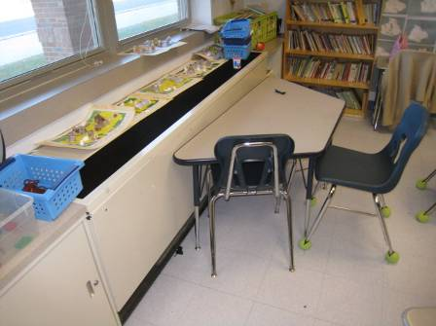

Classroom Univent, Also Note Tennis Balls on Chair Legs

Picture 2

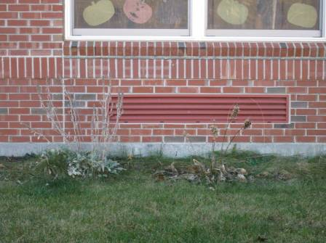

Univent Fresh Air Intake

Picture 3

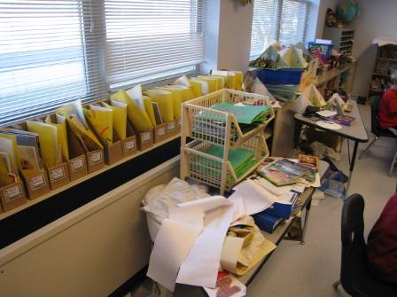

Univent Return Vent (Bottom Front) Obstructed by Furniture

Picture 4

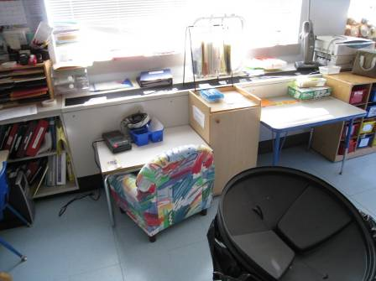

Univent Return Vent (Bottom Front) Obstructed by Furniture

Picture 5

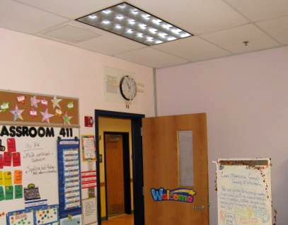

Proximity of Ceiling Exhaust Vent to Open Hallway Door

Picture 6

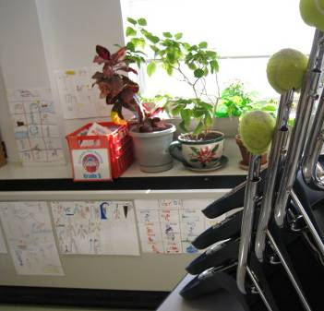

Plants on Classroom Univent, Also Note Tennis Balls on Chair Legs

Picture 7

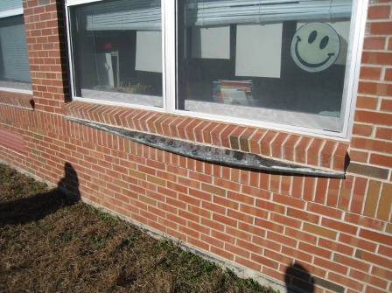

Missing/Damaged Flashing beneath Classroom Window at Rear of Building

Picture 8

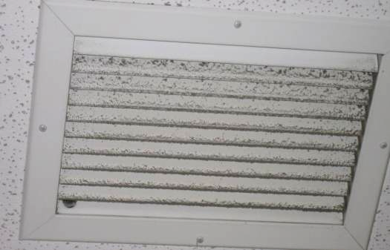

Accumulated Dust/Debris on Exhaust Vent

Picture 9

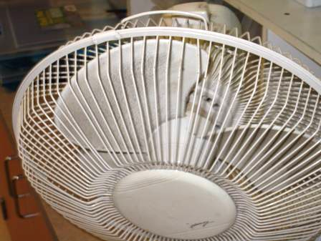

Accumulated Dust/Debris on Personal Fan

Picture 10

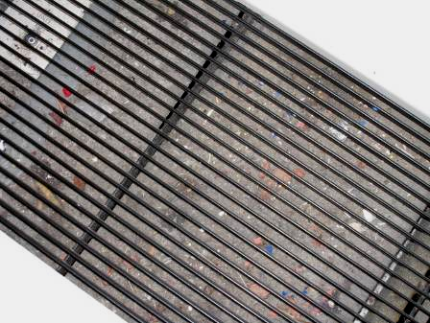

Accumulated Dust/Debris in Univent Air Diffuser
Location/ Room | Occupants  in Room | Temp  (°F) | Relative  Humidity  (%) | Carbon  Dioxide  (ppm) | Carbon Monoxide  (ppm) | PM2.5  (µg/m³) | Windows  Openable | Ventilation |  | Remarks
 |  |  |  |  |  |  |  | Supply | Exhaust | Remarks
background |  | 51 | 31 | 350 | ND | 9 |  |  |  | Cool, clear, sunny
A-1021  Nurse | 4 | 72 | 24 | 592 | ND | 8 | Y  1 of 2 open | Y | Y  near door | DO
A-1022  Nurse |  |  |  |  |  |  | Y | Y | Y | DO
A-1023  Nurse |  |  |  |  |  |  | N | Y | Y | DO, microwave, refrigerator
A-1025 | 0 | 73 | 22 | 514 | ND | 7 | Y | Y | Y | Items on UV, DEM, PS near UV, TB
A-1026 | 1 | 72 | 29 | 775 | ND | 6 | Y | Y | Y | Items on UV, DEM, DO, PF
A-1029 | 24 | 71 | 23 | 594 | ND | 8 | Y | Y | Y | CPs, DO, DEM, PF
A-1032 | 1 | 74 | 23 | 564 | ND | 6 | Y | Y | Y  dust | DEM, DO, PF, TB
A-1036 | 20 | 73 | 28 | 1000 | ND | 12 | Y | Y  UV off | Y  off | Debris in UV, PF
A-1037 OT/PT | 0 | 73 | 26 | 709 | ND | 9 | Y | Y | Y  off | PC
A-1038 | 22 | 75 | 24 | 678 | ND | 9 | Y | Y | Y  off | TB, DO
A-1041 | 1 | 74 | 21 | 496 | ND | 9 | Y  open | Y | Y  off | TB, DO, 20 occupants gone 30 mins
A-1043 | 8 | 75 | 21 | 507 | ND | 10 | Y | Y | Y | PF
A-1044 | 23 | 75 | 23 | 829 | ND | 8 | N | Y | Y | Dusty vents, interior room no windows
A-1045 | 0 | 73 | 24 | 572 | ND | 5 | Y | Y  UV off | Y | WD CTs, DO, DEM
A-2000 | 0 | 75 | 16 | 401 | ND | 5 | N | Y | Y  above door | 4 PCs, vending machine, microwave, refrigerator, DEM, DO, PF
A-2002 | 1 | 75 | 18 | 437 | ND | 6 | Y  1 of 2 open | Y | Y | CPs, DEM, PF
A-2003 | 12 | 76 | 21 | 613 | ND | 5 | Y | Y | Y | PF
A-2004 | 22 | 76 | 17 | 503 | ND | 6 | Y | Y | Y | Plants near UV, DEM, TB
A-2005 | 21 | 76 | 22 | 748 | ND | 6 | Y  2 of 4 open | Y | Y | DEM, DO
A-2006 | 16 | 76 | 27 | 1098 | ND | 8 | Y  1 of 4 open | Y | Y | CPs, DEM, DO, PF, TB
A-2007 | 18 | 73 | 22 | 728 | ND | 9 | Y | Y | Y | Debris in UV, TB
A-2008 | 20 | 74 | 20 | 614 | ND | 9 | Y | Y | Y | DO, CP, PF
A-2011 | 0 | 75 | 23 | 701 | ND | 9 | Y | Y | Y | DO, 2 ACs
A-2012 | 19 | 76 | 19 | 592 | ND | 9 | Y | Y | Y  off | No draw exhaust, DO, PF
A-2013 | 1 | 76 | 20 | 549 | ND | 8 | Y | Y | Y  off | No draw exhaust, 24 occupants gone 20 mins, DO, PF
A-2014 | 24 | 76 | 24 | 792 | ND | 10 | Y | Y | Y  off | No draw exhaust, plants, TB, PF
A-2015 | 22 | 77 | 22 | 768 | ND | 9 | Y  open | Y | Y  off | No draw exhaust, TB, 1 WD CT, DO, plants on UV
A-2016 | 0 | 77 | 22 | 766 | ND | 10 | Y  open | Y | Y  off | No draw exhaust, PF, FO
A-2017 | 6 | 76 | 20 | 607 | ND | 8 | Y  open | Y | Y  off | No draw exhaust, reeds/oil, TB, PF
A-2018 | 2 | 76 | 20 | 552 | ND | 9 | Y | Y | Y  off | No draw exhaust, plants
B-1057  storage |  |  |  |  |  |  |  |  | Y  dust | DO
B-1058 | 0 | 75 | 21 | 401 | ND | 4 | Y | Y | Y  near door | Items on UV, DEM, DO, 2 PCs
B-1059 | 23 | 75 | 22 | 675 | ND | 5 | Y | Y | Y  near door | Items on UV, CPs, DEM, DO, TB
B-1060 | 25 | 74 | 19 | 472 | ND | 5 | Y | Y | Y | Items on UV, TB
B-1061 | 24 | 74 | 21 | 536 | ND | 5 | Y | Y | Y | DEM, DO, PF, TB
B-1062 | 20 | 75 | 21 | 525 | ND | 6 | Y | Y | Y  dust | DEM, DO, PF, TB
B-1063 | 8 | 75 | 19 | 409 | ND | 5 | Y | Y | Y | DEM
B-1066 | 22 | 73 | 35 | 1200 | ND | 11 | Y | Y | Y | DO, TB, egg cartons
B-1067 | 23 | 70 | 23 | 560 | ND | 8 | Y | Y | Y | Items in front of UV return vent, DO
B-1068 | 22 | 72 | 34 | 1400 | ND | 10 | Y | Y  UV off | Y | DO, TB
B-1069 | 24 | 71 | 26 | 766 | ND | 8 | Y | Y | Y | PF, TB, DO
B-1070 | 1 | 70 | 25 | 666 | ND | 7 | Y | Y | Y | 24 occupants gone ~10 mins, TB, PF, DO
B-2023 | 1 | 75 | 20 | 526 | ND | 8 | Y  open | Y | Y | 18 occupants gone 10 mins, PF, DO
B-2024 | 0 | 75 | 21 | 589 | ND | 10 | Y | Y | Y | Debris in UV, 2 WD CT, PF, DO
B-2025 | 17 | 75 | 24 | 792 | ND | 11 | Y | Y | Y | DO, 1 WD CT (near interior wall)
B-2026 | 21 | 74 | 23 | 633 | ND | 9 | Y | Y | Y | DO
B-2027 | 0 | 74 | 21 | 550 | ND | 9 | Y | Y | Y | Occupants at lunch, TB, DO
B-2030 | 1 | 74 | 23 | 709 | ND | 8 | Y | Y | Y | PF, DEM odor, 21 occupants gone 3 minutes
B-2031 | 24 | 75 | 26 | 992 | ND | 8 | Y | Y | Y | DEM, DO
B-2032 | 22 | 76 | 25 | 854 | ND | 5 | Y | Y | Y | CPs, PF, accumulated items stored in room
B-2033 | 20 | 75 | 26 | 985 | ND | 6 | Y | Y | Y | DEM, DO, PF, TB
B-2034 | 23 | 75 | 24 | 791 | ND | 7 | Y  3 of 4 open | Y | Y | DO
B-2038  Storage |  |  |  |  |  | 5 | N |  | Y  above door | WD CTs, DO
C-1101 | 0 | 75 | 22 | 518 | ND | 6 | Y | Y | Y  dust | Items on UV, WD CTs, vending machine, microwave, toaster oven, refrigerator
C-1102 | 25 | 74 | 27 | 848 | ND | 5 | Y | Y | Y  dust | DEM, PF
C-1105 | 24 | 76 | 26 | 751 | ND | 11 | Y | Y | Y | DO, TB
C-1113 | 4 | 73 | 27 | 764 | ND | 4 | Y | Y | Y | Plants on window above UV, DEM, DO
C-1116 | 22 | 76 | 33 | 1160 | ND | 6 | Y | Y | Y  off | No draw exhaust vent-reportedly deactivated at the request of occupants due to noise
C-1119 | 8 | 74 | 28 | 845 | ND | 8 | Y | Y | Y  dust | Spray CP
Cafeteria | 250 | 74 | 24 | 709 | ND | 10 | Y | Y | Y | DO to hallway
Gym | ~40 | 73 | 26 | 726 | ND | 12 | N | Y | Y
Gym Office | 0 | 72 | 27 | 650 | ND | 12 | N | Y  passive door vent | Y
Media Center | 1 | 74 | 21 | 582 | ND | 9 | Y | Y | Y | 28 occupants gone ~2 mins, 2 WD CT, plants, PF, reports of mold concerns above CTs-dry, no visible mold or current WD
Media Center Office | 0 | 74 | 22 | 592 | ND | 11 | N | Y | Y | Reports of mold concerns above CTs-dry, no visible mold or current WD, lamination machine near desk

