INDOOR AIR QUALITY ASSESSMENT

Graham and Parks School
44 Linnaean Street
Cambridge, MA 02138

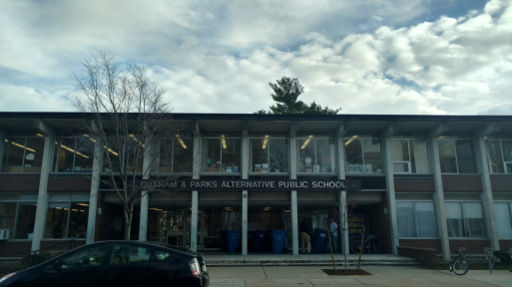

Prepared by:
Massachusetts Department of Public Health
Bureau of Environmental Health
Indoor Air Quality Program
December 2016

Background/Introduction
Building: | Graham and Parks School (GPS)
Address: | 44 Linnaean St., Cambridge, MA 02138
Assessment Requested by: | Sam Lipson, Director of Environmental Health, Cambridge Public Health Department
Reason for Request: | General indoor air quality (IAQ) assessment
Date of Assessment: | November 21, 2016
Massachusetts Department of Public Health/Bureau of Environmental Health (MDPH/BEH) Staff Conducting Assessment: | Sharon Lee, Environmental Analyst, IAQ Program
Date of Building Construction: | 1961
Building Description: | Two-story brick building consisting of classrooms, auditorium, gymnasium, art rooms, kitchen, cafeteria, library and office space. Some rooms were subdivided to accommodate additional teaching space. A new boiler was installed in 2014.
Building Population: | The school has approximately 360 students and 60 staff
Windows: | Openable

Methods
Please refer to the IAQ Manual and appendices for methods, sampling procedures, and interpretation of results (MDPH, 2015).

Results and Discussion
The following is a summary of indoor air testing results (Table 1).
- Carbon dioxide measurements were above the MDPH recommended level of 800 parts per million (ppm) in a majority of areas surveyed. In some areas, carbon dioxide levels exceeded 2000 ppm. Carbon dioxide levels reflect lack of ventilation in the building.
- Temperature was below the MDPH recommended range of 70°F to 78°F in about half the areas visited and was above the recommended range in one area at the time of assessment.
- Relative humidity (RH) was below the MDPH recommended range of 40% to 60% in almost all areas assessed.
- Carbon monoxide levels were non-detectable in all areas tested.
- Particulate matter (PM2.5) concentrations measured were below or close to the National Ambient Air Quality (NAAQS) level of 35 μg/m³ in areas surveyed. PM2.5 levels reflect lack of ventilation in the building.

Ventilation
Fresh air in classrooms is supplied by unit ventilator (univent) systems (Pictures 1 and 2). Univents draw air from outdoors through a fresh air intake located on the exterior walls of the building (Picture 3) and return air through an air intake located at the base of each unit (Figure 1). Fresh and return air are mixed, filtered, heated, and provided to classrooms through a fresh air diffuser located in the top of the unit. Each univent has a fiber filter that is reportedly replaced every 6 months. BEH staff spot checked filters in a few areas. While filters appeared new, dust and debris were noted within the unit’s air chamber (Picture 4). Please note, some univents were also missing paneling (Picture 2).
Univents were found deactivated in classrooms throughout the school. Obstructions to airflow, such as papers and books stored on univents and bookcases and/or carts and desks located in front of univent returns, were observed in a number of classrooms (Picture 1). In order for univents to provide fresh air as designed, intakes must remain free of obstructions; importantly these units must remain “on” and allowed to operate while rooms are occupied. Some items on top of or near the univent (e.g. plastic, crayons) can become sources of odor when heated.
It is important to note that fresh air dampers within many of the univents cannot be adjusted due to the age of the system. As a result, fresh air provided to classrooms may be limited. A source of fresh air is important for the dilution of normally-occurring indoor air pollutants. Univents at the GPS are original to the building’s construction, nearly 55 years old. Efficient function of such aged equipment is difficult, since compatible replacement parts are often unavailable. According to the American Society of Heating, Refrigeration, and Air-Conditioning Engineering (ASHRAE), the service life for a unit heater (hot water or steam) is 20 years, assuming routine maintenance of the equipment (ASHRAE, 1991). Despite attempts to maintain the equipment, the operational lifespan of this equipment has been exceeded.
Exhaust ventilation in classrooms is provided by vents located in the upper interior wall of open closets (Picture 5). These vents are connected to rooftop exhaust fans. These fans were not operating at the time of assessment, which prevents removal of normally-occurring indoor air pollutants. The location of the exhaust vents makes it easy for the vents to be blocked by stored materials (Picture 6). In a number of classrooms, these vents were blocked with books, backpacks, and boxes. In order to function properly, these vents must remain free of obstructions.
In order to have proper ventilation with a mechanical supply and exhaust system, these systems must be balanced to provide an adequate amount of fresh air while removing stale air from a room. The date of the last balancing of these systems was not available at the time of the assessment. It is recommended that existing ventilation systems be re-balanced every five years to ensure adequate air systems function (SMACNA, 1994).
A functioning heating, ventilation, and air-conditioning system (HVAC) could not be identified in the gymnasium. While a heating source may be present, no fresh air source could be identified. The carbon dioxide level in the gymnasium was 952 ppm, which exceeds the MDPH recommended carbon dioxide level of 800 ppm. Carbon dioxide levels are expected to be lower in areas with high ceilings.
The assessment results indicate that the ventilation system is not providing adequate fresh air or appropriate exhaust functions to the building, particularly classrooms. At the time of the visit, air was flowing from classroom univent supply vents; however, it is likely that the tempered air provided to classrooms is primarily recycled air. Lack of adequate ventilation was particularly evident in three classrooms, where carbon dioxide levels exceeded 2000 ppm. This indicates that the system is not bringing in sufficient fresh air during operation.
Window-mounted air-conditioning units were observed in some areas. This type of equipment has a filter, which should be cleaned prior to use. These units can also be used as a source of fresh air when operated in the fan on setting.

Microbial/Moisture Concerns
A roof leak was reported in space leased to a local theatre group, as well as in a shared hallway. This space is accessed by a stairwell in the gymnasium, as well as a hallway to the rear of the auditorium where student instruments are stored. Water-damaged interlocking ceiling tiles were observed in the hallway (Picture 7). Standing water (Picture 8) and musty odors were noted in the stairwell leading down towards the boiler room. At the time of assessment, Michael Lane, Director of Facilities, indicated that water-damaged ceiling tiles would be replaced.
Missing ceiling tiles were observed in the art room (Picture 9), reportedly from a separate water leak. These ceiling tiles were also scheduled for replacement. Missing and ajar ceiling tiles can allow dust and debris from the ceiling plenum system to migrate into occupant spaces. All ceiling tile systems should be intact and flush.
Measures should be taken to ensure water-damaged materials are cleaned, replaced, and/or repaired in a manner consistent with the U.S. Environmental Protection Agency’s (US EPA, 2008). The US EPA and the American Conference of Governmental Industrial Hygienists (ACGIH) recommend that porous materials (e.g., carpeting, gypsum wallboard) be dried with fans and heating within 24 to 48 hours of becoming wet (US EPA, 2008; ACGIH, 1989). If not dried within this time frame, mold growth may occur. Once mold has colonized porous materials, they are difficult to clean and should be removed/discarded.
Terrariums were observed in a few classrooms (Table 1). These need to be kept clean so that stagnant water and organic matter (e.g., soil, vegetation) do not become a source of odors.
Several classrooms contained plants (Table 1). In one instance, a plant was observed suspended over a univent (Picture 10). Plants can be a source of pollen and mold, which can be respiratory irritants to some individuals. Plants should be properly maintained and equipped with drip pans to prevent water damage to porous materials. Plants should also be located away from air diffusers to prevent the aerosolization of dirt, pollen, and mold.
Plant vines were observed on the building’s exterior (Picture 11). Roots growing into the brick mortar can create fissures, which can cause crumbing and deterioration of the building exterior due to freezing and thawing of water trapped in these spaces. Over time, water can enter the building through damage to the exterior wall.
A compost bin was noted outside, near the univent fresh air intake for classroom 105 (Picture 3). This bin should be relocated away from fresh air intakes to prevent entrainment of odors. Measures should be taken to ensure that any compost bins are stored in an appropriate place and functioning properly.
Hand sinks were observed in a number of classrooms. Many of the sinks examined had sealants to the space between the backsplash and countertop, which prevents damage to manufactured materials. These seams should be examined periodically to ensure sealant is intact.

Other Concerns
Exposure to low levels of total volatile organic compounds (TVOCs) may produce eye, nose, throat, and/or respiratory irritation in some sensitive individuals. To determine if VOCs were present, BEH/IAQ staff examined rooms for products containing VOCs. BEH/IAQ staff noted hand sanitizers, cleaners, air deodorizers, and dry erase materials in use within the building (Pictures 12 and 13; Table 1). All of these products have the potential to be irritants to the eyes, nose, throat, and respiratory system of sensitive individuals.
It is important to note that many of the cleaning products used in the school are not consistent with products used by the cleaning staff. In some cases, cleaning products were placed in unlabeled bottles. Measures should be taken to ensure cleaning products used by teaching staff are consistent with those used during housekeeping. In addition, safety data sheets (SDSs) should be available at the school.
Tennis balls had been sliced open and placed on chair footings to reduce noise (Picture 14). Tennis balls are made of a number of materials that are a source of respiratory irritants. Constant wearing of tennis balls can produce fibers and lead to off-gassing of VOCs. Tennis balls are made with a natural rubber latex bladder, which becomes abraded when used as a chair leg pad. Use of tennis balls in this manner may introduce latex dust into the school environment. Some individuals are highly allergic to latex (e.g., spina bifida patients) (SBAA, 2001). It is recommended that the use of materials containing latex be limited in buildings to reduce the likelihood of symptoms in sensitive individuals (NIOSH, 1997; NIOSH, 1998).
In classrooms throughout the school, items were observed on windowsills, tabletops, counters, bookcases and desks. The large number of items stored in classrooms provides a source for dusts to accumulate. These items, (e.g. papers, folders, boxes) make it difficult for custodial staff to clean. Dust can be irritating to eyes, nose, and respiratory tract. Items should be relocated and/or be cleaned periodically to avoid excessive dust build up.
Upholstered furniture was seen in several classrooms (Table 1). Upholstered furniture, pillows, and cushions are covered with fabric that comes in contact with human skin. This type of contact can leave oils, perspiration, hair and skin cells. Dust mites feed upon human skin cells and excrete waste products that contain allergens. In addition, if relative humidity levels increase above 60 percent, dust mites tend to proliferate (US EPA, 1992). In order to remove dust mites and other pollutants, frequent vacuuming of upholstered furniture is recommended (Berry, 1994). It is also recommended that upholstered furniture (if present in schools), be professionally cleaned on an annual basis. If outdoor conditions or indoor activities (e.g., renovations) create an excessively dusty environment, cleaning frequency should be increased to every six months (IICRC, 2000).
Personal fans were observed in a number of areas (Table 1). Dust settled onto fan blades can be aerosolized when the fan is activated. Personal fans should be stored in a manner that prevents dust accumulation and cleaned prior to use during warm weather.
This building had a previous history of rodents, as documented in a report issued by the IAQ Program (MDPH, 2003). Measures should be taken to ensure all food product and food wastes are removed at the end of the day. Food packaging re-proposed for use should be washing thoroughly to remove odors/food residues that can attract pests. Food appliances in classrooms and staff areas should also be cleaned periodically.
Pipe penetrations were observed in walls in a few areas (Picture 15). Walls for occupant areas should be finished. Any openings around pipes should be sealed to prevent migration of odors, dusts, and particulates. Abandoned pipe should also be capped.

Conclusions/Recommendations
In view of the findings at the time of the inspection, the following is recommended:
- Examine each univent for function. Survey classrooms for univent function to determine damper condition and ensure adequate air supply exists for each room.
- Remove all blockages from univents and exhaust vents to ensure adequate airflow. Ensure plastic and wax-based products are not placed on top or in front of univents.
- Replace missing univent cabinet panels/diffusers; have new ones fabricated if necessary.
- Ensure univent cabinets and air chambers are cleaned/vacuumed periodically to prevent aerosolization and distribution of dust and debris. Ensure filters fit flush in their racks with no spaces in between allowing bypass of unfiltered air into the unit.
- Make appropriate repairs to exhaust ventilation.
- Operate all ventilation systems throughout the building (e.g., gym, locker rooms, cafeteria, classrooms) continuously during periods of school occupancy.
- Use openable windows and window-mounted air conditioning units to supplement fresh air and increase air exchange in the building. Care should be taken to ensure windows are properly closed at night and weekends to avoid the freezing of pipes and potential flooding. Ensure filters for air-conditioning units are cleaned periodically.
- Consider methods for cross-ventilation and increasing fresh air to the gymnasium, particularly during high occupancy.
- Consult a ventilation engineer concerning re-balancing of the ventilation systems. Ventilation industrial standards recommend that mechanical ventilation systems be balanced every five years (SMACNA, 1994).
- Repair roof/plumbing leaks and replace stained ceiling tiles.
- Replace missing ceiling tiles to prevent the egress of dirt, dust, and particulate matter into classrooms. Consider using water-catching ceiling tile to collect water for persistent leaks. Ensure water catching receptacles are emptied daily and cleaned to prevent odors.
- Ensure that the roof gets examined regularly for deterioration and leaks, and that debris is removed regularly.
- Ensure that procedures are in place for occupants to report leaks, wet tiles, and other maintenance conditions so that they can be logged and repaired promptly.
- Ensure standing water is removed from the stairwell to the basement. Consider using fans to remove air from the stairwell and into the boiler room as a method for drying the stairwell and reducing odors to the area.
- Ensure terrariums are monitored and cleaned regularly to prevent odors.
- Move plants away from univents in classrooms. Avoid over-watering and examine drip pans periodically for mold growth. Disinfect with an appropriate antimicrobial where necessary.
- Remove plants growing against the exterior wall/foundation of the building to prevent water penetration.
- Examine and consider removing ivy/vine growth on exterior walls to prevent damage.
- Examine seams between the sink countertops and backsplashes periodically to ensure sealant is intact. Seal areas around sinks to prevent water damage to cabinet interiors and adjacent wallboard.
- Move the compost bins away from any fresh air intakes. Examine compost bins periodically to ensure odor control.
- Eliminate the use of scented items, including air deodorizing sprays and plug-ins to prevent respiratory irritation.
- Consider supplying teaching staff with cleaning products consistent with those used with the Cambridge Public Schools Facilities Department. Ensure SDSs are available.
- Replace tennis balls on chair footings with latex-free glides.
- Relocate or consider reducing the amount of materials stored in classrooms to allow for more thorough cleaning. Clean items regularly with a wet cloth or sponge to prevent excessive dust build-up.
- Clean upholstered items regularly to remove dust and debris that can be reaerosolized.
- Ensure personal fans are cleaned to prevent aerosolization of dust.
- For buildings in New England, periods of low relative humidity during the winter are unavoidable. Therefore, scrupulous cleaning practices should be adopted to minimize common indoor air contaminants whose irritant effects can be enhanced when the relative humidity is low. To control for dusts, a high efficiency particulate arrestance (HEPA) filter equipped vacuum cleaner in conjunction with wet wiping of all surfaces is recommended. Avoid the use of feather dusters. Drinking water during the day can help ease some symptoms associated with a dry environment (throat and sinus irritations).
- Ensure food is stored properly and food containers are cleaned thoroughly to reduce pest attractants.
- Seal wall openings and cap abandoned pipes to prevent migration of odors and particulates.
- Consider adopting the US EPA (2000) document, “Tools for Schools”, as an instrument for maintaining a good IAQ environment in the building. This document is available at: https://www.epa.gov/iaq-schools.
- Refer to resource manual and other related IAQ documents located on the MDPH’s website for further building-wide evaluations and advice on maintaining public buildings. These documents are available at: http://mass.gov/dph/iaq.

References
American Conference of Governmental Industrial Hygienists (ACGIH). 1989. Guidelines for the Assessment of Bioaerosols in the Indoor Environment. American Conference of Governmental Industrial Hygienists, Cincinnati, OH.
American Society of Heating, Refrigeration and Air Conditioning Engineers (ASHRAE). 1991. ASHRAE Applications Handbook, Chapter 33 “Owning and Operating Costs”. American Society of Heating, Refrigeration and Air Conditioning Engineers, Atlanta, GA.
Berry, M.A. 1994. Protecting the Built Environment: Cleaning for Health. Michael A. Berry, Chapel Hill, NC.
National Institute for Occupational Safety and Health (NIOSH). 1997. NIOSH Alert Preventing Allergic Reactions to Natural Rubber latex in the Workplace. National Institute for Occupational Safety and Health, Atlanta, GA.
National Institute for Occupational Safety and Health (NIOSH). 1998. Latex Allergy A Prevention. National Institute for Occupational Safety and Health, Atlanta, GA.
Institute of Inspection Cleaning and Restoration (IICRC). 2000. IICRC S001: Reference Guideline for Professional On-Location Cleaning of Textile Floor Covering Materials. Institute of Inspection, Cleaning and Restoration Certification. Institute of Inspection Cleaning and Restoration, Vancouver, WA.
Massachusetts Department of Public Health (MDPH). 2003. Indoor Air Quality Assessment Report: Andrew Peabody School, 44 Linnaean St, Cambridge, MA.
SBAA. 2001. Latex In the Home And Community Updated Spring 2001. Spina Bifida Association of America, Washington, DC. http://spinabifidaassociation.org/latex/
SMACNA. 1994. HVAC Systems Commissioning Manual. 1st ed. Sheet Metal and Air Conditioning Contractors’ National Association, Inc., Chantilly, VA.
US EPA. 1992. Indoor Biological Pollutants. US Environmental Protection Agency, Environmental Criteria and Assessment Office, Office of Health and Environmental Assessment, research Triangle Park, NC. EPA 600/8-91/202 January 1992.
US EPA. 2000. Tools for Schools. Office of Air and Radiation, Office of Radiation and Indoor Air, Indoor Environments Division (6609J). EPA 402-K-95-001, Second Edition. https://www.epa.gov/iaq-schools.
US EPA. 2008. “Mold Remediation in Schools and Commercial Buildings”. Office of Air and Radiation, Indoor Environments Division, Washington, DC. EPA 402-K-01-001. September 2008. Available at: http://www.epa.gov/mold/mold-remediation-schools-and-commercial-buildings-guide.
Picture 1
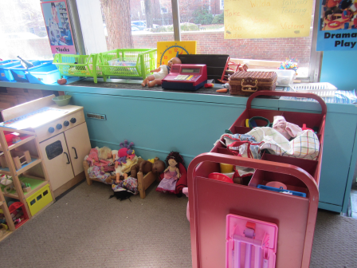
Classroom univent, note items placed on top and in front of unit

Picture 2
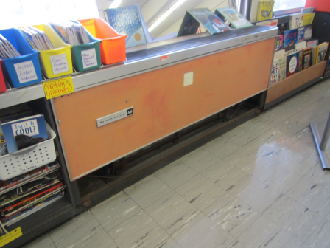
Classroom univent, note missing panel
Picture 3
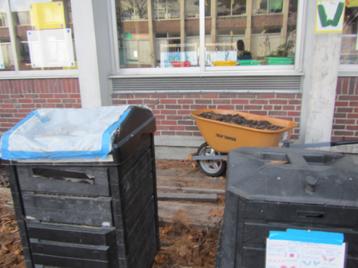
Univent fresh air intake, note wheel barrel and compost bins in proximity

Picture 4
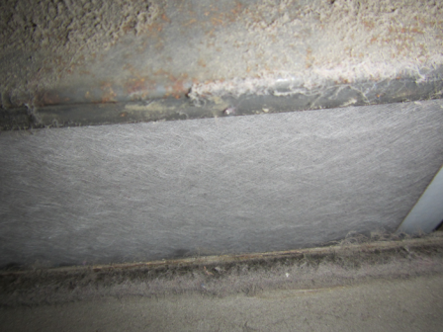
Univent filter, note dust/debris within univent air chamber
Picture 5
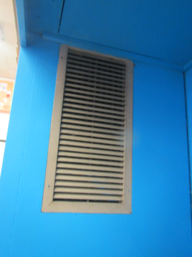
Classroom exhaust vent located in closets
Picture 6
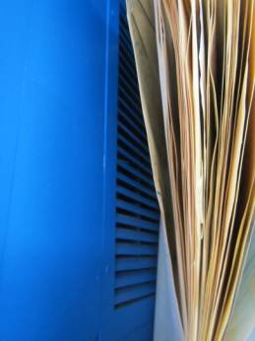
Classroom exhaust vent blocked by files
Picture 7
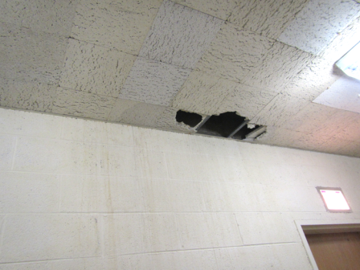
Water-damaged interlocking ceiling tiles

Picture 8
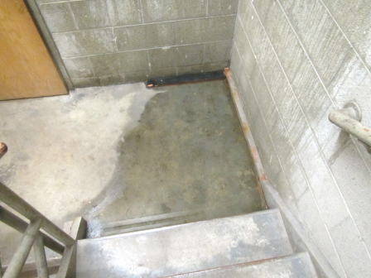
Standing water in stairwell to boiler room
Picture 9
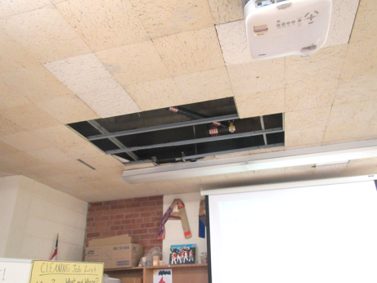
Missing ceiling times in art room
Picture 10
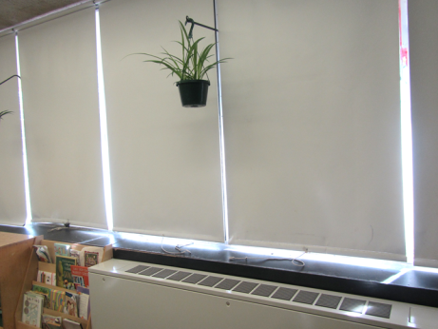
Plant hanging over univent
Picture 11
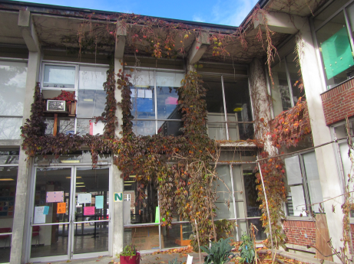
Vine growth against building exterior
Picture 12
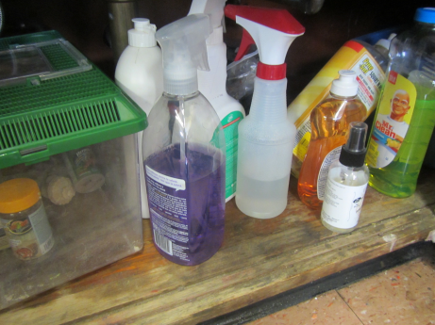
Variety of cleaning products, note unlabeled bottle
Picture 13
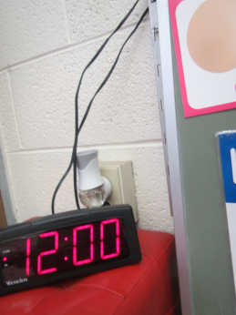
Plug-in air deodorizer
Picture 14
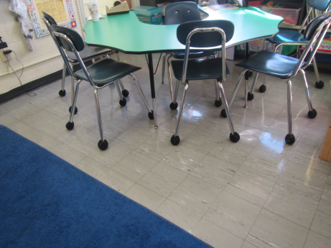
Tennis balls on chair legs
Picture 15
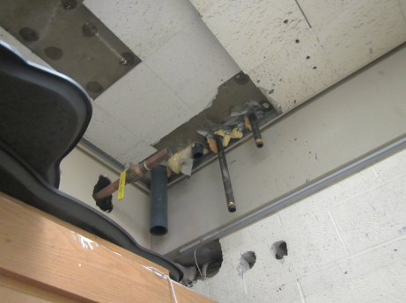
Wall openings and abandoned pipes

Location | Carbon  Dioxide  (ppm) | Carbon Monoxide  (ppm) | Temp  (°F) | Relative  Humidity  (%) | PM2.5  (µg/m³) | Occupants  in Room | Windows  Openable | Ventilation |  | Remarks
 |  |  |  |  |  |  |  | Supply | Exhaust
Background | 439 | ND | 45 | 36 | 7
Principal’s Office | 1191 | ND | 67 | 35 | 3 | 4 | Y |  |  | DO, CPs, space heater, plants
Main Office | 1141 | ND | 68 | 34 | 14 | 2 | N | Y | N | Space heater
School Ops Manager | 1026 | ND | 69 | 30 | 5 | 2 | Y | Y | N | DO, WD ceiling
SEI small office | 1051 | ND | 69 | 32 | 3 | 0 | N | Y  off | N | Plants, CPs, terrarium, DEM
Gym | 952 | ND | 69 | 30 | 10 | 19 | N | Y  off | Y  off | Plants, CPs, unlabeled bottle
Sue’s Room | 517 | ND | 70 | 31 | 33 | 0 | N | Y |  | CPs
Stage Storage | 420 | ND | 69 | 31 | 33 | 0 | N | Y | Y
Back hallway above stage |  |  |  |  |  |  |  |  |  | WD-CT
Gym office | 460 | ND | 68 | 29 | 12 | 0 | N | Y | N
Auditorium instrument storage | 507 | ND | 67 | 39 | 3 | 0 | N | N | N | Items
Art | 1005 | ND | 65 | 33 | 13 | 1 | Y | Y | Y | Plants, PF, CPs, 4 WD CT, MT
Stage | 679 | ND | 65 | 40 | 10 | 0 | N | Y  off | Y blocked
Cafeteria | 745 | ND | 64 | 40 | 18 | 60 | N | Y | N | MTs
Teacher’s lounge | 630 | ND | 71 | 23 | 7 | 0 | Y | N | N | Food, small appliances, MT, DO
Math liaison | 781 | ND | 70 | 26 | 8 | 0 | N | N | N | DO, MT
101 | 592 | ND | 76 | 18 | 8 | 1 | Y | Y  items |  | Plants, terrarium, items, food, CPs, DO
101A | 910 | ND | 75 | 24 | 7 | 3 | Y | N | N | Items, food
102 | 776 | ND | 72 | 23 | 8 | 1 | Y | Y  Items, laminator | Y | Sandbox, DO
103 | 762 | ND | 67 | 35 | 10 | 1 | Y | Y doors, items | Y  off | DO, items, CPs, WAC
104 | 812 | ND | 73 | 26 | 14 | 0 | Y | Y | Y  off | DO, CPs
105 | 681 | ND | 80 | 20 | 8 | 0 | Y | Y  items | Y  off | Sandbox, CPs, compost outside
106 | 1296 | ND | 68 | 29 | 9 | 1 | Y | Y  off, blocked | Y blocked | Plants, DO, CPs, UF
107 | 1130 | ND | 71 | 27 | 8 | 18 | Y | Y | Y  off, blocked | Plants, PF
108 | 474 | ND | 71 | 20 | 6 | 0 | Y | Y | Y  off
109 | 963 | ND | 68 | 29 | 8 | 2 | Y | N | N | WD ceiling
110 | 1030 | ND | 69 | 28 | 8 | 22 | Y | Y  items | Y  off | Terrarium
111 | 1034 | ND | 70 | 38 | 4 | 25 | Y | Y  items | Y  off | UF, items
111A | 907 | ND | 70 | 26 | 8 | 1 | Y | Y  items | N | PF, CPs
115 | 802 | ND | 69 | 27 | 7 | 0 | Y | N  FCU off | N | DO, PF
209 library | 1192 | ND | 69 | 31 | 7 | 2 | Y | Y | Y blocked | DO
212 | 1056 | ND | 71 | 27 | 8 | 0 | Y | Y | Y | WAC, CPs, terrarium
213 | 1165 | ND | 73 | 27 | 8 | 0 | Y | Y | Y  off | TB, CPs
214 | 1120 | ND | 72 | 27 | 8 | 3 | Y | Y | Y  off | CPs. DO
215 | 2031 | ND | 72 | 36 | 8 | 3 | Y | Y | Y  off | CPs, PF
216 | 1760 | ND | 73 | 38 | 7 | 0 | Y | Y  items, blocked | Y  off | TB, plants
217A | 1749 | ND | 71 | 37 | 8 | 2 | Y | N | N | PF, CPs
217B | 2047 | ND | 70 | 40 | 10 | 5 | Y | Y off | Y blocked | TB
218 offices | 971 | ND | 69 | 30 | 8 | 2 | N | N | N
218 | 1337 | ND | 68 | 34 | 8 | 11 | Y | Y  off | Y  off | WAC, plants
220 | 2509 | ND | 73 | 36 | 15 | 20 | Y | Y | Y  off | CPs, solar gain
221 | 1733 | ND | 73 | 30 | 7 | 3 | Y | Y  items, blocked | Y  off | TB, plants, CPs, WAC
222 | 1214 | ND | 70 | 28 | 7 | 0 | Y | Y  off | Y  off | AD, CPs, items
223 | 571 | ND | 70 | 22 | 7 | 0 | Y | Y | Y  off | CPs
224 | 1243 | ND | 70 | 27 | 7 | 16 | Y | Y  items | Y  off | DO, CPs, UF
225 | 1347 | ND | 69 | 29 | 10 | 11 | Y | Y missing panel | Y
226 | 924 | ND | 69 | 25 | 7 | 0 | Y | Y | Y | DEM
232 | 1546 | ND | 69 | 36 | 8 | 1 | N | Y | N | WAC, CPs, AT, DO

The service life is the median time during which a particular system or component of …[an HVAC]… system remains in its original service application and then is replaced. Replacement may occur for any reason, including, but not limited to, failure, general obsolescence, reduced reliability, excessive maintenance cost, and changed system requirements due to such influences as building characteristics or energy prices (ASHRAE, 1991).

