INDOOR AIR QUALITY ASSESSMENT

Granite Valley Middle School
21 Thompson Street
Monson, Massachusetts 01057

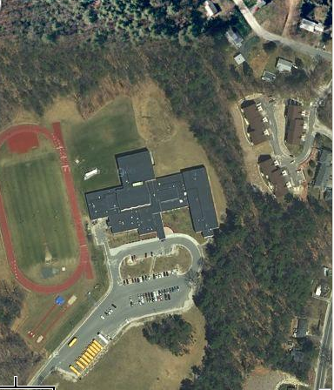

Prepared by:
Massachusetts Department of Public Health
Bureau of Environmental Health
Indoor Air Quality Program
May 2009

Background/Introduction
At the request of Interim School Superintendent Linda Denault, the Massachusetts Department of Public Health (MDPH), Bureau of Environmental Health (BEH) provided assistance and consultation regarding indoor air quality concerns at Granite Valley Middle School (GVMS), 21 Thompson Street, Monson, Massachusetts. The request was prompted by the hospitalization of a building occupant.
On December 23, 2008, a visit to conduct an assessment was made to the GVMS by Lisa Hébert and James Tobin, Indoor Air Inspectors in BEH’s Indoor Air Quality (IAQ) Program. At that time, the assessment focused on several locations that originally prompted the IAQ complaint. On January 14, 2009, Lisa Hébert returned to GVMS to conduct follow up testing in the remainder of the school for comparison and to conduct air sampling for volatile organic compounds (VOCs). On March 27, 2009, Michael Feeney, Director of BEH’s Indoor Air Quality Program and Lisa Hébert visited the building to complete the assessment.
The GVMS is a two story brick building originally constructed in the mid 1960s as a high school. The building was substantially renovated in 2002. New gypsum wallboard, installation of membrane roof and an elevator were all part of the 2002 renovation. The building is roughly rectangular, and consists of general classrooms, an auditorium, library, gymnasium, music and art rooms and offices. Windows were openable throughout most of the building. Shop areas that were used when the building was a high school were no longer in use as such and are currently used for storage of maintenance department supplies.
Due to the concerns about indoor air quality, the GVMS had been previously evaluated by Universal Environmental Consultants (UEC) in October, 2008. UEC made no recommendations based on their building evaluation. IAQ staff examined the following areas of concern: the cafeteria, classroom 113, the main office conference room and the hallway outside the Teacher’s Copy Room. Each of these areas was evaluated, as well as the remainder of the building to compare to each of the listed locations.

Methods
Air tests for carbon monoxide, carbon dioxide, temperature and relative humidity were conducted with the TSI, Q-Trak, IAQ Monitor, Model 8551. Air tests for airborne particle matter with a diameter less than 2.5 micrometers were taken with the TSI, DUSTTRAK™ Aerosol Monitor Model 8520. Screening for total volatile organic compounds (TVOCs) was conducted using a Rae Systems, Mini Rae 2000 Photoionization Detector (PID). Background readings for January 14, 2009 were obtained from Weather Underground. BEH staff also performed visual inspection of building materials for water damage and/or microbial growth.

Results
The GVMS has an employee population of approximately 48 and serves 460 children in grades five through eight. Tests were taken under normal operating conditions and results appear in Table 1. Air sampling results are listed in the table by location that the air sample was taken.

Discussion

Ventilation
It can be seen from Table 1 that carbon dioxide levels were above 800 parts per million (ppm) in 14 of 50 areas surveyed on December 23, 2008 and in 8 of 17 areas surveyed on January 14, 2009. These levels of carbon dioxide indicate adequate air exchange in the majority of the areas tested. However, it is also important to note that several classrooms were sparsely populated, which can greatly reduce carbon dioxide levels. Carbon dioxide levels would be expected to increase with full occupancy.
Fresh air in classrooms is supplied by either a wall or ceiling mounted unit ventilator (univent) system (Figure 1). A univent draws air from outdoors through a fresh air intake located on the exterior walls of the building and return air through an air intake located at the base of each unit. The mixture of fresh and return air is drawn through a filter and heating coil, and is then expelled from the univent by motorized fans through fresh air diffusers. Importantly, the units must remain “on” and allowed to operate while these rooms are occupied. Stale air and contaminants are removed from classrooms by wall or ceiling mounted exhaust ventilators (Pictures 1 and 2).
Four rooftop air handling units (AHUs) service the Principal’s offices, the library, the auditorium, and the Superintendent’s offices. Fresh air is provided by the AHUs through ducted ceiling mounted air diffusers. Stale air and contaminants are removed from these areas by ducted exhaust vents.
To maximize air exchange, the MDPH recommends that both supply and exhaust ventilation operate continuously during periods of school occupancy. In order to have proper ventilation with a mechanical supply and exhaust system, the systems must be balanced to provide an adequate amount of fresh air to the interior of a room while removing stale air from the room. It is recommended that HVAC systems be re-balanced every five years to ensure adequate air systems function (SMACNA, 1994). The systems at GVMS were reportedly balanced in 2002.
The Massachusetts Building Code requires a minimum ventilation rate of 15 cubic feet per minute (cfm) per occupant of fresh outside air or have openable windows in each room (SBBRS, 1997; BOCA, 1993). The ventilation must be on at all times that the room is occupied. Providing adequate fresh air ventilation with open windows and maintaining the temperature in the comfort range during the cold weather season is impractical. Mechanical ventilation is usually required to provide adequate fresh air ventilation.
Carbon dioxide is not a problem in and of itself. It is used as an indicator of the adequacy of the fresh air ventilation. As carbon dioxide levels rise, it indicates that the ventilating system is malfunctioning or the design occupancy of the room is being exceeded. When this happens, a buildup of common indoor air pollutants can occur, leading to discomfort or health complaints. The Occupational Safety and Health Administration (OSHA) standard for carbon dioxide is 5,000 parts per million parts of air (ppm). Workers may be exposed to this level for 40 hours/week, based on a time-weighted average (OSHA, 1997).
The MDPH uses a guideline of 800 ppm for publicly occupied buildings. A guideline of 600 ppm or less is preferred in schools due to the fact that the majority of occupants are young and considered to be a more sensitive population in the evaluation of environmental health status. Inadequate ventilation and/or elevated temperatures are major causes of complaints such as respiratory, eye, nose and throat irritation, lethargy and headaches. For more information concerning carbon dioxide, consult Appendix A.
Temperature measurements in the school ranged from 64° F to 73° F in the areas surveyed on December 23, 2008, which were below the MDPH recommended range in 24 of 50 areas surveyed (Table 1). Temperature measurements in the school ranged from 63° F to 74° F in the areas tested on January 14, 2009, which were below the MDPH recommended range in 8 of 17 areas surveyed (Table 2). The MDPH recommends that indoor air temperatures be maintained in a range of 70º F to 78º F in order to provide for the comfort of building occupants. In many cases concerning indoor air quality, fluctuations of temperature in occupied spaces are typically experienced, even in a building with an adequate fresh air supply.
The relative humidity measured in the building ranged from 12 to 21 percent in the areas tested on December 23, 2008. The relative humidity measured in the building ranged from 6 to 20 percent in the areas tested on January 14, 2009. All of these measurements were below the MDPH recommended comfort range at the time of the assessments (Tables 1 and 2). The MDPH recommends a comfort range of 40 to 60 percent for indoor air relative humidity. Relative humidity levels in the building would be expected to drop during the winter months due to heating. “Extremely low (below 20%) relative humidity may be associated with eye irritation [and]…may affect the mucous membranes of individuals with bronchial constriction, rhinitis, or cold and influenza related symptoms (Arundel et al., 1986). The sensation of dryness and irritation is common in a low relative humidity environment. Low relative humidity is a very common problem during the heating season in the northeast part of the United States. In addition to “dry and sore nose and throat, inability to wear contact lenses, and dry, itchy, flaky skin [low relative humidity] can” contribute to an increase in respiratory illness by weakening the defense provided by the mucous membranes” (Bayer et al., 1999).

Microbial/Moisture Concerns
Several potential sources of water damage and/or mold growth were observed. Water damaged ceiling tiles were observed in several locations at GVMS. Several areas of water damaged tiles appeared to have been previously painted over rather than replaced (Picture 3). Additionally, in the basement, in the rear storage room, a ceiling area above the Modine heater exhibited extensive water damage (Picture 4). In the same storage room, the surfaces of some wooden furniture exhibited mold colonization. Porous materials exposed to chronic dampness provide the conditions condusive to mold colonization.
In the library, the inner office exhibited extensive water damage to ceiling tiles as well as gypsum wallboard (Picture 5). The former wood shop, which is currently used for storage, exhibits evidence of chronic moisture damage on the wood floor on either side of the overhead door (Picture 6).
A refrigerator is located on carpeted flooring in the copy room. When warm, moist air passes over the cooler refrigerator, condensation can collect on the surface. Condensation is the collection of moisture on a surface at or below the dew point. The dew point is the temperature that air must reach for saturation to occur. Over time, condensation can collect and form water droplets. These water droplets can drip from the refrigerator surface to the carpeting. As previously discussed, moistened carpeting can be a source of mold growth. Additionally, a sizable stain was observed on the carpet adjacent to the refrigerator.
The US Environmental Protection Agency (US EPA) and the American Conference of Governmental Industrial Hygienists (ACGIH) recommend that porous materials be dried with fans and heating within 24 to 48 hours of becoming wet (US EPA, 2001; ACGIH, 1989). If not dried within this time frame, mold growth may occur. Once mold has colonized porous materials, they are difficult to clean and should be removed/discarded.
Plants were noted throughout the GVMS, located on or near unit ventilators, as well as a hanging over a carpeted area. A planter can be a source of moisture that can chronically moisten carpet and lead to mold growth. Plant soil and drip pans can serve as a source of mold growth. Plants should be properly maintained and be equipped with drip pans. Plants should also be located away from the air stream of mechanical ventilation to prevent aerosolization of dirt, pollen or mold.
An aquarium was observed in the front office. Aquariums should be properly maintained to prevent microbial/algae growth, and unpleasant odors.
BEH staff examined the exterior of the building to identify breaches in the building envelope that could provide a source of water penetration. Several potential sources were identified:
- Numerous exterior doors exhibit sizable gaps, including the overhead door in the basement (Picture 7). This can allow moisture, unconditioned air as well as rodents and insects into the building.
- Efflorescence was observed on several portions of the building (Picture 8). Efflorescence is a characteristic sign of water intrusion. As penetrating moisture works its way through mortar and around brick, it leaves behind characteristic mineral deposits.
- Some portions of the brick building lack weep holes. Exterior wall systems should be designed to prevent moisture penetration into the building interior. An exterior wall system should consist of an exterior curtain wall. Behind the curtain wall is an air space that allows for water to drain downward and for the exterior cladding system to dry. In order to allow for water to drain from the exterior brick system, a series of weep holes is customarily installed in the exterior wall, at or near the foundation slab/exterior wall system junction. Weep holes allow for accumulated water to drain from a wall system (Dalzell, 1955). Opposite the exterior wall and across the air space is a continuous, water-resistant material adhered to the back up wall that forms the drainage plane. The purpose of the drainage plane is to prevent moisture that crosses the air space from penetrating the interior of the building. The plane also directs moisture downwards toward the weep holes. The drainage plane can consist of a number of water resistant materials, such as tarpaper or, in newer buildings, plastic wraps. The drainage plane should be continuous. Where breaks exist in the drainage plane (e.g., window systems, door systems, air intakes), additional materials (e.g., flashing) are installed as transitional surfaces to direct water to weep holes. If the drainage plane is discontinuous, missing flashing or lacking air space, rainwater may accumulate inside the wall cavity and lead to moisture penetration into the building.
- Pieces of the outer layer of brick are flaking and falling off the building, a condition known as spalling (Picture 9). As can be seen in Picture 9, salt crystals are visible on the newly exposed brick surface. This condition is known as subflorescence. Subflorescence is indicative of moisture penetration through masonry. As moisture penetrates the brick surface, mineral salts are deposited on the interior of the brick. In the winter months, through the actions of freezing and thawing, the expansion within the brick creates spalling. Pieces of brick of various sizes were observed at the base of the building. The upper portions of the affected exterior walls appear to be buckling and bulging in response to this condition.
- Of note were expansion joints which were cracked and deteriorating (Picture 10). Expansion joints must be watertight and airtight, while at the same time, allowing for the joint to expand as necessary (“Accommodating Expansion”). As can be seen in Picture 11, the two sections of exterior walls that are joined at this expansion joint are not in the same plane. One or both of the walls appear to have shifted; therefore, one wall is higher and has moved more forward than the other (Picture 11).
- Mortar is cracked and missing in some areas. The missing mortar may allow rainwater, unconditioned air as well as insects to enter the building’s envelope. As water penetrates the interior brick surfaces and is exposed to the elements, particularly the conditions of freezing and thawing, it can further deteriorate the building’s components. On the roof, caulking and mortar were observed to be missing or deteriorated adjacent to windows and fresh air intakes (Picture 12).
- Moss was observed on lower exterior walls, walkways and in the lawn on the north side of the building (Picture 13). The presence of moss on the brick and mortar shown in Picture 13 is indicative of repeated water exposure. The two main requirements of a moss are sufficient moisture and accessible nutrients. For example, the moist environment of a rooftop shaded by trees seems just fine for mosses, [which] prefer to colonize shingles above the eaves, on detritus that builds up in the eaves’ troughs or other depressions. Mosses will be at their best in the winter when there is plenty of water, little light and low temperatures” (OSU, 2000). It is evident from the moisture stains on the exterior brick, (known as mustaching) that the brick has been exposed to moderate to heavy amounts of moisture (Picture 14).
- Some egress doors were blocked by snow accumulation at the rear of the building. In addition, snow and ice accumulation was observed on the ledge outside the wood shop’s overhead door (Picture 15). This condition may be entirely responsible for the water damage of the interior wooden floor as the snow and ice melt.
- A broken vent was observed on the exterior of the building (Picture 16). The vent appeared to contain an accumulation of snow and leaves. This accumulation could result in mold colonization in the vent.
- The foundation exhibited cracks in some areas. One area of foundation near a univent exhibited moisture, which may indicate a plumbing leak in the univent (Picture 17). GVMS custodial staff stated they would assess whether a leak has occurred and if so, will arrange for its repair.
- A shrub was noted growing against the building wall. The growth of roots against exterior walls can bring moisture in contact with the foundation. Plant roots can eventually penetrate, leading to cracks and/or fissures in the sublevel foundation. Over time, this process can undermine the integrity of the building envelope, providing a means of water entry into the building via capillary action through foundation concrete and masonry (Lstiburek & Brennan, 2001).

Other IAQ Evaluations
Indoor air quality can be negatively influenced by the presence of respiratory irritants, such as products of combustion. The process of combustion produces a number of pollutants. Common combustion emissions include carbon monoxide, carbon dioxide, water vapor and smoke (fine airborne particle material). Of these materials, exposure to carbon monoxide and particulate matter with a diameter of 2.5 micrometers (μm) or less (PM2.5) can produce immediate, acute health effects upon exposure. To determine whether combustion products were present in the school environment, BEH staff obtained measurements for carbon monoxide and PM2.5.

Carbon Monoxide
Carbon monoxide is a by-product of incomplete combustion of organic matter (e.g., gasoline, wood and tobacco). Exposure to carbon monoxide can produce immediate and acute health affects. Several air quality standards have been established to address carbon monoxide and prevent symptoms from exposure to these substances. The MDPH established a corrective action level concerning carbon monoxide in ice skating rinks that use fossil-fueled ice resurfacing equipment. If an operator of an indoor ice rink measures a carbon monoxide level over 30 ppm, taken 20 minutes after resurfacing within a rink, that operator must take actions to reduce carbon monoxide levels (MDPH, 1997).
The American Society of Heating Refrigeration and Air-Conditioning Engineers (ASHRAE) has adopted the National Ambient Air Quality Standards (NAAQS) as one set of criteria for assessing indoor air quality and monitoring of fresh air introduced by HVAC systems (ASHRAE, 1989). The NAAQS are standards established by the US EPA to protect the public health from six criteria pollutants, including carbon monoxide and particulate matter (US EPA, 2006). As recommended by ASHRAE, pollutant levels of fresh air introduced to a building should not exceed the NAAQS levels (ASHRAE, 1989). The NAAQS were adopted by reference in the Building Officials & Code Administrators (BOCA) National Mechanical Code of 1993 (BOCA, 1993), which is now an HVAC standard included in the Massachusetts State Building Code (SBBRS, 1997). According to the NAAQS, carbon monoxide levels in outdoor air should not exceed 9 ppm in an eight-hour average (US EPA, 2006).
Carbon monoxide should not be present in a typical, indoor environment. If it is present, indoor carbon monoxide levels should be less than or equal to outdoor levels. On the day of assessment, outdoor carbon monoxide concentrations were non-detect (ND) (Table 1). Carbon monoxide levels measured in the school were also ND.

Particulate Matter (PM2.5)
The US EPA has established NAAQS limits for exposure to particulate matter. Particulate matter is airborne solids that can be irritating to the eyes, nose and throat. The NAAQS originally established exposure limits to particulate matter with a diameter of 10 μm or less (PM10). According to the NAAQS, PM10 levels should not exceed 150 microgram per cubic meter (μg/m³) in a 24-hour average (US EPA, 2006). These standards were adopted by both ASHRAE and BOCA. Since the issuance of the ASHRAE standard and BOCA Code, US EPA established a more protective standard for fine airborne particles. This more stringent PM2.5 standard requires outdoor air particle levels be maintained below 35 μg/m³ over a 24-hour average (US EPA, 2006). Although both the ASHRAE standard and BOCA Code adopted the PM10 standard for evaluating air quality, MDPH uses the more protective PM2.5 standard for evaluating airborne particulate matter concentrations in the indoor environment.
Outdoor PM2.5 concentrations taken on December 23, 2008 were measured at 5 μg/m³. PM2.5 levels measured inside the school on December 23, 2008 ranged from 2 to 19 μg/m³ (Table 1). An outdoor PM2.5 measurement was not taken on January 14, 2009 assessment; however, ambient levels were predicted to be between 1-50 μg/m³ (AIRNow, 2009). PM2.5 levels measured inside the school on January 14, 2009, PM2.5 ranged from 1-6 μg/m³. Indoor PM2.5 levels for both days of assessment were below the NAAQS PM2.5 level of 35 μg/m³. Frequently, indoor air levels of particulates (including PM2.5) can be at higher levels than those measured outdoors. A number of mechanical devices and/or activities that occur in schools can generate particulate matter during normal operations. Sources of indoor airborne particulates may include but are not limited to particles generated during the operation of fan belts in the HVAC system, cooking in the cafeteria stoves and microwave ovens; use of photocopiers, fax machines and computer printing devices; operation of an ordinary vacuum cleaner and heavy foot traffic indoors.

TVOCs
Indoor air concentrations can be greatly impacted by the use of products containing volatile organic compounds (VOCs). VOCs are carbon-containing substances that have the ability to evaporate at room temperature. Frequently, exposure to low levels of total VOCs (TVOCs) may produce eye, nose, throat and/or respiratory irritation in some sensitive individuals. For example, chemicals evaporating from a paint can stored at room temperature would most likely contain VOCs. In an effort to determine whether VOCs were present in the building, air monitoring for TVOCs was conducted. An outdoor air sample was taken for comparison. Outdoor TVOC concentrations were 0.7 ppm (Table 1). Indoor TVOC concentrations ranged from non-detectable to 1.4 ppm (Table 1). In an effort to identify materials that can potentially increase indoor VOC concentrations, BEH staff also examined classrooms for products containing these respiratory irritants.
Some classrooms contained dry erase boards and dry erase markers. Materials such as dry erase markers and dry erase board cleaners may contain volatile organic compounds (VOCs) (e.g., methyl isobutyl ketone, n-butyl acetate and butyl-cellusolve), which can be irritating to the eyes, nose and throat (Sanford, 1999). The highest reading was taken in a classroom in which the instructor was using a marker on an overhead projector.
Located in the copier room are a number of photocopying machines and a laminator. Of note were two printers (Risograph®), which use a liquid toner. BEH obtained the Material Safety Data Sheet (MSDS) for this product (Appendix B). This product contains petroleum distillates, which are VOCs that can be irritants to the eyes, nose and respiratory system. In accordance with the MSDS for this product, exposure to vapors or mist either from heating the Risograph ink or from exposure to it in poorly ventilated areas may cause irritation of the nose and throat, headache and nausea. Photocopiers can also produce VOCs and ozone, particularly if the equipment is older and in frequent use. VOCs and ozone are respiratory irritants (Schmidt Etkin, 1992). It is recommended that local separate exhaust systems that do not recirculate into the general ventilation system be used.
A spray can of Vandalism Mark Remover was observed in a cabinet in the art room. BEH staff obtained a copy of the material safety data sheet (MSDS) for this product, which contains VOCs that which can be irritating to the eyes, nose and throat. BEH subsequently contacted the principal to recommend that the product be removed from the classroom and stored in an area that is inaccessible to children. It was also recommended that the product be used only after school hours and that teachers be notified in the event that additional cans of the product are being stored in other classrooms. It is important that MSDS’ be obtained and stored in a central location for all products brought into the GVMS for informational purposes for building occupants and in the event of an emergency.
Numerous cans of paints and stains were observed in the basement. One can of paint had been left open to the atmosphere and dried around a paintbrush (Pictures 18 and 19). As previously mentioned, paints contain VOCs, which can be irritating to the respiratory system.
Candle warmers, reed diffusers and deodorizing materials were observed in several areas at the GVMS (Picture 20). Air deodorizers contain chemicals that can be irritating to the eyes, nose and throats of sensitive individuals. Many air fresheners contain 1,4-dichlorobenzene, a VOC which may cause reductions in lung function (NIH, 2006). Furthermore, deodorizing agents do not remove materials causing odors, but rather mask odors that may be present in the area. A lawnmower was also observed to be stored in the basement. In addition to being a potential fire hazard, the potential exists for VOC emissions from the gas tank to enter the basement area.
In an effort to reduce noise from sliding chairs and tables, tennis balls were sliced open and placed on chair legs in at least one classroom (Picture 21). Tennis balls are made of a number of materials that are a source of respiratory irritants. Constant wearing of tennis balls can produce fibers and off-gas VOCs. Tennis balls are made with a natural rubber latex bladder, which becomes abraded when used as a chair leg pad. Use of tennis balls in this manner may introduce latex dust into the school environment. Some individuals are highly allergic to latex (e.g. spina bifida patients) (SBAA, 2001). It is recommended that the use of materials containing latex be limited in buildings to reduce the likelihood of symptoms in sensitive individuals (NIOSH, 1997). A question and answer sheet concerning latex allergy is attached as Appendix C (NIOSH, 1998).
Other conditions that can affect indoor air quality were observed during the assessment. Obstructions to airflow, such as papers, books and supplies stored on univents were seen in a number of classrooms (Picture 22). In order for univents to provide fresh air as designed, intakes must remain free of obstructions.
The interior of the univent in room 113 was examined by BEH staff. The interior contained an accumulation of dirt/debris (Picture 23). Univents should be thoroughly cleaned on a routine basis to prevent aerosolization of these materials. Some of the debris appeared to be an accumulation of grass clippings (Picture 24). Care should be taken to deposit clippings away from the fresh air intakes.
Although the univent filter was clean and appeared to have been recently changed at the time of the assessment, the filter had not been installed properly into its filter slot and had a space on one side (Picture 25). This placement will allow air to bypass the filter. As air bypasses a filter, the opportunity exists for airborne dirt, dust, odors and particulates to be drawn into the univent and be subsequently distributed to occupied areas. Aerosolized dust, particulates and odors can provide a source of eye, skin and respiratory irritation to certain individuals. In addition, these materials can accumulate on flat surfaces in occupied areas and subsequently be re-aerosolized causing further irritation. A strong musty odor was observed in room 113, and was attributed to the recent storage of a large amount of old newspapers on the carpeting in the room. It should be noted that the exhaust in room 113 did not appear to be functioning on the day of the assessment.

Possible Allergen Sources
BEH staff also examined the building for allergens. An allergen is a substance that is foreign to the body and that may cause an allergic reaction in some people. For individuals with pre-existing asthma, exposure to allergens may trigger symptoms, which may include shortness of breath. Common allergens include pet dander, dust mites, pollen, mold, rodents and their urine as well as some foods.
A variety of potential allergens were noted at GVMS. Numerous rodent traps were observed in the dry food storage room as well as in the kitchen area (Picture 26). GVMS staff informed BEH that numerous mice had been caught this year in the kitchen/dry storage area. Additionally, a strong odor of decay (most likely a mouse) was detected by BEH staff from within the wall cavity beneath the sink in the copy room. As previously mentioned, several exterior doors exhibit gaps. To penetrate the exterior of a building, rodents require a minimal breach of ¼ inch (MDFA, 1996). Rodent infestation results from easy access to food and water in a building. Rodent infestation can result in indoor air quality related symptoms due to materials in their wastes (i.e., urine). Mouse urine contains a protein that is a known sensitizer (US EPA, 1992). A three-step approach is necessary to eliminate rodent infestation:
- removal of the rodents;
- cleaning of waste products from the interior of the building; and
- reduction/elimination of pathways/food sources that are attracting rodents.
To eliminate exposure to allergens, rodents must be removed from the building. Please note that removal, even after cleaning, may not provide immediate relief since allergens can exist in the interior for several months after rodents are eliminated (Burge, 1995). A combination of cleaning, increase in ventilation and filtration should serve to reduce rodent associated allergens once the infestation is eliminated. Under current Massachusetts law that went into effect November 1, 2001, the principles of integrated pest management (IPM) must be used to remove pests in schools (Mass Act, 2000).
In several classrooms, items were observed on the floor, windowsills, tabletops, counters, bookcases and desks. The large number of items stored in classrooms provide a source for dusts to accumulate. These items (e.g., papers, folders, boxes) make it difficult for custodial staff to clean. Items should be relocated and/or be cleaned periodically to avoid excessive dust build up. In addition, these materials can accumulate on flat surfaces (e.g., desktops, shelving and carpets) in occupied areas and subsequently be re-aerosolized causing further irritation.
A number of classrooms contained upholstered furniture and pillows (Picture 27). Upholstered furniture is covered with fabric that comes into contact with human skin, leaving oils, perspiration, hair and skin cells. Dust mites feed upon human skin cells and excrete waste products that contain allergens. In addition, if relative humidity levels increase above 60 percent, dust mites tend to proliferate (US EPA, 1992). In order to remove dust mites and other pollutants, frequent vacuuming of upholstered furniture is recommended (Berry, 1994). It is also recommended that upholstered furniture (if present in schools), be professionally cleaned on an annual basis. If an excessive dusty environment exists due outdoor conditions or indoor activities (e.g., renovations), cleaning frequency should be increased (every six months) (IICR, 2000). Elevated outdoor levels of airborne particulates can result in increased levels of indoor particulates by entering into the building through open windows, doors and filter bypass.
Several personal fans, air supply diffusers and exhaust grilles had accumulated dust and debris. Dust can be a source for eye and respiratory irritation. Personal fans with dust can serve to distribute particles once activated. Lastly, several classrooms exhibited window curtains which can accumulate dusts if not cleaned on a routine basis.
Containers of peanut butter were observed in the dry storage room off the kitchen. Peanut allergy is the most prevalent food allergy in the US (PeanutAllergy.com, 2009). Food allergies affect 6-8% of school-age children, and 40-50% of those persons with a diagnosed food allergy are judged to have a high risk of a life-threatening allergic reaction (anaphylaxis) (MA DOE, 2002).
Signs of bird roosting and nesting materials were observed in a number of recesses (e.g. within overhangs, above light fixture) around the exterior of the building near a fresh air intake (Pictures 28 and 29). Accumulated bird waste was observed on exterior brick walls. Birds can be a source of disease, and bird wastes and feathers can contain mold and mildew, which can be irritating to the respiratory system. No obvious signs of bird roosting inside the building or in ventilation components were noted by BEH staff or reported by occupants. A few fresh air intakes exhibited hornets’ nests. Nests can contain bacteria and may also be a source of allergenic material.

Other Concerns
Kitchen odors were observed in the halls surrounding the kitchen at GVMS. It was determined that the kitchen exhaust hood was in operation at the time the odors were observed. That would indicate that the exhaust, while functioning, is not currently sufficient to remove cooking odors. BEH was informed that it had been approximately four months since the belts had been changed and adjusted on this system. Odors were also evident in a hallway adjacent to the copy room. The copy room exhaust vent did not appear operational. Additionally, the adjacent hallway also lacked exhaust ventilation. Therefore, cooking odors from an adjacent cooking class as well as copy room odors lingered in this hallway. Lastly, odors were observed to be lingering in the teachers’ lounge due to the fact that the ceiling mounted univent was competing with the exhaust vent. In this case, either the exhaust must be increased or the vent on the door eliminated.
Open utility holes were observed in the basement ceiling and in copy room wall. Open utility holes can provide a means of egress for odors, fumes, dusts and vapors between rooms and floors. Packages of ceiling tiles, and pleated filters for ventilation systems are currently stored in the basement. Additionally, numerous pieces of upholstered furniture were stored in the basement as well. These materials can provide surfaces on which dust can accumulate. In addition, these items can provide a medium on which mold colonization can occur if moisture is present in the basement at any time.
Broken fluorescent light bulbs were observed in the basement storage area (Picture 30). These bulbs contain and release mercury when broken, therefore, they must be stored, utilized and disposed of with care. GVMS staff were provided with information regarding cleanup guidelines (Appendix D).
The shop sink as well as one classroom sink exhibited a dry drain (Picture 31). The purpose of a drain trap is to prevent sewer system gases and odors from entering the occupied space. When water is poured into a trap, an air tight seal is created by the water in the U-bend section of the pipe. These drains must have water poured into the traps at least twice a week to maintain the integrity of the seal. Without water, the drain opens the room to the sewer system. If a mechanical device depressurizes the room, air, gas and odors can be drawn from the sewer system into the room. The effect of this phenomenon can be increased if heavy rains cause an air backup in the sewer system.

Conclusions/Recommendations
After examining the cafeteria, classroom 113, the main office conference room and the hallway outside the Teacher’s Copy Room, IAQ staff could find no single, common indoor environmental source among each of these locations. Each area of concern has completely separate HVAC systems. In addition, no appreciable concentrations of VOCs, PM2.5 or carbon monoxide were observed that would be of concern with respect to health impacts. While the exterior conditions noted in the assessment may provide points of entry for moisture to penetrate the building envelope and may eventually cause structural issues in the building, at present these areas do not correlate with areas of concern that were mentioned relative to the interior of the building (Pictures 32 and 33). Therefore, no single source of environmental pollutants could be identified that would link these areas as cause for concern. In addition, each area of concern have conditions are similar to other examined areas of the building. Therefore, there do not appear to be conditions that can account for the health effects reported to IAQ staff.
There are conditions noted at GVMS that can have an effect on indoor air quality. In order to address these concerns, a two-phase approach is required for remediation. The first consists of short-term measures to improve air quality and the second consists of long-term measures that will require planning and resources to adequately address the overall indoor air quality concerns.
In view of the findings at the time of the visits, the following short-term recommendations should be considered for implementation:
- Ensure leaks are repaired and replace water damaged ceiling tiles and gypsum wallboard. Examine the area above and around these areas for mold growth. Disinfect areas of water leaks with an appropriate antimicrobial.
- Obtain Material Safety Data Sheets (MSDS) for all cleaning products used within GVMS and keep them in a central area that is accessible to all individuals during periods of building operations as required by the Massachusetts Right-To-Know Act (MGL, 1983). Store cleaning products properly and out of reach of students. Ensure spray bottles are properly labeled. All cleaning products used at the facility should be approved by the school department.
- Ensure filters for all AHUs and univents fit flush in their racks with no spaces to prevent bypass of unfiltered air.
- Change filters for air-handling equipment (e.g., univents, AHUs and ACs) as per the manufacturer’s instructions or more frequently if needed. Ensure interior as well as exterior portions of the univents (fresh air intakes) and exhaust grates are in a clean condition as well.
- Consider adopting a balancing schedule of every 5 years for all mechanical ventilation systems, as recommended by ventilation industrial standards (SMACNA, 1994).
- Contact an HVAC engineering firm to evaluate the draw of the kitchen exhaust hood and repair as necessary to eliminate cooking odors from GVMS hallways. Ventilation in teachers’ lounge should be reviewed as well.
- Use the principles of integrated pest management (IPM) to prevent infestation of pests. A copy of the IPM recommendations from the Massachusetts Department of Food and Agriculture (MDFA, 1996) can be obtained at the following website: http://www.mass.gov/agr/pesticides/publications/docs/IPM_kit_for_bldg_mgrs.pdf. Activities that can be used to eliminate pest infestation may include the following:
- Evaluate the use of food in the classroom.
- Rinse recycled food containers. Seal recycled containers with a tight fitting lid to prevent rodent access.
- Remove non-food items that could be consumed by rodents.
- Store food in tight fitting containers.
- Avoid eating at workstations. In areas where food is consumed, periodically vacuum to remove crumbs.
- Clean crumbs and other food residues from ovens, toasters, toaster ovens, microwave ovens, coffee pots and other food preparation equipment on a regular basis.
- Examine each room and the exterior walls of the building for means of rodent egress and seal. Holes as small as ¼” are enough space for rodents to enter an area. If doors do not seal at the bottom, install a weather strip as a barrier to rodents. Reduce harborages (e.g. cardboard boxes) where rodents may reside (MDFA, 1996).
- Continue rodent monitoring and removal from the building. Eliminate pathways into the building. Develop rigorous cleaning practices for areas subject to rodent traffic within the building.
- Seal spaces around utility holes and breaches in walls/floors and ceilings with an appropriate fire-rated sealant.
- Relocate or consider reducing the amount of materials stored in classrooms to allow for more thorough cleaning of classrooms. Clean items regularly with a wet cloth or sponge to prevent excessive dust build-up.
- Establish routine vacuuming of upholstered furniture and carpets in order to remove dust mites and other pollutants.
- Clean personal fans, air diffusers, exhaust, return vents and adjacent ceiling tiles periodically of accumulated dust. If soiled ceiling tiles cannot be cleaned, they should be replaced.
- Discontinue use of dry erase markers. If not feasible, utilize markers with lower VOCs.
- Ensure all paints are stored with tightly closed lids. Properly dispose of old paints and stains that are no longer being used.
- Eliminate use of candle warmers, reed diffusers and air fresheners.
- Discontinue use of tennis balls on classroom chairs.
- Store and dispose of fluorescent light bulbs in accordance with DEP guidelines.
- Unused or rarely used sinks should be either have drains filled regularly with water or sinks should be removed and properly capped in order to eliminate the potential of sewer gas entering the building.
- Consider providing plants with drip pans and avoid over-watering. Examine drip pans periodically for mold growth. Disinfect with an appropriate antimicrobial where necessary.
- Clean and maintain the aquarium in order to prevent microbial growth.
- Consider cleaning classroom curtains on a regular schedule to prevent dust accumulation.
- Consider cleaning carpeting annually (or semi-annually in soiled high traffic areas ) as per the recommendations of the Institute of Inspection, Cleaning and Restoration Certification (IICRC). Copies of the IICRC fact sheet can be downloaded at: http://www.cleancareseminars.com/carpet_cleaning_faq4.htm. (IICRC, 2005)
- Seal bottom edge of overhead door to the former shop and keep snow and ice from accumulating on adjacent exterior ledge.
- When mowing lawn, position mower in order to ensure grass clippings are blowing away from univent fresh air intakes.
- Clean areas of all bird wastes and disinfect with an appropriate antimicrobial. Remove insect nests from exterior of univents.
- Repair missing and broken mortar on the exterior of the building.
- Repair/replace expansion joint sealant. Repair cracks in concrete as well.
- Develop a routine cleaning and maintenance program for roof drains in order to prevent rainwater from accumulating on the roof.
- Repair/Seal broken vent on the back of the building.
- Use openable windows in conjunction with mechanical ventilation to facilitate air exchange. Care should be taken to ensure windows are properly closed at night and weekends to avoid the freezing of pipes and potential flooding.
- Consider discontinuing the practice of storing ceiling tiles, upholstered furniture and ventilation filters in the basement. Additionally, consider removal of furniture and textiles that are no longer in use.
- For buildings in New England, periods of low relative humidity during the winter are often unavoidable. Therefore, scrupulous cleaning practices should be adopted to minimize common indoor air contaminants whose irritant effects can be enhanced when the relative humidity is low. To control for dusts, a high efficiency particulate arrestance (HEPA) filter equipped vacuum cleaner in conjunction with wet wiping of all surfaces is recommended. Avoid the use of feather dusters. Drinking water during the day can help ease some symptoms associated with a dry environment (throat and sinus irritations).
- Consider adopting the US EPA (2000) document, “Tools for Schools”, as an instrument for maintaining a good indoor air quality environment in the building. This document is available at: http://www.epa.gov/iaq/schools/index.html.
- Refer to resource manual and other related indoor air quality documents located on the MDPH’s website for further building-wide evaluations and advice on maintaining public buildings. These documents are available at: http://mass.gov/dph/indoor_air.
- Consider utilizing Massachusetts Department of Education document, “Managing Life Threatening Food Allergies in Schools” to obtain more information on food allergies. This document is available at: www.doe.mass.edu/cnp/allergy.pdf.

Due to structural integrity related issues observed on the exterior of the building, the following long-term recommendations are made:
- Consider having exterior walls re-pointed to prevent water intrusion.
- Consider contacting a structural engineer/building envelope specialist for an examination of the exterior brick work of the building, especially in areas where the exterior wall is “bowing” outwards. This measure should include a full building envelope evaluation.
- Consider installing separate exhaust ventilation for copy room.
- Consider eliminating carpet from areas adjacent to and under the refrigerator in the copy room.
- If wood shop is contemplated to re-open in the future, consider installing dedicated exhaust.

References
ACGIH. 1989. Guidelines for the Assessment of Bioaerosols in the Indoor Environment. American Conference of Governmental Industrial Hygienists, Cincinnati, OH.
AirNow. 2009. http://www.airnow.gov/index.cfm?action=airnow.displaymaps&pollutant=OZONE&StateID=26&domain=east&mon=1&dayofmon=14&yr=2009&display=summary
Arundel et al. 1986. Indirect Health Effects of Relative humidity on Indoor Environments. Env. Health Perspectives 65:351-361.
ASHRAE. 1989. Ventilation for Acceptable Indoor Air Quality. American Society of Heating, Refrigeration and Air Conditioning Engineers. ANSI/ASHRAE 62-1989
Bayer, C. et al. 1999. Causes of Indoor air Quality Problems in Schools. US Department of Energy, Oak Ridge National Laboratory, Energy Division, Oak Ridge, TN
Berry, M.A. 1994. Protecting the Built Environment: Cleaning for Health, Michael A. Berry, Chapel Hill, NC.
BOCA. 1993. The BOCA National Mechanical Code/1993. 8th ed. Building Officials and Code Administrators International, Inc., Country Club Hill, IL.
Burge, H.A. 1995. Bioaerosols. Lewis Publishing Company, Boca Raton, FL.
Dalzell, J.R. 1955. Simplified Masonry Planning and Building. McGraw-Hill Book Company, Inc. New York, NY.
IICRC. 2000. IICRC S001 Reference Guideline for Professional On-Location Cleaning of Textile Floor Covering Materials Institute of Inspection, Cleaning and Restoration Certification. Institute of Inspection Cleaning and Restoration, Vancouver, WA.
IICRC. 2005. Carpet Cleaning FAQ 4 Institute of Inspection, Cleaning and Restoration Certification. Institute of Inspection Cleaning and Restoration, Vancouver, WA.
Lstiburek, J. & Brennan, T. 2001. Read This Before You Design, Build or Renovate. Building Science Corporation, Westford, MA. U.S. Department of Housing and Urban Development, Region I, Boston, MA
MA DOE. 2002. Managing Life Threatening Food Allergies in Schools. Massachusetts Department of Education. www.doe.mass.edu/cnp/allergy.pdf.
Mass. Act. 2000. An Act Protecting Children and families from Harmful Pesticides. 2000 Mass Acts c. 85 sec. 6E.
MDFA. 1996. Integrated Pest Management Kit for Building Managers. Massachusetts Department of Food and Agriculture, Pesticide Bureau, Boston, MA.
MDPH. 1997. Requirements to Maintain Air Quality in Indoor Skating Rinks (State Sanitary Code, Chapter XI). 105 CMR 675.000. Massachusetts Department of Public Health, Boston, MA.
MGL. 1983. Hazardous Substances Disclosure by Employers. Massachusetts General Laws. M.G.L. c. 111F.
NIH. 2006. Chemical in Many Air Fresheners May Reduce Lung Function. NIH News. National Institute of Health . July 27, 2006. http://www.nih.gov/news/pr/jul2006/niehs-27.htm
NIOSH. 1997. NIOSH Alert Preventing Allergic Reactions to Natural Rubber latex in the Workplace. National Institute for Occupational Safety and Health, Atlanta, GA.
NIOSH. 1998. Latex Allergy A Prevention. National Institute for Occupational Safety and Health, Atlanta, GA.
OSHA. 1997. Limits for Air Contaminants. Occupational Safety and Health Administration. Code of Federal Regulations. 29 C.F.R 1910.1000 Table Z-1-A.
OSU 2000. Basic Moss Biology. Retrieved August 19, 2008, from Oregon State University, Living with Mosses website: http://bryophytes.science.oregonstate.edu/mosses.htm.
PeanutAllergy.com. 2009. What is a Peanut Allergy? PeanutAllergy.com. Your Online Peanut Allergy Resource. http://www.peanutallergy.com/what-is-a-peanut-allergy.html.
Sanford. 1999. Material Safety Data Sheet (MSDS No: 198-17). Expo® Dry Erase Markers Bullet, Chisel, and Ultra Fine Tip. Sanford Corporation. Bellwood, IL.
SBAA. 2001. Latex In the Home And Community Updated Spring 2001. Spina Bifida Association of America, Washington, DC.
SBBRS. 1997. Mechanical Ventilation. State Board of Building Regulations and Standards. Code of Massachusetts Regulations. 780 CMR 1209.0.
Schmidt Etkin, D. 1992. Office Furnishings/Equipment & IAQ Health Impacts, Prevention & Mitigation. Cutter Information Corporation, Indoor Air Quality Update, Arlington, MA.
SMACNA. 1994. HVAC Systems Commissioning Manual. 1st ed. Sheet Metal and Air Conditioning Contractors’ National Association, Inc., Chantilly, VA.
US EPA. 1992. Indoor Biological Pollutants. US Environmental Protection Agency, Environmental Criteria and Assessment Office, Office of Health and Environmental Assessment, research Triangle Park, NC. EPA 600/8-91/202 January 1992.
US EPA. 2000. Tools for Schools. Office of Air and Radiation, Office of Radiation and Indoor Air, Indoor Environments Division (6609J). EPA 402-K-95-001, Second Edition. http://www.epa.gov/iaq/schools/tools4s2.html.
US EPA. 2001. Mold Remediation in Schools and Commercial Buildings. US Environmental Protection Agency, Office of Air and Radiation, Indoor Environments Division, Washington, D.C. EPA 402-K-01-001. March 2001.
US EPA. 2006. National Ambient Air Quality Standards (NAAQS). US Environmental Protection Agency, Office of Air Quality Planning and Standards, Washington, DC. http://www.epa.gov/air/criteria.html.
Picture 1

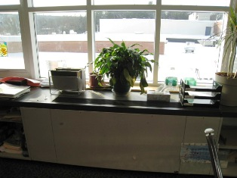

Unit Ventilator
Note Plant in Air Stream
Picture 2

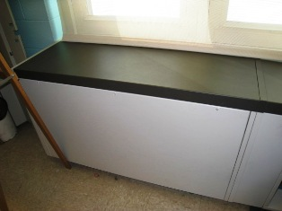

Unit Exhaust

Picture 3

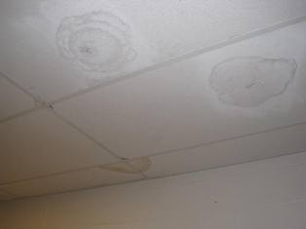

Water Damaged Ceiling Tiles
Note Painted Areas of Previous Water Damage
Picture 4

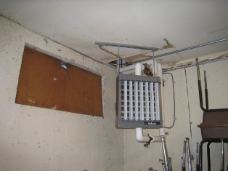

Water Damage Above Modine Heater
Note large penetration of pipes into ceiling
Picture 5

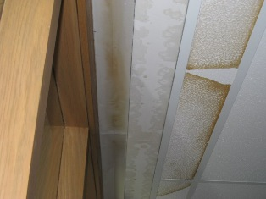

Water Damaged Ceiling Tiles and Drywall in Library

Picture 6

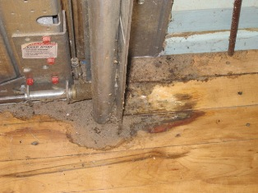

Water Damage to Wooden Floor in Former Shop

Picture 7

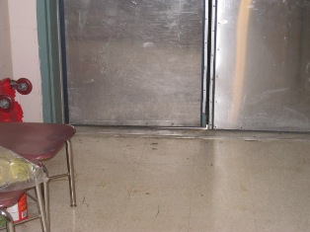

Gap in Exterior Door

Picture 8

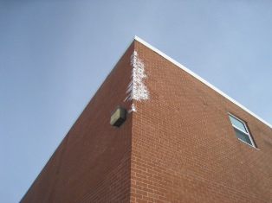

Efflorescence

Picture 9

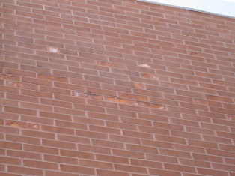

Section of Bricks Spalling Due To Sub-florescence
Note Mineral Salts Visible on Exposed Masonry

Picture 10

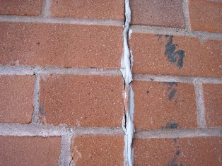

Deteriorating Sealant on Expansion Joint
Picture 11

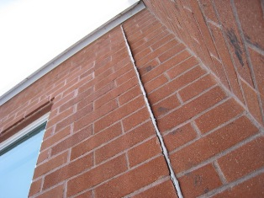

Walls at Expansion Joint In Different Planes

Picture 12

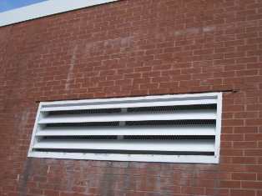

Missing Mortar, Caulking and Water Stains on Masonry
Picture 13

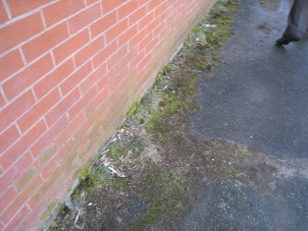

Moss Growth On Masonry and Asphalt

Picture 14

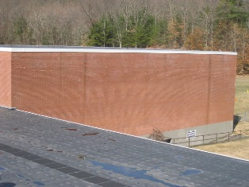

Water Stains on Masonry

Picture 15

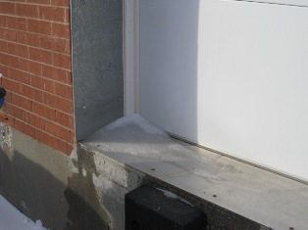

Ice Accumulation on Loading Dock to Wood Shop

Picture 16

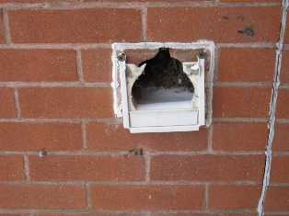

Broken Vent Cover Reveals Accumulation of Snow and Organic Debris

Picture 17

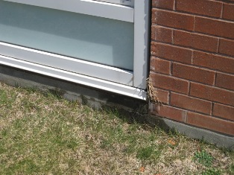

Water Stains Adjacent to Univent

Picture 18

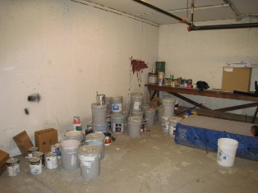

Numerous Paints/Stains Stored in Basement
Picture 19

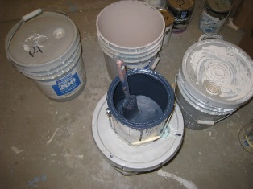

Open Can of Paint

Picture 20

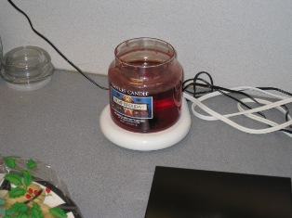

Candle Warmer

Picture 21

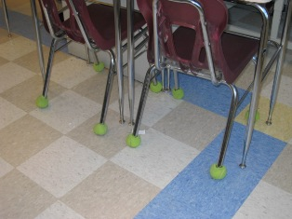

Tennis Balls Used on Chair Legs

Picture 22

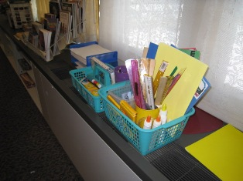

Supplies Stored on Top of Univent

Picture 23

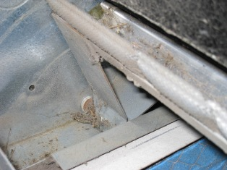

Dust Accumulation on Interior of Univent
Picture 24

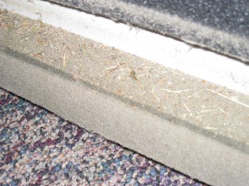

Grass Clippings on Interior Cover of Univent

Picture 25

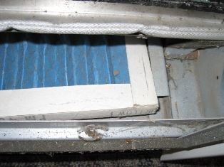

Filter Installation Allows Air to Bypass Filter

Picture 26

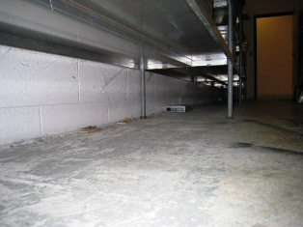

Mousetraps Observed Beneath Shelving in Dry Storage Room

Picture 27

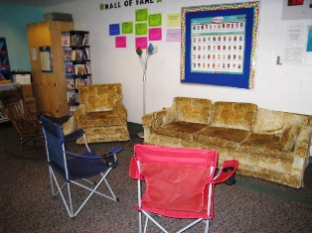
Upholstered Furniture in Classroom

Picture 28

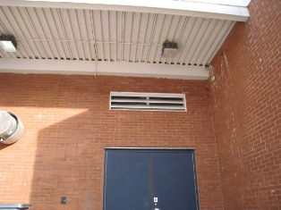

Bird Nesting Materials in Proximity to Air Intake

Picture 29

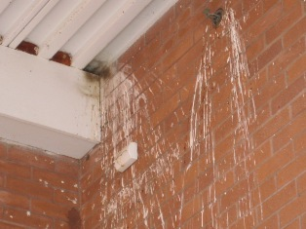

Bird Droppings on Exterior of Building Near Air Intake

Picture 30

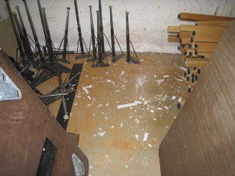

Broken Fluorescent Light Bulb(s) in Basement

Picture 31

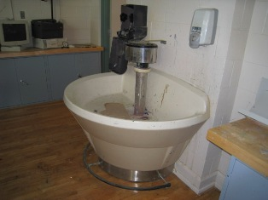

Shop Sink With Dry Drain

Picture 32

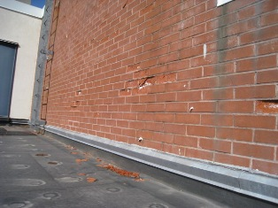

Spalling, Water Stains and Subflorescence on Exterior of Gymnasium

Picture 33

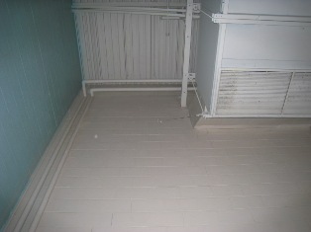

Absence of Water Damage on Interior Gymnasium Walls
Location/ Room | Occupants  in Room | Temp  (°F) | Relative  Humidity  (%) | Carbon  Dioxide  (ppm) | Carbon Monoxide  (ppm) | PM2.5  (µg/m³) | Windows  Openable | Ventilation |  | Remarks
 |  |  |  |  |  |  |  | Supply | Exhaust | Remarks
Background: | - | 34 | 29 | 423 | ND | 5 | - | - | -
Admin. Conf. Room | 0 | 67 | 14 | 581 | ND | 2 | N | Y | Y | DO, WDCT, Carpet, Dirty Diffuser
Admin. Front Office | 1 | 69 | 13 | 514 | ND | 2 | N | Y | Y | DO, Plants Copier, Plants, Carpet
Business Office | 1 | 70 | 12 | 549 | ND | 2 | N | Y | Y  Off | DO, WDCTs(6), Carpet
Cafeteria | 76 | 70 | 16 | 825 | ND | 8 | Y | Y | Y | DO, WDCTs (3)
Kitchen | 2 | 70 | 14 | 592 | ND | 4 | Y | Y | Y | DC
Office (front) | 2 | 71 | 15 | 757 | ND | 3 | Y | Y | N | DC, Carpet
Principal’s Office | 3 | 73 | 13 | 655 | ND | 4 | Y | Y | Y | DC, Plants
Office Conf. Room | 2 | 72 | 12 | 566 | ND | 2 | Y  0/3 | Y | Y  Off | DC, Carpet
Media Rm in Library | 0 | 66 | 15 | 572 | ND | 3 | N | Y | Y | DC, Carpet
Library Conf Room | 0 | 65 | 15 | 454 | ND | 3 | N | Y | Y | DC, UF, Carpet
Girl’s Rest Room | 0 | 68 | 17 | 710 | ND | 4 | N | Y | Y
Copy Room | 0 | 71 | 14 | 654 | ND | 6 | N | Y | Y  Off | DO, FC, Carpet, Door vent to book storage
Room 113 | 29 | 71 | 14 | 939 | ND | 5 | Y  0/4 | Y | Y  Off | DC, Carpet
Guidance | 0 | 71 | 15 | 671 | ND | 5 | N | Y  Off | Y  Off | DO, DEM, WDCT, TB, PF
Room 111 | 22 | 68 | 13 | 1026 | ND | 7 | Y  0/4 | Y | Y | DO, DEM, WDCT, TB, PF
Room 126 | 0 | 69 | 14 | 696 | ND | 5 | Y  0/4 | Y | Y | DO, Plants, Carpet
Room 121 | 1 | 69 | 15 | 849 | ND | 4 | Y  0/4 | Y | Y | Strong odor of DEM, 7 comp., UF, carpet
Room 107 | 0 | 69 | 13 | 695 | ND | 6 | Y  0/4 | Y | Y | DC, AP, Carpet, 5 comp.
Room 108 | 4 | 67 | 15 | 763 | ND | 5 | Y  0/4 | Y | Y | DO, DEM, PF, 5 comp., Carpet
110 | 0 | 68 | 13 | 583 | ND | 3 | N | Y | Y
Room 102 | 1 | 68 | 17 | 808 | ND | 4 | Y | Y  0/4 | Y | DO, WDCTs, DEM, Comp (5), Carpet
Hallway Front Entrance | 0 | 69 | 13 | 579 | ND | 6 | N | Y | Y
Café Hallway (soda mach) | 0 | 69 | 14 | 542 | ND | 6 | N | N | Y
Café Hallway (bathroom) | 0 | 69 | 13 | 522 | ND | 5 | N | N | Y
Middle Office Area | 0 | 71 | 15 | 584 | ND | 5 | N | Y | Y | PC, Fax
Assistant Principal | 0 | 71 | 13 | 511 | ND | 4 | Y  0/3 | Y | Y | DO, Radiator
Office Mail Area | 0 | 72 | 14 | 605 | ND | 6 | N | Y | ?? | Frige, micro, toaster, cleaning products
Library | 0 | 64 | 16 | 476 | ND | 19 | N | Y | Y | DO, Carpet
Book Room Storage | 0 | 66 | 16 | 478 | ND | 4 | N | N | Y  Dirt, dust | WDCTs near exhaust
Nurse – Main Rm | 3 | 72 | 14 | 598 | ND | 4 | Y  0/3 | Y | Y | DO, Floor tile
Nurse (Small Room) | 0 | 72 | 14 | 568 | ND | 5 | N | Y | N
Room 114 | 30 | 70 | 13 | 718 | ND | 8 | Y  0/4 | Y | Y  Blocked | Items on UV, PFs
Room 129 | 27 | 70 | 14 | 739 | ND | 10 | Y  0/6 | Y | Y | Floor tile
Room 124 | 0 | 69 | 14 | 498 | ND | 18 | Y  0/4 | Y | Y | DO, PF, DEM, Floor tile
Room 116 | 7 | 69 | 16 | 761 | ND | 6 | Y  0/4 | Y | Y | DO, Carpet
Room 109 | 1 | 69 | 18 | 843 | ND | 5 | Y  0/4 | Y | Y | DO, PF, Carpet
Room 106 | 1 | 69 | 20 | 894 | ND | 5 | Y  0/4 | Y | Y | DO, Plants, Tile, Cleaning Products
Room 101 | 1 | 69 | 17 | 720 | ND | 5 | Y  0/4 | Y | Y | DO, PF, Carpet, Writing on overhead projector sheet
Room 214 | 20 | 73 | 21 | 1637 | ND | 5 | Y  0/4 | Y | Y | DO, DEM, PF, Carpet
Team Planning Rm | 0 | 71 | 14 | 863 | ND | 4 | Y  0/2 | Y | Y | DO, DEM, U Chairs
Room 203 | 0 | 71 | 12 | 568 | ND | 4 | Y  0/4 | Y | Y | PF, DEM, Plants, Carpet
Landing (Stair 213) | 0 | 70 | 15 | 980 | ND | 4 | N | N | N
First floor hall (near locker 1265) | 4 | 70 | 15 | 802 | ND | 6 | N | N | N
Hallway (near locker 1403) | 0 | 70 | 16 | 742 | ND | 7 | N | N | N
Hallway (near stairway 112A) | 0 | 70 | 15 | 725 | ND | 6 | N | Y | N
Basement | 0 | 68 | 15 | 535 | ND | 5 | N | N | N
Room 210 | 26 | 70 | 17 | 994 | ND | 9 | Y  0/4 | Y | Y | DO, Plants, Pencil in Univent, Cleaning products
Room 204 | 0 | 71 | 15 | 748 | ND | 6 | Y  0/4 | Y | Y | Carpet
First floor stairs | 0 | 70 | 16 | 846 | ND | 8 | N | N | N
Eighth Grade Hall Intersection | 0 | 69 | 17 | 951 | ND | 12 | N | N | N

Location/ Room | Occupants  in Room | Temp  (°F) | Relative  Humidity  (%) | Carbon  Dioxide  (ppm) | Carbon Monoxide  (ppm) | PM2.5  (µg/m³) | Windows  Openable | Ventilation |  | Remarks
 |  |  |  |  |  |  |  | Supply | Exhaust | Remarks
Background: | - | 19 | 43 | - | - | - | - | - | -
Room 202 | 0 | 67 | 13 | 649 | ND | 4 | Y  0/4 | Y | Y | DO, DEM, 5 comp., Plants
Room 208 | 22 | 71 | 15 | 1003 | ND | 3 | Y  0/4 | Y | Y | DO, DEM, PF, Carpet
Room 225 | 26 | 71 | 20 | 1594 | ND | 6 | Y  0/4 | Y | Y | DC, PF, DEM, Lace curtains, Paper accum.
Room 226 | 1 | 70 | 14 | 849 | ND | 3 | Y  0/4 | Y | Y | DO, DEM, Plants on cloth, PF
Room 227 | 14 | 70 | 16 | 1040 | ND | 4 | Y  0/4 | Y | Y | DO, DEM, Plants, carpet, 7 comp.
Room 228 | 30 | 71 | 19 | 1357 | ND | 5 | Y  0/4 | Y | Y | DO, DEM, PFs, carpet, 5comp.
Room 222 | 0 | 71 | 12 | 870 | ND | 4 | Y  0/4 | Y | Y | DO, Dry drain
Room 217 | 0 | 71 | 10 | 636 | ND | 3 | Y  0/4 | Y | Y | DO, UF, Carpet
Room 218 | 0 | 74 | 12 | 828 | ND | 3 | Y  0/4 | Y | Y | DC, strong odor, candle warmer
Comp. Room | 0 | 70 | 14 | 516 | ND | 2 | N | Y | Y | DC, DEM, 25 comp.
Auditorium | 0 | 68 | 6 | 435 | ND | 1 | N | Y | Y | DO
Receiving | 2 | 63 | 7 | 450 | ND | 4 | N | N | N | DO, also laundry area
Tech. Ed. | 1 | 66 | 12 | 548 | ND | 3 | Y  0/3 | Y | Y | DC, DEM, carpet
Wood shop | 0 | 68 | 11 | 466 | ND | 3 | Y  0/6 | Y | Y | DO
Band/Chorus | 5 | 69 | 12 | 684 | ND | 3 | N | Y | Y | DO, comp. (3)
Art | 23 | 69 | 16 | 885 | ND | 2 | Y  0/4 | Y | Y | DO, comp (5)
Gym | 21 | 69 | 12 | 598 | ND | 4 | N | Y | Y | DO, wood floor

Location/ Room | TVOCs  (ppm) | Remarks
Background: | 0.7
Admin. Conf. Room | 0.0
Admin. Front  Office | 0.0
Business Office | 0.0
Cafeteria | 1.1
Kitchen | 1.0
Office (front) | 0.6
Principal’s Office | 0.6
Office Conf. Room | 0.6
Girl’s rest room | 0.7
Copy room | 0.7
Room 113 | 0.8
Hall (outside Rm 113) | 0.8
Room 111 | 0.8
Room 126 | 0.6
Room 121 | 0.7
Hall (outside Rm 121) | 0.7
Room 107 | 0.6
Room 108 | 0.7
Room 110 | 0.7
Room 102 | 0.8
Hallway, Front  Entrance | 0.7
Middle Office Area | 0.6
Assistant Principal | 0.6
Office Mail Area | 0.6
Library | 0.5
Nurse’s Office | 0.6
Room 114 | 0.8
Room 129 | 0.7
Room 124 | 0.7
Room 109 | 0.8
Room 106 | 0.9
Room 101 | 1.4 | Instructor using marker to write on overhead projector
Room 214 | 0.2
Team Planning Room | 0.0
Room 203 | 0.3
Landing (Stair 213) | 0.8
Hall (near locker 1265) | 0.8
Hall (near locker 1403) | 0.8
Hall (near stairway 112A) | 0.8
Room 202 | 0.0
Room 208 | 0.3
Room 225 | 0.5
Room 226 | 0.5
Room 227 | 0.6
Room 228 | 0.6
Room 222 | 0.7
Room 217 | 0.6
Room 218 | 0.7
Room 210 | 0.2
Room 204 | 0.2
Comp. Room | 0.5
Auditorium | 0.4
Receiving | 0.4
Tech Ed. | 0.4
Wood Shop | 0.4
Band/Chorus | 0.6
Art | 0.5
Gym | 0.5

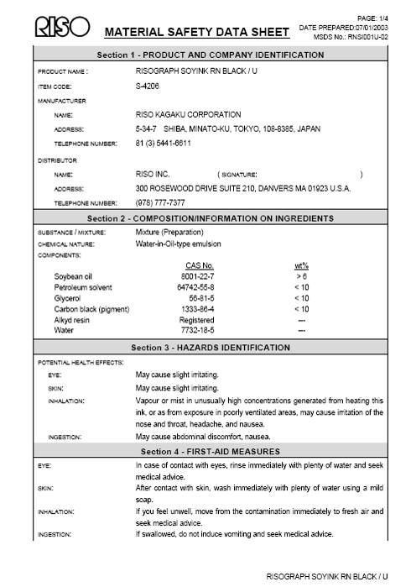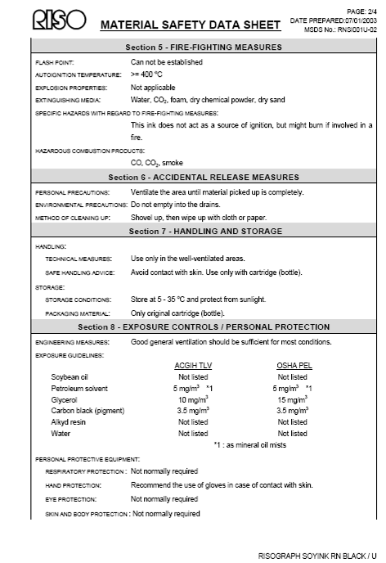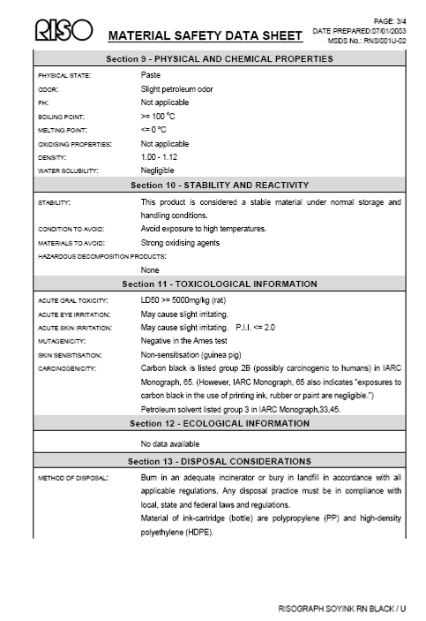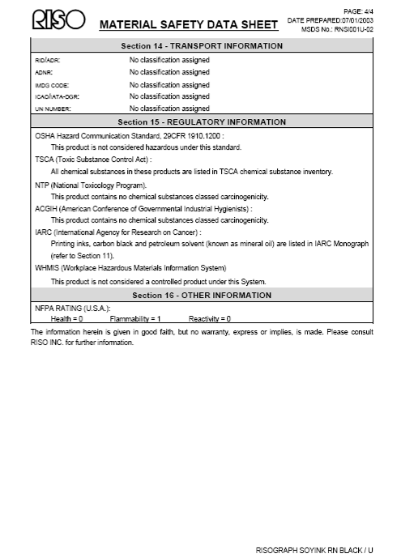

BUREAU OF ENVIRONMENTAL HEALTH
Indoor Air Quality Program

Mercury Spill Clean Up Procedure

February 2008

The Indoor Air Quality (IAQ) Program routinely receives inquiries concerning the accidental spill and clean up of small amounts of elemental mercury. Such spills are usually associated with mercury containing devices, such as thermometers, thermostats, barometers and medical equipment, such as older sphygmomanometer (blood pressure cuffs).

For cleaning, handling and disposal of broken fluorescent lights, including compact fluorescent lights, please refer to the Massachusetts Department of Environmental Protection’s (MDEP) guidelines. The MDEP has posted compact fluorescent light (CFL) information for consumers and cleanup guidance at http://mass.gov/dep/toxics/stypes/cflinfo.htm (Consumer Information CFL Bulbs) and http://mass.gov/dep/toxics/stypes/brkncfls.htm (Guidance for Cleaning up Broken CFL Bulbs) and info about recycling options at http://mass.gov/dep/toxics/stypes/cflrlocs.xls and (Municipal & Commercial Drop-Off Locations for Mercury-Added Product Recycling).

The IAQ Program recommends the following procedures to assess potential health impacts and to clean up small amounts of mercury from spills that occur in homes or other buildings.

Ventilation and Isolation
- Do Not Walk either on broken mercury-containing materials or on visible mercury.
- Do Not Use a vacuum cleaner or broom to remove or gather broken mercury-containing materials or on visible mercury.
- Close interior doors of spill areas.

How to Ventilate the Mercury Spill Location
Fan in Window
Door Closed
Spill
Airflow of Fan
Hallway

- Place a fan in the window operating in a manner to blow air directly outdoors.
- Interior doors should stay closed to prevent mercury contamination in other areas of house/building.
- Operate the fan in the spill areas for at least a day whether mercury is visible or not to ensure optimal ventilation (weather permitting).

Spill Clean up
If mercury was spilled on a hard, non-porous surface (e.g., metal, tile, plastic, etc.):
- Do not use a vacuum cleaner or broom to clean the area. Use of a vacuum cleaner can both contaminate the vacuum cleaner and spread the mercury contamination.
- Gather visible mercury together using a rigid material (e.g. squeegee, cardboard, thick paper).
- Work to gather spilled mercury beads toward a central location to form a large bead.
- Push the mercury beads into a plastic dustpan or use an eyedropper to pick up the beads.
- Tape can also pick up small mercury beads, but use caution due to problems associated with mercury adhering to tape.
- Collect all mercury into a used, wide-mouthed, plastic container with a screw-on lid.
- Optional step: Sprinkle sulfur powder (available at some lawn and garden stores) on the spill area after cleaning up the beads of mercury; a color change from yellow to brown indicates that mercury is still present and more cleanup is needed. If the sulfur powder stays yellow, this indicates clean up efforts were successful.
- After mercury is removed, clean area with soap and water. Discard bucket, sponge and rubber gloves as if mercury contaminated.
If the mercury was spilled on hardwood or other surfaces that may have crevices:
- If mercury accumulates in cracks in flooring or below floorboards, it cannot be completely removed using the methods described previously.
- Contacting an environmental remediation firm that possesses a mercury spill clean up kit may be necessary.

If the mercury was spilled on carpet or other cloth material:
- Cloth materials cannot be cleaned completely of mercury contamination and should be discarded.
- If the contaminated item is removable and disposable (throw rug, furniture cover, sheet, clothing, paper, cardboard, etc.), carefully place the contaminated material into a sealable plastic bag.
- Place the disposable container into a plastic bag that you can tie off at the top (to keep the contents inside) and transport to an outdoor trash bin right away.

Anything that has come in contact with mercury, including all clean up materials must be taken to a recycling facility or household hazardous waste program for proper disposal.

Once mercury clean up is completed, wash your hands and other parts of your body that may have come in contact with mercury.

Questions
If you have any questions concerning these guidelines, please contact:

Massachusetts Department of Public Health
Bureau of Environmental Health
Indoor Air Quality Program
250 Washington Street, 7th Floor
Boston, MA 02108

Phone: (617) 624-5757 Fax: (617) 624-5777

Document Reviewed: August 2008

The U.S. Environmental Protection Agency, National Oceanic and Atmospheric Agency, National Park Services, tribal, state, and local agencies developed the AIRNow Web site to provide the public with easy access to national air quality information. Predicted levels are calculated using a method that averages particulate levels measured over a 12-hour period average and an adjusted 4-hour average (AirNow, 2008).

