How to Login and Apply for Grants on MassGRANTS
The following guide will explain how to apply for Commonwealth grants using the MassGRANTS application portal. The guide includes instructions for:
- Creating a MassGRANTS account using your MMARS Vendor Code
- Requesting a temporary code if your organization does not have an MMARS Vendor Code
- Finding and applying for grants
- Pausing and saving an application in progress
Creating a MassGRANTS Account
- Log in to the MassGRANTS portal using the following link: https://maanfgrants.force.com/s/loginpage
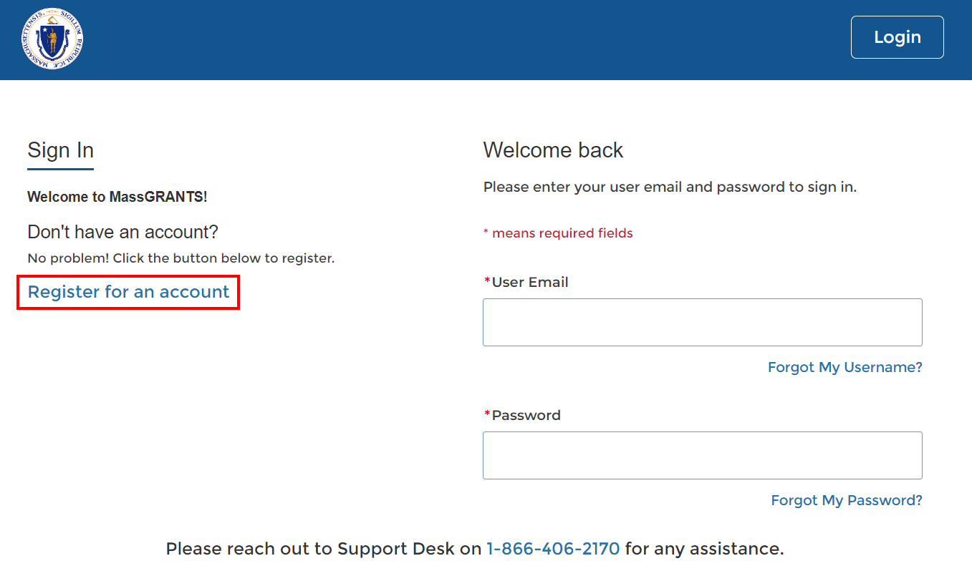
- If you do not have an account, create one by clicking “Register for an account” on the left-hand side of the page (Figure 1).

Figure SEQ Figure \* ARABIC 1: Registering for a New Account
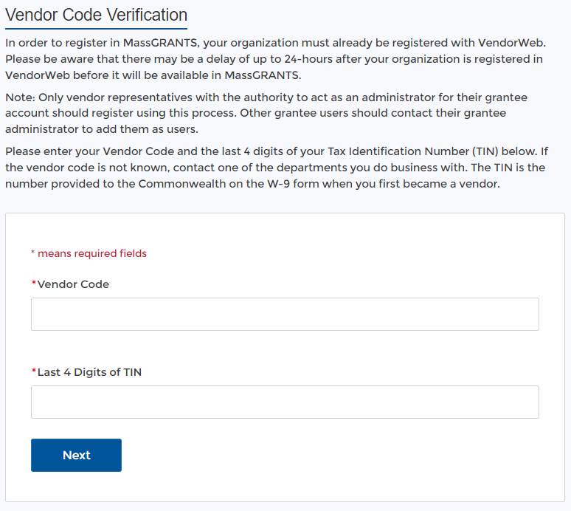
You will be prompted to provide your MMARS Vendor Code and the last four digits of your tax identification number (TIN) on the following screen (Figure 2).
Figure SEQ Figure \* ARABIC 2: Vender Code Verification
Your MMARS Vendor Code is the same code you use to log in to VendorWeb. It begins with “VC” followed by 10 digits. If you cannot remember your Vendor Code, please contact the Commonwealth agency you are currently doing business with.
If you do not have a Vendor Code, follow the instructions in the section below to get a temporary code.

Your TIN is the number the IRS uses to identify you or your organization. In most cases, that is a social security number (SSN) for individuals or an employer identification number (EIN) for organizations. An EIN is a nine-digit number with the following format: xx-xxxxxxx. You can find your TIN on tax returns, any forms filed with the IRS, or, for organizations, on your EIN Confirmation Letter.

- Enter your Vendor Code and the last four digits of your TIN and click Next to pick your username and password.
Only one account can be created using a VC and TIN. If someone has already created an account for your organization, you cannot create a new one. In that case, the system will inform you that someone has created an account and provide their email address. Ask that person to add you as an account user. Once they do, you will receive an email to set up your own login credentials for the account.

If You Do Not Have a Vendor Code
If you do not have a Vendor Code, you can use a temporary code to create an account and submit your application. However, if your grant is chosen for funding, your organization will need to have an active MMARS account and Vendor Code to receive program funds.
You can request a temporary code by emailing MassGrantsSupport@mtxb2b.com. You will need to provide the following:
- Your organization’s legal name and business address
- A completed W9 form
- The name, email, and phone number of the primary contact on your application
Once you have received your temporary code, complete the steps listed above to create your MassGRANTS account.
Finding and Applying for a Grant
- After you log in, select the Grants Management tab on the left-hand navigation bar (Figure 3).
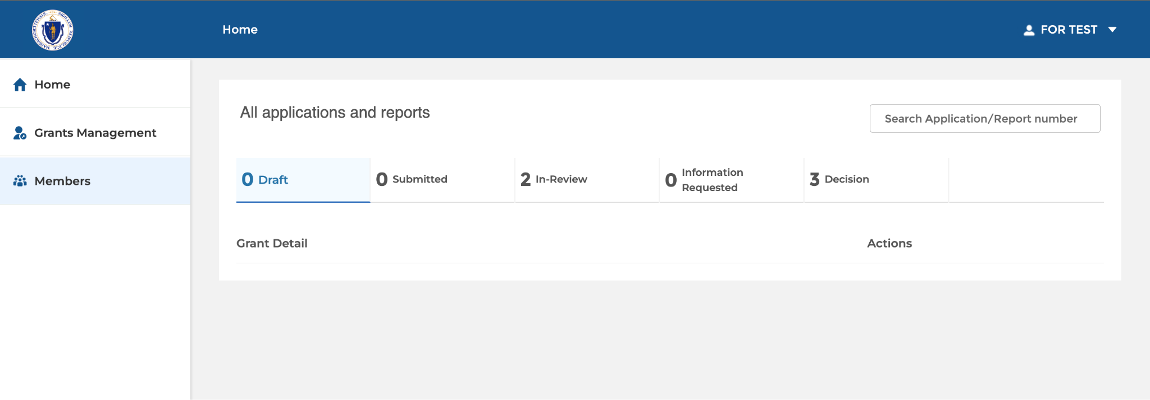
Figure 3

- Search for the grant you wish to apply for using the search bar in the upper right corner (Figure 4).

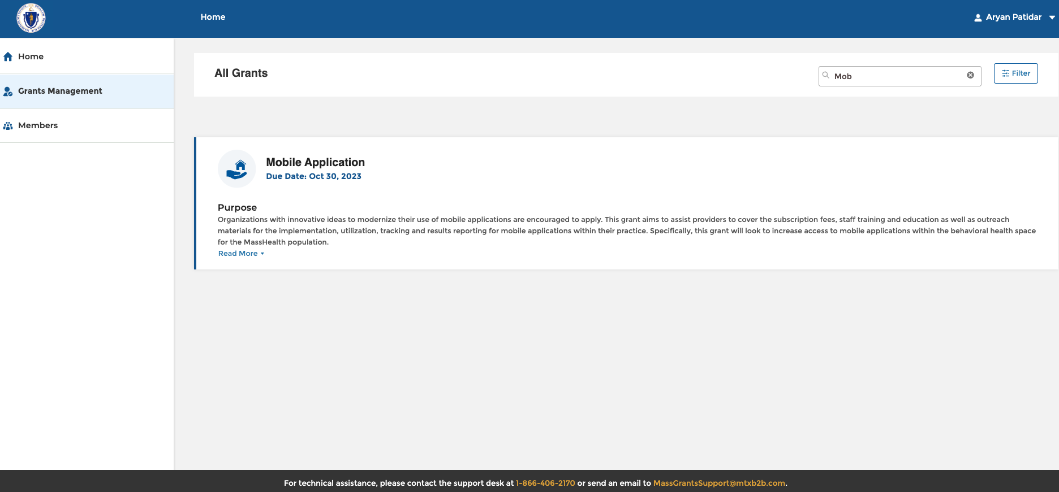
Figure 4

- Click on the title of the grant program you wish to apply for in the list of search results.
- On the next screen, click “Apply” in the upper-right corner to begin your application (Figure 5).

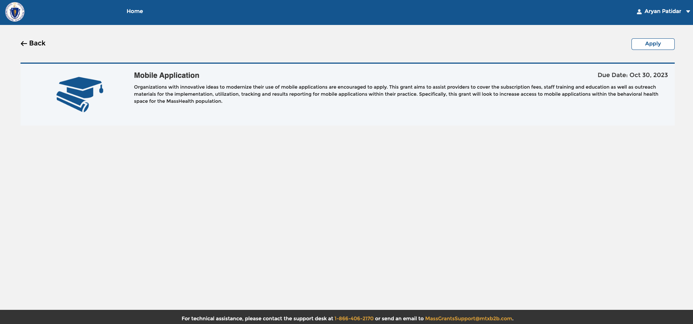
Figure 5

- Fill in the appropriate information and click Submit when you finish your application.

Pausing and Saving an Application in Progress
- At any point, you can pause and save an application in progress by clicking the Home button in the upper-left corner (Figure 6). This will automatically save your progress and return you to the MassGRANTS home page.

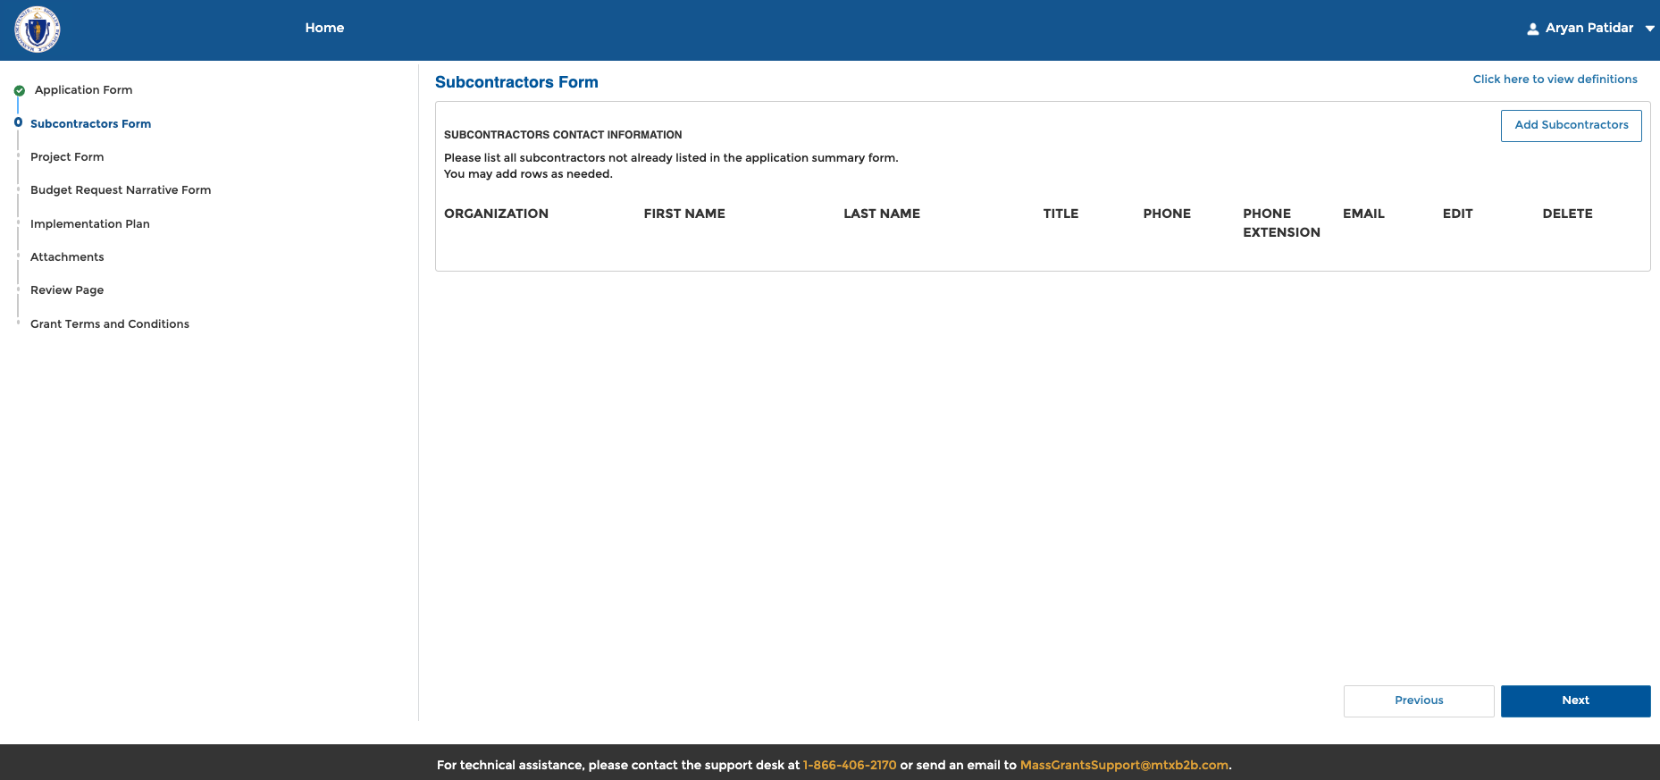
Figure 6

- When you are ready, or the next time you log in, you can resume any application by navigating to the Home tab, selecting the Draft section, and clicking Resume on the relevant application (Figure 7).

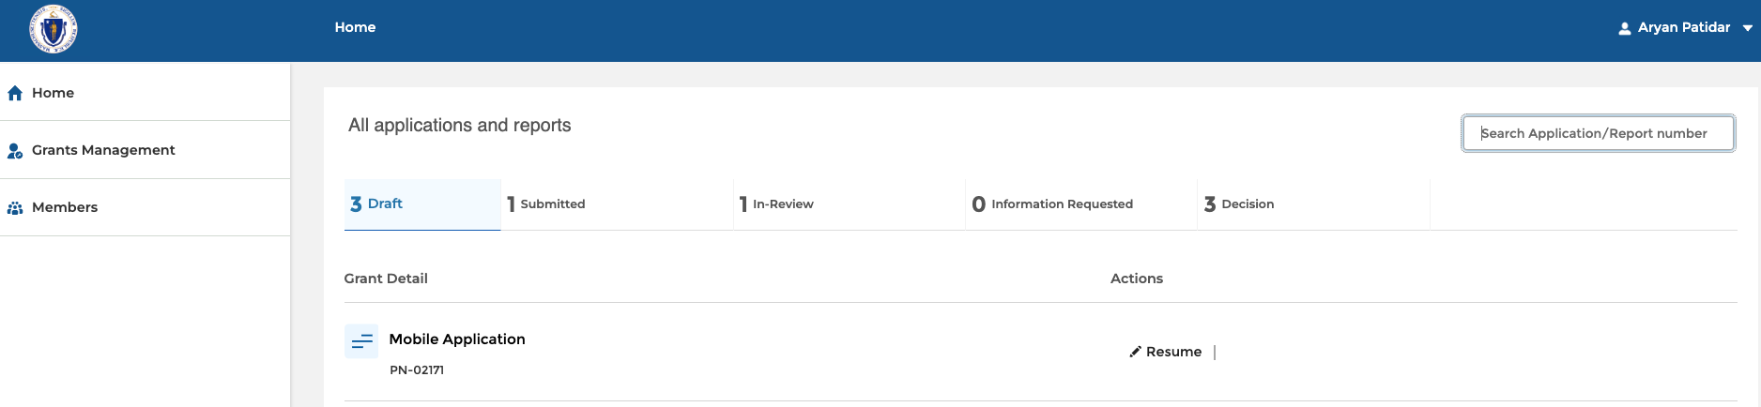
Figure 7

