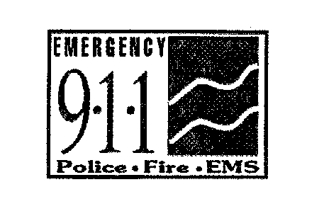

The Commonwealth of Massachusetts

EXECUTIVE OFFICE OF PUBLIC SAFETY AND SECURITY

**State 911 DEPARTMENT**

*151 Campanelli Drive, Suite A, Middleborough, MA 02346*

*Tel: 508-828-2911 ~ TTY: 508-947-1455*

*www.mass.gov/e911*

**Charles D. Baker Thomas A. Turco, III**

*Governor Secretary*

**Karyn E. Polito Frank Pozniak**

*Lieutenant Governor Executive Director*

**Agenda**

**State 911 Department**

**FY 2022 Regional Development Grant Workshop**

**Wednesday, February 10, 2021 10:30 a.m**.

**(via Virtual Teams Meeting)**

[Click here to join the meeting](https://teams.microsoft.com/l/meetup-join/19%3ameeting_MjZiNmIxOTYtODFkNi00N2NlLTk3ZTAtYTY2Y2NiMzk1NDJh%40thread.v2/0?context=%7b%22Tid%22%3a%223e861d16-48b7-4a0e-9806-8c04d81b7b2a%22%2c%22Oid%22%3a%22e1e827cb-895d-4b37-a316-d2caba7fb9ae%22%7d)

***We encourage you to join the meeting using the Teams***

***Application through the link listed above. If you do not***

***have access to Teams, please join via phone:***

***+1 857-327-9245 Conference ID: 827 784 464#***

* Introductions
* Overview of the grant
* What’s New
* Application/Considerations
* Radio Projects
* Key dates and information
* Questions and Answers