A Great Career Opportunity with
Benefits, Training & Career Advancement!

Become A Personal Care Attendant (PCA)
The Personal Care Attendant (PCA) program is delivered by MassHealth. MassHealth pays consumer- employers (individuals with physical, intellectual, or developmental disabilities) to hire PCAs to assist with activities of daily living:

- Meal preparation and feeding
- Housekeeping and shopping
- Help with ambulation and transfers
- Support with walking
- Help with toileting
- Help with bathing and dressing

Requirements
- PCAs must be legally able to work in the United States
- PCAs must be able to understand and carry out instructions from the consumer- employer
- New PCAs must complete a New Hire Orientation training within nine (9) months of their hire date
- See other requirements in MassHealth regulation at 130 CMR 422.000

Career Advancement
On the first day of the second year of employment, PCAs become eligible for:
- College tuition vouchers (eight credits free per year) in credit-bearing or degree programs in the information technology, health care or education fields
- Certified Nurse Aid (CNA) Program includes the course fee, certification test and uniform

Benefits
- Hourly wage of $19.00
- Paid family medical leave
- Earn up to 50 hours of paid time off
- Unemployment eligibility

Free Training
- After your first day of PCA employment you can register for several multi-session courses and one-day workshops!

Get started today!
- More information is available at www.MADirectCare.com.
- Create a worker profile at www.MassPCADirectory.org.
- Connect online with people who want to hire a PCA. Potential consumer-employers will learn about your work preferences, qualifications, skills, and training.

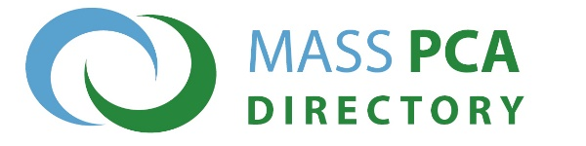
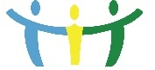PCA Quality Home Care Workforce Council
pcacouncil@mass.gov | www.mass.gov/pca

