INDOOR AIR QUALITY ASSESSMENT

Greater Lowell Technical High School
250 Pawtucket Boulevard
Tyngsborough, Massachusetts

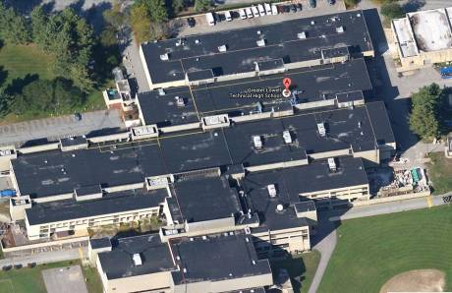

Prepared by:
Massachusetts Department of Public Health
Bureau of Environmental Health
Indoor Air Quality Program
September 2014

Background/Introduction
In response to a request from Roger Bourgeois, Superintendent-Director, Greater Lowell Technical High School, the Massachusetts Department of Public Health (MDPH), Bureau of Environmental Health (BEH) provided assistance and consultation regarding indoor air quality (IAQ) at the Greater Lowell Vocational Technical High School (GLT) located at 250 Pawtucket Boulevard, Tyngsborough, Massachusetts. The request was prompted by GLT staff concerns regarding impacts of ongoing construction in the school over the summer. On August 8, 2014, the GLT was visited by Ruth Alfasso, Environmental Engineer/Inspector in BEH’s IAQ Program to conduct an IAQ assessment. BEH/IAQ staff were accompanied during the assessment by Superintendent Bourgeois, Garry Pharris of the Massachusetts Department of Labor Standards (DLS) and members of the construction team. At the completion of the assessment, BEH/IAQ staff provided verbal recommendations to improve on methods for separating construction areas from occupied areas. These recommendations are detailed later in the report.
The GLT is a multi-story building that was built in the 1970s, with atrium areas and skylights, composed primarily of concrete and metal. The building has a flat roof that has reportedly undergone recent repairs. The building houses numerous classrooms, offices, laboratories, shop areas, kitchens, cafeterias, a gymnasium and other rooms. Most windows in the building are not openable.
Over this summer and the next, the school is and will continue to undergo extensive construction and remodeling, which includes the addition of a large all-school cafeteria, removal of a wood block floor from the main hallways/atrium areas, replacing the gymnasium ventilation and flooring, other heating, ventilation and air conditioning (HVAC) upgrades, and asbestos abatement. While the bulk of the construction work will be occurring while school is not in session (e.g., summer and Christmas breaks), isolated areas of construction, including converting the old cafeterias into laboratory space and renovation of bathrooms will be occurring while school is in session and occupied.
It is important to note that in 2010, the Massachusetts School Building Authority (MSBA) amended their regulations 963 CMR 2.04 to address concerns associated with school renovation projects in Massachusetts. The regulations specifically state that “[e]ligible Applicants shall implement containment procedures for dusts, gases, fumes, and other pollutants created during construction of an Approved Project if the building is occupied by students, teachers or school department staff while such renovation and construction is occurring. Such containment procedures shall be consistent with the “IAQ Guidelines for Occupied Buildings Under Construction” published by the Sheet Metal and Air Conditioning Contractors National Association, Inc. (SMACNA), in effect at time of project approval. All bids and proposals received for an Approved Project shall include the cost of planning and execution of containment of construction/renovation pollutants consistent with such SMACNA guidelines” (MSBA, 2010).

Methods
Air tests for carbon monoxide, carbon dioxide, temperature and relative humidity were conducted with the TSI, Q-Trak, IAQ Monitor, Model 7565. Air tests for airborne particle matter with a diameter less than 2.5 micrometers were taken with the TSI, DUSTTRAK™ Aerosol Monitor Model 8520. Air tests for total volatile organic compounds (TVOC) were conducted using a MiniRAE 2000 photoionization detector. BEH/IAQ staff also examined containment barriers to help improve separation between occupied areas and areas under construction.

Results
The GLT was not in session on the day of the assessment, but approximately 25 staff were working at the time. Test results appear in Table 1.

Discussion

Ventilation
It can be seen from Table 1 that carbon dioxide levels were below 800 parts per million (ppm) in all but one of the 16 areas tested, indicating adequate air exchange in occupied areas of the building at the time of the assessment. Mechanical ventilation is provided by a combination of rooftop air-handling units (AHUs) and univents, both of which provide heating and cooling. Fresh air in areas supplied by rooftop units is ducted to supply diffusers (Picture 1). Return air in these areas is drawn into ceiling-mounted vents (Picture 2) and ducted back to AHUs. Areas along the outside wall of the building are served by univents (Picture 3), which are designed to draw air from outdoors through a fresh air intake located on the exterior wall of the building. Return air is drawn through an air intake located at the base of each unit where fresh and return air are mixed, filtered, heated or cooled and provided to classrooms through an air diffuser located in the top of the unit (Figure 1).
Some areas were additionally served by portable ducted or ductless air conditioning units (Picture 4) on the day of the assessment due to portions of the HVAC system being deactivated for construction; some of these units supplied fresh air while others were did not have the capacity to do so. MDPH recommends that HVAC systems be separated and/or turned off when construction is occurring in a building to prevent entrainment and distribution of construction-related pollutants into occupied areas. This had reportedly been done during construction; in some areas, it was observed that overhead supply vents were not operational, as they had been deliberately turned off.
Employees present during the renovations were mostly administrative staff. Many of these staff had been relocated to a variety of areas because of construction, including existing offices such as the superintendent’s suite, classrooms, and areas normally used for kitchens and other activities. This provides challenges for supplying fresh air to occupants, however given the overall low number of employees present during the construction, supply ventilation appeared to be adequate.
To maximize air exchange, the MDPH recommends that both supply and exhaust ventilation operate continuously during periods of occupancy. In order to have proper ventilation with a mechanical supply and exhaust system, the systems must be balanced to provide an adequate amount of fresh air to the interior of a room while removing stale air from the room. It is recommended that HVAC systems be re-balanced every five years to ensure adequate air systems function (SMACNA, 1994). Balancing of the HVAC system is reportedly planned for this building once the HVAC system is back on line.
Minimum design ventilation rates are mandated by the Massachusetts State Building Code (MSBC). Until 2011, the minimum ventilation rate in Massachusetts was higher for both occupied office spaces and general classrooms, with similar requirements for other occupied spaces (BOCA, 1993). The current version of the MSBC, promulgated in 2011 by the State Board of Building Regulations and Standards (SBBRS), adopted the 2009 International Mechanical Code (IMC) to set minimum ventilation rates. Please note that the MSBC is a minimum standard that is not health-based. At lower rates of cubic feet per minute (cfm) per occupant of fresh air, carbon dioxide levels would be expected to rise significantly. A ventilation rate of 20 cfm per occupant of fresh air provides optimal air exchange resulting in carbon dioxide levels at or below 800 ppm in the indoor environment in each area measured. MDPH recommends that carbon dioxide levels be maintained at 800 ppm or below. This is because most environmental and occupational health scientists involved with research on IAQ and health effects have documented significant increases in indoor air quality complaints and/or health effects when carbon dioxide levels rise above the MDPH guidelines of 800 ppm for schools, office buildings and other occupied spaces (Sundell et al., 2011). The ventilation must be on at all times that the room is occupied. Providing adequate fresh air ventilation with open windows and maintaining the temperature in the comfort range during the cold weather season is impractical. Mechanical ventilation is usually required to provide adequate fresh air ventilation.
Carbon dioxide is not a problem in and of itself. It is used as an indicator of the adequacy of the fresh air ventilation. As carbon dioxide levels rise, it indicates that the ventilating system is malfunctioning or the design occupancy of the room is being exceeded. When this happens, a buildup of common indoor air pollutants can occur, leading to discomfort or health complaints. The Occupational Safety and Health Administration (OSHA) standard for carbon dioxide is 5,000 parts per million parts of air (ppm). Workers may be exposed to this level for 40 hours/week, based on a time-weighted average (OSHA, 1997).
The MDPH uses a guideline of 800 ppm for publicly occupied buildings. A guideline of 600 ppm or less is preferred in schools due to the fact that the majority of occupants are young and considered to be a more sensitive population in the evaluation of environmental health status. Inadequate ventilation and/or elevated temperatures are major causes of complaints such as respiratory, eye, nose and throat irritation, lethargy and headaches. For more information concerning carbon dioxide, please see Appendix A.
Temperature readings during the assessment ranged from 74ºF to 78ºF, which were within the MDPH recommended comfort guidelines (Table 1). The MDPH recommends that indoor air temperatures be maintained in a range of 70ºF to 78ºF in order to provide for the comfort of building occupants. In many cases concerning indoor air quality, fluctuations of temperature in occupied spaces are typically experienced, even in a building with an adequate fresh air supply.
The relative humidity measured during the assessment ranged from 37 to 58 percent (Table 1), which was within or slightly below the MDPH recommended comfort range. The MDPH recommends a comfort range of 40 to 60 percent for indoor air relative humidity. Relative humidity levels in the building would be expected to drop during the winter months due to heating. The sensation of dryness and irritation is common in a low relative humidity environment. Low relative humidity is a very common problem during the heating season in the northeast part of the United States.

Construction/Renovations
Renovation activities can produce a number of pollutants, including dirt, dust, particulate matter, and combustion products such as carbon monoxide from construction equipment. Materials generated from construction activities can settle on horizontal surfaces. Dusts can be irritating to the eyes, nose and respiratory tract. BEH/IAQ staff recommended that higher efficiency filters be installed in classroom univents during construction and that these filters, as well as filters on the rooftop HVAC units, be changed prior to the beginning of the regular school year.
Note that because of the layout of the school, with open atrium/hallways (Picture 5), open stairwells and the distribution of staff in areas throughout the building rather than in one single area, containment between areas of construction and areas occupied by staff was incomplete. Staff were reportedly moved away from the most active and disruptive activities, including floor-removal activities in the main hallway, which are discussed further under the Total Volatile Organic Compounds section below. Areas specifically under renovation that included asbestos remediation were subject to the enclosures and other activities required by asbestos remediation regulations, as overseen by the DLS.

IAQ Evaluations/Air Testing
The primary purpose of air testing at the school was to identify and reduce/prevent pollutant pathways. Air monitoring was conducted in areas that were currently occupied by staff working in the school. Please note, air measurements are only reflective of the indoor air concentrations present at the time of testing.
Indoor air quality can be negatively influenced by the presence of respiratory irritants, such as products of combustion. The process of combustion produces a number of pollutants. Common combustion emissions include carbon monoxide, carbon dioxide, water vapor and smoke (fine airborne particle material). Of these materials, exposure to carbon monoxide and particulate matter with a diameter of 2.5 micrometers (μm) or less (PM2.5) can produce immediate, acute health effects upon exposure. To determine whether combustion products (e.g., construction equipment/vehicle exhausts) were present in the indoor environment, BEH/IAQ staff obtained measurements for carbon monoxide and PM2.5.

Carbon Monoxide
Carbon monoxide is a by-product of incomplete combustion of organic matter (e.g., gasoline, wood and tobacco). Exposure to carbon monoxide can produce immediate and acute health effects. Several air quality standards have been established to address carbon monoxide and prevent symptoms from exposure to these substances. The MDPH established a corrective action level concerning carbon monoxide in ice skating rinks that use fossil-fueled ice resurfacing equipment. If an operator of an indoor ice rink measures a carbon monoxide level over 30 ppm, taken 20 minutes after resurfacing within a rink, that operator must take actions to reduce carbon monoxide levels (MDPH, 1997).
The American Society of Heating Refrigeration and Air-Conditioning Engineers (ASHRAE) has adopted the National Ambient Air Quality Standards (NAAQS) as one set of criteria for assessing indoor air quality and monitoring of fresh air introduced by heating, ventilating and air conditioning (HVAC) systems (ASHRAE, 1989). The NAAQS are standards established by the US EPA to protect the public health from six criteria pollutants, including carbon monoxide and particulate matter (US EPA, 2006). As recommended by ASHRAE, pollutant levels of fresh air introduced to a building should not exceed the NAAQS levels (ASHRAE, 1989). The NAAQS were adopted by reference in the Building Officials & Code Administrators (BOCA) National Mechanical Code of 1993 (BOCA, 1993), which is now an HVAC standard included in the Massachusetts State Building Code (SBBRS, 2011). According to the NAAQS, carbon monoxide levels in outdoor air should not exceed 9 ppm in an eight-hour average (US EPA, 2006).
Carbon monoxide should not be present in a typical, indoor environment. If it is present, indoor carbon monoxide levels should be less than or equal to outdoor levels. Outdoor carbon monoxide concentrations were non-detect (ND) at the time of the assessment (Tables 1). No measurable levels of carbon monoxide were detected inside the building during the assessment (Table 1).

Particulate Matter
The US EPA has established NAAQS limits for exposure to particulate matter. Particulate matter includes airborne solids that can be irritating to the eyes, nose and throat. The NAAQS originally established exposure limits to PM with a diameter of 10 μm or less (PM10). In 1997, US EPA established a more protective standard for fine airborne particulate matter with a diameter of 2.5 μm or less (PM2.5). The NAAQS has subsequently been revised, and PM2.5 levels were reduced. This more stringent PM2.5 standard requires outdoor air particle levels be maintained below 35 μg/m³ over a 24-hour average (US EPA, 2006). Although both the ASHRAE standard and BOCA Code adopted the PM10 standard for evaluating air quality, MDPH uses the more protective PM2.5 standard for evaluating airborne PM concentrations in the indoor environment.
Outdoor PM2.5 concentrations the day of the assessment ranged from 5 to 18 μg/m³. PM2.5 levels measured inside the building ranged from 4 to 100 μg/m³ (Table 1). Of the 19 areas tested, three were above the NAAQS PM2.5 level of 35 μg/m³. In all three of these instances, it was observed that doors were open between areas occupied by staff and where construction-related activities were taking place (Picture 6). During the assessment, staff were advised to keep interior doors closed between areas of active construction and areas occupied by staff. In some areas, this may be difficult as some of the occupied rooms had no mechanical ventilation (e.g., room 1341), which may lead to increased levels of carbon dioxide when doors are kept shut. BEH/IAQ staff also recommended increased cleaning in occupied areas during construction to keep levels of particulates down.
Additionally, note that indoor air levels of particulates (including PM2.5) can be at higher levels than those measured outdoors. A number of mechanical devices and/or activities that occur indoors can generate particulate matter during normal operations. Sources of indoor airborne particulates may include but are not limited to particles generated during the operation of fan belts in the HVAC system, use of stoves and/or microwave ovens in kitchen areas; use of photocopiers, fax machines and computer printing devices; operation of an ordinary vacuum cleaner and heavy foot traffic indoors.

Volatile Organic Compounds
Indoor air concentrations can be greatly impacted by the use of products containing volatile organic compounds (VOCs). VOCs are carbon-containing substances that have the ability to evaporate at room temperature. Frequently, exposure to low levels of total VOCs (TVOCs) may produce eye, nose, throat and/or respiratory irritation in some sensitive individuals. For example, chemicals evaporating from a paint can stored at room temperature would most likely contain VOCs.
In an effort to determine whether VOCs originating from construction/renovation activities were migrating into occupied areas of the building, air monitoring for TVOCs was conducted. An outdoor air sample was taken for comparison. Outdoor TVOC concentrations were ND. Levels of TVOC in the building ranged from 0.3 to 4 ppm (Table 1). Levels of TVOC less than 1 ppm are typically considered within the range of background concentrations and all occupied areas had levels less than 1 ppm on the day of the assessment. One likely source of TVOCs in the building on the day of the assessment was off-gassing from the floor in the hallway and atrium (“mall”) section of the first floor of the building. This floor was originally constructed of a layer of creosote with wooden blocks set into it, cross-grain-side up (Picture 7), which was then covered with several topcoat layers. Part of the renovation included removing the wood blocks and covering the base layer with several inches of poured concrete (Picture 5). During the process of removal of the wood, layers of creosote were exposed, leading to odors.
Creosote is composed of a mixture of hydrocarbons (ATSDR, 2002) and can have a strong odor even at low concentrations, mostly due to the presence of naphthalene, which has an odor threshold significantly below 1 ppm (ATSDR, 2005). Reportedly, ever since the building was constructed, occupants would detect creosote odors in this area upon entering the building. The pouring of several inches of concrete on top of the remaining creosote is expected to reduce or eliminate these odors. TVOC measurements in the hallway above the area where this floor is under remodeling were between 2 and 4 ppm (Table 1) and an odor of creosote was detected in this area. BEH/IAQ staff recommended that ventilation be increased throughout the open hallway/atrium as much as possible during unoccupied periods (e.g., nights and weekends) using open doors and fans to remove lingering odors. Since odors can also linger on surfaces, washing/cleaning of surfaces, including walls may also be helpful in removing these odors from the building. Due to construction activities on flooring, occupants had been moved to the unaffected wing of the building prior to the start of the flooring removal/refinishing to reduce exposure to nuisance odors.
Other sources of TVOCs are or may also be present, including:
- Hand sanitizer: hand sanitizers may contain ethyl alcohol and/or isopropyl alcohol, which are highly volatile and may be irritating to the eyes and nose. Sanitizing products may also contain fragrances to which some people may be sensitive.
- Photocopiers: photocopiers can be sources of pollutants such as VOCs, ozone, heat and odors, particularly if the equipment is older and in frequent use. Both VOCs and ozone are respiratory irritants (Schmidt Etkin, 1992). Photocopiers should be kept in well ventilated rooms, and should be located near windows or exhaust vents.
- Paints/finishes used for renovation/construction.
On the day of the assessment, it was also observed that the wood platform for a new gymnasium floor was in the process of being constructed (Picture 8). The finishing of the gym floor would include the use of a coating containing polyurethane. These coatings give off TVOCs and odors when they are applied and until they are cured. At the time of the visit, BEH/IAQ staff recommended that staff should not be in the area of the gymnasium when the coating was applied, and that preferably the coatings should be applied after hours on weekends or during otherwise unoccupied times. BEH/IAQ staff further advised that the area should be isolated and generously ventilated to the outdoors using fans to keep the area under negative pressure to avoid the odors getting into occupied spaces until the coatings are completely cured.

Conclusions/Recommendations
In view of the findings, the following recommendations were made at the time of the visit and are reiterated below:
- Continue to relocate staff away from areas of active construction until the project has wound down and regular operation of the school resumes.
- Ensure that all doors remain closed between occupied areas and areas of construction. Whenever possible, install barriers including taped plastic sheeting and possibly more permanent installations, isolating areas where construction is taking place from areas that are occupied. These barriers should be maintained in good condition at all times, and should be regularly monitored for integrity, with a logbook kept of observations of the containment. These actions should be taken while any construction is taking place during the occupied periods at the school, and particularly when students have returned.
- Ventilate the hallway/atrium areas to the greatest extent possible to remove lingering odors and TVOCs from creosote flooring. Consider washing all surfaces (e.g., walls) with a mild detergent to remove odorous material that may have deposited there over time.
- Ensure that the gymnasium area is well ventilated and completely separated from the rest of the building when the polyurethane flooring is being applied and while it cures. Ensure that all ventilation systems to the gym that may have recirculation be turned off and covered. Use fans and open doors/windows to create a negative pressure in the gym as compared to the rest of the building to prevent migration of odors. Perform as much of this work off-hours (evenings and weekends) as possible.
- Use the guidance “Methods Used to Reduce/Prevent Exposure to Construction/Renovation Generated Pollutants in Occupied Buildings” which is included here as Appendix B during all construction in the building, including during the school year.
- Clean all surfaces, including carpeting, floors and desks, regularly in areas of construction. Thoroughly clean all occupied areas of the school prior to reopening.
- Consider changing filters for univents and rooftop AHUs prior to the beginning of school.
- For buildings in New England, periods of low relative humidity during the winter are often unavoidable. Therefore, scrupulous cleaning practices should be adopted to minimize common indoor air contaminants whose irritant effects can be enhanced when the relative humidity is low. To control for dusts, a high efficiency particulate arrestance (HEPA) filter equipped vacuum cleaner in conjunction with wet wiping of all surfaces is recommended. Avoid the use of feather dusters. Drinking water during the day can help ease some symptoms associated with a dry environment (throat and sinus irritations).
- The BEH/IAQ program can return on request during the school year to assess general IAQ conditions at the school and offer additional recommendations regarding the ongoing construction project.
- Refer to resource manuals and other related indoor air quality documents for further building-wide evaluations and advice on maintaining public buildings. Copies of these materials are located on the MDPH’s website: http://mass.gov/dph/iaq.

References
ASHRAE. 1989. Ventilation for Acceptable Indoor Air Quality. American Society of Heating, Refrigeration and Air Conditioning Engineers. ANSI/ASHRAE 62-1989.
ATSDR. 2002. Toxicological Profile for Wood Creosote, Coal Tar Creosote, Coal Tar, Coal Tar Pitch, And Coal Tar Pitch Volatiles. Agency for Toxic Substances and Disease Registry, Atlanta, GA. September 2002.
ATSDR. 2005. Public Health Statement for Naphthalene, 1-Methylnaphthalene, and 2-Methylnaphthalene. Agency for Toxic Substances and Disease Registry, Atlanta, GA. August 2005. (http://www.atsdr.cdc.gov/phs/phs.asp?id=238&tid=43).
BOCA. 1993. The BOCA National Mechanical Code/1993. 8th ed. Building Officials & Code Administrators International, Inc., Country Club Hills, IL.
MDPH. 1997. Requirements to Maintain Air Quality in Indoor Skating Rinks (State Sanitary Code, Chapter XI). 105 CMR 675.000. Massachusetts Department of Public Health, Boston, MA.
MSBA. 2010. Massachusetts School Building Authority’s Regulations, 963 CMR 2.04(2) (2) Design and Construction Standards: Indoor Air Quality. Page 11. Promulgated 4/16/10. http://www.massschoolbuildings.org/sites/default/files/edit-contentfile/Guidelines_Forms/Statutes_Regulations/MSBA_Regs_program_04_16_10.pdf.
OSHA. 1997. Limits for Air Contaminants. Occupational Safety and Health Administration. Code of Federal Regulations. 29 C.F.R 1910.1000 Table Z-1-A.
SBBRS. 2011. Mechanical Ventilation. State Board of Building Regulations and Standards. Code of Massachusetts Regulations, 8th edition. 780 CMR 1209.0.
Schmidt Etkin, D. 1992. Office Furnishings/Equipment & IAQ Health Impacts, Prevention & Mitigation. Cutter Information Corporation, Indoor Air Quality Update, Arlington, MA.
SMACNA. 1994. HVAC Systems Commissioning Manual. 1st ed. Sheet Metal and Air Conditioning Contractors’ National Association, Inc., Chantilly, VA.
Sundell. 2011. Sundell, J., H. Levin, W. W. Nazaroff, W. S. Cain, W. J. Fisk, D. T. Grimsrud, F. Gyntelberg, Y. Li, A. K. Persily, A. C. Pickering, J. M. Samet, J. D. Spengler, S. T. Taylor, and C. J. Weschler. Ventilation rates and health: multidisciplinary review of the scientific literature. Indoor Air, Volume 21: pp 191–204.
US EPA. 2006. National Ambient Air Quality Standards (NAAQS). US Environmental Protection Agency, Office of Air Quality Planning and Standards, Washington, DC. http://www.epa.gov/air/criteria.html.
Picture 1

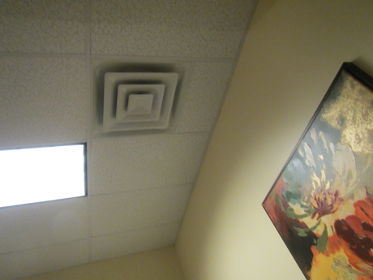

Supply vent from rooftop AHU

Picture 2

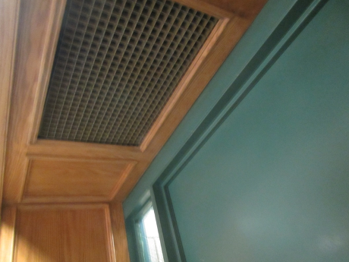

Return vent inside superintendent’s suite
Picture 3

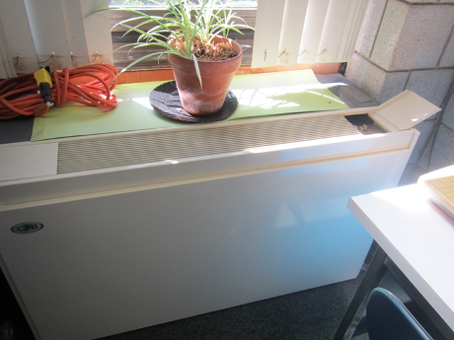

Typical univent, note plant on top

Picture 4

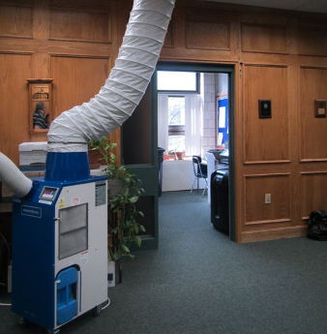

Portable air conditioner
Picture 5

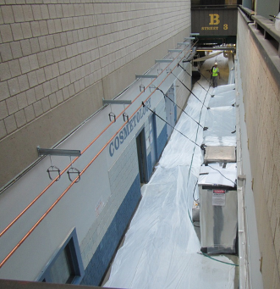

Open hallway from second floor balcony area; note hallway concrete has been poured and covered with plastic to aid curing

Picture 6

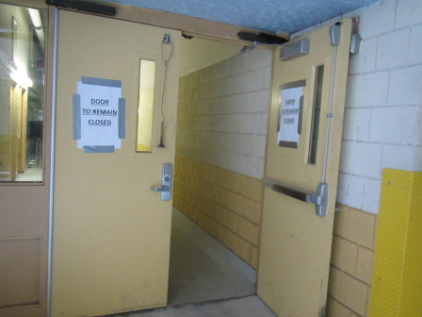

Door with sign found open during the assessment
Picture 7

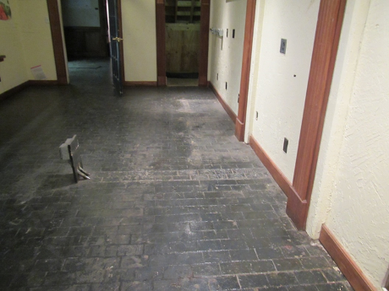

Original first-floor flooring, wood block over creosote

Picture 8

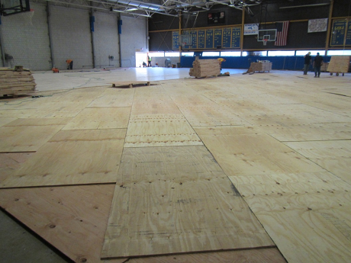

New gym floor under construction
Location | Carbon  Dioxide  (ppm) | Carbon Monoxide  (ppm) | Temp  (°F) | Relative  Humidity  (%) | PM2.5  (µg/m³) | TVOC  (ppm) | Occupants  in Room | Windows  Openable | Ventilation |  | Remarks
 |  |  |  |  |  |  |  |  | Supply | Exhaust | Remarks
Background | 400 | ND | 71 | 57 | 5-18 | ND |  |  |  |  | Sunny
Library | 386 | ND | 76 | 56 | 13 | 0.3 | 0 | N | Y | Y | Plants
Discipline Office | 409 | ND | 75 | 53 | 60 | 0.3 | 1 | N | Y | Y
Assistant Program Director | 400 | ND | 75 | 54 | 8 | 0.3 | 1 | N | Y | Y | Door open to outside
Restaurant Area (Business Office) | 371 | ND | 75 | 58 | 27 | 0.3 | 0 | N | Y | Y
Administration Office | 724 | ND | 76 | 37 | 14 | 0.7 | 0 | N | Y | Y
Superintendent | 624 | ND | 74 | 45 | 9 | 0.5 | 0 | N | Y | Y | Plants and papers
HR | 445 | ND | 76 | 45 | 11 | 0.3 | 1 | N | Y | Y | Items, supply vent on, WD CT
Academic Chair of English | 523 | ND | 75 | 50 | 18 | 0.3 | 0 | N | Y | Y | HS, part carpeted
Construction Cluster | 930 | ND | 76 | 55 | 100 | 0.3 | 0 | N | Y | N | Transom
2nd Floor Hallway |  |  |  |  |  | 2-5 |  |  |  |  | Above the area where flooring had been removed, not occupied
2nd Floor Classroom | 461 | ND | 75 | 51 | 15 | 0.3 | 2 | N | Y | Y | WD CT, HS
1341 LPN | 467 | ND | 75 | 56 | 84 | 0.5 | 1 | N | N | N | PF, DO, transom
2285 | 518 | ND | 75 | 51 | 4 | ND | 1 | N | Y | Y | Carpet, plants
2289 | 459 | ND | 76 | 53 | 9 | ND | 2 | N | Y | Y | PC
2293 | 447 | ND | 75 | 52 | 21 | 0.3 | 3 | N | Y | Y | Carpet, WD CT
2295 | 444 | ND | 75 | 50 | 22 | 0.3 | 0 | N | Y | Y | Carpet
3160 | 448 | ND | 78 | 43 | 2-9 | 0.3 | 0 | N | Y | Y | UV on
3260 Testing |  | ND | 77 | 48 | 7-22 | 0.3-0.5 | 0 | Y | Y | Y | UV on

