INDOOR AIR QUALITY ASSESSMENT

Greater Lowell Technical High School
250 Pawtucket Boulevard
Tyngsborough, Massachusetts

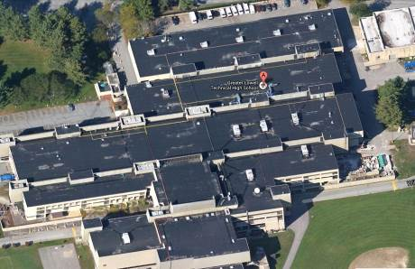

Prepared by:
Massachusetts Department of Public Health
Bureau of Environmental Health
Indoor Air Quality Program
November 2014

Background/Introduction
In response to a request from Roger Bourgeois, Superintendent-Director, Greater Lowell Technical High School, the Massachusetts Department of Public Health (MDPH), Bureau of Environmental Health (BEH) provided assistance and consultation regarding indoor air quality (IAQ) at the Greater Lowell Vocational Technical High School (GLT) located at 250 Pawtucket Boulevard, Tyngsborough, Massachusetts. The request was prompted by concerns regarding impacts on IAQ during ongoing construction/renovations in the school as well as general IAQ concerns in both classrooms and vocational/shop areas. On September 25, 2014, the GLT was visited by Ruth Alfasso, Environmental Engineer/Inspector in BEH’s IAQ Program, and Kathleen Gilmore and Jason Dustin, Environmental Analysts/Inspectors in the BEH’s IAQ Program to conduct an IAQ assessment. During the September 25, 2014 visit, general classroom and administrative areas were primarily visited. On October 7, 2014, BEH/IAQ staff returned to the building to conduct an assessment in vocational/shop areas. Ruth Alfasso, Environmental Engineer/Inspector in BEH’s IAQ Program and Michael Feeney, Director of BEH’s IAQ Program conducted this portion of the assessment.
Previously, on August 8, 2014, BEH/IAQ staff visited the GLT to conduct an IAQ assessment to identify procedures to reduce/prevent pollutant pathways from migrating from construction areas into occupied areas while the school was undergoing extensive construction and renovations. Recommendations were made at that time and are detailed in a separate report (MDPH, 2014).
The GLT is a multi-story building that was built in the 1970s, with atrium areas and skylights, composed primarily of concrete and metal. The building has a flat roof that has reportedly undergone recent repairs. The building houses numerous classrooms, offices, laboratories, shop areas, kitchens, cafeterias, a gymnasium, a swimming pool and other rooms. Most windows in the building are not openable.

Methods
Air tests for carbon monoxide, carbon dioxide, temperature and relative humidity were conducted with the TSI, Q-Trak, IAQ Monitor, Model 7565. Air tests for airborne particle matter with a diameter less than 2.5 micrometers were taken with the TSI, DUSTTRAK™ Aerosol Monitor Model 8520. Air tests for total volatile organic compounds (TVOC) were conducted using a MiniRAE 2000 photoionization detector. BEH/IAQ staff also performed visual inspection of building materials for water damage and/or microbial growth.

Results
The GLT houses a student population of approximately 2,200 and approximately 400 staff members. Tests were taken during normal operations at the school. Results from the September 25, 2014 visit appear in Table 1, while results from the October 7, 2014 visit appear in Table 2

Discussion

Ventilation
It can be seen from Table 1 that carbon dioxide levels were above 800 parts per million (ppm) in 128 out of 213 areas tested during the September 25, 2014 visit, indicating inadequate air exchange in over half the areas tested. As shown in Table 2, carbon dioxide levels were above 800 ppm in 38 of 63 areas tested during the October 7, 2014 visit indicating inadequate air exchange in nearly two thirds of the areas tested during that visit.
It is important to note that several areas were empty/sparsely populated at the time measurements were taken, which can greatly reduce carbon dioxide levels. In addition, some of the shop areas had open windows and doors (Table 2). Carbon dioxide levels would be expected to increase with full occupancy and windows/doors closed.
Mechanical ventilation is provided by a combination of rooftop air-handling units (AHUs) and univents, both of which provide heating and cooling. Fresh air in areas supplied by rooftop units is ducted to supply diffusers (Picture 1). Return air in these areas is drawn into ceiling-mounted vents (Picture 2) and ducted back to AHUs. Areas along the outside wall of the building are served by univents (Picture 3), which are designed to draw air from outdoors through a fresh air intake located on the exterior wall of the building. Return air is drawn through an air intake located at the base of each unit where fresh and return air are mixed, filtered, heated or cooled and provided to classrooms through an air diffuser located on the top of the unit (Figure 1).
BEH/IAQ staff observed a lack of supply and exhaust air from both univents and AHUs in several areas of the building indicating inoperable/deactivated ventilation systems. Some univents were found obstructed by paper, plants and other items on top of air diffusers and/or in front of return vents along the bottom of the units (Picture 3). In addition, supply vents were found covered with plastic in several areas (Picture 4; Tables 1 and 2). As previously mentioned, construction activities were in progress at the time of both the September 25, 2014 and the October 7, 2014 visits, including activation of new/upgraded HVAC systems. It was reported by building staff that work on the rooftop HVAC units is in the final phase of completion and ventilation systems whould be completed and activated several weeks following the assessment. Univents were found marked for removal and replacement, which is expected to occur over the current school year.
During the September 25, 2014 visit, it was observed that some restroom exhaust vents were not drawing air (Table 1). Exhaust ventilation is necessary to remove excess moisture and prevent restroom odors from penetrating into adjacent areas.
Additional supply and/or exhaust ventilation is provided to many of the shop/vocational areas, although in many cases these systems were found turned off or not functional. For example, the following conditions were observed from the October 7, 2014 visit:
- In the graphics area, it appears that what should have been exhaust ventilation was either backdrafting or connected to supply air (Table 2). In addition, no local exhaust was present for the activities occurring in the space.
- In the classroom adjacent to the graphics room (Table 2), supply ventilation was obstructed by paper/cardboard and no local exhaust ventilation was present, allowing products of spray glue use to linger.
- In the plumbing classroom (room 1442, Table 2), the exhaust ventilation was observed to be turned off even though there was plumbing work occurring in the space. Staff members turned the exhaust ventilation on at the time of the visit.
- The HVAC classroom located in 1443 showed evidence of being used for acetylene welding (Picture 5). This classroom is not equipped with any local or dedicated exhaust ventilation to remove products of combustion and fumes from this type of activity.
- Exhaust ventilation was observed to be off or ineffective in the metal machine shop (Room 1420), where a visible haze was present as well as high levels of particulate matter (discussed further in the Particulate Matter section of this assessment).
- Several painting areas, including the autobody area (Table 2, Picture 6) had spray booths with local exhaust ventilation; these appeared to be in good condition and operable. Spray painting activities should take place in an operable spray booth with local exhaust ventilation activated to prevent the escape of fumes and particulate matter from painting processes.
- Local exhaust ventilation was also present in the metal fabrication area which is set up to allow several types of welding activities. The exhaust appeared to be operable, although some of the dedicated ducting does not have the ability to move closer to the work areas.
- The culinary arts area is equipped with exhaust ventilation for the kitchen equipment; this appeared to be operable.
- It was reported that for several areas, new exhaust ventilation is being installed and should be operational within a few weeks.
To maximize air exchange, the MDPH recommends that both supply and exhaust ventilation operate continuously during periods of occupancy. In order to have proper ventilation with a mechanical supply and exhaust system, the systems must be balanced to provide an adequate amount of fresh air to the interior of a room while removing stale air from the room. It is recommended that HVAC systems be re-balanced every five years to ensure adequate air systems function (SMACNA, 1994). Balancing of the HVAC systems is reportedly planned once the systems are back online.
Minimum design ventilation rates are mandated by the Massachusetts State Building Code (MSBC). Until 2011, the minimum ventilation rate in Massachusetts was higher for both occupied office spaces and general classrooms, with similar requirements for other occupied spaces (BOCA, 1993). The current version of the MSBC, promulgated in 2011 by the State Board of Building Regulations and Standards (SBBRS), adopted the 2009 International Mechanical Code (IMC) to set minimum ventilation rates. Please note that the MSBC is a minimum standard that is not health-based. At lower rates of cubic feet per minute (cfm) per occupant of fresh air, carbon dioxide levels would be expected to rise significantly. A ventilation rate of 20 cfm per occupant of fresh air provides optimal air exchange resulting in carbon dioxide levels at or below 800 ppm in the indoor environment in each area measured. MDPH recommends that carbon dioxide levels be maintained at 800 ppm or below. This is because most environmental and occupational health scientists involved with research on IAQ and health effects have documented significant increases in indoor air quality complaints and/or health effects when carbon dioxide levels rise above the MDPH guidelines of 800 ppm for schools, office buildings and other occupied spaces (Sundell et al., 2011). The ventilation must be on at all times that the room is occupied. Providing adequate fresh air ventilation with open windows and maintaining the temperature in the comfort range during the cold weather season is impractical. Mechanical ventilation is usually required to provide adequate fresh air ventilation.
Carbon dioxide is not a problem in and of itself. It is used as an indicator of the adequacy of the fresh air ventilation. As carbon dioxide levels rise, it indicates that the ventilating system is malfunctioning or the design occupancy of the room is being exceeded. When this happens, a buildup of common indoor air pollutants can occur, leading to discomfort or health complaints. The Occupational Safety and Health Administration (OSHA) standard for carbon dioxide is 5,000 parts per million parts of air (ppm). Workers may be exposed to this level for 40 hours/week, based on a time-weighted average (OSHA, 1997).
The MDPH uses a guideline of 800 ppm for publicly occupied buildings. A guideline of 600 ppm or less is preferred in schools due to the fact that the majority of occupants are young and considered to be a more sensitive population in the evaluation of environmental health status. Inadequate ventilation and/or elevated temperatures are major causes of complaints such as respiratory, eye, nose and throat irritation, lethargy and headaches. For more information concerning carbon dioxide, please see Appendix A.
Temperature readings during the September 25, 2014 visit ranged from 68ºF to 77ºF, which were within or close to the MDPH recommended comfort guidelines (Table 1). On the October 7, 2014 visit, temperature readings ranged from 69ºF to 77ºF, which were also within or close to the MDPH comfort range. The MDPH recommends that indoor air temperatures be maintained in a range of 70ºF to 78ºF in order to provide for the comfort of building occupants. In many cases concerning indoor air quality, fluctuations of temperature in occupied spaces are typically experienced, even in a building with an adequate fresh air supply.
The relative humidity measured during the September 25, 2014 visit ranged from 40 to 55 percent (Table 1), which was within the MDPH recommended comfort range. During the October 7, 2014 visit, relative humidity measurements ranged from 48 to 69 percent, with the exception of the swimming pool area, in which relative humidity was measured at 86 percent. The MDPH recommends a comfort range of 40 to 60 percent for indoor air relative humidity. Note that most of the relative humidity measurements above the MDPH comfort range during the October 7, 2014 visit were in areas with direct contact to the outside through open doors; a rain shower had occurred during that visit which would have influenced relative humidity in those areas.
Relative humidity levels in the building would be expected to drop during the winter months due to heating. The sensation of dryness and irritation is common in a low relative humidity environment. Low relative humidity is a very common problem during the heating season in the northeast part of the United States.

Microbial/Moisture Concerns
Some areas had water-damaged ceiling tiles (Tables 1 and 2; Picture 7), which may stem from roof leaks, plumbing leaks and/or condensation from air conditioning components. If repeatedly moistened, ceiling tiles can be a mold growth medium. Water-damaged ceiling tiles should be replaced after a water leak is discovered and repaired.
Some classrooms had sinks, BEH/IAQ staff observed that the backsplash in a few rooms were open or not fully sealed (Table 1). If not watertight, water can penetrate through the seam, causing water damage. Water-damaged wood was observed in one sink cabinet from a historic plumbing leak or condensation from cold-water piping. Several classroom sinks were also found to have porous materials (e.g., cardboard, paper, cloth) stored beneath them where the materials can be subject to water exposure.
Water dispensers were located in several hallways over carpeting (Table 1; Picture 8). Overflow/spills from water coolers/fountains can moisten carpeting. It is recommended that these dispensers be located on non-porous flooring or a waterproof mat. It is also important that the catch basin of water coolers be cleaned regularly as stagnant water can be a source of odors.
Plants were observed in several classrooms and offices (Tables 1 and 2; Picture 3). Plant soil, standing water and drip pans can be potential sources of mold growth. Drip pans should be inspected periodically for mold growth and over watering should be avoided. Plants should also be located away from ventilation sources to prevent aerosolization of dirt, pollen or mold.
A fish tank was observed in one classroom (Table 2). Fish tanks should be kept clean to prevent odors, and should not be placed on porous materials in case of leaks or spills.
In several of the shops, emergency showers and eyewash stations were observed located in carpeted areas (Picture 9, Table 2). Carpeting in these areas should be removed.
A dehumidifying unit was observed in the graphics workroom (Table 2). This unit had a condensation drain into the sink. Dehumidifiers should be cleaned regularly and maintained in accordance with manufacturer’s instructions in order to prevent spills and odors from stagnant water.
The outside of the building was examined for additional sources of water penetration. The building façade shows signs of water staining in some areas (Picture 10), which may indicate that roof drains or gutter systems are not functioning ideally and need cleaning and/or maintenance. It may also indicate that weep holes along the bottom of the building are clogged and should be cleaned. An exterior wall system should consist of an exterior curtain wall (Figure 2). Behind the curtain wall is an air space that allows for water to drain downward and for the exterior cladding system to dry. In order to allow for water to drain from the exterior brick system, a series of weep holes is customarily installed in the exterior wall, at or near the foundation slab/exterior wall system junction. Weep holes allow for accumulated water to drain from a wall system (Dalzell, 1955). Opposite the exterior wall and across the air space is a continuous, water-resistant material adhered to the back-up wall that forms the drainage plane. The purpose of the drainage plane is to prevent moisture that crosses the air space from penetrating the interior of the building. The plane also directs moisture downwards toward the weep holes. The drainage plane should be continuous. Where breaks exist in the drainage plane (e.g., window systems, door systems, air intakes), additional materials (e.g., flashing) are installed as transitional surfaces to direct water to weep holes. If the drainage plane is discontinuous, missing flashing or lacking air space, rainwater may accumulate inside the wall cavity and lead to moisture penetration into the building (Figure 3).

Other Indoor Air Evaluations
Indoor air quality can be negatively influenced by the presence of respiratory irritants, such as products of combustion. The process of combustion produces a number of pollutants. Common combustion emissions include carbon monoxide, carbon dioxide, water vapor, and smoke (fine airborne particle material). Of these materials, exposure to carbon monoxide and particulate matter with a diameter of 2.5 micrometers (μm) or less (PM2.5) can produce immediate, acute health effects upon exposure. To determine whether combustion products were present in the indoor environment, BEH/IAQ staff obtained measurements for carbon monoxide and PM2.5.

Carbon Monoxide
Carbon monoxide is a by-product of incomplete combustion of organic matter (e.g., gasoline, wood and tobacco). Exposure to carbon monoxide can produce immediate and acute health effects. Several air quality standards have been established to address carbon monoxide and prevent symptoms from exposure to these substances. The MDPH established a corrective action level concerning carbon monoxide in ice skating rinks that use fossil-fueled ice resurfacing equipment. If an operator of an indoor ice rink measures a carbon monoxide level over 30 ppm, taken 20 minutes after resurfacing within a rink, that operator must take actions to reduce carbon monoxide levels (MDPH, 1997).
The American Society of Heating Refrigeration and Air Conditioning Engineers (ASHRAE) has adopted the National Ambient Air Quality Standards (NAAQS) as one set of criteria for assessing indoor air quality and monitoring of fresh air introduced by HVAC systems (ASHRAE, 1989). The NAAQS are standards established by the US EPA to protect the public health from six criteria pollutants, including carbon monoxide and particulate matter (US EPA, 2006). As recommended by ASHRAE, pollutant levels of fresh air introduced to a building should not exceed the NAAQS levels (ASHRAE, 1989). The NAAQS were adopted by reference in the Building Officials & Code Administrators (BOCA) National Mechanical Code of 1993 (BOCA, 1993), which is now an HVAC standard included in the Massachusetts State Building Code (SBBRS, 2011). According to the NAAQS, carbon monoxide levels in outdoor air should not exceed 9 ppm in an eight-hour average (US EPA, 2006).
Carbon monoxide should not be present in a typical, indoor environment. If it is present, indoor carbon monoxide levels should be less than or equal to outdoor levels. Outdoor carbon monoxide concentrations were non-detect (ND) and no measurable levels of carbon monoxide were detected in the building during the September 25, 2014 visit (Table 1). Outdoor carbon monoxide measurements on the day of the October 7, 2014 visit were ND (Table 2). However, carbon monoxide measurements of 7.6 to 9.0 ppm were detected in one area, the HVAC workroom (Table 2) during the October 7, 2014 visit; DPH staff believe this was due to workshop activities being conducted in that room, which generated products of combustion.
It was verbally recommended at the time of the October 7, 2014 visit that the door be opened to the outside in the HVAC workroom to reduce carbon monoxide levels. In addition, it was recommended that carbon monoxide detectors be installed in all classrooms and other areas where combustion-related activities regularly take place. This includes the kitchen areas, where stoves were observed to have pilot lights. Kitchen hoods will vent products of combustion when activated, however pilot lights continue to produce small amounts of combustion products at all times. It may be beneficial to replace stoves with pilot lights with those using electric ignition.

Particulate Matter
The US EPA has established NAAQS limits for exposure to particulate matter. Particulate matter includes airborne solids, which can result in eye and respiratory irritation if exposure occurs. The NAAQS originally established exposure limits to particulate matter with a diameter of 10 μm or less (PM10). According to the NAAQS, PM10 levels should not exceed 150 micrograms per cubic meter (μg/m³) in a 24-hour average (US EPA, 2006). These standards were adopted by both ASHRAE and BOCA. Since the issuance of the ASHRAE standard and BOCA Code, US EPA established a more protective standard for fine airborne particles. This more stringent PM2.5 standard requires outdoor air particle levels be maintained below 35 μg/m³ over a 24-hour average (US EPA, 2006). Although both the ASHRAE standard and BOCA Code adopted the PM10 standard for evaluating air quality, MDPH uses the more protective PM2.5 standard for evaluating airborne particulate matter concentrations in the indoor environment.
During the September 25, 2014 visit, outdoor PM2.5 was measured at 13 μg/m³ (Table 1) and PM2.5 levels measured indoors ranged from 1 to 45 μg/m³ (Table 1), most of which were below the NAAQS PM2.5 level of 35 μg/m^{3,} with the exception of 4 classrooms/areas, which were close to the standard. During the October 7, 2014 visit, outdoor PM2.5 was measured at 11 μg/m³. Levels indoors ranged from 4 μg/m³ to 1,470 μg/m³. Approximately half of the areas tested during the October 7, 2017 visit had PM2.5 readings above the NAAQS PM2.5 standard. This is due to the nature of activities that are occurring in vocational shops which produce smoke, dust, spray and other aerosols. Elevated levels were measured in areas where active processes, including use of spray glue (in a graphics room), painting, carpentry, masonry, and electronics, plumbing and HVAC hot work. The highest levels (up to 1,470 μg/m³) were measured in the metal fabrication lab, where it appeared that most of the machines were operating simultaneously and the dedicated exhaust systems were off, resulting in a visible haze and metallic/burning odors in the room. While elevated levels of particulate matter are to be expected in the industrial-type settings represented by vocational shops, additional controls for dust, spray and fume can be put in place to assist in reducing generation and increasing removal of particulate matter, including:
- Operating local and other dedicated exhaust ventilation (e.g., activating the exhaust system in the HVAC, plumbing and metal fabrication labs);
- Adding dedicated exhaust ventilation in the electronics lab, where soldering was occurring;
- Discontinuing the performance of hot work, such as acetylene braising/welding in room 1443, which has no dedicated exhaust and moving those activities to a room more suitable for such work, or adding local exhaust to this area;
- Turning on AIRMAX filter systems in the masonry workshops to remove large particles from the air, and increasing cleaning of floors and other surfaces to remove particulate matter that can later be aerosolized; and
- Use dedicated exhaust ventilation and consider operating only those machines needed in the metal fabrication machinery room (1420).
Frequently, indoor air levels of particulate matter (including PM2.5) can be at higher levels than those measured outdoors. A number of mechanical devices and/or activities that occur in buildings can generate particulate matter during normal operations. Sources of indoor airborne particulate matter may include but are not limited to particles generated during the operation of fan belts in the HVAC system, use of stoves and/or microwave ovens in kitchen areas; use of photocopiers, fax machines and computer printing devices; operation of an ordinary vacuum cleaner and heavy foot traffic indoors.

Volatile Organic Compounds
Indoor air concentrations can be greatly impacted by the use of products containing volatile organic compounds (VOCs). VOCs are carbon-containing substances that have the ability to evaporate at room temperature. Frequently, exposure to low levels of total VOCs (TVOCs) may produce eye, nose, throat and/or respiratory irritation in some sensitive individuals. For example, chemicals evaporating from a paint can stored at room temperature would most likely contain TVOCs.
To determine whether TVOCs were present in areas being investigated, air monitoring for TVOCs was conducted during both the September 25, 2014 and the October 7, 2014 visit. Outdoor levels were ND during both visits. During the September 25 2014 visit, levels measured indoors ranged from ND to 6.1ppm (Table 1). Levels of TVOC less than 1 ppm are typically considered within the range of background concentrations. Levels in excess of 1 ppm were measured in the Graphics room, the hallway outside and a classroom associated with plumbing (Table 1). These concentrations of TVOCs indicate that the graphics and plumbing areas need additional exhaust ventilation for the work that is occurring there.
During the October 7, 2014 visit, TVOCs measured inside ranged from ND to 13.1 ppm. Areas with levels in excess of 1 ppm included the Graphics area, the metal fabrication area (room 1420, as discussed under Particulate Matter above) and one of the cosmetology rooms. Again, these measurements indicate the need for better control of work areas, including increased exhaust ventilation and source control. Consideration should also be given to substitution of chemicals used in the graphics areas.
TVOC measurements in cosmetology areas may stem from the use of sterilization and beauty products such hair spray and permanent/color solutions. Other chemicals that may release VOCs that are common in cosmetology include nail polish, removers, cleaners and products containing fragrances/perfumes. The odor of hair permanent solution was detected in hallways near one of the cosmetology rooms; doors to this room should remain closed while work is being conducted.
BEH/IAQ staff also recommend the use of vented manicure tables for the cosmetology program. These tables are frequently used in nail salons to reduce exposure to VOCs. The tables are equipped with a small exhaust vent at the top near the work surface and fan/blower to remove VOCs from the area of active use (e.g., where nail lacquer, nail polish removers, and glues are applied). If they are used, measures should be taken to ensure exhaust from these tables is properly directed outside, and that the mechanical equipment is maintained and serviced regularly for optimal function.
Current Material Safety Data Sheets (MSDSs) for all products used in the building must be available in case of an accident or spill. In addition, containers of products that may emit VOCs should be kept tightly closed whenever not in use.
During the September 25, 2014 visit, a strong odor was observed in the gymnasium and it was reported that the floor had been finished with polyurethane within the last five days. Coatings of polyurethane give off TVOCs and odors when they are applied and until they are cured/dried. BEH/IAQ staff further advised that the area should be isolated and generously ventilated to the outdoors using fans to keep the area under negative pressure to avoid the odors getting into occupied spaces until the coatings are completely cured.
There are photocopiers in various areas of the building (Tables 1 and 2). Photocopiers can be sources of pollutants such as VOCs, ozone, heat and odors, particularly if the equipment is older and in frequent use. Both VOCs and ozone are respiratory irritants (Schmidt Etkin, 1992). Photocopiers and laminators should be kept in well ventilated rooms, and should be located near windows or exhaust vents. 3-D printers were also observed in several rooms (Picture 11; Table 2). These devices melt plastic and/or other materials and can produce VOCs as well as heat and odors. They should be located in a well-ventilated area.
Cleaning and sanitization products were observed in some rooms (Tables 1 and 2). These products contain chemicals that can be irritating to the eyes, nose and throat of sensitive individuals. Cleaning products should be properly labeled and stored in an area inaccessible to children. In addition, a Material Safety Data Sheets (MSDS) should be available at a central location for each product in the event of an emergency. Consideration should be given to providing teaching staff with school issued cleaning products and supplies to prevent any potential for adverse chemical interactions between residues left from cleaners used by the facilities staff and those left by cleaners brought in by others.
Dry erase boards and related materials were noted in some classrooms (Tables 1 and 2). Materials such as dry erase markers and dry erase board cleaners may contain VOCs, such as methyl isobutyl ketone, n-butyl acetate and butyl-cellusolve (Sanford, 1999), which can be irritating to the eyes, nose and throat.
Air fresheners, deodorizing materials and other scented products were observed in some areas (Tables 1 and 2; Picture 12). Air deodorizers contain chemicals that can be irritating to the eyes, nose and throat of sensitive individuals. Many air fresheners contain 1,4-dichlorobenzene, a VOC which may cause reductions in lung function (NIH, 2006). Furthermore, deodorizing agents do not remove materials causing odors, but rather mask odors that may be present in the area.
Hand sanitizer was also found in some spaces (Tables 1 and 2). Hand sanitizer products may contain ethyl alcohol and/or isopropyl alcohol which are highly volatile and may be irritating to the eyes and nose, and may also contain fragrances to which some people may be sensitive (GOJO, 2007).

Other Conditions
In the electronics laboratory, work was being performed on small electronic devices using soldering irons. A spool of lead-containing solder was observed in this room (Picture 13). Lead is a neurotoxin and poses health risks, particularly among children under six years of age; lead exposure in pregnant women can also impact the development of the fetus. Lead can be stored in the body for a lengthy period of time (ATSDR, 2007) and can be absorbed into the body through inhalation (breathing of dust or fumes) and through ingestion (eating or drinking lead-contaminated food or beverages). Use of lead-containing solder can provide exposure opportunities, particularly with the lack of exhaust ventilation noted, and there is the potential for lead-containing dusts to persist on hands, clothing and other items in the classroom where they can later be transferred to food or other items placed into the mouth.
Lead and other toxic constituents may be present in the small electronics used in this area as well as those used in plumbing programs (e.g., lead and oakum joints). In areas/vocational programs where toxic constituents may be encountered, including the electronics laboratory, students should wash their hands at the end of the session, especially before eating, to prevent the spread of lead dust and other contaminants to food. The use of disposable gloves to protect hands from contamination should also be considered. Cleanup in areas where lead and other toxic metals may be encountered should be performed regularly and thoroughly.
It was observed during the September 25, 2014 visit that the childcare area (“tot shop”) is located directly adjacent to some of the cosmetology rooms. As noted above, cosmetology programs can be a source of a number of pollutants, including TVOCs and particulate matter. Children are particularly susceptible to the effects of pollutants. Increasing the exhaust ventilation to the cosmetology area and ensuring the doors to those workshops remain closed is important to protect the health of the children in care.
At the time of the September 25, 2014 visit, in the biology laboratory storage/work room, the refrigerator appeared to be used for both food and chemical storage (Table 1). Additionally, there was a microwave and other food preparation equipment located in this room. Food should not be stored or prepared in the same locations as chemical use and storage because of the potential for cross contamination. It was reported that this room is part of the next phase of the construction and will not be used after approximately January 2015. Until that time, food preparation activities should be moved to another location.
In an engineering classroom, plastic fabrication machinery was observed located in a carpeted area, and plastic bits and dust were observed on the carpet. Carpeting is hard to keep clean and can serve as a reservoir of particulate matter that can be reaerosolized. This carpeting should be removed and replaced with tile or other non-porous flooring.
Holes were observed in ductwork in a few rooms (Picture 14; Tables 1 and 2). These holes were used during the construction over the summer for portable HVAC equipment. Holes in ductwork can prevent effective air distribution and allow particulate matter and odors to enter ducts and be distributed to other areas of the building. These holes should be sealed. Similarly, in some areas ceiling tiles were observed to be ajar or missing (Picture 15, Tables 1 and 2), which can allow the distribution of particulate matter and odors between areas. An intact ceiling tile system should be maintained.
In one of the engineering classrooms, a “drying box” had been constructed using a hand dryer as the source of warm air (Picture 16). If this device is used, any VOCs, dusts or other materials that are off-gassing from the items being dried would be distributed to the rest of the occupied classroom. This device was disconnected during the assessment.
In some areas, items were observed on the floor, windowsills, tabletops, counters, bookcases and desks (Picture 17; Tables 1 and 2). The large number of items stored in classrooms provides a source for dusts to accumulate. These items (e.g., papers, folders, boxes) make it difficult for custodial staff to clean. Items should be relocated and/or cleaned periodically to avoid excessive dust build up.
Dust was observed accumulated on the blades of personal fans and supply vents (Picture 18; Table 1). Vents and fans should be cleaned periodically in order to prevent them from serving as a source of aerosolized particulate matter.
As mentioned, floors in some areas of the GLT are covered by wall-to-wall carpeting. It was not clear whether a carpet cleaning program is in place. The Institute of Inspection, Cleaning and Restoration Certification (IICRC), recommends that carpeting be cleaned annually (or semi-annually in soiled high traffic areas) (IICRC, 2012). It was reported that the carpeting was installed in the 1970s. The average lifespan of carpeting is approximately 11 years (Bishop, 2002); therefore, consideration should be given to planning for new flooring. Disintegrating textiles can be a source of airborne particulate matter, which can be irritating to the eyes, nose and throat.

Conclusions/Recommendations
In view of the findings, the following recommendations are made:
- Continue with plans to make renovations/upgrades to building HVAC systems including installing and repairing exhaust ventilation and replacement of univents.
- Operate, supply and exhaust ventilation and univents continuously during periods of school occupancy to maximize air exchange.
- Operate all dedicated exhaust vents and task-based exhaust ventilation, including welding exhaust and spray booths, continuously when work is ongoing in that area and for a period of time after. For areas where pollutant-generating work is often being performed, consider putting exhaust ventilation on a timer to ensure that these exhaust systems are on when needed.
- Maintain all spray booths in accordance with manufacturer’s instructions and use them to perform spray painting activities.
- Remove blockages from the univents and supply vents to allow for airflow.
- Restore exhaust ventilation to restrooms to remove excess moisture and odors. Ensure that exhaust vents are ducted to the outside of the building.
- Consider adopting a balancing schedule for mechanical ventilation systems every 5 years, as recommended by ventilation industrial standards (SMACNA, 1994).
- For buildings in New England, periods of low relative humidity during the winter are often unavoidable. Therefore, scrupulous cleaning practices should be adopted to minimize common indoor air contaminants whose irritant effects can be enhanced when the relative humidity is low. To control for dusts, a high efficiency particulate arrestance (HEPA) filter equipped vacuum cleaner in conjunction with wet wiping of all surfaces is recommended. Avoid the use of feather dusters. Drinking water during the day can help ease some symptoms associated with a dry environment (throat and sinus irritations).
- Remove water-damaged ceiling tiles and examine for source of water. Monitor for future leaks. After necessary repairs are made, replace any water-damaged ceiling tiles.
- Seal breaches, seams, and spaces between sink countertops and backsplashes to prevent water damage.
- Refrain from storing porous materials beneath sinks.
- Consider moving water dispensing equipment to areas with tiled floors instead of carpeting, or installing waterproof mats to prevent water damage to carpeting.
- Ensure indoor plants are equipped with drip pans. Examine drip pans periodically for mold growth and disinfect with an appropriate antimicrobial, as needed. Move plants away from the air stream of mechanical ventilation equipment.
- Remove carpeting and install non-porous flooring materials in the areas where emergency showers and eyewashes are present.
- Clean and maintain dehumidifiers in accordance with manufacturer’s instructions.
- Examine roof drain and weephole systems to ensure that they are not clogged and are functioning efficiently to drain water from the building. Repair as necessary.
- Consider installing carbon monoxide detectors in areas where combustion products may be produced, such as the HVAC workroom.
- Consider replacing stoves that have pilot lights with those using electric ignition to reduce exposure to products of combustion.
- Ensure that any activities that may produce high levels of particulate matter, fumes, TVOCs and/or odors take place in rooms with operable exhaust ventilation. For example: discontinue the performance of welding/hot work in room 1443 or ensure that this room is supplied with exhaust, consider adding task-based exhaust to the electronics laboratory where soldering takes place, and consider the use of task-based exhaust in the form of manicure tables in the cosmetology workshop.
- Use the AIRMAX systems in the masonry workshops and clean surfaces regularly to reduce levels of particulate matter.
- Ensure that exhaust is functional in the metal fabrication area, and do not use machines all at once unless exhaust systems can handle the load.
- Increase/repair exhaust ventilation in the graphics areas and consider adding task-based dedicated exhaust for printing and other activities that may produce significant amounts of TVOCs. Ensure exhaust ventilation in this area is not backdrafting. Ensure that doors to the hallway from this area remain closed during work.
- Consider substitution of chemicals that are less toxic and produce fewer TVOCs for graphics-related processes.
- Ensure that students wash hands thoroughly after any workshop activities, including electronics work, which may expose students to heavy metals or other toxic constituents. Consider the use of disposable gloves in cases where materials are handled.
- Ensure that all chemicals in use in the building, whether in the science areas, workshop/vocational areas or for janitorial/cleaning purposes, are kept in clearly labeled, sealed containers and that MSDSs are available in case of spill or incident. All cleaning products used at the facility should be approved by the school department with MSDS’ available at a central location.
- Ensure that the gymnasium area is well ventilated and completely separated from the rest of the building while the polyurethane flooring is being applied and while it cures. Use fans and open doors/windows to create negative pressure in the gym as compared to the rest of the building to prevent migration of odors. Perform as much of this work off-hours (evenings and weekends) as possible.
- Consider moving all photocopiers, laminators and 3-D printers to areas with dedicated exhaust ventilation.
- Clean chalk and dry erase boards and trays, as well as pencil sharpeners regularly to avoid build-up of particulate matter.
- Avoid combining areas where food is stored or prepared with areas where chemicals are stored or used to prevent cross contamination. Do not use chemical storerooms for food preparation or eating.
- Consider replacing carpeting in the plastics fabrication area with floor tile or move plastic lathes and similar equipment to uncarpeted areas.
- Repair ductwork to close holes left from use of portable HVAC systems.
- Replace missing ceiling tiles and ensure that the ceiling tile system is intact.
- Remove the “drying box” shown in Picture 16; if this function is needed, ensure that the exhaust from the unit vents to the outside of the building.
- Clean accumulated dust and debris periodically from supply vents and blades of personal fans.
- Store cleaning products properly and out of reach of students. Ensure spray bottles are properly labeled. All cleaning products used at the facility should be approved by the school department/administration with MSDS’ available at a central location.
- Refrain from having scented candles or using air fresheners/deodorizers to prevent exposure to VOCs.
- Consider reducing the amount of items that are stored in classrooms to assist with cleaning.
- Clean carpeting annually or semi-annually in soiled high traffic areas as per the recommendations of the Institute of Inspection, Cleaning and Restoration Certification (IICRC, 2012). Replace carpeting over 11 years old. Consider a non-porous surface (e.g., vinyl floor tiles) or carpet squares for easier maintenance/replacement.
- For construction that will occur while the building is occupied this school year, please refer to Appendix B, Methods Used to Reduce/Prevent Exposure to Construction/Renovation Generated Pollutants in Occupied Buildings.
- Consider adopting the US EPA (2000) document, “Tools for Schools,” as an instrument for maintaining a good indoor air quality environment in the building. This document is available at: http://www.epa.gov/iaq/schools/index.html.
- Refer to resource manual and other related indoor air quality documents located on the MDPH’s website for further building-wide evaluations and advice on maintaining public buildings. These documents are available at http://mass.gov/dph/iaq.

References
ASHRAE. 1989. Ventilation for Acceptable Indoor Air Quality. American Society of Heating, Refrigeration and Air Conditioning Engineers. ANSI/ASHRAE 62-1989.
ATSDR. 2007. Toxicological Profile for Lead (Update). Agency for Toxic Substances and Disease Registry, Atlanta, GA. July 1999.
Bishop. 2002. Bishop, J. & Institute of Inspection, Cleaning and Restoration Certification. A Life Cycle Cost Analysis for Floor Coverings in School Facilities.
BOCA. 1993. The BOCA National Mechanical Code/1993. 8th ed. Building Officials & Code Administrators International, Inc., Country Club Hills, IL.
Dalzell, J.R. 1955. Simplified Masonry Planning and Building. McGraw-Hill Book Company, Inc. New York, NY.
GOJO. 2007. Material Safety Data Sheet for Purell® Instant Hand Sanitizer. GOJO Industries, Akron, OH. October 15, 2007.
IICRC. 2012. Institute of Inspection, Cleaning and Restoration Certification. Carpet Cleaning: FAQ. Retrieved from http://www.iicrc.org/consumers/care/carpet-cleaning/#faq.
MDPH. 1997. Requirements to Maintain Air Quality in Indoor Skating Rinks (State Sanitary Code, Chapter XI). 105 CMR 675.000. Massachusetts Department of Public Health, Boston, MA.
MDPH. 2014. Indoor Air Quality Assessment. Greater Lowell Technical High School. Massachusetts Department of Public Health, Bureau of Environmental Health, Boston, MA. September 2014.
NIH. 2006. Chemical in Many Air Fresheners May Reduce Lung Function. NIH News. National Institute of Health. July 27, 2006. http://www.nih.gov/news/pr/jul2006/niehs-27.htm
OSHA. 1997. Limits for Air Contaminants. Occupational Safety and Health Administration. Code of Federal Regulations. 29 C.F.R 1910.1000 Table Z-1-A.
Sanford. 1999. Material Safety Data Sheet (MSDS No: 198-17). Expo® Dry Erase Markers Bullet, Chisel, and Ultra Fine Tip. Sanford Corporation. Bellwood, IL.
SBBRS. 2011. Mechanical Ventilation. State Board of Building Regulations and Standards. Code of Massachusetts Regulations, 8th edition. 780 CMR 1209.0.
Schmidt Etkin, D. 1992. Office Furnishings/Equipment & IAQ Health Impacts, Prevention & Mitigation. Cutter Information Corporation, Indoor Air Quality Update, Arlington, MA.
SMACNA. 1994. HVAC Systems Commissioning Manual. 1st ed. Sheet Metal and Air Conditioning Contractors’ National Association, Inc., Chantilly, VA.
Sundell. 2011. Sundell, J., H. Levin, W. W. Nazaroff, W. S. Cain, W. J. Fisk, D. T. Grimsrud, F. Gyntelberg, Y. Li, A. K. Persily, A. C. Pickering, J. M. Samet, J. D. Spengler, S. T. Taylor, and C. J. Weschler. Ventilation rates and health: multidisciplinary review of the scientific literature. Indoor Air, Volume 21: pp 191–204.
US EPA. 2006. National Ambient Air Quality Standards (NAAQS). US Environmental Protection Agency, Office of Air Quality Planning and Standards, Washington, DC. http://www.epa.gov/air/criteria.html.

Picture

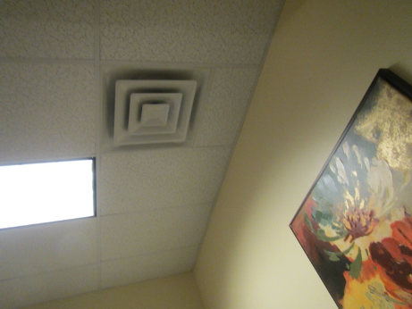

Supply vent from rooftop AHU

Picture 2

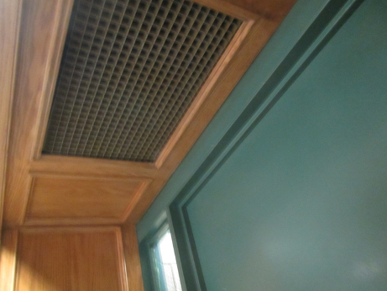

Return vent inside superintendent’s suite
Picture 3

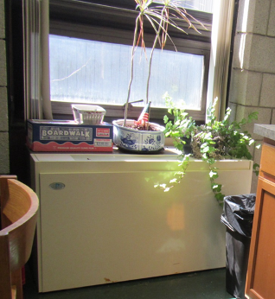

Univent blocked with items and plants

Picture 4

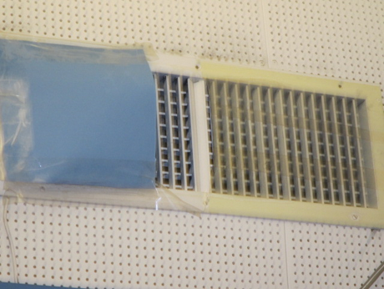

Supply vent blocked with plastic
Picture 5

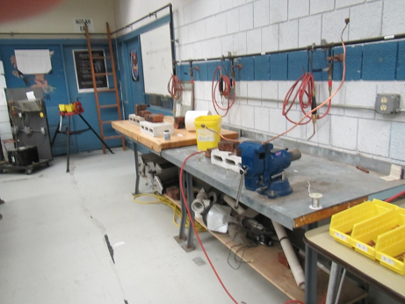

Acetylene welding setup in HVAC room with no exhaust ventilation

Picture 6

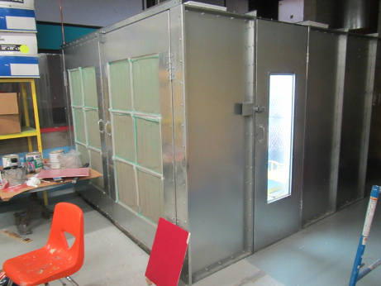

Spray booth
Picture 7

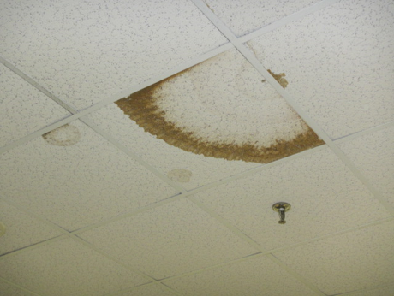

Water-damaged ceiling tiles

Picture 8

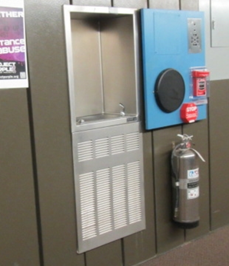

Water dispenser over carpet
Picture 9

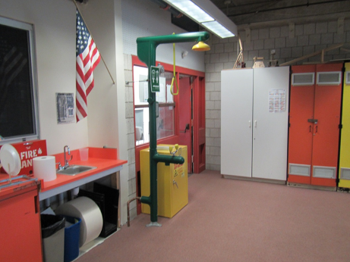

Safety shower in carpeted area

Picture 10

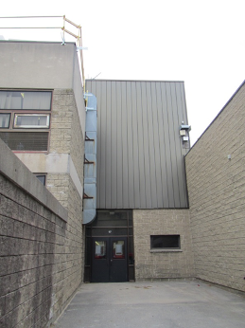

Signs of water staining on exterior walls
Picture 11

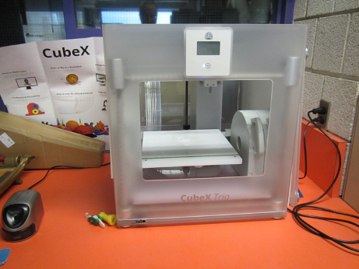

One kind of 3-D printer found in the school

Picture 12

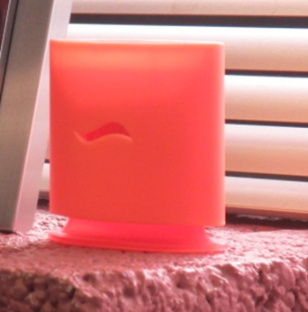

Scented air deodorizer
Picture 13

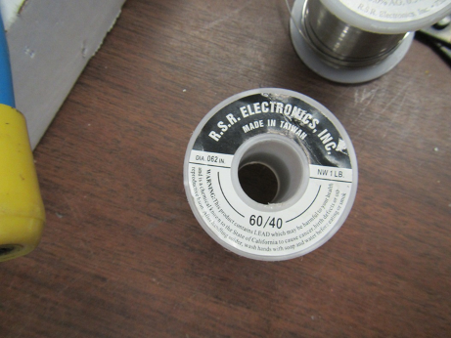

Solder containing lead in the electronics lab

Picture 14

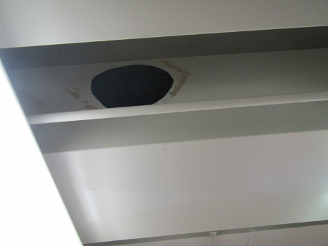

Hole in ductwork from portable HVAC system
Picture 15

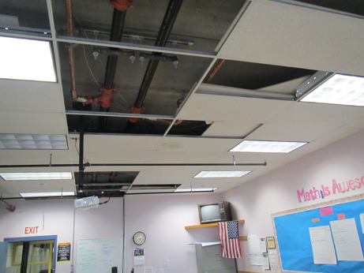

Missing ceiling tiles

Picture 16

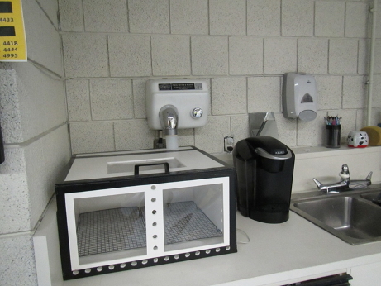

Homemade drying box connected to hand dryer
Picture 17

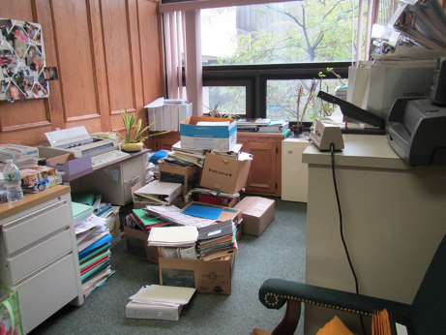

Items on desks and floor in office

Picture 18

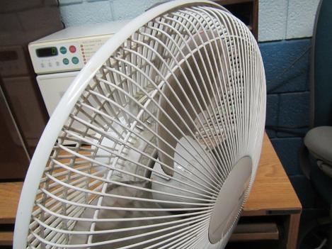

Dirty personal fan
Location | Carbon  Dioxide  (ppm) | Carbon Monoxide  (ppm) | Temp  (°F) | Relative  Humidity  (%) | PM2.5  (µg/m³) | TVOC  (ppm) | Occupants  in Room | Windows  Openable | Ventilation |  | Remarks
 |  |  |  |  |  |  |  |  | Supply | Exhaust
Background | 363 | ND | 61 | 65 | 13 | ND |  |  |  |  | Cloudy
1140 | 1013 | ND | 74 | 48 | 10 | ND | 5 | N | Y | N | DEM
1142 | 901 | ND | 74 | 48 | 10 | 0.3 | 9 | Y | Y | Y
1157 Childcare | 922 | ND | 72 | 54 | 3 | 0.7 | 6 | N | Y | Y | Adjacent to Cosmetology
1160 | 852 | ND | 71 | 51 | 7 | 0.8 | 11 | Y | Y | N
1162 Childcare | 767 | ND | 73 | 48 | 9 | 0.3 | 8 | N | Y | Y | Adjacent to Cosmetology Lab
1164 Childcare | 842 | ND | 72 | 52 | 3 | 0.7 | 15 | N | Y | Y | Across from Cosmetology
1321 | 950 | ND | 69 | 52 | 31 | 0.8 | 22 | N | Y | N | NC, DEM
1323 | 998 | ND | 71 | 52 | 11 | 0.3 | 15 | N | Y | Y | NC, DEM
1324 | 742 | ND | 69 | 55 | 2 | 0.7 | 0 | N | Y | Y | DEM, AD
1341 | 801 | ND | 73 | 52 | 11 | ND | 12 | N | Y | Y | Carpet
1342 | 700 | ND | 70 | 51 | 33 | 0.7 | 0 | N | Y |  | Carpet
1343 | 743 | ND | 71 | 52 | 13 | 0.2 | 0 | N | Y | Y | DO, carpet
1407 |  |  |  |  |  |  | 1 | N |  |  | Ducts cleaned, access covers
1421 | 597 | ND | 68 | 51 | 38 | 1.0 | 1 | N | Y
1503 | 457 | ND | 68 | 52 | 15-40 | 0.4 | 16 | N |  |  | NC
2140 | 1071 | ND | 74 | 46 | 5 | 0.6 | 8 | N | Y | Y | CD, PF
2140 | 1076 | ND | 73 | 48 | 10 | .3 | 5 | N | Y | N | DEM
2141 | 1013 | ND | 73 | 48 | 12 | .4 | 18 | N | Y | N | Carpet
2142 | 931 | ND | 74 | 48 | 11 | .5 | 9 | N | Y | Y | DEM, CD
2144 | 1091 | ND | 73 | 47 | 2 | 0.6 | 0 | N | Y | N | Hole in duct (prior use for portable AC unit)
2145 | 1129 | ND | 72 | 48 | 8 | 0.5 | 3 | N | N |  | Fake plants, scented candles
2146 | 1157 | ND | 72 | 47 | 5 | ND | 3 | N | N |  | Carpet, hole in duct (for use of portable HVAC, needs sealing)
2147 storage | 1143 | ND | 74 | 45 | 6 | ND | 0 | N | N |  | Items, books
2149 | 1062 | ND | 74 | 49 | 22 | ND | 18 | Y | Y UV |  | Kitchen, items, carpet
2149 office | 1124 | ND | 74 | 47 | 9 | ND | 1 | N | Y
2154 | 1851 | ND | 75 | 54 | 6 | 0.5 | 9 | N | Y | Y | DEM, chemicals
2155 | 1777 | ND | 74 | 55 | 9 | 0.5 | 0 | N | Y | Y | DEM
2157 | 1625 | ND | 74 | 53 | 7 | 0.5 | 9 | N | Y | Y | DEM
2160 | 889 | ND | 74 | 47 | 6 | 0.3 | 15 | N | Y | Y | DEM
2162A | 767 | ND | 73 | 48 | 9 | 0.5 | 4 | N | Y | Y
2170 Computer Room | 891 | ND | 72 | 49 | 9 | 0.5 | 13 | N | Y | Y | Carpet, DEM, plants, CD
2243 | 1032 | ND | 72 | 48 | 10 | 0.3 | 6 | N | Y | Y | CD, DEM, carpet
2244 | 978 | ND | 72 | 48 | 10 | 0.3 | 12 | N | Y | Y | Carpet
2245 | 1001 | ND | 71 | 46 | 9 | ND | 24 | N | Y | N
2245 | 1001 | ND | 71 | 46 | 9 | ND | 24 | N | Y | N | Carpet
2245 front | 851 | ND | 72 | 50 | 8 | 0.4 | 5 | N | Y | Y | Plants, HS, DO
2245 rear | 775 | ND | 70 | 40 | 3 | 0.3 | 1 | N | Y | Y | DEM, servers
2246 | 1051 | ND | 72 | 49 |  | 0.5 | 9 | N | Y | Y | HS
2247 | 1105 | ND | 75 | 48 | 27 | ND | 14 | N | Y |  | Computers, DO, carpet, DEM
2249 | 933 | ND | 72 | 48 | 11 | ND | 7 | Y | Y | Y | Carpet, DEM
2249 | 823 | ND | 73 | 50 | 10 | ND | 0 | Y | Y | N
2260 Office storage | 731 | ND | 73 | 46 | 9 | ND | 0 | Y | Y UV | Y
2260 Assistant Superintendent | 725 | ND | 72 | 47 | 3 | ND | 0 | N | Y | Y | Carpet
2260 Copy | 738 | ND | 74 |  |  | ND |  | Y | Y UV |  | Plant, DO, shredder, PC
2260 Superintendent Conference Room | 739 | ND | 74 | 46 | 3 | ND | 0 | Y | Y UV |  | Plants on UV, DO
2260 Superintendent Director | 731 | ND | 73 | 47 | 14 | ND | 1 | Y | Y UV | Y | DO
2260 Superintendent Lunchroom |  |  |  |  | 6 | ND | 1 | Y | Y UV |  | Fridge, microwave, sink – CP and open backsplash
2260 Superintendent Suite | 725 | ND | 72 | 49 | 4 | ND | 1 | N | Y | Y | Carpet, items
2261 | 665 | ND | 72 | 49 | 10 | 0.4 | 0 | N | N | Y
2262 | 665 | ND | 72 | 49 | 11 | 0.4 | 0 | N | Y | N
2280 | 999 | ND | 73 | 47 | 10 | 0.3 | 0 | Y | Y | Y
2281 (Nurse 1) | 681 | ND | 72 | 49 | 20 | ND | 0 | N | Y | Y | NC, refrigerator, microwave, WD CT
2282 | 888 | ND | 70 | 46 | 11 | 0.3 | 10 | Y | Y | Y | Microwave, MT
2285 | 1026 | ND | 74 | 49 | 2 | 0.2 | 11 | N | Y | Y | DEM
2285 | 990 | ND | 73 | 50 | 19-22 | ND | 19 | N | Y dusty | Y | Carpet, dirty CT, WD CT
2287 | 898 | ND | 73 | 48 | 1 | ND | 23 | N | Y | Y | Bowed CT
2288 | 974 | ND | 73 | 51 | 2 | 0.4 | 22 | N | Y | Y | CD, DEM
2291 | 1049 | ND | 74 | 52 | 9 | 0.4 | 23 | N | Y | Y | Supply/exhaust vents dirty, WD-CT, carpet, DEM, UF
2293 | 923 | ND | 71 | 52 | 1 | ND | 21 | N | Y | Y | DEM, 5+ WD-CT, HS
2295 | 777 | ND | 75 | 48 | 27 | ND | 19 | N | Y | Y | Carpet, HS, DEM
2320 | 781 | ND | 71 | 48 | 29 | 1.0 | 22 | N | Y |  | DEM, NC, CP
2321 | 758 | ND | 71 | 49 | 4 | 0.5 | 1 | N | Y |  | DEM, NC
2323 | 715 | ND | 68 | 52 | 2 | 0.6 | 1 | N | Y | Y | DEM, AI
2326 | 720 | ND | 70 | 49 | 3 | 0.7 | 0 | N | Y | N
2327 | 870 | ND | 72 | 49 | 8 | 0.9 | 2 | N | Y | Y | DEM, HS
2328 | 885 | ND | 70 | 51 | 10 | 0.5 | 22 | N | Y | Y
2330 (Biology) | 889 | ND | 72 | 51 | 20 | 1.5 | 0 | N | Y |  | NC
2331 | 835 | ND | 70 | 51 | 2 | 0.5 | 22 |  |  |  | DEM, NC
2332 |  |  |  |  |  |  |  |  |  |  | Storage, old refrigerator
2340 | 908 | ND | 73 | 49 | 6 | 0.7 | 12 | N | Y | Y | DEM, carpet
2341 | 784 | ND | 73 | 46 | 10 | ND | 15 | N | Y |  | DEM, carpet, parrot cage (no parrot)
2344 | 658 | ND | 70 | 45 | 4 | 0.6 | 0 | N | Y | Y | Carpet
2363 | 784 | ND | 70 | 51 | 5 | 0.4 | 0 | N | Y | Y | Carpet, boxes
2366 |  |  |  |  |  |  |  |  |  |  | Storage, items on floor
2370 lecture hall | 525 | ND | 69 | 51 | 2 | 0.2 | 0 | N | Y | Y | Plastic sheeting
2380 Gym | 603 | ND | 73 | 49 | 11 | 0.6 | 0 | N | Y off | Y off | New poly floor finish
2420 | 948 | ND | 72 | 45 | 21 | 1.4 | 16 | N | Y | Y | HS
2425 | 927 | ND | 73 | 48 | 5 | 0.7 | 13 | N | Y | Y
2429 | 857 | ND | 72 | 50 | 8 | 1.5 | 0 | N | Y |  | PC, carpet
2430 Chemistry storage |  |  |  |  |  | 1.4 |  | N | Y | Y | Sinks
2440 Graphics | 732 | ND | 71 | 46 | 9 | 6.1 | 10 | N | Y | Y | Silkscreen, inadequate exhaust
2440 Graphics | 856 | ND | 72 | 46 | 9 | 5.5 | 12 | N | Y | Y off | Ink
2442 | 727 | ND | 72 | 50 | 8 | 0.3 | 2 | Y | N | Y | DO, carpet
2443 | 775 | ND | 74 | 46 | 11 | 0.1 | 1 | N | Y | N | Carpet, DEM, plant
2449 | 1066 | ND | 74 | 50 | 10 | 0.3 | 16 | N | Y | Y | DO, carpet
2460 Front | 708 | ND | 69 | 48 | 5 | 0.6 | 0 | N | Y | Y | 3D printer
2460 Middle | 706 | ND | 68 | 46 | 5 | 0.5 | 8 | N | Y | Y | CD
2460 Rear | 665 | ND | 68 | 46 | 5 | 0.2 | 0 | N | Y | Y | DEM
2463 | 1229 | ND | 72 | 48 | 16 | ND | 0 | N | Y |  | NC, sink – backsplash open, CP, WD under sink
2464 | 1321 | ND | 71 | 52 | 11 | 0.3 | 18 | N | Y | Y | DEM
2464 | 652 | ND | 70 | 54 | 11 | ND | 1 | N | Y | Y | Supply vent covered with plastic, carpet
2464 | 652 | ND | 70 | 54 | 11 | ND | 1 | N | Y | Y | Supply vent covered with plastic, carpet
2465 | 1313 | ND | 73 | 51 | 32 | 0.6 | 10 | N | Y | Y dirty | PF, DEM
2481 | 1013 | ND | 70 | 51 | 13 | 0.4 | 20 | N | Y | Y | DEM
2483 | 743 | ND | 71 | 51 | 14 | ND | 0 | Y | Y UV on |  | NC, DEM, ceiling tiles missing
2520 Lab | 1022 | ND | 72 | 53 | 12 | 0.5 | 0 | Y | Y | Y | Computers, DEM
2522 | 1353 | ND | 73 | 48 | 30 | 0.8 | 12 | N | Y
2524 | 784 | ND | 71 | 44 | 30 | 0.8 | 1 | N | Y |  | CP, NC
2541 | 926 | ND | 74 | 49 | 7 | 0.8 | 20 | N | Y | Y | DEM, PF
2542 | 835 | ND | 74 | 48 | 36 | ND | 24 | N | Y |  | CD, PF
2544 | 784 | ND | 73 | 49 | 8 | 0.3 | 6 | N | Y | N | Carpet, DEM, plant
2546 | 733 | ND | 72 | 48 | 9 | 0.4 | 0 | N | Y | N
2560 Engineering | 649 | ND | 73 | 47 | 9 | ND | 4 | N | Y |  | Carpet, sink, safety shower and eyewash
2561 | 760 | ND | 73 | 49 | 5 | 0.5 | 0 | N | Y | Y | 30+ computers, DEM, carpet
2564 | 768 | ND | 73 | 47 | 30 | 0.4 | 0 | N | Y |  | WAC in wall
2565 | 1118 | ND | 72 | 50 | 11 | 0.5 | 19 | N | Y | Y | DEM, PF
2566 | 1077 | ND | 73 | 47 | 24 | 0.4 | 14 | N | Y |  | DEM, carpet
2nd floor restroom |  |  |  |  |  |  |  |  | Y | Y | Exhaust not drawing air
3100 Reading | 678 | ND | 72 | 46 | 9 | ND | 0 | N | Y | Y
3101 | 701 | ND | 72 | 50 | 11 | ND | 0 | N | Y | Y
3143 | 820 | ND | 76 | 44 | 4 | ND | 0 | N | Y | Y | Stand fan, carpet, (worn)
3145 | 795 | ND | 74 | 46 | 2 | 0.3 | 0 | N | Y | Y | Food odor passing through walls from cafeteria.
3145 | 823 | ND | 76 | 46 | 13 | ND | 2 | N | Y | N | Carpet, DEM, Plant
3151 | 899 | ND | 74 | 51 | 10 | 0.4 | 0 | N | Y | Y
3152 | 1016` | ND | 72 | 51 | 9 | 0.5 | 9 | N | Y | Y off | Carpet, PF dirty, HS
3163 | 882 | ND | 74 | 44 | 3 | 0.3 | 2 | N | Y | Y | Plants, carpet
3164 | 922 | ND | 74 | 46 | 2 | 0.2 | 4 | N | Y | Y | Carpet, CD
3165 | 854 | ND | 74 | 46 | 2 | 0.2 | 0 | N | Y | Y | Carpet
3166 | 840 | ND | 74 | 46 | 3 | 0.3 | 0 | N | Y | Y
3167 | 931 | ND | 75 | 44 | 5 | ND | 2 | N | Y | N | Carpet, shredder
3167? | 944 | ND | 76 | 45 | 10 | ND | 4 | N | Y dusty |  | DEM, CP, carpet
3171 | 925 | ND | 75 | 44 | 8 | ND | 0 | Y open | Y UV off |  | Plants, on UV, carpet
3172 | 1010 | ND | 75 | 48 | 9 | ND | 0 | Y | Y | N | Carpet, plant
3173 | 949 | ND | 75 | 44 | 8 | ND | 1 | Y | Y | Y | Carpet
3174 | 949 | ND | 75 | 44 | 8 | ND | 1 | Y closed | Y UV |  | Plants, carpet
3176 | 848 | ND | 74 | 45 | 10 | 0.3 | 13 | Y | Y | Y | Carpet, CD, PF dirty
3240 | 792 | ND | 72 | 50 | 11 | ND | 2 | N | Y | N | Carpet, DEM
3242 | 818 | ND | 73 | 50 | 11 | ND | 2 | N | Y | N | PC, refrigerator, water dispenser
3245 | 693 | ND | 74 | 46 | 4 | 0.2 | 0 | N | Y | N | DEM, DO
3246 | 844 | ND | 77 | 43 | 6 | 0.5 | 1 | N | Y | N | AD, boxes on floor
3246 | 855 | ND | 72 | 52 | 11 | ND | 5 | N | Y | Y | DEM
3248 | 799 | ND | 76 | 43 | 4 | 0.3 | 0 | N | Y | N | PF
3248 | 1063 | ND | 73 | 50 | 12 | 0.1 | 1 | N | Y | y | CD
3249 | 898 | ND | 73 | 50 | 12 | ND | 10 | N | Y | Y | DEM ,carpet
3250A | 760 | ND | 73 | 42 | 14 | ND | 1 | N | Y |  | Carpet, UF
3252 | 886 | ND | 77 | 44 | 9 | ND | 20 | N | Y | Y | Fan, CD, water in sink, paper under sink
3253 office | 1064 | ND | 73 | 50 | 11 | .4 | 0 | N | Y | Y | Carpet, plants
3254 | 789 | ND | 71 | 51 | 12 | ND | 0 | N | Y | N
3255 | 820 | ND | 75 | 44 | 4 | 0.4 | 0 | N | Y | N
3257 | 779 | ND | 76 | 44 | 20 | ND | 0 | N | Y |  | Carpet, plush chairs, DEM
3258 | 706 | ND | 74 | 45 | 8 | ND | 0 | N | N | N | Water stains on concrete wall/ceiling, carpet
3260 | 730 | ND | 74 | 45 | 10 | ND | 5 | N | Y UV on | Y | Large room, plants, carpet
3260 | 815 | ND | 76 | 44 | 11 | ND | 1 | N | Y ? | N | carpet, PF dusty (3), DEM, fridge
3261 | 775 | ND | 74 | 45 | 10 | ND | 3 | Y open | N | N | DEM, PF, plant, door open to 3060
3263 | 967 | ND | 73 | 50 | 7 | ND | 1 | N | Y | N
3340 Computer | 799 | ND | 74 | 47 | 11 | ND | 16 | N | Y | Y | Carpet, HS
3342 | 815 | ND | 74 | 46 | 13 | ND | 1 | N | Y | Y | Carpet, DEM, PF on
3441 | 971 | ND | 74 | 47 | 16 | ND | 0 | N | Y | Y
3443 | 1190 | ND | 75 | 47 | 34 | ND | 1 | N | Y | ? | Carpet, PC, WD on concrete, heater
3444 | 764 | ND | 73 | 46 | 27 | ND | 0 | N | Y |  | HS, carpet, DO
3445 | 1209 | ND | 73 | 50 | 33 | ND | 23 | N | Y | Y | Carpet
3447 | 1367 | ND | 74 | 49 | 33 | ND | 21 | N | Y | Y | ND, CD, carpet
3449 | 801 | ND | 75 | 45 | 10 | 0.3 | 10 | N | Y  (dirty) | N
3450 | 952 | ND | 73 | 51 | 10 | 0.3 | 13 | N
3451 | 1101 | ND | 74 | 47 | 34 | ND | 16 | N | Y |  | Carpet, CD
3452 | 1076 | ND | 72 | 50 | 11 | 0.4 | 13 | N | Y | Y | DEM, plant
3458 | 783 | ND | 74 | 47 | 13 | ND | 0 | Y | Y | Y | Carpet, HS, DEM
3461 | 972 | ND | 75 | 43 | 2 | 0.2 | 0 | N | Y on | Y | DEM, carpet, AD
3464 | 1133 | ND | 73 | 47 | 27 | ND | 2 | N | Y | Y | Carpet
3465 | 938 | ND | 73 | 45 | 9 | ND | 0 | N | Y | N | Carpet, DO, fridge, HS
3466 | 1314 | ND | 74 | 49 | 20 | ND | 15 | N | Y | N | Carpet, CD
3467 | 1135 | ND | 73 | 47 | 3 | 0.3 | 19 | N | Y | Y on | ventilation on  CD, HS
3468 | 1038 | ND | 73 | 47 | 2 | 0.3 | 0 | N | Y | Y | HS
3468 | 861 | ND | 72 | 49 | 13 | ND | 5 | N | Y | Y | Carpet, DEM, CD
3469 | 890 | ND | 73 | 50 | 16 | 0.3 | 0 | N | Y | Y
3470 | 1056 | ND | 73 | 48 | 7 | 0.3 | 0 | N | Y | Y | DO, DEM
3471 | 1021 | ND | 72 | 51 | 8 | 0.4 | 8 | N | Y | Y
3472 | 1072 | ND | 73 | 49 | 14 | ND | 17 | N | Y | Y | DEM
3473 | 1085 | ND | 72 | 51 | 6 | 0.5 | 5 | N | Y | Y
3475 | 956 | ND | 74 | 46 | 8 | 0.2 | 2 | Y (open) | Y |  | Carpet, AD, DEM, CD
3476 | 1131 | ND | 75 | 47 | 9 | 0.2 | 9 | Y | Y | Y | Carpet, UF, plush toys
3480 | 1483 | ND | 72 | 47 | 6 | 0.5 | 11 | N | Y | Y | DEM, PF
3481 | 1402 | ND | 74 | 50 | 30 | ND | 21 | N | Y | Y | DEM, carpet
3482 | 1438 | ND | 74 | 50 | 28 | ND | 19 | N | Y | Y | DEM, carpet worn
3483B | 1432 | ND | 73 | 51 | 20 | ND | 20 | N | Y | Y | DEM, DO, carpet, HS, PF, carpet worn and wrinkled
3484 | 1615 | ND | 73 | 53 | 2 | 0.5 | 24 | N | Y | Y | DEM
3540 | 685 | ND | 73 | 48 | 19 | ND | 3 | N | Y | Y | Carpet, items
3541 | 547 | ND | 71 | 48 | 8 | ND | 2 | N | Y | Y | Carpet, items
3542 | 752 | ND | 74 | 49 | 12 | ND | 0 | N | Y | Y
3543 | 797 | ND | 73 | 50 | 11 | 0.2 | 2 | N | Y | Y
3544 | 515 | ND | 70 | 55 | 8 | ND | 2 | N | Y | Y | Carpet, DEM
3546 | 632 | ND | 72 | 51 | 19 | ND | 21 | N | Y |  | Carpet, DEM
3547 | 589 | ND | 73 | 48 | 9 | ND | 2 | N | Y | Y
3548 | 572 | ND | 71 | 48 | 11 | ND | 7 | N | Y | Y | Carpet (worn), DO
3549 | 600 | ND | 71 | 49 | 13 | ND | 0 | N | Y | Y | Carpet, DEM
3551 | 878 | ND | 73 | 50 | 10 | ND | 10 | N | Y | Y | Carpet, Dem, CD, HS
3551 | 701 | ND | 71 | 51 | 18-31 | ND | 22 | N | Y | Y | DEM, CD, carpet, DO
3552 | 1745 | ND | 74 | 50 | 11 | 0.2 | 9 | N | Y | Y
3555 | 1627 | ND | 72 | 55 | 6 | 1.1 | 20 | N | Y | Y off | HS, DEM, carpet
3561 | 842 | ND | 74 | 49 | 3 | 0.3 | 2 | N | Y | Y off | DEM, carpet, plants
3562 | 966 | ND | 75 | 48 | 2 | 0.2 | 3 | N | Y | Y off | DEM, carpet
3563 | 920 | ND | 76 | 44 | 3 | 0.3 | 4 | N | Y | Y | PF, plants
3563L | 1022 | ND | 76 | 48 | 3 | 0.5 | 15 | N | Y | Y off | DEM
3564 front | 953 | ND | 77 | 44 | 3 | 0.3 | 17 | N | Y | Y off | TV, CPU’s, DEM, HS
3564 rear | 973 | ND | 77 | 45 | 3 | 0.5 | 0 | N | Y | Y off | DEM
3565 | 853 | ND | 77 | 43 | 2 | 0.2 | 0 | N | Y | Y off | Carpet
3566 | 1100 | ND | 76 | 44 | 4 | 0.4 | 12 | N | Y | Y off | Media
3rd floor East commons | 809 | ND | 73 | 52 | 13 | ND | 0 | N | Y | Y | Carpet
3rd floor Restroom |  |  |  |  |  |  |  | N |  | Y | Exhaust not drawing air
3rd floor West commons | 884-950 | ND | 75 | 47 | 10-19 | ND | ~140 | N | Y | Y | Condensation on a window, carpet
AD-ELA | 743 | ND | 74 | 49 | 2 | 0.2 | 0 | N | Y | Y | DEM, DO, porous items under sink
Adm. Meeting Room | 585 | ND | 70 | 50 | 5 | 0.7 | 0 | N | Y | Y | DO
Administrator | 552 | ND | 71 | 48 | 4 | 0.8 | 1 | N | Y | Y | DO
Athletic Director | 874 | ND | 74 | 52 | 2 | 0.2 | 1 | N | Y | Y
Auditorium | 544 | ND | 73 | 51 | 7 | ND | 0 | N | Y | Y | Ceiling fans dirty
CNA Lab | 902 | ND | 73 | 49 | 12 | 0.2 | 16 | N | Y | Y
Drafting Room | 665 | ND | 72 | 49 | 14 | 1.0 | 13 | N | Y | Y | DEM, carpet
Guidance | 787 | ND | 74 | 46 | 9 | ND | 2 | Y
Gym | 541 | ND | 73 | 47 | 22 | 0.5 | 0 | Doors | Y | Y | Smell of new gym floor
Library | 635 | ND | 73 | 48 | 9 | ND | N | N | Y | Y | Plants. HS
Library staff area | 682 | ND | 74 | 46 | 5 | 0.3 | 2 | N | Y | Y | Item, plants
Media room | 716 | ND | 73 | 45 | 7 | 0.3 | 4 | N | Y | Y | PF, AV equipment
Media storage | 673 | ND | 73 | 47 | 4 | 0.2 | 3 | N | Y | Y
Plant services | 582 | ND | 70 | 48 | 2 | ND | N | Y | Y |  | Microwave, carpet
Plant services manage | 554 | ND | 70 | 48 | 5 | ND | N | Y | Y
Plumbing class | 625 | ND | 71 | 52 | 12 | 1.2 | 3 | N | N | N | Supply blocked, no exhaust
Teacher’s lounge | 687 | ND | 71 | 50 | 10 | 0.4 | 5 | N | Y | Y | DO, carpet, fridge, microwave, UF
Teachers Testing area | 731 | ND | 74 | 45 | 34-45 | ND | 0 | N | Y |  | Carpet, 2 PCs
Testing Room | 788 | ND | 73 | 48 | 21 | 0.3 | 0 | N | Y | Y | Computers
Wet Lab | 904 | ND | 75 | 48 | 12 | 0.8 | 0 | N | N | N | Eye wash/shower, equipment not operable

Location | Carbon  Dioxide  (ppm) | Carbon Monoxide  (ppm) | Temp  (°F) | Relative  Humidity  (%) | PM2.5  (µg/m³) | TVOC  (ppm) | Occupants  in Room | Windows  Openable | Ventilation |  | Remarks
 |  |  |  |  |  |  |  |  | Supply | Exhaust
Background | 397 | ND | 73 | 63 | 11 | ND |  |  |  |  | Sun and showers, humid
2440 graphics | 785 | ND | 71 | 55 | 41 | 4-8 | 7 | N | Y | Y | Working on printing
Computer graphics area | 1003 | ND | 71 | 57 | 270 | 13.1 | 15 | N | Y | Y | Painting ongoing, recent use of spray glue, DEM, CP
Copy center | 786 | ND | 71 | 54 | 33-44 | 3.6 | 2 | N | Y | Y | Reportedly new exhaust to be installed
Digital graphics | 794 | ND | 71 | 54 | 11 | 3.8 | 12 | N | Y | Y | Airbrush stations with local exhaust (not on)
Graphics copy area | 800 | ND | 71 | 53 | 11 | 3.7 | 8 | N | Y | Y | DEM, PCs, carpet
Graphics staff workroom/  lunch | 1043 | ND | 71 | 56 | 35 | 1.5 | 0 | N | Y | Y | Food, dehumidifier, sink, NC
Graphics storage | 802 | ND | 71 | 56 | 33 | 6.1 | 0 | N | Y | Y | Paper and items on pallets
2460 CAD (engineering) | 1075 | ND | 74 | 51 | 19 | 0.4 | 0 | N | Y | Y | NC, DEM, 3-D printer
2561 engineering | 889 | ND | 72 | 60 | 18 | 0.2 | 22 | N | Y | Y | Carpet, DEM, 3-D printer, printers, solar gain
2562 engineering | 884 | ND | 73 | 57 | 14 | 0.2 | 14 | N | Y | Y | Computers, sink, small shop equipment over carpet, including plastics lathing, DEM
Computers drawing | 1065 | ND | 70 | 50 | 9 | 0.5 | 5 | N | Y | Y | NC, computers, 3-D printer (plastics, on)
Engineering (Mr. King) | 711 | ND | 74 | 56 | 20 | 0.1 | 1 | N | Y | Y | Computers, safety shower on carpet, sink, PS
Engineering workroom |  |  |  |  |  |  |  |  |  |  | Safety shower, hood-off, incubator, sinks, NC
Prototype area | 1053 | ND | 70 | 51 | 9 | 0.4 | 2 | N | Y | Y | NC, sink, DEM, drying station with hand dryer (disconnected after)
2621 electronics | 1020 | ND | 74 | 59 | 34 | 0.1 | 0 | N | Y UV | Y | DEM, NC, computers
2621A electronics | 1175 | ND | 74 | 58 | 32 | 0.1 | 8 | Y | Y UV on | Y | NC, DEM, soldering irons.
Electronics lab | 1370 | ND | 74 | 57 | 150-200 | 0.3 | 22 | N | Y | Y | Soldering ongoing, NC, PF
2622 storage | 1303 | ND |  |  |  |  |  |  |  |  | PC, food, fridge
2521 | 900 | ND | 74 | 48 | 24 | 0.3 | 15 | N | Y | Y | Carpet
2524 |  |  |  |  |  |  |  |  |  | Y
2524 lab | 1136 | ND | 74 | 51 | 38 | 0.3 | 3 | N | Y | Y | DEM, equipment
2520 lab | 1133 | ND | 73 | 51 | 48 | 0.2 | 12 | N | Y | Y | Lab equipment, electronics
2249 programming/web | 980 | ND | 73 | 52 | 18 | 0.2 | 16 | N | Y | ? | NC, DEM, computers
Computer lab | 1028 | ND | 73 | 50 | 28 | 0.2 | 11 | N | Y | Y | Carpet, computers, PF
2162A computers | 830 | ND | 72 | 51 | 7 | 0.2 | 5 | N | Y | Y | Carpet, computers
2162 | 754 | ND | 73 | 59 | 16 | 0.2 | 9 | Y | Y | Y | Carpet, computers
2163 | 653 | ND | 73 | 58 | 21 | ND | 7 | Y | Y | Y | Fish tank, computers, plants, carpet
2248 health assisting | 957 | ND | 73 | 52 | 22 | ND | 17 | N | Y | Y | Carpet, plant, computers
1265 cosmetology | 961 | ND | 72 | 55 | 5 | 0.4 | 9 | N | Y | Y | Hair perm odor (in hallway too), dryers
1265 cosmetology right side | 998 | ND | 73 | 53 | 13 | 0.3 | 12 | N | Y | Y | MT, HS, NC, packages, dropped ceiling tile system
Cosmetology-related classroom | 1037 | ND | 73 | 52 | 18 | 0.3 | 1 | N | Y UV on | Y | NC
1160 | 790 | ND | 72 | 53 | 23 | 0.2 | 0 | N | Y | Y | Temporary intake hose, parts carpeted
1164 tot shop | 745 | ND | 71 | 60 | 11 | 0.2 | 4 | Y door | Y | Y | Outside door open, part carpeted, NC, kitchen equipment
1164 laundry room |  |  |  |  |  |  |  | N | N | N | Vent from dryer to outside is very long
1156 cosmetology | 953 | ND | 72 | 56 | 16 | 1.2-2.1 | 5 | N | Y | Y | DEM, hairspray and other chemicals
1256 | 861 | ND | 72 | 52 | 9 | 0.2 | 17 | N | Y | Y | Part carpeted, DEM
1251 | 959 | ND | 73 | 53 | 14 | 0.3 | 0 | N | Y | Y | Industrial kitchen equipment, hood works
1253 office | 807 | ND | 73 | 56 | 15 | 0.2 | 0 | N | Y | Y | DO
1140 cafeteria kitchen |  |  |  |  |  |  |  |  |  |  | Stove with pilot light hoods
1153 kitchen staff | 538 | ND | 72 | 65 | 27 | ND | 2 | N | Y | Y | ND, DO, PF, NC
1453 plumbing | 914 | ND | 72 | 56 | 15 | ND | 1 | N | Y | Y | NC, pipe fitting ongoing
1460 painting | 839 | ND | 71 | 59 | 59 | 0.5 | 1 | N | Y | Y | NC, paint and paint odors
Spray booth |  |  |  |  |  |  |  |  |  |  | Well-designed appeared functional
1441 | 838 | ND | 71 | 58 | 56 | 0.5 | 5 | N | Y | Y | Paint odor, NC, PF on
1443 HVAC | 839 | ND | 72 | 57 | 31 | 0.4 | 0 | N | Y | Y | Acetylene equipment, hot work recently done
1562 HVAC | 717 | ND | 72 | 61 | 53 |  | 1 | N | Y | Y | NC, microwave, DEM, TBs, PF, HVAC equipment and canisters of R22
1444 Hospitality | 764 | ND | 72 | 57 | 31 | 0.4 | 1 | N | Y | Y | Hospitality, noise from shops nearby, DEM, carpet, PF
1585 masonry classroom | 671 | ND | 73 | 63 | 31-56 | 0.2 | 0 | N | Y | Y | NC
Masonry classroom | 598 | ND | 72 | 62 | 57 | 0.2 | 0 | N | Y | Y | AIRmax filtration system, all off, dusty and gritty in room (no current work ongoing)
Masonry shop area | 992 | ND | 72 | 64 | 319 | ND | 14 | N open door to outside | Y | Y | Floor drains, PF
1540 carpentry | 681 | ND | 73 | 60 | 100 | 0.3 | 12 | Door to outside | Y | Y | New HVAC reported installed soon, dusty
1545 carpentry classroom | 740 | ND | 72 | 58 | 71 | 0.4 | 0 | N | Y | Y | DO, fan in transom
1442 plumbing | 847 | ND | 73 | 58 | 162 | 0.6 | 15 | N | Y | Y | Exhaust not on, turned on.
Plumbing | 634 | ND | 73 | 61 | 50 | 0.3 | 0 | N | Y | Y | Hoods
1420 metal fab | 982 | ND | 73 | 57 | 1470 | 2.3 | 5 | N | y | Y | Visible haze, all machines on, smoke
1424 | 980 | ND | 74 |  | 270 | 0.5 | 0 | N | Y | Y
1445 | 800 | ND | 74 | 58 | 105 | 0.6 | 10 | N | Y | Y | DO
1445 metal fab | 1009 | ND | 73 | 60 | 130 | 0.4 | 15 | N | Y | Y | Welding
1601 automotive classroom | 432 | ND | 69 | 67 | 26 | 0.2 | 0 | N
1602 auto | 434 | ND | 70 | 68 | 19 | 0.2 | 6 | N |  |  | New HVAC
Autobody | 399 | ND | 70 | 68 | 8 | 0.1 | 0 | N
Autobody | 401 | ND | 69 | 68 | 46 | 0.3 | 8 |  |  |  | Paint odor
Autobody shop office | 451 | ND | 69 | 69 | 78 | 0.3 | 0 |  |  |  | DO, paint odor
Mall shop | 875 | ND | 70 | 62 | 68 | 0.3 | 2 |  |  |  | Scented candles for sale
1331 mall shop | 848 | ND | 71 | 58 |  | 0.3 | 2 |  |  |  | Clothing for sale, sweeping occurring
Swimming pool | 500 | ND | 77 | 86 | 4 | 0.3 | 0
1480 HVAC | 636 | ND | 74 | 57 | 78 | 0.3 | 15 |  |  |  | Use of torches
HVAC workroom | 808 | 7.6-9.0 | 72 | 60 | 90 |  | 9 |  |  |  | Odors

