INDOOR AIR QUALITY ASSESSMENT

Green Meadow Elementary School
5 Tiger Drive
Maynard, Massachusetts



Prepared by:
Massachusetts Department of Public Health
Bureau of Environmental Health
Indoor Air Quality Program
August 2011

Background/Introduction
At the request of Kevin Sweet, Public Health Director, Maynard Board of Health, the Massachusetts Department of Public Health (MDPH), Bureau of Environmental Health (BEH) provided assistance and consultation regarding indoor air quality concerns at the Green Meadow Elementary School (GMES) at 5 Tiger Drive in Maynard, Massachusetts. Concerns regarding general indoor air quality (IAQ) prompted the request. On April 6, 2011, an assessment of the school was conducted by Sharon Lee, an Environmental Analyst/Inspector within BEH’s IAQ Program. Ms. Lee was accompanied by Mr. Sweet during the assessment.
The school is a single-story brick building. The original portion of the school was constructed in 1956. Additions were constructed in 1974 and 1988. The school consists of general classrooms, art room, music room, offices, library, gymnasium, and cafeteria.
A number of upgrades have been made to the building over the past few years. The heating system was converted from oil to natural gas. Univents in the original 1956 section of the building were replaced. Approximately 80 percent of the flat roof membrane that resides over the original portion of the building was also repaired/restored.

Methods
Air tests for carbon dioxide, carbon monoxide, temperature and relative humidity were conducted with the TSI, Q-Trak, IAQ Monitor, Model 7565. Air tests for airborne particle matter with a diameter less than 2.5 micrometers were taken with the TSI, DUSTTRAK™ Aerosol Monitor Model 8520. BEH staff also performed a visual inspection of building materials for water damage and/or microbial growth.

Results
This GMES houses approximately 550 pre-kindergarten through grade 3 students and approximately 110 staff. Tests were taken under normal operating conditions and results appear in Table 1.

Discussion

Ventilation
It can be seen from Table 1 that the carbon dioxide levels were elevated above 800 parts per million (ppm) in 10 of 47 areas surveyed, indicating adequate air exchange in a majority of the areas tested at the school. Please note, a number of areas were sparsely populated at the time of the assessment. Low occupancy can greatly reduce carbon dioxide levels. With increased occupancy, carbon dioxide levels would be expected to increase.
Fresh air in classrooms is supplied by unit ventilators (univents) (Figure 1; Picture 1). A univent is designed to draw air from outdoors through a fresh air intake located on the exterior wall of the building. Return air is drawn through an air intake located at the base of each unit. Fresh and return air are mixed, filtered, heated and provided to classrooms through a fresh air diffuser located in the top of the unit. As mentioned, new univents were installed in the 1956 portion of the building. However, univents in the 1974 and 1988 additions are original equipment.
According to the American Society of Heating, Refrigeration and Air-Conditioning Engineers (ASHRAE), the service life for a unit heater, hot water or steam is 20 years, assuming routine maintenance of the equipment (ASHRAE, 1991). Despite attempts to maintain the univents (i.e., cleaning univents and changing filters regularly), the operational lifespan of this equipment in the 1974 and 1988 sections has been exceeded. Maintaining the balance of fresh air to exhaust air will become more difficult as the equipment ages and as replacement parts become increasingly difficult to obtain.
While examining univents, BEH staff observed utility holes in the divider that separates the side cabinets of the univent from the fan cabinet (Picture 2). These holes can allow air, dust, debris, and odors to be drawn into the univent’s main compartment post-filtration, resulting in the distribution of unfiltered air and debris that may accumulate in the side cabinet. The unit ventilator cabinet walls should be rendered airtight and breaches around pipes should be sealed to prevent distribution of unfiltered air.
The univent filters installed in the building offer minimal filtration. The purpose of a filter is to provide filtration of respirable dusts. In order to decrease aerosolized particulates, disposable filters with an increased dust spot efficiency should be installed in place of current filter media. The dust spot efficiency is the ability of a filter to remove particulates of a certain diameter from air passing through the filter. Filters that have been determined by ASHRAE to meet its standard for a dust spot efficiency of a minimum of 40 percent (Minimum Efficiency Reporting Value equal to 9) would be sufficient to reduce many airborne particulates (Thornburg, 2000; MEHRC, 1997; ASHRAE, 1992).
Please note, fresh air intakes for univents in classrooms along the northern wall of the original building were sealed with insulation board (Picture 3). It is unclear how long these fresh air intakes have been sealed. Additionally, univents were found deactivated in a number of areas at the time of the assessment. Furthermore, univents were obstructed by items such as chairs, tables, desks, and books in many classrooms. In order to function as designed, univents must be activated and allowed to operate free of obstructions and blockages. Without adequate fresh air, normally occurring pollutants can accumulate, leading to indoor air quality complaints.
Exhaust ventilation in the 1954 portion of the building is provided by switch activated vents located in closets. These vents are ducted to rooftop fans that remove air from the building. At the time of the assessment, the majority of these exhaust vents were not operating. Exhaust ventilation in classrooms in the 1974 and 1988 classrooms is provided by wall- or ceiling-mounted vents that are also ducted directly to rooftop fans.
In central areas of the building, including the cafeteria, gymnasium, and office areas, mechanical supply and exhaust ventilation is provided by individual rooftop or ceiling mounted air-handling units (AHUs). Fresh air is distributed via ceiling-mounted air diffusers and ducted back to AHUs via ceiling- or wall-mounted return vents.
To maximize air exchange, the MDPH recommends that both supply and exhaust ventilation operate continuously during periods of school occupancy. In order to have proper ventilation with a univent and exhaust system, the systems must be balanced to provide an adequate amount of fresh air to the interior of a room while removing stale air from the room. It is recommended that HVAC systems be re-balanced every five years to ensure adequate air systems function (SMACNA, 1994).
The Massachusetts Building Code requires that each area have a minimum ventilation rate of 15 cubic feet per minute (cfm) per occupant of fresh outside air or openable windows (BOCA, 1993; SBBRS, 1997). The ventilation must be on at all times that the room is occupied. Providing adequate fresh air ventilation with open windows and maintaining the temperature in the comfort range during the cold weather season is impractical. Mechanical ventilation is usually required to provide adequate fresh air ventilation.
Carbon dioxide is not a problem in and of itself. It is used as an indicator of the adequacy of the fresh air ventilation. As carbon dioxide levels rise, it indicates that the ventilating system is malfunctioning or the design occupancy of the room is being exceeded. When this happens a buildup of common indoor air pollutants can occur, leading to discomfort or health complaints. The Occupational Safety and Health Administration (OSHA) standard for carbon dioxide is 5,000 parts per million parts of air (ppm). Workers may be exposed to this level for 40 hours/week based on a time-weighted average (OSHA, 1997).
The MDPH uses a guideline of 800 ppm for publicly occupied buildings. A guideline of 600 ppm or less is preferred in schools due to the fact that the majority of occupants are young and considered to be a more sensitive population in the evaluation of environmental health status. Inadequate ventilation and/or elevated temperatures are major causes of complaints such as respiratory, eye, nose and throat irritation, lethargy and headaches (Appendix A).
Temperature readings ranged from 68 ºF to 75 ºF, which were within or close to the MDPH comfort guidelines during the assessment. The MDPH recommends that indoor air temperatures be maintained in a range between 70 ºF to 78 ºF in order to provide for the comfort of building occupants. Temperature control complaints are reportedly a frequent occurrence at the GMES, which may be due to poorly functioning/deactivated ventilation equipment. In many cases concerning indoor air quality, fluctuations of temperature in occupied spaces are typically experienced, even in a building with an adequate fresh air supply.
Relative humidity measurements ranged from 17 to 31 percent, which were below the MDPH recommended comfort range in all areas surveyed during the assessment. The MDPH recommends a comfort range of 40 to 60 percent for indoor air relative humidity. Relative humidity levels in the building would be expected to be lower during the winter months due to heating. The sensation of dryness and irritation is common in a low relative humidity environment. Low relative humidity is a very common problem during the heating season in the northeast part of the United States.

Microbial/Moisture Concerns
At the time of assessment, school staff reported an active roof leak in classroom 4D. Water-damaged acoustic ceiling tiles and walls were observed there and in other classrooms in the 1988 wing (Picture 4). These leaks are likely related to spaces that may exist in roofing/flashing where two different roofs join (Picture 5). Evidence of moss growth in these areas suggests heavy water is accumulating in the “valleys”.
Of note was the presence of water-damaged fiberglass insulation and ceiling tiles in the library office (Picture 6). It appears that fiberglass insulation was installed in the ceiling plenum area above the suspended tile system. The purpose of the fiberglass insulation is likely for sound attenuation. If not dried completely, fiberglass insulation can be a source of mold growth.
Breaches were observed between countertops and sink backsplashes in a number of classrooms (Picture 7; Table 1). If not watertight, water can penetrate through backsplash seams or can leak from plumbing. Water penetration and chronic exposure of porous and wood-based material can cause swelling and show signs of water damage. As discussed, moistened materials that are not dried within 24 to 48 hours can become potential sources for mold growth.
Some hallway areas in the building are carpeted. These carpets are original to the building in some areas (the 1974 addition) and used for encapsulating asbestos-containing floor tiles in other areas (the original 1954 section). Efforts should be made to remove these carpets and replace them with non-porous materials (i.e., floor tiles). Water-damaged carpeting can be a potential source for mold growth. In addition, worn/disintegrating textiles observed in a few areas (Picture 8) can be a source of particulates, which can be irritating to the eyes, nose and throat.
The tile under carpeting in the 1954 section of the building reportedly contains asbestos. Removal of carpeting in this area should be done with care. Intact asbestos-containing materials do not pose a health hazard. If damaged, asbestos-containing materials can be rendered friable and become aerosolized. Any damage to tile should be remediated by a licensed asbestos remediation firm in accordance with state and federal regulations. In 1986, the Asbestos Hazard Emergency Response Act [AHERA; Asbestos Containing Materials (ACM) in Schools, 40 CFR Part 763, Subpart E] was enacted. AHERA requires the inspection of schools for asbestos containing building materials (location, type, and condition) and preparation of management plans which recommend the best way to reduce asbestos hazards (US EPA, 1986). Under AHERA, facilities are required to be inspected for asbestos containing material (visually every six months and comprehensively every three years by an accredited inspector). The Massachusetts Division of Occupational Safety (MDOS) provides technical assistance to schools in Massachusetts by reviewing management plans and conducting on-site assessments for compliance with AHERA. In addition, MDOS regulates asbestos abatement in schools and other buildings through its regulations, licensing, site visits, and enforcement.
Water stains were also observed around floor tiles in the cafeteria (Picture 9), likely indicating condensation accumulation in this portion of the building. Over time, repeated exposure to moisture can result in damage to these tiles. Given the age of this portion of the building (1974), it is likely that these are asbestos-containing tiles. As indicated above, appropriate precautions should be taken with asbestos-containing materials.
The US Environmental Protection Agency (US EPA) and the American Conference of Governmental Industrial Hygienists (ACGIH) recommends that porous materials be dried with fans and heating within 24 to 48 hours of becoming wet (US EPA, 2001; ACGIH, 1989). If porous materials are not dried within this time frame, mold growth may occur. Water-damaged porous materials cannot be adequately cleaned to remove mold growth. The application of a mildewcide to moldy porous materials is not recommended.
Plants were observed in several areas, some of which were located on or directly adjacent to univents (Table 1; Picture 10). Plants should be properly maintained and equipped with washable drip pans. Plants should be located away from ventilation sources to prevent aerosolization and distribution of dirt, pollen or mold. Plants should also not be placed on porous materials (e.g., paper or cardboard), since water damage to porous materials may lead to microbial growth.
An aquarium was observed with microbial/algal growth. Aquariums should be properly maintained to prevent microbial/algal growth as they can emit unpleasant odors into the classroom.
Leaves and debris were observed on a classroom univent, below a window-mounted air conditioner (Picture 1). With the insulation removed, the area below the air-conditioning unit is no longer sealed (Picture 11). As a result, materials/debris and moisture from the outdoors was allowed to penetrate into the classroom through this opening. This space can also serve as a pathway for pests.
BEH staff examined the outside perimeter of the building to identify breaches in the building envelope and/or other conditions that could provide a source of moisture. Gutters/downspouts were missing, which may allow water to pool against the building rather than drain away (Picture 12). Over time, these conditions can undermine the integrity of the building envelope and provide a means of water entry into the building via capillary action through foundation concrete and masonry (Lstiburek & Brennan, 2001). The freezing and thawing of water during winter months can lead to further damage and subsequent water penetration into the interior of the building. In addition, these breaches may provide a means for pests/rodents into the building.
Leaves and associated debris was also located in close proximity to fresh air intakes (Picture 3). As leaves begin to decompose, materials and odors can become entrained in the univent systems and subsequently be distributed to classrooms. Furthermore, leaf material holds water against the base of the building, which can result in damage to the foundation.

Other IAQ Evaluations
Indoor air quality can be negatively influenced by the presence of respiratory irritants, such as products of combustion. The process of combustion produces a number of pollutants. Common combustion emissions include carbon monoxide, carbon dioxide, water vapor and smoke (fine airborne particle material). Of these materials, exposure to carbon monoxide and particulate matter with a diameter of 2.5 micrometers (μm) or less (PM2.5) can produce immediate, acute health effects upon exposure. To determine whether combustion products were present in the indoor environment, BEH staff obtained measurements for carbon monoxide and PM2.5.

Carbon Monoxide
Carbon monoxide is a by-product of incomplete combustion of organic matter (e.g., gasoline, wood and tobacco). Exposure to carbon monoxide can produce immediate and acute health affects. Several air quality standards have been established to address carbon monoxide and prevent symptoms from exposure to these substances. The MDPH established a corrective action level concerning carbon monoxide in ice skating rinks that use fossil-fueled ice resurfacing equipment. If an operator of an indoor ice rink measures a carbon monoxide level over 30 ppm, taken 20 minutes after resurfacing within a rink, that operator must take actions to reduce carbon monoxide levels (MDPH, 1997).
The American Society of Heating Refrigeration and Air-Conditioning Engineers (ASHRAE) has adopted the National Ambient Air Quality Standards (NAAQS) as one set of criteria for assessing indoor air quality and monitoring of fresh air introduced by HVAC systems (ASHRAE, 1989). The NAAQS are standards established by the US EPA to protect the public health from six criteria pollutants, including carbon monoxide and particulate matter (US EPA, 2006). As recommended by ASHRAE, pollutant levels of fresh air introduced to a building should not exceed the NAAQS levels (ASHRAE, 1989). The NAAQS were adopted by reference in the Building Officials & Code Administrators (BOCA) National Mechanical Code of 1993 (BOCA, 1993), which is now an HVAC standard included in the Massachusetts State Building Code (SBBRS, 1997). According to the NAAQS, carbon monoxide levels in outdoor air should not exceed 9 ppm in an eight-hour average (US EPA, 2006).
Carbon monoxide should not be present in a typical, indoor environment. If it is present, indoor carbon monoxide levels should be less than or equal to outdoor levels. Outdoor carbon monoxide concentrations were non-detect (ND) at the time of the assessment (Table 1). No measureable levels of carbon monoxide were detected inside the building during the assessment (Table 1).

Particulate Matter
The US EPA has established NAAQS limits for exposure to particulate matter. Particulate matter is airborne solids that can be irritating to the eyes, nose and throat. The NAAQS originally established exposure limits to particulate matter with a diameter of 10 μm or less (PM10). According to the NAAQS, PM10 levels should not exceed 150 micrograms per cubic meter (μg/m³) in a 24-hour average (US EPA, 2006). These standards were adopted by both ASHRAE and BOCA. Since the issuance of the ASHRAE standard and BOCA Code, US EPA established a more protective standard for fine airborne particles. This more stringent PM2.5 standard requires outdoor air particle levels be maintained below 35 μg/m³ over a 24-hour average (US EPA, 2006). Although both the ASHRAE standard and BOCA Code adopted the PM10 standard for evaluating air quality, MDPH uses the more protective PM2.5 standard for evaluating airborne particulate matter concentrations in the indoor environment.
Outdoor PM2.5 concentrations the day of the assessment were measured at 4 μg/m³ (Table 1). PM2.5 levels measured inside the building ranged from 5 to 14 μg/m³ (Table 1), which were below the NAAQS PM2.5 level of 35 μg/m³. Frequently, indoor air levels of particulates (including PM2.5) can be at higher levels than those measured outdoors. A number of activities that occur indoors and/or mechanical devices can generate particulate during normal operations. Sources of indoor airborne particulates may include but are not limited to particles generated during the operation of fan belts in the HVAC system, use of stoves and/or microwave ovens in kitchen areas; use of photocopiers, fax machines and computer printing devices; operation of an ordinary vacuum cleaner and heavy foot traffic indoors.

Volatile Organic Compounds
Indoor air can be greatly impacted by the use of products containing volatile organic compounds (VOCs). VOCs are carbon-containing substances that have the ability to evaporate at room temperature. Frequently, exposure to low levels of total VOCs (TVOCs) may produce eye, nose, throat and/or respiratory irritation in some sensitive individuals. For example, chemicals evaporating from a paint can stored at room temperature would most likely contain VOCs. In an effort to identify materials that can potentially increase indoor VOC concentrations, BEH staff examined rooms for products containing these respiratory irritants.
Cleaning and sanitization products were observed in a number of rooms (Picture 13; Table 1). These products contain chemicals that can be irritating to the eyes, nose and throat of sensitive individuals. Cleaning products should be properly labeled and stored in an area inaccessible to children. In addition, a Material Safety Data Sheets (MSDS) should be available at a central location for each product in the event of an emergency. Consideration should be given to providing teaching staff with school issued cleaning products and supplies to prevent any potential for adverse chemical interactions between residues left from cleaners used by the facilities staff and those left by cleaners brought in by others.
A number of classrooms contained dry erase boards and related materials. Materials such as dry erase markers and dry erase board cleaners may contain VOCs, such as methyl isobutyl ketone, n-butyl acetate and butyl-cellusolve (Sanford, 1999), which can be irritating to the eyes, nose and throat.

Other Conditions
Other conditions that can affect indoor air quality were observed during the assessment. Mouse droppings and traps were observed in the sink of a classroom (Picture 14). The presence of rodents is likely related to food storage/preparation equipment observed in the area (Picture 15). Rodent infestation can result in indoor air quality related symptoms due to materials in their wastes. Mouse urine contains a protein that is a known sensitizer (US EPA, 1992). A sensitizer is a material that can produce symptoms (e.g., running nose or skin rashes) in sensitive individuals.
A three-step approach is necessary to eliminate rodent infestation:
- removal of the rodents;
- cleaning of waste products from the interior of the building; and
- reduction/elimination of pathways/food sources that are attracting rodents.
To eliminate exposure to allergens, rodents must be removed from the building. Please note that removal, even after cleaning, may not provide immediate relief, since allergens can exist in the interior for several months after rodents are eliminated (Burge, 1995). Once the infestation is eliminated, a combination of cleaning and increased ventilation and filtration should serve to reduce allergens associated with rodents.
In several classrooms, items were observed on windowsills, tabletops, counters, bookcases and desks. The large number of items stored in classrooms provides a source for dusts to accumulate. These items (e.g., papers, folders, boxes) make it difficult for custodial staff to clean. Items should be relocated and/or be cleaned periodically to avoid excessive dust build up. In addition, these materials can accumulate on flat surfaces (e.g., desktops, shelving and carpets) in occupied areas and subsequently be re-aerosolized causing further irritation.
BEH staff observed chalk/dry erase board trays containing a build-up of chalk dust and whiteboard marker debris. These materials can be aerosolized by air movement from the ventilation system, doors opening and closing, and/or foot traffic and may present a respiratory irritant.
A number of fans/blades, exhaust vents and univent diffusers had accumulated dust/debris (Picture 16). Fans should be cleaned periodically in order to prevent them from serving as a source of aerosolized particulates. Exhaust vents and univent diffusers should also be cleaned to prevent re-aerosolization of dust when deactivated equipment is re-activated.
Window-mounted air conditioners (ACs) were observed in some areas (Picture 1; Table 1). These units are normally equipped with filters, which should be cleaned or changed as per manufacturer’s instructions. AC filters were found to have accumulations of dirt, dust and debris.

Conclusions/Recommendations
In view of the findings at the time of this visit, the following recommendations are made to improve indoor air quality:
- Operate all ventilation systems (e.g., AHUs and univents) throughout the building continuously during occupied periods. To increase airflow in classrooms, set univent controls to “high”.
- Make repairs to exhaust system. Ensure classroom exhaust vents are turned on at the start of school and are allowed to operate during occupancy.
- Consult with an HVAC engineering firm regarding the feasibility of repair vs. replacement of ventilation system components given their age. In the interim, work with an HVAC engineering firm to adjust/repair univents and exhaust vents to improve air exchange in classrooms.
- Remove all blockages from univents and exhaust vents to ensure adequate airflow. Ensure fiberboard is removed from exterior fresh air intakes (Picture 3).
- Encourage the closing of classroom doors during occupied periods to facilitate air exchange.
- Consider increasing the dust-spot efficiency of univent filters. Prior to any increase of filtration, each piece of air handling equipment should be evaluated by a ventilation engineer as to whether it can maintain function with more efficient filters.
- Use openable windows in conjunction with mechanical ventilation to facilitate air exchange during periods of mild weather. Care should be taken to ensure windows are properly closed at night and weekends to avoid the freezing of pipes and potential flooding.
- Seal spaces around pipes and univent cabinets with a fire-rated sealant where needed.
- For buildings in New England, periods of low relative humidity during the winter are often unavoidable. Therefore, scrupulous cleaning practices should be adopted to minimize common indoor air contaminants whose irritant effects can be enhanced when the relative humidity is low. To control for dusts, a high efficiency particulate arrestance (HEPA) filter equipped vacuum cleaner in conjunction with wet wiping of all surfaces is recommended. Avoid the use of feather dusters. Drinking water during the day can help ease some symptoms associated with a dry environment (throat and sinus irritations).
- Ensure any roof/plumbing leaks are repaired (e.g., classroom 4D). Replace water-damaged ceiling tiles and fiberglass insulation (Picture 6). Examine the area above and around these areas for mold growth. Disinfect areas of water leaks with an appropriate antimicrobial.
- Repair or replace broken or missing downspouts to drain water away from the foundation.
- Continue with plans for carpet removal/replacement as funds/materials become available.
- Remove carpeting installed over asbestos tile in the 1950s portion of the building with care. If tiles are damaged, contact the Massachusetts Division of Occupational Safety (DOS) and/or an asbestos remediation firm.
- Clean existing carpeting annually (or semi-annually in soiled high traffic areas) as per recommendations of the Institute of Inspection, Cleaning and Restoration Certification (IICRC). Copies of the IICRC fact sheet can be downloaded at: http://www.cleancareseminars.com/carpet_cleaning_faq4.htm (IICRC, 2005)
- To help prevent condensation in the cafeteria and/or reduce musty odors from carpeting in other areas, use portable dehumidifiers and/or air conditioners during periods of excessive relative humidity (e.g., over 70% for extended periods of time).
- Increase frequency of waxing cafeteria floor to create seal and improve cleaning.
- Ensure dehumidifiers are cleaned/maintained as per the manufacturer’s instructions to prevent mold/bacterial growth.
- Seal areas around sinks to prevent water damage to the interior of cabinets and adjacent wallboard. Repair/replace countertop as necessary. Consider replacing these with a one piece/seamless molded countertop.
- Periodically inspect/remove plant growth, leaves and debris from exterior univent air intakes and against foundation.
- Move plants away from univents in classrooms. Ensure all plants are equipped with drip pans. Examine drip pans for mold growth and disinfect areas of water leaks with an appropriate antimicrobial where necessary.
- Seal spaces around air-conditioners to prevent drafts, moisture, and pest entry.
- Clean and maintain aquariums to prevent bacterial/microbial growth and associated odors.
- Store cleaning products properly and out of reach of students. Ensure spray bottles are properly labeled. Consider providing standard school-issued cleaning products to staff.
- Reduce the amount of food stored and prepared in classrooms and the number of classrooms with microwaves and other food preparation equipment. Stored and waste food products can be attractive to insect and rodent pests and the operation of microwaves, toasters and other food preparation equipment can contribute to indoor air quality problems.
- Seal spaces around pipes under sinks to prevent a pathway for rodents into cabinets.
- Use the principles of integrated pest management (IPM) to rid this building of pests. Activities that can be used to eliminate pest infestation may include the following activities.
  - Store foods in tight fitting containers.
  - Do not use recycled food containers for other purposes, as residues and odors may attract pests. Store material to be recycled in containers with tight fitting lids to prevent rodent access.
  - Remove non-food items that rodents are consuming or using as bedding.
  - Avoid eating at workstations. In areas were food is consumed, vacuum periodically to remove crumbs.
  - Regularly clean crumbs and other food residues from toasters, toaster ovens, microwave ovens coffee pots and other food preparation equipment;
  - Examine each room and the exterior walls of the building for means of rodent egress and seal appropriately. A hole as small as ¼” is enough space for rodents to enter an area. If doors do not seal at the bottom, install a weather strip as a barrier to rodents.
  - Reduce harborages (cardboard boxes, paper) where rodents may reside.
  - Refer to the IPM Guide, which can be obtained at the following internet address: http://www.state.ma.us/dfa/pesticides/publications/IPM_kit_for_bldg_mgrs.pdf.
- Consider developing a written notification system for building occupants to report indoor air quality issues/problems. Have these concerns relayed to the maintenance department/ building management in a manner that allows for a timely remediation of the problem.
- Relocate or consider reducing the amount of materials stored in classrooms to allow for more thorough cleaning of classrooms. Clean items, including chalk trays, pencil shaving trays and dry erase marker trays regularly with a wet cloth or sponge to prevent excessive dust build-up.
- Clean personal fans, univent air diffusers, return vents and exhaust vents periodically of accumulated dust.
- Clean/change filters for window-mounted ACs as recommended by the manufacture.
- Consider adopting the US EPA (2000) document, “Tools for Schools”, to maintain a good indoor air quality environment on the building. This document can be downloaded from the Internet at: http://www.epa.gov/iaq/schools/index.html.
- Refer to resource manuals and other related indoor air quality documents for further building-wide evaluations and advice on maintaining public buildings. These materials are located on the MDPH’s website: http://mass.gov/dph/iaq.

References
ACGIH. 1989. Guidelines for the Assessment of Bioaerosols in the Indoor Environment. American Conference of Governmental Industrial Hygienists, Cincinnati, OH.
ASHRAE. 1989. Ventilation for Acceptable Indoor Air Quality. American Society of Heating, Refrigeration and Air Conditioning Engineers. ANSI/ASHRAE 62-1989.
ASHRAE. 1991. ASHRAE Applications Handbook, Chapter 33 “Owning and Operating Costs”. American Society of Heating, Refrigeration and Air Conditioning Engineers, Atlanta, GA.
ASHRAE. 1992. Gravimetric and Dust-Spot Procedures for Testing Air-Cleaning Devices Used in General Ventilation for Removing Particulate Matter. American Society of Heating, Refrigeration and Air Conditioning Engineers. ANSI/ASHRAE 52.1-1992.
BOCA. 1993. The BOCA National Mechanical Code/1993. 8th ed. Building Officials & Code Administrators International, Inc., Country Club Hills, IL.
Burge, H.A. 1995. Bioaerosols. Lewis Publishing Company, Boca Raton, FL.
IICRC. 2005. Carpet Cleaning FAQ 4 Institute of Inspection, Cleaning and Restoration Certification. Institute of Inspection Cleaning and Restoration, Vancouver, WA.
Lstiburek, J. & Brennan, T. 2001. Read This Before You Design, Build or Renovate. Building Science Corporation, Westford, MA. U.S. Department of Housing and Urban Development, Region I, Boston, MA.
MDPH. 1997. Requirements to Maintain Air Quality in Indoor Skating Rinks (State Sanitary Code, Chapter XI). 105 CMR 675.000. Massachusetts Department of Public Health, Boston, MA.
MEHRC. 1997. Indoor Air Quality for HVAC Operators & Contractors Workbook. MidAtlantic Environmental Hygiene Resource Center, Philadelphia, PA.
OSHA. 1997. Limits for Air Contaminants. Occupational Safety and Health Administration. Code of Federal Regulations. 29 C.F.R 1910.1000 Table Z-1-A.
Sanford. 1999. Material Safety Data Sheet (MSDS No: 198-17). Expo® Dry Erase Markers Bullet, Chisel, and Ultra Fine Tip. Sanford Corporation. Bellwood, IL.
SBBRS. 1997. Mechanical Ventilation. State Board of Building Regulations and Standards. Code of Massachusetts Regulations. 780 CMR 1209.0
SMACNA. 1994. HVAC Systems Commissioning Manual. 1st ed. Sheet Metal and Air Conditioning Contractors’ National Association, Inc., Chantilly, VA.
Thornburg, D. 2000. Filter Selection: a Standard Solution. Engineering Systems 17:6 pp. 74-80.
US EPA. 1986. Asbestos Hazard Emergency Response Act. Hazard Emergency Response Act of 1986 (AHERA) Public Law 99-519, Oct 22, 1986. 15 USC Section 2651.
US EPA. 1992. Indoor Biological Pollutants. US Environmental Protection Agency, Environmental Criteria and Assessment Office, Office of Health and Environmental Assessment, research Triangle Park, NC. EPA 600/8-91/202 January 1992.
US EPA. 2000. Tools for Schools. Office of Air and Radiation, Office of Radiation and Indoor Air, Indoor Environments Division (6609J). EPA 402-K-95-001, Second Edition. http://www.epa.gov/iaq/schools/tools4s2.html
US EPA. 2001. “Mold Remediation in Schools and Commercial Buildings”. Office of Air and Radiation, Indoor Environments Division, Washington, DC. EPA 402-K-01-001. March 2001. Available at: http://www.epa.gov/iaq/molds/mold_remediation.html
US EPA. 2006. National Ambient Air Quality Standards (NAAQS). US Environmental Protection Agency, Office of Air Quality Planning and Standards, Washington, DC. http://www.epa.gov/air/criteria.html.
Picture 1

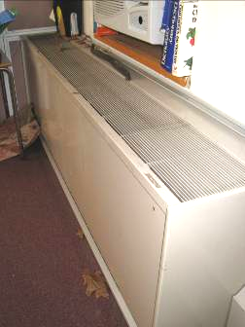

Classroom univent, note leaves and displaced insulation for air conditioner (arrows)

Picture 2

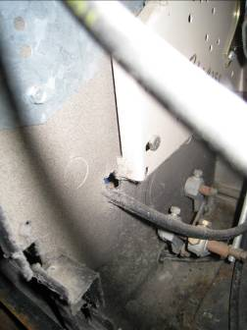

Hole in univent cabinet (arrow), note visible filter

Picture 3

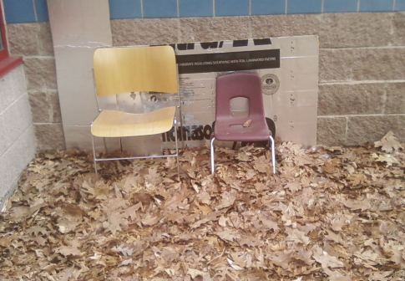

Univent fresh air intake covered by insulation board, note leaf litter

Picture 4

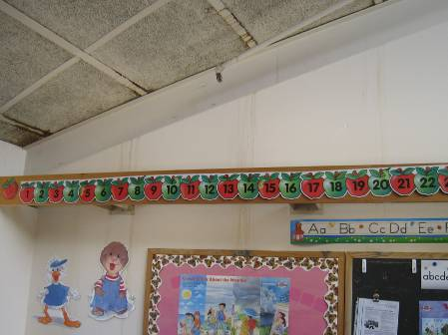

Water stains on acoustic ceiling tiles and wall

Picture 5

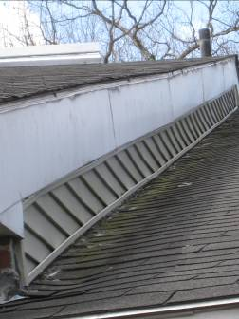

Lifted asphalt shingles, note moss growth

Picture 6

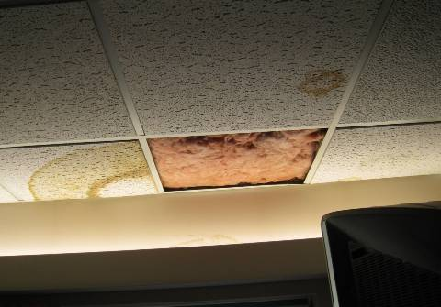

Water-damaged ceiling tiles and fiberglass insulation

Picture 7

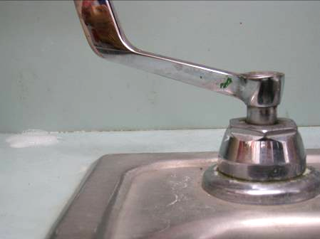

Breach between sink backsplash and countertop

Picture 8

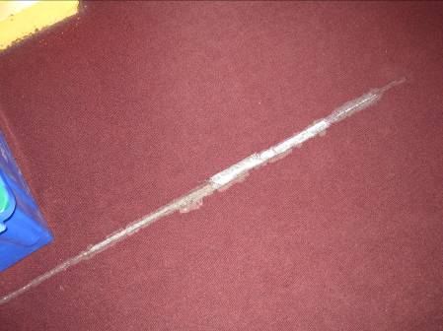

Damaged/fraying carpeting

Picture 9



Stains around floor tile edges

Picture 10

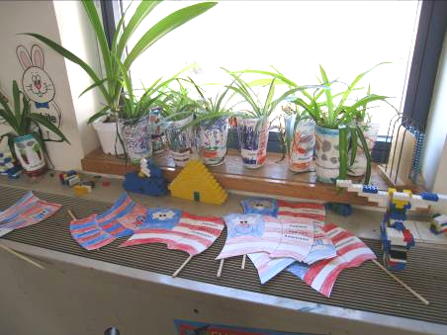

Plants and items on univent

Picture 11

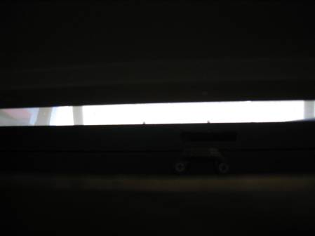

Space below air conditioner

Picture 12

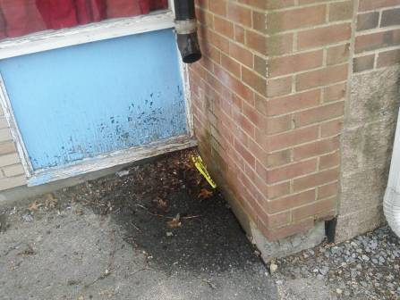

Downspout emptying against building exterior

Picture 13

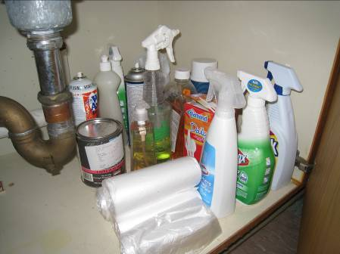

Cleaning products stored under unlocked sink

Picture 14

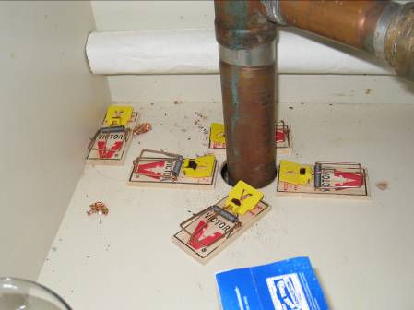

Mouse droppings and traps, note space around pipe

Picture 15

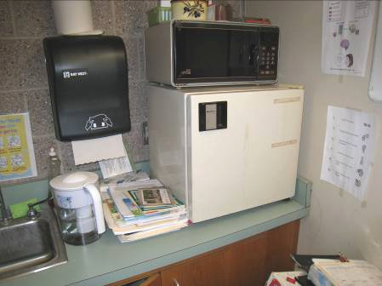

Food preparation equipment in classroom

Picture 16

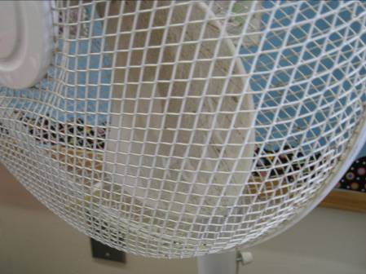

Accumulated dust on fan blades
Location | Carbon  Dioxide  (ppm) | Carbon Monoxide  (ppm) | Temp  (°F) | Relative  Humidity  (%) | PM2.5  (µg/m3) | Occupants  in Room | Windows  Openable | Ventilation |  | Remarks
 |  |  |  |  |  |  |  | Supply | Exhaust | Remarks
Background | 428 | ND | 45 | 27 | 4 |  |  |  |  | Sunny/breezy
1A | 702 | ND | 72 | 19 | 7 | ~20 occupants gone 2 mins | Y | Y | Y | DEM, CP, PF, dusty exhaust vent
1B | 690 | ND | 71 | 20 | 6 | 24 | Y | Y | Y | CP, breach-sink/countertop, stained carpet
1C | 605 | ND | 71 | 19 | 9 | 0 | Y | Y | Y | DO
1D | 702 | ND | 72 | 19 | 7 | 19 | Y | Y | Y | Dusty exhaust vent, DO, AC
1E | 639 | ND | 71 | 20 | 6 | 0 | Y | Y | Y | Dusty exhaust vent, PF, DO
1G | 589 | ND | 73 | 20 | 6 | 24 | Y | Y | Y | Exhaust vent dusty, AC, DEM, breach-sink/countertop
2A | 874 | ND | 72 | 23 | 6 | 19 | Y | Y | Y | Dusty exhaust vent, plants, accumulated items, CP, DO
2B | 766 | ND | 71 | 22 | 6 | 15 | Y | Y | Y | Items on UV, dusty exhaust vent, CPs - odors
2C | 750 | ND | 71 | 22 | 7 | 1 | Y | Y | Y | Supply vent off, exhaust vent dusty, DO, AC, furniture blocking UV
2D | 807 | ND | 71 | 22 | 7 | 18 | Y | Y | Y | Dusty exhaust vent, DO, plants, CP
2E | 747 | ND | 71 | 21 | 6 | 2 | Y | Y | Y | Dusty exhaust vent, DO
3A | 1083 | ND | 72 | 25 | 9 | 16 | Y | Y | Y | Supply vent off, plants/items on UV, PF, DO, accumulated items
3B | 710 | ND | 71 | 21 | 6 | 20 | Y | Y | Y | Plants on UV, DO, breach-sink/countertop
3C | 751 | ND | 71 | 21 | 8 | 4 | Y | Y | Y | Supply vent off, exhaust vent dusty, DO, plants, CP, breach-sink/countertop, mouse traps and droppings under sink
3D | 559 | ND | 72 | 19 | 6 | 0 | Y | Y | Y | Plants on UV, DO, exhaust vent dusty
4A | 606 | ND | 74 | 18 | 7 | 19 | Y | Y | Y | 2/3 windows open, DO, CP
4B | 749 | ND | 71 | 20 | 6 | 22 | Y | Y | Y | Dusty exhaust vent, accumulated items, breach-sink/countertop
4D | 482 | ND | 71 | 31 | 5 | 2 | Y | Y | Y | Supply vent off, exhaust vent dusty, active roof leak-stains, termites
4E | 766 | ND | 73 | 21 | 6 | 2 | Y | Y | Y
5A | 600 | ND | 72 | 18 | 5 | 9 | Y | Y | Y | 1/3 windows open, dusty exhaust vent, PF, CP, breach-sink/countertop
5B | 701 | ND | 73 | 19 | 5 | 5 | Y | Y | Y | Debris in UV, items on UV, CP, PF, breach-sink/countertop
5C | 780 | ND | 72 | 20 | 5 | 23 | Y | Y | Y | CP and items on UV, dusty exhaust vent, accumulated items, CD
5D | 488 | ND | 72 | 18 | 6 | 1 | Y | Y | Y | Items on UV, dusty exhaust vent, plants, DO, accumulated items
5F | 694 | ND | 73 | 19 | 5 | 0 | N | Y | N | WD, 1 MT, 3 WD CT
6A | 945 | ND | 71 | 24 | 5 | 21 | Y | Y | Y | Items on UV, VL-above door, DO, CP, PF, breach-sink/countertop
6B | 839 | ND | 73 | 22 | 5 | 20 | Y | Y | Y | Items on UV, dusty exhaust vent, CP, breach-sink/countertop
6C | 569 | ND | 75 | 18 | 7 | 2 | Y | Y | Y | Exhaust vent dusty, DO, breach-sink/countertop
7A | 883 | ND | 75 | 21 | 9 | 16 | Y | Y | Y | Exhaust turned off-loud, accumulated items, DO
7C | 801 | ND | 71 | 22 | 6 | 0 | Y | Y | Y | 8 WD CT, CD, DO, 2 MT,
7D | 883 | ND | 71 | 23 | 6 | 6 | Y | Y | Y | Aqua, 2 WD CT, PF, interior DO, dusty exhaust vent, unlabelled bottle on UV, CD
7E | 647 | ND | 71 | 22 | 7 | 0 | Y | Y | Y | Exhaust vent dusty, 2 MT, DO
7F | 684 | ND | 71 | 22 | 8 | 0 | Y | Y | Y | Exhaust vent dusty, 3 WD CT, 3 MT
7G | 797 | ND | 72 | 19 | 8 | 0 | Y | Y | Y | Supply blocked, exhaust off-sealed with paper, 12 MT (glued CT system)
7H | 602 | ND | 68 | 21 | 5 | 0 | Y | Y | Y | Exhaust off, 3 MT, UV supply blocked
7I | 541 | ND | 70 | 18 | 10 | 0 | Y | Y |  | AC, DO
7J | 782 | ND | 72 | 22 | 14 | 11 | Y | Y | Y | AC, plants, accumulated items
7K | 798 | ND | 71 | 22 | 7 | 15 | Y | Y | N | Supply dusty, terrarium, 5 WD CT
7L | 748 | ND | 71 | 19 | 8 | 12 | Y | Y | Y | Exhaust off, CP
7M | 849 | ND | 72 | 22 | 8 | 20 | Y | Y | Y | Exhaust off/dusty, AC, accumulated items
Cafeteria | 981 | ND | 71 | 28 | 10 | ~100 | Y | Y | Y | WD-condensation on floor
Conference Room | 607 | ND | 73 | 17 | 6 | 0 | Y | N | N | DO
Gym | 624 | ND | 69 | 23 | 10 | 0 | N | Y | N
Health Suite | 702 | ND | 74 | 19 | 8 | 2 | Y | N | N | Plants, DO
Library | 495 | ND | 70 | 19 | 5 | 25 | Y | Y | Y | Ceiling fans
Library Office | 554 | ND | 71 | 20 | 5 | 0 | Y | Y | N | PC, 7 WD CT, leak-insulation in ceiling plenum
Main Office (Back) | 624 | ND | 73 | 18 | 7 | 1 | Y | N | N | CF, WD CT
Main Office (Front) | 681 | ND | 74 | 18 | 9 | 3 | N | N | N | DO, CF, PF

The service life is the median time during which a particular system or component of …[an HVAC]… system remains in its original service application and then is replaced. Replacement may occur for any reason, including, but not limited to, failure, general obsolescence, reduced reliability, excessive maintenance cost, and changed system requirements due to such influences as building characteristics or energy prices (ASHRAE, 1991).

