**INDOOR AIR QUALITY ASSESSMENT**

**Green Meadow Elementary School**

**5 Tiger Drive**

**Maynard, MA**

Front view of
Green Meadow Elementary School
5 Tiger Drive
Maynard, MA


Prepared by:

Massachusetts Department of Public Health

Bureau of Environmental Health

Indoor Air Quality Program

September 2018

# Background

|  |  |
| --- | --- |
| Building: | Green Meadow Elementary School (GME) |
| Address: | 5 Tiger Drive, Maynard, MA |
| Assessment Requested by: | Aaron Miklosko, Director of Public Works, Town of Maynard |
| Reason for Request: | Concerns regarding water damage, mold and health as well as general indoor air quality (IAQ) |
| Date of Assessment: | September 12, 2018 |
| Massachusetts Department of Public Health/Bureau of Environmental Health (MDPH/BEH) Staff Conducting Assessment: | Ruth Alfasso, Environmental Engineering/Inspector, IAQ Program |
| Date of Building Construction/Description: | The GME is a brick and cinderblock school with a single story. The original wing was constructed in the 1950s and has a flat roof. An addition with peaked shingled roofs was constructed in the 1980s. |
| Building Population: | Approximately 535 students in grades pre-K through 3rd grade with a staff of approximately 75 |
| Windows: | Openable |

# IAQ Testing Results

Please refer to the IAQ Manual for methods, sampling procedures, and interpretation of results (MDPH, 2015). The following is a summary of indoor air testing results (Table 1).

* ***Carbon dioxide levels*** were below the MDPH guideline of 800 parts per million (ppm) in the majority of areas tested, indicating adequate air exchange in most areas of the building. As shown in Table 1, many classrooms had low occupancy and windows or doors open which can reduce carbon dioxide levels.
* ***Temperature*** was within the recommended range of 70°F to 78°F in most areas the day of assessment with a few slightly above which is reflective of outdoor conditions.
* ***Relative humidity*** was above the recommended range of 40 to 60% in all but one area tested, which is reflective of high outdoor humidity and rain during the assessment.
* ***Carbon monoxide*** levels were non-detectable in all areas tested.
* **Fine particulate matter (PM2.5)** concentrations measured were below the National Ambient Air Quality (NAAQS) limit of 35 μg/m3 in all areas tested.

## Ventilation

A heating, ventilating and air conditioning (HVAC) system has several functions. First it provides heating and, if equipped, cooling. Second, it is a source of fresh air. Finally, an HVAC system will dilute and remove normally-occurring indoor environmental pollutants by not only introducing fresh air, but by filtering the airstream and ejecting stale air to the outdoors via exhaust ventilation. Even if an HVAC system is operating as designed, point sources of respiratory irritation may exist and cause symptoms in sensitive individuals.

Mechanical ventilation is provided by univents located near the windows of classrooms (“univents”, Picture 1), or, in some cases, above the ceiling. Univents draw air from the outdoors through a fresh air intake located on the exterior wall of the building (Picture 2) and return air through an air intake located at the base of the unit. Fresh and return air are mixed, filtered, heated or cooled and provided to rooms through an air diffuser located in the top of the unit (Figure 1). In many areas items were on top or in front of univents (Pictures 1 and 3; Table 1), which can block air circulation.

Exhaust vents are located along interior walls of classrooms, with some in closets (Picture 4); they are ducted to fans on the roof. Some exhaust vents were not working at the time of the assessment. In some cases, these vents are operated when a switch on the wall is turned on; some were found turned off; and others did not activate fan motors. As shown in Picture 4, some of the exhaust vents in closets were blocked with items which can reduce their effectiveness.

Of note, is that the main office area is not currently served by any fresh air ventilation. Fresh air is supplied through either open windows or window air conditioners in an exterior-facing office. Heating is provided by a radiator. Doors are left open to the office suite area to supply fresh air, heating and cooling to the rest of the office. The nurse’s office has a restroom with an exhaust vent which is the only source of stale air removal. This configuration makes controlling temperature and supplying fresh air to the office area difficult.

Building maintenance staff reported that univents and other ventilation equipment are also connected to a centralized computer system which can remotely control on/off timing and fresh air vent dampers. It is recommended that fresh air ventilation and exhaust be on whenever the building is occupied.

Window air conditioners (WAC) were found in some classrooms and offices with some in use due to the warm humid weather during this assessment. It was reported that these units are also interlocked with operation of univents, so that univents are turned off during WAC operation to prevent overloading the system with warm humid outside air. While the use of the WAC can provide for more comfortable temperature and humidity, a WAC can only provide a small amount of outside air in comparison to the univents, so the need for fresh air should be balanced with the need for temperature control in deciding when to operate the WAC. Note, however, that one classroom had a window open while the WAC was in operation. The use of air conditioning with windows open while also bringing in warm, humid air will not achieve temperature control and dehumidification as desired, and can lead to surfaces becoming covered with condensation if chilled by the WAC.

In order to have proper ventilation with a mechanical supply and exhaust system, these systems must be balanced to provide an adequate amount of fresh air while removing stale air from a room. It is recommended that existing ventilation systems be re-balanced every five years to ensure adequate air systems function (SMACNA, 1994). It is unknown the last time these systems were balanced. Increased relative humidity can cause heat discomfort.

When relative humidity increases, the ability of moisture to evaporate from skin decreases, preventing heat loss and increasing an individual’s discomfort. The heat index is a description of how hot a person feels as temperature in combination with relative humidity rises. Humidity levels above the DPH recommended range can feel muggy and lead to increased temperature complaints. The guidance document “Methods for Increasing Comfort in Non-Air-Conditioned Schools” provides strategies for dealing with these conditions; it is included as Appendix A.

Prolonged periods of elevated humidity can also lead to condensation on building materials, water damage, and microbial growth. The guidance document “Guidance Concerning Remediation and Prevention of Mold Growth and Water Damage in Public Schools/Buildings to Maintain Air Quality” describes strategies that can be used to reduce the impact of these conditions and remediate any damage; this is included as Appendix B.

## Microbial/Moisture Concerns

Water-damaged ceiling tiles and other ceiling materials were observed in classrooms, offices and other areas (Pictures 5-7; Table 1). A few ceiling tiles had dark stains that may indicate mold growth. Water-damaged ceiling tiles should be replaced, with priority given to those with evidence of mold growth. Some tiles in the school are of an interlocking type (spline) that are difficult to replace.

Most stained tiles are from roof leaks. Building maintenance staff reported that a section of the flat roof on the original wing was patched within the last two years and this has reduced the leaking in that section of the building. SMS staff report that the shingles on the newer section of the roof peak are reaching the end of their service life. Gutters and downspouts were damaged and leaking (Picture 8 and 9) in some areas, likely due to ice-related damage in previous winters. Damage to gutters can increase the likelihood of leaking along the building edges when water builds up and does not drain. When water drains close to the building from leaking gutters, this can lead to damage and potential water infiltration along the foundation.

The area above the ceiling tile system was examined in classroom 7B. Note that the area above the ceiling tile system in most parts of the school is a wide open space (Pictures 10 and 11). This allows any moistened tiles to dry quickly most of the time, with less chance of any microbial growth. In the room examined, near the outside edge of the building where there are soffit vents, there is some insulation. This insulation was dry at the time of the visit. When any stained ceiling tiles are removed for replacement, the area above should be examined for odors, water-damaged materials, insulation and other conditions and remediated as necessary.

Mold growth was observed on the refrigerator gasket in the teacher’s lunch room (Picture 12). Refrigerators should be cleaned on a regular schedule, including disinfection of gaskets and the interior with an antimicrobial solution. Mold growth on gaskets can be an indication that the gaskets are too worn to seal properly and should be replaced.

A water-damaged upholstered chair was also noted in the teacher’s lunchroom (Picture 13). Any items which have been water-damaged and not dried promptly, or that show signs of microbial growth such as moldy odors should be discarded. In general, the US Environmental Protection Agency (US EPA) and the American Conference of Governmental Industrial Hygienists (ACGIH) recommends that porous materials (e.g., wallboard, carpeting) be dried with fans and heating within 24 to 48 hours of becoming wet (US EPA, 2008; ACGIH, 1989). If porous materials are not dried within this time frame, mold growth may occur.

Many classrooms had sinks. In some rooms, the sink backsplashes had a gap which can allow water into the porous material underneath (Table 1). This can lead to water damage and mold growth. Some sinks also had plumbing leaks, which should be repaired. Many sinks also had a significant amount of items stored underneath, which makes it difficult to detect leaks (Picture 14). Porous items (paper, cardboard) should not be stored underneath sinks as it is a moist environment.

Indoor plants were observed in a few areas (Table 1). Plants can be a source of pollen and mold, which can be respiratory irritants to some individuals. Plants should be properly maintained and equipped with drip pans and should be located away from air diffusers to prevent the aerosolization of dirt, pollen and mold.

## Other IAQ Evaluations

Exposure to low levels of total VOCs (TVOCs) may produce eye, nose, throat, and/or respiratory irritation in some sensitive individuals. To determine if VOCs were present, BEH/IAQ staff examined rooms for products containing VOCs. BEH/IAQ staff noted hand sanitizers, cleaners/spray bottles, and dry erase materials in use (Table 1). All of these products have the potential to be irritants to the eyes, nose, throat, and respiratory system of sensitive individuals. In addition, spray bottles/cleaning products should be kept out of reach of children.

Many classrooms had personal or stand fans to provide circulation. Some of these had dusty blades/housing (Picture 15, Table 1). Some exhaust vent louvers were also observed to be dusty. This dust can be reaerosolized when the equipment is activated. Univent cabinet diffusers also had debris inside (Picture 16) which can be a source of odors, especially when heated. Note that univents are equipped with filters, which should be changed on a regular schedule, two to four times a year. Filters are reportedly changed three times a year (Picture 17). This type of filter, however, does not provide much filtration. It is recommended that pleated filters with a minimum efficiency rating value (MERV) of 8. However, with the age of the univents, they may not be able to operate with higher efficiency filters.

Window air conditioners were also dusty in some places (Picture 18). Furthermore, these units have filters which need to be cleaned regularly.

In many areas, items, including books, papers, toys and decorative items were observed on floors, windowsills, tabletops, counters, bookcases, and desks. These items can make it difficult for custodial staff to clean. It is particularly important that porous items, including boxes, papers, books and toys, be kept off the floor and away from areas that may become damp from condensation or leaks. Organic items, such as science demonstrations (Picture 19) can be a source of mold, allergens and odors, and should be carefully vetted before being brought into classrooms or removed entirely.

Most classrooms had area rugs. Carpeting should be cleaned annually or semi-annually in soiled high traffic areas as per the recommendations of the Institute of Inspection, Cleaning and Restoration Certification (IICRC, 2012). If carpeting has been exposed to water from leaks or condensation, they should be carefully examined, particularly on the underside, for any signs of mold growth. Some area rugs appeared soiled and should be discarded when too worn out or soiled to be cleaned.

Note that the Environmental Protection Agency (EPA) conducted a National School Radon Survey in which it discovered nearly one in five schools had “…at least one frequently occupied ground contact room with short-term radon levels above 4 [picocuries per liter] pCi/L” (US EPA 1993). The BEH/IAQ Program therefore recommends that every school be tested for radon, and that this testing be conducted during the heating season while school is in session in a manner consistent with USEPA radon testing guidelines. Radon measurement specialists and other information can be found at [www.nrsb.org](http://www.nrsb.org) and <http://aarst-nrpp.com/wp>, with additional information at: <http://www.mass.gov/eohhs/gov/departments/dph/programs/environmental-health/exposure-topics/iaq/radon>.

# Conclusions/Recommendations

The following recommendations are made to assist in improving IAQ:

1. Operate univents equipment *continuously* during occupied periods. Remove all obstructions from the front and top of the univents.
2. Work with staff to monitor/adjust computerized HVAC system for fresh air intake/comfort.
3. Use openable windows to supplement fresh air during temperate weather. Ensure all windows are tightly closed at the end of the day.
4. Ensure all exhaust vents are operable and switched on during occupied periods. Reduce clutter near closet-mounted vents to ensure air flow.
5. Consider adopting a balancing schedule of every 5 years for all mechanical ventilation systems, as recommended by ventilation industrial standards (SMACNA, 1994).
6. If possible, consult an engineering firm to provide fresh air supply and exhaust to the main office area.
7. Use the information in “Methods for Increasing Comfort in Non-Air-Conditioned Schools” (Appendix A) and “Guidance Concerning Remediation and Prevention of Mold Growth and Water Damage in Public Schools/Buildings to Maintain Air Quality” (B) to assist with hot humid conditions to maintain comfort and air quality.
8. For buildings in New England, periods of low relative humidity during the winter are often unavoidable. Therefore, scrupulous cleaning practices should be adopted to minimize common indoor air contaminants whose irritant effects can be enhanced when the relative humidity is low. To control dusts, a high efficiency particulate arrestance (HEPA) filter equipped vacuum cleaner in conjunction with wet wiping of all surfaces is recommended. Avoid the use of feather dusters. Drinking water during the day can help ease some symptoms associated with a dry environment (throat and sinus irritations).
9. Ensure that procedures are in place for occupants to report leaks, wet tiles, and other maintenance conditions so that they can be logged and dried/repaired promptly.
10. Replace any water-damaged ceiling tiles and wall materials. During replacement, examine the area above these tiles for mold growth and odors and remediate as necessary.
11. Ensure the ceiling tile system is intact/complete to prevent odors and particulates from migrating into occupies spaces.
12. Repair gutters, downspouts and related drainage to remove water away from the building.
13. Consider a long-term plan for roof repairs to reduce leaking.
14. Clean and disinfect interior of refrigerators and freezers with mild detergent or antimicrobial agent. Consider replacing poorly-sealed or mold-contaminated gaskets. Clean spilled food promptly, and clean out the refrigerator of expired items on a regular schedule.
15. Remediate or discard any other water-damaged porous materials such as upholstered furniture, carpeting, papers and other items.
16. Repair any leaking plumbing in sinks. Avoid storing large amounts of materials or porous materials under sinks.
17. Properly maintain plants, including drip pans, to prevent water damage to porous materials. Plants should also be located away from air diffusers to prevent the aerosolization of dirt, pollen, and mold.
18. Reduce use of products and equipment that create VOCs (e.g., air fresheners).
19. Keep spray bottles/cleaning products out of reach of children (e.g., in cabinets over sinks).
20. Continue to change filters for HVAC equipment 2-4 times a year. The MDPH recommends using pleated filters of Minimum Efficiency Reporting Value (MERV) of 8, which are adequate in filtering out pollen and mold spores (ASHRAE, 2012). Consult with an engineer to determine if current ventilating equipment can be used with more effective filters.
21. Regularly clean AHU cabinets, supply/return/exhaust vents, WAC housings and filters, and personal fans to avoid aerosolizing accumulated particulate matter.
22. Consider reducing the amount of items stored in classrooms to make cleaning easier. Periodically move items to clean flat surfaces. Store materials in plastic totes for ease of movement and protection from water, dust and pests.
23. Examine items brought into classrooms, including books, toys, and particularly organic items for science demonstrations, for any sign of water damage, mold, odors or allergens. Discard any suspect items.
24. Clean area rugs annually (or semi-annually in soiled high traffic areas) as per the recommendations of the Institute of Inspection, Cleaning and Restoration Certification (IICRC).
25. The school should be tested for radon by a certified radon measurement specialist during the heating season when school is in session. Radon measurement specialists and other information can be found at: [www.nrsb.org](http://www.nrsb.org/), and <http://aarst-nrpp.com/wp>.
26. Consider adopting the US EPA (2000) document, “Tools for Schools”, as an instrument for maintaining a good IAQ environment in the building available at: <http://www.epa.gov/iaq/schools/index.html>.
27. Refer to resource manual and other related IAQ documents located on the MDPH’s website for further building-wide evaluations and advice on maintaining public buildings. These documents are available at: <http://mass.gov/dph/iaq>.

# References

ACGIH. 1989. Guidelines for the Assessment of Bioaerosols in the Indoor Environment. American Conference of Governmental Industrial Hygienists, Cincinnati, OH.

ASHRAE. 2012. American Society of Heating, Refrigeration and Air Conditioning Engineers (ASHRAE) Standard 52.2-2012 -- Method of Testing General Ventilation Air-Cleaning Devices for Removal Efficiency by Particle Size (ANSI Approved).

IICRC. 2012. Institute of Inspection, Cleaning and Restoration Certification. Carpet Cleaning: FAQ.

MDPH. 2015. Massachusetts Department of Public Health. “Indoor Air Quality Manual: Chapters I-III”. Available at: <http://www.mass.gov/eohhs/gov/departments/dph/programs/environmental-health/exposure-topics/iaq/iaq-manual/>.

SMACNA. 1994. HVAC Systems Commissioning Manual. 1st ed. Sheet Metal and Air Conditioning Contractors’ National Association, Inc., Chantilly, VA.

US EPA. 1993. Radon Measurement in Schools, Revised Edition. Office of Air and Radiation, Office of Radiation and Indoor Air, Indoor Environments Division (6609J). EPA 402-R-92-014. <https://www.epa.gov/sites/production/files/2014-08/documents/radon_measurement_in_schools.pdf>

US EPA. 2000. Tools for Schools. Office of Air and Radiation, Office of Radiation and Indoor Air, Indoor Environments Division (6609J). EPA 402-K-95-001, Second Edition. <http://www.epa.gov/iaq/schools/index.html>.

US EPA. 2008. Mold Remediation in Schools and Commercial Buildings. US Environmental Protection Agency, Office of Air and Radiation, Indoor Environments Division, Washington, D.C. EPA 402-K-01-001. <http://www.epa.gov/mold/mold-remediation-schools-and-commercial-buildings-guide>.

Fan

Mixed Air

Air Diffuser

**Outdoors**

**Indoors**

Heating/Cooling Coil

Filter

Air Mixing Plenum

Return Air

Outdoor Air

Air Flow Control Louvers

# Air Flow

 = Fresh air return

 = Mixed air

**Picture 1**

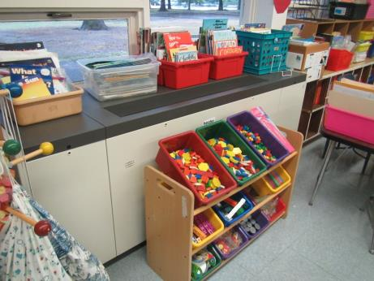

**Classroom unit ventilator (univent), note obstructions in front**

**Picture 2**

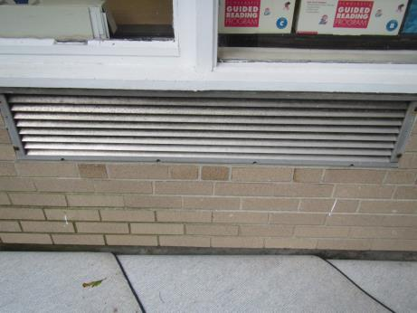

**Fresh air intake for univent, note that louvers are dusty**

**Picture 3**

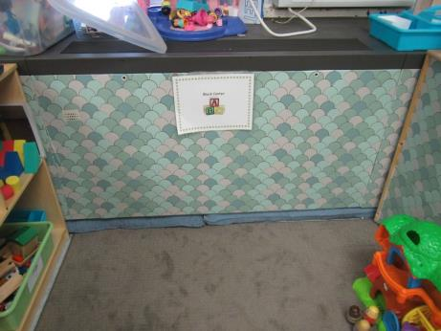

**Univent with return vent along the bottom obstructed**

**Picture 4**

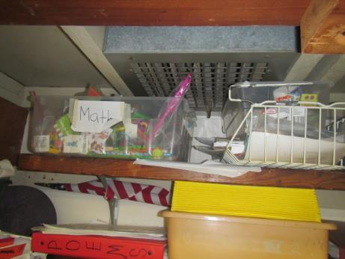

**Closet-mounted exhaust vent, note materials obstructing flow**

**Picture 5**

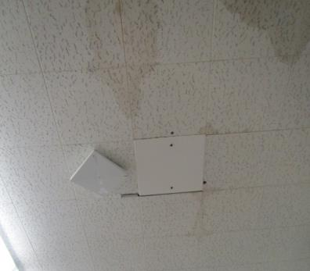

**Water-damaged ceiling tiles of the interlocking type**

**Picture 6**

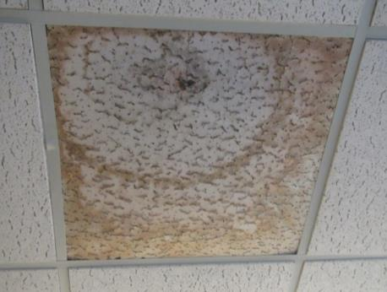

**Water-damaged ceiling tile with dark stain suggesting mold growth**

**Picture 7**

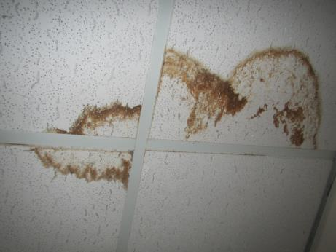

**Water-damaged ceiling tiles**

**Picture 8**

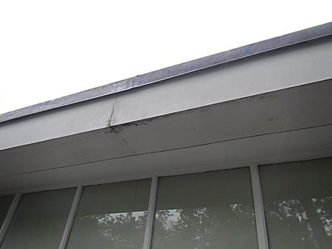

**Damaged gutter**

**Picture 9**

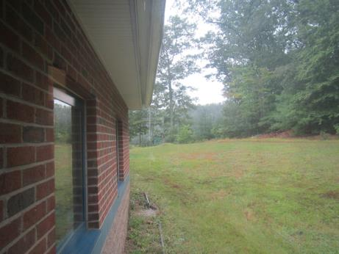

**Water running over edge of gutter, note puddle near foundation**

**Picture 10**

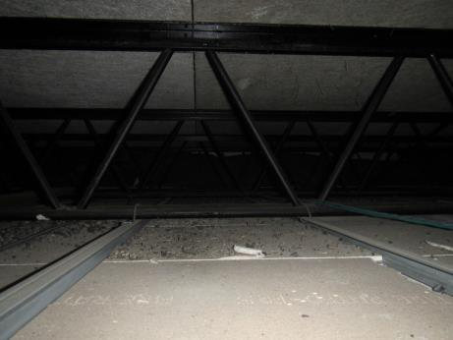

**Air space between ceiling tiles and roof deck**

**Picture 11**

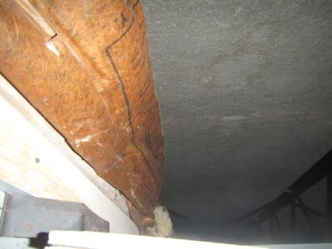

**Area above ceiling tile system showing insulation along the outer edge, which was dry**

**Picture 12**

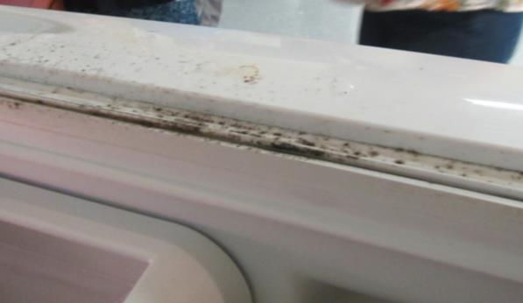

**Mold-stained gasket in teachers’ lunchroom**

**Picture 13**

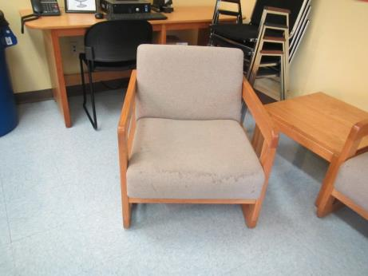

**Water stains on upholstered chair**

**Picture 14**

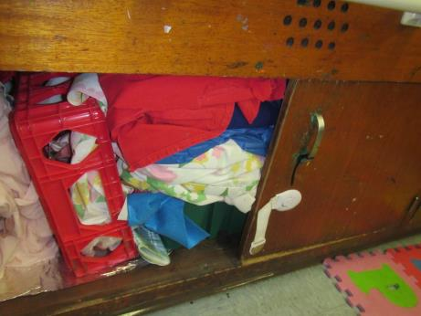

**Significant amounts of porous items under a classroom sink**

**Picture 15**

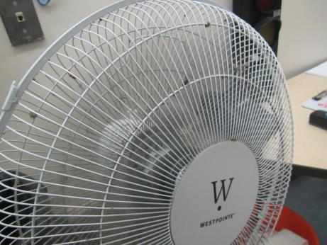

**Dusty fan**

**Picture 16**

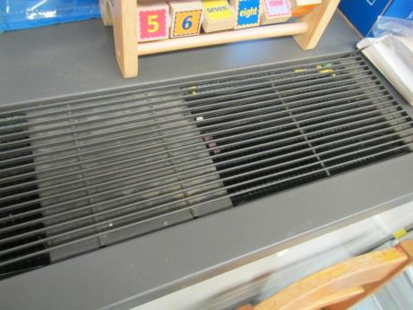

**Debris in univent diffuser**

**Picture 17**

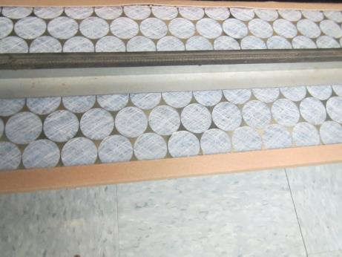

**Filter in classroom univent**

**Picture 18**

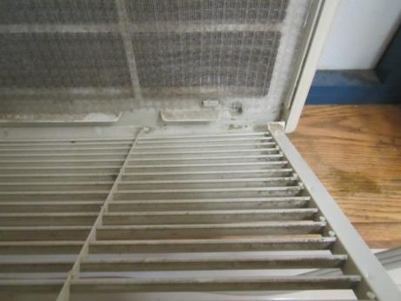

**Window air conditioner housing and filter are dusty**

**Picture 19**

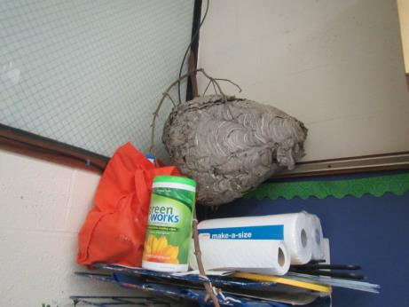

**Science item (wasp nest) in classroom**

| **Location** | **Carbon**  **Dioxide**  **(ppm)** | **Carbon Monoxide**  **(ppm)** | **Temp**  **(°F)** | **Relative**  **Humidity**  **(%)** | **PM2.5**  **(µg/m3)** | **Occupants**  **in Room** | **Windows**  **Openable** | **Ventilation** | | | **Remarks** |
| --- | --- | --- | --- | --- | --- | --- | --- | --- | --- | --- | --- |
| **Supply** | **Exhaust** | |
| Background | 467 | ND | 71 | 82 | 5 |  |  |  | |  | Steady rain, high of 82°F later in the day |
| 7B | 796 | ND | 75 | 81 | 5 | 15 | Y | Y on | | Y off |  |
| Coppola | 1348 | ND | 76 | 74 | 10 | 16 | Y | Y off | | Y off |  |
| 9 | 980 | ND | 76 | 75 | 6 | 19 | Y | Y | | Y on |  |
| Wallace | 1378 | ND | 77 | 77 | 7 | 20 | Y | Y | | Y off |  |
| Mazeika | 679 | ND | 76 | 73 | 3 | 1 | Y | Y on | | Y on |  |
| Galdamez | 711 | ND | 76 | 75 | 3 | 25 | Y | Y on | | Y off |  |
| Excel Kindergarten |  | ND | 74 | 74 | 3 | 2 | Y 1 open | Y on | | Y | WAC dusty, area rugs, lots of items in storage |
| Teacher Resource Room/Duclos Library | 521 | ND | 75 | 74 | 3 | 0 |  | Y on | | Y |  |
| Megan | 1046 | ND | 75 | 66 | 9 | 0 | Y | Y on | |  |  |
| Mooradian | 752 | ND | 76 | 76 | 4 | 11 | Y | Y on | |  |  |
| K3 | 774 | ND |  | 76 | 15 | 15 | Y (1 open) | Y off | | Y |  |
| K4 | 565 |  |  |  |  |  |  | Y on | | Y |  |
| K5 | 560 | ND | 75 | 78 | 12 | 20 | Y | Y on | |  | Area rug, DEM, restroom with exhaust, HS, WAC on, bowed CT |
| OT/PT | 991 | ND | 75 | 75 | 2 | 3 | Y | Y on | | Y | Higher ceiling, HS, mats and foam and beanbag chairs |
| Mr. Thomas | 1393 | ND | 76 | 74 | 4 | 15 | Y | Y off | | Y | PF dusty, backsplash gap, area rug, DEM, CP |
| 6A Mrs. McPhail | 743 | ND | 75 | 58 | 3 | 21 | Y | Y off | | Y | WAC on, a few TBs, DEM, stain on plaster/painted ceiling |
| 5C |  | ND | 76 | 75 | 2 | 18 | Y | Y on | | Y | WAC, area rugs |
| Mr. Mehigan | 549 | ND | 76 | 76 | 3 | 20 | Y | Y on | | Y | Area rugs, books on UV, DEM, DO |
| Mrs. Tretheway | 581 | ND | 76 | 74 | 3 | 0 | Y | Y on | | Y | Area rug |
| 5E | 550 | ND | 76 | 74 | 3 | 0 | N | Y | | Y | Office, now vacant, WD CT |
| 5A | 764 | ND | 75 | 75 | 5 | 9 | Y 1 open | Y on | | Y | Area rug, stand fan |
| 4B Computers | 694 | ND | 73 | 73 | 3 | 0 | N, but door to outside | Y off | |  | DEM, area rug, dusty PF |
| 4E office | 694 | ND | 72 | 72 | 4 | 1 | N | Y | | Y | DEM, PF |
| Mrs. Toss | 565 | ND | 74 | 74 |  | 0 | Y | Y on | | Y | Area rug, DEM, HS, PF |
| Mrs. Lewis | 581 | ND | 76 | 74 | 3 | 0 | Y 2 open | Y | | Y | HS, CP, DEM |
| 4C | 555 | ND | 77 | 74 | 5 | 0 | Y | Y on | | Y | PF on, area rug, backsplash gap, DEM |
| 3B | 665 | ND | 77 | 74 | 3 | 22 | Y 2 open | Y | | Y | Area rug, clutter in closet, HS, paper art items |
| 3A | 635 | ND | 77 | 75 | 4 | 22 | Y | Y on | | Y | Area rug, DEM |
| 3 office | 531 | ND | 76 | 72 | 3 | 2 | Y | Y off | | Y | DEM |
| Girls RR |  |  |  |  |  | 0 | Y | Y | | Y on | Cleaner odor |
| 3D | 453 | ND | 76 | 73 | 2 | 2 | N | Y on | | Y | Area rug |
| Boys RR |  |  |  |  |  | 0 | Y 1 open | Y | | Y on |  |
| Miss Mara | 649 | ND | 77 | 73 | 3 | 1 | Y 1 open | Y on | | Y | Area rug, DEM, PF, HS |
| 2E office | 570 | ND | 78 | 69 | 4 | 0 | N | Y | | Y | PF on, DEM |
| 2A | 572 | ND | 77 | 70 | 3 | 5 | Y 2 open | Y on | | Y | PF, DEM, area rug, HS |
| 2C | 524 | ND | 77 | 72 | 3 | 0 | Y | Y on | | Y | DEM, WAC – filter and unit dusty, area rug |
| 2D | 502 | ND | 76 | 72 | 3 | 0 | Y 1 open | Y | | Y | Area rug |
| 1B | 625 | ND | 76 | 67 | 3 | 1 | Y 1 open | Y on | | Y | WAC on (with window open), DEM, area rug |
| 1F | 638 | ND | 76 | 69 | 3 | 0 | N | Y | | N | Closet/storage, 2 WD CT |
| 1E | 660 | ND | 76 | 69 | 4 | 1 | N | Y | | Y | DEM, HS |
| 1A | 694 | ND | 77 | 72 | 3 | 21 | Y | Y | | Y dusty | HS area rug |
| 1C | 590 | ND | 77 | 72 | 5 | 0 | Y | Y on | | Y | Area rug, HS, PF on |
| 1D | 653 | ND | 75 | 61 | 3 | 19 | Y | Y | | Y | WAC on, DEM, HS, univent blocked |
| 1G Staff workroom | 608 | ND | 76 | 73 | 4 | 0 | Y | Y on | | Y | WAC, DEM, mats |
| Tech closet | 653 | ND | 78 | 72 | 4 | 0 | N | Y | |  | WD CT (5), items |
| Library | 638 | ND | 79 | 70 | 5 | 1 | N | Y | | Y | Some carpeted, computers, office with laminator adjacent between this and the library |
| Gym | 660 | ND | 79 | 70 | 5 | 20 | N | Y | | Y | DEM |
| Gym office | 663 | ND | 78 | 69 | 7 | 0 | N | Y | | N | HS |
| Custodian’s office | 584 | ND | 77 | 71 | 4 | 0 | N | Y | |  | Food, PF on |
| Girls and boys RR near gym |  |  |  |  |  |  |  | N | |  | Exhaust vent hard to identify |
| Art | 561 | ND | 77 | 71 | 3 | 20 | Y 1 open | N | | Y | WD ceiling, DEM, PFs |
| Teacher’s staff workroom | 418 | ND | 75 | 73 | 2 | 0 | Y | Y on | | Y | DEM, carpet |
| Science storage |  |  |  |  |  |  | N | N | | N | Items |
| Teachers’ lunch | 407 | ND | 75 | 74 | 4 | 1 | Y 2 open | Y off | | Y | Has restroom with dusty vent, upholstered furniture, stove, fridge, microwave. Fridge gasket with stains |
| Restroom next to teachers’ lunch |  |  |  |  |  |  | N | N | | Y off | WD near vent |
| Mrs. Schwartz | 824 | ND | 75 | 77 | 4 | 0 | N | Y | | Y | PF, this is a small office |
| Behind stage | 831 | ND | 77 | 79 | 4 | 0 | N |  | |  |  |
| Music | 669 | ND | 76 | 73 | 4 | 1 | Y 1 open | Y | | Y |  |
| Music closet |  |  |  |  |  |  | N |  | |  | WD CT and MT, storage |
| Music office | 796 | ND | 75 | 76 | 6 | 0 | N |  | |  | WD/moldy CT, rusty vent |
| Office next to cafeteria | 852 | ND | 76 | 76 | 6 | 1 | N | Y | | Y | WAC in wall |
| CAF | 749 | ND | 77 | 77 | 5 | ~100 | Y 4 open | Y | | Y | Items hanging from ceiling |
| Small prep room | 650 | ND | 77 | 70 | 4 | 0 | N | Y | | Y |  |
| Girls RR |  |  |  |  |  |  |  |  | | Y | WD CT |
| Boys RR |  |  |  |  |  |  |  |  | | Y | WD CT |
| Main staff office | 746 | ND | 76 | 67 | 5 | 2 | N | N | | N | Heating and cooling in principal’s office only, doors kept open to distribute, DEM |
| Principal | 716 | ND | 73 | 54 | 4 | 0 | Y | N | | N | WAC on |
| Nurse | 717 | ND | 73 | 65 | 5 | 0 | Y | N | | Y in attached restroom |  |
| Old vault/storage |  |  |  |  |  |  | N | N | | N | No vents, rubber band odor |
| Conference | 835 | ND | 74 | 68 | 7 | 0 | N | N | | N | 1 WD CT, DEM |
| Copy/lounge | 856 | ND | 74 | 67 | 5 | 0 | Y | Y on | | N | Upholstered furniture |



**BUREAU OF ENVIRONMENTAL HEALTH**

**Indoor Air Quality Program**

**Methods for Increasing Comfort in Non-Air-Conditioned Schools**

July 2007

The Indoor Air Quality (IAQ) Program routinely receives inquiries concerning the problem of high temperatures in schools and other buildings during unseasonably hot, humid weather. These concerns are usually raised in late spring/early summer or late summer/early fall. School officials should treat hot, humid weather in the same manner as foul weather (e.g., snow) when making decisions concerning student and staff safety. In an effort to aid school officials in judging the effects of heat, this document compiles information concerning indoor air quality in non-air-conditioned school buildings. Please note that excessively hot weather can produce conditions of heat cramps, heat exhaustions and in extreme conditions heat stroke, which is a medical emergency (US EPA, 2006). All of these conditions can occur in individuals who are active in hot weather.

A large number of schools do not have mechanical air-conditioning building-wide, but rather rely on open windows to provide heat relief during hot weather. The IAQ Program recommends that indoor air temperatures be maintained in a range of 70o F to 78o F in order to provide for the comfort of building occupants. Frequently, the upper limit of this comfort range is exceeded in warm weather, since control of temperature in non-air-conditioned buildings is difficult. Relying on openable windows and cross ventilation in hot weather will at best, render indoor temperature to a level equal to outdoor temperature. The heat load carried by building materials exposed to direct sunlight further increases the internal temperature of buildings. Building components, such as single-paned window glass, insulated window frames, skylights and exterior brick, can radiate heat into the interior, resulting in increased indoor temperatures over the course of a school/work day. Frequently, older school buildings are not designed to prevent transfer of heat from solar heated exterior walls and windows to interior occupied space. Therefore, many buildings (particularly schools) are not equipped to provide for the comfort of building occupants during hot/humid weather during summer months.

**What Is Extreme Heat?**

Temperatures that hover 10 degrees or more above the average high temperature for the region and last for several weeks are defined as extreme heat (CDC, 2006). Humid or muggy conditions, occur when damp air is near the ground. Droughts occur when a long period passes without substantial rainfall. A heat wave combined with a drought can be a very dangerous situation (CDC, 2006).

**Methods That Can Be Used To Increase Thermal Comfort in a Building**

**Hydration**

Replacement of fluids is of utmost importance during hot weather. Building occupants should be encouraged to drink water regularly during school/business hours (consultation concerning the appropriate amount of hydration with the school medical staff is encouraged). ***Please note***that some building occupants may be particularly susceptible to heat related problems. Individuals who are **at greater risk** include:

* Infants and children up to four years of age;
* People over 65 years of age;
* Individuals who are overweight;
* Individuals who overexert due to exercise; and
* Individuals who are physically ill, especially those with heart disease or high blood pressure, or who take certain medications, such as for depression, insomnia or poor circulation (CDC, 2006).

These individuals should be monitored, and accommodations should be made to address hot weather concerns for these individuals beyond hydration*.*

**Heat Gain Reduction/Waste Heat Elimination**

An additional strategy used to reduce heat in a building may include employing methods to reduce heat gain transmitted through single pane, metal window frame systems. Use of opaque, heat absorbing curtains to block heat transmission should be considered. Dedicated local exhaust ventilation can be used to direct waste heat produced by equipment to the outdoors. If no exhaust ventilation exists, minimize the use of fossil-fuel and electric-powered equipment where feasible (e.g., cooking equipment, photocopiers, computers, pottery kilns, fluorescent lights).

**Increased Airflow**

A variety of methods can be used to increase comfort indoors during hot weather, however, caution must be used. “Electric fans may provide comfort, but **when the temperature is in the high 90s, fans will not prevent heat-related illness**” (CDC, 2006). Therefore, mechanical fans can be used to supplement a variety of other actions that can be used to increase the comfort of building occupants; however, fans should not be used solely to increase comfort.

The method employed to increase airflow is dependent on the type of building. Buildings built prior to 1940 were configured in a manner that utilizes cross-ventilation to provide comfort for building occupants. These buildings frequently are equipped with windows on opposing exterior walls. In addition, these buildings will have a hinged window located above the hallway door. This hinged window, known as a transom, enables occupants to close the hallway door while maintaining a pathway for air to flow. This design allows for airflow to enter an open window, pass through a classroom, pass through the open transom, enter the hallway, pass through the opposing open classroom hallway, into the opposing classroom and exit the building on the leeward side of the building ([Figure 1](http://www.mass.gov/Eeohhs2/docs/dph/environmental/iaq/appendices/open_transoms_figure.rtf)). With all windows and transoms open, airflow can be maintained in a building regardless of the direction of the wind. This system fails if the windows or transoms are closed. These buildings generally have a long pole with a hook used to open the hoop latch that locks the transom in each room ([Figure 2](http://www.mass.gov/Eeohhs2/docs/dph/environmental/iaq/appendices/closed_transoms_figure.rtf)). To aid in the draw of fresh outdoor air in warm weather, portable fans can be placed directing air out windows on the leeward side of the building. Fans positioned in this manner will serve to increase the draw of outdoor air across a school floor without interfering with the natural internal airflow pattern of a building. If no transoms exist, hallway doors should be opened to create airflow.

Buildings constructed after 1940 are frequently equipped with unit ventilator (univent) systems ([Figure 3](http://www.mass.gov/Eeohhs2/docs/dph/environmental/iaq/appendices/univent.doc)). The interior wall will typically be equipped with a ducted exhaust ventilation system that is connected to a rooftop vent motor. This system can provide airflow in a building independent of outdoor wind direction. With this type of ventilation system, univents should be operating during school hours with the fresh air damper open 100%. In essence, this configuration converts the univent into a large fan system. The operation of the exhaust vent system will serve to create airflow and remove heat and water vapor from classrooms. Many schools deactivate the univents and exhaust vents in the mistaken belief that these systems only provide heat during winter months. Operating these systems during hot weather will *supplement* the use of open windows. If sections of the ventilation system do not operate, the placement of fans to exhaust air from the leeward side of a building with hallway doors open may be employed.

**Removal of Water Vapor**

Internal sources of water vapor (e.g., food services and restrooms) can serve as sources of moisture that can increase local relative humidity levels, especially in hot, humid weather. Kitchens frequently are equipped with local exhaust ventilation for ovens and dishwashing equipment. Operation of these systems during hot weather is essential to remove both heat and moisture from the kitchen and cafeteria. Restrooms are also equipped with local exhaust ventilation that can reduce moisture load in occupied areas. Locker rooms with showers also frequently have local exhaust ventilation. The operation of local exhaust ventilation to remove water vapor can be used to improve comfort in hot weather.

**Temperature Guidelines**

The IAQ Program using a guideline of 70o F to 78o F as a comfort range for temperature inside buildings. If indoor temperatures exceed 78o F, methods to increase the thermal comfort of building occupants may be employed. Several guidelines exist concerning heat stress and discomfort in hot weather.

**Heat Index**

Temperature comfort is also dependent on the perception of heat by an individual, which can be expressed as the heat index. The body cools by producing sweat to reduce internal body heat through the skin. When relative humidity increases, the ability of moisture to evaporate from skin decreases, therefore preventing heat loss and increasing an individual’s discomfort. The heat index is a description of how hot a person feels as temperature in combination with relative humidity rises. The following chart produced by the National Weather Service (NWS) shows the heat index that corresponds to the actual air temperature and relative humidity.

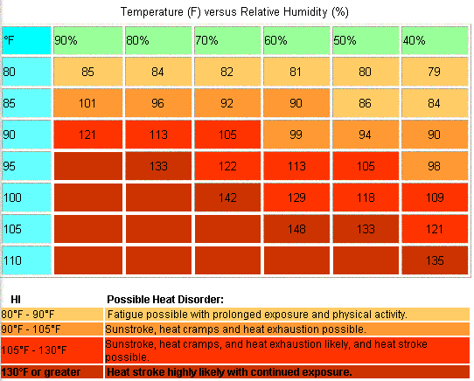

**Table 1: Heat Index Table**

This chart is based upon shady, light wind conditions. **Exposure to direct sunlight can increase the HI by up to 15°F.** Due to the nature of the heat index calculation, the values in the tables below have an error +/- 1.3ºF (NWS, 2005)

Using this chart as a guide, when the heat index indoors ***exceeds 88°F***, methods to increase the thermal comfort of building occupants should be employed.

**Thermal Comfort Guidelines**

Several conditions can affect the comfort level in a building during warm weather:

1. Individuals in warm weather adapt to the temperature of the environment over time. Where outdoor temperatures fluctuate between 10o F to 20o F, individuals become uncomfortable for a time until their body acclimates to the increased temperature.
2. The amount of heat perceived by the individual is related to the activity of the individual. The more physical the activity, the greater the need of cooling.
3. Increased relative humidity increases discomfort with increasing temperature.
4. Radiant sources of heat can serve to increase temperature inside a building. Photocopiers, computer monitors, televisions, fax machines, ceiling lights and laser jet printers are all sources of waste heat that, if not vented, can add to the heat load inside a building.
5. Clothing provides insulation to the body. The thicker the clothing, the greater the insulation and therefore the greater the discomfort of the individual.

The American Society of Heating, Refrigerating and Air-Conditioning Engineers (ASHRAE) produced guidelines to maintain thermal comfort in buildings, including hot weather. As comfort levels decrease with increased temperature coupled with increased relative humidity, the ASHRAE thermal guidelines provide a comfort range that will provide for comfort of 90% of a building population, with 10% of that population expressing dissatisfaction. An individual dressed in typical summer clothing during light, primarily sedentary activity would be comfortable in a temperature range of 72.5o F to 78.5o F at a relative humidity of 60 %; or in a temperature range of 73.5o F to 82o F with a relative humidity of 30% (ASHRAE, 1992). These temperatures coupled with relative humidity are the ranges to assess whether 90% of a building population will be comfortable.

**Occupational Guideline for Workers**

Thermal stress guidelines for workers provide guidance that may be of some assistance. In an environment where the individual working hour consisting of 25% work and 75% rest, an unacclimated individual conducting light work (e.g., sitting or standing to control a machine, performing light hand or arm work) would have a threshold limit value of ***roughly 88o F*** (ACGIH, 1999). This temperature assumes that the individual is a healthy adult at a workplace. The American Conference of Governmental Industrial Hygienists (ACGIH) does not provide guidelines for activities that are defined as resting (e.g., sitting quietly or sitting with moderate arm movements) or for the elderly, non-adults or individuals with compromised health.

**Conclusion**

Precautions should be taken to increase the comfort of individuals in non-air-conditioned buildings in hot, humid weather, particularly individuals with compromised health. Information concerning recognition of heat related symptoms and treatment can be found in the Summer Heat Precautions Fact sheet posted at the MDPH’s website: <http://www.mass.gov/dph/seasonal/sumheat.htm>. For further information on methods that can be used to reduce heat in un-air-conditioned building and other indoor air quality related issues, contact the Indoor Air Quality Program at (617) 624-5757.

**Questions**

If you have any questions concerning these guidelines, please contact:

Massachusetts Department of Public Health

Bureau of Environmental Health

Indoor Air Quality Program

250 Washington Street, 7th Floor

Boston, MA 02108

Phone: (617) 624-5757 Fax: (617) 624-5777

*Document Reviewed: August 2008*

**References**

ACGIH. 1999. Threshold Limit Values for Chemical Substances and Physical Agents-1999. American Conference of Governmental Industrial Hygienists, Cincinnati, OH.

ASHRAE. 1992. American Society of Heating, Refrigeration and Air Conditioning Engineers. Thermal Environmental Conditions for Human Occupancy. ANSI/ASHRAE 55-1992.

CDC. 2006. Extreme Heat: A Prevention Guide to Promote Your Personal Health and Safety. Centers for Disease Control & Prevention, Office of Emergency Preparedness and Response, Atlanta, GA. <http://www.bt.cdc.gov/disasters/extremeheat/heat_guide.asp>

NWS. 2005. Heat Index. National Oceanic and Atmospheric Administration, National Weather Service Forecast Office, Pueblo, CO. Last modified: April 21 2005. http://www.crh.noaa.gov/pub/heat.php

US EPA. 2006. Excessive Heat Events Guidebook. United States Environmental Protection Agency, Office of Atmospheric Programs (6207J), Washington, DC. EPA 430-B-06-005 | June 2006. http://www.epa.gov/heatisland/about/pdf/EHEguide_final.pdf



**BUREAU OF ENVIRONMENTAL HEALTH**

**Indoor Air Quality Program**

**Preventing Mold Growth in Massachusetts Schools**

**during Hot, Humid Weather**

June 2004

**Background/Statement of the Problem**

During the summers of 2002 and 2003, schools and other municipal buildings experienced significant mold problems. As a result, at least thirty school systems have experienced delayed school openings and/or have spent substantial funds on cleaning and remediating mold growth in schools. These mold growth problems are directly related to unusual weather patterns in New England (e.g., extended periods of hot, humid weather).

Mold growth in a building can produce eye, nose, throat and respiratory irritation. Mold may also exacerbate pre-existing respiratory problems (e.g., asthma) and cause symptoms in hypersensitive individuals. For these reasons, it is recommended that mold contaminated materials be removed or cleaned, where feasible (US EPA, 2001).

This document provides guidance on preventing or minimizing mold growth within a building. Most mold prevention steps can be employed in any building. However, certain steps involving dehumidification can only be achieved with dehumidifiers and/or heating, ventilating, and air-conditioning (HVAC) equipment

**Understanding Dew Point**

In general, two water phases - liquid and vapor - can create conditions conducive to fungal colonization of vulnerable materials. Leaks through the building envelope (e.g., roof, exterior wall components, foundation) or plumbing problems are obvious water sources. If the indoor environment is improperly managed, high relative humidity combined with hot weather can also cause damage. Under certain conditions, condensation can accumulate and moisten materials, especially porous, carbon-containing items (e.g., gypsum wallboard, carpeting, cloth, paper, cardboard).

The key to managing condensation within a building is understanding dew point. When warm, moist air passes over a cooler surface, condensation can form. Condensation is the collection of moisture on a surface at or below the dew point. The dew point is the temperature that air must reach for saturation to occur. If a building material/component has a temperature **below the dew point**, condensation will accumulate on that material. Over time, condensation can collect and form water droplets.

For example, at a temperature of 76oF and relative humidity of 30%, the dew point temperature at which condensation can collect on a surface is approximately 42oF. At temperatures less than 43oF, water vapor can condense and form droplets on a surface. During humid weather, when the temperature is 85oF and relative humidity is 90%, the dew point is approximately 82oF. Therefore, surfaces with a temperature below 83oF are prone to condensation formation.

According to American Society of Heating, Refrigerating and Air-Conditioning Engineers (ASHRAE), if relative humidity exceeds 70%, mold growth may occur due to wetting of building materials (ASHRAE, 1989). It is recommended that porous material be dried with fans and heating within **24 to 48 hours of becoming wet** (US EPA, 2001, ACGIH, 1989). If porous materials are not dried within this time frame, mold growth may occur. Water damaged porous materials cannot be adequately cleaned to remove mold growth. To prevent condensation formation, the following points are recommended:

**Action Step:** Monitor weather through extended weathercasts to determine if hot, humid weather for more than 2 days is predicted. Many web-based weather services will provide a dew point listing.

**Action Step:** Monitor temperature of condensation prone building components with a laser thermometer. If the temperature of the building component is below the dew point during hot, humid weather, steps should be taken to decrease humidity levels.

**Reducing Relative Humidity through Mechanical Means**

***Cooling***

Cooling air is the easiest method to reducing airborne water vapor. Window-mounted air conditioners and most HVAC systems are equipped with cooling coils. Each of these cooling efforts operates by drawing air over cooling coils that are set to a temperature below the dew point. As a result, condensation forms. In this manner, moisture is removed, before air is provided to a room. Although this method is the easiest for reducing indoor relative humidity, two disadvantages exist. First, drainage for condensation must be adequate to remove water at a sufficient rate. If a significant amount of water accumulates and lingers in the drip pan, the operation of HVAC system fans can reintroduce the moisture into the air stream. In addition, stagnant water can provide a medium for mold growth and associated odors.

**Action Step:** If systems equipped with cooling coils are used to remove moisture, ensure drain pans are operating as designed. Drain pans should not rely on evaporation to remove condensation; rather, water should drain rapidly. If pans are draining improperly, the drainage should be repaired. If proper drainage cannot be provided, this method of relative humidity reduction should be avoided.

Another problem associated with using cooling coils to reduce relative humidity is the potential for condensation generation on building components. This occurs when the HVAC system chills building components below the dew point. Most problems experienced in schools occurred in August 2003, when the buildings were unoccupied. HVAC systems are typically configured for occupied rooms, where room occupants generate heat. However, lack of building occupancy reduces the waste heat in a room. If the HVAC system operates at settings for occupied rooms during extended periods of vacancy, the chilling system operates at a temperature below the design. In this manner, building components are chilled below the dew point, causing condensation to form. Under these circumstances, monitoring of building component temperatures is vital to preventing/ minimizing condensation development.

**Action Step:** Monitor temperature of condensation prone building components with a laser thermometer. If the temperature of building components is below the dew point, raise the HVAC system set point to elevate the temperature of building materials above the dew point. The temperature of insulated chilled water pipes and HVAC components in contact with chilled air should also be monitored.

***Dehumidifying***

As with window-mounted air conditioners and HVAC systems, dehumidifiers also remove moisture from an indoor environment by cooling air drawn into the system. Although this method is effective, the dehumidification process also has limitations. Condensation usually drips into a collection well. If the water in the collection well becomes stagnant, it can provide the potential for mold growth.

**Action Step:** Clean and maintain dehumidifiers as per manufacturer’s instructions. Some dehumidifiers are also equipped with condensation drain hoses. Measures should be taken to ensure water is draining out of hoses when dehumidifiers are operating.

**Action Step:** Ensure drain hoses are pointed downwards into a suitable receptacle (e.g., sink) and away from porous materials. Monitor draining when the dehumidifier is actively operating.

***Heating***

Although counterintuitive, the application of heat to building components (e.g., slab floors and foundation in contact with soil, below grade areas) can reduce condensation generation and prevent mold growth. This method is typically employed in areas lacking mechanical ventilation (e.g. storage rooms).

**Action Step:** Use carpet-drying fans to apply heat to slab floors with carpeting and below grade occupied areas with carpeting, gypsum wallboard, particleboard, plywood or ceiling tiles.

***Increasing airflow***

By increasing the airflow of a building, accumulation of hot, moist air can be reduced, decreasing the opportunity for porous materials to become wet. Areas particularly prone to elevated moisture include storage closets and occupied spaces without mechanical ventilation.

**Action Step:** Implement the following methods to promote increased airflow:

1. Open all interior doors between rooms and closets.
2. Operate HVAC systems not equipped with chilling components (e.g., unit ventilators, or univents) with the fresh air intake vents closed.
3. Operate general exhaust ventilation system normally.
4. Arrange floor fans in hallways to circulate air.

***Operating specialized exhaust ventilation***

Activities in some non-classroom areas can generate water vapor. These areas include pools, kitchens, restrooms and locker rooms/showers. Specially designed exhaust ventilation systems in these areas should be provided to remove both odors and water vapor. This equipment is designed to prevent migration of odors and water vapor to other areas of a building.

**Action Step:** Operate exhaust vents in restrooms and locker rooms/showers during hot, humid weather to remove water vapor. The pool exhaust ventilation should be operating at all times.

**Removing Porous Materials from Exposure to Water Vapor**

To prevent mold growth in buildings, a number of mitigation steps can be taken. Measures may include the removal of porous materials from areas likely to be in contact with surfaces that have a temperature below the dew point, or removal of porous materials from hot, humid areas.

**Action Step:** The following measures can be used to reduce fungal growth of porous materials.

1. Avoid placing wall-to-wall carpeting or other porous materials on slab in contact with soil or on floors in below grade areas.
2. Avoid placing porous materials on temperature bridges. A temperature bridge is a structure that allows cooler temperatures to transfer between two areas. Furniture made of metal is more likely to be susceptible to temperature fluctuations. Avoid storing porous materials on metal objects that are low and in contact with floor or foundation walls.
3. Store porous materials in airtight, hard plastic containers.
4. Avoid placing porous materials between fresh air supply vents and exhaust vents. The air between this equipment is likely to hold moisture, since these systems are used to remove water vapor from a building interior.

**Preventing Moisture Intrusion**

***Separating occupied areas from unoccupied areas***

A crawlspace is an unoccupied area that typically consists of a dirt floor, which holds moisture. As a result, this area is prone to high relative humidity and mold growth. The crawlspace is often used as a chase way to run pipes and electrical services to rooms through a building. Crawlspaces are usually present in schools that are equipped with univents connected to heating pipes. Spaces and holes in walls and floors provide a pathway for crawlspace air to penetrate classrooms. Breaches around pipes also provide a means for crawlspace air and associated odors/particles to be drawn and distributed to classrooms via univents. In order to prevent moisture and potential fungal pollutant migration from the crawlspace to occupied areas, penetrations should be rendered airtight.

**Action Step:** Seal holes/breaches with an appropriate fire-rated sealant compound to prevent air draw from the crawlspace.

***Reducing the Water Load on the Building Envelope***

Breaches in the building envelope or water pooling on/against a building structure can also result in water penetration and subsequent mold growth. Buildings are typically designed for minimal water impingement via building envelope components, including the roof, exterior walls, foundation and other penetration points through the structures. For example, exterior wall systems should be designed weep holes and drainage plans to prevent moisture accumulation penetration.

An exterior wall system of many buildings contains an exterior curtain wall. Behind the curtain wall is an air space that allows for water to drain downward and for the exterior cladding system to dry. At the base of the curtain wall should be weep holes that allow for water drainage. Opposite the exterior wall and across the air space is a continuous, water-resistant material adhered to the back up wall that forms the drainage plane.

The purpose of the drainage plane is to prevent moisture that crosses the air space from penetrating the interior building system. The plane also directs moisture downwards toward the weep holes. The drainage plane can consist of a number of water-resistant materials, such as tarpaper or, in newer buildings, plastic wraps. The drainage plane should be continuous. Where breaks exist in the drainage plane (e.g., window systems, door systems and univent fresh air intakes), additional materials (e.g., copper flashing) are installed as transitional surfaces to direct water to weep holes. If the drainage plane is discontinuous, missing flashing or lacking air space, rainwater may accumulate inside the wall cavity and lead to water vapor/moisture penetration into the building.

In order to allow water to drain from the exterior brick wall system, a series of weep holes is customarily installed at or near the foundation slab/exterior wall system junction. Weep holes allow for accumulated water to drain from a wall system (Dalzell, 1955). Lack of weep holes in brickwork or burial of weep holes below grade will allow water to accumulate in the base of walls, resulting in seepage and possible moistening of building components.

Unless a structure is **designed** to be in contact with pooling water, efforts should be made to prevent water from pooling for extended periods. For example, standing water on flat roofs as well as water in contact with foundations and floor slabs should be removed. Mitigation efforts may include modifications to the building design and construction.

**Action Step:** Reduce pooling water around the building envelope and around the exterior wall system through the following methods:

1. Install gutters and downspouts to direct rainwater at least five feet away from the foundation. Gutters should extend along the entire roof edge.
2. Remove foliage and wood chips to no less than five feet from the foundation.
3. Improve the grading of the ground away from the foundation at a rate of 6 inches per every 10 feet (Lstiburek & Brennan, 2001).
4. Install a water impermeable layer (e.g., clay cap) on ground surface to prevent water saturation of ground near foundation (Lstiburek & Brennan, 2001).
5. Remove trees in close proximity to building to increase drying of exterior walls.
6. Ensure weep holes in exterior walls are not blocked with wicks or buried below grade. Weep holes must be free of blockage and located above grade to allow water to drain and air to penetrate and aid in drying into the drainage plane. Configure the weep hole opening to prevent insect entry into the drainage plane.

**Questions**

If you have any questions concerning these guidelines, please contact:

Massachusetts Department of Public Health

Bureau of Environmental Health

Indoor Air Quality Program

250 Washington Street, 7th Floor

Boston, MA 02108

Phone: (617) 624-5757 Fax: (617) 624-5777

*Document Reviewed: August 2008*

**References**

ACGIH. 1989. Guidelines for the Assessment of Bioaerosols in the Indoor Environment. American Conference of Governmental Industrial Hygienists, Cincinnati, OH.

ASHRAE. 1989. Ventilation for Acceptable Indoor Air Quality. American Society of Heating, Refrigerating, and Air-Conditioning Engineers, Atlanta, GA. ANSI/ASHRAE 62-1989.

Dalzell, J.R. 1955. *Simplified Masonry Planning and Building*. McGraw-Hill Book Company, Inc. New York, NY.

Lstiburek, J. & Brennan, T. 2001. Read This Before You Design, Build or Renovate. Building Science Corporation, Westford, MA. U.S. Department of Housing and Urban Development, Region I, Boston, MA

US EPA. 2001. Mold Remediation in Schools and Commercial Buildings. US Environmental Protection Agency, Office of Air and Radiation, Indoor Environments Division, Washington, D.C. EPA 402-K-01-001. March 2001. <http://www.epa.gov/iaq/molds/mold_remediation.html>