**WATER DAMAGE ASSESSMENT**

**William S. Greene Elementary School**

**409 Cambridge Street**

**Fall River, MA**



Prepared by:

Massachusetts Department of Public Health

Bureau of Climate and Environmental Health

January 2025

# BACKGROUND

|  |  |
| --- | --- |
| Building: | Greene Elementary School (GES) |
| Address: | 409 Cambridge St, Fall River, MA |
| Requestor: | Superintendent Tracy Curley |
| Reason for Request: | Concerns about mold in the school |
| Date of Assessment: | October 4, 2024 |
| Massachusetts Department of Public Health/Bureau of Climate and Environmental Health (MDPH/BCEH) Staff Conducting Assessment: | Michael Feeney, Senior Advisor, BCEH, and Thomas Murphy, Environmental Analyst, Division of Environmental Health Regulations and Standards (DEHRS) |
| Building Description: | GES is a two-story, red-brick building constructed in 2002. |
| Windows: | Openable in most areas |

# EXECUTIVE SUMMARY

MDPH received a complaint of water damage/mold growth at the GES. No visible mold or musty odors were observed during an inspection of the school. The GES has a heating, ventilating, and air-conditioning (HVAC) system that has an ability to provide chilled air during summer months. An HVAC system is designed to maintain temperature of a fixed volume of air (the design capacity of the HVAC system). The water damage reported in this building suggests that a significant amount of exterior air is entering the building independent of the HVAC system, exceeding the volume of air that the system can condition. If this occurs, condensation can develop on building materials that have a temperature below the dew point of air in the building.

Based on observations made during this assessment, several possible sources of unconditioned outdoor air exist including unsealed seams between metal panels and exterior brick, soffit vents that are not connected to ridge and hip vents in the roof, possibly sealed soffit vents, and/or openings in the structure connecting the main entrance portico to the building exterior. Reduction of humid air entering the building is necessary to prevent mold in hot, humid weather.

To reduce unintended sources of outdoor air penetration, the following is recommended:

* Apply sealant to seams between exterior walls and brick
* Examine the connection of the portico roof over the main entrance to the exterior wall for openings that may be a pathway for hot, humid air to be drawn into the building. If openings exist, seal with an appropriate insulating material.
* Determine if soffit vents are constructed to direct outdoor air to ridge and hip roof vents by rafter baffles.
* Any necessary mold remediation should be conducted following the US EPA’s “Mold Remediation in Schools and Commercial Buildings” <http://www.epa.gov/mold/mold-remediation-schools-and-commercial-buildings-guide>.
* Refer to the following document “Preventing Mold Growth In Schools During Hot, Humid Weather” <https://www.mass.gov/info-details/preventing-mold-growth-in-massachusetts-schools-during-hot-humid-weather> which can be used to minimize the impact of such weather on classroom materials.

# METHODS

Please refer to the IAQ Manual for methods, sampling procedures, and interpretation of results (MDPH, 2015).

**RESULTS AND DISCUSSION**

The following is a summary of indoor air testing results (Table 1):

* ***Temperature*** was within or close to the MDPH recommended range of 70°F to 78°F in areas tested on the day of the assessment.
* ***Relative Humidity*** was above the MDPH recommended comfort range of 40 to 60% in many areas tested. Relative humidity outdoors was 61%. Many indoor relative humidity measurements were above outdoors measurements which is unusual in a building that has HVAC system that is designed to provide cooling during hot weather. The US Environmental Protection Agency (US EPA) recommends keeping indoor relative humidity between 30 and 50% to prevent mold growth, which presents a unique challenge in regions with high relative humidity in the outdoor environment (Center for Green Schools, 2024).

## Ventilation

A heating, ventilating, and air conditioning (HVAC) system has several functions. First it provides heating and, if equipped, cooling. Second, it is a source of fresh air. Finally, an HVAC system will dilute and remove normally occurring indoor environmental pollutants by not only introducing fresh air, but by filtering the airstream and ejecting stale air to the outdoors via exhaust ventilation. Even if an HVAC system is operating as designed, point sources of respiratory irritation may exist and cause symptoms in sensitive individuals.

Fresh air in some areas assessed is provided by air-handling units (AHUs) located on the roof. Air is drawn into the AHUs from outside, heated or cooled, and delivered to occupied space via supply diffusers. Exhaust vents remove stale air from classrooms. Heating, cooling, filtration, and recirculation is provided in most classrooms by unit ventilators (univents).

To have proper ventilation with a mechanical ventilation system, the systems must be balanced after installation to provide an adequate amount of fresh air to the interior of a room while removing stale air from the room. It is recommended that HVAC systems be re-balanced every five years to ensure adequate air systems function (SMACNA, 1994). Information regarding balancing was not available at the time of this visit.

Of note is the relative humidity measured indoors. As noted, the GES is equipped with multiple AHUs with the ability to provide cooling. In general, AHUs operating in chilling mode will reduce indoor relative humidity. All AHUs appear to be operating normally during this site assessment. In the experience of MDPH staff, indoor relative humidity is routinely measured to be roughly 20% below outdoor relative humidity when AHUs are operating in cooling mode. Of specific interest in this building is that relative humidity in areas that were using dehumidifiers were not clearly lower than in other areas.

Based on these measurements, a significant source of unconditioned outdoor air appears to be entering the GES independent of the HVAC system. One source may be opening windows, however windows were closed during this assessment, indicating that a source of unconditioned exists that is independent of opening windows.

Sources of unconditioned outside air entry may include:

* A lack of a sealant between brick and metal panels on exterior walls. To prevent exterior air and moisture from entering the building, a sealant is installed. At the GES, several areas were found to have no sealant between brick and mortar (Picture 1). Hot, moist air entering the building may cause bowing ceiling tiles (Picture 2) in this and other areas.
* To prevent ice dams on a roof, soffit and ridge vents are installed. Frequently, a channel is created (rafter baffle) directly under the sloped roof that connects the soffit vents to ridge vents. If no channels exist, hot moist air may enter the roof structure and be drawn into the building’s HVAC system.
* In addition to ridge vents, roof hips appear to be equipped with hip vents (Picture 3), which would serve the same role as ridge vents. If a building roof has ridge vents, the purpose of a hip vent is not clearly understandable. In addition, due to their position on the roof, any wind-driven hot humid air will readily be introduced into the building interior, particularly if the hip vents are not connected to soffit vents by rafter baffles.
* The front entrance of the GES is covered by a large portico that is connected to the brick exterior wall. In the experience of MDPH staff, it is possible that open spaces exist in the connection between the portico to the exterior wall in the building which would allow for hot, moist air to enter the GES.

Note that peaked roofs are commonly equipped with both soffit vents and ridge/gable vents to prevent ice dams from developing along the roof edge, which can cause water damage to ceilings and walls inside. The purpose of ridge/gable vents is to provide a means to release hot air that may accumulate under a roof. If the roof becomes heated, accumulated snow melts on the roof, which freezes into ice as it flows to the roof edge, creating a dam. The roof ice dam then prevents additional snowmelt from draining. To work properly, a building must have both soffit **and** roof ridge vents. As noted above, soffit vents are frequently connected to ridge vents by rafter baffles. Without rafter baffles, hot, moist air may be drawn to the HVAC system which may increase indoor relative humidity. Material was noted hanging from a soffit vent that appears to be foam insulation used to seal the vent (Picture 4). If soffit vents were sealed with foam insulation, this may indicate that rafter baffles were not installed. Please note that MDPH staff could not examine the underside of the roof for the presence of rafter baffles or review blueprints to determine if rafter baffles were to be installed in the building.

If soffit vents are sealed, the ridge and hip roof vents would not function to prevent ice dams and, in addition, would likely be a pathway for hot, moist air to enter the GES. This condition may also present difficulty in heating the building in the winter. With unconditioned humid air entering the building interior, building materials in proximity to classroom ceiling fresh air diffusers and univents can be cooled to temperatures at or below the dew point. Building materials that have a temperature at or below the dew point can become moistened by condensation:

* As an HVAC system operates during hot, humid weather, outdoor air passes across coils chilled with a coolant. This not only cools the air but removes water vapor in the form of condensation on the coils. Condensation forms water droplets, which then fall into a pan connected to a drain. In general. HVAC systems can reduce some, but not all humidity in air during normal operations in an occupied building.
* During extremely hot, humid weather, water vapor remaining in the supply air can moisten materials that are in the stream of air. This may include ceiling tiles, gypsum wallboard, cardboard, paper, dust, and other debris on top of cabinets. If moistened materials are notdried within 24 hours, such materials may become media for growing mold.

## Moisture/Microbial Issues

Many ceiling tiles were found to be slightly sagging in the ceiling tile grid (Picture 2). Ceiling tiles that are bowed in this manner frequently indicate exposure to high humidity for an extended period, as may occur during a long period of hot, humid weather. Bowed ceiling tiles without discoloration/stains are not mold colonized, but are a sign of long-term water vapor exposure, which causes sagging due to the weight of water in the ceiling tile and its effect on binders that hold the tile intact.

The drains of sinks (and other drains) have traps to prevent sewer gas from entering occupied spaces. These traps consist of a u-shaped pipe which collects water, forming a seal. Schools such as the GES are particularly vulnerable to dry drain traps due to the extended summer vacation when the building is unoccupied. Wetting drain traps regularly to maintain the airtight water seal is particularly important when heavy rains occur. As large amounts of water enter storm/sewer pipes, air and water vapor/odors/pollutants can be forced up drainpipes, which would be prevented from entering the occupied space by a wet drain trap.

*Mold Testing Recommendations*

The presence of mold does not necessarily indicate a problem. Visual evidence of mold growth and/or the presence of musty odors are reliable indicators of mold problems that are correlated with health risks in buildings where indoor environmental complaints have been made. Mold spores waft through the indoor and outdoor air continually. There is no practical way to eliminate all mold and mold spores in the indoor environment; the way to control indoor mold growth is to control moisture (U.S. EPA, 2024).

There is no means by which to determine whether an individual’s symptoms or reactions were caused by mold by conducting environmental air testing for mold. While mold, spores, and other associated materials can make allergies and asthma symptoms worse, different people react differently to mold and mold spores. In addition to mold, reactions experienced by individuals could be caused by bacteria, other compounds in the air caused by the breakdown of wet building materials, or something different altogether (NIOSH, 2024; California DPH, unknown; Mendell, M. J., Mirer, A. G., Cheung, K., & Douwes, J. 2011; WHO. 2009).

The U.S. Environmental Protection Agency (EPA) does not recommend testing. DPH follows the guidelines contained in the U.S. EPA Mold Remediation in Schools and Commercial Buildings report for cleaning and removing water-damaged materials. US EPA’s guidelines recommend, in most cases, that if visible mold growth is present, mold sampling is not necessary. A number of international, US Federal, and state agencies either do not have or recommend against conducting mold testing as part of mold remediation (see References with headings of: Agencies with guidelines recommending against mold testing and References from government agencies, industrial hygiene groups and/or other environmental professional guidelines that denote that no mold exposure limits have been established for mold in workplaces, government buildings, or residences). For example, the U.S. Department of Housing and Urban Development (HUD) does not recommend conducting environmental mold testing.

*“No matter what kind of mold you have, you need to get rid of it and fix the moisture problems that made it grow. Most experts think it’s better to spend your time and money on cleaning up the problem than testing”* (HUD, 2024).

In addition, multiple worker safety agencies and organizations have no worker safety air levels established for exposure to species of mold. The following agencies and professional industrial hygiene agencies have not established mold exposure levels in the workplace that would justify air testing. The following industrial safety guidelines do not list any mold species and air level concentrations:

* US Occupational Safety and Health Administration has not established any mold Permissible Exposure Limits (PELs) for mold air levels.
* American Conference of Governmental Industrial Hygienists (ACGIH) has no established Threshold Limit Values (TLVs) for mold air levels.
* National Institute of Occupational Safety and Health (NIOSH) has no established Recommended Exposure Limits (RELs) for mold air levels.
* American Industrial Hygiene Association (AIHA) has no established Workplace Environmental Exposure Levels (WEELs) for mold air levels.

In addition, even if worker safety exposure limits existed for mold, such guidelines **would not apply** to non-employees in a building. These individuals include students in primary education schools; students in secondary education facilities; adults outside worker ages as defined by OSHA; individuals with chronic health conditions; patients in any medical facility; adults who are invitees, customers, or visitors to the workplace and other members of the general public.

For non-employees, there are **no established mold exposure limits** (international, Federal, or state regulations, building standards or guidelines) on how much mold can exist in air before health impacts are expected for the general population. In addition, no international, Federal, state, or building standards agency have established mold remediation clean-up levels that must be achieved after mold remediation efforts are completed.

This means that even if tests are conducted, there is no way to compare results or determine whether the measured level could cause health effects or meet clean-up levels. Multiple Federal agencies, including the US EPA, US Department of Housing and Urban Development and the US Federal Emergency Management Agency (FEMA) have not established mold exposure standard or recommend environmental mold testing in any water damage/flood recovery guidelines. With no established worker or general public safety exposure limits, air testing will not influence how mold remediation efforts would be conducted.

To remove mold from buildings, of primary importance is to identify, repair and/ or limit the moisture source causing damage in the building. Once the moisture source is remediated, then discarding and/or cleaning of mold contaminated materials can be completed.

# CONCLUSIONS/RECOMMENDATIONS

The GES has several issues related to moisture in the building. As noted, soffit vents without ridge/gable vents may be a source of unconditioned outdoor air that may result in condensation on building surfaces that are chilled to a temperature below the dew point.

The capacity of mechanical ventilation equipment to provide adequate chilled air and reduce relative humidity indoors is limited if unconditioned outdoor air enters the building. It is important to note that with extreme relative humidity and rain of this past summer, management of the GES in such weather can be challenging. The following documents can provide guidance that can be used to reduce the impact of hot, humid weather in buildings, even ones equipped with a HVAC system that provides chilled air.

* Mold growth Prevention during Hot, Humid Weather <https://www.mass.gov/service-details/preventing-mold-growth-in-massachusetts-schools-during-hot-humid-weather>
* Remediation and Prevention of Mold Growth and Water Damage in Public Schools <https://www.mass.gov/service-details/remediation-and-prevention-of-mold-growth-and-water-damage-in-public-schools-and>
* Methods for Increasing Comfort in Non-air-conditioned Schools <https://www.mass.gov/doc/methods-for-increasing-comfort-in-non-air-conditioned-schools/download>

To address the building’s problems, two sets of recommendations are made: **short-term** measures that may be implemented as soon as practicable and **long-term** measures that will require planning and resources to address overall IAQ concerns. In view of the findings at the time of the visit, the following recommendations are provided:

## Short Term Recommendations

### Ventilation recommendations

1. Continue to adjust the set point for chilling to avoid condensation in concert with limiting the introduction of unconditioned air into the building.
2. Have the HVAC system balanced every 5 years in accordance with SMACNA recommendations (SMACNA, 1994).

### Water damage recommendations

1. Examine blueprints to determine if rafter baffles were intended to be installed to connect soffit vents. If soffit vents are not sealed inside a rafter baffle and are open into the building ceiling system, sealing of all soffit vents beneath roof edges should be considered.
2. If soffit vents are sealed, both ridge and hip vents should also be sealed to prevent hot, moist air entry.
3. If soffit and ridge/hip vents are sealed, monitor the building for the development of ice dams after soffit vents are sealed. Consider retrofitting an appropriate ice dam and ridge vent system when the roof is planned for replacement.
4. Examine all metal and brick seams in the exterior wall for proper sealing. If sealant is missing, consider installing an appropriate sealing compound on every unsealed seam between metal and brick on exterior walls,
5. Examine the connection above the portico ceiling to determine if any spaces exist in the portico/exterior wall junction.
6. Consider working with an HVAC contractor to determine if the HVAC system can be operated or modified to provide additional dehumidification while in chilling mode.
7. Use dehumidifiers in the building until outdoor conditions are cooler and drier and building heating is being used.
8. Maintain all dehumidifiers and regularly remove water and clean receptacles to avoid stagnant water, odors, and the potential for leaks.
9. Avoid storing porous materials on the floor, particularly on the lower level, to avoid moistening through condensation.
10. If mold reoccurs, continue to continue to conduct remediation in a manner consistent with the EPA guideline “Mold Remediation in Schools and Commercial Buildings” (US EPA, 2008).

## Long Term Recommendations

1. Consideration should be given to consulting a building engineering firm for advice and to conduct a building-wide ventilation systems assessment. Based on historical issues with air exchange/indoor air quality complaints, age, physical deterioration, and availability of parts for ventilation components, such an evaluation is necessary to determine the operability and feasibility of replacing the equipment.

# REFERENCES

## General References

Center for Green Schools. 2024. U.S. Green Building Council, Inc. [School mold prevention programs help keep schools healthy | U.S. Green Building Council (usgbc.org)](https://www.usgbc.org/articles/school-mold-prevention-programs-help-keep-schools-healthy). Lauren Bolton, Aug 22, 2024.

MDPH. 2015. Massachusetts Department of Public Health. Indoor Air Quality Manual: Chapters I-III. Available at: <https://www.mass.gov/lists/indoor-air-quality-manual-and-appendices#indoor-air-quality-manual->.

SMACNA. 1994. HVAC Systems Commissioning Manual. 1st ed. Sheet Metal and Air Conditioning Contractors’ National Association, Inc., Chantilly, VA.

US EPA. 2008. “Mold Remediation in Schools and Commercial Buildings”. Office of Air and Radiation, Indoor Environments Division, Washington, DC. EPA 402-K-01-001. September 2008. Available at: <http://www.epa.gov/mold/mold-remediation-schools-and-commercial-buildings-guide>.

## Mold Testing References

ACGIH, 1989. Guidelines for the Assessment of Bioaerosols in the Indoor Environment. American Conference of Governmental Industrial Hygienists, Cincinnati, OH

ASHRAE, 1985. ASHRAE Transactions. Optimum Relative Humidity Ranges for Health. American Society of Heating, Refrigeration and Air Conditioning Engineers. Vol. 91, Part 1B.

CA DPH, unknown. California Department of Public Health Statement on Building Dampness, Mold, and Health. [California Department of Public Health Statement on Building Dampness Mold and Health](https://www.cdph.ca.gov/Programs/cls/dehl/ehl/CDPH%20Document%20Library/MoldDampStatement2017_ENG.pdf)

HUD. 2024. Help Yourself to a Healthy Home. US Department of Housing and Urban Development. Washington, DC. PAGES and Cover002.indd (hud.gov).

IICRC, 1997. IICRC S001 Standards Reference Guide for Professional On-location Cleaning of Installed Textile Floor Covering Materials. 3rd ed. The Institute of Inspection, Cleaning and Restoration Certification, Vancouver, WA.

Mendell, M. J., Mirer, A. G., Cheung, K., & Douwes, J. 2011. Respiratory and allergic health effects of dampness, mold, and dampness-related agents: a review of the epidemiologic evidence. Environmental Health Perspectives 119(6):748. <https://pubmed.ncbi.nlm.nih.gov/21269928/>

NIOSH, 2024. [Mold, Testing, and Remediation | Workplace Mold | CDC](https://www.cdc.gov/niosh/mold/testing-remediation/index.html)

US EPA, 2008. “Mold Remediation in Schools and Commercial Buildings”. Office of Air and Radiation, Indoor Environments Division, Washington, DC. EPA 402-K-01-001. September 2008. Available at: <http://www.epa.gov/mold/mold-remediation-schools-and-commercial-buildings-guide>

U.S. EPA, 2024, Frequent Questions on Mold and Moisture, Updated: October 14, 2024. [Mold Frequently Asked Questions | US EPA](https://www.epa.gov/mold/mold-frequently-asked-questions)

WHO, 2009. WHO Guidelines for Indoor Air Quality: Dampness and Mould. World Health Organization Copenhagen: WHO Europe. WHO guidelines for indoor air quality: dampness and mould <https://www.who.int/publications/i/item/9789289041683>

**Agencies with guidelines recommending against mold testing**

APHC. Residential Indoor Mold and Residential Mold Air Sample Results What Do They Mean? FACT SHEET 55-026-0319. U.S. Army Public Health Center, Industrial Hygiene Field Services Program, Aberdeen Proving Ground, Maryland. [Microsoft Word - IAQ and Mold Sample Result Fact Sheet_Version 4 HRCD 28 Mar](https://ph.health.mil/PHC%20Resource%20Library/IAQandMoldSampleResultFactSheet.pdf)

CA HESIS. 2005. Molds in Indoor Workplaces. California Hazard Evaluation System and Information Service. P.2 Molds in Indoor Workplaces: Fact Sheet for Workers and Employers (ca.gov) Nov. 2005 <https://www.cdph.ca.gov/Programs/CCDPHP/DEODC/OHB/HESIS/CDPH%20Document%20Library/molds.pdf>

CDC. 2024. Mold. Centers for Disease Control. Atlanta, GA. [Mold | Mold | CDC](https://www.cdc.gov/mold-health/about/index.html).

CTDPH. 2012. Get the Mold Out: Mold Clean-Up Guidance for Residences Fact Sheet. Connecticut Department of Public Health Environmental & Occupational Health Assessment Program Environmental Health Secon 410 Capitol Avenue, MS # 11EOH. [Get The Mold Out_ fact sheet082012](https://portal.ct.gov/-/media/departments-and-agencies/dph/dph/environmental_health/eoha/pdf/getthemoldoutpdf.pdf)

FEMA, 2015. Homeowner’s and Renter’s Guilder to Mold Cleanup after Disasters. <https://www.fema.gov/sites/default/files/documents/fema_hm-cdc-homeowners-and-renters-mold-guide_english.pdf>

Health Canada. Guide to addressing moisture and mould indoors. <https://www.canada.ca/en/health-canada/services/publications/healthy-living/addressing-moisture-mould-your-home.html>

MDHHS. 2010. Mold Fact Sheet. Maine Department of Health and Human Services, Bangor, ME. <https://www.maine.gov/dhhs/mecdc/infectious-disease/epi/disease/documents/pdf/mold.pdf>

MNDPH. 2024. Testing for Mold. [Testing For Mold - MN Dept. of Health (state.mn.us)](https://www.health.state.mn.us/communities/environment/air/mold/moldtest.html)

NHDHHS. 2013. Mold and moisture. New Hampshire Department of Health and Human Services, Concord, NH. <https://www.dhhs.nh.gov/sites/g/files/ehbemt476/files/documents/2021-11/holu-dphs-mold-policy-letter.pdf>

NIOSH. 2024. Mold, Testing, and Remediation. National Institute of Occupational Safety and Health, Cincinnati, OH.

NYDOL. Mold Assessment and Remediation in New York State. Mold Assessment and Remediation in New York State. New York Department of Labor. [p227.pdf (ny.gov)](https://dol.ny.gov/system/files/documents/2021/03/p227.pdf)

ODHS. Unknown. FAST FACTs: Household Mold. Oregon Department of Human Services, Public Health Division, Office of Environmental Public Health: Toxicology Consulting Services. [Moldfactsheet.pdf (oregon.gov)](https://www.oregon.gov/oha/ph/HealthyEnvironments/TrackingAssessment/EnvironmentalHealthAssessment/Documents/Moldfactsheet.pdf)

OSHA. Mold. US Occupational Safety and Health Administration. [Mold - Recognize Mold Hazards | Occupational Safety and Health Administration (osha.gov)](https://www.osha.gov/mold/hazards)

USAPHC. 2018. Technical Guide 278 Industrial Hygiene Public Health Mold Assessment Guide. US Army Public Health Center, Public Health 6582 Magrath Ave BLDG 2059 Fort Carson, Colorado. <https://ph.health.mil/PHC%20Resource%20Library/TG278.pdf> .

VTDH. 2024. Mold Inside Home and Other Buildings. <https://www.healthvermont.gov/sites/default/files/document/env-hh-mold-indoors.pdf>

WSDH. Unknown. Mold. Washington State Department of Health, [Mold | Washington State Department of Health](https://doh.wa.gov/community-and-environment/contaminants/mold)

**References from government agencies, industrial hygiene groups and/or other environmental professional guidelines that denote that no mold exposure limits have been established for mold in workplace, government buildings or residences.**

AIHA. 2019. FAQs About Spore Trap Air Sampling for Mold for Direct Microscopical Examination Mold Analysis Document. American Industrial Hygiene Association, Falls Church, VA. <https://aiha-assets.sfo2.digitaloceanspaces.com/AIHA/resources/FAQs-About-Spore-Trap-Air-Sampling-for-Mold-for-Direct-Examination-Guidance-Document.pdf>

APHC. Residential Indoor Mold and Residential Mold Air Sample Results What Do They Mean? FACT SHEET 55-026-0319. U.S. Army Public Health Center, Industrial Hygiene Field Services Program, Aberdeen Proving Ground, Maryland. [Microsoft Word - IAQ and Mold Sample Result Fact Sheet_Version 4 HRCD 28 Mar](https://ph.health.mil/PHC%20Resource%20Library/IAQandMoldSampleResultFactSheet.pdf)

FEMA, 2015. Homeowner’s and Renter’s Guilder to Mold Cleanup after Disasters. <https://www.fema.gov/sites/default/files/documents/fema_hm-cdc-homeowners-and-renters-mold-guide_english.pdf>

MDHHS. 2010. Mold Fact Sheet. Maine Department of Health and Human Services, Bangor, ME. <https://www.maine.gov/dhhs/mecdc/infectious-disease/epi/disease/documents/pdf/mold.pdf>

OHHN. 2023. Mold Basics. Ohio Healthy Homes Network, Columbus, Ohio. [Mold Basics | Ohio Healthy Homes Network (ohhn.org)](https://www.ohhn.org/mold-basics/)

WDHS. 2021. Controlling Mold and Moisture Household Mold Guidance for Local Health Professionals Wisconsin Department of Health Services, Indoor Air and Radon Program Division of Public Health, Bureau of Environmental and Occupational Health. <https://www.dhs.wisconsin.gov/publications/p02069.pdf>

WHO, 2009. WHO Guidelines for Indoor Air Quality: Dampness and Mould. World Health Organization Copenhagen: WHO Europe. WHO guidelines for indoor air quality: dampness and mould <https://www.who.int/publications/i/item/9789289041683>

**Picture 1**

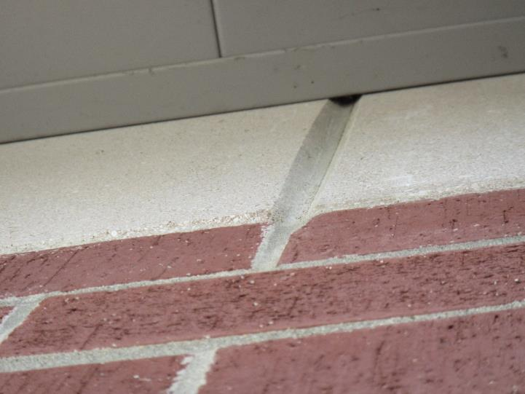

**Metal and brick with unsealed seam that allows hot, humid air into building interior**

**Picture 2**

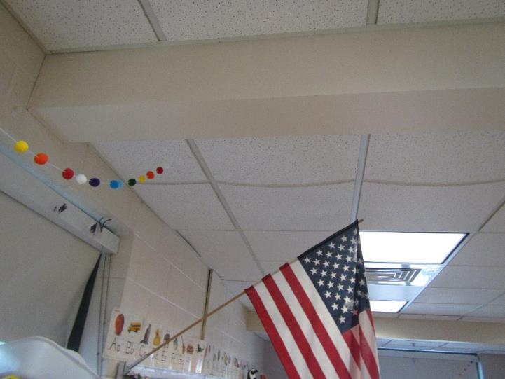

**Bowing ceiling tiles in classroom adjacent to open seams in Picture 1**

**Picture 3**

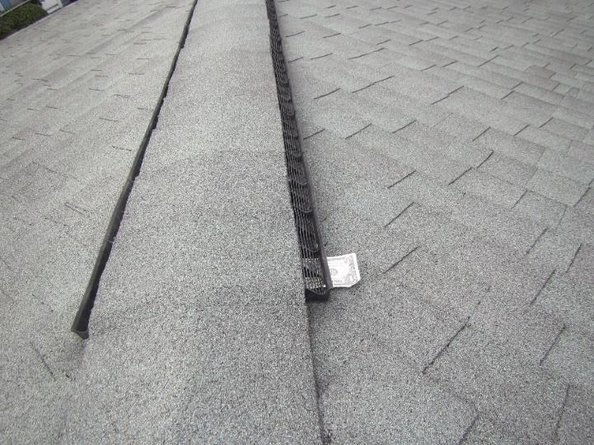

**Hip roof vent**

**Picture 4**

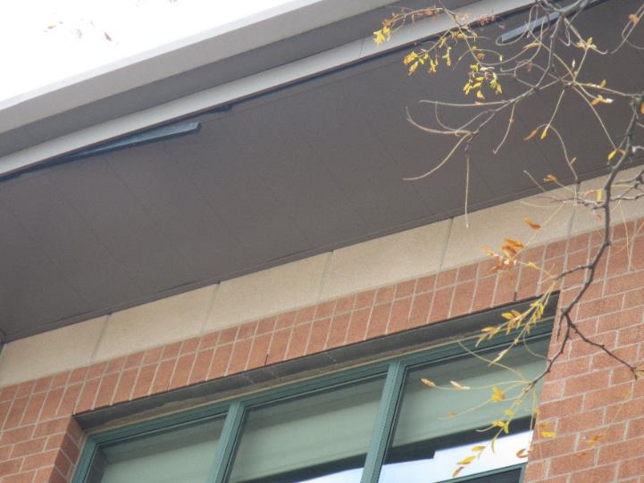

**Material hanging from soffit vent that may have been used to seal soffit vent**

| Location | **Temp**  **(°F)** | **Relative**  **Humidity (RH)**  **(%)** | **RH Difference compared to outdoors** | **Bowing ceiling tiles** | **Remarks** |
| --- | --- | --- | --- | --- | --- |
|
| Background (Outdoors) 11:00 AM | 75 | 61 |  |  | Sunny |
| 101 | 74 | 63 | +2 | N | Dehumidifier, rusty exhaust vent |
| 102 | 74 | 55 | -6 | Y | Dehumidifier blocked due to placement, rust/condensation on ceiling univent, moisture/condensation on supply vent, loose ceiling tiles |
| 103 | 74 | 64 | +3 | Y | Dehumidifier |
| 104 | 74 | 66 | +5 | Y |  |
| 105 | 71 | 54 | -7 | Y |  |
| 106 | 72 | 66 | +5 | N |  |
| 107 | 73 | 66 | +5 | N |  |
| 108 | 75 | 64 | +3 | N | Dehumidifier |
| 109 | 75 | 65 | +4 | N | Dehumidifier, univent partially blocked, exhaust vent blocked |
| 110 | 73 | 66 | +5 | N | Dehumidifier |
| 111 | 75 | 60 | -1 | N | Dehumidifier |
| 112 | 74 | 63 | +2 | N |  |
| 201 | 74 | 61 | 0 | Y | Dehumidifier |
| 202 | 75 | 61 | 0 | Y |  |
| 203 | 76 | 57 | -4 | Y |  |
| 204 | 75 | 62 | +1 | Y |  |
| 205 | 74 | 62 | +1 | Y | Dehumidifier |
| 206 | 77 | 55 | -6 | Y | Dehumidifier |
| 207 | 75 | 61 | 0 | Y | Rust/condensation around univent |
| 208 | 75 | 65 | +4 | Y |  |
| 209 | 74 | 63 | +2 | Y |  |
| 210 | 73 | 63 | +2 | N | Dehumidifier |
| 211 | 73 | 64 | +3 | N | Dehumidifier |
| 212 | 73 | 63 | +2 | Y | Dehumidifier |
| 213 | 75 | 61 | 0 | Y | Dehumidifier |
| 214 | 74 | 63 | +2 | Y | Dehumidifier |
| 215 | 73 | 64 | +3 | Y |  |
| 216 | 73 | 63 | +2 | Y |  |
| 217 | 71 | 64 | +3 | Y | Dehumidifier |
| 218 | 72 | 63 | +2 | N | Dehumidifier |
| 219 | 72 | 64 | +3 | Y |  |
| 301 | 74 | 61 | 0 | Y | Dehumidifier |
| 302 | 75 | 61 | 0 | Y |  |
| 303 | 75 | 61 | 0 | Y |  |
| 304 | 75 | 60 | -1 | N | Dehumidifier |
| 305 | 75 | 60 | -1 | N | Univent not working, window air conditioner installed |
| 307 | 79 | 60 | -1 | Y | Dehumidifier |
| 308 | 71 | 61 | 0 | N |  |
| 309 | 76 | 59 | -2 | Y |  |
| 310 | 75 | 61 | 0 | Y |  |
| 311 | 74 | 64 | +3 | N |  |
| 312 | 75 | 61 | 0 | Y | Wall exhaust vent blocked |
| 313 | 76 | 62 | +1 | Y | Wall exhaust vent blocked, univent partially blocked |
| 314 | 75 | 61 | 0 | Y |  |
| 315 | 76 | 62 | 1 | Y | Wall exhaust vent blocked |
| 316 | 75 | 63 | +2 | Y | Wall exhaust vent partially blocked |
| 317 | 75 | 61 | 0 | Y | Wall exhaust vent blocked, dehumidifier |
| 320 | 74 | 62 | +1 | Y |  |
| 322 | 76 | 60 | -1 | Y |  |
| 323 | 76 | 60 | -1 | Y |  |
| 325 | 75 | 60 | -1 | Y |  |
| Cafeteria | 74 | 63 | +2 | N |  |
| Gym | 74 | 62 | +1 | N |  |
| Gym | 75 | 64 | +3 | N |  |
| Library | 75 | 60 | -1 | N | Hole in ceiling |
| Main Office | 73 | 63 | +2 | Y |  |
| Nurse | 73 | 61 | 0 | Y |  |
| Office 1 | 75 | 60 | -1 | N |  |
| Office 2 | 76 | 61 | 0 | N |  |
| Office 3 | 76 | 59 | -2 | N | Dehumidifier |
| Office 4 | 75 | 60 | -1 | N |  |
| Principal’s Office | 74 | 63 | +2 | N |  |
| Teacher Planning Room | 75 | 61 | 0 | Y |  |
| Teacher Work Room | 76 | 59 | -2 | Y | Dehumidifier |