**INDOOR AIR QUALITY**

**POST-OCCUPANCY ASSESSMENT**

**Department of Children and Families Greenfield Area Office**

**143 Munson Street, Unit 4**

**Greenfield, MA**

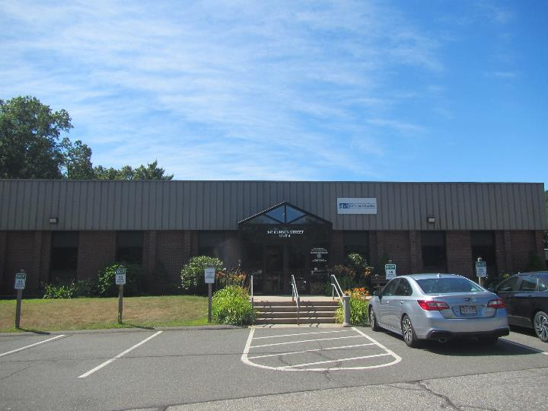

Prepared by:

Massachusetts Department of Public Health

Bureau of Climate and Environmental Health

Division of Environmental Health Regulations and Standards

July 2025

# BACKGROUND

|  |  |
| --- | --- |
| Building: | Department of Children and Families (DCF) Greenfield Area Office |
| Address: | 143 Munson Street, Unit 4, Greenfield MA |
| Assessment Requested by: | Jamie Merrill Blood, Regional Planner, Senior Project Manager, Division of Capital Asset Management & Maintenance (DCAMM),  Office of Leasing and State Office Planning |
| Reason for Request: | Post-occupancy indoor air quality (IAQ) assessment. |
| Date of Assessment: | July 23, 2025 |
| Massachusetts Department of Public Health/Bureau of Climate and Environmental Health (MDPH/BCEH) Staff Conducting Assessment: | Thomas Murphy, Environmental Analyst, Division of Environmental Health Regulations and Standards (EHRS) |
| Building Description: | The DCF is in a square brick building with a flat roof most likely built in the 2000s. Significant renovations to the space included new flooring/carpeting, ceilings, room additions, removing walls, creating open office concept models, painting, furnishings, and HVAC ductwork. |
| Windows: | Not openable |

Note that this building was visited several times by DPH for an IAQ assessment before the renovations. Reports from the most recent assessments can be found at <https://www.mass.gov/info-details/indoor-air-quality-reports-cities-and-towns-g#greenfield>

# METHODS

Please refer to the IAQ Manual for methods, sampling procedures, and interpretation of results (MDPH, 2015).

# RESULTS AND DISCUSSION

The following is a summary of indoor air testing results (Table 1).

* ***Carbon dioxide*** measurements were below the MDPH guideline of 800 parts per million (ppm) in all areas tested, indicating adequate air exchange at the time of assessment.
* ***Temperature*** was within or slightly below the recommended range of 70°F to 78°F in all areas.
* ***Relative humidity*** was within the recommended range of 40% to 60% in all areas.
* ***Carbon monoxide*** levels were non-detectable (ND) in all indoor areas tested.
* ***Fine particulate matter (PM2.5)*** concentrations were below the National Ambient Air Quality Standard (NAAQS) level of 35 μg/m3 in all areas tested.
* ***Total Volatile Organic Compounds***were ND in all areas tested.

## Ventilation

A heating, ventilating, and air conditioning (HVAC) system has several functions. First, it provides heating and, if equipped, cooling. Second, it is a source of fresh air. Finally, a HVAC system will dilute and remove normally occurring indoor environmental pollutants by not only introducing fresh air but also filtering the airstream and ejecting stale air outdoors via exhaust ventilation. Even if an HVAC system is operating as designed, point sources of respiratory irritation may exist and affect symptoms in sensitive individuals.

The HVAC system consists of air handling units (AHUs) on the roof (Picture 1) which draw in outside air and heat/cool it. Fresh air is supplied to the DCF through ceiling-mounted supply vents (Picture 2) and returned to the system through ceiling-mounted return/exhaust vents (Picture 3).

The HVAC system should be equipped with filters of at least a minimum efficiency reporting value (MERV) of 8 which are adequate for filtering out pollen and mold spores (ASHRAE, 2012). Higher MERV ratings can be used to further reduce airborne particulates if the systems are capable of handling it without a loss of flow or mechanical issues. Filters should be changed at least twice a year, or more frequently if recommended by the manufacturer. The AHUs, which were not assessed during this visit, should be vacuumed/cleaned during filter changes.

Thermostats in the DCF were observed to be set to “fan auto” (Picture 4). In the rear hallway female restroom, the supply vent and two exhaust vents were not operating when tested, preventing the introduction of fresh air and removal of odors and moisture. Dust was visibly observed on several exhaust vents in the DCF including this restroom (Picture 5; Table 1). The MDPH/BCEH recommends that HVAC controls be set to have the fan *on* to provide *continuous* air filtration and circulation throughout the space when the building is occupied, rather than only providing fresh air when a change in temperature is required.

To have proper ventilation with a mechanical ventilation system, the systems must be balanced after installation to provide an adequate amount of fresh air to the interior of a room while removing stale air from the room. It is recommended that HVAC systems be re-balanced every five years and after significant renovations to ensure adequate air systems function (SMACNA, 1994). According to DCAMM staff, the HVAC system was re-balanced in June 2025.

## Microbial/Moisture Concerns

Plants were found in at least two locations (Picture 6; Table 1). Plants can be a source of pollen, odors, and mold, particularly if not well cared for. Plants should be placed on non-porous drip pans that are cleaned periodically and should not be overwatered.

A liquid spill was observed in the kitchen refrigerator (Picture 7). Appliances such as refrigerators, toasters, and microwaves should be kept clean and free from spills to avoid smoke, odors, mold growth, and attracting pests. Food was also observed in some areas (Picture 8; Table 1). Food should be kept in tightly-sealed, pest-resistant containers when not in use.

In the public area of the DCF there is a restroom equipped with a shower for visitors to use. The exhaust vent in this restroom should remain on during all occupied periods to remove excess moisture. If the shower will not be used for several weeks, water should be poured down the drain periodically to ensure the trap remains sealed with water. There is a washing machine available for use in an adjacent room. It should be monitored for any leaks and repaired accordingly. No vent was found for the dryer, which was along an interior wall. Unless the dryer is intended to be used without a vent, it should be vented to the outdoors in some manner to remove heat and moisture from operation. Lint traps and dryer vents should be cleaned regularly to avoid lint buildup that may lead to a fire.

Water dispensers were observed in common areas. Use of a waterproof mat underneath these types of appliances, or keeping them on a non-carpeted area, can help prevent water damage.

### Building Envelope Concerns

Plants and bushes were observed in contact with and near the exterior foundation (Picture 9). Plants near the building can cause water damage to the DCF’s foundation. Additionally, plants shading exterior walls can slow drying. Water can eventually penetrate the foundation, subsequently freezing and thawing during the winter. This freezing/thawing action can weaken and damage the DCF’s exterior components.

Trees were also noted very close to the building (Picture 10). The presence of large trees can enhance water retention, prevent drying of the exterior, and affect drainage as well as overhang the roof. These trees pose several hazards:

* Leaves and other debris accumulate around gutters, which inhibits rainwater drainage. Clogged gutters and/or ineffective drains can lead to water moistening exterior walls.
* Trees prevent sunlight from drying walls and soil.
* The trees are a possible danger due to the distance from exterior walls:
  + The recommended safe distance that any tree should be planted is the minimum of the expected maximum growth height of the species from the exterior of a building (BI, 2015).
  + Soil subsidence may also be caused by tree roots, which can undermine the structure of a building to cause wall and floor cracking and related damage. To prevent subsidence, a sufficient distance appropriate for the tree species is recommended (Williams, 2006).
  + Severe weather may result in the tree falling onto the building or the tree roots damaging the foundation. Due to the height of the trees, each is likely located closer than recommended distances.
* In general, a tree root system will spread out in all directions from its trunk. In some cases, tree roots can extend for over 100 feet from their trunk. Any structure disrupting the root structure may make the tree unstable if subjected to high winds from a certain direction. Based on the location, the foundation walls likely disrupt the roots of several trees.
* The Federal Emergency Management Agency (FEMA) provides several recommendations in order to prepare for severe thunderstorms. Of note FEMA recommends “Cut down or trim trees that may be in danger of falling on your [building]” (FEMA, 2018).

## Other IAQ Concerns

Testing was conducted for total volatile organic compounds (TVOCs). All measurements were non-detect (ND). An examination was conducted for products that may be a source of VOCs in indoor air. Disinfectant wipes and a disinfectant spray were observed (Pictures 11 and 12; Table 1). VOCs from these products can build up and lead to irritation of the mucous membranes. Consult “[Clean Air Is Odor Free](https://www.mass.gov/doc/clean-air-is-odor-free-removing-fragrances-to-improve-indoor-air-quality-in-schools-and-offices-0/download)” for more information on fragrances in buildings.

Cardboard boxes and other items were noted on the floor in some areas (Picture 13; Table 1). While these are reported to be from the recent move after renovations, items should be stored up off the floor to allow for thorough cleaning. These items can also become attractive to pests as harborage if not moved.

As previously mentioned, it was observed exhaust vents including in the restrooms had accumulated dust/debris. At least one supply vent was also noted to have accumulated dust/debris (Picture 14; Table 1). This dust can be aerosolized under certain conditions and can also be a medium for mold growth. At least one small personal fan was noted in an office. All supply vents, exhaust vents, and personal fans should be checked and cleaned consistently to remove any dust.

Multiple pieces of upholstered furniture were noted (Table 1). Upholstered furniture should be cleaned regularly to remove dust and debris.

A fair amount of the DCF is carpeted. Carpets should be cleaned regularly in accordance with Institute of Inspection, Cleaning and Restoration Certification (IICRC) recommendations (IICRC, 2012).

At least one carbon dioxide sensor system was observed in the conference room to measure the level of carbon dioxide (Picture 15; Table 1). At the time of the assessment, this sensor appeared to be calibrated/operational, as the reading was similar to MDPH/BCEH measurements. During a discussion with DCAMM staff, they were unable to identify what pre-defined threshold level of carbon dioxide would trigger the sensor of an exceeding amount. MDPH/BCEH guidelines recommend carbon dioxide levels less than 800 parts per million are preferred. It is worth noting that this system needs to be regularly calibrated/maintained in accordance with the manufacturer’s instructions to ensure proper operation.

# CONCLUSIONS/RECOMMENDATIONS

In view of the findings at the time of the visit, the following recommendations are made:

## Ventilation recommendations

1. Air handling units should be equipped with MERV 8-rated filters (or higher), which are adequate to filter out pollen and mold spores. Filters should be changed 2-4 times a year, or as per the manufacturers’ recommendations.
2. Vacuum and clean air handling units during filter changes.
3. Operate the HVAC system (supply/exhaust) to provide for *continuous* fresh air ventilation during occupied hours and switch all thermostats from the “fan auto” setting to “fan on”.
4. Ensure that all exhaust vents are operating during occupied hours.
5. Have the HVAC system balanced every 5 years in accordance with SMACNA recommendations (SMACNA, 1994).

## Water damage recommendations

1. Keep indoor plants in good condition and place them on waterproof drip pans that can be cleaned/sanitized.
2. Keep refrigerators and other kitchen appliances clean to prevent smoke and odors.
3. Store all food in tightly-sealed pest-resistant containers when not in use.
4. Ensure the drain in the shower is wetted every week to keep the trap seal intact if the shower is not used regularly.
5. Monitor the washing machine for any leaks and repair accordingly.
6. Unless the dryer is intended to operate without a vent, vent it to the outdoors. Clean the lint trap and dryer vent regularly.
7. Keep water dispensers on non-carpeted areas or use a waterproof mat to prevent water damage.
8. Trim back any bushes/shrubbery to a distance at least 5 feet away from the DCF foundation walls.

## Other recommendations

1. Use VOC-containing products in areas with good ventilation and keep tightly closed when not in use. Avoid products with strong scents and avoid mixing incompatible products.
2. Refer to “[Clean Air Is Odor Free](https://www.mass.gov/doc/clean-air-is-odor-free-removing-fragrances-to-improve-indoor-air-quality-in-schools-and-offices-0/download)” for more information on fragrances in buildings.
3. Ensure cardboard boxes and other items are stored off the floor and in appropriate locations as soon as possible, to make thorough cleaning easier.
4. Clean dust/debris from all supply and exhaust vents in the DCF.
5. Periodically dust the blades of personal fans.
6. Clean upholstered furniture regularly.
7. Clean carpeting in accordance with IICRC recommendations (IICRC, 2012); annually (or semi-annually in soiled/high traffic areas).
8. Institute a regular program/preventative maintenance system to ensure carbon dioxide sensor integrity and proper HVAC operation.
9. Identify a pre-defined threshold level of carbon dioxide in accordance with MDPH/BCEH guidelines that would trigger the carbon dioxide sensor to activate the HVAC system to increase fresh air.
10. Consider installing/using more indoor air sensors to measure information such as carbon dioxide levels throughout the entire DCF. As indoor air sensors become more sophisticated and less expensive, they can be placed in more buildings to measure and provide accurate, real-time information via an application or web-based dashboard, eliminating the need for personnel to take measurements with hand-held equipment.
11. Consider adding HEPA-equipped air purifiers with or without a carbon filter which can be used to provide additional filtration. Avoid using units that may contain ozone and keep equipment in good repair including filter changes. Where possible, have the outlet of the unit in the breathing zone of occupants for better function.
12. Use guidance in [construction and renovation generated pollutants in occupied buildings](https://www.mass.gov/info-details/construction-and-renovation-generated-pollutants-in-occupied-buildings) to prevent issues when nearby spaces are under renovations.
13. Refer to resource manual and other related IAQ documents located on the MDPH’s website for further building-wide evaluations and advice on maintaining public buildings. These documents are available at: <http://mass.gov/dph/iaq>.

## Long-term recommendations

1. Consider removing all trees preventing drying of the DCF exterior walls and roof or able to damage the building if they fall.

# REFERENCES

ASHRAE. 2012. American Society of Heating, Refrigeration and Air Conditioning Engineers (ASHRAE) Standard 52.2-2012 -- Method of Testing General Ventilation Air-Cleaning Devices for Removal Efficiency by Particle Size (ANSI Approved).

BI. 2015. A List of Trees and the Recommended Safe Distance from Buildings. Bickers Insurance, Littlehampton, West Sussex, UK. <https://www.bickersinsurance.co.uk/about-us/latest-news/property-owners-news/a-list-of-trees-and-the-recommended-safe-distance-from-buildings/>

FEMA. 2018. How to Stay Safe When a Thunderstorm Threatens. Federal Emergency Management Agency, Washington, DC. FEMA V-1009/May 2018.

IICRC. 2012. Institute of Inspection, Cleaning and Restoration Certification. Carpet Cleaning: FAQ.

MDPH. 2015. Massachusetts Department of Public Health. Indoor Air Quality Manual: Chapters I-III. Available at: <https://www.mass.gov/lists/indoor-air-quality-manual-and-appendices>.

SMACNA. 1994. HVAC Systems Commissioning Manual. 1st ed. Sheet Metal and Air Conditioning Contractors’ National Association, Inc., Chantilly, VA.

Williams, A. 2006. The Distance at Which Trees Can Affect a Building is Quite Significant. The Architects’ Journal. <https://www.architectsjournal.co.uk/home/the-distance-at-which-trees-can-affect-a-building-is-quite-significant/130858.article>

**Picture 1**

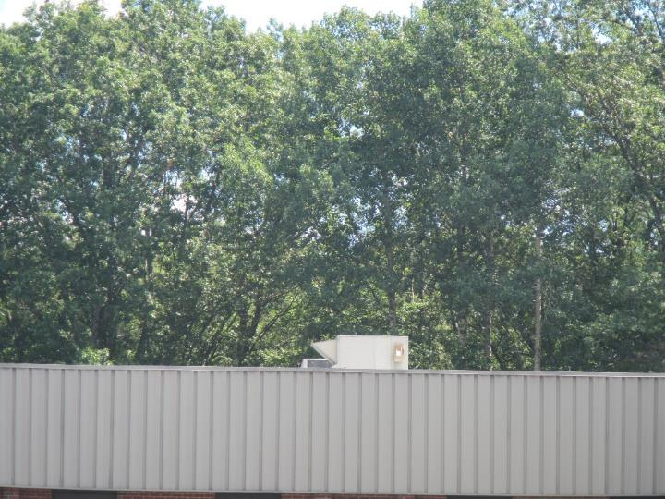

**Air handling unit on the roof**

**Picture 2**

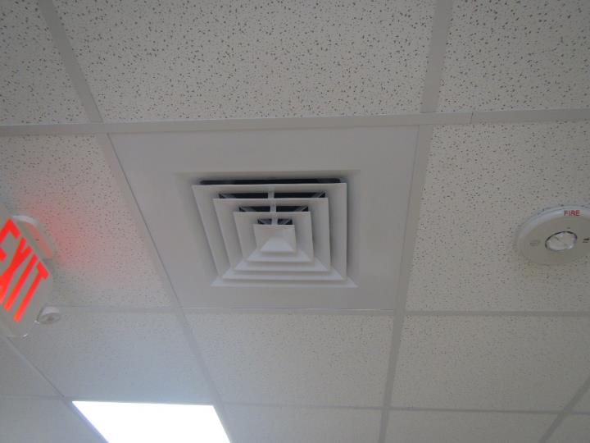

**Typical supply vent**

**Picture 3**

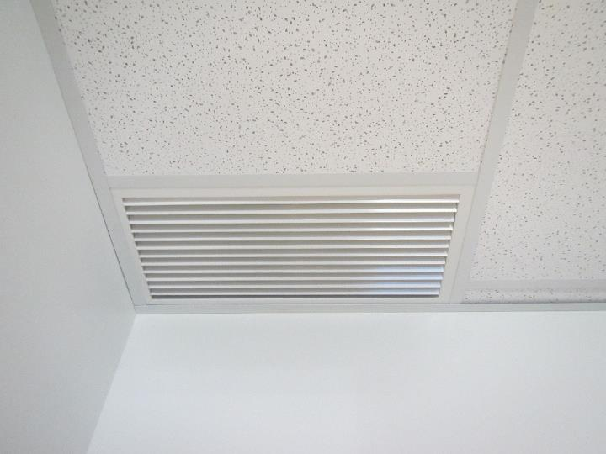

**Typical return/exhaust vent**

**Picture 4**

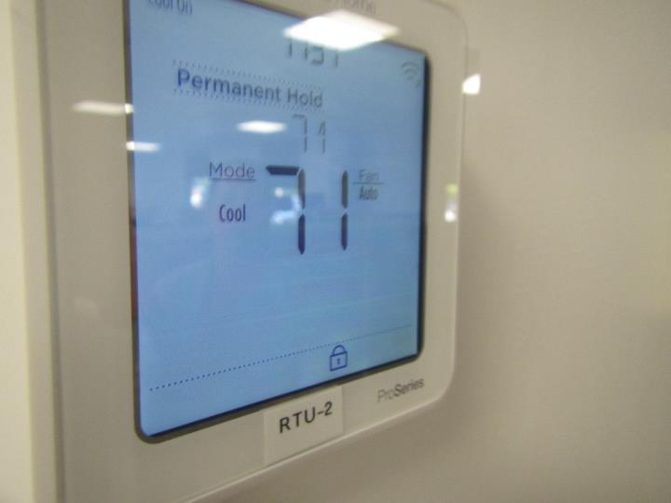

**Thermostat showing “fan auto” setting**

**Picture 5**

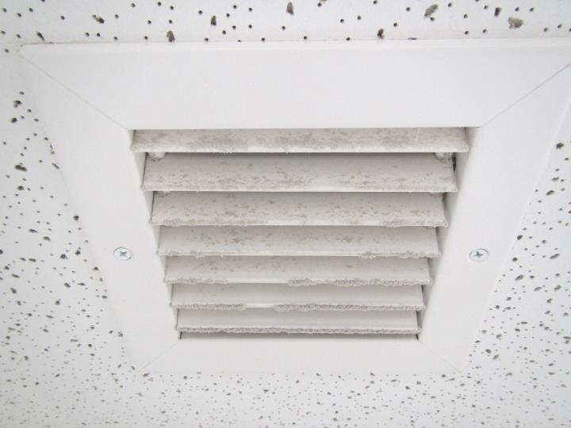

**Dusty exhaust vent which was not operating in rear hallway female restroom**

**Picture 6**

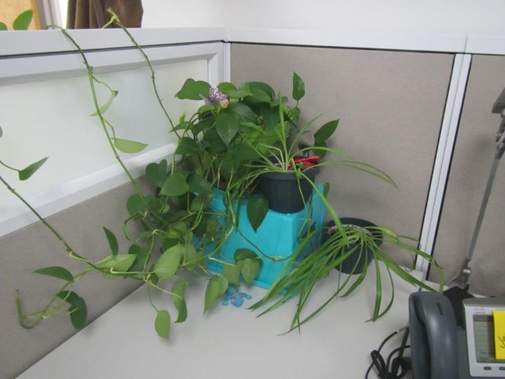

**Plants without drip pans on a desk**

**Picture 7**

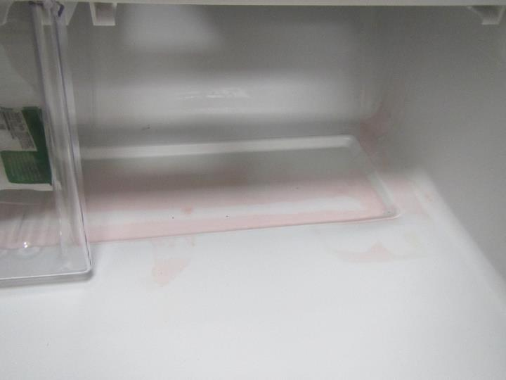

**Liquid spill in kitchen refrigerator**

**Picture 8**

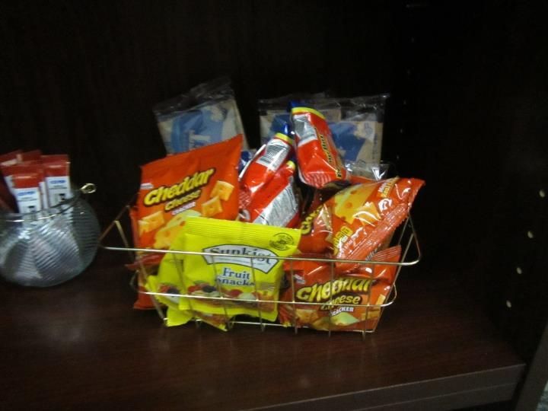

**Food in an office**

**Picture 9**

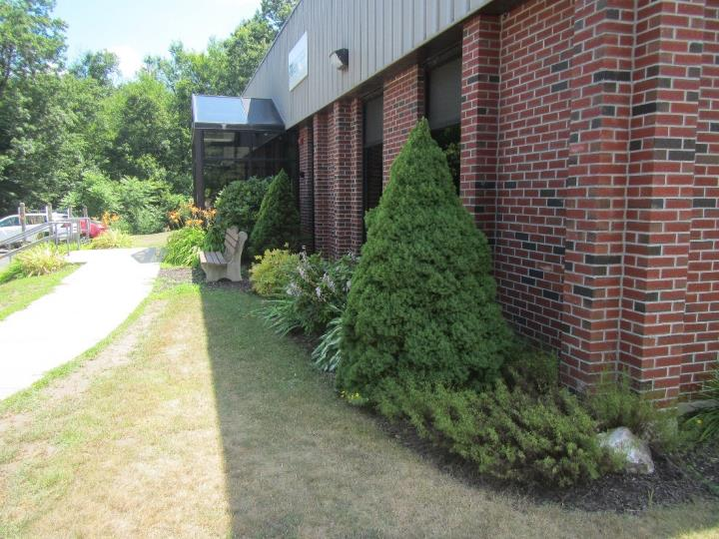

**Plants and shrubbery in contact with and near the exterior foundation**

**Picture 10**

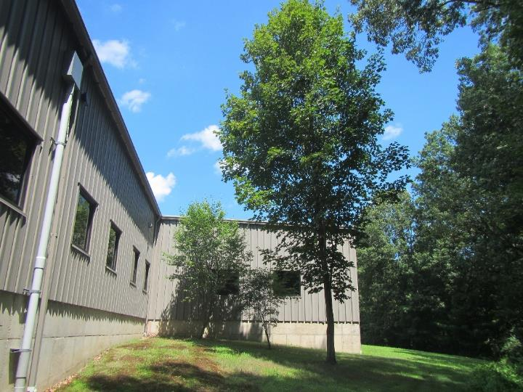

**Trees close to the building (note shade on side of building including near window)**

**Picture 11**

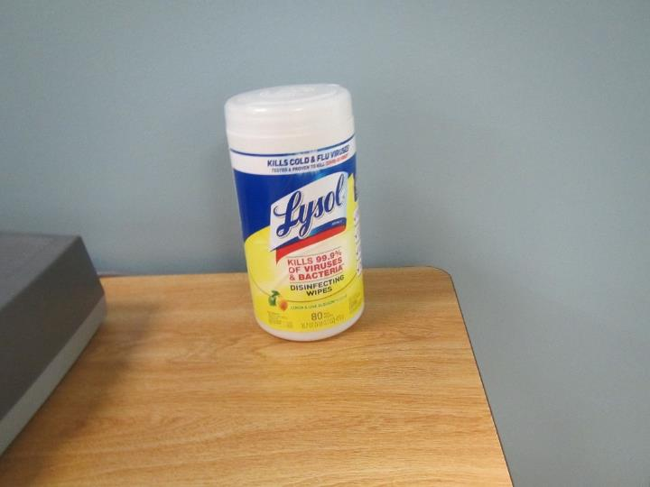

**Disinfectant wipes on table**

**Picture 12**

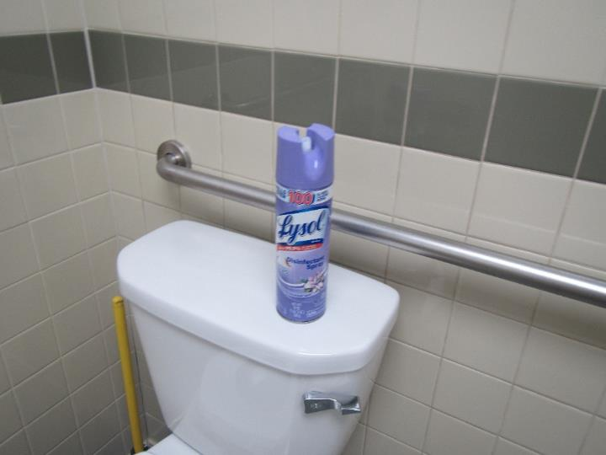

**Disinfectant spray in restroom**

**Picture 13**

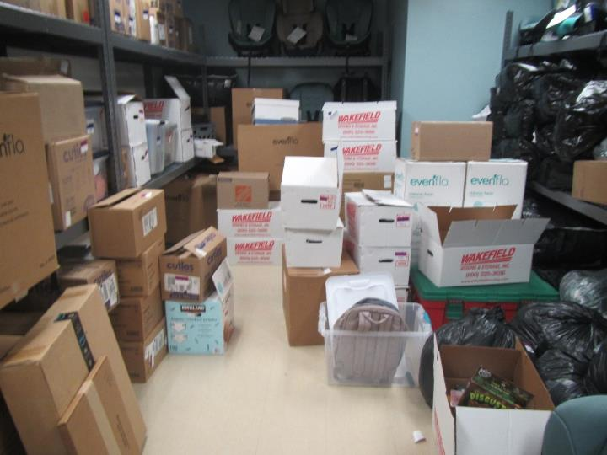

**Carboard boxes on floor**

**Picture 14**

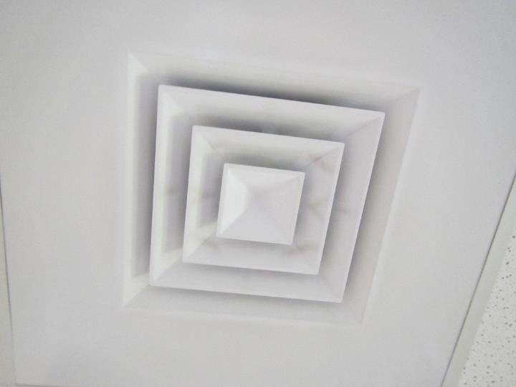

**Dusty supply vent**

**Picture 15**

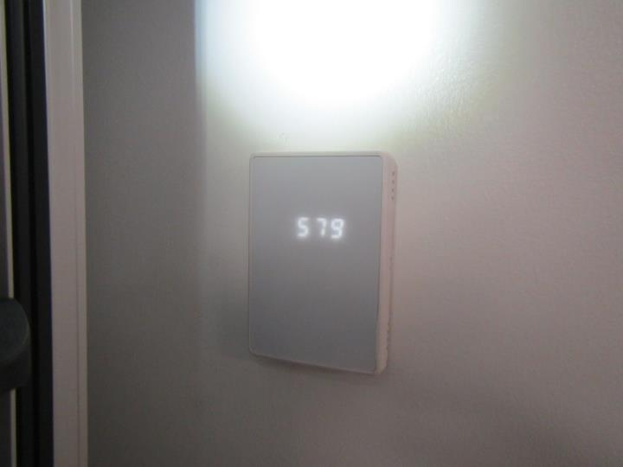

**Carbon dioxide sensor on wall**

| **Location** | **Carbon**  **Dioxide**  **(ppm)** | **Carbon Monoxide**  **(ppm)** | **Temp**  **(°F)** | **Relative**  **Humidity**  **(%)** | **PM2.5**  **(µg/m3)** | **TVOC**  **(ppm)** | **Occupants**  **in Room** | **Windows**  **Openable** | **Ventilation** | | **Remarks** |
| --- | --- | --- | --- | --- | --- | --- | --- | --- | --- | --- | --- |
| **Supply** | **Exhaust** |
| Background | 409 | ND | 86 | 37 | 1 | ND |  |  |  |  | Sunny |
| Visitor Area | | | | | | | | | | | |
| Lobby | 691 | ND | 74 | 50 | ND | ND | 2 | N | Y | Y |  |
| 103 | 764 | ND | 74 | 53 | 1 | ND | 0 | N | Y | Y |  |
| 104 | 708 | ND | 73 | 52 | ND | ND | 0 | N | Y | Y |  |
| 105 | 636 | ND | 72 | 57 | 1 | ND | 1 | N | Y | Y |  |
| 106 | 653 | ND | 72 | 54 | ND | ND | 0 | N | Y | Y | Furniture |
| 107 | 655 | ND | 71 | 54 | ND | ND | 0 | N | Y | Y |  |
| 108 | 609 | ND | 71 | 55 | ND | ND | 0 | N | Y | Y |  |
| 109 | 723 | ND | 75 | 51 | ND | ND | 0 | N | Y | Y |  |
| 110 | 687 | ND | 72 | 53 | 1 | ND | 0 | N | Y | Y |  |
| 111 | 652 | ND | 72 | 54 | 1 | ND | 1 | N | Y | Y | Cardboard boxes on floor |
| 112 | 728 | ND | 71 | 54 | 1 | ND | 0 | N | Y | Y | Washing machine, dryer, attached restroom with shower |
| 117 | 638 | ND | 71 | 54 | 1 | ND | 1 | N | Y dusty | Y | Cardboard boxes on floor |
| Lobby Restroom Left | 662 | ND | 71 | 55 | ND | ND | 0 | N | Y | Y |  |
| Lobby Restroom Right | 675 | ND | 72 | 54 | 1 | ND | 0 | N | Y | Y dusty |  |
| Non-Visitor Area | | | | | | | | | | | |
| Cubicles 1 - 3 | 688 | ND | 73 | 53 | ND | ND | 1 | N | Y | Y |  |
| Cubicles 9 - 11 | 719 | ND | 73 | 54 | ND | ND | 1 | N | Y | Y |  |
| Cubicles 12 - 14 | 777 | ND | 73 | 54 | ND | ND | 5 | N | Y | Y | Cleaning products |
| Cubicles 20 - 22 | 727 | ND | 72 | 54 | ND | ND | 2 | N | Y | Y |  |
| Cubicles 23 - 25 | 689 | ND | 71 | 54 | 1 | ND | 0 | N | Y | Y |  |
| Cubicles 31 – 33 | 688 | ND | 71 | 56 | 1 | ND | 1 | N | Y | Y |  |
| Cubicles 34 - 38 | 753 | ND | 73 | 54 | 1 | ND | 1 | N | Y | Y | Plants |
| Cubicles 39 - 41 | 709 | ND | 73 | 50 | ND | ND | 2 | N | Y | Y | Plants |
| Cubicles 47 - 49 | 710 | ND | 73 | 50 | 1 | ND | 1 | N | Y | Y |  |
| 118 | 678 | ND | 73 | 53 | ND | ND | 0 | N | Y | Y |  |
| 124 | 715 | ND | 72 | 53 | ND | ND | 1 | N | Y | Y |  |
| 125 | 690 | ND | 73 | 51 | ND | ND | 0 | N | Y | Y |  |
| 126 | 733 | ND | 73 | 51 | 1 | ND | 0 | N | Y | Y |  |
| 130 | 705 | ND | 72 | 55 | 1 | ND | 0 | N | Y | Y | Cleaning products |
| 134 | 713 | ND | 71 | 54 | ND | ND | 0 | N | Y | Y | Food |
| 136 | 702 | ND | 72 | 53 | 1 | ND | 0 | N | Y | Y |  |
| 137 | 725 | ND | 72 | 53 | 1 | ND | 0 | N | Y | Y |  |
| 140 | 737 | ND | 73 | 52 | ND | ND | 1 | N | Y | Y |  |
| 141 | 718 | ND | 72 | 51 | ND | ND | 0 | N | Y | Y | Microwave, mini refrigerator |
| 142 | 696 | ND | 72 | 50 | ND | ND | 0 | N | Y | Y | Cleaning products |
| 143 | 701 | ND | 72 | 51 | ND | ND | 0 | N | Y | Y |  |
| 144 | 712 | ND | 73 | 50 | ND | ND | 0 | N | Y | Y dusty | Personal fan |
| 145 | 723 | ND | 72 | 51 | 1 | ND | 1 | N | Y | Y dusty | Cardboard boxes on floor |
| 146 | 755 | ND | 72 | 52 | 1 | ND | 2 | N | Y | Y dusty |  |
| 147 | 727 | ND | 72 | 51 | 1 | ND | 0 | N | Y | Y dusty | Cleaning products |
| 149 | 738 | ND | 72 | 51 | 1 | ND | 0 | N | Y | Y | Cardboard boxes on floor |
| 150 | 694 | ND | 73 | 49 | ND | ND | 0 | N | Y | Y |  |
| 152 | 752 | ND | 75 | 49 | ND | ND | 0 | N | Y | Y | Cardboard boxes on floor |
| 153 | 706 | ND | 73 | 50 | ND | ND | 2 | N | Y | Y | Furniture |
| 158 | 676 | ND | 72 | 50 | ND | ND | 0 | N | Y | Y |  |
| 163 | 712 | ND | 73 | 50 | ND | ND | 1 | N | Y | Y |  |
| 165 | 755 | ND | 72 | 51 | ND | ND | 0 | N | Y | Y | Furniture, food |
| 166 | 707 | ND | 72 | 51 | ND | ND | 0 | N | Y | Y |  |
| 167 | 697 | ND | 69 | 57 | 1 | ND | 0 | N | Y | Y |  |
| 171 | 652 | ND | 69 | 53 | 1 | ND | 0 | N | Y | Y |  |
| 172 | 657 | ND | 69 | 54 | 1 | ND | 0 | N | Y | Y |  |
| 173 | 632 | ND | 69 | 54 | 1 | ND | 0 | N | Y | Y |  |
| 176 (kitchen) | 744 | ND | 69 | 55 | 2 | ND | 0 | N | Y | Y | Refrigerator with liquid spill, toaster, microwave, coffee maker, toaster oven |
| 177B | 582 | ND | 69 | 54 | 1 | ND | 0 | N | Y | Y | Carbon dioxide sensor, cardboard boxes on floor |
| 181 | 612 | ND | 71 | 49 | ND | ND | 0 | N | Y | Y dusty |  |
| 182 | 601 | ND | 69 | 52 | ND | ND | 0 | N | Y | Y | Cardboard boxes on floor |
| 185 | 628 | ND | 68 | 55 | 1 | ND | 0 | N | Y | Y | Cardboard boxes on floor |
| 187 | 627 | ND | 68 | 57 | 0 | ND | 0 | N | Y | Y | Cardboard boxes on floor |
| Mail Area | 785 | ND | 73 | 52 | 1 | ND | 3 | N | Y | Y | Cardboard boxes on floor |
| Female Restroom (rear hallway) | 666 | ND | 69 | 55 | 1 | ND | 0 | N | Y off | Y off, dusty |  |
| Male Restroom (rear hallway) | 608 | ND | 68 | 53 | 2 | ND | 0 | N | Y | Y |  |
| Restroom (near mail area) | 652 | ND | 73 | 52 | 2 | ND | 0 | N | Y | Y | Disinfectant spray |