INDOOR AIR QUALITY ASSESSMENT

Greenfield Public Library
402 Main Street
Greenfield, Massachusetts

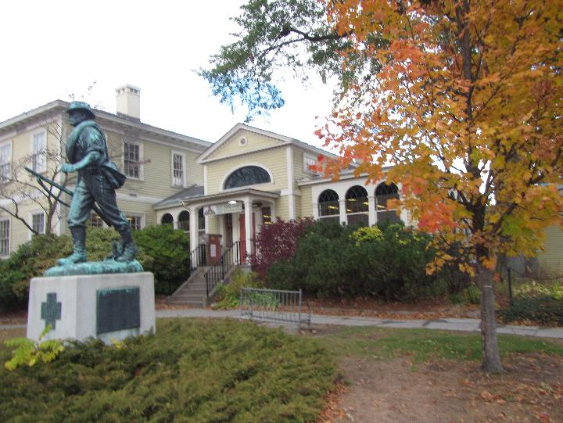

Prepared by:
Massachusetts Department of Public Health
Bureau of Environmental Health
Indoor Air Quality Program
November 2019

Background

Building: | Greenfield Public Library (GPL)
Address: | 402 Main Street  Greenfield, MA
Assessment Requested by: | George VanDelinder, Central Maintenance Director,  Town of Greenfield
Reason for Request: | General indoor air quality (IAQ) and water damage/mold growth concerns
Date of Assessment: | October 18, 2019
Massachusetts Department of Public Health/Bureau of Environmental Health (MDPH/BEH) Staff Conducting Assessment: | Michael Feeney, Director, IAQ Program
Building Description: | The library contains two wings in a split-level configuration. “The library resides in the historic Leavitt-Hovey House, a wooden structure built in 1797, with east and west wings added in 1817. In 1907, the town of Greenfield took the house and property by eminent domain to establish a public library. A 4,000 square foot masonry addition designed to hold the adult book stacks was added to the north of the original building in 1908, and the Greenfield Public Library opened on January 11, 1909. In 1952, a 500 square foot bookmobile garage was added to the east wing” (GPL, 2016). The GPL was renovated in 1998 (MJA & KL., 1998).  The second floor of the 1797 wing is used for administrative offices. The ground floor of the 1907 wing contains a conference room, an office and restrooms. The basement of the 1797 wing is used for storage of books and contains a mechanical room and the custodial office.
Windows: | Openable

Previous Recommendations
An assessment of this building was conducted in 2001, with a report finalized in 2002 including recommendations to improve IAQ based on assessment findings. In the 2002 report, the following recommendations were made (with note indicating action taken):
- Consider replacing carpeting in the basement conference room with tile or other non-porous surface. Note: original carpeting replaced with carpet tile.
- Extend condensation drains to empty at ground level. Note: no extensions appear to have been installed.
- Continue to remove clinging ivy from the exterior walls of the GPL. Note: clinging plants have regrown to cover rear portions of GPL.
- Examine the feasibility of providing mechanical exhaust ventilation for the basement book stacks and the second floor offices. For the second floor offices with univents, examine the feasibility of converting the existing airshafts of the original ventilation system into mechanical systems. Contact an HVAC engineering firm to determine if existing vents, ductwork, etc. can be retrofitted for mechanical ventilation. Note: no remedial efforts regarding exhaust ventilation were taken.
- Install a gutter/downspout system to properly drain rainwater away from the foundation. Note: no gutter system was installed.
Methods
Please refer to the IAQ Manual for methods, sampling procedures, and interpretation of results (MDPH, 2015).

IAQ Testing Results
The following is a summary of indoor air testing results (Table 1).
- Carbon dioxide levels were below the MDPH guideline of 800 parts per million (ppm) in all areas assessed, indicating adequate fresh air in the space at the time of this assessment.
- Temperature was within the recommended range of 70°F to 78°F in all areas assessed.
- Relative humidity was within or close to the lower end of the recommended range of 40% to 60% in areas assessed.
- Carbon monoxide levels were non-detectable (ND) in all areas assessed.
- Fine particulate matter (PM2.5) concentrations measured were below the National Ambient Air Quality Standard (NAAQS) level of 35 μg/m³ in all areas assessed.

The assessment results indicate that the ventilation system is providing adequate fresh air for the occupancy in the building. Note that many areas had low occupancy, which can reduce the creation of carbon dioxide. To maximize air exchange, the BEH recommends that mechanical ventilation systems operate continuously during periods of occupancy. Without the system operating as designed, normally occurring pollutants cannot be diluted or removed, allowing them to build up and lead to IAQ/comfort complaints.

Ventilation
A heating, ventilating, and air conditioning (HVAC) system has several functions. First it provides heating and, if equipped, cooling. Second, it is a source of fresh air. Finally, an HVAC system will dilute and remove normally occurring indoor environmental pollutants by not only introducing fresh air, but by filtering the airstream and ejecting stale air to the outdoors via exhaust ventilation. Even if an HVAC system is operating as designed, point sources of respiratory irritation may exist and cause symptoms in sensitive individuals.
Fresh air is supplied by a unit ventilator (univent) system (Figure 1). Univents draw air from outdoors through a fresh air intake located on the exterior walls of the building and return air through an air intake located at the base of each unit. Fresh and return air are mixed, filtered, heated and provided to rooms through an air diffuser located in the top of the unit. Univents were functioning in the majority of areas examined.
Exhaust ventilation is provided by ceiling-mounted exhaust vents in the first floor library areas. The basement conference room has a wall-mounted exhaust vent, which is connected to a large fan installed on the rear exterior wall. In all areas examined, exhaust vents were deactivated. Without a functional exhaust system, normally occurring environmental pollutants can build-up and lead to indoor air quality complaints.
The administrative offices on the second floor do not have mechanical exhaust ventilation. The roof of the 1797 wing has two chimney-like structures, which appear to be exhaust ventilation airshafts. A large grill in the staff office appears to be connected to the western brick ventilation shaft by ductwork in the attic. A second large grill located at the top of the stairwell from the first floor may be connected to the eastern brick ventilation shaft. The sound of vehicle traffic was noted emanating from this grill, indicating the airshaft is likely open to the outdoors. These vents are not mechanical, but use rising, heated air to draw environmental pollutants from the building. While this system can work well during the heating season to provide exhaust ventilation, the system does not work during the air conditioning season. These vents may also serve as a moisture source during summer weather. Additionally, a number of areas in the basement do not have a mechanical fresh air supply system (Table 1).
It is also important to note that the HVAC system is over 20 years old. Efficient function of equipment of this age is difficult to maintain, since compatible replacement parts are often unavailable. According to the American Society of Heating, Refrigeration and Air-Conditioning Engineering (ASHRAE), the service life for the various components of the HVAC system is between 20 to 30 years, assuming routine maintenance of the equipment (ASHRAE, 1991). Despite attempts to maintain the equipment, the optimal operational lifespan of this equipment has been exceeded.
To maximize air exchange, the IAQ program recommends that both supply and exhaust ventilation operate continuously during periods of building occupancy. In order to have proper ventilation with a mechanical supply and exhaust system, the systems must be balanced to provide an adequate amount of fresh air to the interior of a room while removing stale air from the room. The date of the last servicing and balancing was not available at the time of the assessment. It is recommended that existing ventilation systems be re-balanced every five years to ensure adequate air systems function (SMACNA, 1994).

Microbial/Moisture Concerns
Room B101 had extensive water damage along its western wall (Picture 1). It also appears that repairs were attempted in the past in the form of gypsum wallboard (GW) patches used to fill holes in the base of the plaster wall (Picture 2), as indicated by the presence of paper inside the wall. The use of GW as a patch is inappropriate since the paper backing can become mold-colonized if chronically wet. The likely source of moisture causing this damage is pooling water against the foundation. Cement slabs were placed against the foundation to form a walkway and provide some amount of water drainage from the building. Chronic exposure to rainwater has resulted in the cement slabs subsiding and losing sealant. In addition, the subsidence has created a trench next to the building which will further prevent drainage (Picture 3). Water likely accumulates in the trench, which then penetrates through the exterior wall to damage interior wall plaster and serve as a moisture source for water vapor to accumulate beneath carpet tiles.
Water-damaged ceiling tiles were observed in a number of areas. Some of the observed stained tiles were from roof leaks that have reportedly been repaired. The roof of the building was also examined. The roof membrane had become loose, resulting in pooling water (Picture 4). Debris is also present from tree branches that overhang the roof. Debris holds moisture on the roof, which can damage the membrane and can be attractive to pests.
During the summer of 2018, the Boston area experienced an unprecedented period of extended hot, humid weather. According to the Washington Post, “[d]ata…show[s]…cities in the Northeast have witnessed such humidity levels for record-challenging duration...[i]ncluding Albany, Boston, Burlington Portland and Providence” during the summer of 2018 (WP, 2018). “Boston and nearby locations… [saw]…historic numbers of those warm nights with low temperatures at or above 70 degrees…Providence and Blue Hill Observatory have already broken their annual records” (WP, 2018).
If a building does not have adequate exhaust ventilation and air chilling capacity to remove/reduce relative humidity from outside air, then hot, moist air introduced into a building can linger to increase occupant discomfort as well as possibly moisten materials that may lead to mold growth.
As noted previously, the building is configured in a manner where significant hot, moist air can readily pass into interior of the building. Other sources of hot, humid air impacting the main offices include spaces around the basement door, as well as outdoor exterior doors. Note that both liquid water and water vapor can create conditions conducive to fungal colonization of vulnerable materials. Leaks through the building envelope (e.g., roof, exterior wall components, and foundation) or plumbing issues are obvious water sources. High relative humidity combined with hot weather can also cause damage. Under certain conditions, condensation can accumulate and moisten materials. If these materials are porous, carbon-containing items (e.g., gypsum wallboard, carpeting, cloth, paper, and cardboard), mold can grow.
The key to managing condensation in hot, humid weather indoors is understanding dew point. When warm, moist air passes over a cooler surface, condensation can form. Condensation is the collection of moisture on a surface at or below the dew point. The dew point is the temperature that air must reach for saturation to occur. If a building material/component has a temperature below the dew point, condensation will accumulate on that material. Over time, condensation can collect and form water droplets.
According to American Society of Heating, Refrigerating and Air-Conditioning Engineers (ASHRAE), if relative humidity exceeds 70%, mold growth may occur due to wetting of building materials (ASHRAE, 1989). It is recommended that porous material be dried with fans and heating within 24 to 48 hours of becoming wet (US EPA, 2008, ACGIH, 1989). If porous materials are not dried within this time frame, mold growth may occur. Water-damaged porous materials cannot be adequately cleaned to remove mold growth.

Building Materials Prone to Condensation
A method to locate areas in a building prone to condensation would be to measure air and building material temperatures. If a wide temperature range exists between measurements, the building materials at the colder end of the range may be prone to becoming moistened with condensation in hot, humid weather.
Using a laser thermometer, the surface temperature of the following locations were measured: interior walls, window frames, GW in close proximity to the floor, and floor temperature approximately five feet (5′) from exterior walls. Air temperature and relative humidity were also measured. Several conditions were noted (Table 2):
- Measurement of wall temperature was done during a clear day with solar heating. Wall temperatures measured in a range from 59 to 63°F, while the indoor temperature was in a range of 70 to 72°F. The difference in temperature indicates that the walls are not insulated or energy efficient and can serve as thermal bridges. Where a thermal bridge exists, condensation is likely to form on the warm side of the cold object, which can moisten materials, such as plaster.
- Floor temperatures were also measured in a range from 59 to 63°F, while the indoor temperature was in a range of 70 to 72°F. The floor is likely not insulated and can serve as a thermal bridge, leading to potential condensation on the floor, which can moisten carpeting and items placed on the floor.

In each of these instances, the lower temperature of the floors and walls combined with the presence of thermal bridges in addition to possible water penetration through the cement floor from poorly draining rainwater (rooms B101/B103) make these materials vulnerable to moistening and mold growth under the weather conditions experienced in Massachusetts over the summer of 2018.

Exterior Conditions Impacting the Building
An oak tree exists near the southeast corner of the GPL property, which overhangs the roof (Picture 5). This tree poses a number of hazards to the GPL as well as a possible danger to free egress for the Greenfield Fire Department (GFD) from its firehouse driveway:
- As reported by Greenfield public officials, the roots of the oak tree are entering sewer pipes for the GPL, resulting in blockage.
- Leaves and acorns accumulate around the flat roof drain, which creates a dam that inhibits rainwater drainage from the roof. This condition can also lead to ice accumulation blocking this drain, which can lead to water running off the roof to moisten exterior walls.
- The oak tree prevents sunlight from drying the eastern wall of the GPL.
- The oak tree is a possible danger to the GPL due to its distance from its exterior walls. The recommended safe distance from which an oak tree should be planted is recommended to be approximately 98 feet (33 yards) from the exterior of a building (BI, 2015). Soil subsidence may also be caused by oak tree roots, which can undermine the structure of a building to cause wall and floor cracking as well as other related damage. To prevent subsidence, a 98 feet distance is recommended (Williams, A. 2006). Within this distance, severe weather may result in the tree falling onto the GPL or having the tree roots damage the sewer service. The oak tree is well within 98 feet from the building.
- Also of note is resistance of the oak tree to uprooting during high wind events. In general a tree root system will spread out in all directions from its trunk. As noted previously, an oak tree root can extend in a 196 foot diameter from its trunk. Any structure disrupting the root structure would then to make the tree unstable if subjected to high winds from a certain direction. The east side of the tree has its root system disrupted by a sidewalk and the driveway of the GFD (Picture 6). A strong westerly wind would make the oak tree prone to falling eastward to block the GFD driveway. If the oak tree is subjected to strong southeasterly winds, which are rare but possible, it is feasible that the tree can uproot to fall on the GPL.

The Federal Emergency Management Agency (FEMA) provides a number of recommendations in order to prepare for severe thunderstorms. Of note FEMA recommends “Cut down or trim trees that may be in danger of falling on your [building]” (FEMA, 2018). Given the proximity to the GPL, the damage done to sewer lines and its location near the GFD driveway, removal of the oak tree should be strongly considered.

Conclusions/Recommendations
Based on observations at the time of assessment, the following is recommended:
- Consider implementing recommendations in the 2002 report that have not already implemented. A copy of the 2002 report is attached as Appendix A.
- Remove GW used to repair the basement wall in B103. Repair with an appropriate material (e.g., cement board) that is not susceptible to mold growth.
- To prevent future water damage from rain/groundwater in basement rooms a number of options to improve drainage from the west-facing wall of the 1907 building can be considered:
    - Install a French drain at the base of the wall;
    - Install a water-impermeable apron that resists settling to drain water away from the wall like the tarmac apron installed on the westernmost wall of the building (Picture 7);
    - Install a gutter/downspout system to reduce rainwater impact on the cement slabs. Once installed, reset the cement slabs in a manner to prevent settling.
- It is highly recommended to remove the oak tree from the southwest corner of the building to improve roof drainage and prevent potentially catastrophic damage in severe wind conditions/heavy rain.
- Given the age of the HVAC system, consideration should be given to having a ventilation engineer examine the HVAC system for upgrade or replacement.
- In order to prevent mold growth/water damage to building materials in basement areas during extended hot, humid weather (e.g., heatwave). The following actions are recommended:
    - Operate the fresh air supply and exhaust system in the basement levels continuously when outdoor relative humidity is greater the 70%.
    - Consider raising the temperature set point for the HVAC system in the basement during periods of hot weather when the building is mostly empty of occupants to limit condensation.
    - Use dehumidifiers in the basement areas to supplement humidity reduction during periods of extended heat with high relative humidity (>48 hours):
      - Dehumidifiers need to be properly drained of water and properly cleaned and maintained.
      - Dehumidifiers only need to be used during periods of high outdoor relative humidity (>70%) during a heat wave.
- Refer to resource manual and other related IAQ documents located on the MDPH’s website for further building-wide evaluations and advice on maintaining public buildings. These documents are available at: http://mass.gov/dph/iaq.

References
ACGIH. 1989. Guidelines for the Assessment of Bioaerosols in the Indoor Environment. American Conference of Governmental Industrial Hygienists, Cincinnati, OH.
ASHRAE. 1989. Ventilation for Acceptable Indoor Air Quality. American Society of Heating, Refrigeration and Air Conditioning Engineers. ANSI/ASHRAE 62-1989.
ASHRAE. 1991. ASHRAE Applications Handbook, Chapter 33 “Owning and Operating Costs”. American Society of Heating, Refrigeration and Air Conditioning Engineers, Atlanta, GA.
BI. 2015. A List of Trees and the Recommended Safe Distance from Buildings. Bickers Insurance, Littlehampton, West Sussex, UK. https://www.bickersinsurance.co.uk/about-us/latest-news/property-owners-news/a-list-of-trees-and-the-recommended-safe-distance-from-buildings/
FEMA. 2018. How to Stay Safe When a Thunderstorm Threatens. Federal Emergency Management Agency, Washington, DC. FEMA V-1009/May 2018.
GPL. 2016. Greenfield Public Library 2016-2020 Long Range Plan. Greenfield Public Library, Greenfield, MA. https://greenfieldpubliclibrary.org/files/Long-Range-Plan-2016-2020.pdf
MDPH. 2015. Massachusetts Department of Public Health. Indoor Air Quality Manual: Chapters I-III. Available at: http://www.mass.gov/eohhs/gov/departments/dph/programs/environmental-health/exposure-topics/iaq/iaq-manual/.
MJA & KL. 1998. Blueprint for Addition and Renovations to Greenfield Public Library, Greenfield, Massachusetts. Margo Jones, Architects, Greenfield, MA; Kohler & Lewis, Keene, NH. March 16, 1998. MV-1, MV-2.
SMACNA. 1994. HVAC Systems Commissioning Manual. 1st ed. Sheet Metal and Air Conditioning Contractors’ National Association, Inc., Chantilly, VA.
US EPA. 2008. “Mold Remediation in Schools and Commercial Buildings”. Office of Air and Radiation, Indoor Environments Division, Washington, DC. EPA 402-K-01-001. September 2008. Available at: http://www.epa.gov/mold/mold-remediation-schools-and-commercial-buildings-guide.
Williams, A. 2006. The Distance at Which Trees Can Affect a Building is Quite Significant. The Architects’ Journal. https://www.architectsjournal.co.uk/home/the-distance-at-which-trees-can-affect-a-building-is-quite-significant/130858.article
WP. 2018. ‘It’s been relentless’: Smothering summer humidity in the Northeast has crushed records. Washington Post, Washington, DC. https://www.washingtonpost.com/news/capital-weather-gang/wp/2018/08/30/its-been-relentless-smothering-summer-humidity-in-the-northeast-has-crushed-records/
Picture 1
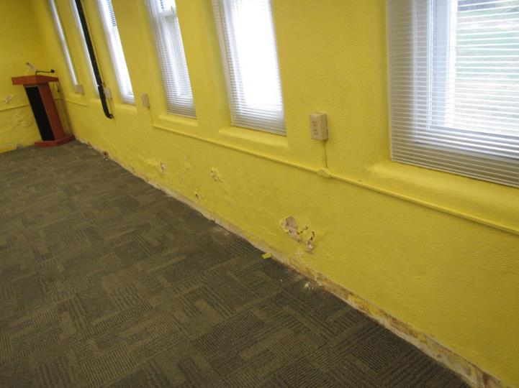
Room B101 had extensive water damage along its western wall
Picture 2
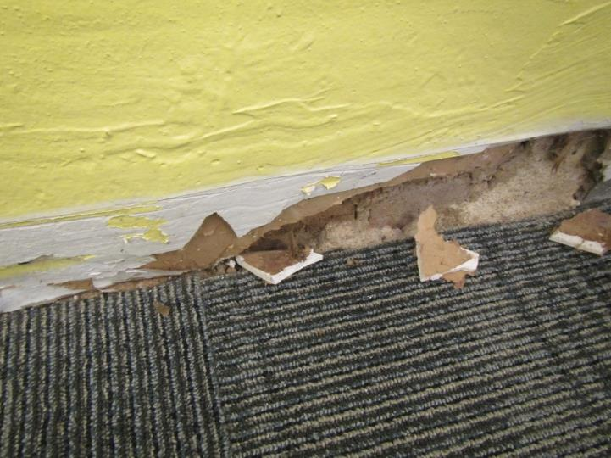
GW inside plaster wall
Picture 3
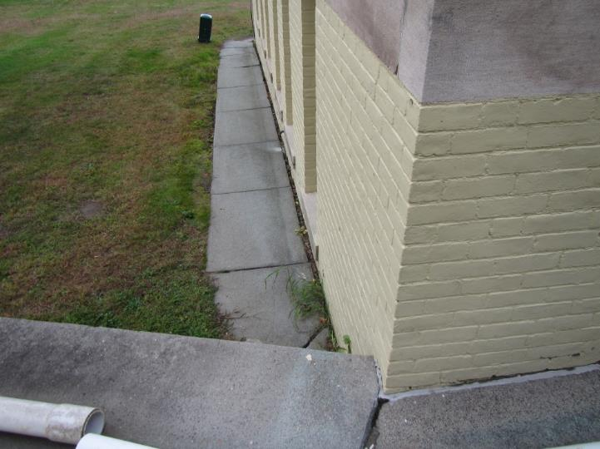
Subsiding and ajar cement slabs at base of west wall
(Note missing sealant in slab/wall junction)
Picture 4
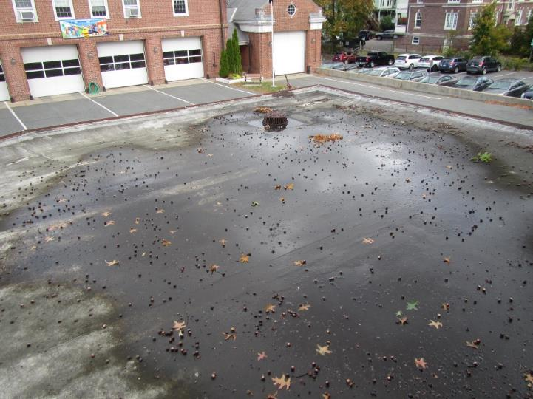
Pooling water on roof
Picture 5
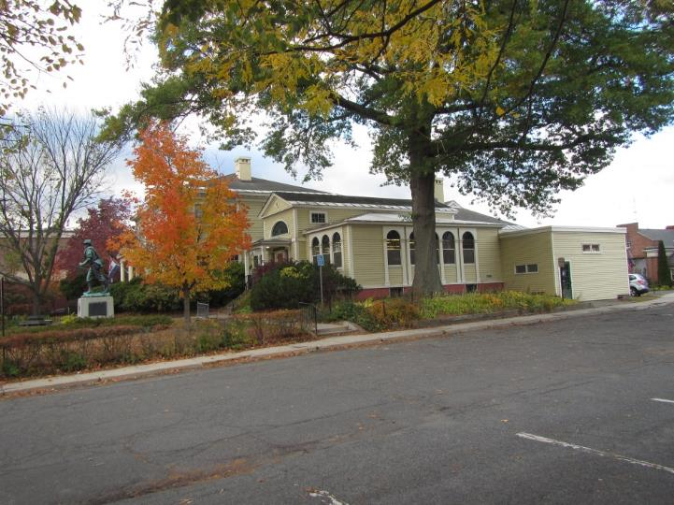
Oak tree overhanging building
Picture 6
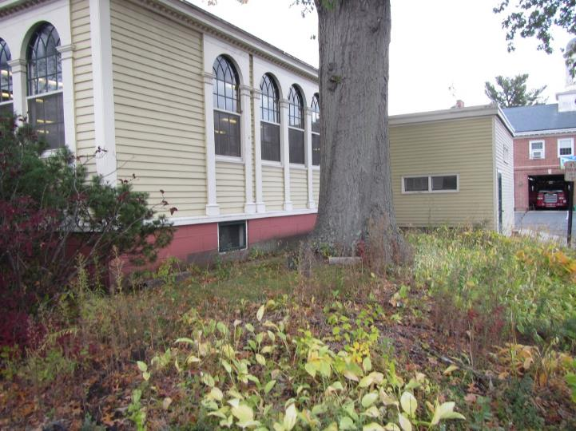
The east side of the tree has its root system disrupted by a sidewalk and the driveway of the Greenfield Fire Station
Picture 7
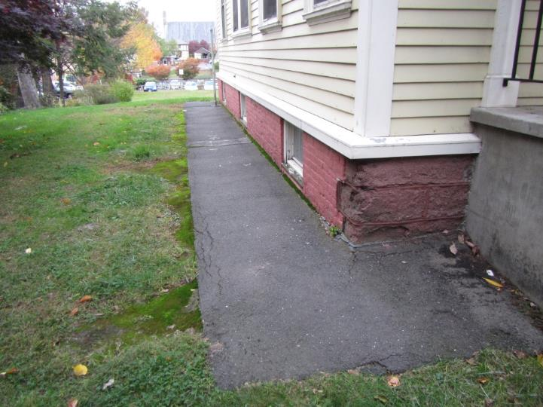

Tarmac apron at base of the westernmost wall of the GPL

Location | Carbon  Dioxide  (ppm) | Carbon Monoxide  (ppm) | Temp  (°F) | Relative  Humidity  (%) | PM2.5  (µg/m³) | Occupants  in Room | Windows  Openable | Ventilation |  | Remarks
 |  |  |  |  |  |  |  | Supply | Exhaust
Background (Outdoors) | 396 | ND | 59 | 41 | 8
2nd floor  SW office | 646 | ND | 74 | 41 | ND | 1 | Y | Y | N | Honey combs in windows
SE office | 618 | ND | 74 | 39 | ND | 0 | Y | Y | N | Air filter
N office | 624 | ND | 74 | 40 | 2 | 1 | Y | Y | N | Air filter
Kitchen | 626 | ND | 74 | 42 | ND | 0 | Y | Y | N
1st floor information | 613 | ND | 74 | 40 | 1 | 1 | Y | Y | N | Air filter
DVDs | 631 | ND | 75 | 40 | ND | 0 | Y | Y | N | Air filter
Computer | 733 | ND | 74 | 39 | ND | 12 | Y | Y | N | Air filter
Children’s stack SW corner | 577 | ND | 73 | 40 | ND | 4 | Y | Y | N | Musty odor
Children’s west | 564 | ND | 72 | 41 | ND | 0 | Y | Y | Y
Children’s picture book | 534 | ND | 71 | 40 | ND | 0 | Y | Y | N
Children’s office | 600 | ND | 73 | 41 | ND | 0 | Y | Y | N
Front desk office | 652 | ND | 73 | 44 | ND | 2 | N | N | N | Plants
Front desk | 647 | ND | 73 | 43 | 3 | 2 | N | Y | N | Plants
Adults Stack west | 669 | ND | 73 | 42 | ND | 0 | Y | Y | N
Adults stack center | 664 | ND | 73 | 43 | ND | 2 | Y | Y | N
Adults stack east | 771 | ND | 72 | 44 | ND | 2 | Y | Y | N | Floor tile cracking
Basement  B101 | 476 | ND | 72 | 43 | ND | 0 | Y | Y | N | Water-damaged plaster
B103 | 470 | ND | 70 | 46 | ND | 0 | Y | Y | Y

Location | Air Temperature  (ºF) | Temperature Range of Floors  (ºF) | Difference in Temperature of Air v. Floor  (ºF)
B 101 | 72 | 59-63 | +9-13
B 103 | 70 | 59-65 | +11-15

INDOOR AIR QUALITY ASSESSMENT

Greenfield Public Library
402 Main Street
Greenfield, Massachusetts

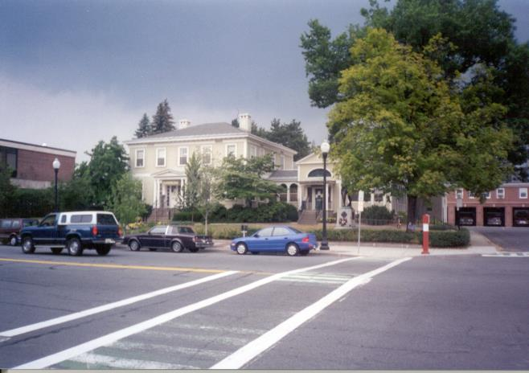

Prepared by:
Massachusetts Department of Public Health
Bureau of Environmental Health Assessment
February, 2002

Background/Introduction
At the request of Lisa Hebert of the Greenfield Board of Health, the Massachusetts Department of Public Health (MDPH), Bureau of Environmental Health Assessment (BEHA) provided assistance and consultation regarding indoor air quality at the Greenfield Public Library, 402 Main Street, Greenfield, Massachusetts. Reports from building occupants of indoor air quality related symptoms prompted this request. On August 13, 2001, a visit was made to this school by Michael Feeney, Chief of Emergency Response/Indoor Air Quality (ER/IAQ), BEHA, to conduct an indoor air quality assessment.
The library contains two wings in a split-level configuration. The original wing was a free standing, two-story, wood frame mansion constructed in 1797 (see Picture 1). A two-story brick wing was added to the rear of the building in the 1950s. The library occupies the first floor of the 1797 wing and the second floor of the 1950s wing. The second floor of the 1797 wing is used for administrative offices. The ground floor of the 1950s wing contains a conference room, an office and restrooms. The basement of the 1797 wing is used for storage of books and contains a mechanical room and the custodial office. An elevator shaft services each floor of the 1797 wing. Windows are sash windows that are not openable. The library exhaust ventilation was renovated in 1998 (MJA & KL, 1998). Exhaust vents were removed and new motors were added to the basement and first floor.

Methods
Air tests for carbon dioxide, temperature and relative humidity were taken with the TSI, Q-Trak ™, IAQ Monitor Model 8551. Water content of carpeting was measured with a Delmhorst, BD-2000 Model, Moisture Detector with a Delmhorst Standard Probe. Moisture measurements were taken in the basement conference room.

Results
The library has a staff of 10 and is used by 100+ members of the public daily. Tests were taken during normal operations at the library and results appear in Tables 1-2.

Discussion
Ventilation
It can be seen from the tables that carbon dioxide levels were elevated above 800 parts per million of air (ppm) in 16 of 18 areas surveyed, indicating a ventilation problem in most areas. It is also noted that a number or areas were sparsely populated during the assessment. Under ordinary circumstances, low population in areas of the building would be expected to greatly reduce carbon dioxide levels.
Fresh air is supplied by a unit ventilator (univent) system (see Figure 1). Univents draw air from outdoors through a fresh air intake located on the exterior walls of the building and return air through an air intake located at the base of each unit. Fresh and return air are mixed, filtered, heated and provided to rooms through an air diffuser located in the top of the unit. Univents were functioning in the majority of areas examined.
Exhaust ventilation is provided by ceiling-mounted exhaust vents in the first floor library areas. The basement conference room has a wall-mounted exhaust vent, which is connected to a large fan installed on the rear exterior wall (see Picture 2). In all areas examined, exhaust vents were deactivated. Without a functional exhaust system, normally occurring environmental pollutants can build-up and lead to indoor air quality complaints.
The administrative offices on the second floor do not have mechanical exhaust ventilation. The roof of the 1797 wing has two chimney-like structures, which appear to be exhaust ventilation airshafts. A large grill in the staff office appears to be connected to the western brick ventilation shaft by ductwork (see Picture 3) in the attic. A second large grill located at the top of the stairwell from the first floor may also be connected to the eastern brick ventilation shaft. The sound of vehicle traffic was noted emanating from this grill, indicating the airshaft is likely open to the outdoors. These vents are not mechanical, but use rising, heated air to draw environmental pollutants from the building. While this system can work well during the heating season to provide exhaust ventilation, the system does not work during the air- conditioning season. These vents may also serve as a moisture source during summer weather. Additionally, a number of areas in the basement do not have mechanical fresh air supply systems (see Tables).
To maximize air exchange, the BEHA recommends that both supply and exhaust ventilation operate continuously during periods of building occupancy. In order to have proper ventilation with a mechanical supply and exhaust system, the systems must be balanced to provide an adequate amount of fresh air to the interior of a room while removing stale air from the room. The date of the last servicing and balancing was not available at the time of the assessment. It is recommended that existing ventilation systems be re-balanced every five years to ensure adequate air systems function (SMACNA, 1994).
The Massachusetts Building Code requires a minimum ventilation rate of 20 cubic feet per minute (cfm) per occupant of fresh outside air or have openable windows in each room (SBBRS, 1997; BOCA, 1993). The ventilation must be on at all times that the room is occupied. Providing adequate fresh air ventilation with open windows and maintaining the temperature in the comfort range during the cold weather season is impractical. Mechanical ventilation is usually required to provide adequate fresh air ventilation.
Carbon dioxide is not a problem in and of itself. It is used as an indicator of the adequacy of the fresh air ventilation. As carbon dioxide levels rise, it indicates that the ventilating system is malfunctioning or the design occupancy of the room is being exceeded. When this happens a buildup of common indoor air pollutants can occur, leading to discomfort or health complaints. The Occupational Safety and Health Administration (OSHA) standard for carbon dioxide is 5,000 parts per million parts of air (ppm). Workers may be exposed to this level for 40 hours/week, based on a time-weighted average (OSHA, 1997).
The Department of Public Health uses a guideline of 800 ppm for publicly occupied buildings. A guideline of 600 ppm or less is preferred in schools due to the fact that the majority of occupants are young and considered to be a more sensitive population in the evaluation of environmental health status. Inadequate ventilation and/or elevated temperatures are major causes of complaints such as respiratory, eye, nose and throat irritation, lethargy and headaches.
Temperature readings ranged from 71º F to 76 º F, which were within the BEHA recommended comfort guidelines in all areas measured. The BEHA recommends that indoor air temperatures be maintained in a range of 70 º F to 78 º F in order to provide for the comfort of building occupants. In many cases concerning indoor air quality, fluctuations of temperature in occupied spaces are typically experienced, even in a building with an adequate fresh air supply.
- The relative humidity was measured in a range of 46 to 59 percent (with the exception of the basement conference room, which measured 70 percent), which were also within the BEHA recommended comfort range in all areas sampled. The BEHA recommends that indoor air relative humidity is comfortable in a range of 40 to 60 percent. Relative humidity levels in the building would be expected to drop during the winter months due to heating. The sensation of dryness and irritation is common in a low relative humidity environment. Low relative humidity is a very common problem during the heating season in the northeast part of the United States.

Microbial/Moisture Concerns
Of note was the conference room on the ground floor of the 1950s wing, which had a relative humidity measurement of 70 percent. Prolonged relative humidity concentrations indoors above 70 percent can foster mold growth in susceptible materials (ASHRAE, 1989) such as carpeting, cardboard, paper, books, cloth and other materials. Porous materials, if repeatedly exposed to high humidity, can serve as mold growth media. A musty odor was perceived upon entering this room.
In order to ascertain whether carpet was dampened by high relative humidity, moisture sampling was done in the carpeting. Most areas of carpeting had moisture content measurements of 8.8 to 33.2 percent, indicating that the carpet was indeed moistened. Two factors may be contributing to the moistening of the carpet: operation/non operation of different components of the ventilation system and/or water penetration through the exterior wall of this wing of the GPL. During the assessment, the univent in this room was operating and the exhaust vent fan was deactivated. Under these conditions, water vapor introduced into this area of the building from outdoors by the univent can build up, since the exhaust vent is not removing air from the space. This condition is extremely problematic when outdoor relative humidity is high (on this day, 91 percent). While the operation of the univent will remove some moisture from air passing through cooling coils, extreme relative humidity conditions outdoors can introduce excess moisture into the indoor environment. This excess moisture can then be absorbed by building components, particularly carpeting.
The American Conference of Governmental Industrial Hygienists (ACGIH) recommends that carpeting be dried with fans and heating within 24 hours of becoming wet (ACGIH, 1989). If carpets are not dried within this time frame, mold growth may occur. Water-damaged carpeting cannot be adequately cleaned to remove mold growth. The application of a mildewcide to moldy carpeting is not recommended.
Moisture introduction into the basement can also be problematic for the books stored in the basement stacks. Paper and book binding materials can support mold growth if chronically exposed to water vapor. Control of moisture/water penetration is necessary to prevent microbial growth.
A second possible means for introducing moisture into the basement area is chronic moistening of the rear exterior wall from a combination of a lack of a gutter/downspout system for the roof and the existence of clinging ivy on the rear wall. Water damage to the foundation wall (see Picture 4), brick support pillars (see Picture 5) and a basement stairwell (see Picture 6) in contact with the wall itself, indicate signs of chronic water penetration. During the course of the assessment, a thunderstorm producing a heavy rainfall occurred. This rainfall allowed Mr. Feeney to observe water drainage around the exterior of the building. The lack of a gutter/downspout system allows back-splashing rainwater to impact on the ground adjacent to the exterior wall, which results in chronic wetting. This condition allows water to pool against the building’s exterior wall and foundation (see Picture 7). Gutters and downspouts should be designed to direct rainwater away from the base of the building to prevent the chronic wetting of exterior walls which can result in damaged brickwork and/or mold growth.
Another source of moisture penetration into the building may be through the rear exterior wall, which was formerly covered with a substantial ivy growth (see Picture 8). Clinging plants can cause water damage to brickwork by inserting tendrils into brick and mortar. Water can penetrate into the brick along the tendrils, which can subsequently freeze and thaw during the winter. This freezing/thawing action can weaken bricks and mortar, resulting in damage to the wall. In addition, the growth of roots against the exterior walls can bring moisture in contact with wall brick and eventually lead to cracks and/or fissures in the foundation/slab below ground level. Over time, this process can undermine the integrity of the building envelope and provide a means of water entry into the building via capillary action through foundation concrete and masonry (Lstiburek, J. & Brennan, T.; 2001). In order to avoid this problem, clinging plants on brickwork is not recommended.
During the course of the evaluation, accumulated water was observed on the surface of univent fresh air diffusers. This condition can indicate the uncontrolled introduction of moisture into the interior of the building. Two exhaust vents exist on the second floor of the building that belong to a former ventilation system. As mentioned previously, the exhaust vent in the second floor office is connected by ductwork to a chimney-like structure. The connection of the other exhaust vent could not be determined, however as discussed, outdoor noises such as passing traffic were heard in the airshaft indicating that this vent is likely open to the outdoors. Each of these vents corresponds to chimney-like structures on the roof of the 1797 wing (see Picture 9). These vents can be a source of moisture being introduced into the building, resulting in excessive production of condensation.
Condensation is generated under the following conditions. When warm, moist air passes over a surface that is colder than the air, water condensation can collect on the cold surface. Over time, water droplets can form, which can then drip from a suspended cold surface. For this reason, HVAC systems are equipped with drainage systems beneath cooling coils to drain condensate as moist outdoor air is cooled. Univents have drain (drip) pans that are connected to a drainage pipe system. Each of these drip pans empty through a PVC pipe that exits through the exterior wall clapboard (see Picture 10). Each of these pipes drain condensation directly onto the exterior wall, resulting in chronic moistening that is rotting the clapboard. This chronic moistening can result in water penetration into the interior of the building.
Several rooms contained a number of plants, some of which were located on top of univents. Plant soil and drip pans can also provide a source of mold growth. Over-watering of plants should be avoided and drip pans should be inspected periodically for mold growth. Plants should have drip pans to prevent wetting and subsequent mold colonization of window frames. Plants should also be located away from univents and exhaust ventilation to prevent the aerosolization of mold, dirt and pollen.
A water fountain was observed above carpeting in the children’s section (see Picture 11). Spills from the water fountain can result in wetting of the carpet, which can lead to mold growth.

Other Concerns
Cleaning products, label remover and other materials were found in the staff office. Many of these products contain chemicals, which can be irritating to the eyes, nose and throat. These products should be stored properly and used in an area with proper exhaust ventilation to remove odors.
The staff work office contained a photocopier. VOCs and ozone can be produced by photocopiers, particularly if the equipment is older and in frequent use. Ozone is a respiratory irritant (Schmidt Etkin, D., 1992). Library personnel should ensure that local exhaust ventilation is activated while equipment is in use to help reduce excess heat and odors in this area.

Conclusions/Recommendations
Occupant symptoms and complaints are consistent with what might be expected in an environment with a poorly operating ventilation system and chronic moisture penetration into the basement. The conditions observed in the GPL raise several issues. The combination of the building design, maintenance, work hygiene practices and the condition of stored materials in the building can have an adverse impact on indoor air quality. No exhaust ventilation exists in the book stack area of the basement. Without exhaust ventilation, water vapor can build up and linger in the basement. Water vapor penetration through the foundation walls must be halted in order to prevent further mold colonization of the library book collection in the basement stacks. However, this remedy does not solve the issue of lack of mechanical exhaust ventilation for the basement, which should decrease the overall water vapor load for the building.
As an initial step, options concerning the preservation of materials stored in this area should be considered. Since many books are stored in this area, an evaluation concerning disposition of these materials must be made. Porous materials that are judged not worthy of preservation, restoration or transfer to another media (e.g., microfiche or computer scanning) should be discarded. Where stored materials are to be preserved, restored or otherwise handled, an evaluation should be done by a professional book/records conservator. This process can be rather expensive, and may be considered for conservation of irreplaceable documents that are colonized with mold. Due to cost of book conservation, disposal or replacement of moldy materials may be the most economically feasible option.
For these reasons a two-phase approach to correcting IAQ problems is required, consisting of immediate (short-term) measures to improve air quality and long-term measures that will require planning and resources to adequately address overall indoor air quality concerns.

The following short-term measures should be considered for immediate implementation:
- Consider removing any water damaged carpeting from the basement conference room. Disinfect non-porous surfaces with an appropriate antimicrobial compound. After disinfection, clean non-porous surfaces with soap and water.
- Consider replacing carpeting in the basement conference room with tile or other non-porous surface.
- Temporarily seal the original exhaust vents above the second floor stairwell with polyethylene plastic and duct tape until a permanent seal can be erected.
- Consider using a floor fan set on the lowest setting to direct air into the exhaust vent in the staff office.
- Consider consulting a professional book/records conservator to obtain guidance concerning the proper methods for preserving the stored materials in the 1797 building basement.
- Examine other porous materials for mold growth and musty odors. If present, discard these materials.
- Extend condensation drains to empty at ground level.
- Operate the basement conference room exhaust ventilation fan when the univent is operating to remove water vapor.
- Survey all univent functions to ascertain if an adequate air supply exists for each room and make univent repairs as needed. Check fresh air intakes for repair and increase the percentage of fresh air intake if necessary. Consider consulting a heating, ventilation and air conditioning (HVAC) engineer concerning the calibration of univent fresh air control dampers building-wide.
- To maximize air exchange, the BEHA recommends that mechanical ventilation operate continuously during periods of occupancy, independent of thermostat control.
- Continue to remove clinging ivy from the exterior walls of the GPL.
- For buildings in New England, periods of low relative humidity during the winter are often unavoidable. Therefore, scrupulous cleaning practices should be adopted to minimize common indoor air contaminants whose irritant effects can be enhanced when the relative humidity is low. To control for dusts, a high efficiency particulate arrestance (HEPA) filter equipped vacuum cleaner in conjunction with wet wiping of all surfaces is recommended. Avoid the use of feather dusters. Drinking water during the day can help ease some symptoms associated with a dry environment (throat and sinus irritations).
- Move plants away from univents. Ensure plants have drip pans. Examine drip pans periodically for mold growth and disinfect with an appropriate antimicrobial where necessary.
- Use cleaning and other supplies with adequate ventilation. Obtain Material Safety Data Sheets (MSDS) for cleaning products from manufacturers or suppliers. Maintain these MSDS and train individuals in the proper use, storage and protective measures for each material in a manner consistent with the Massachusetts Right-To-Know Law, M.G.L. c. 111F (MGL, 1983)

The following long-term measures should be considered:
- Examine the feasibility of providing mechanical exhaust ventilation for the basement book stacks and the second floor offices. For the second floor offices with univents, examine the feasibility of converting the existing airshafts of the original ventilation system into mechanical systems. Contact an HVAC engineering firm to determine if existing vents, ductwork, etc. can be retrofitted for mechanical ventilation.
- Install a gutter/downspout system to properly drain rainwater away from the foundation
- Repair roof and replace/repair any water-stained ceiling tiles and wall plaster. Examine the area above and around these areas for mold growth. Disinfect areas of water leaks with an appropriate antimicrobial if necessary.
References

ACGIH. 1989. Guidelines for the Assessment of Bioaerosols in the Indoor Environment. American Conference of Governmental Industrial Hygienists, Cincinnati, OH.

ASHRAE. 1989. American Society of Heating, Refrigeration and Air Conditioning Engineers. Ventilation for Acceptable Indoor Air Quality. ANSI/ASHRAE 62-1989

BOCA. 1993. The BOCA National Mechanical Code-1993. 8th ed. Building Officials & Code Administrators International, Inc., Country Club Hills, IL. M-308.1

Lstiburek, J. & Brennan, T. 2001. Read This Before You Design, Build or Renovate. Building Science Corporation, Westford, MA. U.S. Department of Housing and Urban Development, Region I, Boston, MA

MGL. 1983. Hazardous Substances Disclosure by Employers. Massachusetts General Laws. M.G.L. c. 111F.

MJA & KL. 1998. Blueprint for Addition and Renovations to Greenfield Public Library, Greenfield, Massachusetts. Margo Jones, Architects, Greenfield, MA; Kohler & Lewis, Keene, NH. March 16, 1998. MV-1, MV-2.

OSHA. 1997. Limits for Air Contaminants. Occupational Safety and Health Administration. Code of Federal Regulations. 29 C.F.R 1910.1000 Table Z-1-A.

SBBRS. 1997. Mechanical Ventilation. State Board of Building Regulations and Standards. Code of Massachusetts Regulations. 780 CMR 1209.0

Schmidt Etkin, D. 1992. Office Furnishings/Equipment & IAQ Health Impacts, Prevention & Mitigation. Cutter Information Corporation, Indoor Air Quality Update, Arlington, MA.

SMACNA. 1994. HVAC Systems Commissioning Manual. 1st ed. Sheet Metal and Air Conditioning Contractors’ National Association, Inc., Chantilly, VA.

Picture 1

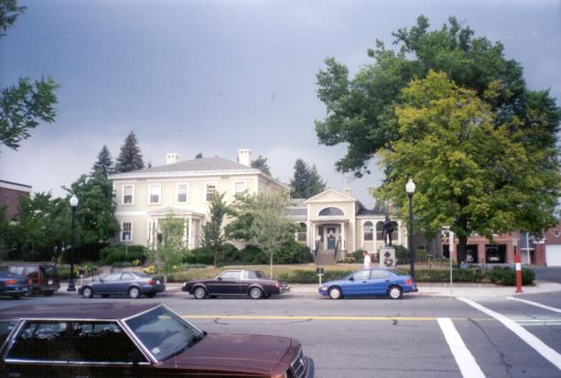

Wood Frame Mansion Constructed In 1797

Picture 2

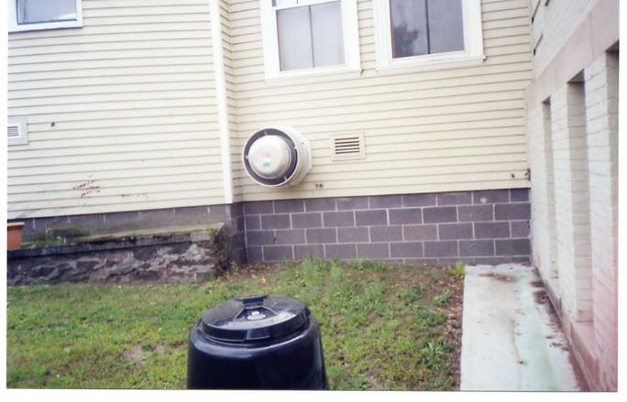

Exhaust Fan for Basement Meeting Room

Picture 3

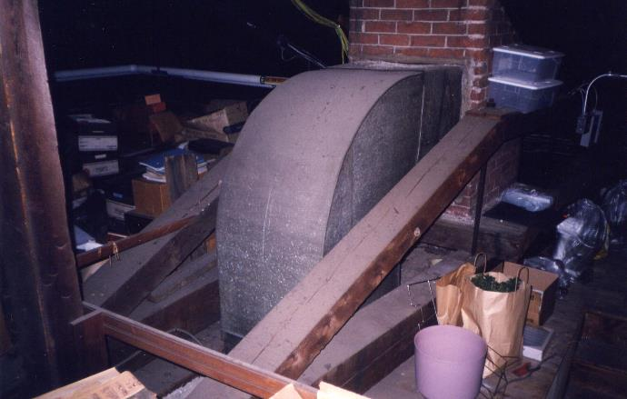

Ductwork in Attic Connected to the Western Brick Ventilation Shaft

Picture 4

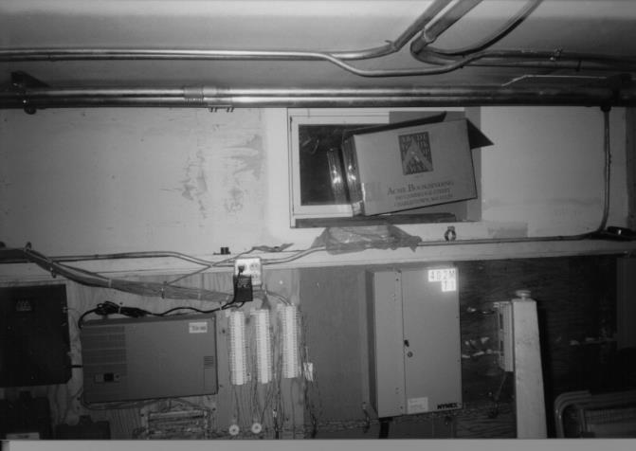

Water Damage to Foundation Wall

Picture 5

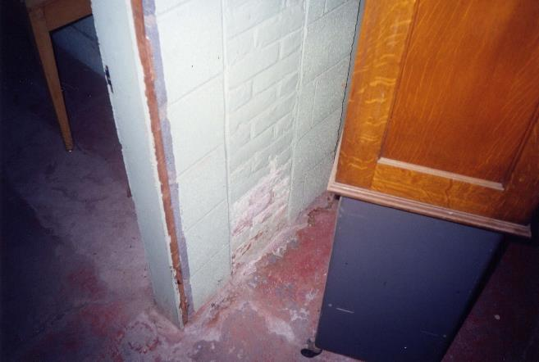

Water Damage to Brick Support Pillars

Picture 6

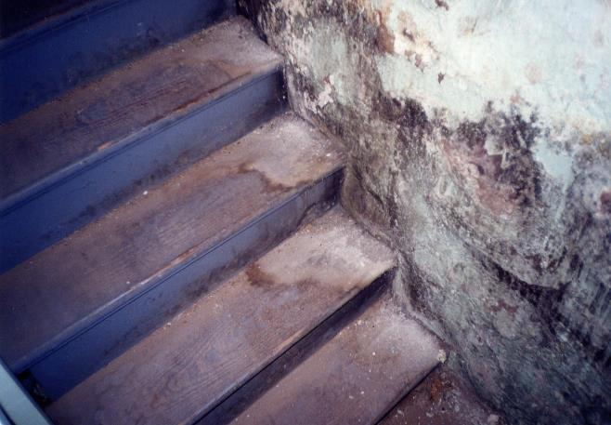

Water Damage to Basement Stairwell and Foundation Wall

Picture 7

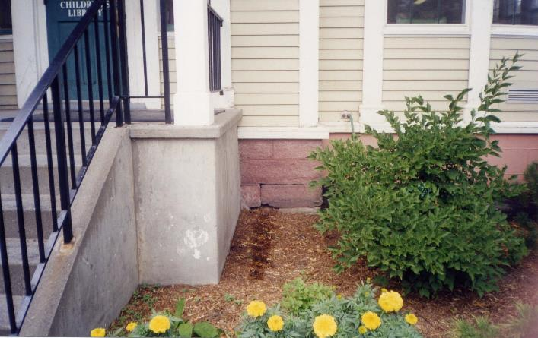

Pooling Rainwater from Roof, Note Damage to Foundation Stone in Proximity to Pool

Picture 8

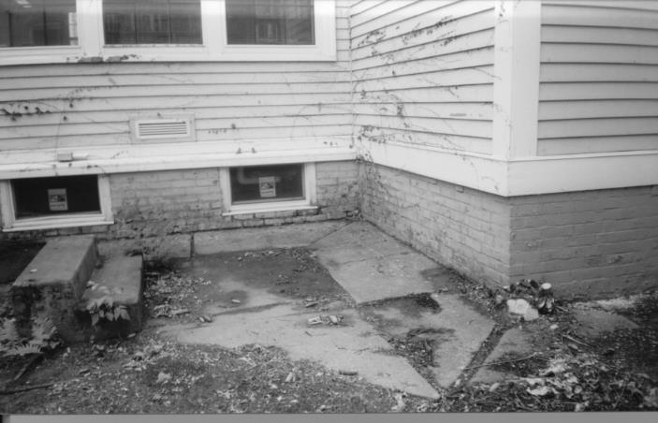

Exterior Wall at Rear of Building Formerly Covered With Substantial Ivy Growth

Picture 9

Chimney-Like Structures on the Roof Of the 1797 Wing

Picture 10

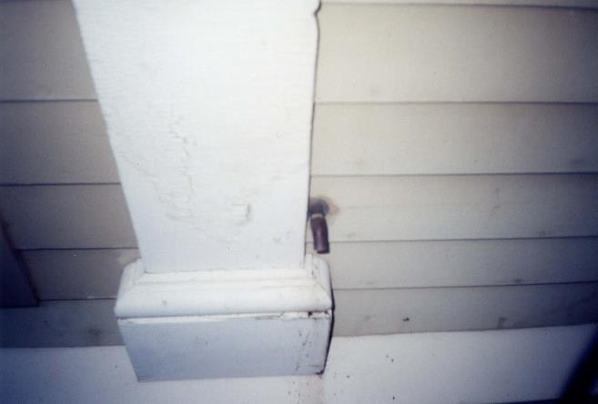

Condensation Drain Emptying Onto Exterior Wall Clapboard,
Note Damage to Wood below Drain

Picture 11

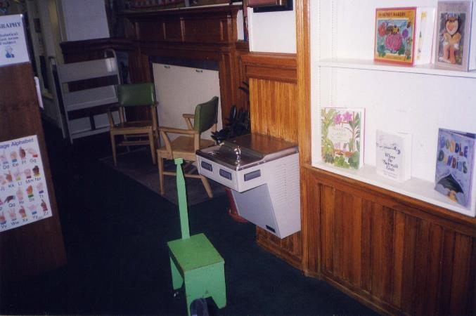

Water Fountain Observed Above Carpeting in the Children’s Section

Location | Carbon | Temp. | Relative | Occupants | Windows | Ventilation |  | Remarks
 | Dioxide  *ppm | °F | Humidity  % | in Room | Openable | Intake | Exhaust
Outside  (Background) | 393 | 82 | 91 |  |  |  |  | Measurements taken @ 1:45 pm
Director’s Office | 806 | 71 | 59 | 1 | No | Yes  (1) | No | Fireplace, univent-condensation on louver, door open
Staff Office | 782 | 74 | 59 | 3 | No | Yes  (2) | No | univent-condensation on louver, door open
Staff Office-Printer | 802 | 76 | 53 | 1 | No | Yes  (1) | No | Door open
Kitchen | 781 | 74 | 62 | 0 | No | Yes  (1) | No | Door open
Restroom |  |  |  |  | No | No | Yes | Exhaust vent broken
Reference Area | 1203 | 72 | 50 | 3 | No | Yes  (2) | No | Fireplace
Computer Area | 1209 | 72 | 49 | 7 | No | Yes  (1) | No | univent-condensation on louver
Front Desk Area | 1229 | 72 | 50 | 4 | No | Yes  (1) | No | univent-condensation on louver
Elevator Stack Area | 1081 | 73 | 52 | 3 | Yes | Yes  (1) | Yes | Exhaust off
Rear Stack | 835 | 74 | 54 | 1 | Yes | Yes  (2) | No
Child Library Room | 1007 | 71 | 49 | 4 | No | Yes  (3) | Yes | Exhaust off, univent-condensation on louver, fireplace, water bubbler over carpet, plants, door open
Child Library Inner Room | 1138 | 73 | 46 | 1 | No | Yes  (1) | No
Greenfield Room | 1301 | 73 | 56 | 2 | No | Yes  (1) | Yes | Exhaust off, musty odor
Elevator Car | 1168 | 73 | 54 | 1 | No | No | No
Conference Room | 530 | 74 | 70 | 0 | No | Yes | Yes | Exhaust off, musty odor – carpet moisture – 8.8%-33.2%
Stack Room | 946 | 75 | 56 | 0 | No | No | No | Pillars-efflorescence, water damage-outer wall-mold
Children’s Library | 1175 | 75 | 49 | 0 | No | Yes | No | Supply off
Children’s Library Closet |  |  |  |  |  | No | Yes | Water damaged plaster
Children’s Library Restroom |  |  |  |  |  | No | Yes | No undercut door
Front Desk Area | 1389 | 73 | 53 | 17 | Yes | Yes | No | Taken @ 3:05 pm

The service life is the time during which a particular system or component of …[an HVAC]… system remains in its original service application and then is replaced. Replacement may occur for any reason, including, but not limited to, failure, general obsolescence, reduced reliability, excessive maintenance cost, and changed system requirements due to such influences as building characteristics or energy prices (ASHRAE, 1991).
Condensation is the collection of moisture on a surface with a temperature below the dew point. The dew point is a temperature determined by air temperature and relative humidity. For example, at a temperature of 73°F and relative humidity of 57 percent indoors, the dew point for water to collect on a surface is approximately 57°F.
A thermal bridge is an object (usually metallic) in a wall space through which heat is transferred at a greater rate than materials surrounding it. During the heating season, the window comes in contact with heated air from the interior and chilled air from the outdoors, resulting in condensation formation if the window frame temperatures are below the dew point.

