ODOR ASSESSMENT

Greenleaf School
26 Belmont Avenue
Haverhill, MA

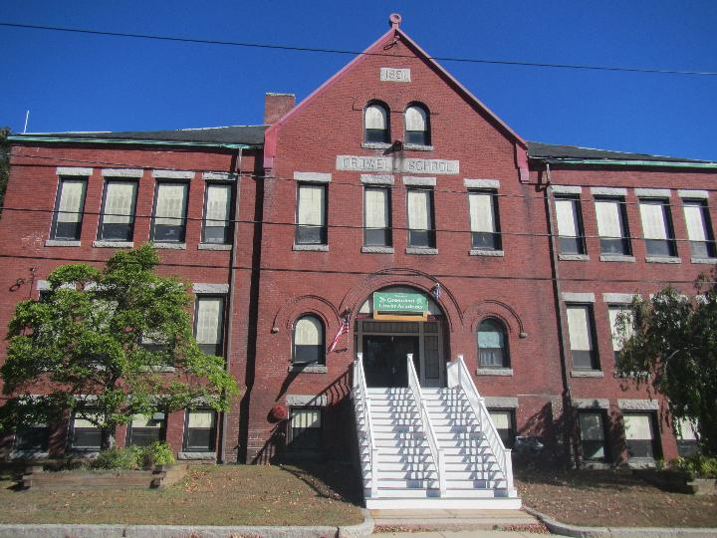

Prepared by:
Massachusetts Department of Public Health
Bureau of Climate and Environmental Health
Division of Environmental Health Regulations and Standards
October 2025

BACKGROUND
Building: | Greenleaf School
Address: | 26 Belmont Ave, Haverhill, MA
Assessment Coordinated Through: | Steven Dorrance, Director of Facilities, Haverhill School Department
Reason for Request: | Concerns about odor issues in the basement
Date of Assessment: | October 16, 2025
Massachusetts Department of Public Health, Bureau of Climate and Environmental Health, Division of Environmental Health Regulations and Standards (MDPH/BCEH/EHRS) Staff Conducting Assessment: | Ruth Alfasso, Environmental  Engineer, EHRS
Building Description: | The Greenleaf School is a special-purpose school for a small number of young students who are unable to attend regular elementary schools. It was originally built in the 1880s as the Crowell School and has been used as a school most of the time since then. Greenleaf School has only been using the building for a short time.

BACKGROUND
On October 3, 2025, the EHRS IAQ unit received emailed contact from a representative of the Mass Nurses Association regarding oil odors in the lowest level of the Greenleaf School in Haverhill. The school facilities department was contacted and Mr. Steven Dorrance took steps to investigate and remediate the issue. He explained that an oil tank had existed in this school and had been removed within the last several years. When the school was reopened in its current use, some occupants noted an oily odor when they were using the kitchen area which is located in the basement near the utility rooms.
Cleaning and other activities were conducted, and then, on October 7, the entire room was sealed with concrete. This assessment was performed after the concrete had thoroughly dried.

METHODS
Please refer to the indoor air quality (IAQ) Manual for methods, sampling procedures, and interpretation of results (MDPH, 2015). Only the basement utility room was tested.

RESULTS AND DISCUSSION
Measurements for IAQ parameters are summarized below:
- Total volatile organic compounds (TVOC) were ND in the area assessed.
- No odors were detected in the rooms assessed

Odor Concerns and Other Observations
As noted above, no odors were detected in the basement rooms including the area where the concrete had been poured, the storage areas adjacent to it, or the occupied areas of the kitchen. The area where concrete had been poured was dry and had no signs of oil or dampness (Picture 1).
The other basement areas assessed were dry and relatively clean. Stored items were on pallets or shelving to keep them off the floor and prevent water damage (Picture 2). Pest traps were noted, and Mr. Dorrance reported that regular visits are made by a licensed pest control company but that there have been no significant issues with pests in this building.
Odors can linger in locations without any ventilation. Because only a few areas of this building are currently used, including the kitchen adjacent to the utility spaces, increasing ventilation in the occupied areas where possible can help prevent odors from migrating from other areas. Unfortunately, due to the design of the hallway between the utility areas and the kitchen, a door or other barrier would be very difficult to implement without significant construction, so there is no barrier to air from other areas of the basement entering into the occupied areas.

CONCLUSIONS/RECOMMENDATIONS
As mentioned, no odor, signs or oil, or other issues were noted in the space examined. The following is recommended to ensure good IAQ going forward:
- Continue to use whatever heating and ventilation equipment is available in occupied areas of the school, including openable windows, to provide fresh air, heating, and exhaust ventilation for occupants.
- Ensure any gas-fired equipment in use at the school, including heating, hot water, or kitchen equipment, is in good condition and regularly maintained. Where equipment is hooked up to gas but not planned to be used again, it should be properly disconnected or decommissioned.
- Ensure all school staff know how to report issues within the building to the proper contacts at the facilities department for prompt attention.
- Continue to keep the storage areas clean, organized, and dry.
- If more intensive uses of the building are planned in the future, consider having a ventilation engineering consultant evaluate mechanical systems to ensure adequate function for the proposed uses.
- Refer to resource manual and other related IAQ documents located on the MDPH’s website for further building-wide evaluations and advice on maintaining public buildings. These documents are available at: http://mass.gov/dph/iaq.

REFERENCES
MDPH. 2015. Massachusetts Department of Public Health. Indoor Air Quality Manual: Chapters I-III. Available at: https://www.mass.gov/lists/indoor-air-quality-manual-and-appendices.

Picture 1
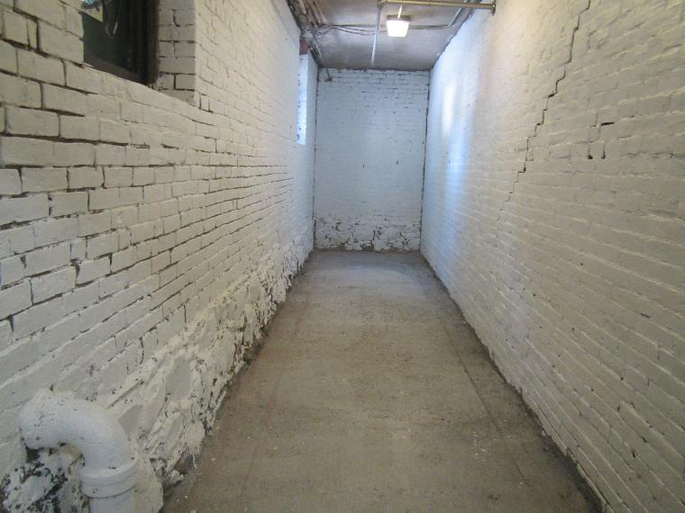
Area of the former oil tank, now covered in a layer of concrete
Picture 2
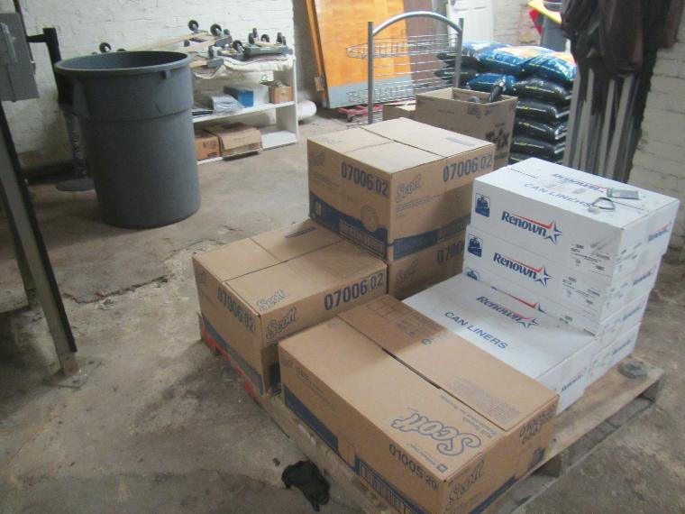
A dry floor with stored items up off the ground

