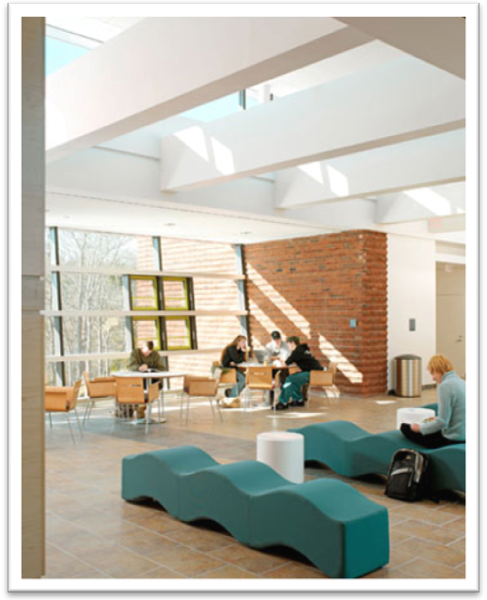
Case Study 11: Green Technology Center at Cape Cod Community College
The Lyndon P. Lorusso Applied Technology Building located at Cape Cod Community College is the first state government LEED certified building in Massachusetts. Completed in September 2006, the technology center cost $8 million to construct and is the first new building on campus since 1974. In 2004, the project earned the DCAM Programming Study Award.
The facility has numerous cutting-edge sustainable design features that conserve resources. Site design, daylighting, renewable energy usage, water conservation, and recycled materials have been included in the development, resulting in a LEED Gold certification. While these green features in and around the building cost about 7% more than conventional construction techniques, the cost is estimated to be recouped within four or five years.
The site for the technology center was chosen because it takes advantage of underutilized parking areas at the commuter-oriented school. By choosing this location, the school eliminated the need for new parking lots. Cape Cod Community College also signed a written commitment to preserve the adjacent open space around the building.
The building “is a statement about this institution and its leadership, and about the Cape and Islands and its commitment to the environment.”
To maximize sunlight exposure, the building is designed on an east-west axis to allow daylight to penetrate through large windows. Additionally, daylight and occupancy sensors are placed throughout the building to control the amount of light the fixtures can emit. Utilizing daylighting enhances the environment of interior spaces while lessening energy consumption.

The facility features renewable energy technologies to increase its energy efficiency. The main component are the 122 photovoltaic panels located on the roof and above the windows of the building. These panels generate 15% of the Lorusso Applied Technology Building's power needs. Combined with daylighting, the solar collectors result in a building that uses 35% less energy than a conventional facility. Also, 100% of the additional power the school needs to purchase for the building will come from a renewable energy source for at least two years.
Building Features
- Site selection maximizing sunlight exposure and minimizing erosion
- Permeable paving
- Photovoltaic panels
- No-flush, waterless urinals
- Maximizing daylight reflection
- Gray-water system
- High efficiency gas boilers
- CO₂ ventilation
- Using recycled or high recycled content whenever possible
- Construction waste recycling

A variety of measures are employed both inside and outside of the facility to promote water conservation. Located in the basement of the building is an 8,000 gallon tank that collects rainwater to be used in toilets, which reduces groundwater usage by 60%. When combined with a water collection and reuse irrigation system, drought-resistant plant species in the landscaping, low-flow toilets and fixtures, and waterless urinals, the water consumption of the building is reduced by 85%.
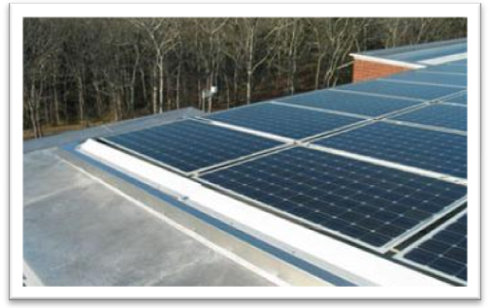
The Lorusso Building is made with recycled materials and low-volatile organic paints and glues wherever possible to conserve natural resources and to improve indoor air quality. 90% of the construction waste was either recycled or reused. In addition, most of the materials were purchased from local sources to reduce transportation costs and environmental impacts.

