INDOOR AIR QUALITY ASSESSMENT

Greenwood Elementary School
1030 Main Street
Wakefield, MA

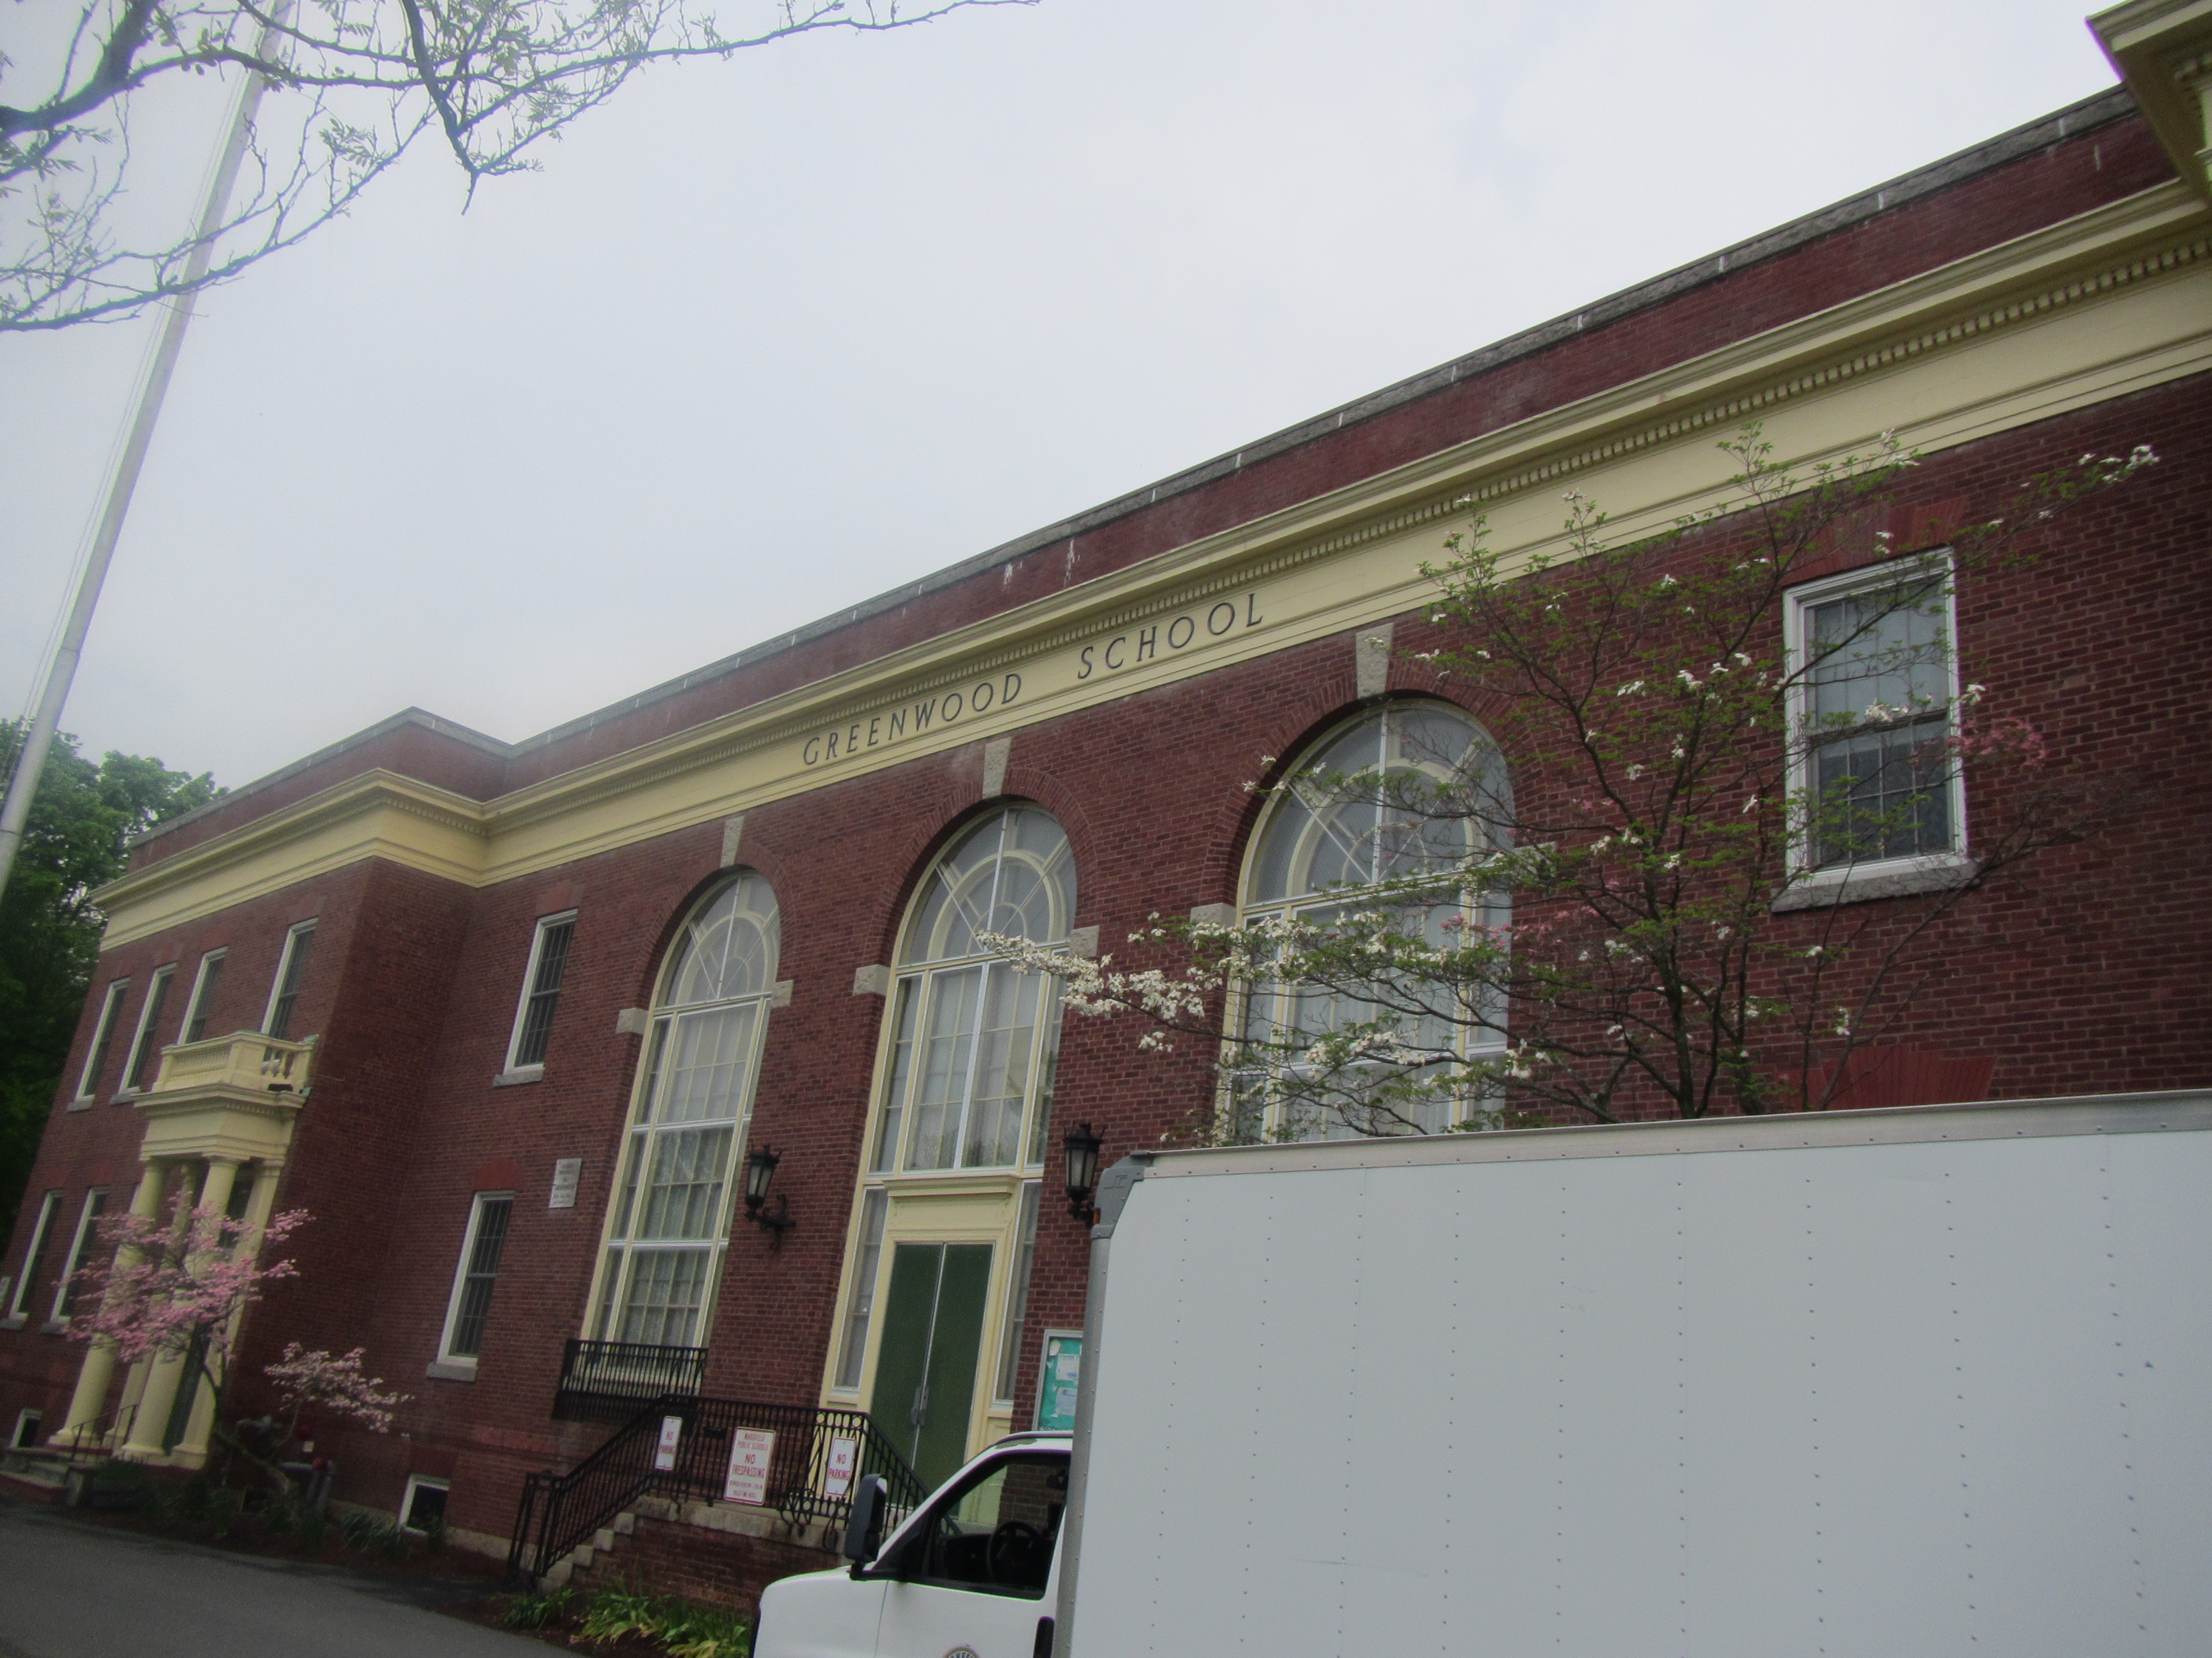

Prepared by:
Massachusetts Department of Public Health
Bureau of Environmental Health
Indoor Air Quality Program
June 2019

Background

Building: | Greenwood Elementary School (GES)
Address: | 1030 Main Street, Wakefield, MA
Assessment Requested by: | Bob Schiaroli  Director of Facilities  Wakefield Public Schools
Reason for Request: | General indoor air quality (IAQ)
Date of Assessment: | May 20, 2019
Massachusetts Department of Public Health/Bureau of Environmental Health (MDPH/BEH) Staff Conducting Assessment: | Jason Dustin, Environmental Analyst/Inspector, IAQ Program
Building Description: | The GES is a two-story brick structure originally constructed in 1897. The building underwent renovations in 1924. Windows are openable throughout the building.
Building Population: | Approximately 250 total students and staff
Windows: | Most windows are openable

This building has been visited by the IAQ program in the past. Reports from previous visits are available on request.

IAQ Testing Results
Please refer to the IAQ Manual for methods, sampling procedures, and interpretation of results (MDPH, 2015). The following is a summary of indoor air testing results (Table 1).
- Carbon dioxide levels were above the MDPH guideline of 800 parts per million (ppm) in more than half of all rooms tested, indicating inadequate air exchange in those areas.
- Temperature was within the MDPH recommended range of 70°F to 78°F in most areas tested, however many occupants expressed temperature complaints. Some basement spaces were below the MDPH recommended range.
- Relative humidity was above or at the higher end of the MDPH recommended range of 40 to 60% in all areas on the day of the assessment.
- Carbon monoxide levels were non-detectable (ND) in all areas tested with the exception of the kitchen. A level of 2.7 ppm was measured there due to the lack of an exhaust hood while operating a gas range.
- Fine particulate matter (PM2.5) concentrations measured were below the National Ambient Air Quality (NAAQS) limit of 35 μg/m³ in all areas tested.

Ventilation
A heating, ventilating and air conditioning (HVAC) system has several functions. First it provides heating and, if equipped, cooling. Second, it is a source of fresh air. Finally, an HVAC system will dilute and remove normally occurring indoor environmental pollutants by not only introducing fresh air, but by filtering the airstream and ejecting stale air to the outdoors via exhaust ventilation. Even if an HVAC system is operating as designed, point sources of respiratory irritation may exist and cause symptoms in sensitive individuals.
Fresh air was originally provided by an air handling unit (AHU) located in a large room on the ground floor that is connected to ductwork. Fresh air was drawn into the building through a louvered vent in the basement. Air was drawn through heating elements into a fan unit that distributed the air through ducts to wall-mounted fresh air grilles in classrooms. This ventilation system appears to have been abandoned and was recommended to be either refurbished or sealed in 2002 by a private consultant as well as the MDPH (ATC, 2002; MDPH, 2003). These nonfunctioning ducts and vent openings may serve as pathways for particulates, odors, and moisture from the basement (Picture 1).
The original exhaust ventilation system used exhaust vents located at floor level in each classroom that were connected by ventilation shafts to the basement heating elements. Heated air rising through the vent stacks from the basement created a draw of air into the exhaust vents of each classroom. The amount of air into these vents was controlled by a draw chain pulley system. Because this system has been abandoned, no means of mechanical supply or exhaust ventilation exists for the majority of the GES, leaving openable windows as the only source of fresh air.
The athletic room in the basement is the only room with mechanical ventilation. This room is equipped with a heat recovery ventilator (HRV) unit (Picture 2) that was not in use at the time of the visit. The unit is designed to exhaust stale air from the room while drawing in fresh air from outside. Both air streams pass through a heat recovery core without mixing. The HRV units are designed to capture heat from outgoing exhaust so that it tempers the incoming air. The unit in this room was noted to have supply vents but no exhaust vents were located. It is possible that the exhaust ductwork was not installed due to space limitations and that the unit is drawing air from an open exhaust port at the top of the unit. The unit should be inspected to ensure that it is installed and ducted properly according to manufacturer specifications. These units also have filters which should be changed regularly.
As shown in Table 1, all of the classrooms having full occupancy had elevated carbon dioxide levels. This condition is an indicator of poor air exchange and may allow commonly found indoor air pollutants to accumulate in these areas thereby increasing IAQ complaints. Occupants should be use openable windows and ceiling fans/portable fans to improve air exchange and reduce IAQ complaints.

Microbial/Moisture Concerns
Water-damaged ceiling tiles were observed in some areas (Picture 3; Table 1), which indicate leaks from the building envelope or plumbing system. Stained ceiling tiles should be discarded and replaced as they are considered porous and therefore susceptible to microbial colonization when chronically moistened.
Most classrooms at the GES have either hardwood or plaster ceilings which are not conducive to mold growth. Some plaster ceilings/walls were noted to have water damage and a white powdery material (Pictures 4 and 5). The white material is called efflorescence; efflorescence is a characteristic sign of water damage to building materials such as brick, mortar, or plaster, but it is not mold growth. As moisture penetrates and works its way through mortar or plaster, water-soluble compounds dissolve, creating a solution. As the solution moves to the surface of masonry materials, water evaporates, leaving behind white, powdery mineral deposits. This condition indicates that water from the exterior has penetrated into the building. Plaster and brick do not typically support mold growth because these materials are not carbon-based; however paint, items, or debris on/near the walls may become mold-colonized when moistened. When present, efflorescence can be readily cleaned. Plaster ceilings and walls can be scraped, patched and painted so long as lead-safe practices are used given the age of the building.
One classroom was reported to have a drain pipe which actively leaks on occasion. The insulation wrap for this drain appeared to be in poor condition. Occupants are advised not to store/place porous items in areas where leaks occur and to report any leaks or water infiltration promptly.
Some lower level areas were noted to have porous items (e.g., boxes of paper) stored directly on the floor (Pictures 6 and 7). Porous materials can become water-damaged and mold-colonized with repeated exposure to moisture due to condensation on the concrete floor. Carpeting (e.g., Picture 7) is not recommended in lower levels for this same reason.
Indoor plants were observed in a few areas (Table 1). Plants can be a source of pollen and mold, which can be respiratory irritants to some individuals. Plants should be properly maintained, equipped with non-porous drip pans, and should be located away from air streams to prevent the aerosolization of dirt, pollen and mold.
Vegetation was observed growing in close proximity to the building exterior (Picture 8). This condition can allow moisture to be held against the building and cause damage to the mortar which may lead to water infiltration.

Other IAQ Evaluations
The GES kitchen is reportedly used for short periods of time per day mainly to warm food. The kitchen has had a new gas range installed recently. BEH staff measured a carbon monoxide level of 2.9 ppm in this area at the time of this assessment. No exhaust fan or hood was present for this stove. Exhaust hoods are used to eject products of combustion (e.g., carbon monoxide, nitrogen dioxide, carbon dioxide, water vapor, particulates, odors, heat) to the outdoors. Due to the central location of the kitchen, installing an exhaust vent that is directed outside will be challenging. However, since the kitchen is adjacent to several classrooms, it is important that this be accomplished. Exchanging the gas range for an electric range would be an improvement but would not address the particulates, water vapor, heat, and odors associated with cooking/heating of foods.
Exposure to low levels of total volatile organic compounds (TVOCs) may produce eye, nose, throat, and/or respiratory irritation in some sensitive individuals. To determine if VOCs were present, BEH/IAQ staff examined rooms for products containing VOCs. BEH/IAQ staff noted hand sanitizers, scented cleaners, air fresheners, and dry erase materials in use within the building (Picture 9). All of these products have the potential to be irritants to the eyes, nose, throat, and respiratory system of sensitive individuals (e.g., asthmatics). Note that without a mechanical ventilation system, there is no means for exhausting TVOCs from the indoor air or filtering particulates from the air in the building.
BEH staff received a number of temperature complaints at the GES. Most complaints were related to excessive heat from radiators. Other complaints involved solar gain from windows. Temperature can affect an occupant’s comfort and perception of indoor air quality.
In many areas, accumulated items including books, papers, and decorative items were observed on floors, windowsills, tabletops, counters, bookcases, and desks. Excess items on surfaces can make it more difficult for custodial staff to clean. Items should be stored neatly (e.g., shelves, totes) and moved periodically to allow wet wiping of surfaces
Some areas of the school have carpeting. Carpets should be cleaned annually (or semi-annually in soiled/high traffic areas) in accordance with Institute of Inspection, Cleaning and Restoration Certification (IICRC) recommendations, (IICRC, 2012). Regular cleaning with a high efficiency particulate air (HEPA) filtered vacuum in combination with an annual cleaning will help to reduce accumulation and potential aerosolization of materials from carpeting.
It is important to note that due to the age of the building, asbestos-containing materials (ACM) may be present. Ensure the school is in compliance with the Asbestos Hazard Emergency Response Act (AHERA), which requires inspection of asbestos containing materials every three years as well as a semi-annual walkthrough to determine current conditions of asbestos-containing materials.
Note that the Environmental Protection Agency (EPA) conducted a National School Radon Survey in which it discovered nearly one in five schools had “…at least one frequently occupied ground contact room with short-term radon levels above 4 [picocuries per liter] pCi/L” (US EPA 1993). The BEH/IAQ Program therefore recommends that every school be tested for radon, and that this testing be conducted during the heating season while school is in session in a manner consistent with USEPA radon testing guidelines. Radon measurement specialists and other information can be found at www.nrsb.org and http://aarst-nrpp.com/wp, with additional information at: http://www.mass.gov/eohhs/gov/departments/dph/programs/environmental-health/exposure-topics/iaq/radon.

Conclusions/Recommendations
The conditions related to IAQ problems at the GES raise a number of issues. Some of these conditions can be remedied by actions of building occupants. Other remediation efforts will require alteration to the building structure and equipment. For these reasons, a two-phase approach is required for remediation. The first consists of short-term measures to improve air quality and the second consists of long-term measures that will require planning and resources to adequately address overall IAQ concerns.

Short-term measures:
- Investigate methods to install a local exhaust hood in the kitchen to eject products of combustion from the building. If this is not feasible consider exchanging the gas range for an electric range; however this will not allow for the ejection of heat, moisture, and particulates from cooking activities.
- Seal abandoned ventilation duct openings using non-porous materials until such time that the system can be inspected and refurbished or replaced.
- Ensure there is a method for staff to report issues with leaks and other building related concerns to facilities staff. This should include a tracking method to ensure follow-up and communication back to the reporter regarding the status of issues.
- Educate occupants on the need to use openable windows since this is the only means of introducing fresh air to occupied areas. Windows should be tightly closed at the end of the day to avoid the introduction of pests and moisture to the building.
- Use ceiling fans or portable fans in classrooms in conjunction with open windows to facilitate fresh air exchange during occupied hours.
- Check restroom exhaust vents for draw periodically and repair any non-operating motors/vents.
- Inspect the HRV unit in the athletic room in the basement to ensure that it is ducted properly and is drawing exhaust air from this room. Perform regular maintenance and filter changes according to manufacturer recommendations.
- Ensure any roof and plumbing leaks are repaired promptly and replace any water-damaged ceiling tiles or other porous building materials.
- Repair water-damaged plaster ceilings and walls. Perform this work in a manner that is lead safe given the age of the building.
- Avoid storing any items, particularly porous items in areas with known leaks.
- Refrain from storing porous items directly on the floors of the lower level. These items may be exposed to moisture due to condensation.
- Remove any carpeting from basement areas due to condensation potential. Area rugs should be rolled up and stored off the floor during summer break.
- Properly maintain plants, including drip pans, to prevent water damage to porous materials.
- Trim vegetation back at least 5 feet from building exterior.
- Reduce the use of products and equipment that contain VOCs and eliminate the use of scented products such as air fresheners, reed diffusers and similar products. Ensure only school-supplied cleaning products are used in the building and that they are used in accordance with package instructions, including any need for dilution or ventilation.
- Ensure that the school is in compliance with AHERA regulations for asbestos-containing materials including inspection and planning.
- Consult with a heating contractor to troubleshoot the temperature control issues experienced with the radiators at the school.
- Consider installing light filtering shades or films to the windows where solar gain is a problem.
- Consider reducing the amount of items stored in rooms to make cleaning easier. Periodically move items to clean flat surfaces. Store porous items on shelving and away from walls.
- HEPA vacuum carpeting daily and clean carpeting annually (or semi-annually in soiled high traffic areas). Clean area rugs similarly and discard any that are too worn or soiled to be cleaned.
- The school should be tested for radon by a certified radon measurement specialist during the heating season when school is in session. Radon measurement specialists and other information can be found at: www.nrsb.org, and http://aarst-nrpp.com/wp.
- Consider adopting the US EPA (2000) document, “Tools for Schools”, as an instrument for maintaining a good IAQ environment in the building available at: http://www.epa.gov/iaq/schools/index.html
- Refer to resource manual and other related IAQ documents located on the MDPH’s website for further building-wide evaluations and advice on maintaining public buildings. These documents are available at: http://mass.gov/dph/iaq.

Long-term measures
- Contact an HVAC engineering firm to determine the feasibility of adding mechanical ventilation to the school.

References
ATC. 2002. Report of Indoor Air Quality Site Visit, Greenwood School, Wakefield, MA. Dated October 23, 2001. ATC Associates, Inc., Woburn, MA. ATC Associates Project No.: 60-20290.0004.

IICRC. 2012. Carpet Cleaning FAQ 4 Institute of Inspection, Cleaning and Restoration Certification. Institute of Inspection Cleaning and Restoration, Vancouver, WA.
MDPH, 2003. Indoor Air Quality Assessment. Greenwood Elementary School. Dated January, 2003. Massachusetts Department of Public Health

MDPH. 2015. Massachusetts Department of Public Health. “Indoor Air Quality Manual: Chapters I-III”. Available at: http://www.mass.gov/eohhs/gov/departments/dph/programs/environmental-health/exposure-topics/iaq/iaq-manual/.
US EPA. 1993. Radon Measurement in Schools, Revised Edition. Office of Air and Radiation, Office of Radiation and Indoor Air, Indoor Environments Division (6609J). EPA 402-R-92-014. https://www.epa.gov/sites/production/files/2014-08/documents/radon_measurement_in_schools.pdf
US EPA. 2000. Tools for Schools. Office of Air and Radiation, Office of Radiation and Indoor Air, Indoor Environments Division (6609J). EPA 402-K-95-001, Second Edition. http://www.epa.gov/iaq/schools/index.html.

Picture 1
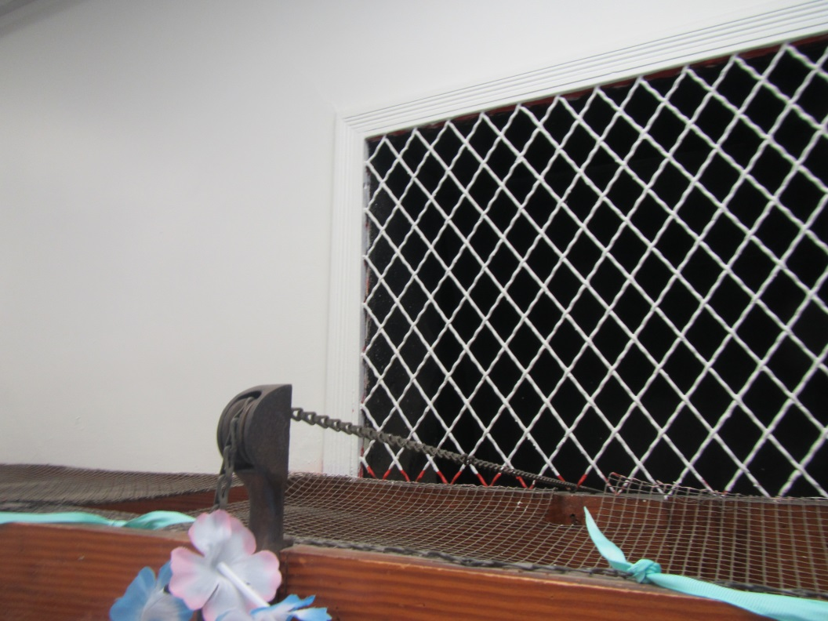
Abandoned ventilation grate in classroom
Picture 2
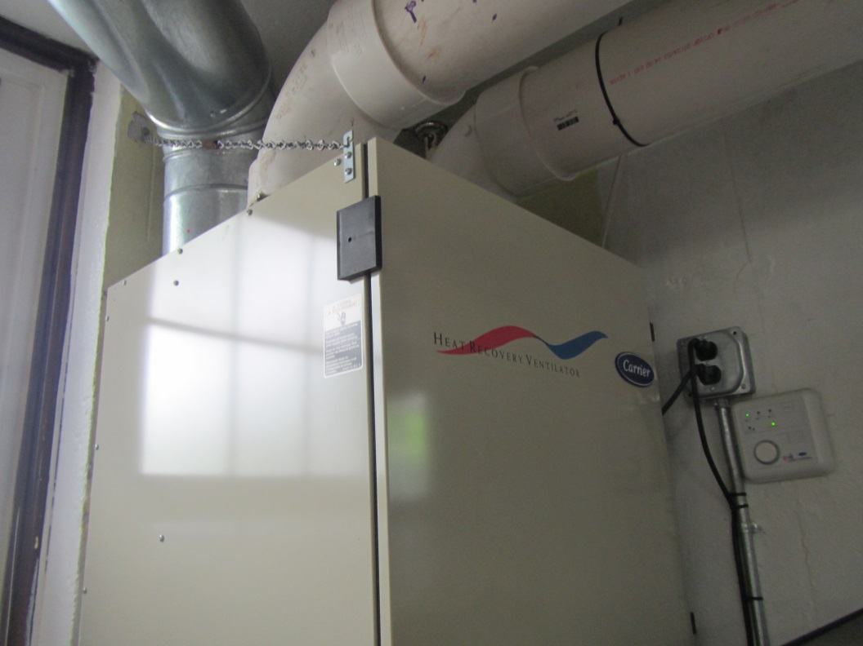
Heat Recovery Ventilator (HRV) in basement athletics room
Picture 3
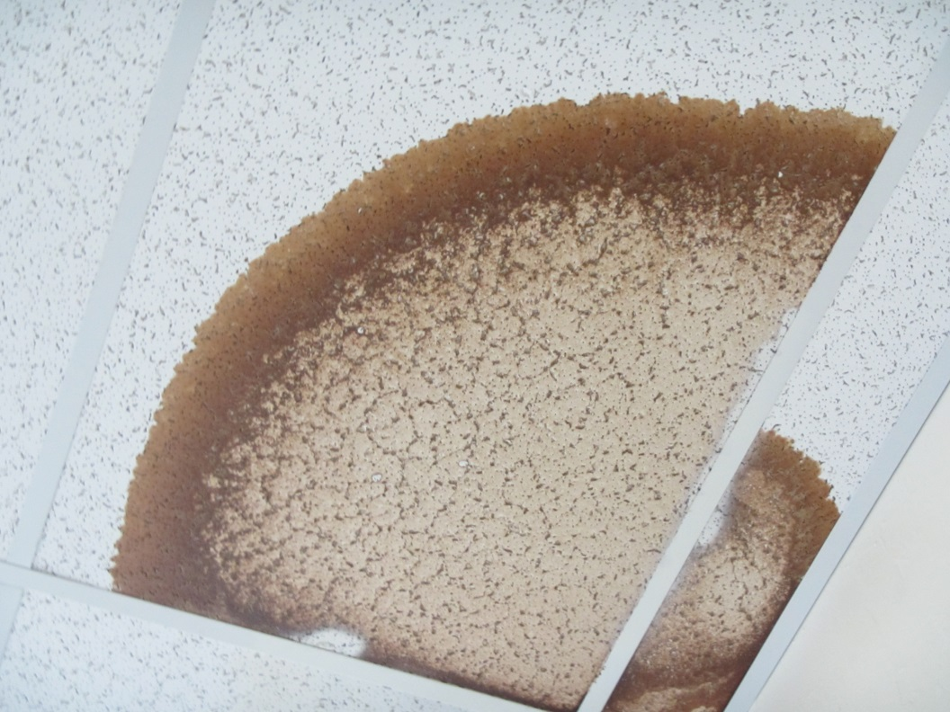
Water-damaged ceiling tiles
Picture 4
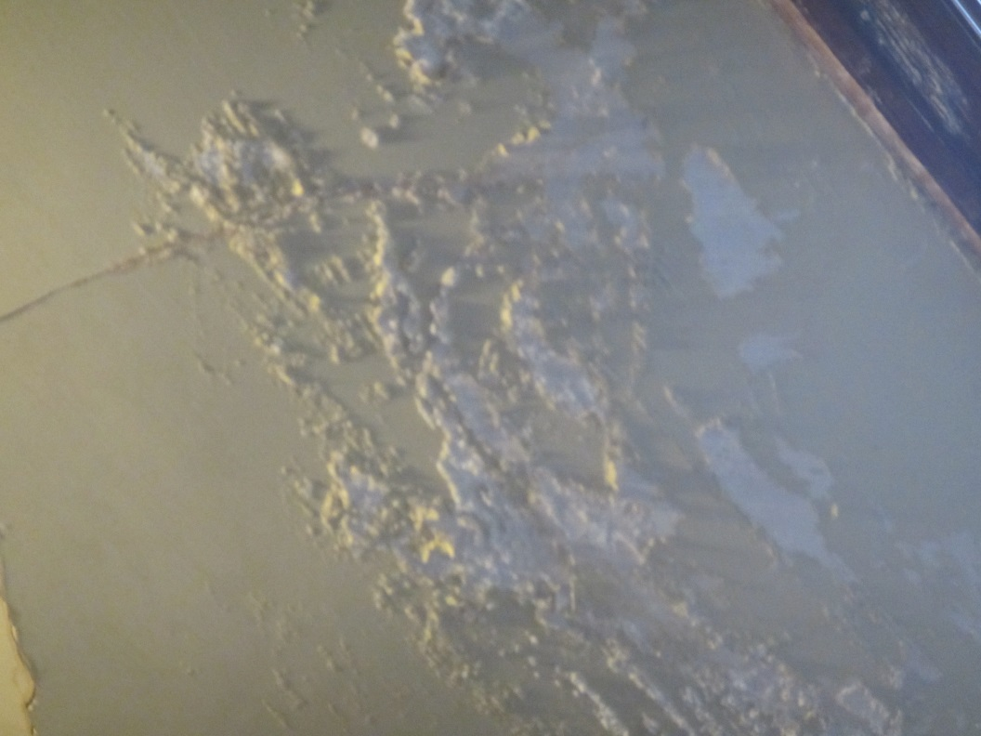
Water-damaged plaster with efflorescence (white powder-like material)
Picture 5
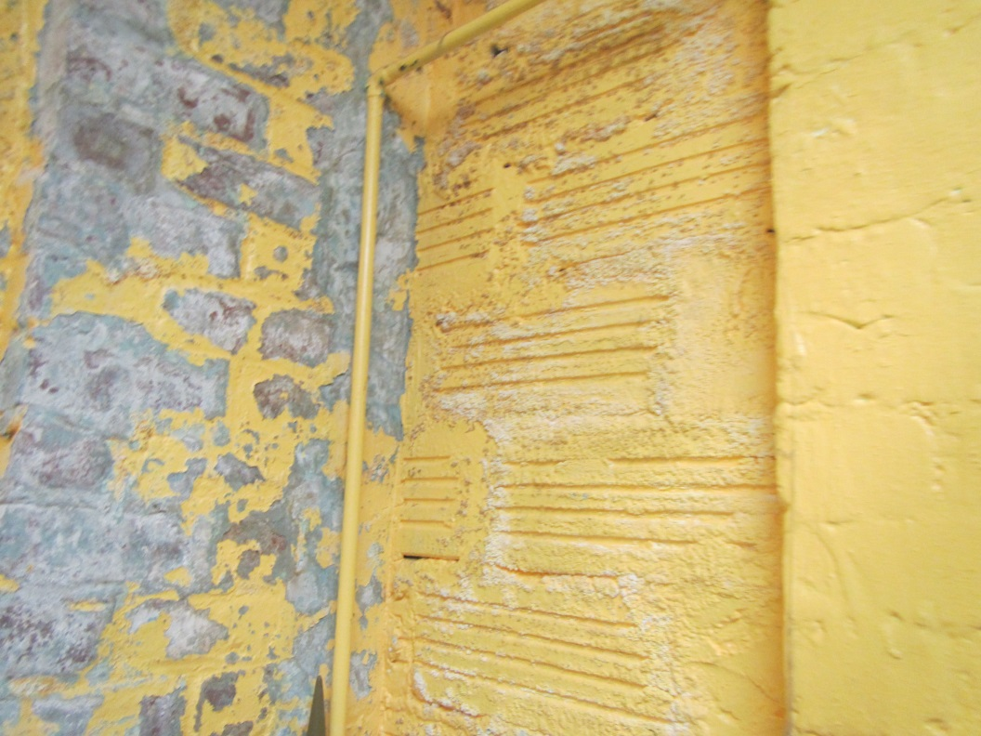
Water-damaged painted brick/mortar with efflorescence
Picture 6
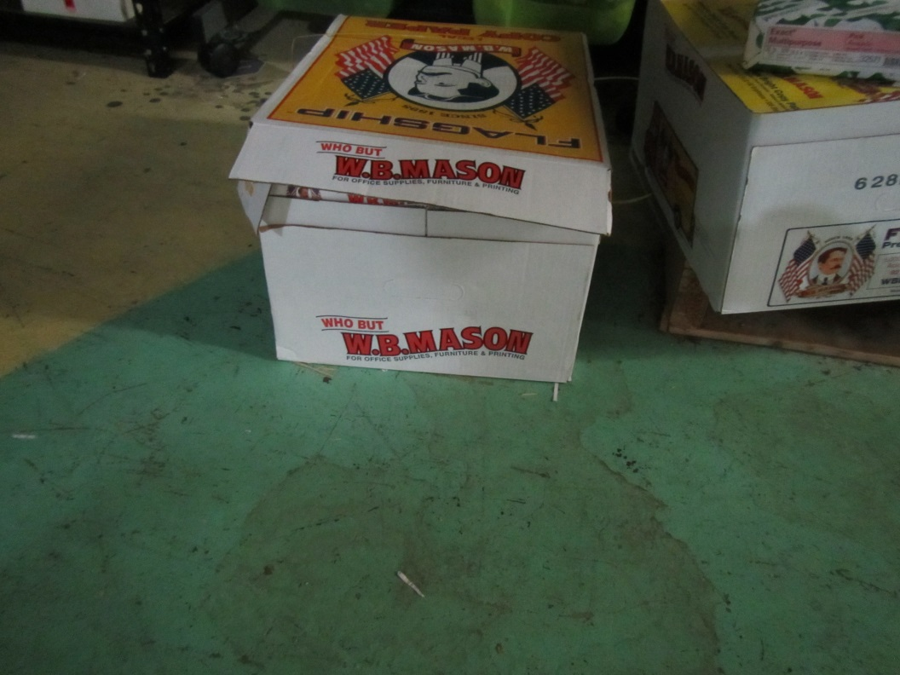
Paper stored on the floor in the basement
Picture 7
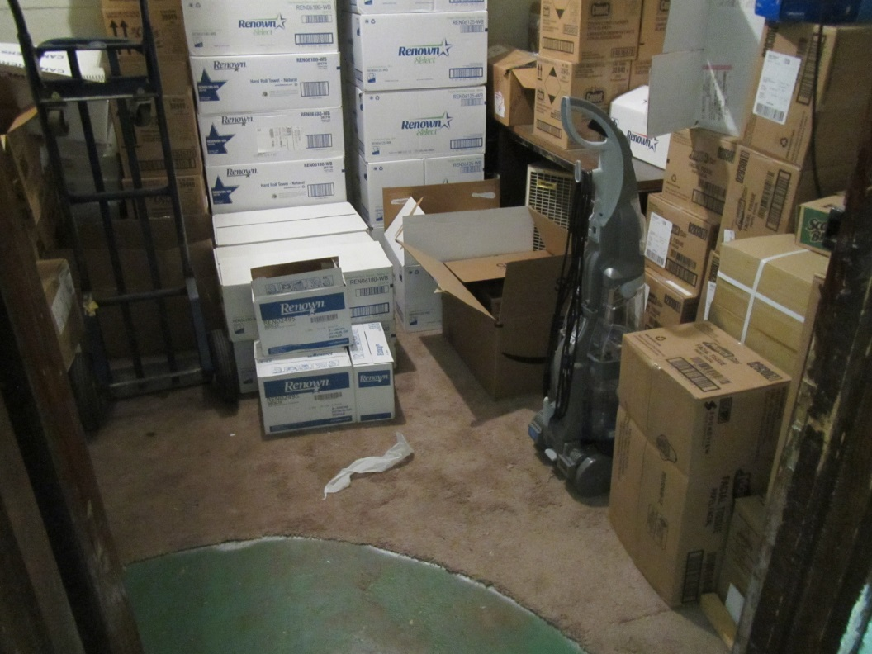
Porous items stored on the floor and carpeting in basement
Picture 8
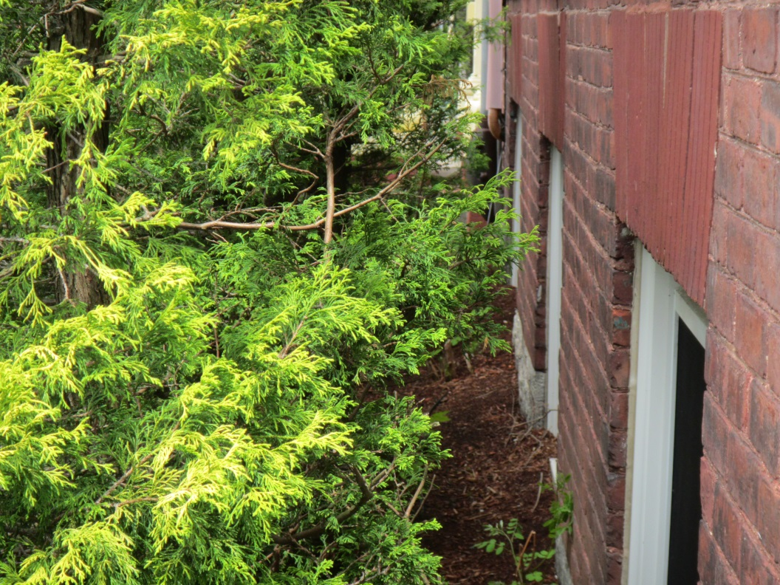
Vegetation growing in close proximity to building
Picture 9
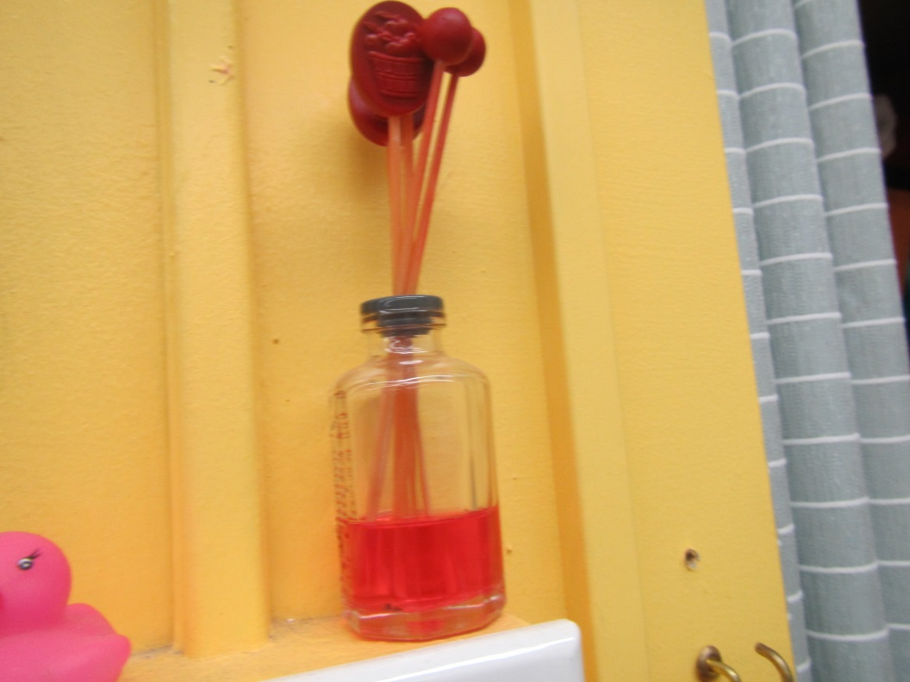
Air freshener in classroom

Location | Carbon  Dioxide  (ppm) | Carbon Monoxide  (ppm) | Temp  (°F) | Relative  Humidity  (%) | PM2.5  (µg/m³) | Occupants  in Room | Windows  Openable | Ventilation |  | Remarks
 |  |  |  |  |  |  |  | Supply | Exhaust
Background (outside) | 389 | ND | 79 | 64 | 28 | - | - | - | - | Warm, partly sunny
Second Floor
10A Occupational therapy | 716 | ND | 73 | 66 | 22 | 2 | Y | N | N | DEM, tile floor
Speech | 622 | ND | 73 | 69 | 26 | 1 | Y | N | N | DEM, wood floors, WD CT outside door
10B Teachers | 685 | ND | 73 | 64 | 22 | 1 | Y | N | N | DEM, tile floor, old abandoned vent
Teachers’ copy | 772 | ND | 74 | 63 | 20 | 1 | N | N | N | PC, slight musty odor (paper stored in basement?)
11B | 812 | ND | 73 | 62 | 19 | 2 | Y | N | N | Tile floor, old abandoned vents
11A | 872 | ND | 73 | 59 | 17 | 2 | Y | N | N | AI, PF, HS, CPs
12 | 1378 | ND | 73 | 61 | 14 | 20 | Y | N | N | CPs, tile floor, WD CT
13 | 966 | ND | 74 | 62 | 18 | 1 | Y | N | N | AI, plants
14 | 949 | ND | 74 | 63 | 21 | 23 | Y | N | N | AI, WD plaster ceiling
15 | 920 | ND | 74 | 60 | 15 | 2 | Y | N | N | DEM, area rugs, WD ceiling, CPs
16 | 601 | ND | 73 | 58 | 10 | 1 | Y | N | N | DEM, HS
17 | 737 | ND | 73 | 61 | 12 | 1 | Y | N | N | AI
18 | 754 | ND | 73 | 59 | 13 | 1 | Y | N | N | HS
First Floor
9 | 747 | ND | 71 | 61 | 8 | 1 | Y | N | N | Multiple plants
Gym | 927 | ND | 72 | 61 | 8 | 17 | N | N | N
8 | 1482 | ND | 73 | 63 | 13 | Left <5min | Y | N | N | AI, area carpet
7 | 1850 | ND | 73 | 67 | 28 | 18 | Y | N | N | AF
6 | 2078 | ND | 73 | 65 | 13 | 21 | Y | N | N | CPs, plants
5 | 2007 | ND | 74 | 65 | 19 | 19 | Y | N | N | AI
Small kitchen | - | 2.7 | - | - | - | - | - | - | - | New gas range, no local exhaust hood, abuts classrooms
4 | 1595 | ND | 77 | 59 | 18 | 22 | Y | N | N | DEM, HS
3 | 1508 | ND | 75 | 63 | 21 | 17 | Y | N | N | HS, DEM
Library | 507 | ND | 75 | 72 | 27 | 2 | Y open | N | N
Copy area | 773 | ND | 74 | 68 | 23 | 1 | Y | N | N | PCs x 2
Main office | 621 | ND | 74 | 70 | 26 | 2 | Y | N | N | HS, PC, plants, tile floor
Conference | 886 | ND | 78 | 72 | 31 | 2 | Y | N | N
Nurse | 851 | ND | 77 | 70 | 29 | 2 | N | N | N
Principal | 888 | ND | 72 | 66 | 26 | 2 | Y | N | N | DEM, tile floor
Basement
Custodian | 391 | ND | 71 | 76 | 30 | 1 | Y | N | N | Fan in window blowing in, aquarium
After School | 629 | ND | 68 | 75 | 22 | 0 | Y | N | N
Supply | - | - | - | - | - | - | - | - | - | Stored boxes of paper in basement area, some on concrete floor
Old gun range-storage room | - | - | - | - | - | - | - | - | - | Stored paper, some on ground, old gun range reportedly removed years ago
Music | 833 | ND | 65 | 71 | 15 | 3 | Y | N | N | Area rugs below grade
Athletic | 725 | ND | 65 | 65 | 15 | 3 | Y | N | N | AI, 9x9 tiles, HRV (no exhaust vent, only supply vents noted??)- not on

