105 CMR 210.000 – Administration of Medications in Schools

Public Hearing 2/13/25 2:00 pm

Dear Commissioner Goldstein, MD, PHD

I am writing to provide my comments on the rules around the Administration in Schools.

I serve as a volunteer, appointed school committee member from North Attleboro to the Tri-Country Regional Vocations High School in Franklin, MA. I am also the father of a student at the school. My comments are personal and do not represent the committee.

My son was hospitalized for multiple days at Hasbro Children’s Hospital in Providence, RI. for Cellulitis. This was a scary time for him and our family. Fortunately, with aggressive treatment, he has made a full recovery.

This experience provided me with a unique perspective on the regulations that we are discussing today, and I have the following recommendations that I would ask that you consider:

Comments on:

210.006: Self Administration of Prescription Medications[1]

And

**Adding self-carry:** While the existing regulation described circumstances [2]where students could self-administer medication, it does not allow for students to self-carry medication, making self-administration impractical. The revised regulation addresses this issue by providing clear guidance for students to self-carry medication.

For High School-Age students, the regulations around self-carry and self-administration should be changed to allow for more reasonable flexibility, given the student's age and maturity.

With the written permission of a parent, students should self-carry and self-administer the over-the-counter medication.

The current procedure requires the school nurse to administer medication per the Medication Permission Form:

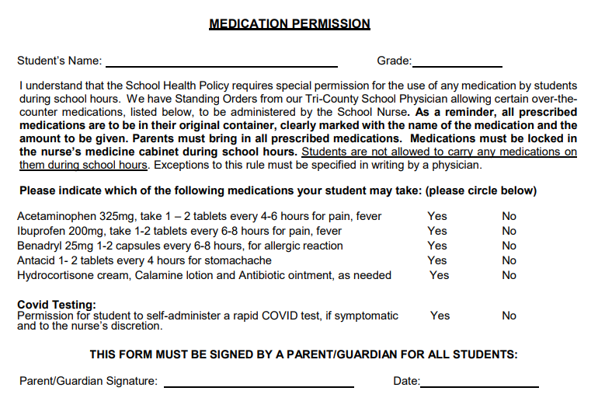

I would suggest that Prescription Medication specifically antibiotics be allowed to be self-carry and self-administrated because of the timing requirements of dosages.

I would also like to comment on the regulation requiring prescriptions to be in a pharmacy or manufacturer-labeled container.

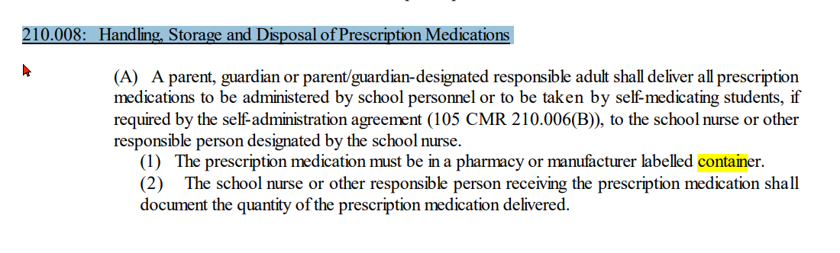

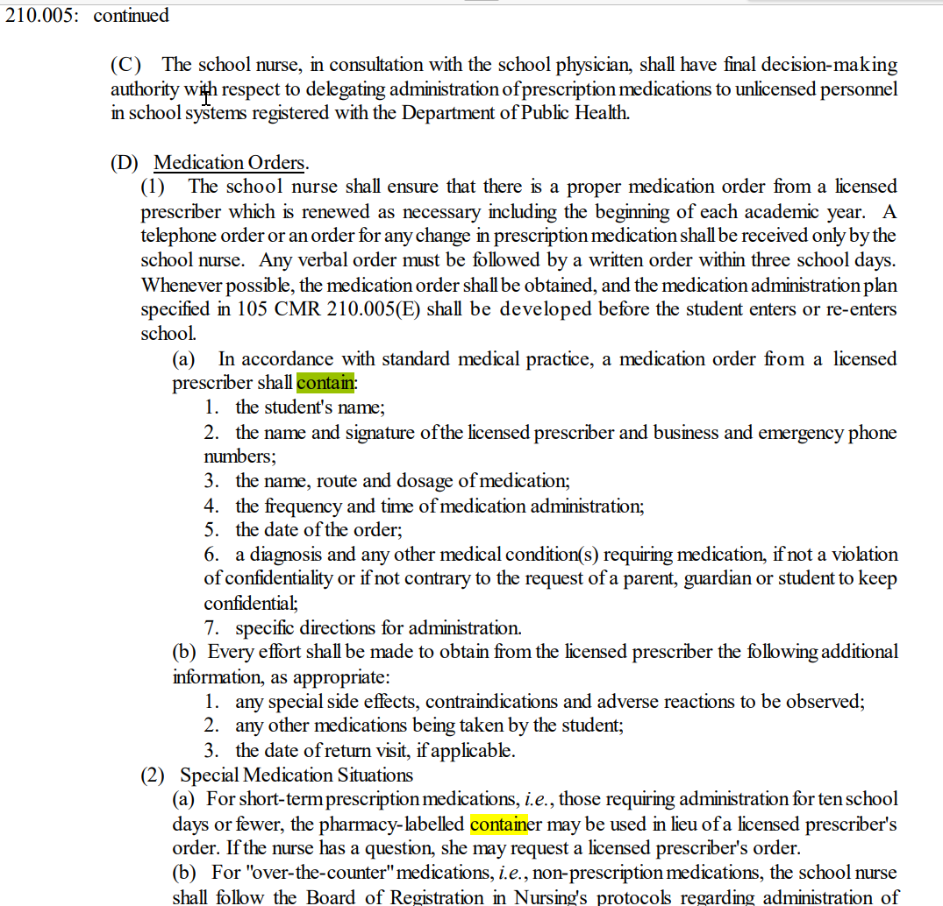

I am pleading with the Department of Health to provide reasonable flexibility in the regulations. In some situations, the strict requirement for a pharmacy-labeled container is an unreasonable burden to worried parents.

**Please provide flexibility.**

As a parent, I need the bottle at home where the student is taking the most dosages of the medication. This is critical because the bottle protects the medication and has the information needed in case there is a medical issue, such as an allergy.

**Requiring a stressed parent with a sick child to remember to ask for a second pharmacy container label with the medication lacks empathy. The current procedure must consider the parent's real-life situation, which is missing.**

The parent is likely overwhelmed and may not have access to the prescriber (they may be a hospital or emergency room prescriber)

I am not suggesting that the school nurse shouldn’t confirm that the medication they must give to the student is the correct medication. I am suggesting that there **must** be other options than a strict container requirement.

Thank you for your time and consideration,

Gregory St. Lawrence

109 Donald Tennant Circle

North Attleboro, MA

(508)-316-1799

(401)-292-7743

1. [105 CMR 210](https://www.mass.gov/doc/105-cmr-210-the-administration-of-prescription-medications-in-public-and-private-schools/download)
2. RE: Informational Briefing on Proposed Amendments to 105 CMR 210: *The Administration of Prescription Medications in Public and Private Schools Letter 1/15/25*