ODOR INVESTIGATION

Groton-Dunstable Regional High School
703 Chicopee Row
Groton, Massachusetts

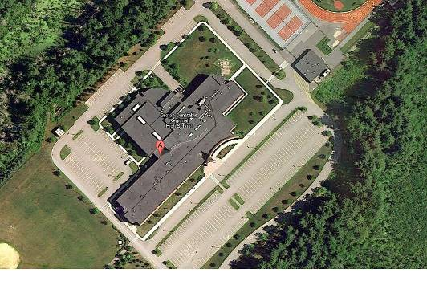

Prepared by:
Massachusetts Department of Public Health
Bureau of Environmental Health
Indoor Air Quality Program
June 2012

Background/Introduction
At the request of Marilyn Galliardo of the Groton-Dunstable Regional School District (GDRSD), the Massachusetts Department of Public Health’s (MDPH) Bureau of Environmental Health (BEH) visited the Groton-Dunstable Regional High School (GDRHS), 703 Chicopee Row, Groton, Massachusetts for purposes of an indoor air quality assessment. On April 20, 2012, Ruth Alfasso, an Inspector in BEH’s Indoor Air Quality (IAQ) Program conducted an odor investigation. Ms. Alfasso was accompanied by Ms. Galliardo and Mr. Stephen Byrne, Director of Buildings and Grounds for the GDRSD. Concerns of an odor detected in an art classroom prompted the assessment. These odors were attributed to a kiln, which was operating in the adjacent ceramic arts classroom. Staff reported health impacts (e.g., respiratory problems) that they attributed to the odor which was reportedly a one-time occurrence.
The GDRHS is a multi-story building constructed in 2004. BEH staff observed conditions in the two adjacent art rooms on the top floor of the building, one of which is the ceramic arts classroom. Two kilns are located in a small room adjacent to the ceramic arts classroom.

Methods
Air tests for carbon dioxide, carbon monoxide, temperature and relative humidity were conducted with the TSI, Q-Trak, IAQ Monitor, Model 7565. Air tests for airborne particle matter with a diameter less than 2.5 micrometers were taken with the TSI, DUSTTRAK™ Aerosol Monitor Model 8520. Air tests for total volatile organic compounds (TVOCs) were conducted with a MiniRAE 2000 photoionization detector.

Results
Tests were taken while the school was closed. The electric kilns had been left on overnight as they are under typical operation, but no clay materials were being fired. Results appear in Table 1.

Discussion

Ventilation
It can be seen from Table 1 that carbon dioxide levels were below 800 parts per million (ppm) in all areas, indicating that the ventilation systems were operating in the building. Low carbon dioxide levels are expected based on the lack of occupancy in the school at the time of the visit. Carbon dioxide measurements in the kiln room were higher than in other areas, indicating that make-up air to the room may not have been adequate to meet the demands of the dedicated exhaust in the kiln room.
The art classrooms examined have ceiling-mounted supply and exhaust vents that are connected to central air-handling units (AHUs). The ceramic arts room and adjacent art classroom can be accessed via the main hallway. These rooms are also connected by a small office/preparation room. Doors leading to the small office/preparation room are typically closed.
The kilns are located in a small dedicated kiln room off the ceramic arts classroom. The kiln room (Picture 1) has a dedicated exhaust system; an exhaust pipe from each kiln (Picture 2) is vented into an overhead hood (Picture 3) which is served by a dedicated exhaust fan on the roof (Picture 4). The fan was operating at the time of the visit and reportedly operates whenever the kilns are in use. The door to the kiln room is typically closed when the kilns are in operation.
No dedicated make-up air supply for the kiln room was observed at the time of the visit. Instead, the room relies on air that is drawn via an undercut kiln room door. It was reported that a grilled vent would be installed in the kiln room door to allow for air flow so the exhaust vents can operate more efficiently in removing heat, odors and any other pollutants generated by the kiln.
Based on an examination of the classrooms and roof area, there did not appear to be a transport pathway for kiln-generated odors/materials to move from the kiln room into adjacent areas. The kiln room exhaust vent is not adjacent to any air intakes, windows or other potential pathways back into the building.
To maximize air exchange, the MDPH recommends that both supply and exhaust ventilation operate continuously during periods of occupancy. In order to have proper ventilation with a mechanical supply and exhaust system, the systems must be balanced to provide an adequate amount of fresh air to the interior of a room while removing stale air from the room. It is recommended that heating, ventilation and air conditioning (HVAC) systems be re-balanced every five years to ensure adequate air systems function (SMACNA, 1994).
The Massachusetts Building Code requires a minimum ventilation rate of 15 cubic feet per minute (cfm) per occupant of fresh outside air or have openable windows in each room (SBBRS, 1997; BOCA, 1993). The ventilation must be on at all times that the room is occupied. Providing adequate fresh air ventilation with open windows and maintaining the temperature in the comfort range during the cold weather season is impractical. Mechanical ventilation is usually required to provide adequate fresh air ventilation.
Carbon dioxide is not a problem in and of itself. It is used as an indicator of the adequacy of the fresh air ventilation. As carbon dioxide levels rise, it indicates that the ventilating system is malfunctioning or the design occupancy of the room is being exceeded. When this happens, a buildup of common indoor air pollutants can occur, leading to discomfort or health complaints. The Occupational Safety and Health Administration (OSHA) standard for carbon dioxide is 5,000 parts per million parts of air (ppm). Workers may be exposed to this level for 40 hours/week, based on a time-weighted average (OSHA, 1997).
The MDPH uses a guideline of 800 ppm for publicly occupied buildings. A guideline of 600 ppm or less is preferred in schools due to the fact that the majority of occupants are young and considered to be a more sensitive population in the evaluation of environmental health status. Inadequate ventilation and/or elevated temperatures are major causes of complaints such as respiratory, eye, nose and throat irritation, lethargy and headaches. For more information concerning carbon dioxide, consult Appendix A.
The temperature in both art classrooms was 74° F, and the temperature in the kiln room was to 78 °F, within the MDPH recommended range in all areas surveyed (Table 1). The MDPH recommends that indoor air temperatures be maintained in a range of 70° F to 78° F in order to provide for the comfort of building occupants. Since the kilns were operating at several hundred degrees, this comfortable temperature in the kiln room indicates that exhaust is functioning to remove waste heat from the room.

Other IAQ Evaluations
Indoor air quality can be negatively influenced by the presence of respiratory irritants, such as products of combustion. The process of combustion produces a number of pollutants. Common combustion emissions include carbon monoxide, carbon dioxide, water vapor and smoke (fine airborne particle material). Of these materials, exposure to carbon monoxide and particulate matter with a diameter of 2.5 micrometers (μm) or less (PM2.5) can produce immediate, acute health effects upon exposure. To determine whether combustion products were present in the indoor environment, BEH staff obtained measurements for carbon monoxide and PM2.5.

Carbon Monoxide
Carbon monoxide is a by-product of incomplete combustion of organic matter (e.g., gasoline, wood and tobacco). Exposure to carbon monoxide can produce immediate and acute health affects. Several air quality standards have been established to address carbon monoxide and prevent symptoms from exposure to these substances. The MDPH established a corrective action level concerning carbon monoxide in ice skating rinks that use fossil-fueled ice resurfacing equipment. If an operator of an indoor ice rink measures a carbon monoxide level over 30 ppm, taken 20 minutes after resurfacing within a rink, that operator must take actions to reduce carbon monoxide levels (MDPH, 1997).
The American Society of Heating Refrigeration and Air-Conditioning Engineers (ASHRAE) has adopted the National Ambient Air Quality Standards (NAAQS) as one set of criteria for assessing indoor air quality and monitoring of fresh air introduced by HVAC systems (ASHRAE, 1989). The NAAQS are standards established by the US EPA to protect the public health from six criteria pollutants, including carbon monoxide and particulate matter (US EPA, 2006). As recommended by ASHRAE, pollutant levels of fresh air introduced to a building should not exceed the NAAQS levels (ASHRAE, 1989). The NAAQS were adopted by reference in the Building Officials & Code Administrators (BOCA) National Mechanical Code of 1993 (BOCA, 1993), which is now an HVAC standard included in the Massachusetts State Building Code (SBBRS, 1997). According to the NAAQS, carbon monoxide levels in outdoor air should not exceed 9 ppm in an eight-hour average (US EPA, 2006).
Carbon monoxide should not be present in a typical, indoor environment. If it is present, indoor carbon monoxide levels should be less than or equal to outdoor levels. Outdoor carbon monoxide concentrations were non-detect (ND) at the time of the assessment (Table 1). No measureable levels of carbon monoxide were detected in the art classrooms, the kiln room, or from the kiln room’s rooftop exhaust vent.

Particulate Matter
The US EPA has established NAAQS limits for exposure to particulate matter. Particulate matter is airborne solids that can be irritating to the eyes, nose and throat. The NAAQS originally established exposure limits to particulate matter with a diameter of 10 μm or less (PM10). According to the NAAQS, PM10 levels should not exceed 150 micrograms per cubic meter (μg/m³) in a 24-hour average (US EPA, 2006). These standards were adopted by both ASHRAE and BOCA. Since the issuance of the ASHRAE standard and BOCA Code, US EPA established a more protective standard for fine airborne particles. This more stringent PM2.5 standard requires outdoor air particle levels be maintained below 35 μg/m³ over a 24-hour average (US EPA, 2006). Although both the ASHRAE standard and BOCA Code adopted the PM10 standard for evaluating air quality, MDPH uses the more protective PM2.5 standard for evaluating airborne particulate matter concentrations in the indoor environment.
Outdoor PM2.5 concentrations the day of the assessment were measured at 16 μg/m³. PM2.5 levels measured in the art classrooms and the kiln room were all 6 μg/m³ or lower (Table 1). Both indoor and outdoor PM 2.5 levels were below the NAAQS PM2.5 level of 35 μg/m³. Additionally, this suggests that the ventilation and filtration systems in the building are operating to reduce indoor levels of particulates from outside air, and that the kilns are not creating additional particulate that might impact adjacent classrooms.

Volatile Organic Compounds and Odors
Indoor air concentrations can be greatly impacted by the use of products containing volatile organic compounds (VOCs). VOCs are carbon-containing substances that have the ability to evaporate at room temperature. Frequently, exposure to low levels of total VOCs (TVOCs) may produce eye, nose, throat and/or respiratory irritation in some sensitive individuals. For example, chemicals evaporating from a paint can stored at room temperature would most likely contain VOCs.
To determine whether VOCs were present in the areas being investigated, air monitoring for TVOCs was conducted. Outdoor air samples were taken for comparison. Outdoor TVOC concentrations the day of the assessment were ND (Table 1). No measurable levels of TVOCs were detected in the arts classrooms or kiln room during the assessment.
In addition, no odors were detected inside the kiln room or elsewhere in adjacent classrooms during the investigation. Since the classrooms were not in use, materials that might emit VOCs or odors were not open or being used at the time of the assessment. In addition, it should be noted again that nothing was being fired in the operating kilns at the time of the assessment.
As discussed above, the concern that prompted this investigation was an odor attributed to the operation of the kiln at the time. At the time the incident occurred, the odor reportedly dissipated a short time after windows to both classrooms were opened. It was reported that nothing unusual had been placed in the kiln at the time of the odor occurred. The school uses clay, clay treatments and glazing that were approved for use in schools. A kiln servicing company, Boston Kiln Sales and Service, examined the kiln, and they reported no problems with the operation of the kilns (Appendix B).

Conclusions/Recommendations
At the time of the visit, no odors, elevated measurements of common air quality parameters or other conditions were detected/observed in the art classrooms, the kiln room, or at the kiln exhaust roof vent. Due to the transient nature of odors, and the fact that the odor has not reoccurred, it is not possible to determine what may have caused the odor or whether the odor may have contributed to symptoms experienced by staff at the time the incident. In light of this, the following are general recommendations for maintaining IAQ in the arts classrooms:
- Continue to operate the building ventilation systems continuously while the building is occupied;
- Continue to operate the kiln exhaust ventilation whenever the kilns are in use. Install a vent in the door of the kiln room to allow for make-up air for proper operation of the kiln exhaust and keep the kiln room door closed at all times;
- Use only appropriate clay and glazing materials in the kilns;
- Refrain from storing items inside the kiln room;
- Ensure doors between the two classrooms and the internal preparation room are closed when possible and keep the doors to the hallway closed to prevent migration of dusts and odors;
- Follow general good practice with all art materials, including selection of appropriate materials, keeping containers sealed when not in use, cleaning up spills promptly, and disposing of waste materials properly so they do not become airborne;
- Consider adopting the US EPA (2000) document, “Tools for Schools”, as an instrument for maintaining a good indoor air quality environment in the building. This document is available at: http://www.epa.gov/iaq/schools/index.html;
- Refer to resource manual and other related indoor air quality documents located on the MDPH’s website for further building-wide evaluations and advice on maintaining public buildings. These documents are available at: http://mass.gov/dph/iaq;
- If the odor does return, contact the IAQ program as soon as possible to determine availability of IAQ staff to more readily respond.

References
ASHRAE. 1989. Ventilation for Acceptable Indoor Air Quality. American Society of Heating, Refrigeration and Air Conditioning Engineers. ANSI/ASHRAE 62-1989
BOCA. 1993. The BOCA National Mechanical Code/1993. 8th ed. Building Officials and Code Administrators International, Inc., Country Club Hill, IL.
MDPH. 1997. Requirements to Maintain Air Quality in Indoor Skating Rinks (State Sanitary Code, Chapter XI). 105 CMR 675.000. Massachusetts Department of Public Health, Boston, MA.
OSHA. 1997. Limits for Air Contaminants. Occupational Safety and Health Administration. Code of Federal Regulations. 29 C.F.R 1910.1000 Table Z-1-A.
SBBRS. 1997. Mechanical Ventilation. State Board of Building Regulations and Standards. Code of Massachusetts Regulations. 780 CMR 1209.0
SMACNA. 1994. HVAC Systems Commissioning Manual. 1st ed. Sheet Metal and Air Conditioning Contractors’ National Association, Inc., Chantilly, VA.
US EPA. 2000. Tools for Schools. Office of Air and Radiation, Office of Radiation and Indoor Air, Indoor Environments Division (6609J). EPA 402-K-95-001, Second Edition. http://www.epa.gov/iaq/schools/tools4s2.html
US EPA. 2006. National Ambient Air Quality Standards (NAAQS). US Environmental Protection Agency, Office of Air Quality Planning and Standards, Washington, DC. http://www.epa.gov/air/criteria.html.
Picture 1

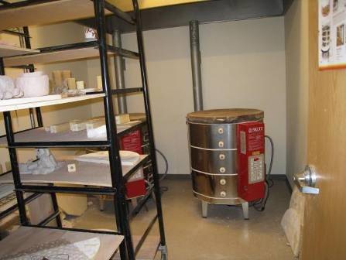

Two Kilns in Kiln Room (arrows point to kiln exhaust vent and hood)

Picture 2

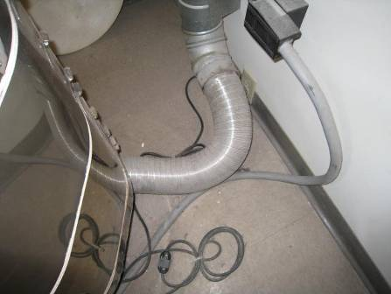

Kiln Exhaust Pipe

Picture 3

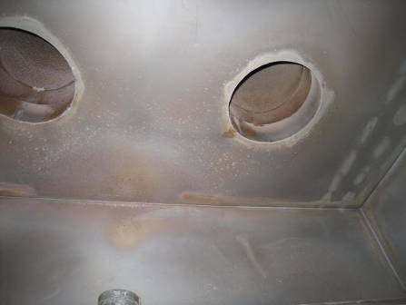

Underside of Exhaust Hood Showing Exhaust Vents to Roof

Picture 4

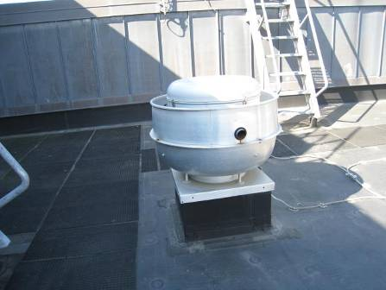

Rooftop Exhaust Vent for Kilns
Location | Carbon  Dioxide  (ppm) | Carbon Monoxide  (ppm) | Temp  (°F) | PM2.5  (µg/m³) | TVOCs  (ppm) | Occupants  in Room | Windows  Openable | Ventilation |  | Remarks
 |  |  |  |  |  |  |  | Supply | Exhaust | Remarks
Background (adjacent parking lot) | 300 | ND | 70 | 16 | ND |  |  |  |  | Breezy, pleasant
In kiln room | 580 | ND | 78 | 6 | ND | 0 | N | Y | Y | Kilns operating with no clay objects being fired, exhaust on
In ceramic arts classroom | 337 | ND | 74 | 6 | ND | 0 | Y | Y | Y | Windows closed
In adjacent art classroom | 300 | ND | 74 | 4 | ND | 0 | Y | Y | Y | Windows closed
On roof, next to operating exhaust vent from kilns | 350 | ND | 70 | 15 | ND

