INDOOR AIR QUALITY ASSESSMENT

Groton-Dunstable Regional Middle School
South Building
344 Main Street
Groton, Massachusetts

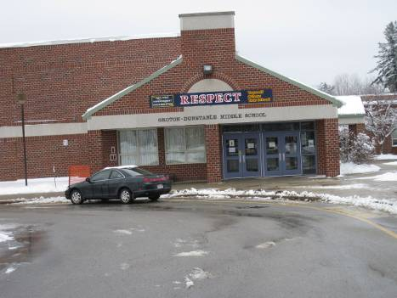

Prepared by:
Massachusetts Department of Public Health
Bureau of Environmental Health
Indoor Air Quality Program
May 2012

Background/Introduction
At the request of The Groton-Dunstable Regional School District (GDRS), the Massachusetts Department of Public Health (MDPH), Bureau of Environmental Health (BEH) conducted an indoor air quality (IAQ) assessment at the Groton-Dunstable Regional Middle School South Building (GDRMS), 344 Main Street, Groton, Massachusetts. The request was prompted by concerns related to water damage, mold and general IAQ. On March 2, 2012, a visit to conduct an IAQ assessment was made to the GDRMS by Michael Feeney, Director of BEH’s IAQ program. Ruth Alfasso, Environmental Engineer/Inspector and Kathleen Gilmore, Environmental Analyst/Inspector of the IAQ Program accompanied Mr. Feeney. Stephen Byrne, Director of Buildings and Grounds for the Groton-Dunstable Regional School District and Caitlyn Entwistle, a teacher at the GDRMS also accompanied Mr. Feeney, Ms. Alfasso, and Ms. Gilmore during the visit.
The GDRMS is a two-story brick building originally constructed in 1988. It has a flat roof, which is reportedly scheduled for replacement in the near future, and a central outdoor courtyard. The building has classrooms, including science and art rooms, a gymnasium, cafeteria, offices, a theater and associated central spaces. Windows were openable in most areas of the building.
In November and December of 2011, Covino, Inc. was contracted by the GDRS to perform visual assessment and laboratory analysis of material on the floor tiles, including tape-lift samples, bulk material samples and bioaerosol monitoring (air samples). According to Covino, sampling did not indicate mold-related issues and no recommendations were made regarding mold remediation (Covino, 2011a; Covino, 2011b).

Methods
Air tests for carbon monoxide, carbon dioxide, temperature and relative humidity were conducted with the TSI, Q-Trak, IAQ Monitor, Model 7565. Air tests for airborne particle matter with a diameter less than 2.5 micrometers were taken with the TSI, DUSTTRAK™ Aerosol Monitor Model 8520. BEH staff also performed a visual inspection of building materials for water damage and/or microbial growth.

Results
The GDRMS houses approximately 430 students in grades 5 and 6 and has a staff of approximately 45. Reportedly, seventh and eighth grade students from the adjacent North Middle School also use some of the facilities in the GDRMS. The tests were taken during normal operations at the school and appear in Table 1.

Discussion

Ventilation
It can be seen from Table 1 that carbon dioxide levels were below 800 parts per million (ppm) in 33 of 45 areas surveyed at the time of the assessment, indicating adequate air exchange in the majority of areas surveyed. It is important to note, however, that some areas were empty/sparsely populated, which can greatly reduce carbon dioxide levels. Carbon dioxide levels would be expected to increase with higher room occupancy.
Fresh air in exterior classrooms is supplied by unit ventilator (univent) systems (Picture 1). A univent is designed to draw air from outdoors through a fresh air intake located on the exterior wall of the building. Return air is drawn through an air intake located at the base of the unit (Figure 1). Fresh and return air are mixed, filtered, heated and provided to classrooms through an air diffuser located in the top of the unit. In a few areas, univents were blocked by various items, limiting airflow in these rooms, and univents were found to be turned off in other areas. In order for univents to provide fresh air as designed, air intakes and returns must remain free of obstructions and the units must be operating.
In some areas, such as offices, the gym, and some classrooms, supply ventilation is provided by centralized air handling units located in mechanical rooms or on the roof. Fresh air in these rooms enters through ceiling-mounted supply diffusers (Picture 2).
Exhaust ventilation to most classrooms is provided by wall or ceiling-mounted vents powered by rooftop motors. It is important to note that many classroom wall exhaust vents are located near hallway doors, which can limit exhaust efficiency. When classroom doors are open, exhaust vents tend to draw air from the hallway, thereby reducing the effectiveness of the vents in removing common environmental pollutants from classrooms. Some of the exhaust vents were also located in areas partially or fully obstructed by the door when the door is open (Pictures 3 and 4).
There are also modular classrooms along the northeast side of the building which have their own heating, ventilation and air conditioning (HVAC) systems; these modular classrooms are currently used only rarely.
The Massachusetts Building Code requires that each room have a minimum ventilation rate of 15 cubic feet per minute (cfm) per occupant of fresh outside air or have openable windows (SBBRS, 1997; BOCA, 1993). The ventilation must be on at all times when a room is occupied. Providing adequate fresh air ventilation with open windows and maintaining the temperature in the comfort range during the cold weather season is impractical. Mechanical ventilation is usually required to provide adequate fresh air ventilation.
Carbon dioxide is not a problem in and of itself. It is used as an indicator of the adequacy of the fresh air ventilation. As carbon dioxide levels rise, it indicates that the ventilating system is malfunctioning or the design occupancy of the room is being exceeded. When this happens, a buildup of common indoor air pollutants can occur, leading to discomfort or health complaints. The Occupational Safety and Health Administration (OSHA) standard for carbon dioxide is 5,000 parts per million parts of air (ppm). Workers may be exposed to this level for 40 hours/week, based on a time-weighted average (OSHA, 1997).
The MDPH uses a guideline of 800 ppm for publicly occupied buildings. A guideline of 600 ppm or less is preferred in schools due to the fact that the majority of occupants are young and considered to be a more sensitive population in the evaluation of environmental health status. Inadequate ventilation and/or elevated temperatures are major causes of complaints such as respiratory, eye, nose and throat irritation, lethargy and headaches. For more information concerning carbon dioxide, see Appendix A.
Temperature readings ranged from 63 ºF to 72 ºF during the assessment, most of which were below the MDPH recommended comfort range (Table 1). The MDPH recommends that indoor air temperatures be maintained in a range of 70 ºF to 78 ºF in order to provide for the comfort of building occupants. In many cases concerning indoor air quality, fluctuations of temperature in occupied spaces are typically experienced, even in a building with an adequate fresh air supply.
The relative humidity measured in the building ranged 17 to 36 percent during the assessment, which was below the MDPH recommended comfort range (Table 1). The MDPH recommends a comfort range of 40 to 60 percent for indoor air relative humidity. Relative humidity levels in the building would be expected to drop during the winter months due to heating. The sensation of dryness and irritation is common in a low relative humidity environment. Low relative humidity is a very common problem during the heating season in the northeast part of the United States.

Microbial/Moisture Concerns
As mentioned, concerns regarding water damage and mold prompted the visit to the GDRMS. The specific concerns related to dark staining and black substances on and around floor tiles in some of the ground floor classrooms.
MDPH staff could not confirm if a vapor barrier was installed beneath the slab to prevent the seepage of moisture from sub-slab areas through the floor. Without a vapor retarder moisture can be drawn upward through the concrete slab by hydrostatic pressure and/or capillary action. Moisture can dissolve alkalis in concrete to form a solution, resulting in higher pH levels beneath flooring that can lead to the breakdown of adhesives (Donnelly, 2005). Since mastic material is sticky, it may collect dirt, dust and debris and provide a media for mold growth, especially if wetted repeatedly (e.g., mopping, high humidity over an extended period/several days). Mastic residue, however, is not mold growth.
Although water infiltration may be a possible source of moisture impacting floor tiles, humidity during summer months also appears to be a potential source for moisture in the building. In particular, it was reported that the issues with the floor tiles occurred in late summer/early fall of 2011, which may coincide with humid weather. Since the floor is on slab, the temperature of the floor may be lower than that of the air. Under conditions of high humidity, a colder floor may be lower than the dew point of the air. The dew point is used as a way to reference humidity – the dew point is the temperature at which the water in the air will start to condense. If there are surfaces with temperatures below the dew point, water condensation may occur. If the floor tiles at GDRMS are at a lower temperature than the dew point during the early fall, this may contribute to moistening of the materials with associated mastic integrity problems, other water damage, and potential mold growth. The location of the affected rooms along the northern side of the building which is shaded by the building, and is near an adjacent forested area, may also subject this area of the building to more condensation/ moistening than other parts of the building. Keeping the floors clean of dust and debris, using cleaning practices that dry floors thoroughly, and limiting the introduction of humid air into the building, are all steps that will help prevent water damage and mold on floor tiles in these locations.
Water-damaged ceiling tiles were observed in some rooms (Picture 5). Water-damaged ceiling tiles can provide a source for mold growth and should be replaced after a water leak is discovered and repaired.
Sinks, present in some classrooms, were examined for water tightness between the backsplashes and countertops. There were spaces observed in some of them and a few of the backsplashes were noted to be damaged (Table 1). If these seams are not watertight, water can penetrate through the seam, causing water damage. Improper drainage or sink overflow can lead to water penetration into the countertop, cabinet interior and areas behind cabinets. Water penetration and chronic exposure of porous and wood-based materials can cause these materials to swell and result in water damage. Classroom sinks were also found to have porous materials (e.g., paper, cloth, bags of potting soils) stored beneath them where they may be subject to moistening (Pictures 6 and 7). Repeated moistening of porous materials can result in mold growth.
A leak was noted from the ceiling vent in the 1st floor ladies restroom resulting in moisture and water accumulation on the floor which can provide a source of mold growth (Picture 8). The source of the leak should be identified and repaired.
Several small refrigerators were noted in classrooms and offices, some of which were located on carpet (Picture 9). Appliances that can condense or leak water should be located on an impermeable surface such as a tiled floor or a plastic mat to prevent water damage to the carpeting.
The US Environmental Protection Agency (US EPA) and the American Conference of Governmental Industrial Hygienists (ACGIH) recommend that porous materials (e.g., carpeting, boxes, books) be dried with fans and heating within 24 to 48 hours of becoming wet (US EPA, 2001; ACGIH, 1989). If not dried within this time frame, mold growth may occur. Once mold has colonized porous materials, they are difficult to clean and should be removed and discarded.
BEH staff examined the outside perimeter of the building to identify breaches in the building envelope and/or other conditions that could provide a source of water penetration. A number of plants were growing in close proximity to the building’s exterior, particularly along the edge of the internal courtyard. The growth of roots against exterior walls can bring moisture in contact with the foundation. Plant roots can eventually penetrate the wall, leading to cracks and/or fissures in the sublevel foundation. The freezing and thawing action of water during the winter months can also create cracks and fissures in the foundation resulting in additional water penetration points. These breaches in exterior areas can also provide a means of drafts and pest entry into the building. All these conditions can undermine the integrity of the building envelope and provide a means of water entry by capillary action into the building through exterior walls, foundation concrete and masonry (Lstiburek & Brennan, 2001).
Inside the theater, light from around the exterior fire doors located behind the stage area indicated a gap around the door. These gaps can be a source of moisture and pest entry and should be sealed using weather stripping.
Indoor potted plants were observed in a few areas. Plants can be a source of pollen and mold which can be respiratory irritants to some individuals. Plants should be properly maintained and equipped with drip pans and located away from univents to prevent the aerosolization of dirt, pollen and mold.
An aquarium containing several turtles was noted in one of the science classrooms (Picture 10). Another covered aquarium was also noted. Aquariums should be properly maintained to prevent microbial/algal growth as they can emit unpleasant odors into the classroom.

Other IAQ Evaluations
Indoor air quality can be negatively influenced by the presence of respiratory irritants, such as products of combustion. The process of combustion produces a number of pollutants. Common combustion emissions include carbon monoxide, carbon dioxide, water vapor, and smoke (fine airborne particle material). Of these materials, exposure to carbon monoxide and particulate matter with a diameter of 2.5 micrometers (μm) or less (PM2.5) can produce immediate, acute health effects upon exposure. To determine whether combustion products were present in the indoor environment, BEH staff obtained measurements for carbon monoxide and PM2.5.

Carbon Monoxide
Carbon monoxide is a by-product of incomplete combustion of organic matter (e.g., gasoline, wood and tobacco). Exposure to carbon monoxide can produce immediate and acute health affects. Several air quality standards have been established to address carbon monoxide and prevent symptoms from exposure to these substances. The MDPH established a corrective action level concerning carbon monoxide in ice skating rinks that use fossil-fueled ice resurfacing equipment. If an operator of an indoor ice rink measures a carbon monoxide level over 30 ppm, taken 20 minutes after resurfacing within a rink, that operator must take actions to reduce carbon monoxide levels (MDPH, 1997).
The American Society of Heating Refrigeration and Air-Conditioning Engineers (ASHRAE) has adopted the National Ambient Air Quality Standards (NAAQS) as one set of criteria for assessing indoor air quality and monitoring of fresh air introduced by HVAC systems (ASHRAE, 1989). The NAAQS are standards established by the US EPA to protect the public health from six criteria pollutants, including carbon monoxide and particulate matter (US EPA, 2006). As recommended by ASHRAE, pollutant levels of fresh air introduced to a building should not exceed the NAAQS levels (ASHRAE, 1989). The NAAQS were adopted by reference in the Building Officials & Code Administrators (BOCA) National Mechanical Code of 1993 (BOCA, 1993), which is now an HVAC standard included in the Massachusetts State Building Code (SBBRS, 1997). According to the NAAQS, carbon monoxide levels in outdoor air should not exceed 9 ppm in an eight-hour average (US EPA, 2006).
Carbon monoxide should not be present in a typical, indoor environment. If it is present, indoor carbon monoxide levels should be less than or equal to outdoor levels. Outdoor carbon monoxide levels were measured at below the detection limit (not detected, or ND). All indoor carbon monoxide measurements were ND during the assessment (Table 1).

Particulate Matter (PM2.5)
The US EPA has established NAAQS limits for exposure to particulate matter. Particulate matter is airborne solids that can be irritating to the eyes, nose and throat. The NAAQS originally established exposure limits to particulate matter with a diameter of 10 μm or less (PM10). According to the NAAQS, PM10 levels should not exceed 150 micrograms per cubic meter (μg/m³) in a 24-hour average (US EPA, 2006). These standards were adopted by both ASHRAE and BOCA. Since the issuance of the ASHRAE standard and BOCA Code, US EPA established a more protective standard for fine airborne particles. This more stringent PM2.5 standard requires outdoor air particle levels be maintained below 35 μg/m³ over a 24-hour average (US EPA, 2006). Although both the ASHRAE standard and BOCA Code adopted the PM10 standard for evaluating air quality, MDPH uses the more protective PM2.5 standard for evaluating airborne particulate matter concentrations in the indoor environment.
Outdoor PM2.5 concentrations were measured at 4 μg/m³ on the day of the visit (Table 1), which is below the NAAQS PM2.5 limit of 35 μg/m³. PM2.5 levels measured inside the school ranged from 4 to 27 μg/m³ (Table 1), which were below the NAAQS PM2.5 limit. Frequently, indoor air levels of particulates (including PM2.5) can be at higher levels than those measured outdoors. A number of mechanical devices and/or activities that occur indoors can generate particulate during normal operations. Sources of indoor airborne particulates may include but are not limited to particles generated during the operation of fan belts in the HVAC system, use of stoves and/or microwave ovens in kitchen areas; use of photocopiers, fax machines and computer printing devices; operation of an ordinary vacuum cleaner and heavy foot traffic indoors.
Two kilns were observed in a small room off one of the art rooms (Picture 11). A hood-style dedicated exhaust vent was observed for the kilns and determined to be functional, operating on a thermostatically-controlled switch. Kilns require dedicated exhaust ventilation to remove heat, gases and particulates generated from the process of firing clay. The door to the kiln room should be undercut by a few inches to allow for air to penetrate the room so that the exhaust ventilation can function effectively in removing the byproducts from kiln use.

Volatile Organic Compounds
Indoor air concentrations can be greatly impacted by the use of products containing volatile organic compounds (VOCs). VOCs are carbon-containing substances that have the ability to evaporate at room temperature. Frequently, exposure to low levels of total VOCs (TVOCs) may produce eye, nose, throat and/or respiratory irritation in some sensitive individuals. For example, chemicals evaporating from a paint can stored at room temperature would most likely contain VOCs. In an effort to identify materials that can potentially increase VOC concentrations, BEH staff examined classrooms for products that may contain these respiratory irritants.
Household cleaning products, air fresheners and deodorizing materials were found in some areas (Table 1). Cleaning products and air deodorizers contain chemicals that can be irritating to the eyes, nose and throat of sensitive individuals. Many air fresheners contain 1,4-dichlorobenzene, a VOC which may cause reductions in lung function (NIH, 2006). Furthermore, deodorizing agents do not remove materials causing odors, but rather mask odors that may be present in the area. Additionally, a Material Safety Data Sheet (MSDS) should be available at a central location for all school chemicals in the event of an emergency such as an adverse chemical interaction between residues left from cleaners used by the facilities staff and those left by cleaners brought in by others.
Most classrooms contained dry erase boards and dry erase board markers (Table 1). Markers and other products were found in some classrooms. Materials such as permanent markers, dry erase markers and dry erase board cleaners and paints may contain VOCs, such as methyl isobutyl ketone, n-butyl acetate and butyl-cellusolve (Sanford, 1999), which can be irritating to the eyes, nose and throat.
In one classroom, a chair was outfitted with tennis balls that had been sliced open and placed on the base of the legs (Picture 12). Tennis balls are made of a number of materials that are a source of respiratory irritants. Constant wearing of tennis balls can produce fibers and cause VOCs to off-gas. Tennis balls made with a natural rubber latex bladder become abraded when used as a chair leg pad. Use of tennis balls in this manner may introduce latex dust into the school environment. Some individuals are highly allergic to latex (e.g., spina bifida patients) (SBAA, 2001). It is recommended that the use of materials containing latex be limited in buildings to reduce the likelihood of symptoms in sensitive individuals (NIOSH, 1997).

Other Conditions
Other conditions that can affect indoor air quality were observed during the assessment. Photocopiers and laminators were located in several areas of the building. Photocopiers can produce VOCs and ozone, particularly if the equipment is older and in frequent use. Lamination machines melt plastic and give off odors and VOCs. VOCs and ozone are respiratory irritants (Schmidt Etkin, D., 1992). If possible, this equipment should be located in an area with local exhaust ventilation and away from sensitive people.
In classroom 95, a section of the coving (the plastic edging material along the bottom of the wall) had been damaged and/or removed. There was a two-foot-long hole in the floor where the floor met the wall. Part of the hole was open through the floor and into the slab resulting in air movement/draft into the room. Other sections of the hole were sealed with expanding foam to fill the holes/gaps (Pictures 13 and 14) however, air movement was still detected. The source/cause of this breach should be identified and be repaired to prevent air, dust and/or odors moving from the building cavity into the occupied space.
BEH staff observed chalk/dry erase board trays containing a build-up of chalk dust and whiteboard marker debris. These materials can be aerosolized by air movement from doors opening and closing, and/or foot traffic and may present a respiratory irritant.
Dust/debris was observed accumulated on univents, supply vents, as well as on the fan blades of personal fans (Table 1). Vents and fans should be cleaned periodically to prevent dust/debris from being aerosolized and redistributed throughout the room. Paint was also noted on the cabinet and blower vents of the univent located in one of the art classrooms. Univents should be kept free of any foreign materials which may impair function or distribute contaminants and odors throughout the classroom.
In several classrooms, items were observed on the floors, windowsills, tabletops, counters, bookcases and desks. Large number of items stored in classrooms provides a source for dusts to accumulate. These items (e.g., papers, folders, boxes) make it difficult for custodial staff to clean. Items should be relocated and/or be cleaned periodically to avoid excessive dust build up. Dust/debris from items placed on top of univents can become airborne through movement of the air.
Floors in some classrooms are covered by wall-to-wall carpeting. It was not clear whether a carpet cleaning program is in place at the GDRMS. Area carpets were observed in several other classrooms (Picture 14). The Institute of Inspection, Cleaning and Restoration Certification (IICRC), recommends that carpeting be cleaned annually (or semi-annually in soiled high traffic areas) (IICRC, 2005). Where an excessively dusty environment exists due to outdoor conditions or indoor activities (e.g., renovations), cleaning frequency should be increased (every six months) (IICRC, 2000).

Conclusions/Recommendations
In view of the findings at the time of the visit the following conclusions and recommendations are made:

- Floor tiles throughout the school should be inspected and monitored routinely for dislodged mastic, moisture and/or water damage and cleaned appropriately to maintain the integrity of the floor.
- To maximize air exchange operate existing ventilation equipment (in working order) continuously throughout the building (e.g., gym, auditorium, classrooms) during periods of school occupancy independent of thermostat control. Ensure all blockages to supply and exhaust vents are removed. Keep classroom doors closed when possible to maximize the ability of the exhaust vents to remove pollutants from classrooms.
- Keep univents free of dust and debris and change filters according to the manufacturer’s specifications.
- Consider adopting a balancing schedule of every 5 years for all mechanical ventilation systems, as recommended by ventilation industrial standards (SMACNA, 1994).
- Use openable windows in conjunction with existing operable equipment to facilitate air exchange. Care should be taken to ensure windows are properly closed at night and weekends to avoid the freezing of pipes and potential flooding.
- For buildings in New England, periods of low relative humidity during the winter are often unavoidable. Therefore, scrupulous cleaning practices should be adopted to minimize common indoor air contaminants whose irritant effects can be enhanced when the relative humidity is low. To control for dusts, a high efficiency particulate arrestance (HEPA) filter equipped vacuum cleaner in conjunction with wet wiping of all surfaces is recommended. Avoid the use of feather dusters. Drinking water during the day can help ease some symptoms associated with a dry environment (throat and sinus irritations).
- Repair any plumbing leaks (e.g., first floor women’s bathroom) and ensure that resultant moistened materials are properly dried.
- Seal breaches between sink countertops and backsplashes to prevent water damage and repair damaged backsplashes. Avoid storage of porous materials under sinks.
- Consider relocating refrigerators to areas with tile floors, or use impermeable mats to contain potential spills or leaks.
- Seal exterior fire doors with weather-stripping. Check for air-tightness by monitoring for light and/or drafts around door.
- Remove foliage to no less than five feet from the foundation.
- Undercut the door to the kiln room by up to three inches to allow for airflow so that the exhaust hood can operate effectively.
- Routinely clean particulate accumulation in chalk/dry erase board trays.
- Store cleaning products properly and out of reach of students. All cleaning products used at the facility should be approved by the school department with MSDS’ available at a central location. Consider providing staff with school-issued cleaning products.
- Consider replacing tennis balls with latex-free tennis balls on furniture legs or glides.
- Routinely clean accumulated dust and debris periodically from the surface of exhaust vents, supply fans and blades of personal fans.
- Clean carpeting annually or semi-annually in soiled high traffic areas as per the recommendations of the Institute of Inspection, Cleaning and Restoration Certification (IICRC). Clean carpeting annually or semi-annually in soiled high traffic areas as per the recommendations of the Institute of Inspection, Cleaning and Restoration Certification (IICRC). Copies of the IICRC fact sheet can be downloaded at: http://www.certifiedcleaners.org/faq.shtml
- Relocate or consider reducing the amount of materials stored in classrooms to allow for more thorough cleaning of classrooms. Clean items regularly with a wet cloth or sponge to prevent excessive dust build-up. Use of plastic totes for storage of items not in use will allow for more thorough cleaning.
- Identify areas where coving has been damaged or removed and repair breaches/holes.
- Consider adopting the US EPA (2000) document, “Tools for Schools”, to maintain a good indoor air quality environment in the building. This document can be downloaded from the Internet at http://www.epa.gov/iaq/schools/index.html.
- Refer to resource manuals and other related indoor air quality documents for further building-wide evaluations and advice on maintaining public buildings. Copies of these materials are located on the MDPH’s website: http://mass.gov/dph/iaq.

References
ACGIH. 1989. Guidelines for the Assessment of Bioaerosols in the Indoor Environment. American Conference of Governmental Industrial Hygienists, Cincinnati, OH.
ASHRAE. 1989. ASHRAE Standard: Ventilation for Acceptable Indoor Air Quality. Sections 5.11, 5.12. American Society of Heating, Refrigerating and Air-Conditioning Engineers, Inc. Atlanta, GA.
BOCA. 1993. The BOCA National Mechanical Code/1993. 8th ed. Building Officials and Code Administrators International, Inc., Country Club Hill, IL.
Covino Environmental Associates Inc. 2011a. Limited Microbial Assessment, Groton Middle School, 344 Main Street, Groton, Massachusetts (Covino Project number 11.01691). November 29, 2011.
Covino Environmental Associates, Inc. 2011b. Bioaerosol Microbial Assessment, Groton Middle School, 344 Main Street, Groton, Massachusetts (Covino Project number 11.01691). December 23, 2011.
Donnelly, G. 2005. Summary of Cause and Measurement Concrete Moisture Vapor Emission and In-Situ Relative Humidity. George Donnelly, http://www.moisturetesting.com/concrete_moisture_vapor.htm
IICRC. 2000. IICRC S001 Reference Guideline for Professional On-Location Cleaning of Textile Floor Covering Materials Institute of Inspection, Cleaning and Restoration Certification. Institute of Inspection Cleaning and Restoration, Vancouver, WA.
IICRC. 2005. Carpet Cleaning FAQ 4 Institute of Inspection, Cleaning and Restoration Certification. Institute of Inspection Cleaning and Restoration, Vancouver, WA.
Lstiburek, J. & Brennan, T. 2001. Read This Before You Design, Build or Renovate. Building Science Corporation, Westford, MA. U.S. Department of Housing and Urban Development, Region I, Boston, MA.
MDPH. 1997. Requirements to Maintain Air Quality in Indoor Skating Rinks (State Sanitary Code, Chapter XI). 105 CMR 675.000. Massachusetts Department of Public Health, Boston, MA.
NIH. 2006. Chemical in Many Air Fresheners May Reduce Lung Function. NIH News. National Institute of Health. July 27, 2006. http://www.nih.gov/news/pr/jul2006/niehs-27.htm
NIOSH. 1997. NIOSH Alert Preventing Allergic Reactions to Natural Rubber latex in the Workplace. National Institute for Occupational Safety and Health, Atlanta, GA.
OSHA. 1997. Limits for Air Contaminants. Occupational Safety and Health Administration. Code of Federal Regulations. 29 C.F.R 1910.1000 Table Z-1-A.
Sanford. 1999. Material Safety Data Sheet (MSDS No: 198-17). Expo® Dry Erase Markers Bullet, Chisel, and Ultra Fine Tip. Sanford Corporation. Bellwood, IL.
SBAA. 2001. Latex In the Home And Community Updated Spring 2001. Spina Bifida Association of America, Washington, DC.
SBBRS. 1997. Mechanical Ventilation. State Board of Building Regulations and Standards. Code of Massachusetts Regulations. 780 CMR 1209.0.
Schmidt Etkin, D. 1992. Office Furnishings/Equipment & IAQ Health Impacts, Prevention & Mitigation. Cutter Information Corporation, Indoor Air Quality Update, Arlington, MA.
US EPA. 2000. Tools for Schools. Office of Air and Radiation, Office of Radiation and Indoor Air, Indoor Environments Division (6609J). EPA 402-K-95-001, Second Edition. http://www.epa.gov/iaq/schools/tools4s2.html
US EPA. 2001. “Mold Remediation in Schools and Commercial Buildings”. Office of Air and Radiation, Indoor Environments Division, Washington, DC. EPA 402-K-01-001. March 2001. Available at: http://www.epa.gov/iaq/molds/mold_remediation.html
US EPA. 2006. National Ambient Air Quality Standards (NAAQS). US Environmental Protection Agency, Office of Air Quality Planning and Standards, Washington, DC. http://www.epa.gov/air/criteria.html
Picture 1

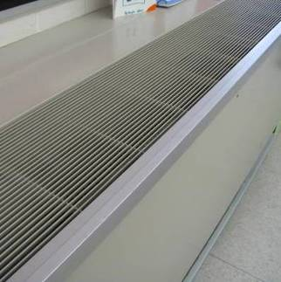

Unit Ventilator (Univent)

Picture 2

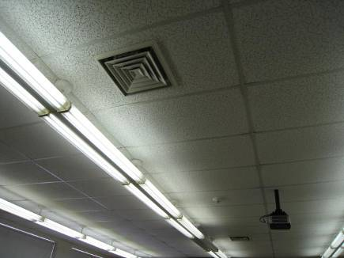

Ceiling-Mounted Supply Vent

Picture 3

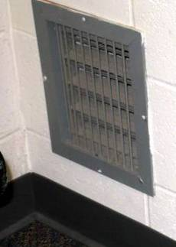

Wall-Mounted Exhaust Vent behind Closed Classroom Door

Picture 4

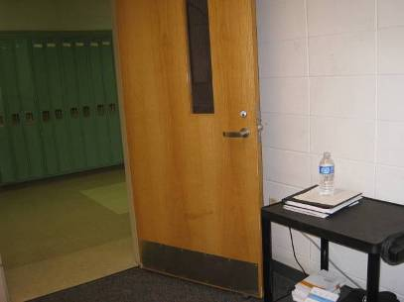

Same Exhaust Vent Obstructed behind Open Classroom Door

Picture 5

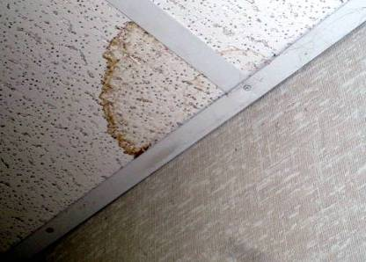

Water-damaged Ceiling Tile

Picture 6

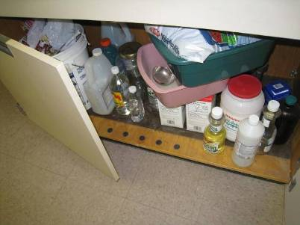

Various Items Stored under Sink

Picture 7

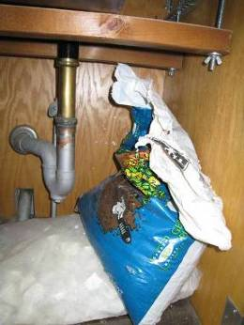

Potting Soil Stored under Sink

Picture 8

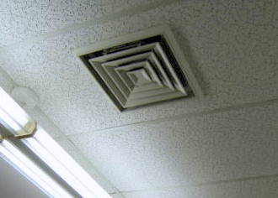

Leaking Ceiling Vent in 1st Floor Restroom

Picture 9

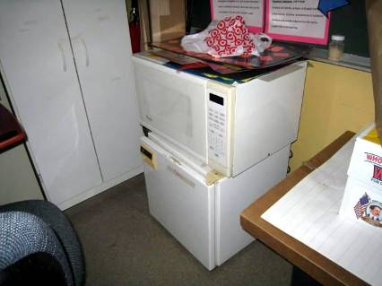

Mini Refrigerator on Carpet

Picture 10

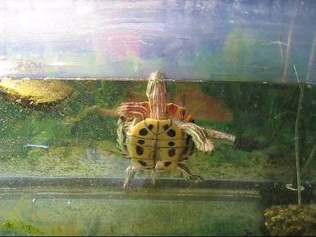

Turtle Aquarium in Science Lab

Picture 11

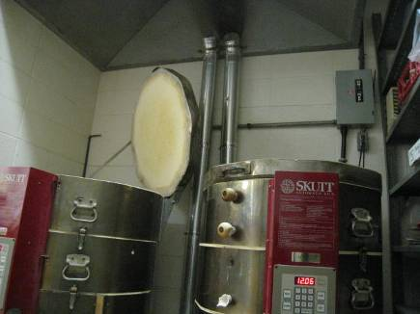

Pottery kilns and dedicated exhaust ventilation

Picture 12

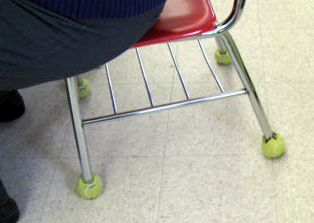

Tennis Balls on Classroom Chair

Picture 13

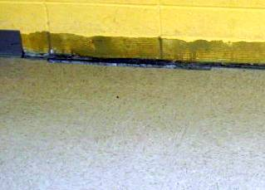

Missing Coving with Hole in Floor: Note Arrow Depicting Hole/Gap

Picture 14

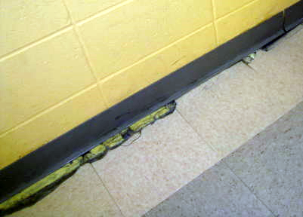

Missing Coving: Note Arrow Depicting Expanding Foam Partially Filling Hole/Gap

Picture 15

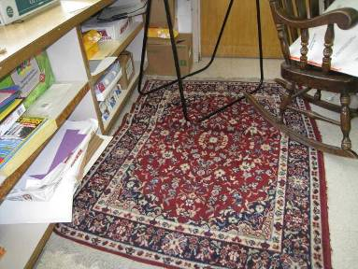

Area Carpet in Classroom

Location | Carbon  Dioxide  (ppm) | Carbon Monoxide  (ppm) | Temp  (°F) | Relative  Humidity  (%) | PM2.5  (µg/m3) | Occupants  in Room | Windows  Openable | Ventilation |  | Remarks
 |  |  |  |  |  |  |  | Supply | Exhaust | Remarks
Background | 222 | ND | 29 | 36 | 4 |  |  |  |  | Cloudy
Cafeteria | 1657 | ND | 69 | 36 | 27 | 100+ | Y | Y | Y | Sunshades on windows
Conference room in modular classroom | 705 | ND | 63 | 34 | 7 | 8 | Y | Y | Y | DEM. Rooms in modular wing not typically used
Gym | 387 | ND | 67 | 20 | 5 | 0 | N | Y | Y | AHU on ceiling
Library (left side) | 636 | ND | 71 | 18 | 13 | 0 (closed) | Y | Y | Y | Clutter, bushes outside windows
Library (right side) | 721 | ND | 71 | 21 | 9 | 0 | Y | Y | Y | Carpet, Laminator, PC, PF
Library media/magazine room | 491 | ND | 72 | 17 | 12 | 0 | Y | Y | Y
Mrs. Hibbard | 520 | ND | 69 | 18 | 13 | 9 | Y | Y | Y | UV 1 of 2 off – some debris in it, CD, plants, DEM
Mrs. Sawyer’s room | 1264 | ND | 68 | 25 | 12 | 25 | Y | Y | Y | UV off, chalk, PS, hand sanitizer
Special language | 529 | ND | 71 | 18 | 13 | 0 | N | Y | Y | CD
Storage room for Mrs. Sawyer’s room | 811 | ND | 68 | 22 | 12 | 0 | Y | Y | N | DEM, WD-CT, 2 PF (dusty)
Men’s rest room 1st floor | 678 | ND | 67 | 23 | 6 | 0 | N | N | Y
Women’s rest Room 1st floor | 595 | ND | 65 | 25 | 5 | 0 | N | N | Y | WD-CT, Water leak from ceiling vent, Water on floor
2nd floor copy room | 541 | ND | 69 | 21 | 13 | 0 | N | Y | Y | 1 PC
2nd floor unisex toilet room |  |  |  |  |  |  |  |  | Y on
16 (nurse) | 426 | ND | 66 | 21 | 16 | 1 | N | Y | Y | DO
62 Guidance | 598 | ND | 72 | 19 | 17 | 3 | Y | Y | Y | UV on, PF, DEM, microwave and mini fridge, air freshener/perfume scent (no source noted)
64 | 341 | ND | 71 | 17 | 13 | 0 | Y | Y | Y | UV on, Carpet, DO, DEM, PF, CD, dead flowers in vase
66 | 441 | ND | 71 | 18 | 15 | 0 | Y | Y | Y | UV on, DEM, DO, PS in UV, items, carpeting
68 | 504 | ND | 72 | 18 | 16 | 2 | Y | Y | Y | DEM, UV on, chalk, items, mini fridge and microwave
70 | 774 | ND | 71 | 22 | 9 | 6 | Y | Y | Y | DO, DEM, PS, PF
82 (guidance) | 719 | ND | 67 | 21 | 8 | 2 | Y | Y | Y | DO, Plants
83 | 642 | ND | 69 | 20 | 11 | 23 just left | Y | Y | Y | DO, exhaust partly blocked, DEM, carpet, CD
87 | 828 | ND | 68 | 20 | 16 | 0 | Y | Y | Y | UV on, DEM, CD
88 (computer lab) | 792 | ND | 67 | 21 | 7 | 18 | Y | Y | Y | No UV, Radiator on, Carpeting
91 | 752 | ND | 67 | 22 | 12 | 0 | Y | Y | Y (obstructed) | UV on high, PS, DEM, carpet, DO
92 | 782 | ND | 66 | 23 | 11 | 6 | Y | N | N | 1 AT, plush chairs
94 (Science) | 354 | ND | 66 | 22 | 11 | 0 | Y | Y | Y
95 | 1002 | ND | 66 | 28 | 8 | 30 | Y | Y | Y | Exhaust blocked by door, Coving missing, Holes in floor with draft, Some holes filled with foam insulation, DEM, PF dirty
202 | 739 | ND | 69 | 21 | 12 | 15 | Y | Y | Y | UV off, DO. DEM, TB on one chair, CD, items, microwave and mini fridge
Room adjacent to 204 | 802 | ND | 68 | 22 | 11 | 0 | N | N | N | DEM
205 | 633 | ND | 68 | 21 | 4 | 0 | Y | Y | Y
206 | 536 | ND | 68 | 20 | 17 | 2 just in | Y | N | N | Paper under sink, DO, DEM, CD, WD backsplash, microwave and mini fridge
210 (science) | 1050 | ND | 70 | 23 | 11 | 21 | y | y | y | Sinks, CP, DP, CD, DEM, PF dusty, AT
212 science | 494 | ND | 69 | 19 | 12 | 0 | y | y | y | Sinks (backsplash ok), PFs, soil under sink in bag, DEM, items, DO, PS
213 Lit lab | 571 | ND | 70 | 19 | 11 | 0 (left recently) | y | y | y | CD,.DEM, UV on
214 | 638 | ND | 68 | 22 | 5 | 1 | Y | Y | Y | Do, DEM, PC dirty, Exhaust blocked, Hand sanitizer
215 | 973 | ND | 67 | 27 | 8 | 21 | Y | Y | Y
216 | 879 | ND | 66 | 25 | 5 | 23 | Y | Y | Y | DO, Exhaust partially blocked by door, DEM, PF dirt
217 | 1130 | ND | 68 | 24 | 7 | 0 | Y | Y | Y | DO, Exhaust blocked by door, DEM, PS  Hand sanitizer
224 | 890 | ND | 68 | 24 | 6 | 28 | Y | Y | Y | DO, Clutter, DEM , UV partially blocked
230 | 790 | ND | 68 | 25 | 9 | 17 | Y | Y | Y | DEM, PS, Chalk, Paper under sink, hand sanitizer
235 | 788 | ND | 68 | 28 | 8 | 24 | Y | Y | Y | DO, PS, DEM, PF
242 (art) | 584 | ND | 72 | 17 | 14 | 0 | Y | Y | Y | Sink door open, refrigerator, dishwasher, CD, AP on shelf (not in use)
243 (Art) | 975 | ND | 71 | 23 | 12 | 25 | Y | Y | Y | 4 WD-CT, UV on, paint staining on UV, art materials, 4 sinks, one with WD backsplash. Adjacent storage room has WD and missing tiles, items
249 | 588 | ND | 69 | 21 | 7 | 0 | N | Y | Y

