Growing Healthy Smiles
In The Child Care Setting

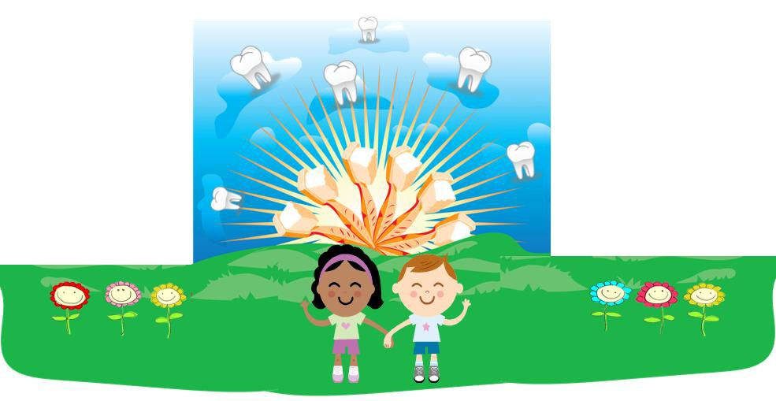

Implementing a Tooth Brushing Program to Promote Oral Health and
Prevent Tooth Decay

Office of Oral Health
Massachusetts Department of Public Health November 2009

Growing Healthy Smiles in the Child Care Setting: Implementing a Tooth Brushing Program to Promote Oral Health and Prevent Tooth Decay

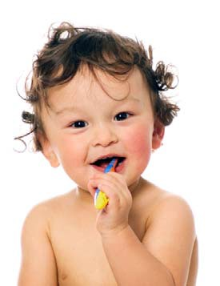With concerns about the increase in dental disease (tooth decay) among young children, the Massachusetts Department of Early Education and Care (EEC) recently adopted a new regulation for child care settings, number 606 CMR 7.11(11)(d), to promote oral health and prevent tooth decay.

Effective January 2010, licensees must assist children with brushing their teeth if:
- The children are in care for more than 4 hours, or
- They have a meal while in care.

This guide has been developed to help early education and care programs. This resource will help child care workers:

- Understand the problem of dental disease in children;
- Understand the cause of tooth decay and how to prevent it;
- Learn strategies to effectively implement a tooth brushing program in a child care setting.

The guide is organized into 3 sections:

Section 1
    - Reviews the causes, risk-factors, and prevention strategies for tooth decay

Section 2
    - Discusses the importance of toothbrushing and provides tips on safely implementing a tooth brushing program, including:
Y Tooth brushing instructions
Y Supplies needed
Y Safe handling and storage of toothbrushes and toothpaste
Y Organization of the tooth brushing activity and staff supervision
Y Sample letter and fact sheet for parents/caregivers

Section 3
o

Offers resources for additional information on other school and group tooth brushing programs and oral health teaching tools/lessons for young children

1

Section 1: Tooth Decay:
Causes, Risk-Factors, and Prevention Strategies

How Does Tooth Decay Happen?
In most children, primary (baby) teeth begin to erupt at around 6 months of age. Once the first tooth erupts, a child is at-risk for tooth decay. In fact, tooth decay is the most common chronic disease among children. Tooth decay or dental cavities is an infectious disease, meaning the bacteria that cause tooth decay can spread from person to person. The disease starts after eating or drinking something with starch or sugar. Bacteria (germs) in the mouth “eat” these carbohydrates, which allow them to grow and collect together on the tooth. This collection of bacteria is called dental plaque. The bacteria in dental plaque continue to eat carbohydrates and produce acids. These acids weaken the tooth and a hole, or a “cavity,” is formed.

The Process of Tooth Decay Formation

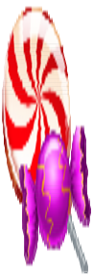
ACID
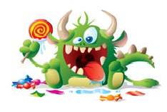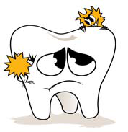Sugar/Starch Bacteria (Germs) in Plaque

Tooth Decay
ACID

Healthy Tooth

Why Should YOU Care About Tooth Decay?

Baby teeth are important! When very young children develop tooth decay it can hurt more than just their smile; nutrition, socialization, self-esteem development, well-being, and the development and eruption of their adult (permanent) teeth can all be impacted negatively. Furthermore, having tooth decay in early childhood puts the child at-risk for tooth decay in adulthood. No child should experience these problems because TOOTH DECAY IS PREVENTABLE. With your help enforcing the new tooth brushing regulations, children in your care will have a lesser chance of suffering from this disease.

2

Section 1: Tooth Decay:
Causes, Risk-Factors, and Prevention Strategies

What Does Tooth Decay Look Like?

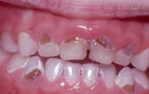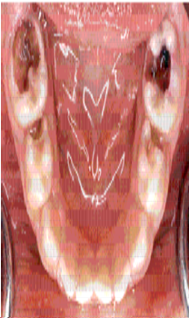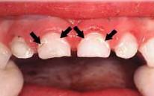The first sign of tooth decay is a white and chalky spot on the tooth, often on the front teeth near the gumline. At this stage, the dental caries process can be stopped and the tooth can be healed if minerals like fluoride in drinking water and toothpaste are used regularly; and if the child’s diet is changed to limit foods and drinks with a lot of sugar, as well as carbohydrates.

If the teeth aren’t kept clean, they don’t receive enough fluoride, and sugar isn’t limited in the diet, eventually a hole forms in the tooth’s
enamel or outer surface. Once the tooth has a hole it must be treated by a dentist. The dentist will remove the infected part of the tooth and fill the hole.

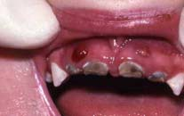If a cavity is not treated, the infection will continue to weaken the tooth. If it spreads to the innermost part of the tooth where the blood vessels and nerves are located, the tooth can become very painful and the infection can spread to other parts of the body. This severe infection must be treated immediately.

What Factors Affect the Tooth Decay Process?

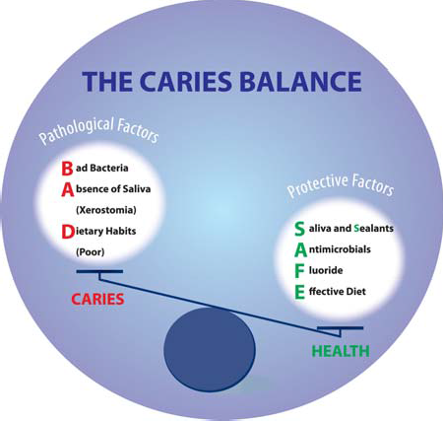The demineralization and remineralization process is affected by several factors. Some of these factors include:
- Saliva
- Oral hygiene behaviors
- Fluoride exposure
- Diet
- Medicine
- General health
All people with teeth (children and adults) are at-risk for developing tooth decay; however primary (baby) teeth have a much thinner layer of enamel compared to adult teeth. Therefore, young children are more at-risk for tooth decay, which usually progresses quicker than it does in adult teeth.

3

Section 1: Tooth Decay:
Causes, Risk-Factors, and Prevention Strategies

Fortunately, TOOTH DECAY CAN BE PREVENTED. In the childcare setting, you can help prevent tooth decay by encouraging two important prevention strategies:

- Mechanically remove dental plaque bacteria with a toothbrush, using a very small smear or pea-sized amount of fluoride toothpaste to strengthen the tooth.

- Decrease the frequency (number of times per day) children consume foods/drinks high in sugar and carbohydrates. Children should never take a nap or go to sleep at night with food or milk/juice.

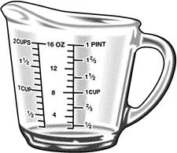~6 oz
American Academy of Pediatrics recommends that children age 1-6 consume no more than 4-6 ounces of fruit juice per day, from a cup (not a bottle or sippy cup) and as part of a meal or snack.

Why is Toothbrushing Important?
~4 oz

According to the Centers for Disease Control and Prevention (CDC), “When done routinely and properly, toothbrushing can reduce the amount of plaque which contains the bacteria associated with gum disease and tooth decay, as well as provide the cavity- preventing benefits of fluoride.” Toothbrushing is important for two major reasons:

- Brushing teeth removes plaque, which contains tooth decay causing germs. Plaque tends to form after meals or drinks that contain any sugar or carbohydrates. Brushing after eating/drinking can remove and control the growth of plaque bacteria (germs) that forms on the teeth.

- Brushing with toothpaste that contains fluoride makes the tooth stronger and less at -risk for developing tooth decay.

Implementing a Tooth Brushing Program

To implement a tooth brushing program, you will need to consider several things:

  - Toothbrushing instructions;
  - Managing and storing supplies;
  - Infection control and organization of tooth brushing activity;
  - Staff involvement and supervision of children; and
  - Informing parents/caregivers about the program and the prevention of tooth decay.

4

Toothbrushing Instructions

Up until about age 8, most children do not have the fine motor skills to independently brush their teeth effectively, so they will need your help. Children will need supervision and assistance in order to brush safely, correctly, and thoroughly.

Use the diagram on the right to help children brush their teeth the proper way. It is especially important to brush all teeth surfaces by gently moving the brush in small circles to remove plaque and food debris, and deliver fluoride from the toothpaste. As a child gets older, they tend to get tooth decay in the molar or large back teeth. Be sure to remind all children to brush these areas, too. Also, don’t forget to brush the tongue.

Important Instructions for Brushing with Fluoride Toothpaste:

Children under 2 years of age should
  - Use a small smear of fluoride toothpaste;
  - Spit it all out in the sink; and

NOT rinse with water after brushing.

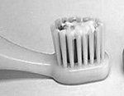
A “smear” of toothpaste is used for children younger than age 2.

Children over 2 years of age should
  - Use a pea-sized amount of fluoride toothpaste;
  - Spit it all out in the sink; and
  - 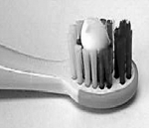Rinse with a little tap water provided in disposable paper cups. Cups should not be shared or used again, and should be thrown away after use.
A “pea-sized” amount of fluoride toothpaste is used for children over age 2.

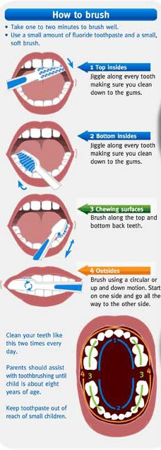

Image courtesy of: http://www.squidoo.com/how- to-get-rid-of-sensitive-teeth
Section 2: Tooth Brushing Program Implementation

5

Section 2: Tooth Brushing Program Implementation

Managing Supplies

First, you will need to designate staff members who will be responsible for managing supply inventory, ordering/purchasing, storage, and distribution. You will need to think about where supplies will be safely stored and how they will be distributed to children.

Your inventory of supplies will vary depending on the number of children that attend your child care facility. It is recommended that supplies are ordered and purchased by the child care facility. If a program relies on each child’s family to provide toothbrushes or toothpaste, the program should have extra supplies on hand for children who forget to bring them from home.

The Mandatory Supplies Include:
  - Toothbrushes
  - Fluoride Toothpaste
  - Toothbrush Labels and Storage Systems
  - Disposable Cups for Rinsing

Toothbrushes

- Toothbrush labeling
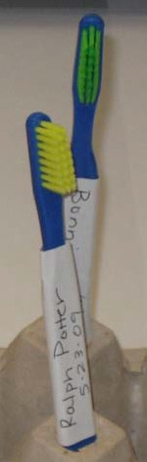Each child should have an age appropriate toothbrush labeled with his or her full name and the date the toothbrush was given to the child. This can be done using masking tape and a permanent marker or waterproof printable labels/photo paper. Do not allow children to share or borrow toothbrushes.

- Choosing an age appropriate toothbrush
Toothbrushes are made for different ages based on a child’s motor skills and growth/developmental stage. Infant brushes usually have a very small toothbrush head (about 1 inch by ½ inch) with extra soft bristles.
As a child ages, his or her mouth grows and more teeth erupt, so a larger toothbrush head is needed. For all children and adults, only toothbrushes with soft bristles should be used. Medium and hard bristles can damage the gums and teeth. Manual brushes should be used, not electric brushes.

- Ordering toothbrushes
Suppliers of oral care products can help you determine what toothbrushes to purchase based on the number of children you care for and their ages.
Toothbrushes of all sizes should be purchased in bulk so replacements are readily available.

6

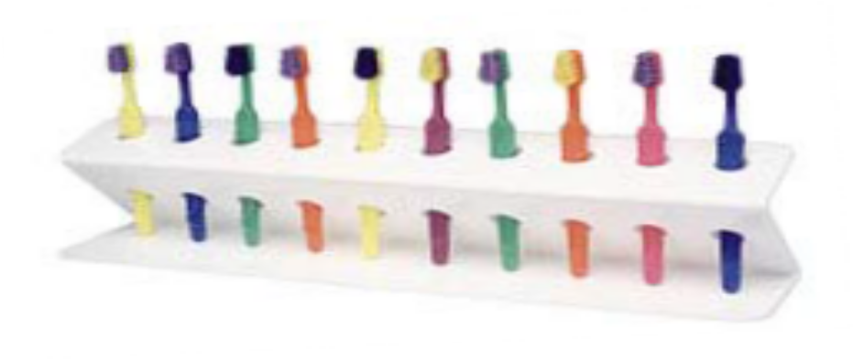
Section 2: Tooth Brushing Program Implementation

Replacing Children’s Toothbrushes
According to the Centers for Disease Control and Prevention (CDC), soaking toothbrushes in disinfecting solutions or mouthwash is NOT recommended because it may actually spread germs. Using dishwashers, microwaves, or ultraviolet devices to disinfect toothbrushes is also not recommended because they can damage toothbrushes and are not proven effective.

How old is that toothbrush?
- Keep track of how old the toothbrush is by marking it with the date it was given to the child using masking tape and a permanent marker.
- On a calendar or spreadsheet, write down the date toothbrushes were given and then the date in 3 months when the brushes should be replaced. Or, use an electronic calendar that automatically reminds you when brushes are due for changing!

However…when in doubt, throw it out!

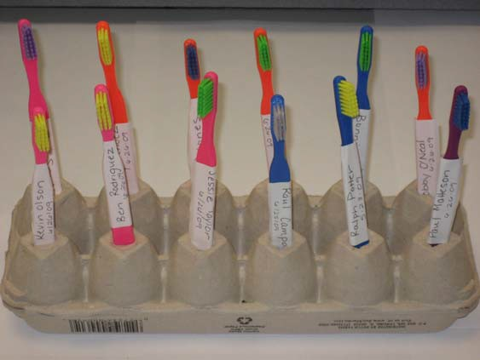Toothbrush Storage Systems
This toothbrush holder is made using an empty egg carton.
- Turn the carton upside down and poke small holes into each compartment.
- Fit a toothbrush into each compartment. The toothbrushes will be upright, not touching each other, and able to dry in the open air.
- Make a new holder using the same method when it is obviously soiled or degrading.

The Massachusetts Department of Public Health does not endorse any particular company or product; however, to assist you on page 13, we have listed some of resources to purchase oral health related items, such as the toothbrush storage system pictured on the right.

7

Section 2: Tooth Brushing Program Implementation

Toothpaste

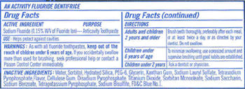Toothpaste chosen for young children should be a general mint flavor. Using fruity flavors encourages children to eat the toothpaste, which is not advised. It is also important to know if a child has any possible allergies to ingredients or additives in toothpaste. When choosing a brand of toothpaste, look for two
important things:

- Sodium Fluoride as an active ingredient

- 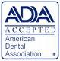The American Dental Association (ADA) Seal of Approval

Toothpaste should always be stored in a locked cabinet, away from children’s reach. Only a child care worker, or adult, should have access to and handle the fluoride toothpaste.

8
Safety First!

Fluoride is a mineral that the tooth can absorb, which makes the tooth stronger and more resistant to decay. Toothpaste is intended to provide a topical source of fluoride; it is NOT supposed to be swallowed by the child. Swallowing too much toothpaste with fluoride over a long period of time may cause the teeth of a child under the age of 10 to develop slight white speckling. More serious affects or fluoride toxicity could occur if a child ingests a large amount of fluoride toothpaste at one time. If this occurs, you should call the Massachusetts Poison Control Center immediately.

POISON EMERGENCY? CALL 1-800-222-1222
If the child has collapsed or is not breathing, call 911 for an ambulance.

Hearing impaired? Call 1-888-244-5313 24 hours a day, 7 days a week.

Section 2: Tooth Brushing Program Implementation

Maintaining Infection Control

Toothbrushes can become contaminated with bacteria, blood, saliva, food, and toothpaste after brushing. Disease transmission is rare, but all precautions should be taken to ensure proper storage and handling of toothbrushes and toothpaste to prevent cross contamination of germs.

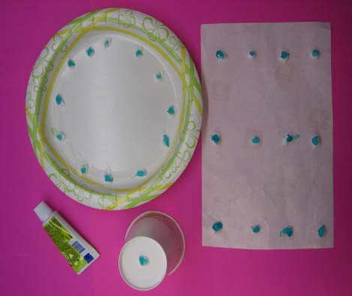Distributing Toothpaste

- Delivering toothpaste directly from the toothpaste container onto all children’s brushes can spread germs. To prevent cross contamination, dispense smears or pea-sized amounts of toothpaste for each child onto a large piece of wax paper, paper plate, or bottom of the rinsing cup. From here, a single serving of toothpaste can be placed onto each child’s toothbrush.

Storing Toothbrushes

- After children finish brushing, they should rinse their toothbrushes thoroughly with tap water. The CDC recommends that toothbrushes be stored in an open container that allows them to stand upright and out of contact with other children’s brushes. As previously mentioned on page 7, you can purchase a toothbrush storage system or easily make one using everyday household items. Toothbrushes should be stored in an open area, but away from the reach of children.

Assisting Children with Tooth Brushing and Clean-Up
Children should be supervised to prevent accidental spitting on each other's arms, hands and toothbrushes. After assisting a child with tooth brushing, the caregivers should wash their hands thoroughly with soap and water before assisting another child. Children should also wash their hands with soap after brushing. Be sure to clean the sink area as you would normally; there is no need for special clean-up.

Replacing Toothbrushes

A toothbrush should be thrown away and replaced with a new one when:

  - The bristles look frayed and worn;

  - A child has been ill with a cold, flu, or bacterial infection; and/or
  - The toothbrush is 3 months old.

9

Section 2: Tooth Brushing Program Implementation

Staff Involvement and Supervision
Depending on the age group of children and the number of children under your supervision, you might need more staff to help you to assist with brushing children’s teeth. Each child should have help brushing his or her teeth until about age 8. Children MUST be well supervised during tooth brushing with fluoride toothpaste, and should not be left unattended or be allowed to dispense the toothpaste alone.

It is recommended that you and your staff develop a specific plan to implement the EEC tooth brushing regulation. Communicate with other child care facilities to get tips and advice on how others are implementing a tooth brushing program in your
local area. It might be helpful to designate specific tasks to each staff member.

Some tasks can include:
  - Keeping track of purchasing toothbrushes and toothpaste
  - Making and/or purchasing toothbrush labels and storage devices
  - Organizing children in two groups: under age 2 and over age 2; and observing them/helping during brushing
  - Distributing toothpaste to children in two groups (under age 2 gets a “smear” of toothpaste and over age 2 gets a “pea-sized” amount), and ensuring it is locked up and safely stored after use
  - Helping children over age 2 to rinse with water
  - Helping children get their brush into their appropriate storage space

Communicating with Parents About Your Toothbrushing Program

It will be important to inform your children’s parents/caregivers about your new tooth brushing program. You could send a note home with each child or you could have an informational meeting for the parents at the child care facility. Parents should understand WHY this new policy is being implemented. Once they understand the policy is to help prevent tooth decay, they may be more willing to start doing more oral health prevention activities at home. The letter and fact sheet on the next two pages are examples of documents you could edit and use to inform and educate parents about the new tooth brushing program. You can encourage parents to:
  - For infants, wipe the baby’s mouth with a wet cloth after feeding (even before teeth erupt!).
  - Begin an oral hygiene brushing routine as soon as the first tooth erupts in the child’s mouth.
  - Reinforce tooth brushing and low-sugar snacks/meals at home.
  - Pack healthy low-sugar meals, and provide water instead of soda or sugary juices to drink
  - Talk to their child’s doctor or dentist about fluoride exposure and the possible need for fluoride supplementation.
  - Talk to their child’s doctor about the possible need for fluoride varnish during the well-medical visits.
  - Seek early preventive dental care for all family members.
10

SAMPLE LETTER FOR PARENTS/CAREGIVERS

Dear Parent or Caregiver:

With concerns about the increase in tooth decay (cavities) among young children, the Massachusetts Department of Early Education and Care (EEC) recently adopted a new regulation for child care settings, number 606 CMR 7.11(11)(d), to promote oral health and prevent tooth decay.

Effective January 2010, child care workers must assist children with brushing their teeth if:
- The children are in care for more than 4 hours, or
- They have a meal while in care.

Some quick facts about the program:

- This program will be implemented safely by following the regulations for infection control set by the U.S. Centers for Disease Control and Prevention (CDC).

- It will be a great benefit for your child, their mouth health and general health

- Children will be brushing with the direct supervision of our child care staff

- Children will be using toothpaste with fluoride and approved by the American Dental Association

- Children will receive new toothbrushes after three months of use, or after they are sick

If you have any questions or concerns, please call

_ at .

Child’s Name:

Parent/Caregiver’s Name:

Signature:

Date:

Comments:

11

SUGGESTED FACT SHEET FOR PARENTS/CAREGIVERS

Quick Facts About Children’s Oral Health

Baby teeth are very important. Baby teeth help your child eat and speak correctly. They also hold the spacing needed for adult teeth to eventually erupt. If a child has tooth decay (cavities) in childhood, he or she is more likely to have tooth decay as they get older.

Unfortunately, tooth decay is the most common chronic disease of children, but it doesn’t have to be. Tooth decay is completely preventable by following a few simple oral hygiene activities:

- During infancy, wipe the child’s mouth with a warm cloth after feeding.
- Don’t give children anything other than water to drink at bedtime.
- Brush teeth with a fluoride toothpaste at least 2 times per day and floss daily.
- Get an exam by a dental professional at least once a year.
- Keep eating sugary snacks and drinks to a minimum.
- Drink fluoridated water.

Tips on helping your child brush his or her teeth
./ Keep the fluoride toothpaste out of children’s reach, and you put it on the brush for them:
  - For children under 2 years old, put only a “smear” of toothpaste on their toothbrush.
  - For children over 2 years old, use a “pea-sized” amount of toothpaste on the toothbrush.
./ Help children to brush in little circles, making sure they get all teeth surfaces, including the outside, inside, and the tops of molars (back teeth).
./ Make sure children spit out all of the toothpaste in their mouths. Children under age
2 years should NOT rinse after spitting. Children over 2 years old should rinse with a small amount of tap water after spitting.
./ Make sure children brush their teeth right before bedtime, and they do not eat or drink anything sugary at bedtime.
12

Section 3: Additional Resources

Learn more about children’s oral health

- Massachusetts Department of Public Health Office of Oral Health www.mass.gov/dph/oralhealth
- Association of State and Territorial Dental Directors http://www.astdd.org/index.php?template=eccioh.html
- Centers for Disease Control and Prevention http://www.cdc.gov/OralHealth/topics/child.htm
- American Academy of Pediatrics http://www.aap.org/oralhealth/cme/page5.htm
- National Maternal and Child Oral Health Resource Center http://www.mchoralhealth.org/
- American Dental Association http://www.ada.org/public/index.asp
- 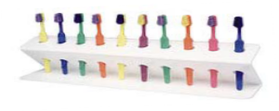American Dental Hygienist’s Association http://www.adha.org/oralhealth/children.htm
- American Academy of Pediatric Dentistry http://www.aapd.org/pediatricinformation/faq.asp

To purchase toothbrush holders like the one Image courtesy of: www.plaksmacker.com

pictured here, visit these websites:
- http://plaksmacker.com/index.php?cPath=58&osCsid=seakntc5buiuhb0ipc8tia0ei0
- \http://www.lakeshorelearning.com/seo/ca%7CproductSubCat~~p%7C2534374302096 017~~f%7C/Assortments/Lakeshore/ShopByCategory/science/healthnutrition.jsp
- http://www.wrapables.com/jsp/ProductDetail.jsp?ProductCode=C51620
- http://www.kidsinkstore.com/480.html
- http://www.topoftheline-travel.com/toothbrush-holder-travel.html
- http://www.sourcingmap.com/family-bathroom-plastic-suction-cup-toothbrush-holder-p- 31300.html

Other helpful supplies

Timers can make brushing teeth fun for children.
  - http://www.dental-mart.com/twoothtimer4.html
- http://www.oompa.com/cgi-bin/category.cgi?item=HA5043&source=nextag
- http://www.twoothtimer.com/rsbfeatures.htm

Models of teeth and the mouth can be great ways to teach children about oral health
  - http://www.shopanatomical.com/ProductDetails.asp?ProductCode=ACC- TH01&Click=26697&gdftrk=gdfV2758_a_7c884_a_7c3469_a_7cACC_d_TH01

To receive an excellent online training on children’s oral health for the child care worker, visit the National Training Institute for Child Care Health Consultants (NTI): http://nti.unc.edu/healthy_smiles/training_index.html

13

Office of Oral Health Massachusetts Department of Public Health
250 Washington Street
Boston, MA 02108
617-624-6074

Additional and related information is also available from the Massachusetts Department of Public Health Office of Oral Health website: www. mass.gov/dph/oralhealth

14

