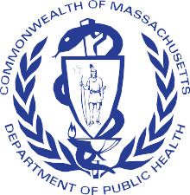

MASSACHUSETTS SCHOOL HEALTH SERVICES

Karen Robitaille, MSN, MBA, RN, NCSN Director of School Health Services
MDPH Division of Child/Adolescent Health and Reproductive Health

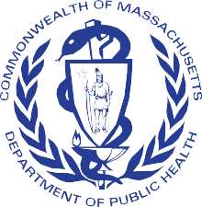

LEARNING OBJECTIVES
- Review the structure and scope of service of School Health Services in Massachusetts
- Review pertinent Acts, Statutes, and Regulations impacting School Health in Massachusetts
- Review regulatory and procedural safeguards and services available to our students with acute and chronic health conditions
- Discuss impact of PANDAS/PANS on student experience in school

SCHOOL HEALTH STRUCTURE AND FUNCTIONS
SCHOOL HEALTH STAFF
- NURSES
- ANCILLARY STAFF

Total FY24 MDPH School Health budget: $26,094,188 Includes: School-based Health Centers $7,040,150 Grant programs: $17,088,496
- 2500 public school nurses
and nurse leaders
- Unknown ancillary staffing
- Unknown non-public school
health staff
  - Estimated 640 non-public
schools
  - 399 public school districts,
1827 schools

3

•
•
- Director (PHNA II) Assistant Director (PHNA II)
Medication Program Manager (PHNA I)
- Nursing Advisor to Non-Public
School (PHNA I)
- Operations Coordinator (PC III)
- Program Coordinator (PC II)
- Epidemiology support (1.5 FTE)
SCHOOL HEALTH UNIT
- ADHERENCE TO REGULATIONS
- GRANT FUNDING
- DATA COLLECTION AND ANALYSIS
- CONSULTATION
REGIONAL CONSULTANTS/BU SHIELD
- MDPH FUNDED
- CONSULTATION AND
PROFESSIONAL DEVELOPMENT

Seven Regional School Nurse Consultants in the 6 EOHHS Regions: West (Hampden/Hampshire & Franklin/Berkshire), Central, Northeast, Boston, Metrowest, Southeast

- 105 CMR 210 – The Administration of Prescription Medications in Public and Private Schools
- 105 CMR 200 - Physical Examination of School Children
- 105 CMR 201 – Head Injuries and Concussions in Extracurricular Athletic Activities
- 105 CMR 215: Standards for School Wellness Advisory Committees
- 105 CMR 220 - Immunization of Students Before Admission to School
- 105 CMR 225 - Nutrition Standards for Competitive Foods and
Beverages in Public Schools
- 105 CMR 700 - Implementation of M.G.L. C. 94c
- 105 CMR 460 - Lead Poisoning Prevention and Control (Screening for Schools)
- 244 CMR 3 – Nurse Practice
- 244 CMR 9 – Standards of Nursing
- 603 CMR 7 - Educator Licensure
- 603 CMR 18 - Program and Safety Standards for Approved Public or Private Day and Residential Special Education School Programs
- 603 CMR 23 - Student Records
- 603 CMR 35 - Evaluation of Educators
- 603 CMR 44 – Educator License (School Nurse and Director/Supervisor)
- 603 CMR 46 - Prevention of Physical Restraint and Requirements If Used
- 603 CMR 50 - Educational Collaboratives (Requirements for School Nurses)
- Health Insurance Portability and Accountability Act (HIPAA)
- Family Education Rights and Privacy Act (FERPA)
- Individuals with Disabilities Act (IDEA)
- Americans with Disabilities Act (ADA)
- McKinney-Vento Act
- MGL. c71, s53 - Appointment of one or more school physicians and registered nurses
- MGL c71 s54B - Administration of Medications in School Setting and Self
Administration
- MGL c71 s54C – AEDs in Schools
- MGL c71 s96 - School Policies Regarding Substance Use Prevention
- MGL c71 s97 - SBIRT
- MGL c94 - Controlled Substances Act
- MGL c112 s80B – Nurse Practice Act
- MGL c258 s2 – Tort Claim Act

PERTINENT ACTS, STATUTES & REGULATIONS

MEDICATION IN SCHOOLS

  - Only licensed healthcare providers can administer medication in MA with limited exceptions.
  - Medication in school settings in MA regulated by 105 CMR 210.
  - Any medication given by unlicensed staff MUST be given under the delegation model.
  - ONLY schools/districts registered with MDPH may participate in medication delegation.
  - The School Nurse is the manager of the medication program.

MODEL (57)

COMPREHENSIVE SCHOOL HEALTH SERVICES GRANTS
    - Larger awards
    - MUST provide all basic school health services
    - MUST implement a case management model and/or a BRYT program
    - MUST have a 1.0 FTE Nurse Manager free
from direct care and on appropriation budget
    - MUST conduct triannual community needs assessment and annual Continuous Quality Improvement (CQI) project
    - Provide services that are community-based and culturally and linguistically relevant meaning they address racial inequities and health disparities as appropriate.

AFFILIATE (112) & NON-PUBLIC (19)
- Smaller awards
- MUST provide all basic school health services; non- publics must be working towards this
- Must work towards having a 1.0 FTE Nurse Manager free from direct care and on appropriation budget
- MUST conduct triannual community needs assessment
- Provide services that are community-based and culturally and linguistically relevant meaning they address racial inequities and health disparities as appropriate.

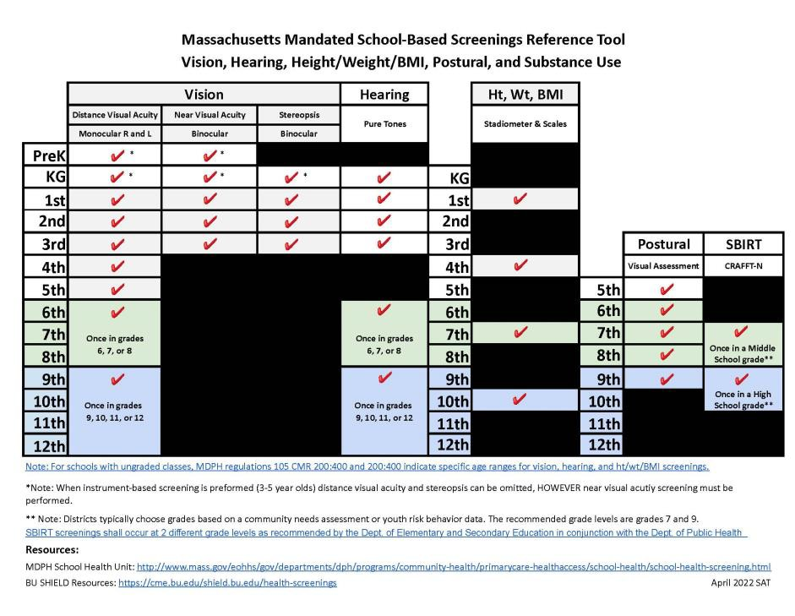
DATA COLLECTION

- DATA REQUIRED BY STATUTE/REGULATION
  - Height, Weight, Body Mass Index (BMI)
  - Screening, Brief Intervention & Referral to Treatment (SBIRT)
- DATA COLLECTED BY OTHER PROGRAMS (not mandatory)
  - Asthma/diabetes prevalence in children aged 5-14 years
  - Immunizations, grades: preK, K, 7 & 11

- DATA COLLECTED FROM CSHS GRANTEES ONLY
  - Monthly reports: office visit data, dispositions, concussions, medications, case management
  - Annual reports: rates for common chronic illnesses, medical technology &
procedures, IHPs/AAPs/504s/DNRs, health services utilization by demographic, health insurance
type, screening results, health services staffing, and grant performance measures

PROFESSIONAL DEVELOPMENT FOR SCHOOL HEALTH STAFF

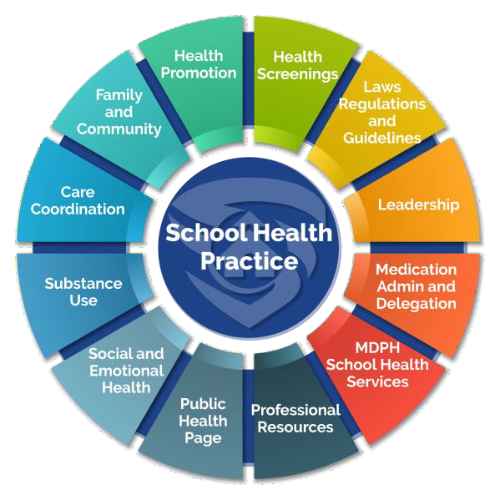
- Foundations of School Nursing Practice(self-paced)
- Medication Administration in a School Setting: School Nursing Practice in
Massachusetts & Medication Administration in Schools: What School Nurse Managers Need to Know (self-paced & live)
- School Health Screening Training (self-paced & live)
- SBIRT in Schools (self-paced & live)
MANDATORY TRAININGS
- The Essentials of School Nurse Leadership (self-paced)
- Strengthening Your Leadership Presence and Management Practices (live & self-paced cohort)
LEADERSHIP TRAINING
RESOURCES

CMC-SHARE: JOINT PROJECT OF MDPH (SCHOOL HEALTH AND MASSTART) & BU SHIELD

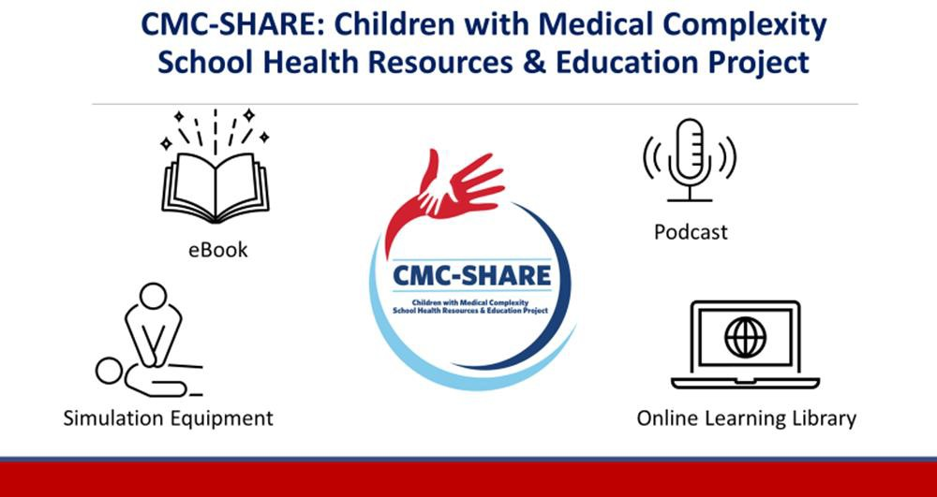

EXISTING RESOURCES RE PANDAS/PANS FOR SCHOOL HEALTH STAFF

- https://pandasnetwork.org/resources/educator-resources/
- https://aspire.care/schools-educators/massachusetts-school- nurse-program-on-pans-pandas/
- https://nepans.org/
- https://neusha.org/resources-handouts/

PANDAS/PAN PREVELANCE

PANDAS at a Glance
- 1 : 200 Children affected by PANDAS/PANS*
- 4 – 10 Average age of onset
- 49% Of patients who had OCD and tics as primary symptoms
- 81% Of patients who reported infections of streptococcal pharyngitis
*These are estimates of lifetime prevalence. Based on U.S. research of OCD incidence and CDC 2013 national surveillance report of emergency hospitalizations of youth to age 21 with mental health issues related to OCD, Tourettes, & Acute Mood Disorders. (MMWR 2013;62(Suppl; May 15, 2013): 1-35. Percentage of cases based on 2018 PANDAS Network survey 1,400 families and multiple published clinical studies.
https://pandasnetwork.org/

From a "retrospective review for the calendar years 2017–2019 at three different academic medical centers", "in several geographically and socioeconomically diverse primary care populations of children":
"the estimated annual incidence of PANDAS/PANS was 1/11,765 for children between 3 and 12 years with some variation between different geographic areas."
https://www.ncbi.nlm.nih.gov/pmc/articles/PMC10551157/#:~:text=The%20incidence%20of%20PANDAS%20can,%E2%80%934%25%20(6)

Connect with DPH
12

@MassDPH
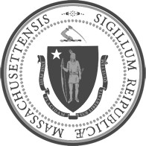
Massachusetts Department of Public Health DPH blog
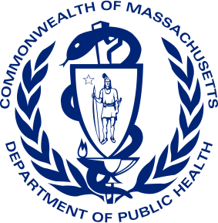
https://blog.mass.gov/publichealth

www.mass.gov/dph

