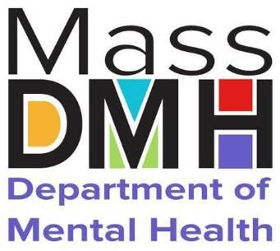

p r e s e n t s

Overview of the

Massachusetts Department of Mental Health Child, Youth and Family Services

PANS/PANDA Advisory Council January 8, 2025

DMH Child, Youth and Family Services Speakers



Mi-Haita James, LCSW Assistant Commissioner

Nandini Talwar, M.D.

Child Psychiatrist and Medical Director

Carol Murphy, LICSW Director of Programs and Practice

#### Commitment to Race, Equity, and Inclusion

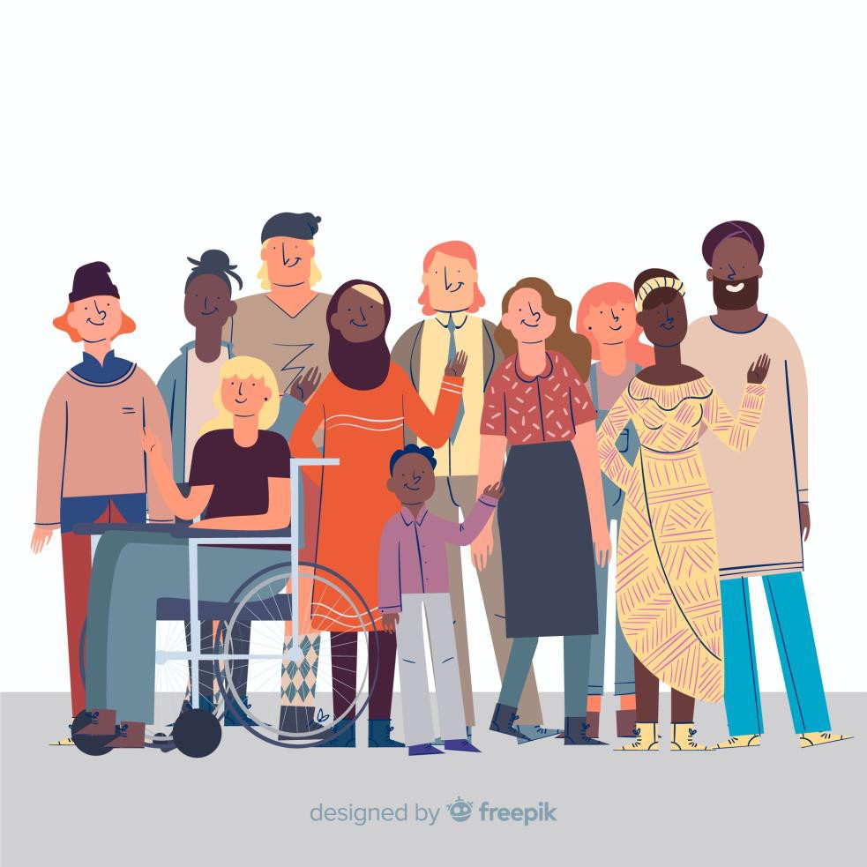

DMH is committed to being an anti-racist and socially just organization where all people are treated fairly, receive resources equitably, and feel valued and safe. This requires continuous effort to create meaningful and long-lasting change. This includes examination of policies, practices, and our contributions on an individual level to inequity. Accomplishing this goal is necessary to achieve DMH’s mission of assuring access and provision of services and supports to meet the mental health needs of all individuals.

#### Commitment to Race, Equity, and Inclusion



A commitment to ensuring race, equity, and inclusion includes but is not limited to:

* Addressing both the results and root causes of historical and systemic disparities
* Providing physical and linguistic accessibility
* Community outreach and engagement
* Physically and emotionally welcoming, safe, and inclusive spaces
* Fair representation, proactive consideration, and empowerment of historically marginalized communities
* Continuous monitoring and evaluation of progress towards these goals
* Transparent, accessible, and ongoing communication with stakeholders
* Swift and appropriate responses to harm caused by discriminatory and/or

inequitable treatment



**Who we are**

5

**Commonwealth Mental**

**Health Authority**

**Serves approximately 29,000**

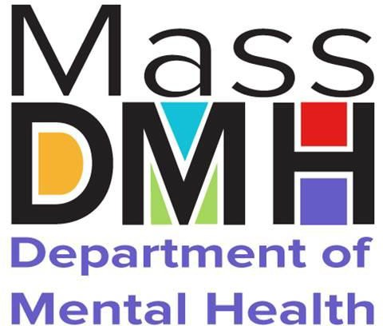**individuals every year**

**Employs 3,300 staff**

**Annual operating budget of**

**$1B**

**Operates and procures services for both Adults and Children/families**

#### Five Geographic Areas Across Massachusetts

**North- eastern Mass (NEA)**

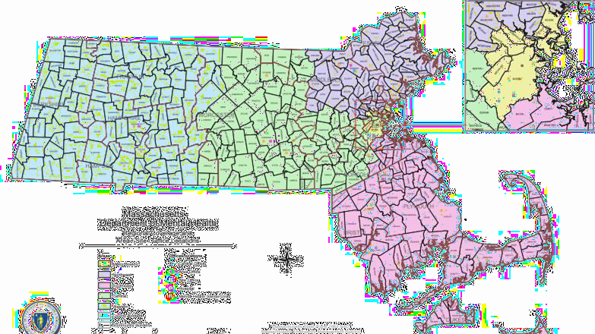

**Western Mass (WMA)**

**Central Mass (CMA)**

**Metro Boston (MBA)**

**South- eastern Mass (SEA)**

#### DMH Serves Two Primary Roles



Serving

**Serving as the Commonwealth’s Mental Health Authority**

Delivering

**Delivering specialized services for adults and children with the most serious behavioral health needs**

#### As the Commonwealth’s Mental Health Authority, DMH:

**Licenses inpatient psychiatric units, IRTP, community crisis stabilization and adult residential programs;**

**Promulgates guidance on standards of care and current**

**best practices;**

**Provides expert consultation to other state agencies**

**and government leaders;**

**Implements capacity-building initiatives in the mental health provider sector.**

Mental Health Services at Mass DMH



* DMH provides specialized services for children, youth and adults with the most serious mental health needs.
* The Department of Mental Health (DMH) provides supports and services that complement those provided by other agencies or systems (commercial insurance, MassHealth, other state agencies such as DCF, schools, community programs, etc.)

CYF DMH in Child Mental Health in MA



Youth Served in System Annually

CBHI - 37K DMH - 3K



# Accessing DMH

12

#### DMH Specialized Services



When should someone apply for DMH Specialized Services? When an individual and their family:

* Are living with a serious mental illness; and
* the needs are not met by current resources (commercial insurance, MassHealth, or other state agencies, e.g. DCF, schools, community programs, etc.)

#### Accessing DMH Specialized Services



##### Clinical Determination

* + Confirm that the person has **a qualifying diagnosis**;
    - Qualifying diagnoses include: Schizophrenia and other psychotic disorders, Major Mood Disorders, Anxiety

Disorders, Dissociative Disorders, Eating Disorders, Borderline Personality Determine **functional impairment** in multiple domains due to qualifying diagnosis

* + Identify urgent needs; and
  + Support navigation to other needed resources.
  + **Establish duration:** has lasted for at least one year or is expected to last one year
  + For youth, must have a serious emotional disturbance which is the primary cause of the functional impairment

#### Service Authorization-Disqualifying Diagnoses



**The following diagnoses do not qualify as the primary cause of functional impairment for the purpose of service authorization for any individual of any age:**

* + - Neurodevelopmental disorders
    - Neurocognitive disorders
    - Mental disorders due to another medical condition (e.g., brain injury)
    - Substance-related/induced and addictive disorders
    - Disruptive, impulse control and conduct disorders



### Accessing DMH Specialized Services



##### Needs and Means

* + Identifies the specialized services that the person needs and
  + Confirms that these needs cannot be met by other available resources
  + <https://www.mass.gov/info-details/applications-for-dmh-services>

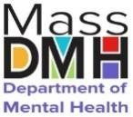



# Child, Youth, and Family

Division

17

#### C:\Users\charmon\AppData\Local\Microsoft\Windows\Temporary Internet Files\Content.IE5\TN7A9K8W\fam27[1].gifChildren, Youth and Family: Values



DMH believes that:

* Families are experts on their children and that both youth and family participation in treatment is essential to the recovery process.
* Every youth and family has strengths, which are important to help overcome challenges. DMH services focus on building upon those strengths.
* Homes are the best settings for all children to grow and develop socially and emotionally.
* Short-term out-of-home treatment to deal with a crisis followed by family-based treatment is more effective than

long-term treatment out of the home

* We must acquire an understanding of how values, beliefs, attitudes and traditions of an individual’s multiple identities contribute to one’s own and others’ culture; understand and acknowledge the power and privilege differences and similarities between and amount groups of people on a personal, institutional and system level; and incorporate this knowledge to work collaboratively and effectively with all people.

## DMH CYF Family Advisory Council



* Representatives from each DMH Area
* Meets monthly
* Provides consultation and feedback on services, policies, initiatives
* Facilitated by DMH Directors of Family Driven Practice



# Child, Youth, and Family

Treatment Services

20

#### Specialized Services

for Children, Youth and Families



* Case Management
* Flexible Support Services
* Day Services
* Intensive Home- Based Therapeutic Care
* Therapeutic Group Care
* Young Adult Staffed and

Supported Apartments

* Program for Assertive Treatment for Youth

Community-Based Services

* Intensive Residential Treatment
* Clinically Intensive Residential Treatment
* Adolescent Continuing Care Units

*Facility-based treatment requires certification of need for continuing inpatient psychiatric treatment done by an acute inpatient physician

Cannot be accessed by DMH application

process

Facility-Based Treatment*



DMH in the Community

###### Youth and Families do not need DMH Service Authorization to access these supports

22

#### Emergency Department:

Diversion Teams



* Provide home based supports via the flex team modality to support youth who are boarding in the Emergency Department (ED) or at risk of boarding. ED Diversion Teams are for youth who **are not enrolled with DMH and are not receiving services from another state agency.**
* Services are intended for youth not actively engaged in other services and not prioritized for an acute hospital bed.

Community and School Support



###### Family Support Programs

* + These services provide education and support for family members of persons with severe emotional disturbance or mental illness.

###### Young Adult Access Centers

* + Provides opportunities for YA to develop a community of peers and engage in a variety of individual and group supports including: peer support, arts, social activities, and linkages to mental health services, healthcare, housing, employment and education resources.

#### The Consortium LogoFamily Support Programs



* System navigation
* Community education and advocacy
* Support groups

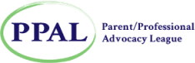Families do not need DMH Service Authorization to access these supports. These services are free and open to all families in the Commonwealth

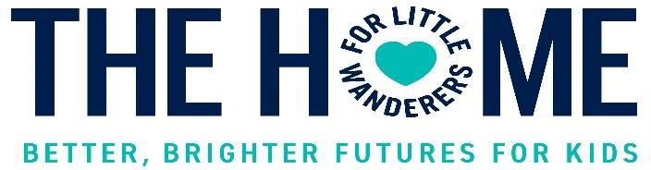

#### A screenshot of a computer Description automatically generated with low confidenceYoung Adult Access Centers



* Low Barrier: No appointments, no eligibility requirements
* Safe for all and welcoming to diversity
* Supports for employment, education, and housing
* Recreation, access to laundry, showers, computers
* Supportive referrals for clinical services
* Staffed by young adult peers along with others focused on positive youth development
* Visit **SpeakingOfHope.org** to find a young adult access center near you



#### BRYT Program - Boardman Glenwood Junior HighNEW INITIATIVE

DMH SCHOOL BRIDGE PROGRAMS (SBBP)

The Department of Mental Health (DMH) has recently awarded a grant to facilitate the establishment of School-Based Bridge Programs (SBBP) for students with Serious Emotional Disturbance/Serious Mental Illness (SED/SMI). The Brookline Center’s bryt team was awarded this grant and is now expanding this school bridge model statewide. Through additional EHS funding, the bryt model will be introduced to approximately 30 additional schools.

For more information about the bryt model, please visit: <https://www.brooklinecenter.org/services/school-based-support/bryt-program/>

#### Technical Assistance for School MH Earmark

BIRCh Project: offers professional development to school professionals on the implementation of evidence-based school mental health interventions, social-emotional learning practices, strategies to create and sustain positive school climates, and conduct universal screening for early identification and intervention of student needs. For more information, please visit: <https://www.umb.edu/birch/online_learning>

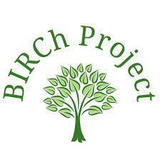

BIRCh TA for Crisis Response in Schools: Focuses on enhancing professional development and behavioral health coordination in Western MA; includes initiatives like universal screening and crisis intervention, with plans to establish three regional training hubs using the NASP PREPaRE model for improved crisis preparedness and interagency collaboration.

### Children’s Behavioral Health Knowledge

Center

* The Knowledge Center fills a gap in the children’s behavioral health system by serving

as an information hub, through its website, workshops, training and webinars. Additionally, the center provides funding for programs and initiatives that support best practices with specific attention to diversity, equity and inclusion.

* As an intermediary organization, activities facilitate connection among the rich array of children’s behavioral health researchers, program developers, providers, practitioners, and consumer advocates in Massachusetts. The Knowledge Center connect research, policy, and practice and connect Massachusetts with national leaders in innovation and best practice.

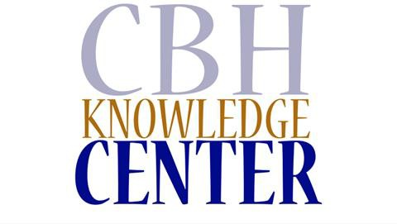

[www.cbhknowledgecenter.center](http://www.cbhknowledgecenter.center/)

### Infant and Early Childhood Mental Health



**Policy**

* Learning and collaboration with other states across the country
* IECMH Policy Workgroup
* IECMH Strategic Planning

**Workforce Development**

* Investment in professional development for clinical and non-clinical

workforce supporting young children and families

* Support of workforce through communities of practice and braided

funding

**What is Infant and Early Childhood Mental Health (IECMH)?**

**Coordination and Collective Impact**

It is the developing capacity of the infant and young child to: form close and secure relationships;

to experience, manage, and express a full range of emotions;

and explore the environment and learn—all in the context of family, community, and culture.

**Innovation**

* Collaboration and Coordination with state agencies and private partners that serve children and families
* Provide recommendations on policies and initiatives that impact young children and families

- Support roll-out of MassAIMH Endorsement credential

- Steering Committees for advancement of IECMH

- Support other agencies in grant application and implementation for

innovative IECMH practices

Interested in learning more? Please reach out to Andrea Goncalves Oliveira by email at [andrea.goncalves-oliveira@mass.gov](mailto:andrea.goncalves-oliveira@mass.gov)



Handhold is an interactive, family-friendly website designed **for parents and caretakers** with highly accessible answers to the following questions:

* **Should I Worry?** Information they need to understand changes in their child’s behavior and figure out when they might need help
* **What Can I Do?** Curated resources for parents looking to help their child cope and heal from mental health challenges, promote healthy social and emotional development, de-escalate challenging situations, and connect to others who have been through this
* **Who Can Help?** A user-friendly “front door” to existing behavioral health system navigation and treatment locator tools, including guides on what to expect, how to find support, and how to prepare for a first visit
* <https://handholdma.org/>

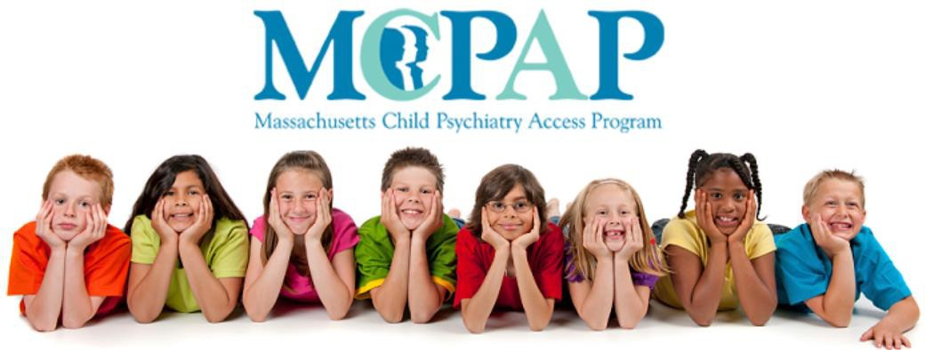

The goal of MCPAP is to improve access to treatment for children with behavioral health needs and their families by making child psychiatry services accessible to primary care providers across Massachusetts.

MCPAP provides quick access to psychiatric consultation and facilitates referrals for accessing ongoing behavioral health care. It encourages and supports PCPs integrating behavioral health resources into their practices and work with behavioral health providers as well as primary care providers. MCPAP is available for all children and families, through their primary care providers, regardless of insurance. MCPAP is free to all PCPs.



#### MCPAP for Moms

* MCPAP for Moms aims to promote maternal and child health by building the capacity of providers serving pregnant and postpartum women and their children up to one year after delivery to effectively prevent, identify, and manage depression.
* MCPAP for Moms provides obstetricians, midwives, and PCPs with psychiatric consultation for behavioral health concerns and questions around medications when pregnant or breastfeeding.
* MCPAP for Moms also supports connections with community-based services and support groups.
* The program is free and available throughout Massachusetts regardless of type of health insurance.



* This interactive online course was created by parents for parents. It will teach you about a communication style called "motivational interviewing" that you can use to have better conversations with teens and young adults.
* Each lesson is roughly ten minutes in length, though you can take as much time as you need and replay the lessons as often as you like.
* [The School of Hard Talks Online —](https://handholdma.org/what-can-i-do/the-school-of-hard-talks-online-lessons-from-motivational-interviewing-for-everyday-families)

[Handhold (handholdma.org)](https://handholdma.org/what-can-i-do/the-school-of-hard-talks-online-lessons-from-motivational-interviewing-for-everyday-families)

## General Questions for Discussion



* + Any available data/stats related to PANDAS/PANS
  + Any relevant case management or training
  + Recent family support efforts
  + Funding
  + Gaps and challenges generally
  + Future goals and initiatives

## PANS/PANDAS Discussion Questions



* + What experience/exposure do you/your organization have with PANDAS/PANS?
  + What knowledge or understanding does your staff/organization have about

PANDAS/PANS?

* + What professional development including training/information resources have you and your staff had related to PANDAS/PANS?
  + What additional trainings or resources do you need to understand PANDAS/PANS better?
  + What kind of barriers do you experience when working with children & youth with PANDAS/PANS and their families?
  + What are your hopes and goals for quality of life and well-being for this community?

### Discussion Questions specific to DMH



* + - Would DMH staff be open to an educational presentation on PANDAS/PANS? (Specifically, their Mass Child Access Psychiatry Program)
    - Is there a trend that there will be more and more co-management between medical teams and psychiatric teams for inpatients? For example, a patient with an eating disorder/depression admitted to a behavioral program, found to have positive Lyme disease not responding to oral antibiotics, is it possible the patient receives IV antibiotics inpatient with the consult from an infectious disease specialist?