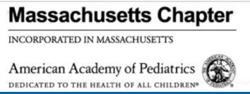

Massachusetts Chapter of the American Academy of Pediatrics

Mary Beth Miotto, MD, MPH, FAAP

Chapter President

March 13, 2024

**MCAAP Mission:**

The Massachusetts Chapter of the American Academy of Pediatrics is committed to the attainment of optimal physical, mental and social health for all infants, children, adolescents, and young adults. To this end, the members of the academy dedicate their efforts and resources.

**Who are We? MCAAP in a Nutshell**

* 1600 members:
  + Include primary care, pediatric subspecialists, and pediatric surgical specialists
  + A majority of Chapter members are Fellows of the American Academy of Pediatrics
  + A full-time Executive Director and one contracted MA Immunization Initiative Program Manager
* Funded Principally by MCAAP dues:
  + Current Policies Preclude Industry Relationships
  + Limited grant support by National AAP and no other financial support from National AAP
* Programs are otherwise implemented by pediatrician and trainee members

**Our Chapter Vision:**

The MCAAP is a leading voice for child health advocacy and high-value equitable care for all youth in the Commonwealth of MA

1. Child Health Programming
   * Education for Child Health Professionals & Child Advocates
2. Advocacy
   * Aligned with National AAP Goals and Tailored to the Commonwealth
3. JEDI: Justice, Equity, Diversity, Inclusion
   * Specific Focus on Vulnerable Communities & Children/Youth with Special Health Needs

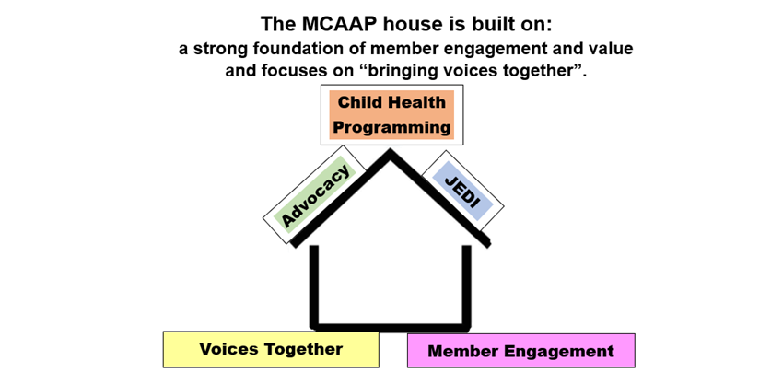

**MCAAP Activities Build on This Foundational Stability:**

1. Child Health Programming
   * Education for Child Health Professionals & Child Advocates
2. Advocacy
   * Aligned with National AAP Goals and Tailored to the Commonwealth
3. JEDI: Justice,Equity, Diversity, Inclusion
   * Specific Focus on Vulnerable Communities & Children/Youth with Special Health Needs

**MCAAP Programming Improves The Quality of Care Families Receive**

* Immunization Webinars and Conferences
* Immunization Initiative Monthly Newsletters
* RSV Prevention Webinar (MCAAP/DPH)
* RSV Childhood Immunization Roundtable (MCAAP/MMS/MA ACOG/MA AFP)
* RSV Prevention/Nirsevimab Resource Packet for Members with monthly updates
* Nirsevimab Birthing Hospital Dashboard for Members with monthly updates through shortage
* Pediatric Mental Health Gateway with Pediatric Team Diagnostic and Treatment Guidance (website)
* Preventive Behavioral Health Visits in Primary Care Co-produced Webinar with MA Health Care for All
* MCAAP 2023 Annual Meeting and CME on Increasing Mental Health Competence and Confidence in Primary Care-virtual
* Monday Biweekly Lunch and Learn Program “Leveraging Community Services To Support Your Patients’ Learning and Developmental Needs”: Live and on-demand videos and hyperlinked slide decks with resources

**MCAAP and Clinical Policy**

* The Massachusetts Chapter of the American Academy of Pediatrics is not typically a clinical policymaking organization.
* The MCAAP Board, officers, and Chapter committees utilize the best evidence and policies published by the national AAP and other national specialty societies to disseminate best practices to Chapter members, nonmember pediatric professionals, child health advocates, and policymakers in the Commonwealth.