Department of Elementary & Secondary Education

DPH PANDAS/PANS Advisory Council Iraida J. Álvarez, Executive Director, Special Education

September 11, 2024

# Agenda

Review

* Review DESE's Educational Vision, Strategic Objectives and how DESE supports school districts across Massachusetts.

Discuss

Questions

* Discuss relevant programs, and initiatives that may be relevant to students and families with PANS/PANDAS and the work of the council.
* Respond to questions from the council.

# Educational Vision



All students

* Are known and valued



Learning experiences

* Are relevant, real-world and interactive



Individualized supports

* Enable students to excel at grade level and beyond

Educational Vision

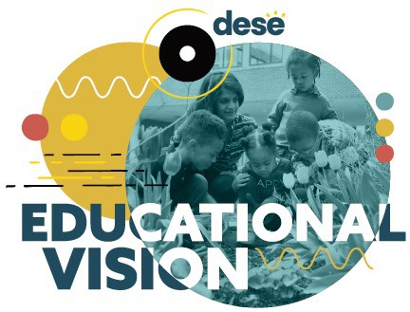**All students in Massachusetts, particularly students from historically underserved groups and communities**, will have equitable opportunities to excel in all content areas across all grades. **Culturally and linguistically sustaining classroom and school practices** will support students to thrive by **creating affirming environments** where students have a **sense of belonging, engage in deeper learning, and are held to high expectations** with targeted support.

# Strategic Objectives

### Strategic Objective 1 - "Whole Student"



* Cultivate systems to support the **whole student** and foster **joyful**, **healthy**, **and supportive** learning environments so that all students feel **valued**, **connected**, **nourished**, and **ready to learn.**



**Strategic Objective 2 - "Deeper Learning"**

* Promote **deeper learning** so that **all** students engage in **grade-level work** that is **real-world**, **relevant**, and **interactive**.

### Strategic Objective 3 - "Diverse and Effective Workforce"



* Develop and sustain a workforce that is **diverse**, **culturally responsive**, **well-prepared**, and committed to **continuous improvement**, so that all students have equitable access to **effective educators**.

# Catalog of Aligned Supports

* Describes DESE's Educational Vision, strategic objectives, and core functions

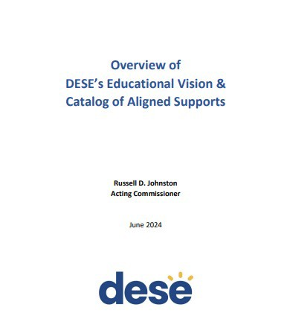

* Outlines DESE's priority strategies for each strategic objective and where to find aligned supports in the catalog

Core DESE Functions



**Setting expectations** including crafting regulations and guidance to implement and explain education laws; specifying what students should know and be able to do by the end of each school year; defining effective teaching and administrative practices; and, where appropriate, establishing criteria for program review and approval.

Spotlight programs and initiatives that align with the goals of the PANDAS/PANS



**Promoting and measuring quality and compliance** including data collection and reporting; assessment; accountability; monitoring programs and their adherence to state and federal laws and regulations; complaint resolution; research and evaluation; fiscal auditing; and recognizing excellence.



**Supporting implementation and catalyzing innovation** through grants, aid, and other funding mechanisms; professional learning opportunities; technical and targeted assistance; partnerships and networks; resources, materials, tools, and technology; seeding innovative school and program models; direct service provision; and creating economies of scale.

Advisory Council



**Communicating and partnering with stakeholders** including communications and information sharing; coordination with other state agencies; and engaging with statewide stakeholders.

## Office of Student and Family Support (SFS)

The Office of Student and Family Support (SFS) works in partnership with educators, schools, students, families, and other agencies and organizations across the Commonwealth to advance the Center for Educational Options and Department's goals and mission. Our programs and initiatives aim to ensure access to **high quality, equity focused, and student-centered pre-K–grade 12 education and strengths-based supports.**

# Office of Student and Family Support

* Bullying Prevention and Intervention
* Early Learning
* Educational Stability
* Mental and Behavioral Health and Wellness Supports
* Safe and Supportive Schools
* Social and Emotional Learning
* Student Attendance
* Trauma-Sensitive Schools

New Comprehensive Health and Physical Education Framework (CHPE)

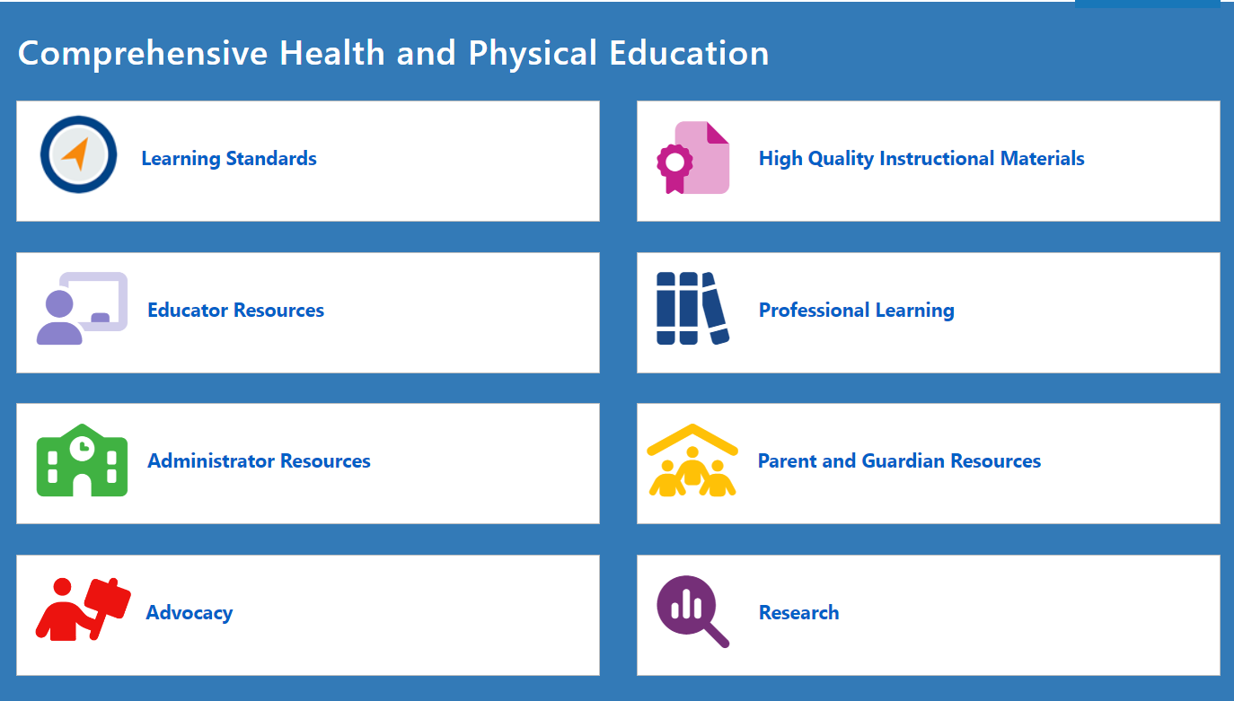

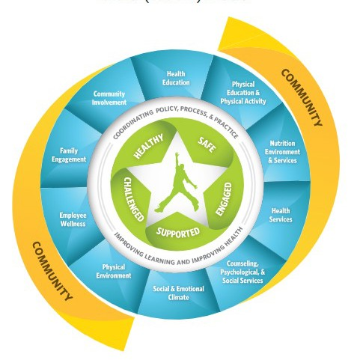Comprehensive Health and Physical Education (CHPE)

Resources & Advocacy

* CDC Healthy Schools works with states, school systems, communities, and national partners to prevent chronic diseases and promote the physical and mental health and well-being of students.
* The Whole School, Whole Community, Whole Child (WSCC) model is CDC's framework for improving health in schools. The WSCC model is student-centered and emphasizes the importance of evidence-based policies and practices and the role of the community in supporting schools.

# Special Education

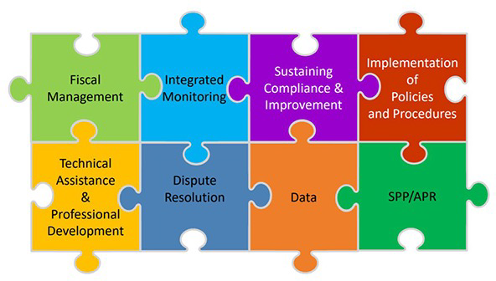As the State Educational Agency, DESE has responsibility for general supervision under Part B of the Individuals with Disabilities Education Act (IDEA). DESE provides technical assistance and monitors local education agencies’ (LEAs) implementation of IDEA and state special education law.

General supervision has eight distinct but interconnected components, creating a cohesive system.

12

**The Six Principles of the Individuals with Disabilities Education Act (IDEA)**

1. Parent and Student Participation
2. Free and Appropriate Public Education (FAPE)
3. Appropriate Evaluation
4. Individualized Education Program (IEP)
5. Least Restrictive Environment (LRE)
6. Procedural Safeguards

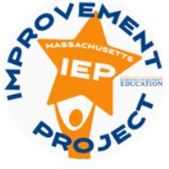New IEP Project Goals

To **improve outcomes** for all students with disabilities by providing guidance, technical assistance, and tools on **equitable processes** to school and district professionals, families, and students so that all students with disabilities have **meaningful access** to the curriculum frameworks and life of the school.

Areas of Focus for Improved IEP Form

Family and student voice

Form documents process

Least Restrictive Environment

Integrated transition planning

Accessibility of language

Q&A

# Resources

#### DESE Vision

* https://[www.doe.mass.edu/commissioner/vision/vision-supports.pdf](http://www.doe.mass.edu/commissioner/vision/vision-supports.pdf)

#### Office of Student and Family Support (SFS)

* https://[www.doe.mass.edu/sfs/](http://www.doe.mass.edu/sfs/)

#### Comprehensive Health and Physical Education (CHPE)

* https://[www.doe.mass.edu/stem/chpe/](http://www.doe.mass.edu/stem/chpe/)

#### Special Education

* Special Education - Massachusetts Department of Elementary and Secondary Education

# Statutes

State Laws

* Massachusetts General Laws Search Page
* Massachusetts General Laws: Education (*See Chapters 69-78A*)
* MGL Chapter 71: Public Schools
* MGL Chapter 71 § 89: Charter Schools
* MGL Chapter 71A: English Language Learners
* MGL Chapter 71B: Children with Special Needs

Enabling Laws for the Board and Department of Elementary and Secondary Education

* G.L. c. 15, s. 1 (Department of Elementary and Secondary Education)
* G.L. c. 15, s. 1E (Board of Education)
* G.L. c. 15, s. 1F (Commissioner of Education)
* G.L. c. 69, s. 1A (Department/Commissioner of Education - general powers and duties)
* G.L. c. 69, s. 1B (Board of Education - general powers and duties)

Other Relevant General Laws Pertaining to the Board and Department of Elementary and Secondary Education

* G.L. c. 15, s. 1G (Advisory councils to Board of Education)
* G.L. c. 69, s. 1D (statewide educational goals and academic standards)
* G.L. c. 69, s. 1E (curriculum frameworks)
* G.L. c. 69, s. 1F (vocational-technical education)
* G.L. c. 69, s. 1G: (school day/school year)
* G.L. c. 69, s. 1H (adult basic education)
* G.L. c. 69, s. 1I (performance assessment of students, schools and districts)
* G.L. c. 69, s. 1J (underperforming schools)
* G.L. c. 69, s. 1K (underperforming districts)
* G.L. c. 71, s. 38G (educator certification/licensure)
* G.L. c. 71, s. 89 (charter schools)

See also various other provisions of G.L. c. 71; c. 71B (special education); and c. 74 (vocational-technical education)

# **Regulations**

* + 603 CMR 1.00Charter Schools
  + 603 CMR 2.00Accountability and Assistance for School Districts and Schools
  + 603 CMR 4.00Vocational Technical Education
  + 603 CMR 5.00Dispute Resolution Under Parental Notification Law
  + 603 CMR 7.00Educator Licensure and Preparation Program Approval
  + 603 CMR 8.00Kindergartens: Minimum School Age
  + 603 CMR 10.00School Finance and Accountability
  + 603 CMR 14.00Education of English Learners Regulations
  + 603 CMR 17.00Racial Imbalance And Magnet School Programs
  + 603 CMR 18.00Program and Safety Standards for Approved Public or Private Day and Residential Special Education School Programs
  + 603 CMR 23.00Student Records
  + 603 CMR 26.00Access to Equal Educational Opportunity
  + 603 CMR 27.00Student Learning Time
  + **603 CMR 28.00Special Education Regulations**
  + 603 CMR 30.00Massachusetts Comprehensive Assessment System And Standards For Competency Determination
* 603 CMR 31.00Massachusetts Certificate of Mastery
* 603 CMR 33.00Anti-Hazing Reporting
* 603 CMR 35.00Evaluation of Educators
* 603 CMR 41.00Regional School Districts
* 603 CMR 44.00Educator License Renewal
* 603 CMR 46.00Prevention of Physical Restraint and Requirements If Used
* 603 CMR 47.00Licensure of Adult Basic Education Teachers and Preparation
* 603 CMR 48.00Innovation Schools Regulations
* 603 CMR 49.00Notification of Bullying and Retaliation
* 603 CMR 50.00Educational Collaboratives
* 603 CMR 51.00Criminal History Checks for School Employees
* 603 CMR 52.00Commonwealth of Massachusetts Virtual Schools
* 603 CMR 53.00Student Discipline Regulations
* 603 CMR 54.00Recovery High Schools
* 603 CMR 55.00Student Opportunity Act Plans
* 603 CMR 56.00Addressing Regulatory Timelines Due To COVID-19 State of Emergency

19

# Connect with DESE

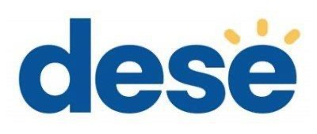

@MASCHOOLSK12 MASSACHUSETTS DEPARTMENT OF

ELEMENTARY & SECONDARY

EDUCATION

DESE NEWSLETTERS WEBSITE:

DOE.MASS.EDU / YOUTUBE