**Guidance Document for the MA PMP MOUD Alert**

MA pharmacies are required to report buprenorphine dispensations to the Massachusetts Prescription Monitoring Program (MA PMP). This accounts for most of the buprenorphine provided to residents throughout the Commonwealth. There is, however, a small amount of buprenorphine medication (e.g., injectable buprenorphine administered from facility stock) that is not currently reported to the PMP.

***Issue*:** Poor adherence to Medication for Opioid Use Disorder (MOUD) protocols for individuals diagnosed with opioid use disorder (OUD) often results in relapse and risk of both non-fatal and fatal overdose. The MA PMP in collaboration with its PMP vendor Bamboo Health has developed functionality in MassPAT and any corresponding PMP application (i.e., the integrated SafeScripts+ application) that alerts prescribers when there is a pre-determined gap in buprenorphine[1] dispensing.

The following guidance is intended for those prescribers and their delegates who receive MOUD alerts.

**What will I see when a patient triggers an MOUD Alert?**

* Prescribers and their delegates will receive an email that a patient has triggered an alert. Additionally, an alert indicator will be featured on the dashboard when logging into the MassPAT web portal or via the integrated setting in your electronic health record (EHR) system. Delegates (individuals who must have a supervisor who is authorized to prescribe controlled medications) do not have access to the integrated platform and will need to log into MassPAT to see the alert on the patient’s dashboard.

**How did we determine what criteria to use for the MOUD Alert?**

* The MA PMP has engaged with researchers at Northeastern University (NEU) to better understand the nature and extent of poor adherence to MOUD. NEU interviewed addiction medicine prescribers and patients who have been prescribed buprenorphine to identify the characteristics that are associated with both poor and successful medication adherence. This research has also provided guidance in establishing the criteria used for the MOUD Alert; however, we will also be able to adjust the criteria as we learn what works best over time.

The associated alerts and indicators will be triggered for patients who have received at least one buprenorphine prescription with a 45-day lookback period and have not received another buprenorphine prescription 8 days after the “*Days Supply*” of the most recent buprenorphine Rx. See Appendix A for some possible MOUD Alert scenarios.

**How will prescribers and delegates be notified of a patient’s gap in buprenorphine therapy?**

* Providers who have active MassPAT accounts (either a prescriber or their authorized delegate) will be notified if one of their patients has a gap in buprenorphine medication by email AND through an alert that will pop up on the dashboard when they log into MassPAT. They will also see an indicator on the individual’s patient report within the ‘*State Indicators’* tile.
* 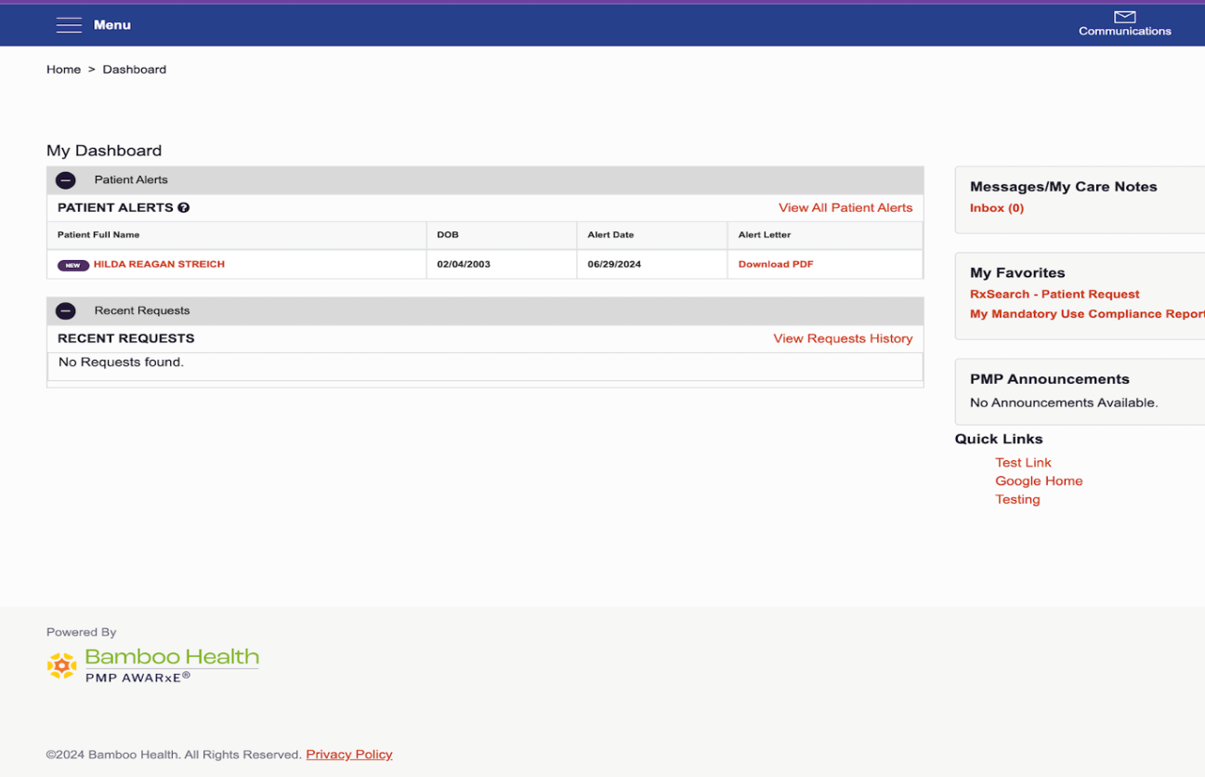

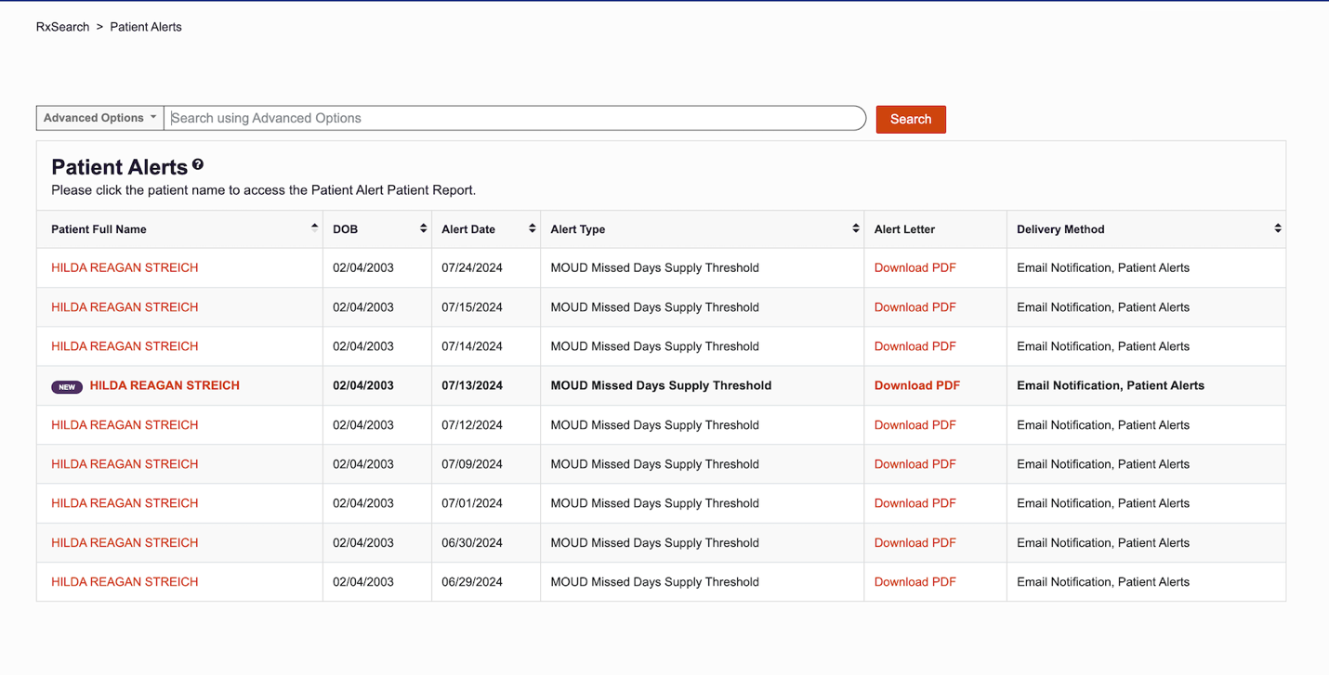

* The screen shot below provides an example of the patient alert email. It also provides instructions on how to view identifying information about the patient. For security and privacy, the email itself will never include any patient identifying information.

* The screen shot (see Screen Shot A) below shows what is displayed when you look up a patient in MassPAT and there is an alert for a possible interruption in MOUD treatment. The alert will be displayed under the “*State Indicators*” tile shown below. For more details about the alert, you will need to click on the “*Details*” box displayed at the bottom of the tile (see Screen Shot B).

**Screen Shot A**

**Screen Shot B**

**Questions or Assistance**

If you need any assistance or have any questions related to the MOUD alert or the MA PMP please contact: [mapmp.dph@mass.gov](mailto:mapmp.dph@mass.gov)

**Appendix A**

The following table depicts some examples of how an alert would/would not be triggered based on the specified criteria and days supply coverage for buprenorphine:

|  |  |  |  |  |  |
| --- | --- | --- | --- | --- | --- |
|  | September | October | November | December | Alert (Y/N) |
| Start Date1  **Dec 15, 2024** | Dispensation History | | | |  |
| Patient A | 1 Bup Rx with Date Sold = 9/10 and a 30 Days Supply2 | No Bup Rx | No Bup Rx | No Bup Rx | N |
| Patient B | 1 Bup Rx with Date Sold = 9/16 and a 30 Days Supply | No Bup Rx | No Bup Rx | No Bup Rx | Y |
| Patient C | No Bup Rx | 1 Bup Rx with Date Sold = 10/31 and a 15 Days Supply | 1 Bup Rx with Date Sold = 11/21 and a 7 Days Supply | 1 Bup Rx with Date Sold = 12/3 and a 7 Days Supply | N |
| Patient D | No Bup Rx | 1 Bup Rx with Date Sold = 10/18 and a 15 Days Supply | 1 Bup Rx with Date Sold = 11/01 and a 15 Days Supply | No Bup Rx | Y |
| Criteria:  1 Lookback period is 45 days based on the Date Sold (i.e., any bup scripts with Days Supply ending prior to November 1, 2024 would not trigger an alert).  2 8 Day Gap from last days supply  **Patient A**: No alert would be triggered because the lookback period begins on Dec 15 and it was beyond the 45 day lookback period that would trigger an alert; therefore the system would not alert the prescriber about this patient.  **Patient B**: An alert would be triggered because the patient’s most recent bup Rx falls within the lookback period, which begins on Dec 15 and there was a greater than 8-day gap since the days supply ended on 10/10/24.  **Patient C**: No alert would be triggered; the patient was within the 45 day lookback period, but the 8-day gap threshold was not exceeded (largest gap was 5 days).  **Patient D**: An alert would be triggered because the patient did not receive any bup Rx in December and the 8-day gap was exceeded. | | | | | |

1. Currently, buprenorphine is the only MOUD medication that the MA PMP monitors. If other medications (e.g., methadone) begin to be reported to the MA PMP this feature can also be used to alert providers to gaps in other MOUD medications.