|  |  |
| --- | --- |
| Department of Public Health | Mass.gov | **Massachusetts Department of Public Health**  Cyanobacteria in Recreational Waters in Massachusetts  2022 Local Board of Health Guidance |

Cyanobacteria in Recreational Waters

**Prepared by**

Board of Health Guidance

**2022**

May 2022

Environmental Toxicology Program

Bureau of Environmental Health

Massachusetts Department of Public Health

250 Washington Street

Boston, MA 02108

Phone: (617) 624-5757

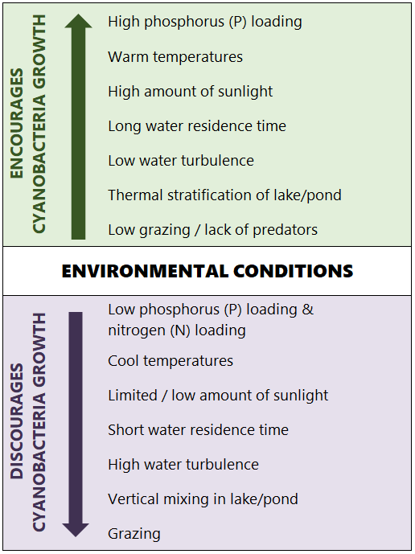**Purpose**

# **CyanoHAB Guidance for Local BOHs**

# Massachusetts Department of Public Health

# Page 1

This document provides guidance to local boards of health (BOHs) and municipal health departments responding to cyanobacteria harmful algal blooms in recreational waterbodies. It has been developed by the Massachusetts Department of Public Health, Bureau of Environmental Health (MDPH/BEH).

**About Cyanobacteria**

Cyanobacteria are microscopic organisms that occur naturally in all water ecosystems. Cyanobacteria are sometimes referred to as blue-green algae, despite

being bacteria rather than algae. Under certain environmental conditions (Fig 1) cyanobacteria can experience exponential growth, creating a highly concentrated area of cyanobacteria cells known as a **cyanobacteria harmful algae bloom**, or **cyanoHAB**. Because some cyanobacteria can produce cyanotoxins, cyanoHABs can be harmful to human health.

Cyanobacteria are photosynthetic organisms, meaning they use sunlight to make food. Many species have gas-filled cavities that allow them to move to different water depths in search of better growth conditions. During a cyanoHAB, cyanobacteria can form mats or

scum layers on the bottom or surface of the waterbody. These surface mats or scum layers commonly appear at shorelines or in protected areas

CyanoHAB at Santuit Pond, Mashpee, MA

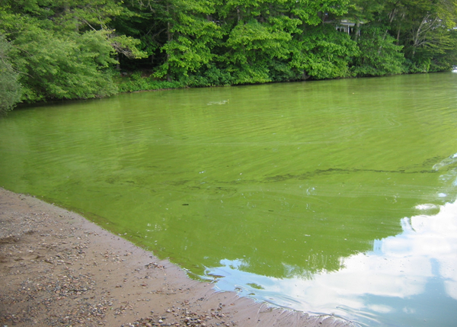

Fig 1. Environmental conditions influencing cyanobacteria growth (adapted from Paerl & Otten 2013)

such as coves. Cyanobacteria may also appear as specks or dots in the water column, may form paint-like streaks on the water surface, or cause the water to take on a bright green, blue-green, or reddish-brown hue.

CyanoHABs may impact an entire waterbody or a portion of it, and a bloom can move to different locations within a waterbody in response to changing water currents or wind direction. Though more common in ponds and lakes, cyanoHABs can also occur

in streams and rivers. Waterbodies experiencing a

cyanoHAB will often have depleted oxygen levels, both due to reduced aquatic plant growth caused by the

bloom blocking sunlight, and from decaying cyanobacteria cells. Low oxygen levels caused by cyanoHABs have been implicated in fish kill events.

**About Cyanotoxins**

# **CyanoHAB Guidance for Local BOHs**

# Massachusetts Department of Public Health

# Page 2

Some cyanobacteria species can produce toxins known as cyanotoxins. There are over 100 types of cyanotoxins, which can be broadly divided into those affecting the liver (hepatoxin), the nervous system (neurotoxin), and the skin (dermatoxin). The most common cyanotoxins found in the United States are:

* Microcystins
* Cylindrospermopsin
* Anatoxin
* Saxitoxin

The ability to produce specific cyanotoxins can vary between different cyanobacteria species and strains, and the factors that cause certain bacteria to produce toxins are not well understood. Cyanotoxins generally stay within the cyanobacteria cell but are released into the water when the cell dies. This can cause toxin levels to increase while the bloom is dissipating, and the

toxin may remain present in the water for a period of time after the cyanoHAB is gone.

Table 1. Cyanotoxin potential health effects and associated cyanobacteria genera

|  |  |  |  |
| --- | --- | --- | --- |
| **Toxin Name** | **Toxin Type** | **Potential Health Effects** | **Cyanobacteria genera** |
| Microcystins | Hepatoxin | Gastrointestinal illnesses, pneumonia, dermatitis, tumor promoter, kidney damage, liver inflammation, liver hemorrhage | *Anabaenopsis, Aphanocapsa, Arthrospira, Calothrix, Dolichospermum (Anabaena), Fischerella, Microcystis, Nostoc, Oscillatoria, Phormidium, Planktothrix, Pseudanabaena, Synechococcus* |
| Cylindrospermopsin | Hepatoxin | Gastrointestinal illnesses, pneumonia, dermatitis, malaise, kidney damage, liver inflammation, liver hemorrhage | *Aphanizomenon, Cylindrospermopsis, Dolichospermum, Raphidiopsis raciborskii, Umezakia* |
| Nodularin | Hepatoxin | Gastrointestinal illnesses, pneumonia, dermatitis, tumor promotion, liver inflammation, liver hemorrhage | *Nodularia, Nostoc* |
| Anatoxin | Neurotoxin | Tingling, burning, numbness, drowsiness, incoherent speech, respiratory paralysis leading to death, cardiac arrhythmia leading to death | *Aphanizomenon, Blennothrix, Cuspidothrix, Cylindrospermopsis, Dolichospermum (Anabaena), Kamptonema, Microcoleus, Oscillatoria, Planktothrix, Phormidium* |
| Saxitoxin | Neurotoxin | Tingling, burning, numbness, drowsiness, incoherent speech, respiratory paralysis leading to death | *Aphanizomenon, Cylindrospermopsis, Dolichospermum, Lyngbya, Planktothrix* |
| B-N-methylamino-L-alanine (BMAA) | Neurotoxin | Potential link to neurodegenerative diseases from chronic exposure (no consensus in scientific community; more research needed) | *Dolichospermum, Microcystis, Nostoc,* |
| Lipopolysaccharide (LPS) | Dermatoxin | Gastrointestinal illnesses, dermatitis | *Microcystis, Oscillatoria, Synechococcus* |
| Lyngbyatoxins | Dermatoxin | Dermatitis | *Lyngbya, Microseira* |
| Aplysiatoxins | Dermatoxin | Dermatitis | *Lyngbya, Oscillatoria, Schizothrix, Sphaerospermopsis* |

*Table adapted from Interstate Technology & Regulatory Council (2020) and World Health Organization (2021)*

**Health Concerns**

# **CyanoHAB Guidance for Local BOHs**

# Massachusetts Department of Public Health

# Page 3

Cyanobacteria and their associated cyanotoxins pose a risk to human and animal health. Cyanotoxins are of primary concern due to the potential for causing serious health effects. Because there are over 100 types of cyanotoxins, testing for them all is not possible or practical. Therefore, the health protective approach is to **assume that cyanotoxins are present in any cyanoHAB.**

The potential risk to human health is a function of both hazard (the presence of cyanotoxins) and exposure, which can occur through a variety of routes (Table 3). Exposure can occur through a variety of recreational activities at waterbodies (Table 2).

Table 2. Recreational activities associated with cyanobacteria exposure (from Stone & Bress, 2007)

|  |  |  |
| --- | --- | --- |
| Exposure Potential | Recreational Activity | Exposure Routes |
| **High** | Swimming / Wading | Ingestion, Dermal |
| Jet Skiing | Ingestion, Dermal, Inhalation |
| **Medium** | Fish consumption | Ingestion |
| Canoeing, sailing, boating, etc. | Inhalation, Dermal |
| **Low** | Catch-and-release fishing | Dermal |
| Running / Walking | N/A |

Table 3. Cyanotoxin exposure routes

|  |  |
| --- | --- |
|  | **INGESTION**  Swallowing water with low levels of cyanobacteria or cyanotoxins may cause gastrointestinal problems, while ingestion of higher levels of cyanotoxins may cause neurological or liver damage. Accidental ingestion of water is most likely to occur while swimming. |
| smell Icon 3411108 | **INHALATION**  Inhaling water droplets that contain cyanobacteria or cyanotoxins may cause allergy-like symptoms, such as runny noses or sore throats. Activities such as jet skiing are likely to result in the greatest exposure by inhalation. |
| Skin Rashes Icon 980168 | **DERMAL**  The most common route of exposure, dermal contact, can cause rashes or skin irritation in some people. These reactions are caused by cyanobacteria themselves, as well as some cyanotoxins. Any water contact may cause these reactions. |
| Fish outline | **CONSUMPTION OF CONTAMINATED FISH/SHELLFISH**  Exposure may also occur through consumption of contaminated seafood, particularly shellfish. Several studies have found cyanotoxins in freshwater fish, but more study is needed to better understand human exposure through fish consumption. |

**Animal Health Concerns**

# **CyanoHAB Guidance for Local BOHs**

# Massachusetts Department of Public Health

# Page 4

Cyanotoxins also pose a threat to pets and livestock. Dogs are particularly at risk as they will often lick off and eat algae caught in their fur after swimming in waters with a cyanoHAB. Severe illness and death can occur in pets within hours to days after exposure.

**DATA SNAPSHOT**

In 2019, cyanoHABs were reported to have caused:

* **63 cases of human illness**
* **367 cases of animal illness**
* **207 animal fatalities**

*Centers for Disease Control and Prevention (CDC). Summary Report – One Health Harmful Algal Bloom System (OHHABS), United States, 2019. Atlanta, Georgia: U.S. Department of Health and Human Services, CDC, 2021.*

*Link to report:* [*https://www.cdc.gov/habs/data/2019-ohhabs-data-summary.html*](https://www.cdc.gov/habs/data/2019-ohhabs-data-summary.html)

**CyanoHAB Response**

In Massachusetts, local Boards of Health are the entities with primary responsibility for responding to reports of a possible cyanoHAB. The BOH authority comes from the MA beach regulations (105 CMR 445) but can otherwise fall under the nuisance statute (MGL c. 111, s. 122). The recommended steps a BOH should take when responding to a cyanoHAB report are illustrated in the flow diagram on the following page.

When a BOH receives a report of a potential bloom, it should first gather specific information, including how the waterbody is used, the bloom location, public access points to the waterbody, and any digital photographs that can be provided.

If the BOH suspects the bloom is cyanobacteria-related, there are several actions it can take. These actions are described in more detail in the following pages of this document:

1. Contact MDPH/BEH for technical assistance – MDPH/BEH staff will evaluate the bloom report and provide guidance on how the BOH should proceed. Potential cyanoHABs can be reported to MDPH/BEH using an online form found here: <https://redcap.link/HAB-Report-Form>
2. Evaluate the bloom using visual inspection and/or water quality measurements
3. Test the water for cyanobacteria and/or cyanotoxins
4. Issue a public health advisory

**Agency Roles in CyanoHAB Reports**

* **Municipal BOHs** are responsible for responding to reports of cyanobacteria and issuing public health advisories.
* **MDPH/BEH** can provide technical assistance to BOHs for cyanoHABs at recreational waterbodies. They are also responsible for issuing public health advisories at waterbodies on state park land.
* Blooms at drinking water sources should be reported to the **Massachusetts Department of Environmental Protection (MassDEP)**  
  at: 1-888-304-1133
* Fish kills should be reported to the **Massachusetts Environmental Police**   
  at: 1-800-632-8075.

**Example CyanoHAB Response Flow Diagram**

# **CyanoHAB Guidance for Local BOHs**

# Massachusetts Department of Public Health

# Page 5

**Visually Identifying CyanoHABs**

# **CyanoHAB Guidance for Local BOHs**

# Massachusetts Department of Public Health

# Page 6

Cyanobacteria can often be identified through visual indicators during bloom conditions. Because most cyanoHAB reports begin when an individual notices an accumulation of algae in the water, interpreting visual evidence is frequently the first and only step needed to determine whether a reported algae bloom is made of cyanobacteria or not.

Visual indicators of the potential presence of cyanoHABs include visual discoloration of the waterbody due to suspended filaments or scum, mat-like accumulation on the shoreline and surface, foul odors, fish kills, and a soup-like water consistency.

A substance may be cyanobacteria if the material consists of small particles (pinhead-sized or smaller), forms a layer at the water’s surface, or causes the water to be murky and take on a bright green, blue-green, or reddish-brown hue.

Example images of cyanoHAB blooms in Massachusetts are included below. Online resources to help visually identify cyanoHABs can be found on the DPH webpage (see pg. 9).

Sometimes other types of (non-toxic) algae or aquatic plants are mistakenly identified as cyanobacteria. A few common examples are included below. In general, a substance is not cyanobacteria if it has leaf-like structures or roots or is long and stringy. Simple field tests – such as the Jar Test and Stick Test – can help determine whether the substance is cyanobacteria or a similar looking algae/aquatic plant. Procedures for the Jar and Stick Tests are included in Appendix A.

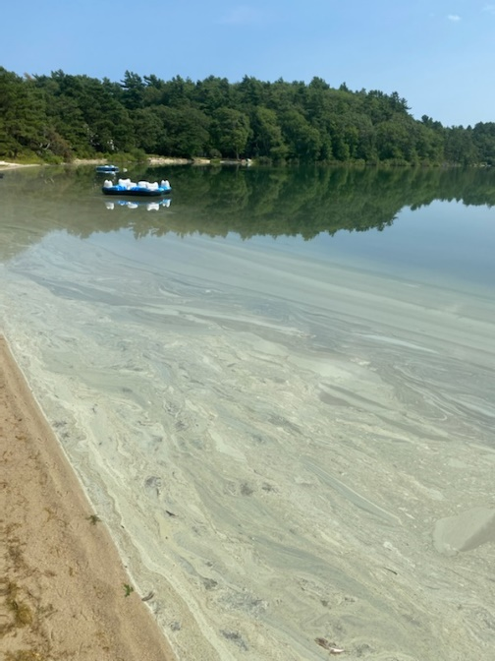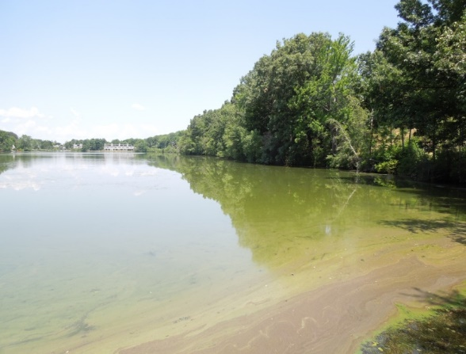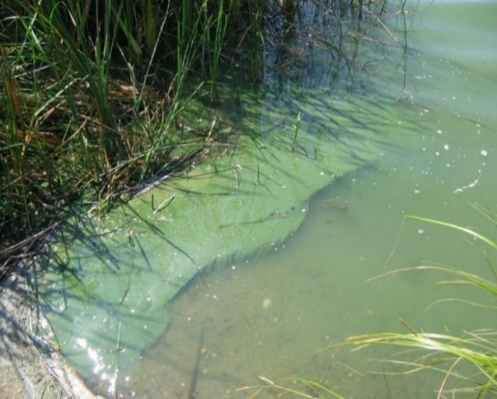**Cyanobacteria**

Stevens Pond (North Andover) Hummock Pond (Nantucket) Great South Pond (Plymouth)

**NOT Cyanobacteria**

Pollen - yellow/green particles with a “dusty” texture

Filamentous green algae – stringy, silky, and able to be draped over a stick

Duckweed – tiny (and harmless) aquatic plant

Microscopic image of *Dolichospermum circinale* (USGS)

# **CyanoHAB Guidance for Local BOHs**

# Massachusetts Department of Public Health

# Page 7

**Cyanobacteria and Cyanotoxin Testing**

The following testing can be performed to identify cyanobacteria and cyanotoxins:

**Identification of cyanobacteria to the genus level** can be performed by public and private laboratories, as well as trained volunteers. The iNaturalist CyanoScope project can assist with identifying cyanobacteria in microscopic photographs (go to: <https://www.inaturalist.org/guides/6092>)

**Cyanobacteria enumeration** describes the concentration of cyanobacteria cells in the water and is typically conducted by a laboratory. Results should be reported as cells per milliliter (cells/ml).

The **presence of some cyanotoxins** can be assessed using commercially available testing kits.

**Cyanotoxin concentration** (reported as ppb) is typically conducted by a laboratory.

**Measurement of Water Quality Parameters**

Some water quality parameters are associated with cyanobacteria and can be useful in helping evaluate cyanoHAB conditions when unable to test for cyanobacteria and/or cyanotoxins. These water quality parameters can be measured in the field or laboratory.

**Turbidity** is a general indicator of water quality and can be measured in the field with a Secchi disk. Although high levels of cyanobacteria will increase turbidity, other factors – such as suspended sediment particles – also contribute to turbidity.

**Chlorophyll-*a*** and **phycocyanin** are photosynthetic pigments contained within cyanobacteria cells, both of which can be measured in the field using a probe or other handheld device. Chlorophyll-*a* is also present in other algae and phytoplankton organisms, so alone is not a good indicator of cyanobacteria levels.

Phycocyanin, however, is specific only to cyanobacteria, and as a result, phycocyanin concentration has increasingly been used as a proxy for cyanobacteria levels. Phycocyanin levels can indicate the relative abundance of cyanobacteria in the water, making it effective as an “early warning” monitoring tool for cyanoHABs. However, because different species of cyanobacteria contain different amounts of phycocyanin, the usefulness of phycocyanin in calculating cyanobacteria concentrations is limited.

Secchi disk in use (USGS)

**Issuing a Public Health Advisory**

MDPH/BEH recommends issuing a public health advisory for cyanoHABs at recreational freshwater locations when **at least one of the following criteria** is met:

1. A visible cyanobacteria scum or mat is evident
2. Total cell count of cyanobacteria exceeds 70,000 cells/ml
3. Concentration of the toxin microcystins exceeds 8 µg/L
4. Concentration of the toxin cylindrospermopsin exceeds 15 µg/L

# **CyanoHAB Guidance for Local BOHs**

# Massachusetts Department of Public Health

# Page 8

CyanoHAB public health advisories alert the public to the potential health risk caused by the cyanoHAB and prevent possible exposure. Advisories are typically issued for an entire waterbody, but in some cases – such as at rivers or at larger lakes with hydrologically distinct basins – advisories are limited to the section(s) of the waterbody potentially impacted by the bloom. Swimming beaches at waterbodies under a cyanoHAB advisory should be closed.

When a cyanoHAB advisory is issued, signs should be posted at all access points to the water warning individuals and their pets against any contact with the water. Signs should include details on how to contact the BOH and where individuals can find information on cyanobacteria-related health risks. MDPH/BEH can provide template signage to local BOHs (see Fig 2).

To track improvements at a waterbody once a cyanoHAB forms, MDPH/BEH recommends visually monitoring bloom conditions (typically once a week).

**Risk Communication**

* The overarching message to convey to the public regarding cyanoHABs is:  
  **“WHEN IN DOUBT, STAY OUT”**
* Risk communication tools may include physical signage, press releases, social media posts, text alerts, and posts on the town’s website.
* Local groups such as lake/pond associations can help raise awareness of an advisory.
* Notify MDPH/BEH when an advisory is issued so it can be added to MDPH’s online list of active cyanoHAB advisories (<https://www.mass.gov/lists/algae-information>).

Examples and Templates

* Template social media posts and press releases for communicating cyanoHAB advisories (EPA): <https://www.epa.gov/cyanohabs/communicating-about-cyanobacterial-blooms-and-toxins-recreational-waters>
* Graphics/images for online communication (CDC): <https://www.cdc.gov/habs/materials/buttons-badges.html>
* Example cyanoHAB social media posts (CDC): <https://www.cdc.gov/habs/materials/socialmedia-library.html>
* Additional CDC communication resources: <https://www.cdc.gov/habs/materials/index.html>

**Lifting an Advisory**

MDPH/BEH recommends cyanoHAB advisories be lifted only after two rounds of samples (collected at least one week apart) show levels below the MDPH/BEH guideline values.

MDPH/BEH can provide sampling resources to BOHs for the purpose of lifting advisories at waterbodies with public access. BOHs should contact MDPH/BEH once there is no longer any visual evidence of cyanobacteria at the waterbody.

**Watershed Management**

# **CyanoHAB Guidance for Local BOHs**

# Massachusetts Department of Public Health

# Page 9

Once a cyanoHAB occurs, there are few options other than to let the bloom run its course. The use of algaecides (such as copper sulfate) as a treatment for an active cyanoHAB is not advised. This can cause the immediate release of cyanotoxins into the water, thus increasing the health risk. In addition, the decaying cyanobacteria can deplete oxygen levels and release phosphorus, which can spur additional blooms.

The best means of reducing the occurrence of cyanoHABs is through preventative measures – primarily effective watershed management. As excess nutrients are one of the main drivers of cyanoHABs, strategies may be implemented to reduce nutrient inputs to the waterbody and the availability of nutrients already present. These strategies include:

* Maintaining septic systems and storm drains
* Reducing application of fertilizer
* Picking up pet waste
* Planting and/or maintaining native vegetation around the water’s edge.

Water aerators are another method used in waterbodies to prevent the formation of cyanoHABs.

Watershed management options are discussed in more detail in the New England Interstate Water Pollution Control Commission’s HAB Control Methods Synopses: <http://click.neiwpcc.org/neiwpcc_docs/NEIWPCC_HABControlMethodsSynopses_June2015.pdf>

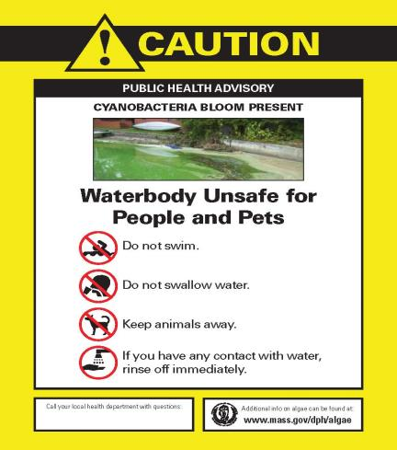

Fig 2. Example cyanoHAB advisory poster

**Funding Acknowledgement**

This work is supported by a Centers for Disease Control and Prevention (CDC) Cooperative Agreement “Strengthening environmental health capacity to detect, prevent, and control environmental health hazards through data-driven, evidence-based approaches” (CDC-RFA-EH20-2005) to the Massachusetts Department of Public Health (6 NUE1EH001400-02-01).  The content does not necessarily represent the official views of CDC or the US Department of Health and Human Services.

**CyanoHAB Online Resources**

* Massachusetts Department of Public Health: <https://www.mass.gov/lists/algae-information>
* Massachusetts Department of Environmental Protection: <https://www.mass.gov/guides/cyanobacterial-harmful-algal-blooms-cyanohabs-water>
* Environmental Protection Agency: <https://www.epa.gov/cyanohabs>
* Centers for Disease Control and Prevention: <https://www.cdc.gov/habs/materials/index.html>
* World Health Organization: <https://www.who.int/publications/m/item/toxic-cyanobacteria-in-water---second-edition>

**References and Additional Resources**

# **CyanoHAB Guidance for Local BOHs**

# Massachusetts Department of Public Health

# Page 10

American Water Works Association. 2005. Standard Methods for the Examination of Water & Wastewater, 21st Edition.

Cheung, M., S. Liang, and J. Lee. 2013. Toxin-producing Cyanobacteria in Freshwater: A Review of the Problems, Impact on Drinking Water Safety, and Efforts for Protecting Public Health. Journal of Microbiology. Vol. 51, No. 1. pp: 1-10.

Connecticut Department of Public Health. 2019. Guidance to Local Health Departments for Blue-Green Algae Blooms in Recreational Freshwater. <https://portal.ct.gov/-/media/Departments-and-Agencies/DPH/dph/environmental_health/BEACH/Blue-Green-AlgaeBlooms_June2019_FINAL.pdf>

ITRC (Interstate Technology & Regulatory Council). 2020. Strategies for Preventing and Managing Harmful Cyanobacterial Blooms (HCB-1). Washington, D.C.: Interstate Technology & Regulatory Council, HCB Team. [www.itrcweb.org](http://www.itrcweb.org/).

MassDEP. 2020. Cyanobacteria and Public Water Systems. <https://www.mass.gov/doc/massdep-guidance-cyanobacteria-and-public-water-systems/download>

New England Interstate Water Pollution Control Commission. 2016. Cyanobacteria and Cyanotoxin Analysis and Testing Services. <http://click.neiwpcc.org/neiwpcc_docs/Cyano-ServicesList-2016_FINAL.pdf>

Oregon Health Authority. 2018. Oregon Harmful Algae Bloom Surveillance HABS Program Sampling Guidelines: Cyanobacterial Harmful Algae Blooms in Recreational Waters. <https://www.oregon.gov/oha/PH/HEALTHYENVIRONMENTS/RECREATION/HARMFULALGAEBLOOMS/Documents/Sampling-Guidelines-Cyanobacterial-Blooms-Recreational-Waters.pdf>

Paerl, H.W. and Otten, T.G., 2013. Harmful cyanobacterial blooms: causes, consequences, and controls. *Microbial ecology*, *65*(4), pp.995-1010.

Stone, D. and W. Bress. 2007. Addressing Public Health Risks for Cyanobacteria in Recreational Freshwaters: The Oregon and Vermont Framework. Integrated Environmental Assessment and Management. Vol. 3, No. 1. pp: 137-143.

U.S. Environmental Protection Agency. 2014. Cyanobacteria and Cyanotoxins: Information for Drinking Water Systems. <https://www.epa.gov/sites/production/files/2014-08/documents/cyanobacteria_factsheet.pdf>

U.S. Environmental Protection Agency. 2019a. Recommendations for Cyanobacteria and Cyanotoxin Monitoring in Recreational Waters. EPA 823-R-19-001. <https://www.epa.gov/sites/production/files/2019-09/documents/recommend-cyano-rec-water-2019-update.pdf>

U.S. Environmental Protection Agency. 2019b. Recommended Human Health Recreational Ambient Water Quality Criteria or Swimming Advisories for Microcystins and Cylindrospermopsin. EPA 822-R-19-001. <https://www.epa.gov/sites/production/files/2019-05/documents/hh-rec-criteria-habs-document-2019.pdf>

USGS. 2008a. National Field Manual for the Collection of Water-Quality Data, Cyanobacteria in Lakes and Reservoirs: Toxin and Taste-and-Odor Sampling Guidelines. Chapter 7.5. <https://water.usgs.gov/owq/FieldManual/Chapter7/7.5.pdf>

USGS. 2008b. Guidelines for Design and Sampling for Cyanobacterial Toxin and Taste-and-Odor Studies in Lakes and Reservoirs. <https://pubs.usgs.gov/sir/2008/5038/pdf/SIR2008-5038.pdf>

Vermont Department of Health. 2015. Cyanobacteria (Blue-green algae): Guidance for Vermont Communities. <http://www.healthvermont.gov/sites/default/files/documents/2016/12/ENV_RW_CyanobacteriaGuidance.pdf>

World Health Organization. 2021. Toxic Cyanobacteria in Water: A Guide to Their Public Health Consequences, Monitoring and Management. <https://www.taylorfrancis.com/books/oa-edit/10.1201/9781003081449/toxic-cyanobacteria-water-ingrid-chorus-martin-welker>

**Appendix A. Simple Tests to Help Identify Cyanobacteria**

If you are concerned about the color or scum in a waterbody, stick or jar tests are quick ways to determine if it is a buildup of algae rather than a cyanoHAB.

**Stick Test Procedure**

1. Wear rubber or latex gloves.
2. Find a sturdy stick that is long enough to reach into the water without getting the material on your hands.
3. Insert the stick into the surface mat of the location of question within the pond and slowly lift out of the water.
4. If the stick looks like it was dipped in green paint after being inserted into the water, the material is likely to be cyanobacteria.
5. A close-up of a leaf

   Description automatically generated with medium confidenceIf the stick pulls out strands that look like hairs, the material is likely filamentous algae, which is not cyanobacteria and poses no health risks.

Filamentous algae – not cyanobacteria

**Jar Test Procedure**

1. Find a clear glass jar with a screw top lid.
2. Use rubber or latex gloves to collect the water sample.
3. Collect the water just below the surface of the water (to avoid collecting just scum).
4. Fill the jar about three-fourths of the way full with water.
5. Wipe off any scum that may be on the outside of the jar.
6. Screw the lid onto the jar.
7. Place the jar in a refrigerator and leave it undisturbed overnight (suggested about 8 hours).
8. After refrigeration, carefully remove the jar from the refrigerator, avoiding any vigorous shaking or disturbances to the water.
9. If the material settled at the bottom of the jar, it is likely that there is NOT a lot of cyanobacteria present in the waterbody.
10. If the material has formed a ring near the top of the jar or appear to be floating near the surface of the water, there is a strong possibility that the waterbody has a significant amount of cyanobacteria present.





If the material settles at the bottom, it is unlikely to be cyanobacteria



If the material forms a green ring around the top, it is likely cyanobacteria.

Initial Sample

Source: Modified from Kansas Department of Health and Environment. “Kansas Jar and Stick Tests”. [*http://www.kdheks.gov/algae-illness/download/Jar_Test.pdf*](http://www.kdheks.gov/algae-illness/download/Jar_Test.pdf)

**For more information on Cyanobacteria, please visit the following websites:**

**DPH:** [http://www.mass.gov/dph/algae](http://www.mass.gov/dph/algae%20)

**CDC:** <http://www.cdc.gov/habs/index.html>

**EPA:** <http://www.epa.gov/cyanohabs>

**Contact information:**

*Massachusetts Department of Public Health*

*Bureau of Environmental Health*

*Environmental Toxicology Program*

*250 Washington Street*

*Boston, MA 02108*

*Email: DPHToxicology@mass.gov*

*Phone: (617) 624-5757*