Guidance on Completing the Climate and Environmental Practices (CEP) Form


Contents

Guidance on Completing the Climate and Environmental Practices (CEP) Form 0
1. Introduction 3
2. CEP Form Structure 4
3. How to Complete the Form 5
4. Importance of Supporting Evidence 7
5. Examples of Sustainability Measures and Sample Responses 8
A. Sustainability Policies 8
A.1 Has your organization adopted a sustainability policy, strategy, or plan? 8
A.1.1 What climate and environmental focal areas are covered by your policy, strategy, or plan? (Conditional Question) 9
B. Sustainability Practices 9
B.1 Has your organization implemented specific measures in the last two years to improve sustainability at your facilities? 9
B.1.1 What specific measures has your organization implemented in the last two years to improve sustainability at your facilities? 10
Renewable Energy 10
Energy Efficiency 12
Water Conservation 13
Waste Reduction 14
Toxics Reduction 14
B.2 Has your organization implemented specific measures in the last two years to ensure climate and environmental responsibility in your supply chain? 15
B.2.1 What specific measures has your organization implemented to ensure climate and environmental responsibility in your supply chain? 16
B.3 Has your organization implemented specific measures in the last two years to reduce the climate and environmental impact of transportation/distribution and/or employee business travel and commuting? 17
B.3.1 What specific measures has your organization implemented to reduce the climate and environmental impact of transportation/distribution and/or employee business travel and commuting? 18
B.4 How many total hours per week does your organization dedicate to climate, sustainability, and/or environmental issues? 19
B.5 Does your organization provide regular training to staff on its sustainability policies and practices? 20
C. Monitoring and Reporting 21
C.1 Has your organization established specific targets to achieve its environmental objectives? 21
C.1.1 What specific targets has your organization established? 21
C.2 Does your organization regularly communicate its climate and environmental achievements? 22
C.3 Does your organization measure Greenhouse Gas (GHG) emissions? 22
C.3.1 Which Greenhouse Gas (GHG) emissions does your organization measure? 23
C.3.2 Which assessment platforms, if any, does your organization use to report its Greenhouse Gas (GHG) emission? 24
D. Certifications and Awards 24
D.1 Has your organization earned any environmental or sustainability certifications, endorsements, and/or awards? 24

List of Figures
Figure 1. CEP Form Field Structure 5
Figure 2. Accessing the Drop-Down Menu 6
Figure 3. Supporting Evidence for Earning Evaluation Points 7
Figure 4. Responding to Conditional Questions 7
Figure 5. Question A.1, Example Response: Sustainability Policy with Link 8
Figure 6. Question A.1, Example Response: Sustainability Policy with Attachment 9
Figure 7. Question A.1, Example Response: Environmental Focal Areas 9
Figure 8. Question A.1, Example Response: Environmental Focal Areas (Including Page Number Reference) 9
Figure 9. Question B.1.1, Example Response: Renewable Energy Generation 11
Figure 10. Question B.1.1, Example Response: Renewable Energy PPAs 11
Figure 11. Question B.1.1, Example Response: Renewable Energy RECs 12
Figure 12. Question B.1.1, Example Response: Energy Efficiency 12
Figure 13. Question B.1.1, Example Response: Water Conservation 13
Figure 14. Question B.1.1, Example Response: Waste Reduction 14
Figure 15. Question B.1.1: Example Response Toxics Reduction 15
Figure 16. Question B.2.1, Example Response: Supplier Sustainability 17
Figure 17. Question B.3.1, Example Response: Transportation and Travel 19
Figure 18. Question B.4, Example Response: Hours Dedicated to Sustainability 20
Figure 19. Question B.5, Example Response: Training 21
Figure 20. Question C.1.1, Example Response: Targets 22
Figure 21. Question C.2, Example Response: Communications 22
Figure 22. Question C.3.1, Example Response: GHG Emissions 23
Figure 23. Question C.3.2, Example Response: GHG Emissions Reporting 24
Figure 24. Question D.1, Example Response: Sustainability Certifications 25

1. Introduction

The Commonwealth of Massachusetts recognizes that its purchasing decisions may have a significant impact on the climate and environment. In Fiscal Year 2024 (FY24), sales of goods and services on Statewide Contracts totaled approximately $2.4 billion. This spending represents a huge opportunity to drive change toward greener, more sustainable markets.

The Commonwealth uses its purchasing power to encourage vendors to offer environmentally preferable products and services and adopt sustainable business practices. The Climate and Environmental Practices (CEP) Form was developed as a tool to gather information on how prospective vendors (hereafter referred to as “Bidders”) are reducing their climate and environmental footprint.

The CEP Form is included in all Statewide Contract Bid Packages, replacing the previous Environmental Practices Form. This Microsoft™ Excel-based questionnaire allows organizations to highlight their environmental policies and sustainability efforts. Completion of all questions in the CEP Form is mandatory; no Bidder will be considered for a contract award without responding to all 10 primary questions (see Section 3 for an overview of question types). Organizations demonstrating strong sustainability performance will earn points towards their CEP Form evaluation.

While the Request for Response (RFR) may outline specific environmental requirements for the products or services being procured, the CEP Form focuses on an organization’s sustainability performance in its facilities and operations. This helps the Commonwealth evaluate how an organization’s practices align with the State’s climate and environmental goals. The data collected serves two key purposes: it aids in the bid evaluation process and contributes to a database for analyzing trends and identifying gaps in vendor climate and environmental performance.

This Guide aims to help Bidders understand what is expected when filling out the CEP Form. It outlines the form’s scope and evaluation criteria, explaining how each section assesses a Bidder's climate and environmental performance. This Guide also covers the mechanics of completing the form and provides tips on how to answer each question, including example responses.

2. CEP Form Structure

The CEP Form is organized into four sections, labeled A, B, C, and D. Each section contains a series of questions (e.g., A.1., B.1., etc.) designed to gather detailed information about your organization’s climate and environmental efforts. An overview of each section is provided below.

- Sustainability Policy
This section looks at whether your organization has a formal sustainability policy. A sustainability policy is a document or statement where your organization outlines its commitment to environmental responsibility. It shows that sustainability is a priority for your organization. If you have a policy, this is your chance to explain its scope and how it guides your operations.

- Climate and Environmental Practices
Here, the form asks about the specific practices your organization has in place at your facilities and operations to reduce your climate and environmental footprint. This may include actions such as reducing energy consumption, minimizing waste, or using low-emissions vehicles and/or logistics providers for the distribution of goods.

- Monitoring Efforts
This section focuses on how your organization tracks and measures its climate and environmental performance. Do you monitor energy usage, waste, or emissions? Have you set targets? And are efforts taken to regularly communicate your progress?

- Certifications and Awards
In this section, you may provide information about environmental management certifications, endorsements, or awards your organization has earned, such as ISO 14001 Environmental Management Systems, UN Global Compact membership, etc. It’s important to note that this section is focused on organizational certifications and does not include product certifications.

3. How to Complete the Form

There are two types of questions in the CEP Form: primary questions, which are shaded in blue and numbered A.1, B.1, B.2, etc., and conditional questions, which are not shaded in blue and numbered A.1.1, B.1.1, B.2.1, etc. (see Figure 1). To be considered “responsive” to a Statewide Contract bid, Bidders must answer all primary questions in the CEP Form. The primary questions should be answered first, and your responses to these questions will determine whether any conditional questions need to be answered. Conditional questions are only required if your response to the preceding primary question is "Yes."

Fields 1, 2, and 3 are designated for Bidder input and are shaded in beige (see Figure 1). Field 1 contains a drop-down menu, while Fields 2 and 3 require typed responses. In most cases, the drop-down menu in Field 1 will offer a simple "Yes" or "No" selection. At a minimum, Bidders must select a response from the drop-down menu in Field 1, even if the answer is "No." Failure to respond to all ten primary questions on the form may result in the Bidder not being considered for a contract award.

Please note, the drop-down menu for conditional questions will only be enabled if you respond "Yes" to the primary question. In this drop-down menu, only the "Yes" option will be available, and you should select "Yes" only for measures your organization has implemented. Therefore, it is essential to complete the questions in sequential order since the conditional questions depend on your responses to the primary questions.

Figure 1. CEP Form Field Structure
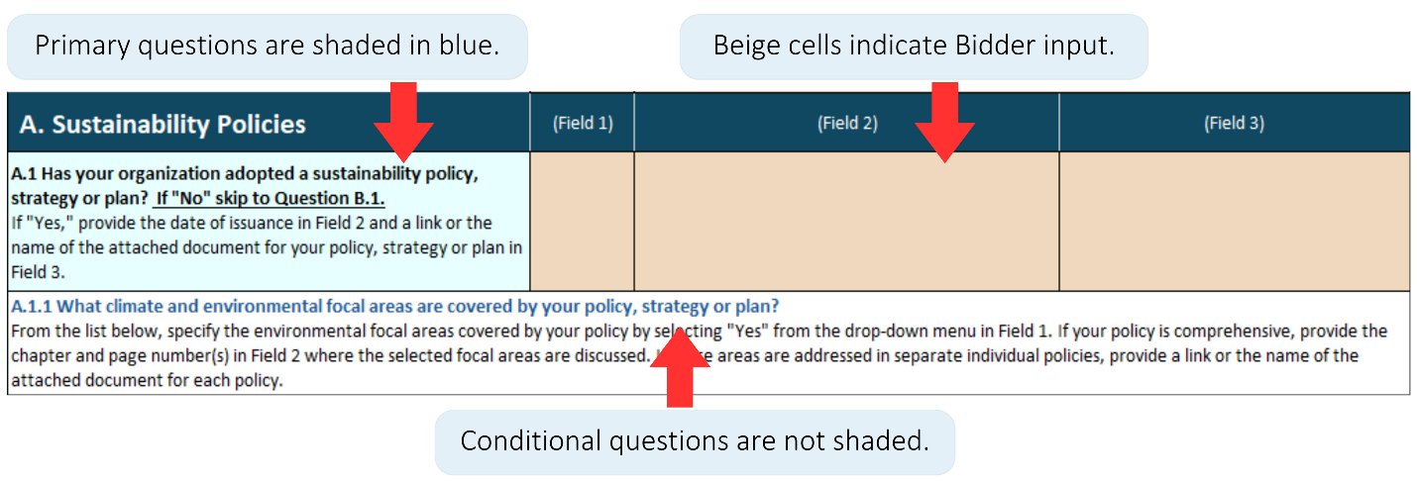

Below is a step-by-step guide on how to complete all fields in the CEP Form.

Field 1: Response Selection

In this field, choose a response from a drop-down menu. Options may include answers like “Yes,” “No,” or other relevant selections depending on the question. Figure 2 illustrates how the drop-down menu may be accessed in Excel. To remove or change a response, simply click on the cell and press delete.

Figure 2. Accessing the Drop-Down Menu
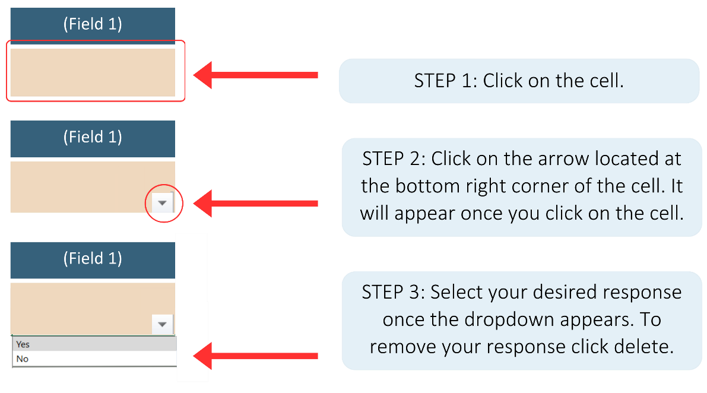

Field 2: Supporting Evidence
In this field, provide a brief explanation or description to support your response. You may need to describe a specific climate or environmental measure your organization has implemented. The response is limited to 250 characters. If your explanation exceeds this limit, provide the full description in a separate document and attach it to the bid.

Field 3: Links to Supporting Documents and Names of Attached Files
Your response in Fields 1 may require supporting documentation. Field 3 is designated for links to these supporting documents. If the documents are not available online, attach them to the bid and include the name of the supporting document in this field.

In many cases, you may also need to reference the specific page number where a particular sustainability measure is mentioned in your document. Please include this page number in Field 2 when applicable. For example, for question A1.1, which asks about the scope of your sustainability policy, if your policy addresses renewable energy, please specify the chapter and page number where this is mentioned.

When attaching documents, name them according to the format specified below:

[Organization Name] CEP Form [Name of Document]

For example, if your organization is "ABC Corp" and you would like to attach your Sustainability Policy, the document name should be: “ABC Corp CEP Form Sustainability Policy.”

4. Importance of Supporting Evidence
Your organization’s climate and environmental performance is evaluated based on responses to questions in the CEP Form. Responses must be supported by evidence that substantiates your organization’s sustainability claims. Responses in Field 1 without supporting evidence (input in Fields 2 and 3) will not be considered for evaluation points (see Figure 3).

Figure 3. Supporting Evidence for Earning Evaluation Points
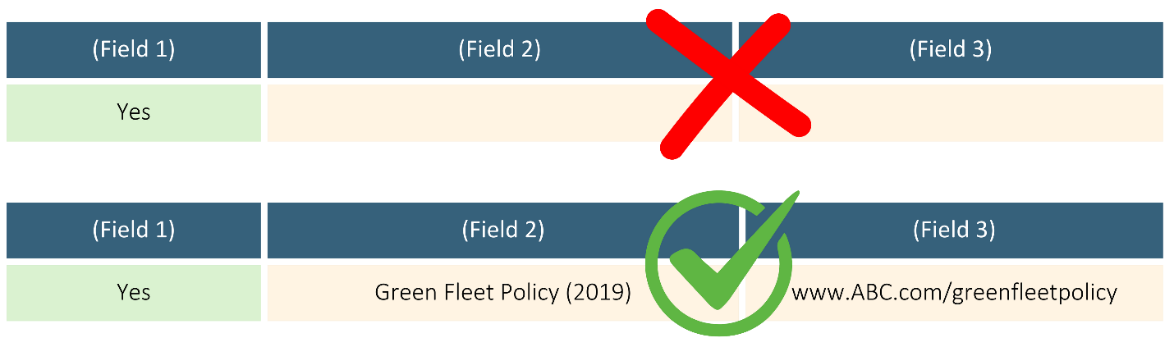

Additionally, in sections B and C of the CEP Form, many primary questions are evaluated in conjunction with responses to conditional questions. If a Bidder answers “Yes” to a primary question without addressing the related conditional question(s), evaluation points will not be awarded for the primary question. It is important to respond to both primary and conditional questions as applicable to ensure full evaluation (see Figure 4).

Figure 4. Responding to Conditional Questions
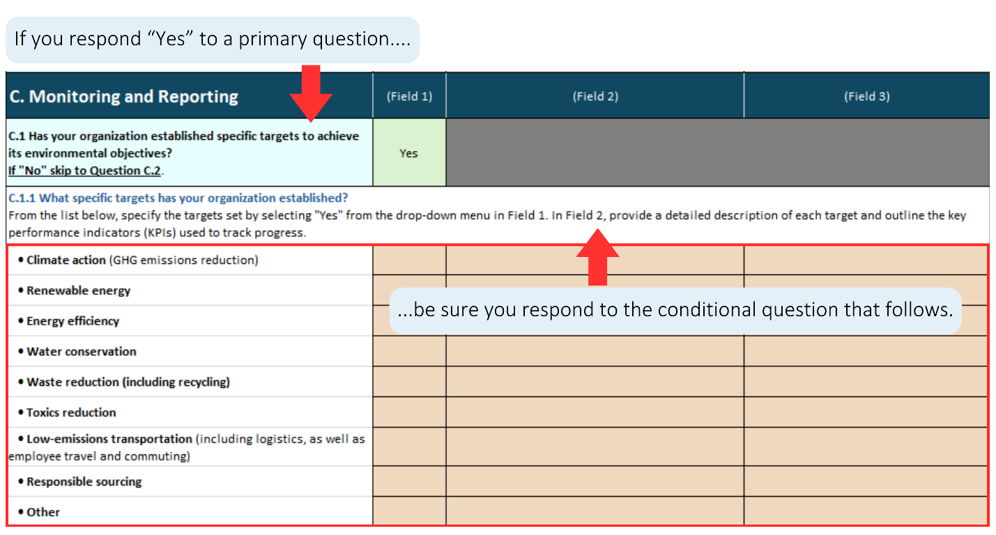

5. Examples of Sustainability Measures and Sample Responses
In this section, we explain each question on the CEP Form, breaking it down by section, and offer examples of possible responses. We also outline the types of supporting evidence that may be needed. While the examples provided cover many common sustainability measures and corresponding evidence, this list is not exhaustive. We encourage you to provide responses that accurately reflect your organization’s sustainability efforts, including any relevant details or documentation.

A. Sustainability Policies
A.1 Has your organization adopted a sustainability policy, strategy, or plan?
(Primary Question - Yes/No)
As mentioned earlier, a sustainability policy, strategy, or plan outlines an organization's commitment to responsible business practices, guiding decision-making and operations toward achieving sustainability objectives. This document can be broad, such as a climate action plan, or more focused, addressing specific environmental areas like recycling or fleet electrification. The following are some examples of sustainability policies:

Sustainability Policies (Broad)
- Sustainability Policy
- Climate Action Plan

Sustainability Policies (Focused)
- Green Fleet Policy
- Zero Waste Policy
- Energy Management Policy
- Water Conservation Policy
- Responsible Sourcing Policy

If your organization has a sustainability policy, select “Yes” from the drop-down menu in Field 1. In Field 2, enter the name of the policy and the year it was issued, and in Field 3, provide a link to the policy, as shown below.

Figure 5. Question A.1, Example Response: Sustainability Policy with Link
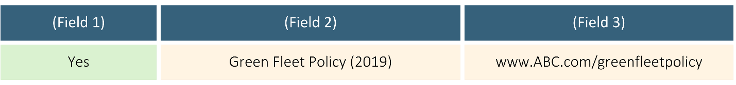

If the policy is not available online, ensure that the document is on company letterhead, attach it to the bid, and specify the document name in Field 3 (see Figure 6).

Figure 6. Question A.1, Example Response: Sustainability Policy with Attachment
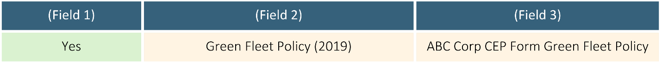

A.1.1 What climate and environmental focal areas are covered by your policy, strategy, or plan? (Conditional Question)
This question assesses the scope of your organization’s sustainability policy, strategy, or plan with regard to climate and environmental issues. It includes a list of specific environmental focal areas (such as renewable energy, energy efficiency, waste reduction, etc.). Select all relevant focal areas covered by your sustainability policy by choosing “Yes” from the drop-down menu in Field 1. For each selected area, provide the policy name that addresses the focal area in Field 2, and include either a link to or the name of the supporting document in Field 3.

Figure 7. Question A.1, Example Response: Environmental Focal Areas
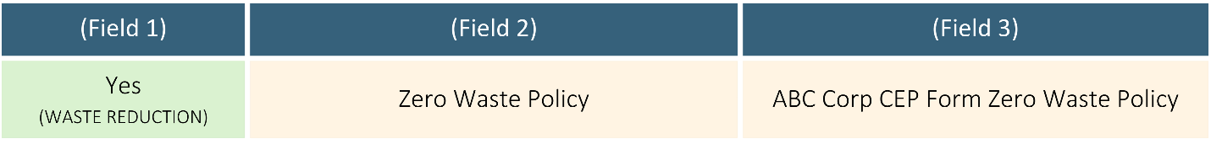

If the document is a broad policy, covering various focal areas, be sure to include the page number where the specific focal area information can be found:

Figure 8. Question A.1, Example Response: Environmental Focal Areas (Including Page Number Reference)
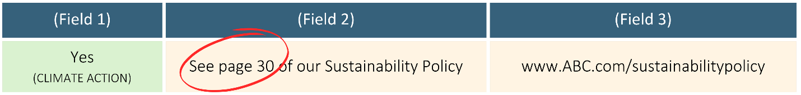

B. Sustainability Practices
B.1 Has your organization implemented specific measures in the last two years to improve sustainability at your facilities? (Primary Question - Yes/No)
Organizations may take a wide range of measures to enhance sustainability within their facilities. By “facilities” we refer to the physical spaces or buildings where your organization operates, including offices, manufacturing plants, warehouses, distribution centers, etc. If you organization operates from a home office, this is also included. Sustainability measures may vary significantly in scale depending on the size of your business, from large, high-impact projects to smaller, incremental changes.

For example:

- Large-scale initiatives might include constructing or renovating facilities to meet high environmental standards, such as achieving LEED (Leadership in Energy and Environmental Design) certification. These could also involve investing in renewable energy infrastructure such as solar panels, upgrading heating and cooling systems to more energy-efficient alternatives, etc.
- Smaller-scale actions could involve replacing incandescent bulbs with energy-efficient LEDs (light-emitting diodes), using smart switches, implementing low-flow plumbing fixtures, etc.

If your organization has implemented either large or small-scale measures to improve sustainability at your facilities in the past two years, select "Yes" from the drop-down menu in Field 1 and proceed to question B.1.1, which asks about your specific sustainability measures. If “No,” skip to Question B.2.

B.1.1 What specific measures has your organization implemented in the last two years to improve sustainability at your facilities? (Conditional Question)
This question gathers details to substantiate your response to Question B.1. It includes a list of environmental focal areas (such as energy efficiency, waste management, water conservation, etc.). Select all relevant focus areas where sustainability practices have been implemented in your facilities by choosing “Yes” from the drop-down menu in Field 1. For each selected area, describe the measures taken in Field 2, and include supporting documentation in Field 3.

Below is a description of each environmental focal area, along with a list of possible measures and supporting evidence. If sustainability reports are used as evidence, be sure to specify the page number where the measure is referenced and provide a link to the report or the name of the attached document. Example responses are included for clarity.

Renewable Energy
Organizations may adopt various measures to utilize renewable energy. They may generate it onsite by installing solar panels, wind turbines, and other technologies, or they may enter into Power Purchasing Agreements (PPAs) with utility providers to obtain renewable energy. Additionally, organizations may choose to purchase Renewable Energy Certificates (RECs) to claim the environmental benefits of renewable energy, even if they don’t directly consume it.

Below are examples of supporting evidence for each type of measure, along with example responses.

Table 1. Question B.1.1: Example Measures and Evidence Renewable Energy

Measures | Evidence
Onsite Renewable Energy Generation | - High-level description highlighting:  - Specific technologies implemented, such as solar panels, wind turbines, geothermal systems, etc.  - Scale of installation, such as the number of solar panels installed or the capacity (e.g. in KW or MW)  - Percentage of total energy produced by renewable sources, indicating how much of the organization’s energy needs are met by renewable power  - Sustainability reports  - Other types of evidence, such as invoices or receipts, production report screenshots, photos, etc.
Power Purchase Agreements (PPAs) | - High-level description highlighting:  - Types of renewable energy included in the contracts, such as solar, wind, or hydroelectric power  - Percentage of total energy consumed from renewable sources  - Duration of the contracts  - Sustainability reports  - Other types of supporting evidence, such as purchase agreements, utility bills, etc.
Renewable Energy Certificates (RECs) | - High-level description highlighting:  - Which REC registry system was used  - How many RECs were purchased and for what period  - What type of RECs did the RECs represent  - Sustainability reports  - Other types of supporting evidence, such as a certificate of transfer, transaction report from the REC registry, etc.

Figure 9. Question B.1.1, Example Response: Renewable Energy Generation
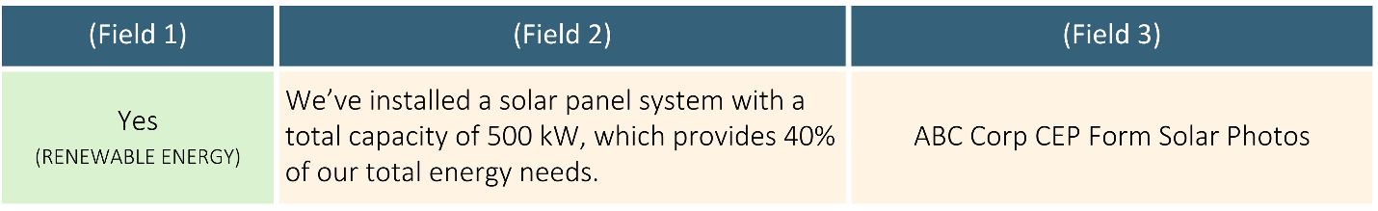

Figure 10. Question B.1.1, Example Response: Renewable Energy PPAs
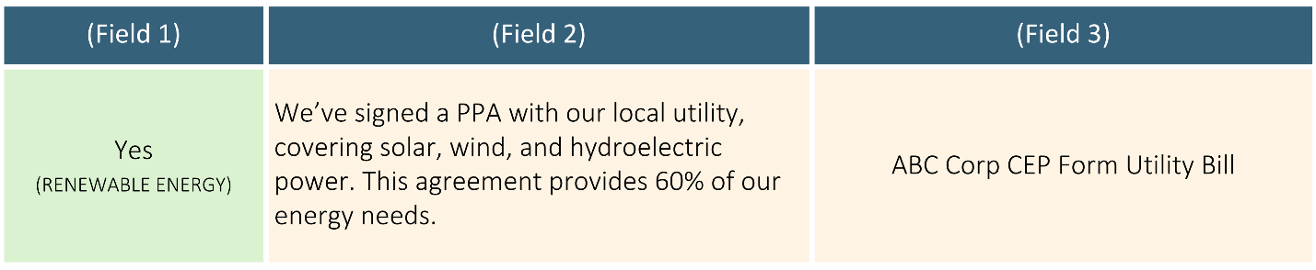

Figure 11. Question B.1.1, Example Response: Renewable Energy RECs
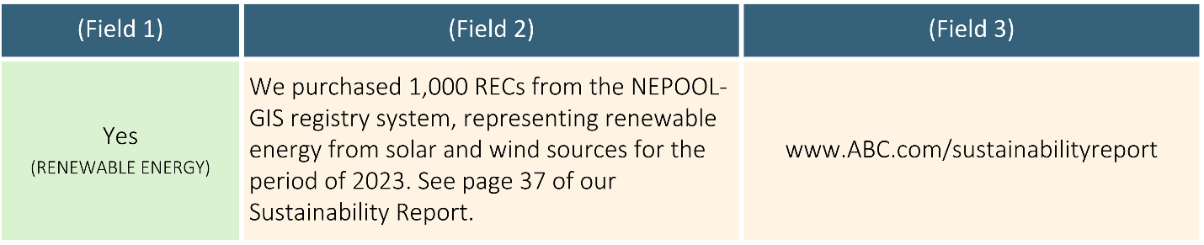

Energy Efficiency
Organizations may implement various measures to improve energy efficiency in their facilities. Examples of these measures and corresponding supporting evidence are outlined below. Figure 12 illustrates an example response.

Measures:
- Upgrade lighting
- Implement smart lighting
- Implement smart thermostats
- Convert heating and cooling to heat pumps
- Seal and insulate building
- Purchase energy-efficient appliances
- Purchase energy-efficient computers and IT equipment

Evidence:
- High-level description highlighting:
- New technology or products installed
- Scale of installation (e.g. quantity of light bulbs installed/replaced)
- Third-party certifications or ecolabels, if relevant (e.g., LEED, ENERGY STAR, EPEAT, TCO certifications or other ecolabels)
- Impact of the change, if available (e.g. energy savings)
- Sustainability reports
- Other supporting evidence, such as invoices or receipts, photos, energy usage reports, etc.

Figure 12. Question B.1.1, Example Response: Energy Efficiency
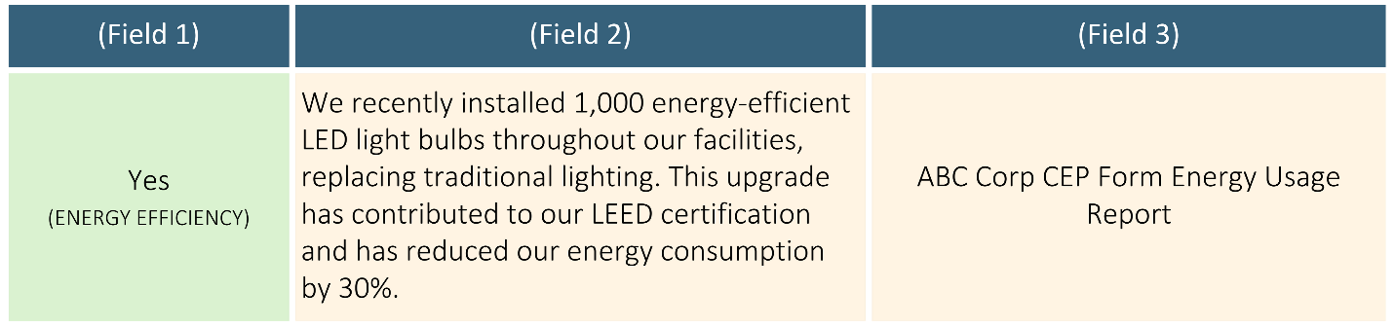

Water Conservation
Organizations may implement various measures to conserve water. Examples of these measures and corresponding supporting evidence are provided below, while Figure 13 offers an example response.

Measures:
- Installation of low-flow plumbing fixtures: Faucets, showerheads, and toilets with low-flow or high-efficiency models that use significantly less water, such as those that are WaterSense certified
- Installation of water-efficient appliances: Dishwashers and washing machines that use less water per cycle
- Implementation of water-saving landscaping: Use of drought-resistant plants and xeriscaping techniques to reduce irrigation needs
- Installation of smart irrigation systems: Use of irrigation systems that adjust watering schedules based on weather conditions and soil moisture levels
- Implementation of rainwater harvesting systems: Installation of rain barrels or cisterns to collect rainwater for irrigation and non-potable uses

Evidence:
- High-level description highlighting:
- New technology or products installed, such as low-flow faucets, toilets, or water-efficient irrigation systems
- Scale of installation (e.g. quantity of plumbing fixtures installed/replaced with water saving technologies)
- Third-party certifications or ecolabels, if relevant (e.g., WaterSense certification or other ecolabels)
- Impact of measure (if data available), such as the amount of water saved annually or the reduction in water usage
- Sustainability reports
- Other supporting evidence such as invoices/receipts for new technology or product purchases; installation documentation and reports showing reduced water usage; photos of water efficiency upgrades.

Figure 13. Question B.1.1, Example Response: Water Conservation
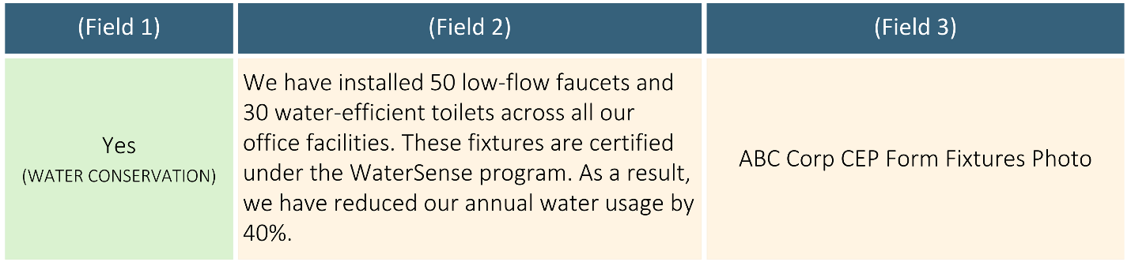

Waste Reduction
Companies may adopt a wide array of practices to minimize waste generation and divert materials from landfills. Below is a list of examples of these measures and corresponding supporting evidence. Figure 14 illustrates an example response.

Measures:
- Implement a recycling program
- Reduce office paper usage
- Adopt a Buy Back Program
- Use biodegradable or recycled packaging
- Implement composting
- Purchase reusable products
- Purchase remanufactured products
- Purchase products with post-consumer recycled content

Evidence:
High-level description highlighting:
- Waste reduction measures implemented (e.g. recycling program, reduced paper usage, composting, etc.)
- Scope of measure, such as whether the initiative is organization-wide, specific to certain locations, or focuses on particular types of materials (e.g. types of recyclables such as paper, plastics, or electronic waste)
- Impact of the measure (if data is available), including quantifiable results such as the amount of waste reduced, the percentage of waste diverted from landfills, or cost savings
- Sustainability reports

Figure 14. Question B.1.1, Example Response: Waste Reduction
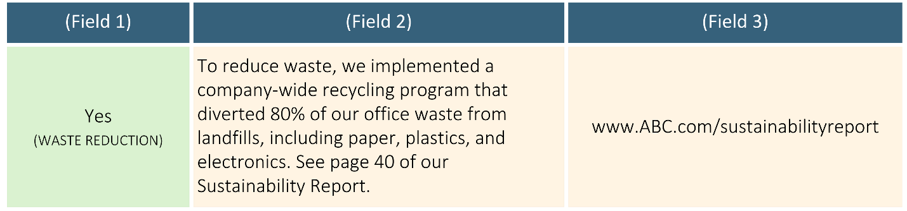

Toxics Reduction
Companies may implement a range of practices to minimize the use and release of hazardous substances and chemicals that pose risks to human health and the environment. The list below provides examples of these measures and corresponding supporting evidence. Figure 15 illustrates an example response.

Measures:
- Use of non-toxic products, such as environmentally preferable cleaning products, paints, adhesives, furniture, carpeting, etc.
- Improvements to indoor air quality, such as increased ventilation and use of air purifiers
- Use of safer alternatives in production: Research and replace hazardous materials in production processes with safer alternatives

Evidence:
High-level description highlighting:
- Toxic reduction measures implemented, such as purchase of non-toxic cleaning supplies, and the elimination of specific harmful chemicals (e.g. chlorine bleach, ammonia, etc.)
- Third-party certifications or standards used to ensure the safety and sustainability of the products (e.g., Green Seal, US EPA Safer Choice, Cradle to Cradle certification, etc.)
- Scope of measure specifying whether the initiative is organization-wide or limited to certain locations
- Sustainability reports
Figure 15. Question B.1.1: Example Response Toxics Reduction
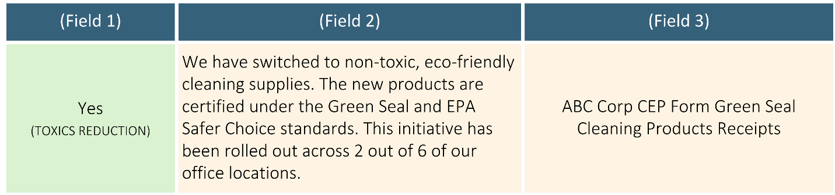

B.2 Has your organization implemented specific measures in the last two years to ensure climate and environmental responsibility in your supply chain? (Primary Question - Yes/No)
All organizations rely on supply chains, regardless of their size or industry. The complexity of a supply chain can vary, with some organizations having straightforward supply chains that involve the procurement of a limited range of goods and services, while others manage more intricate and global supply networks.

For organizations with simpler supply chains, this might involve sourcing products like office supplies, printing paper or laptops from vendors committed to sustainable practices. For example, purchasing recycled printing paper or energy efficient IT equipment.

In contrast, for organizations with more complex supply chains, implementing climate and environmental responsibility may require more comprehensive measures. These can include prioritizing suppliers with verified sustainability certifications (such as ISO 14001), establishing Supplier Codes of Conduct that mandate adherence to environmental standards, and investing in technologies to monitor and reduce the environmental impact of the supply chain.

If your organization has implemented such measures within the last two years, select "Yes" from the drop-down menu in Field 1 and continue to Question B.2.1, which asks about your specific supply chain sustainability measures. If “No,” skip to Question B.3.

B.2.1 What specific measures has your organization implemented to ensure climate and environmental responsibility in your supply chain? (Conditional Question)
This question gathers details to substantiate your response to Question B.2. It includes a list of measures to improve sustainability in the supply chain (such as responsible sourcing, Supplier Codes of Conduct, etc.). Select all relevant measures by selecting “Yes” from the drop-down menu in Field 1. For each selected measure, provide evidence in Field 2 and include relevant supporting documentation in Field 3. If sustainability reports are used as evidence, be sure to specify the page number where the measure is referenced and provide a link to the report or the name of the attached document. Below is a non-exhaustive list of example evidence for each measure. Example responses are included for clarity.

Table 2. Question B.2.1, Example Measures and Evidence: Supply Chain Sustainability

Measures | Evidence
Responsible Sourcing | - High-level description of sustainability criteria used in purchasing decisions, such as references to certifications and standards
Supplier Code of Conduct | - Supplier Code of Conduct as a link or attached document
Due Diligence and Audits | - High-level description in Field 2 of due diligence or audits, highlighting:  - Frequency indicating how often these assessments are conducted (e.g., annually, bi-annually, or after specific milestones)  - Methodology used to carry out the due diligence and/or audits, such as using questionnaires, on-site visits, third-party evaluations, or a combination of these methods  - Scope, outlining key areas assessed (e.g., environmental performance, supply chain transparency, etc.), and specifying how many (or percentage of) suppliers are included in the due diligence and/or audit process
Performance Metrics | - High-level description of specific performance metrics used, data collection methodology and technology used, reporting frequency, benchmarking, and targets  - Screenshots of data dashboards
Training | - High-level description of training, including its objective, key topics, target audience, and delivery method  - Training materials shared with suppliers such as the training agenda, slides, etc.

Figure 16. Question B.2.1, Example Response: Supplier Sustainability
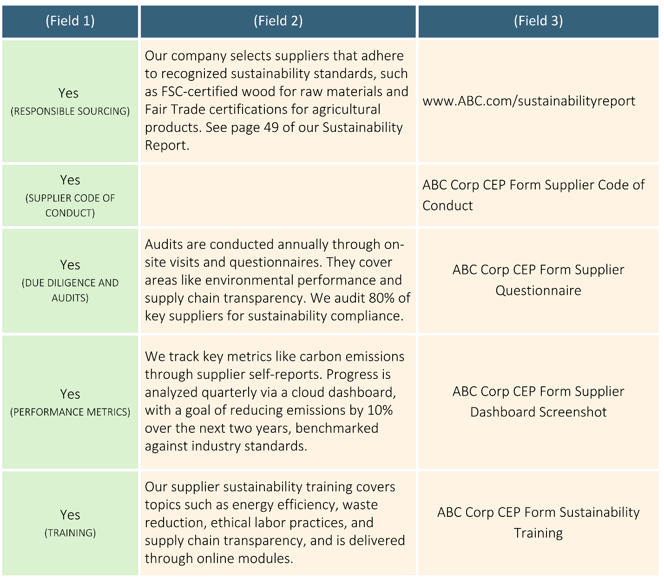

B.3 Has your organization implemented specific measures in the last two years to reduce the climate and environmental impact of transportation/distribution and/or employee business travel and commuting? (Primary Question - Yes/No)
Transportation and employee travel are key components of an organization’s overall environmental footprint. Reducing the environmental impact in these areas can involve a variety of strategies, depending on the nature of the business and its operations.

Measures to reduce the climate and environmental impact of transportation and distribution might include optimizing delivery routes to reduce fuel consumption, transitioning to electric or fuel-efficient vehicles for deliveries, or partnering with logistics providers that prioritize low-emission transportation methods. Advanced software can be used to further optimize routes and improve efficiency, minimizing environmental impact.

For employee business travel and commuting, organizations may implement policies to reduce travel-related emissions by encouraging virtual meetings, promoting the use of alternative transportation like high-speed rail, and incentivizing employees to use public transportation or adopt flexible work arrangements.

If your organization has implemented such measures in the last two years, please select "Yes" from the drop-down menu in Field 1 and continue to Question B.3.1, which asks about the specific actions your organization has taken to reduce the climate and environmental impact of transportation and employee travel. If “No,” skip to Question B.4.

B.3.1 What specific measures has your organization implemented to reduce the climate and environmental impact of transportation/distribution and/or employee business travel and commuting? (Conditional Question)
This question gathers details to substantiate your response to Question B.3. It includes a list of possible measures that organizations may adopt to reduce the climate and environmental impact of transportation, distribution, and employee travel. Select all relevant measures by choosing “Yes” from the drop-down menu in Field 1. For each selected measure, provide supporting evidence in Field 2 and include supporting documentation in Field 3. If sustainability reports are used as evidence, be sure to specify the page number where the measure is referenced and provide a link to the report or the name of the attached document. Table 8 provides examples of supporting evidence for each measure, while Figure 17 illustrates example responses.

Table 8. Question B.3.1, Example Measures and Evidence: Transportation and Travel

Measures | Evidence
Logistics optimization | - Name of the logistics management software used, including a description of the key metrics tracked by the software, such as route optimization, fleet utilization, etc.  - Other types of supporting evidence, such as links to or attachments of reports showing improved efficiency metrics
Use of electric vehicles (EVs) | High-level description highlighting:  - Types of EVs purchased or used by the organization (e.g., electric cars, delivery vans, trucks, etc.)  - Number of EVs in the fleet by type, along with the percentage of the total fleet represented by EVs  - Supporting infrastructure, as applicable, such as the installation of EV chargers, maintenance facilities, etc.  - Scale of implementation, specifying whether EV adoption is occurring organization-wide or at specific locations, regions, or for particular departments
Use of low-emissions logistics providers | - High-level description highlighting:  - Name of low-emissions provider specifying if they specialize in electric, hybrid, or other low-carbon transportation solutions  - SmartWay™ partnership status, indicating whether the provider is a SmartWay Transport Partner  - Scope of use, such as how extensively the provider is used across the organization’s transportation or distribution needs  - Other types of supporting evidence, such as links to or attachments of certificates or documentation from providers showing their emissions reduction practices, performance reports detailing emissions reductions achieved through these partnerships
Remote work | High-level description highlighting:  - Remote work policies, outlining guidelines and flexibility offered  - Number of staff participating in remote work, specifying whether it's a percentage of the total workforce or the total number of employees working remotely  - Scope of remote work arrangements, including whether remote work is offered organization-wide or at specific locations or departments
Public transportation | High-level description highlighting:  - Programs or incentives offered to encourage employees to use public transportation, such as discounted or fully subsidized transit passes, reimbursement for public transportation expenses, etc.  - Scope of the program, including whether it’s available organization-wide or to specific employee groups or locations
Electric vehicle charging | High-level description highlighting:  - Number of EV charging stations installed, specifying both the total number and the location(s) of installation  - Level of charging stations, if available, such as Level 1, 2 or 3, or specific feature(s)
Low-emissions employee business travel | High-level description highlighting:  - Low-emissions employee business travel policy, outlining guidelines

Figure 17. Question B.3.1, Example Response: Transportation and Travel
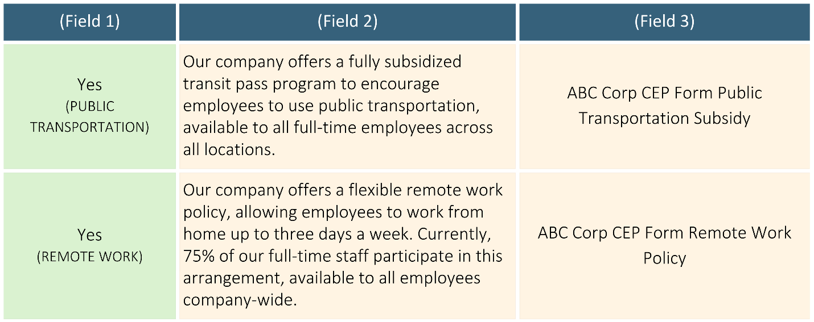

B.4 How many total hours per week does your organization dedicate to climate, sustainability, and/or environmental issues? (Primary Question)
This question aims to understand the staffing levels related to sustainability, helping to gauge the focus and resources your organization allocates to addressing climate and environmental challenges. In some organizations, this may involve a few hours each week dedicated by an individual or a small team to sustainability initiatives. In others, there may be a more structured and extensive commitment, with dedicated teams or departments focusing on sustainability strategy, carbon footprint reduction, waste management, and compliance with environmental regulations.

Select the approximate number of hours your organization dedicates to climate, sustainability, and/or environmental issues from the dropdown menu in Field 1. Below, you will find examples of supporting evidence and a sample response (Figure 18).

Evidence:
- Names and titles of employees dedicated to sustainability at your organization, or the names of consultants or consulting firms providing sustainability services
- Organizational chart
- Job descriptions related to sustainability roles

Figure 18. Question B.4, Example Response: Hours Dedicated to Sustainability
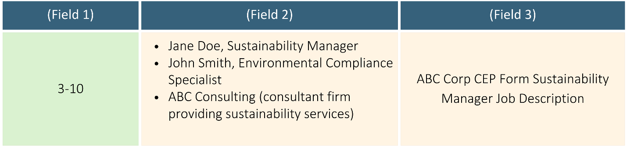
B.5 Does your organization provide regular training to staff on its sustainability policies and practices? (Primary Question)
This question aims to evaluate how your organization educates and engages employees on sustainability. Training on sustainability policies and practices can take many forms. In some organizations, training may be informal or provided on an as-needed basis, focusing on key sustainability policies, energy-saving practices, or waste reduction strategies that are relevant to daily operations. Staff may receive training during onboarding or through occasional workshops or meetings.

In other organizations, regular and structured training programs are implemented. These programs often include dedicated sessions on sustainability policies, environmental compliance, etc. Training may be offered through e-learning modules, workshops, or certification courses to ensure that employees across various departments understand and align with the organization’s sustainability goals. Ongoing updates may also be provided as sustainability practices evolve.

If your organization offers training on its sustainability policies and practices, select “Yes” from the drop-down menu. Below, you will find examples of supporting evidence and a sample response (Figure 19).

Evidence:
- High-level description of training, highlighting its objective, key topics, target audience, and delivery method (virtual, in-person, workshops, seminars, etc.)
- Training materials, such as copies of training schedule, manuals, presentations, or handouts used in sustainability training sessions

Figure 19. Question B.5, Example Response: Training
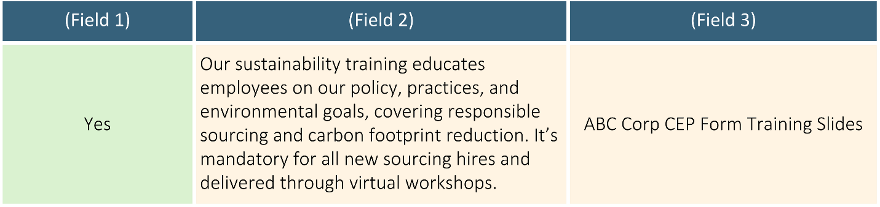

C. Monitoring and Reporting
C.1 Has your organization established specific targets to achieve its environmental objectives? (Primary Question - Yes/No)
This question assesses your organization’s commitment to actionable sustainability practices and its ability to measure progress toward environmental goals. These targets may include outcomes such as reducing energy consumption, minimizing waste, or sourcing sustainable materials. Goals can be set on an annual basis and reviewed periodically to ensure progress.

Environmental targets may be formalized and integrated into broader sustainability strategies. These could include long-term objectives such as reducing carbon emissions, achieving zero waste, or meeting industry-specific environmental standards. Some organizations may also set targets aligned with global frameworks, such as the Paris Agreement or Science-Based Targets, and track progress through comprehensive reporting systems.

If your organization has set climate and environmental targets, select “Yes” from the drop-down menu in Field 1, and continue to Question C.1.1, which asks about the specific targets your organization has set. If “No,” skip to Question C.2.

C.1.1 What specific targets has your organization established? (Conditional Question)
This question gathers details to substantiate your response to Question C.1. It includes a list of environmental focal areas for which your organization may have set targets, such as climate action, renewable energy, energy efficiency, etc. Select all relevant environmental focal areas by choosing “Yes” from the drop-down menu in Field 1. For each selected area, provide a detailed description of the corresponding target and outline the Key Performance Indicators (KPIs) in Field 2. Below, you will find examples of supporting evidence and a sample response (Figure 20).

Evidence:
- Description of the targets.
- Relevant supporting documents, such as a sustainability policy, action plan, annual sustainability report, or other public disclosures (e.g., information available on the organization website).

Figure 20. Question C.1.1, Example Response: Targets
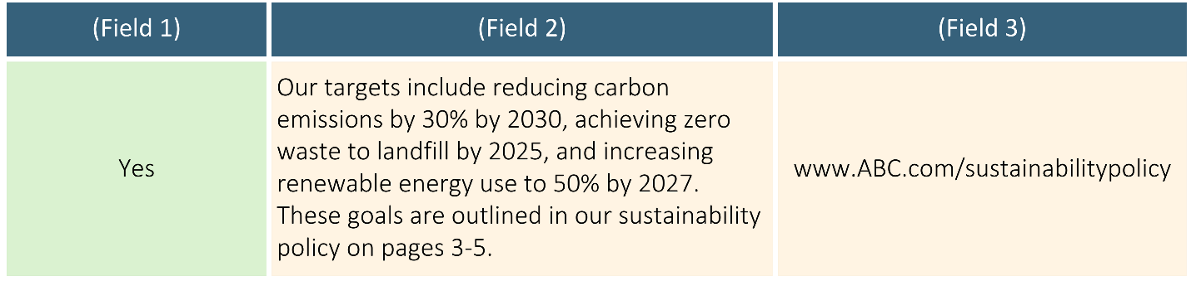

C.2 Does your organization regularly communicate its climate and environmental achievements? (Primary Question - Yes/No)
This could include informal updates, such as sharing key achievements or sustainability updates through newsletters, organization websites, or social media as well as more formal sustainability reports detailing your organization’s environmental impact, goals, progress, and future plans.

Formal reports are often aligned with recognized frameworks like the Global Reporting Initiative (GRI) or the Sustainability Accounting Standards Board (SASB) and often are publicly available to stakeholders, including investors, clients, regulatory bodies, and the general public.

If your organization regularly communicates its climate and environmental achievements, select “Yes” from the drop-down menu in Field 1 and provide supporting evidence as outlined below:

- Description of communications
- Relevant supporting documents, such as an annual sustainability report, newsletter, etc.

Figure 21. Question C.2, Example Response: Communications
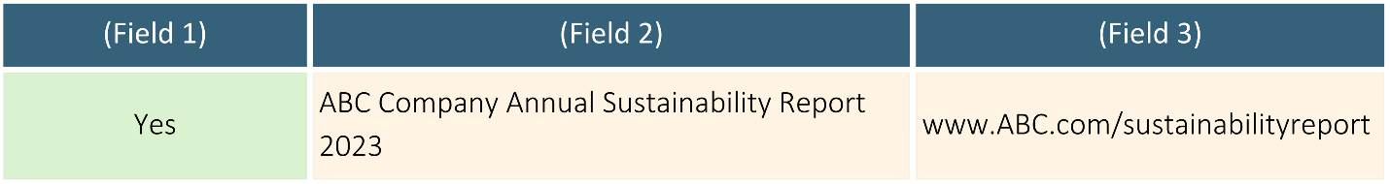

C.3 Does your organization measure Greenhouse Gas (GHG) emissions? (Primary Question - Yes/No)
Greenhouse gas (GHG) emissions are gases released into the atmosphere that trap heat, contributing to global warming and climate change. These emissions primarily come from human activities such as burning fossil fuels, deforestation, and industrial processes, and include gases like carbon dioxide, methane, and nitrous oxide.

If your organization measures GHG emissions, select "Yes" from the drop-down menu in Field 1 and continue to Question C.3.1, which asks about the emissions categories you measure. If “No,” skip to Question D.1.

C.3.1 Which Greenhouse Gas (GHG) emissions does your organization measure? (Conditional Question)
GHG emissions are organized into three categories, known as scopes, to help organizations measure and report their emissions in a structured way. These categories were developed by the Greenhouse Gas (GHG) Protocol, a widely used international accounting tool for understanding, quantifying, and managing GHG emissions.

The three scopes are as follows:

- Scope 1: Direct GHG emissions from owned or controlled sources, such as emissions from an organization’s facilities, vehicles, or industrial processes.
- Scope 2: Indirect emissions from the generation of purchased electricity, steam, heating, and cooling consumed by the organization.
- Scope 3: All other indirect emissions that occur in the value chain, including emissions from suppliers, business travel, waste disposal, and employee commuting.

Organizations typically measure and report Scope 1 and Scope 2 emissions, as these are more directly under their control. Scope 3 emissions, which encompass indirect emissions throughout the supply chain and other business activities, are often more challenging to measure and report, but they are increasingly being included as organizations aim for more comprehensive environmental impact assessments.

Select “Yes” for the categories (Scope 1, 2 and 3) your organization measures in Field 1 and provide supporting evidence in Fields 2 and 3. Below are examples of possible supporting evidence, along with a sample response (Figure 22).

Evidence:
- Description of the standard or framework your organization uses to measure its emissions
- Sustainability reports
- Emissions inventories
- Third-party verification, such as independent audits and/or certification from recognized organizations (e.g., ISO 14064) that verify emissions measurement and reporting processes

Figure 22. Question C.3.1, Example Response: GHG Emissions
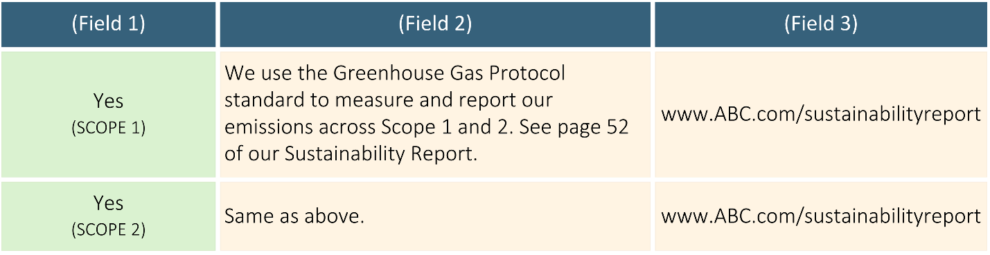

C.3.2 Which assessment platforms, if any, does your organization use to report its Greenhouse Gas (GHG) emission? (Conditional Question)
Understanding whether an organization reports its GHG emissions is crucial for assessing the credibility and reliability of its GHG emissions reporting. Identifying the assessment platforms used may indicate the rigor of the emissions measurement process, adherence to industry standards, and overall transparency in reporting.

Select the sustainability assessment platform your organization reports to by selecting “Yes” from the drop-down menu in Field 1 and providing supporting evidence in Fields 2 and 3. Below are examples of possible supporting evidence along with a sample response (Figure 23).

Evidence:
- Sustainability reports
- Online disclosure
- Database: Links to or screenshots from reporting databases, such as CDP.

Figure 23. Question C.3.2, Example Response: GHG Emissions Reporting
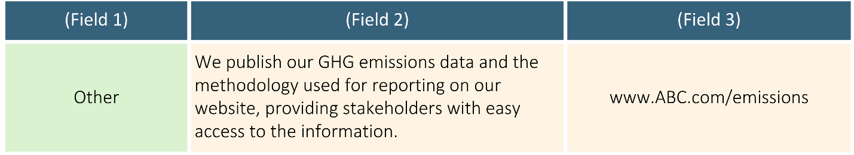

D. Certifications and Awards
D.1 Has your organization earned any environmental or sustainability certifications, endorsements, and/or awards? (Primary Question - Yes/No)
Certifications, endorsements and awards often require independent verification of an organization's sustainability practices, which may enhance credibility and build trust among stakeholders. Earning credentials and recognition indicates an organization's commitment to environmental responsibility and sustainable practices, showcasing their efforts beyond regulatory compliance. This may include certifications such as ISO 14001 Environmental Management Systems, membership in the UN Global Compact, or similar recognition that demonstrate your organization's commitment to environmental sustainability and responsible practices.

If your organization has received any relevant environmental certifications, endorsements, or awards, select “Yes” from the drop-down menu in Field 1, list the certification(s), endorsement(s) and/or award(s) in Field 2 and include any supporting documentation or evidence as applicable in Field 3.

Please note that this section is intended for organizational-level certifications, endorsements and achievements. Product-specific certifications, such as those related to individual products or services (e.g., energy-efficient products, ecolabels), should not be included here.

Below are examples of certifications, endorsements and awards, along with possible supporting evidence (Figure 24).

Examples of Sustainability Certifications, Endorsements and Awards:
Certifications:
- LEED, ISO 14001, Certified B Corporation, Fair Trade, Massachusetts, Sustainable Business Leader, etc.
Endorsements:
- UN Global Compact, etc.
Awards:
- Business Network Awards, Sustainable Purchasing Leadership Council (SPLC) Award, Energy Star Awards for Excellence, EPA National Environmental Leadership Awards, Climate Leadership Awards, etc.

Evidence:
- Certification, endorsement and/or award documentation
- Public disclosure on organization’s website or annual report

Figure 24. Question D.1, Example Response: Sustainability Certifications
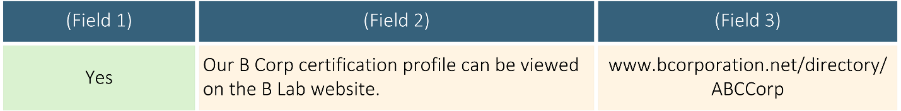

The CEP form may also be used by Executive Departments conducting procurements for departmental contracts. Vendors should review departmental RFRs carefully to understand the requirements and evaluation criteria related to the CEP Form when included in a departmental procurement.

