Do You Rent Your Home?
Look Out for Mold!
Mold occurs naturally in the environment. It is both inside and outside of your home. For some people, mold exposure causes symptoms like a stuffy nose, wheezing, red and watery eyes, and even itchy skin. People with allergies and asthma may have more serious symptoms, like problems breathing.
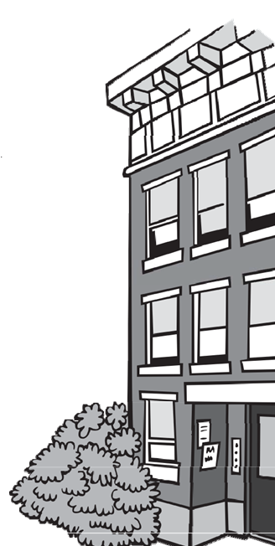

If there is a mold problem, there is also an excess moisture problem. The best way to prevent mold is to control the moisture. Work with your landlord to help identify and control excess moisture and prevent mold in your home.

Help I have mold in my home!
- If you can see the mold, contact your landlord right away.
- If you can see a problem that causes excess moisture, like a plumbing leak, a leaking roof, or condensation due to poor ventilation, tell your landlord so they can fix the problem.
- To eliminate mold growth and to prevent it from coming back, the owner must first fix the source of the moisture.
- Once the source of the moisture is repaired, the owner can remove the mold and clean the area.
- Carpets, ceiling tiles, and other items that cannot be cleaned and dried thoroughly should be replaced.
- If the mold comes back, then the landlord needs to find a long- term solution to control the excess moisture, like installing ventilation fans in bathrooms or dehumidifiers in the basement.
- If you are doing your part, but the owner isn't, call your local health department and ask for a housing inspection.
For More Information About Mold in Your Home and Asthma Prevention, Visit:
- EPA: https://www.epa.gov/mold/brief-guide-mold-moisture-and-your-home
- CDC: https://www.cdc.gov/mold/faqs.htm
- DPH Asthma Program: http://www.mass.gov/service-details/about-the-asthma-prevention-and-control-program

Guidance to Control Excess Moisture and Mold
EPA says the best way to control mold growth is to: CONTROL THE MOISTURE!

What is a mold inspection?
You have the right to call your local health department to ask for an inspection. A mold inspection is a visual inspection looking for excess moisture and the presence of mold. The health inspector does not take environmental samples or test for mold. You can show the inspector where the mold is. If they see visible mold or conditions that cause excess moisture, then they will cite the landlord and order corrections. The health department will not order the landlord to have a mold test done.

Should I get a mold test?
    - There are no federal or state standards to determine what is and what is not a safe amount of mold.
    - Environmental sampling is not recommended. Visible mold must be cleaned up. You do not need to know the amount or type of mold growing in your home to require the landlord to fix the problem and clean up.
    - If you choose to get a mold test, consider this:
    - Molds are part of the environment and it is impossible to get rid of all mold and mold spores indoors. The mold spores will not grow if moisture is not present, which is why health inspections focus on excess moisture.
    - The local health inspector cannot use mold test results alone to order the landlord to make any corrections.
    - The local health inspector cannot order the landlord to reimburse you for the test.
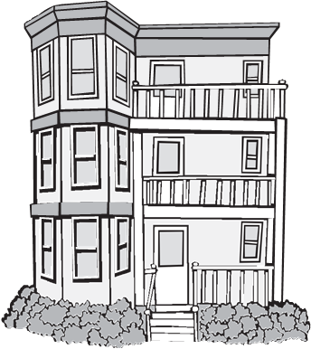

How can I help control the moisture in my home?
- Wipe up water on kitchen and bathroom counters and on bathroom floors after bathing.
- Use the ventilation fan above the stove when you cook, especially when you boil food.
- Don't leave wet towels, clothes, and bathmats around for long periods of time.
- Keep your home clean, especially sinks, showers, and bathtubs to prevent mold growth.
- Use a ventilation fan in the bathroom or open the window when you shower to prevent moisture from building up. Keep the fan running and open the door and/or window for a short period of time after you are finished to get the steam out.
- If you have house plants, spray them to water them. Don't let water spill on to the floor or sit in a dish under the plant.
- If you have spilled water or any liquid on a carpet, clean up the spill and dry the area thoroughly.
- If your basement is damp, don't store cardboard boxes or paper in it. Use plastic bins.
- If your home or basement is humid, ask the landlord for a dehumidifier to help eliminate the moisture in the air.

Mold Clean Up:

- If there is a lot of visible mold, or if the mold is caused by plumbing problems, a flood, or a sewage leak or back up, then the landlord should consider hiring a professional to identify the problem, make the repairs, and clean up the mold.
Massachusetts Department of Public Health  Bureau of Climate and Environmental Health | Community Sanitation Program (CSP)  Call: 1-617-624-5757  TTY: 1-617-624-5286  Email: communitysanitation@mass.gov  www.mass.gov/community-sanitation
- Some repairs on plumbing or HVAC systems may require a licensed contractor, but the mold clean up does not.
- Repairs must be good quality, done safely, and the dust and debris from the repairs must be cleaned up.

