Information for Rental Property Owners and Managers

Mold occurs naturally in the environment. It is both inside and outside of your home. Mold thrives with heat, moisture, and darkness. For some people, mold exposure causes symptoms like a stuffy nose, wheezing,
red and watery eyes, and even itchy skin. People with allergies and asthma may have more serious symptoms, like problems breathing. If there is a mold problem, there is also an excess moisture problem. The best way to prevent mold is to control the moisture.
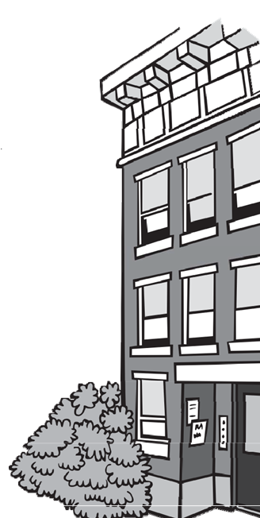

You should know:
- Owners must prevent excess moisture and mold in their homes.
- Owners must maintain a home's structural elements to prevent mold growth. They must maintain weathertight roofs, windows, doors, floors, and walls.
- Owners are not required to test for mold, but if you can see (and sometimes smell) mold or see excess moisture problems, then you must repair the cause of the excess moisture and clean up the mold.
Excess moisture can be an acute problem or a chronic problem. An acute problem is something that happens suddenly and unexpectedly, like a broken water pipe or a flood. A chronic problem is something that happens regularly, like a bathroom that stays damp after showers. Chronic excess moisture problems need long-term solutions, not just quick fixes.
Protect your home from moisture and mold problems:
- Repair all plumbing leaks, including washing machines and dish
washers, right away.
- Ensure clothes dryers vent to the outside, unless designed as ventless.
- Install and/or repair ventilation fans in kitchens and bathrooms to remove excess moisture from cooking and bathing. Fans should vent to the outside. Mechanical ventilation is required as part of the sanitary code if the natural ventilation does not control excess moisture.
- Service, clean, and maintain heating, ventilation, and air conditioning (HVAC) duct work regularly.
- Clean and replace filters for HVAC equipment according to manufacturer’s guidelines.
- Make sure all windows and doors are weathertight.
- Check your roof and make sure shingles and flashing around chimneys are in good repair and that areas around pipes and vents are sealed.
- Replace or repair broken or missing gutters and downspouts and make sure they drain away from the home.
- Regrade your yard or install a French drain so that water drains away from the foundation.
- Inspect after a flood to make sure all areas that were wet are clean and dry within 24- 48 hours.
EPA says the best way to control mold growth is to: CONTROL THE MOISTURE!

Guidance to Control Excess Moisture and Mold

The tenant called about a leak or mold, what now?
- Inspect the property as soon as you can to determine where the mold is and where the leak is coming from. Is there a plumbing leak, leaking roof, and/or condensation due to poor ventilation?
- Once you have identified the source of excess moisture, make the repairs needed.
- If the area is wet or was exposed to a leak or flood, clean and dry it within 24-48 hours to prevent mold growth. Responding quickly is critical.
- After the source of the moisture is identified and the repairs are complete, clean the mold.
- Throw away any carpets, ceiling tiles, or other porous materials that cannot be cleaned and dried quickly and thoroughly.
- Reinspect your repairs and the cleaned area frequently to make sure the leak and the mold does not come back.
Should I get a Mold Test?
There are no federal or state standards to determine a safe or unsafe amount of mold. Environmental testing is not recommended and is not enforced under the Sanitary Code. The regulations apply if there are visible signs of mold or excess moisture. It is your responsibility to repair the moisture problem and clean the mold.

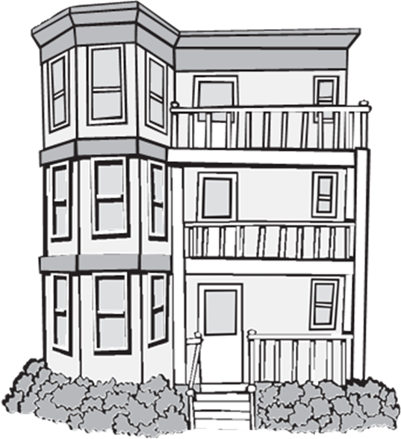
When is it time to hire a professional?

You should call a professional mold remediator if:
  - You or the tenants are particularly sensitive to mold exposure, e.g., severe allergies or asthma.
  - The area affected by the mold is large, greater than 10ft2 per EPA guidance.
  - The mold is a result of a faulty HVAC system or a plumbing leak. A professional may need to repair the system first before the mold can be removed.
  - The mold growth is a result of a flood or sewage leak. A professional can identify and repair the source of the moisture before cleaning the mold. Visit mass.gov/service-details/storm-fact-sheet for additional guidance on what to do after flooding.

There are no licensing requirements for mold remediation; if you choose to hire a professional, you should:
- Ask to see a company Statement of Qualifications (SOQ) or any confirmation to ensure they have relevant experience.
- Check their references.
- Be sure they visit the home and inspect the area(s) where they have identified mold before they begin repair and cleanup work.
For More Information About Mold in Your Home and Asthma Prevention, Visit:
- EPA: epa.gov/mold/brief-guide-mold-moisture-and-your-home
- CDC: cdc.gov/mold/faqs.htm
- DPH Asthma Program: mass.gov/service-details/about-the-asthma-prevention-and-control-program

Massachusetts Department of Public Health
Bureau of Environmental Health

Massachusetts Department of Public Health  Bureau of Climate and Environmental Health |  | Community Sanitation Program (CSP)  Call: 1-617-624-5757  TTY: 1-617-624-5286  Email: communitysanitation@mass.gov  www.mass.gov/community-sanitation

