
The Commonwealth of Massachusetts
Executive Office of Health and Human Services
Department of Public Health
250 Washington Street, Boston, MA 02108-4619
DEVAL L. PATRICK
GOVERNOR
TIMOTHY P. MURRAY
LIEUTENANT GOVERNOR
JOHN W. POLANOWICZ
SECRETARY
LAUREN A. SMITH, MD, MPH
INTERIM COMMISSIONER

Massachusetts Department of Public Health
Guidelines for Community Standard for Maternal/Newborn Screening
For Alcohol/Substance Use

As a health care professional, you have an important role in identifying substance-exposed newborns. These guidelines have been developed to assist health care professionals:
- Improve their ability to effectively identify substance-exposed newborns;
- Implement standardized guidelines for maternal screening in Massachusetts; and
- Improve the health and well-being of women and their at-risk newborns.

Purpose:
These guidelines provide a community standard and consensus approach to the screening of pregnant women and their newborns for exposure to drugs during pregnancy (Note: the term drugs/substance includes alcohol). Providers need to determine the risk of fetal exposure and be able to determine the risk to the newborn after delivery.

Background:
Infants exposed in utero to substances of abuse are known to be at risk for a variety of problems, including medical conditions, growth issues, developmental delays, and child abuse and neglect. Additionally, the federal law, Individuals with Disabilities Education Act, (IDEA) Part C, which addresses children age 0-3 years, includes prenatal drug and alcohol exposure as a risk factor for adverse developmental outcomes, and therefore qualifies these children for evaluation and developmental services, as needed.

Identifying pregnancies complicated by substance use has implications for maternal, fetal, and newborn health. Testing for substances in pregnancy is a complex issue with medical, social, ethical, and legal implications. For these purposes, screening refers to a more global assessment for alcohol and/or substance use by eliciting exposure through history-taking and dialogue with the mother, while testing refers to an actual laboratory tool that identifies the drug in a body substance (e.g., serum, urine, meconium).

These guidelines address the utility of both screening and testing, recognizing that there is controversy on which patients are tested, and whether subgroups of women are being profiled; protection of adult patients’ rights to informed consent and privacy; and protection of vulnerable infants from the harm of prenatal exposure to substances. It is also recognized that an individual may be using and/or abusing a drug or alcohol, however, the screening and/or testing results may be negative.

Massachusetts Department of Public Health (the Department) recommends:

- Screening all pregnant women through interviews using a standard tool (see Appendix A) at the beginning of pregnancy, as well as at 28 weeks and at the time the woman presents for delivery.

- Performing a toxicology panel based on screening results and other defined criteria (see Appendix B).

The Department also recommends that each hospital work with their legal counsel, risk management, nursing, social service, and medical staff to develop a well-defined policy for identifying intra-partum women and newborns with substance use/abuse or exposure. In addition to screening pregnant women, the policy should include specific evidence-based criteria for testing a woman and her newborn, timing of tests, test types, and consent issues. The justification and process for newborn testing will be specific to the written policy of each institution. All health care providers should be informed of the policy and educated in its use. Additional training may be required to assist health care professionals in developing approaches that motivate and guide women to make informed choices regarding testing.

Recommended Standard Approach:
Because of the potentially serious consequences of failing to recognize drug or alcohol exposure in infants and abuse in affected families who do not disclose this condition and fail to receive treatment and other supportive services, the Department recommends the following:

Screen Pregnant Women and Postpartum Women for Substance Use
- Identify individuals at risk for alcohol and/or substance use
- Screen through interview and self-report (questionnaires/screening instruments)
- Follow-up with assessments, which may include laboratory testing
Criteria for Screening
All women should be screened for drug and alcohol use/abuse using a recommended standard tool (see Appendix A #1, Substance Use Risk Profile Pregnancy Tool for Labor and Delivery). Screening should begin with the first prenatal visit to allow for early identification and education, repeated at 28 weeks, and when the mother is admitted to Labor and Delivery. Use of the 5 P’s Screening Tool (Parents, Peers, Partner, Past, Present) is recommended for prenatal and postpartum visits and can be incorporated into the SBIRT (Screening, Brief Intervention, Referral and Treatment) (see Appendix A #2).

Women who answer no to all questions on the Screening Tool are deemed to be at low risk of alcohol or substance use/abuse. Those who answer yes to one question are deemed to be at moderate risk, and those who answer yes to two or more questions are deemed to be at high risk.

Screening:
- Increases the identification of substance users
- Allows for early intervention
- Improves provider skills and comfort addressing the issues
- Provides opportunity for education
- Enhances public awareness and may prevent future use/abuse

Laboratory Testing for Substance Use/Newborn Exposure
Universal testing of women and newborns for substance use/exposure using biological specimens is NOT recommended according to the AAP, ACOG Guidelines for Perinatal Care, 2012. Testing should be based on defined and evidence-based criteria.
Some risk indicators are more predictive of substance use than others. If positive risk indicators are identified at any time during pregnancy or postpartum, rule out other identifiable causes, then test or complete an assessment as appropriate.

Criteria for Testing Women (by urine screen) include:
- Minimal or no prenatal care
- Unusual behavior (e.g., disorientation, somnolence, loose associations, unfocused anger)
- Physical signs of substance abuse or withdrawal
- Smell of alcohol or chemicals
- Recent history of substance abuse or treatment in the past 5 years and/or currently on Medication Assisted Therapy (MAT). (Participation in MAT does not always equal sobriety).

Other Risk Factors to consider that may be associated with substance use include, but are not limited to:
- History of physical abuse or neglect
- Intimate partner violence
- Mental illness
- Previous child with Fetal Alcohol Effects or Syndrome or alcohol related birth defects
- Previous child with Neonatal Abstinence Syndrome
- Fetal Distress
- Unexplained Placenta Abruptio
- Unexplained Intrauterine Growth Restriction (IUGR)

Consent for Testing
Policies should allow testing (without consent) of unconscious or intoxicated patients, or patients with signs and symptoms of complications of intoxication (e.g., seizure).

Hospital policies may require the written consent of pregnant or postpartum women for drug testing. If only verbal consent for testing is obtained, hospitals should be aware that this may not be adequate for reimbursement by some insurers.

If written consent for testing is required, the hospital policy should clarify who is responsible for obtaining the consent for testing (e.g., RN, MD).

Hospital policies should define what actions should be taken if a mother refuses to consent to testing. Considerations may include actions such as:

- Notification to the physician and the hospital social worker requesting further discussion with and evaluation of the mother
- Automatically test the newborn without parental consent
- Notification to the Department of Children and Families (DCF) by a hospital social worker, RN or MD

If laboratory testing is performed staff should:

- Inform the patient of the reason for performing the test and the procedures involved
- Document the patient’s consent
- Review test results with the patient
- Document the patient’s response

Criteria for Testing Newborns for Substance Exposure
A newborn may be presumed substance exposed if the mother is on Medication Assisted Therapy (MAT) and/or has a positive drug test on admission to Labor and Delivery. This does not preclude doing a separate test of the newborn (urine/meconium) if medically indicated, or if there are concerns for substance use during the pregnancy. Please note that that a 51A
Report is required to be filed if an infant has positive urine/meconium test results.

Newborn drug testing is done for the purposes of determining appropriate medical treatment for the infant and ensuring a safe and appropriate discharge plan. Clinical judgment should be used to determine whether testing newborns, including those born to women on Medication Assisted Therapy (MAT), is necessary. (See Appendix B – Newborn Toxicology, and Appendix D-DCF Guideline under exception). It may be helpful to test the newborn if there is a suspected history of substance abuse, or the mother is not compliant with her treatment program. These tests may include confirming the presence of substances in urine and/or meconium.

Neonatal signs of opioid dependence (marked irritability, high pitched cry, feeding disorders, excessive sucking, vomiting, diarrhea, rhinorrhea, and diaphoresis (Finnegan,1986)) may be delayed for as long as 10–14 days depending on the half-life of the substance in question, however, signs are most likely to present in the first four days of life. This time frame may also be confounded by in utero exposure to other medications or substances, including benzodiazepines and selective serotonin reuptake inhibitors (SSRIs).

Reporting

- Physicians, nurses and social workers are all mandated reporters for any concerns related to abuse or neglect of children.

- Hospitals should have a written policy for reporting positive tests and other concerns to the Department of Children and Families (DCF). Policies may include provisions to encourage collaborative work in the best interest of the infant and the infant’s family while maintaining communication between the hospital and DCF staff.

- The Hospital policy should include an action plan on how to evaluate and address positive initial testing in a mother and/or newborn.

- The Hospital policy should include provisions to ensure that the hospital social worker is notified for further evaluation and reporting, as needed.

Mandated reporters, such as physicians, nurses, social workers (see definitions under: Massachusetts General Laws, Chapter, Chapter 119, Section 21 below), must report positive tests at delivery. (Note: M.G.L. Chapter 119, Section 51A, states in part, a mandated reporter who, in his [her] professional capacity, has reasonable cause to believe that a child is suffering physical or emotional injury resulting from physical dependence upon an addictive drug at birth, shall immediately communicate with the Department orally and, within 48 hours, shall file a written report with the Department detailing the suspected abuse or neglect.)

Please see reference web links to applicable laws at M.G.L. Chapter 119, Section 51A and Section 21, below:

http://www.malegislature.gov/Laws/GeneralLaws/PartI/TitleXVII/Chapter119/Section51A

http://www.malegislature.gov/Laws/GeneralLaws/PartI/TitleXVII/Chapter119/Section21

Trauma Informed Care
Many women seeking health services have a history of physical and/or sexual abuse and other types of trauma-induced experiences. These experiences often lead to mental health and physical disorders such as chronic health conditions, substance abuse, eating disorders, and HIV/AIDS, as well as encounters with the criminal justice system.
Trauma-informed services are based on an understanding of the vulnerabilities or triggers of trauma survivors that traditional service delivery approaches may exacerbate. These services and programs are supportive and reduce re-traumatization of the trauma survivor.
Trauma-informed services:
- Incorporate knowledge about trauma in all aspects of service delivery
- Are designed to be comforting and engaging
- Minimize re-victimization

Release of information from Methadone Clinic providers
Confidentiality

Substance abuse treatment information is protected by federal law under 42 Code of Federal Regulations, Part 2 (42 CFR 2). This federal law prohibits disclosure of information unless it is expressly permitted by the written consent of the person to whom it pertains. The only exception is for child abuse/neglect reporting. This exception allows for the initial report only if the provider is the reporter, but does not allow for open access beyond the initial report (first contact only) – including the remainder of screening, investigation, or during initial assessments. Once the report has been received, a signed release of information will be needed to talk with a substance abuse treatment provider.

This signed release must meet the 42 CFR 2 requirements. The Bureau of Substance Abuse Services (BSAS) is piloting a policy to ensure proper consents for sharing information are consistent and 42 CFR, Part 2 compliant. The attached Legal Action Template (Appendix C) can be used to ensure that agencies (including hospitals) have clients sign a release that is 42 CFR Part 2 compliant. Communicating with the methadone provider will provide the best information for the care of the patient. It is essential to obtain a last dose letter from the methadone clinic when the patient is admitted and also to provide a last dose letter to the clinic when the patient is discharged for continuity of care.

Department of Children and Families (DCF) (see Appendix D)

DCF Practice Guideline: Screening Related to Substance Exposed Newborns - This protocol will allow infants born positive to Methadone, Subutex and other appropriate prescribed medications under certain circumstances to be screened out.

A mandated reporter must file file a 51A Report with DCF for all infants who experience neonatal withdrawal as well as all infants born to mothers on opioid maintenance medications (see Appendix D).

If a mandated reporter is a member of the staff of a medical or other public or private institution, school or facility, the mandated reporter may instead notify the person or designated agent in charge of such institution, school or facility who shall become responsible for notifying the department in the manner required by this section. (see web link to Massachusetts General Laws Chapter 119, Section 51A above).

Disclaimer
These guidelines are not an exclusive course of management. Variations that incorporate individual circumstances or institutional preferences may be appropriate.

APPENDICES
and
REFERENCES

A. | Screening for Maternal Substance Use…………………………………… | p. 8
B. | Maternal and Newborn Toxicology………………………………………. | p. 9
C. | Sample Consent Forms………………………………………………….. | p.11
D. | Department of Children and Families Policy…………………………….. | p.12

APPENDIX A

A1. Substance Use Risk Profile Pregnancy Tool for Labor and Delivery*

Ask the following questions to all women admitted to Labor and Delivery:
- Have you smoked marijuana in the last 3-5 years?
- In the 3 months before you knew you were pregnant, approximately how many beers, how much wine, or how much liquor did you drink?
- Have you ever felt that you needed to cut down on your drug or alcohol use?
- Have you ever taken prescription medication for non-medical use?

*Adapted from the Substance Use Risk Profile-Pregnancy scale published in the October 2010 issue of Obstetrics & Gynecology.

A2. 5 P’s Screen for Alcohol/Substance Use: Prenatal and Postpartum visits**

PARENTS: Did any of your parents have a problem with alcohol or drug use? Yes No

PEERS: Do any of your friends have a problem with alcohol or drug use? Yes No ■

PARTNER: Does your partner have a problem with alcohol or drug use? Yes No ■

PAST: In the past, have you had difficulties in your life due to alcohol or other drugs, Yes No
including prescription medications? ■
PRESENT: In the past month, did you drink any alcohol or use other drugs? Yes No ■
1. How many days per month do you drink? ______
2. How many drinks on any given day? ______
3. How often did you have 4 or more drinks per day in the last month? ______

**Adapted from the Institute for Health and Recovery 5 P’s

Questions may also be more specific, for example:

- What kind of alcohol (beer, wine, liquor)/drugs (heroin, cocaine, prescription drugs, methamphetamines, marijuana) do you use?
- During the month before you were pregnant, how many times a week did you drink____ (alcohol)/ use____ (drugs)?
- How many bottles/cans/shots/glasses of ______ (alcohol) /how much ____(name the drug) did you use each time you drank/used drugs during the month before you were pregnant?

APPENDIX B

B 1. Maternal Urine Toxicology

Urine toxicology determines the presence or absence of a drug in a urine specimen. It detects drugs that have been used within the previous 48 -72 hours. It may be useful as a follow-up to a positive interview screen. See criteria for testing mother (page 3 above).
The toxicology results are to be used for medical purposes only and not for any legal or employment purposes.
Each facility should have an established urine toxicology panel, plus the ability to add tests as needed. An example is a basic urine panel: cocaine, TCH, amphetamines, benzodiazipines, opiates. Depending on the assay used for testing, drug cut off values can measure pharmacologic use or levels of abuse. Hospital staff should be familiar with what drugs are identified in the urine toxicology at their hospital and what are the cut off values. For example, Buprenorphine (Subutex, Suboxone), methadone and Oxycontin are not routinely included in the “opiate” portion of all urine toxic screens.

Due to the significant ramifications of a positive test for both mothers and newborns, it is essential that all positive screening tests be confirmed by GC/MS testing before reporting a positive test.

B 2. Newborn Toxicology

See details regarding newborn testing below. A detailed, professionally obtained history can be more helpful than toxicology screening of the newborn to accurately screen for substance abuse.

Urine:
Correlation between maternal and newborn test results is poor, depending upon the time interval between maternal use and birth, properties of placental transfer, and time elapsed between birth and neonatal urine collection, and alcohol is nearly impossible to detect in newborn urine.

If possible, collect the newborn’s first void for testing as the urine will contain the highest concentration of substances. Failure to collect the first urine decreases the likelihood of a positive test.

Newborn urine reflects substance exposure during the preceding one to three days, however, cocaine metabolites may be present for four to five days.

Marijuana may be detected in newborn urine for weeks, depending on maternal usage.

Meconium:
Meconium in term infants reflects substance exposure during the second half of gestation; preterm infants may not be good candidates for meconium testing. Note, a meconium screen may reveal intrapartum medications given to a mother to control pain. The high sensitivity of meconium analysis for opiate and cocaine and the ease of collection make this test ideal for perinatal drug testing. Meconium analysis is available for mass screening with an enzyme immunoassay kit or by radioimmunoassay. Cost of analysis per specimen approximates the cost of urine toxicology. (J Pediatrics 2001; 138:344-8)
Appendix C
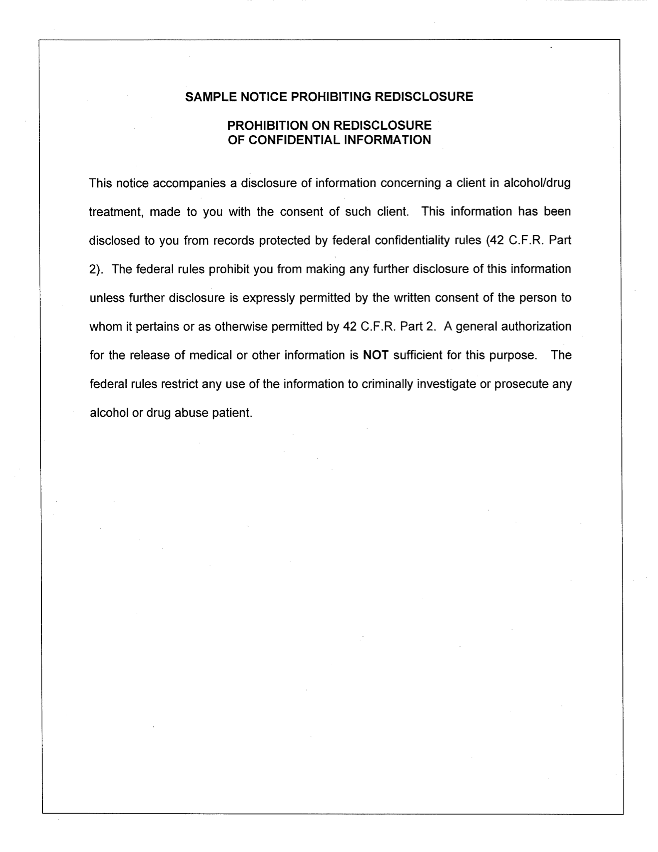
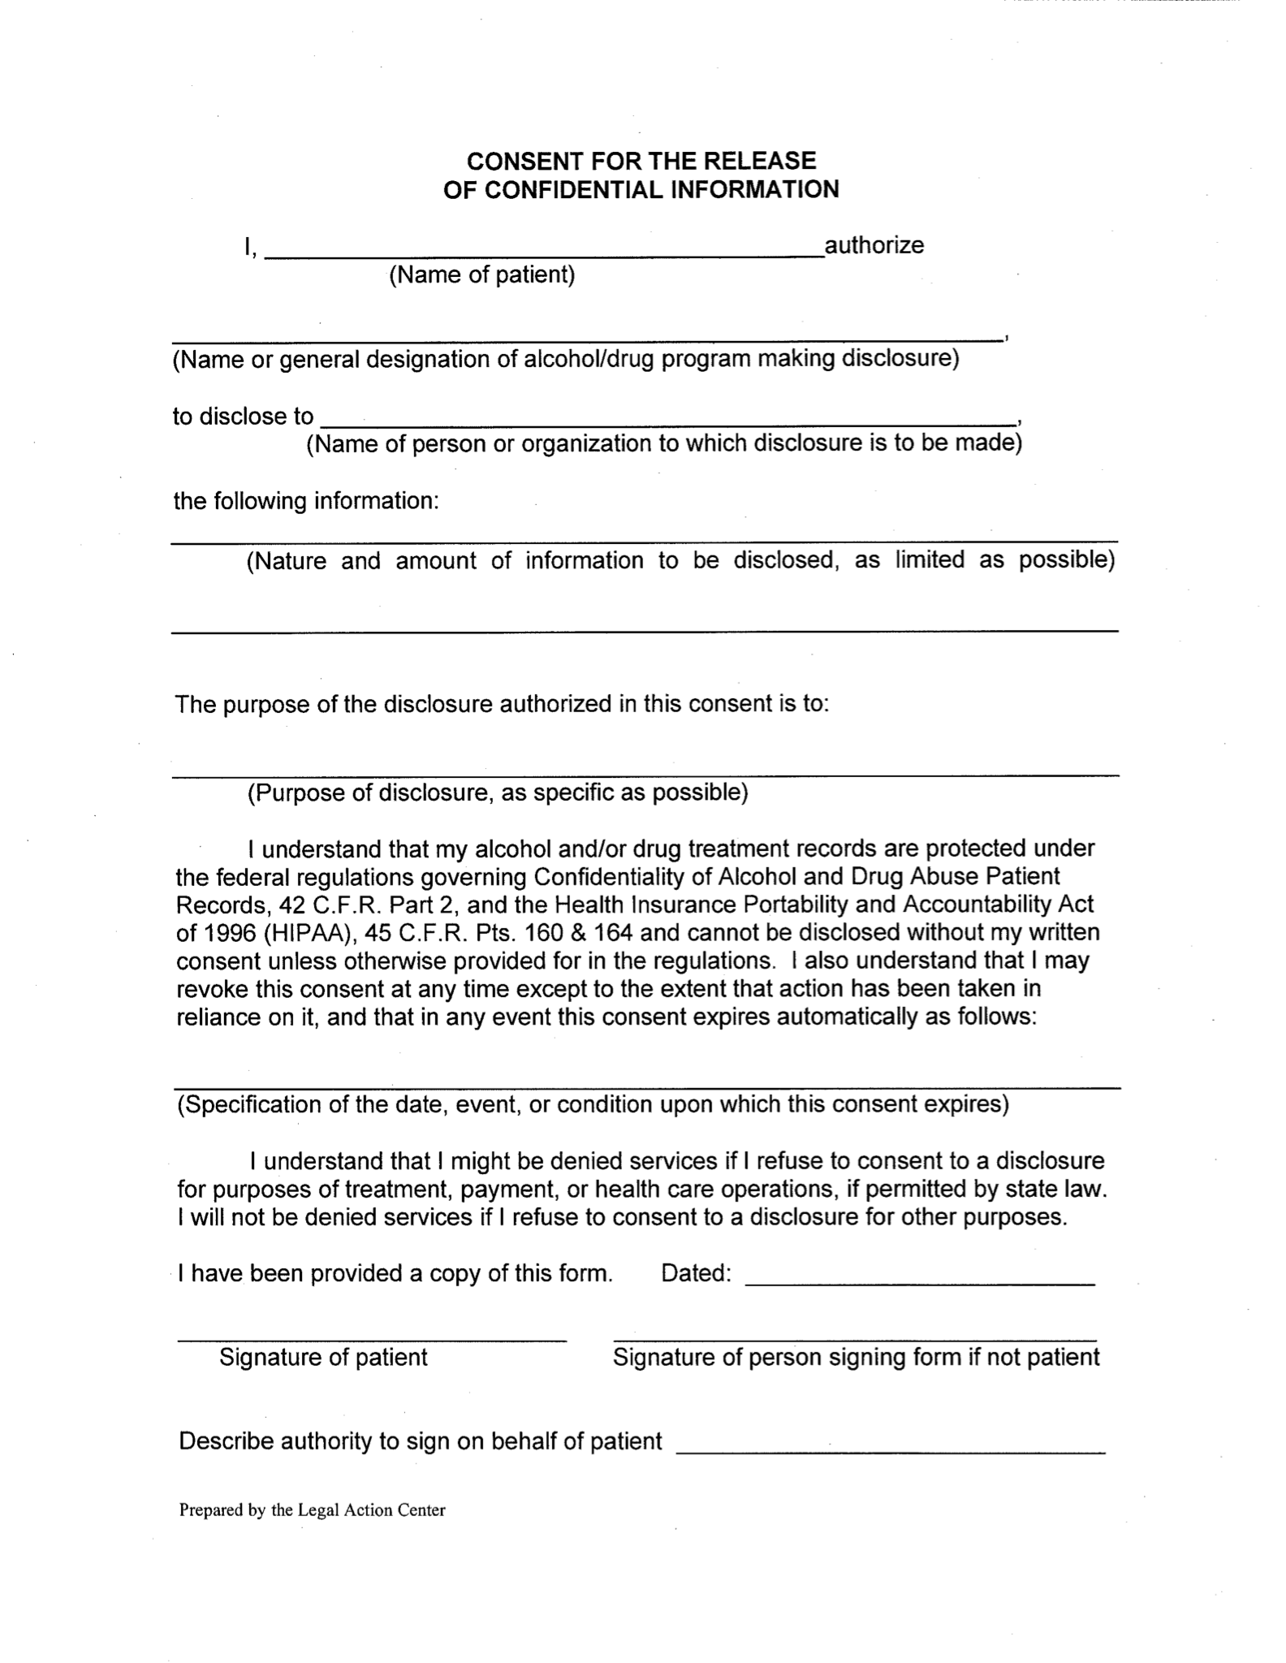

Appendix D

COMMONWEALTH OF MASSACHUSETTS
EXECUTIVE OFFICE OF HEALTH AND HUMAN SERVICES

Department of Children and Families
600 Washington Street
Boston, MA 02111

DEVAL L. PATRICK
Governor
_
TIMOTHY P. MURRAY
Lieutenant Governor
_
JUDYANN BIGBY, M.D.
Secretary
_
ANGELO MCCLAIN
Commissioner

TO: Mandated Reporters, Community Partners and Other Stakeholders
RE: Change in DCF Screening Policy Related to Substance Exposed Newborns (SENs)
DATE: December 14, 2012

The Massachusetts Department of Children and Families (DCF) would like to inform you about a change in policy related to screening of reports involving Substance Exposed Newborns (SENs). This change is being implemented to better protect the vulnerable SEN population, while recognizing the need for medication assisted treatment during pregnancy for women who are dependent upon opioids or who have other medically diagnosed conditions requiring medication.

The change in DCF policy DOES NOT change the responsibility for mandated reporters to report a situation involving a SEN.

Summary of Policy Changes
Effective January 2, 2013, DCF may screen out a 51A report involving a Substance Exposed Newborn (SEN) if the only reported condition is maternal use of methadone, buprenorphine (Subutex), buprenorphine with naloxone (Suboxone) or another appropriately prescribed and used medication (such as psychotropic and narcotic prescription medications) as substance abuse or medical treatment resulting in a SEN, when:
the only substance affecting the newborn was one of the three (3) drugs described above or other appropriately prescribed and used medication;

DCF is able to verify with medical or other qualified providers that mother used the medication as part of substance abuse or medical treatment as authorized; and

there are no other concerns of child abuse and/or neglect as determined by any available information, including a review of DCF’s historical records.

DCF will continue to screen in and complete a response to all other 51A reports involving a SEN.
The Department, in partnership with the DPH Bureau of Substance Abuse Services (BSAS), has established a communication protocol with substance abuse treatment providers for verifying a mother’s treatment history and progress. Opiod treatment providers are being asked to work with mothers prior to delivery to obtain a signed release allowing DCF to speak with providers during the screening process. As required by the updated policy, without appropriate treatment verification, a 51A will be screened in.

DCF will also contact other medication prescribers during screening to verify that mother is using the medication appropriately, as prescribed and there are no other concerns regarding child abuse and/or neglect.

What does this mean for Mandated Reporters?
Mandated reporters should continue to report any situations involving a SEN to DCF. If possible, mandated reporters should include in the 51A report: the name and contact information for the mother’s medication assisted treatment provider and the prescriber(s) of other medications that may appear in the report of a urine or meconium screen.

For Further Information
Please contact Kim Bishop-Stevens, DCF Substance Abuse Manager, at 617-748-2049.

2012 Guidelines for Perinatal Care, 7th Ed. AAP, Elk Grove, IL, published by the American Academy of Pediatrics and the American College of Obstetrics and Gynecology (ACOG).

