Non-Commonwealth Employee User Pre-Registration

Go to https://ppsecuremail.state.ma.us/encrypt

- Enter your email address
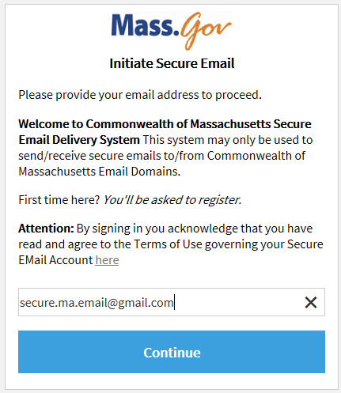

- Click continue – you will see the following screen 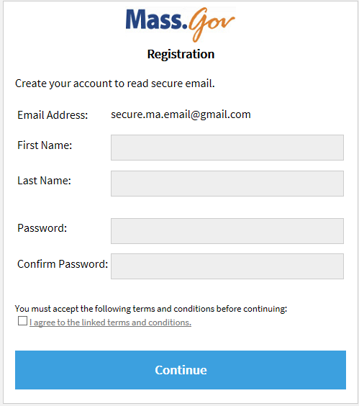

- Enter required information and accept terms and conditions

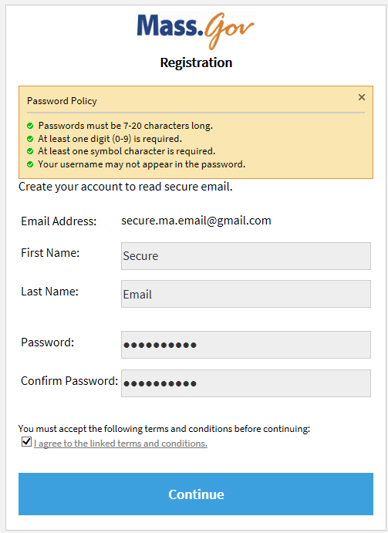

Click Continue

- You will receive the following notification that an email was sent to your account
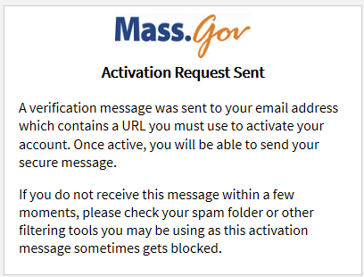
- Click on the link in the email

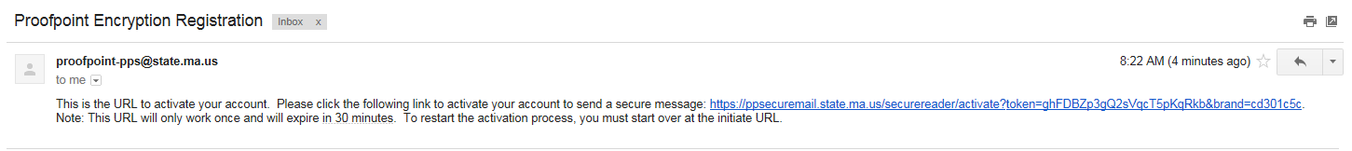
- It will bring you to the Account Activated Screen – click Continue
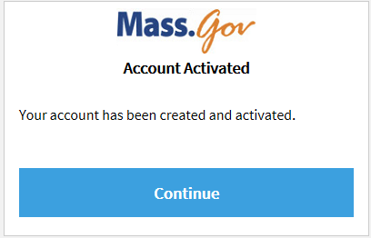
- It will bring you to the Compose Message Screen -

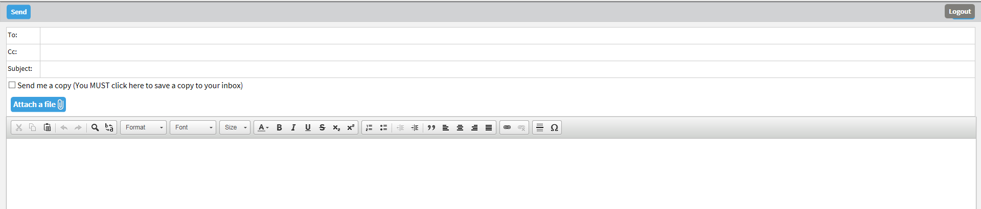
If you are completing this for the first time after 6/27/2017 and would like to send a Secure Message via the new Proofpoint Encryption please do.
Please note when composing a new message if you would like a copy sent to your inbox you MUST click on the box.
Reading a Secure Message

The user will receive a message that looks similar to the following.
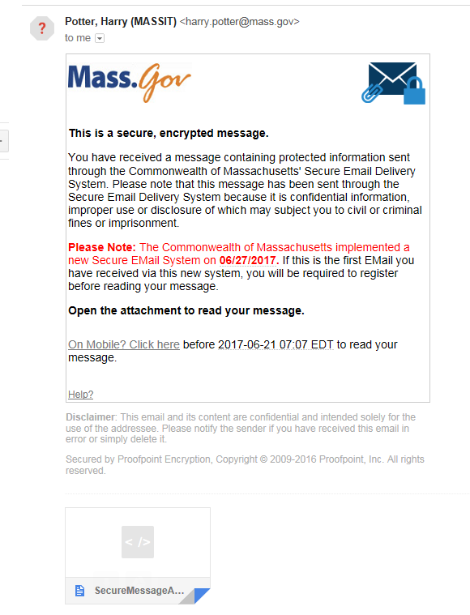
The user should open the attachment to read the message it will bring them to the following screen.
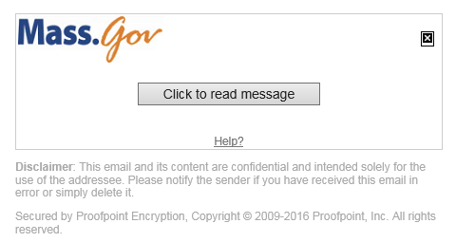

Click to read message – you will be required to login
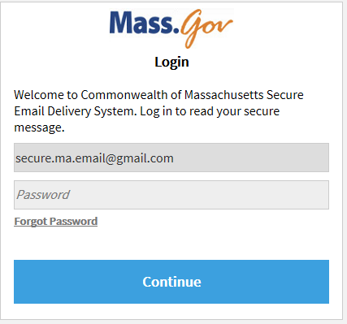

Once you have entered the proper credentials – you can read the message

To reply/reply all click either button
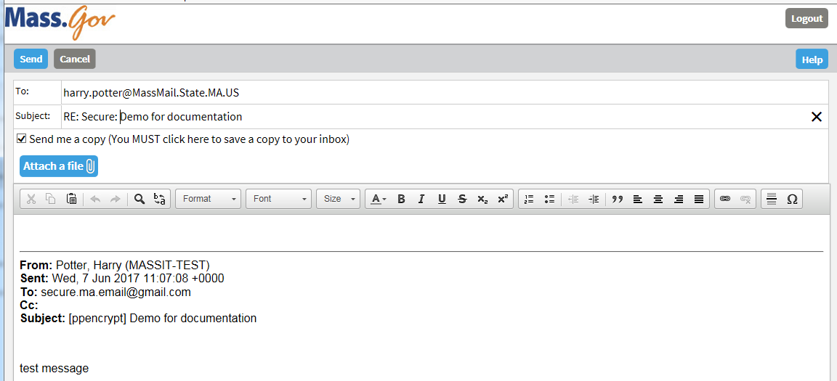

You can just type in your reply and click send or you may add an attachment as well.

To add an attachment click Attach a file, click add, chose your attachment
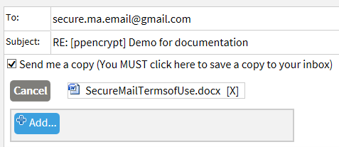

When you’re done with the message click send. Note: on replies you will automatically be sent a copy of the message unless you uncheck the box.

