INDOOR AIR QUALITY ASSESSMENT

Hadley Elementary School
24 Redington Street
Swampscott, MA



Prepared by:
The Massachusetts Department of Public Health
Bureau of Environmental Health
Indoor Air Quality Program
January 2013

Background/Introduction
At the request of Mr. Garrett Baker, Facilities Director, Swampscott Public Schools, the Massachusetts Department of Public Health (MDPH), Bureau of Environmental Health (BEH) conducted an indoor air quality (IAQ) assessment at the Hadley Elementary School (HES) located at 24 Redington Street, Swampscott, Massachusetts.
The request was originally prompted due to concerns associated with mold and general IAQ. The BEH/IAQ Program previously visited this building in 2002 and issued a report detailing conditions observed at that time. This report is available on the MDPH website (http://www.mass.gov/eohhs/docs/dph/environmental/iaq/2002/swampscott-swmphes.pdf). On November 15, 2012 a visit to conduct an IAQ assessment was made to the HES by Cory Holmes, Environmental Analyst/Regional Inspector for BEH’s IAQ Program. BEH/IAQ staff were accompanied by Mr. Baker during the assessment.
The school is a three-story red brick building with basement constructed in 1911. A three-story annex was added in 1915 connected to the original building by an enclosed corridor. The 1911 building contains general classrooms, computer room, library, teachers lounge, gymnasium/auditorium, main office, nurse’s station and art/music room. The annex contains general classrooms, kindergarten, occupational therapy room, cafeteria and offices.

Methods
Air tests for carbon monoxide, carbon dioxide, temperature and relative humidity were conducted with the TSI, Q-Trak, IAQ Monitor, Model 7565. Air tests for airborne particle matter with a diameter less than 2.5 micrometers were taken with the TSI, DUSTTRAK™ Aerosol Monitor, Model 8520. BEH/IAQ staff also performed visual inspection of building materials for water damage and/or microbial growth.

Results
The school houses kindergarten through fifth grades with a student population of approximately 280 and a staff of approximately 35 individuals. The tests were taken under normal operating conditions. Test results appear in Table 1.

Discussion

Ventilation
It can be seen from Table 1 that carbon dioxide levels were above 800 parts per million (ppm) in 19 of 32 areas surveyed, indicating a lack of air exchange in over half of the areas at the time of assessment, largely due to deactivated and/or obstructed mechanical ventilation equipment. Fresh air in classrooms throughout the school is supplied by unit ventilator (univent) systems (Pictures 1 and 2). A univent draws air from the outdoors through a fresh air intake located on the exterior wall of the building (Picture 3) and returns air through an air intake located at the base of the unit. Fresh and return air are mixed, filtered, heated and provided to classrooms through an air diffuser located in the top of the unit (Figure 1). As mentioned, univents were found deactivated throughout the building. As a result, there was no means to mechanically introduce fresh air in these classrooms at the time of assessment. Univents were also obstructed by items such as boxes, papers and books in some areas (Picture 4). In order to function as designed, univents must be activated and allowed to operate free of obstructions.
Note that some of the univents appear to be vintage equipment (i.e., over 20 years old). Function of equipment of this age is difficult to maintain, since compatible replacement parts are often unavailable. According to the American Society of Heating, Refrigeration and Air-Conditioning Engineers (ASHRAE), the service life for a unit heater, hot water or steam is 20 years, assuming routine maintenance of the equipment (ASHRAE, 1991). Despite attempts to maintain these units, the operational lifespan of the equipment has been exceeded. Maintaining the balance of fresh air to exhaust air will become more difficult as the equipment ages and as replacement parts become increasingly difficult to obtain.
Exhaust ventilation is provided by wall-mounted exhaust vents powered by rooftop motors (Pictures 5 and 6). A number of exhaust vents were not operating and some were found to be backdrafting (air was flowing out of them) during the assessment, indicating that they had either been deactivated or had mechanical problems. In addition, some exhaust vents were obstructed by furniture and other items (Pictures 7 and 8), which can impede airflow and reduce the effectiveness of the vent to exchange air. As with the univents, exhaust vents need to be activated to function as designed. Exhaust vents should also be free of debris to prevent re-aerosolization of these materials, particularly if backdrafting occurs when exhaust vents are not functioning as designed. Without adequate supply and exhaust ventilation, excess heat and environmental pollutants can build up and lead to indoor air/comfort complaints.
Fresh air to the gymnasium is provided by air-handling units (AHU) via wall-mounted vents. Air is returned to the AHUs via ducted vents. This system was operating at the time of assessment. The basement has three cafeterias, one of which had no supply or exhaust ventilation system.
To maximize air exchange, the MDPH recommends that both supply and exhaust ventilation operate continuously during periods of building occupancy. In order to have proper ventilation with a mechanical supply and exhaust system, the systems must be balanced to provide an adequate amount of fresh air to the interior of a room while removing stale air from the room. The date of the last balancing of these systems was not available at the time of the assessment.
Minimum design ventilation rates are mandated by the Massachusetts State Building Code (MSBC). Until 2011, the minimum ventilation rate in Massachusetts was higher for both occupied office spaces and general classrooms, with similar requirements for other occupied spaces (BOCA, 1993). The current version of the MSBC, promulgated in 2011 by the State Board of Building Regulations and Standards (SBBRS), adopted the 2009 International Mechanical Code (IMC) to set minimum ventilation rates. Please note that the MSBC is a minimum standard that is not health-based. At lower rates of cubic feet per minute (cfm) per occupant of fresh air, carbon dioxide levels would be expected to rise significantly. A ventilation rate of 20 cfm per occupant of fresh air provides optimal air exchange resulting in carbon dioxide levels at or below 800 ppm in the indoor environment in each area measured. MDPH recommends that carbon dioxide levels be maintained at 800 ppm or below. This is because most environmental and occupational health scientists involved with research on IAQ and health effects have documented significant increases in indoor air quality complaints and/or health effects when carbon dioxide levels rise above the MDPH guidelines of 800 ppm for schools, office buildings and other occupied spaces (Sundell et al., 2011). The ventilation must be on at all times that the room is occupied. Providing adequate fresh air ventilation with open windows and maintaining the temperature in the comfort range during the cold weather season is impractical. Mechanical ventilation is usually required to provide adequate fresh air ventilation.
Carbon dioxide is not a problem in and of itself. It is used as an indicator of the adequacy of the fresh air ventilation. As carbon dioxide levels rise, it indicates that the ventilating system is malfunctioning or the design occupancy of the room is being exceeded. When this happens, a buildup of common indoor air pollutants can occur, leading to discomfort or health complaints. The Occupational Safety and Health Administration (OSHA) standard for carbon dioxide is 5,000 parts per million parts of air (ppm). Workers may be exposed to this level for 40 hours/week, based on a time-weighted average (OSHA, 1997).
The MDPH uses a guideline of 800 ppm for publicly occupied buildings. A guideline of 600 ppm or less is preferred in schools due to the fact that the majority of occupants are young and considered to be a more sensitive population in the evaluation of environmental health status. Inadequate ventilation and/or elevated temperatures are major causes of complaints such as respiratory, eye, nose and throat irritation, lethargy and headaches. For more information concerning carbon dioxide, consult Appendix A.
Temperature measurements ranged from 60°F to 78°F, which were below the MDPH recommended comfort range in a number of areas at the time of assessment (Table 1). The lowest reading of 60°F was in a classroom with open windows. The MDPH recommends that indoor air temperatures be maintained in a range of 70°F to 78°F in order to provide for the comfort of building occupants. In many cases concerning indoor air quality, fluctuations of temperature in occupied spaces are typically experienced, even in a building with an adequate fresh air supply. In addition, it is difficult to control temperature and maintain comfort without operating the ventilation equipment as designed (e.g., univents/exhaust vents deactivated/obstructed).
The relative humidity measured in the building ranged from 30 to 43 percent, which was below the MDPH recommended comfort range in the majority of areas (Table 1). The MDPH recommends a comfort range of 40 to 60 percent for indoor air relative humidity. Relative humidity levels in the building would be expected to drop during the winter months due to heating. The sensation of dryness and irritation is common in a low relative humidity environment. Low relative humidity is a very common problem during the heating season in the northeast part of the United States.

Microbial/Moisture Concerns
In order for building materials to support mold growth, a source of water exposure is necessary. Identification and elimination of the source of water moistening building materials is necessary to control mold growth. Water-damaged ceiling and wall plaster was observed in a number of areas, indicating roof leaks and/or water penetration through the building envelope. Mr. Baker reported that numerous attempts have been made over the past several years to repoint/reseal breaches to prevent further water penetration; evidence of this was evident along the exterior of the building and roof (Pictures 9 through 12).
Despite these attempts, chronic water penetration has resulted in staining and efflorescence on both interior and exterior walls, ceilings, and around window frames in a number of areas throughout the building (Pictures 13 through 15). Efflorescence is a characteristic sign of water damage but it is not mold growth. As moisture penetrates and works its way through mortar, brick or plaster, water-soluble compounds dissolve, creating a solution. As the solution moves to the surface of the material, the water evaporates, leaving behind white, powdery mineral deposits.
The US Environmental Protection Agency (US EPA) and the American Conference of Governmental Industrial Hygienists (ACGIH) recommend that porous materials be dried with fans and heating within 24 to 48 hours of becoming wet (US EPA, 2001; ACGIH, 1989). If not dried within this time frame, mold growth may occur. Once mold has colonized porous materials, they are difficult to clean and should be removed/discarded. Visible mold growth was observed on the surface of water-damaged paint on the top floor of the annex building (Pictures 16 and 17) and on the gasket of the refrigerator/freezer in the OT/PT room (Pictures 18 and 19).
Several exterior doors had damaged weather stripping and light could be seen penetrating through the spaces underneath the door from the outdoors (Picture 20). Spaces around exterior doors can serve as a source of water entry into the building, causing water damage and potentially leading to mold growth. In addition, these spaces can serve as pathways for insects, rodents and other pests into the building.

Other Indoor Air Evaluations
Indoor air quality can be negatively influenced by the presence of respiratory irritants, such as products of combustion. The process of combustion produces a number of pollutants. Common combustion emissions include carbon monoxide, carbon dioxide, water vapor, and smoke (fine airborne particle material). Of these materials, exposure to carbon monoxide and particulate matter with a diameter of 2.5 micrometers (μm) or less (PM2.5) can produce immediate, acute health effects upon exposure. To determine whether combustion products were present in the indoor environment, BEH/IAQ staff obtained measurements for carbon monoxide and PM2.5.

Carbon Monoxide
Carbon monoxide is a by-product of incomplete combustion of organic matter (e.g., gasoline, wood and tobacco). Exposure to carbon monoxide can produce immediate and acute health affects. Several air quality standards have been established to address carbon monoxide and prevent symptoms from exposure to these substances. The MDPH established a corrective action level concerning carbon monoxide in ice skating rinks that use fossil-fueled ice resurfacing equipment. If an operator of an indoor ice rink measures a carbon monoxide level over 30 ppm, taken 20 minutes after resurfacing within a rink, that operator must take actions to reduce carbon monoxide levels (MDPH, 1997).
The American Society of Heating Refrigeration and Air-Conditioning Engineers (ASHRAE) has adopted the National Ambient Air Quality Standards (NAAQS) as one set of criteria for assessing indoor air quality and monitoring of fresh air introduced by HVAC systems (ASHRAE, 1989). The NAAQS are standards established by the US EPA to protect the public health from six criteria pollutants, including carbon monoxide and particulate matter (US EPA, 2006). As recommended by ASHRAE, pollutant levels of fresh air introduced to a building should not exceed the NAAQS levels (ASHRAE, 1989). The NAAQS were adopted by reference in the Building Officials & Code Administrators (BOCA) National Mechanical Code of 1993 (BOCA, 1993), which is now an HVAC standard included in the Massachusetts State Building Code (SBBRS, 2011). According to the NAAQS, carbon monoxide levels in outdoor air should not exceed 9 ppm in an eight-hour average (US EPA, 2006).
Carbon monoxide should not be present in a typical, indoor environment. If it is present, indoor carbon monoxide levels should be less than or equal to outdoor levels. Outdoor carbon monoxide concentrations were non-detect (ND) at the time of assessment (Table 1). No measurable levels of carbon monoxide were detected inside the building during the assessment (Table 1).

Particulate Matter
The US EPA has established NAAQS limits for exposure to particulate matter. Particulate matter is airborne solids that can be irritating to the eyes, nose and throat. The NAAQS originally established exposure limits to particulate matter with a diameter of 10 μm or less (PM10). According to the NAAQS, PM10 levels should not exceed 150 micrograms per cubic meter (μg/m³) in a 24-hour average (US EPA, 2006). These standards were adopted by both ASHRAE and BOCA. Since the issuance of the ASHRAE standard and BOCA Code, US EPA established a more protective standard for fine airborne particles. This more stringent PM2.5 standard requires outdoor air particle levels be maintained below 35 μg/m³ over a 24-hour average (US EPA, 2006). Although both the ASHRAE standard and BOCA Code adopted the PM10 standard for evaluating air quality, MDPH uses the more protective PM2.5 standard for evaluating airborne particulate matter concentrations in the indoor environment.
Outdoor PM2.5 was measured at 6 μg/m³ (Table 1). PM2.5 levels measured indoors ranged from 1 to 8 μg/m³ (Table 1), which were below the NAAQS PM2.5 level of 35 μg/m³. Frequently, indoor air levels of particulates (including PM2.5) can be at higher levels than those measured outdoors. A number of mechanical devices and/or activities that occur indoors can generate particulate during normal operations. Sources of indoor airborne particulates may include but are not limited to particles generated during the operation of fan belts in the HVAC system, use of stoves and/or microwave ovens in kitchen areas; use of photocopiers, fax machines and computer printing devices; operation of an ordinary vacuum cleaner and heavy foot traffic indoors.

Volatile Organic Compounds
Indoor air concentrations can be greatly impacted by the use of products containing volatile organic compounds (VOCs). VOCs are carbon-containing substances that have the ability to evaporate at room temperature. Frequently, exposure to low levels of total VOCs (TVOCs) may produce eye, nose, throat and/or respiratory irritation in some sensitive individuals. For example, chemicals evaporating from a paint can stored at room temperature would most likely contain VOCs. In an effort to identify materials that can potentially increase VOC concentrations, BEH/IAQ staff examined classrooms for products that may contain these respiratory irritants.
Several classrooms contained dry erase boards and dry erase board markers. Materials such as permanent markers, dry erase markers and dry erase board cleaners may contain VOCs, such as methyl isobutyl ketone, n-butyl acetate and butyl-cellusolve (Sanford, 1999), which can be irritating to the eyes, nose and throat.

Other Conditions
Other conditions that can affect indoor air quality were observed during the assessment. In several classrooms, items were observed on the floor, windowsills, tabletops, counters, bookcases and desks. The large number of items stored in classrooms provides a source for dust to accumulate. These items (e.g., papers, folders, boxes) make it difficult for custodial staff to clean. Items should be relocated and/or cleaned periodically to avoid excessive dust build up.
In several areas of the building, BEH/IAQ staff observed missing/broken ceiling tiles and holes/breaches in walls (Pictures 21 and 22). These breaches (if opened into wall cavities) can provide pathways for drafts, dust, odors and particulates to migrate into occupied areas. In one case a ceiling tile was missing exposing fiberglass insulation, which can be a source of skin, eye and respiratory irritation (Picture 23).
A number of areas are provided with window-mounted or portable air conditioners (ACs). ACs are equipped with filters that should be cleaned as directed by the manufacturer or more frequently if necessary.
Finally, accumulated dust/debris and materials were observed in univents, on exhaust vents and on personal fans in classrooms (Pictures 24). This equipment should be cleaned periodically in order to prevent dust/debris from being aerosolized and distributed throughout the room.

Conclusions/Recommendations
It was reported to BEH/IAQ staff that plans to replace the HES in the future have been mentioned; however, even if this plan goes forward, a new school would not be available for several years. If the plan for a new school moves forward, the resources available to make repairs to the existing school may understandably be limited. As a result, the BEH IAQ program recommends a two-phase approach. The first consists of short-term measures to improve air quality and the second consists of long-term measures that will require planning and resources to adequately address the overall indoor air quality concerns, particularly if no new school is planned in the near future.

Short-Term Recommendations
- Operate all functional ventilation systems throughout the building (e.g., gymnasium, cafeteria, classrooms) continuously during periods of occupancy. Repair as needed.
- Consult with HVAC vendor to examine methods of providing mechanical ventilation to the basement cafeteria.
- Reactivate exhaust system. Ensure classroom exhaust vents are turned on at the start of school and are allowed to operate during occupancy.
- Remove all blockages from univents and exhaust vents to ensure adequate airflow.
- Use openable windows in conjunction with classroom univents and exhaust vents to facilitate air exchange until repairs that are more permanent can be made. Care should be taken to ensure windows are properly closed at night and weekends to avoid the freezing of pipes and potential flooding.
- For buildings in New England, periods of low relative humidity during the winter are often unavoidable. Therefore, scrupulous cleaning practices should be adopted to minimize common indoor air contaminants whose irritant effects can be enhanced when the relative humidity is low. To control dusts, a high efficiency particulate arrestance (HEPA) filter equipped vacuum cleaner in conjunction with wet wiping of all surfaces is recommended. Drinking water during the day can help ease some symptoms associated with a dry environment (throat and sinus irritation).
- Continue to repoint damaged mortar and seal any breaches/cracks along the building exterior to prevent water intrusion.
- Continue to make roof repairs as needed. Remove/replace any water-damaged ceiling tiles.
- Scrape and clean efflorescence and loose paint from ceiling/wall plaster and brick, particulary in the top floor hallway of the annex building (Pictures 16 and 17). Remove water-damaged wood in closet of classroom 201.
- Install weather-stripping around exterior doors to prevent drafts, water penetration and pest entry. Ensure tightness by monitoring for light.
- Clean accumulated dust and debris periodically from the interior of univents, exhaust vents and blades of personal fans.
- Replace missing/broken ceiling tiles and seal any open holes/breaches in interior walls to prevent the migration of drafts, odors, particulates from the ceiling plenum/wall cavities into occupied areas.
- Relocate or consider reducing the amount of materials stored in classrooms to allow for more thorough cleaning of classrooms. Clean items regularly with a wet cloth or sponge to prevent excessive dust build-up.
- Clean/change filters for univents, AHUs and ACs as per the manufactures recommendations (typically 2-4 times/yr) or more frequently if needed.
- Consider adopting the US EPA (2000) document, “Tools for Schools”, as an instrument for maintaining a good indoor air quality environment in the building. This document is available at: http://www.epa.gov/iaq/schools/index.html.
- Refer to resource manual and other related indoor air quality documents located on the MDPH’s website for further building-wide evaluations and advice on maintaining public buildings. These documents are available at: http://mass.gov/dph/iaq.

Long-Term Recommendations
- Based on the age, physical deterioration and availability of parts, the BEH recommends that an HVAC engineering firm evaluate options for providing adequate ventilation building-wide. Such an evaluation is necessary to determine the operability and feasibility of repairing/replacing the equipment.
- Consider consulting with an architect, masonry firm or general contractor regarding the integrity of the building envelope, primarily concerning water penetration through the roof and exterior walls.
- Continue to have exterior brick/foundation re-pointed and waterproofed to prevent further water intrusion. Make repairs to water-damaged interior plaster/building components.
- Consider a long-term plan to replace windows (where needed) to prevent air/moisture infiltration.
- Consider replacement of all roof surfaces in the original building, connector and annex.

References
ACGIH. 1989. Guidelines for the Assessment of Bioaerosols in the Indoor Environment. American Conference of Governmental Industrial Hygienists, Cincinnati, OH.
ASHRAE. 1989. Ventilation for Acceptable Indoor Air Quality. American Society of Heating, Refrigeration and Air Conditioning Engineers. ANSI/ASHRAE 62-1989.
ASHRAE. 1991. ASHRAE Applications Handbook, Chapter 33 “Owning and Operating Costs”. American Society of Heating, Refrigeration and Air Conditioning Engineers, Atlanta, GA.
BOCA. 1993. The BOCA National Mechanical Code/1993. 8th ed. Building Officials and Code Administrators International, Inc., Country Club Hill, IL.
MDPH. 1997. Requirements to Maintain Air Quality in Indoor Skating Rinks (State Sanitary Code, Chapter XI). 105 CMR 675.000. Massachusetts Department of Public Health, Boston, MA.
OSHA. 1997. Limits for Air Contaminants. Occupational Safety and Health Administration. Code of Federal Regulations. 29 C.F.R 1910.1000 Table Z-1-A.
Sanford. 1999. Material Safety Data Sheet (MSDS No: 198-17). Expo® Dry Erase Markers Bullet, Chisel, and Ultra Fine Tip. Sanford Corporation. Bellwood, IL.
SBBRS. 2011. Mechanical Ventilation. State Board of Building Regulations and Standards. Code of Massachusetts Regulations, 8th edition. 780 CMR 1209.0
Sundell, J., H. Levin, W. W. Nazaroff, W. S. Cain, W. J. Fisk, D. T. Grimsrud, F. Gyntelberg, Y. Li, A. K. Persily, A. C. Pickering, J. M. Samet, J. D. Spengler, S. T. Taylor, and C. J. Weschler. 2011. Ventilation rates and health: multidisciplinary review of the scientific literature. Indoor Air, Volume 21: pp 191–204.
US EPA. 2000. Tools for Schools. Office of Air and Radiation, Office of Radiation and Indoor Air, Indoor Environments Division (6609J). EPA 402-K-95-001, Second Edition. http://www.epa.gov/iaq/schools/actionkit.html
US EPA. 2001. Mold Remediation in Schools and Commercial Buildings. US Environmental Protection Agency, Office of Air and Radiation, Indoor Environments Division, Washington, D.C. EPA 402-K-01-001. March 2001.
US EPA. 2006. National Ambient Air Quality Standards (NAAQS). US Environmental Protection Agency, Office of Air Quality Planning and Standards, Washington, DC. http://www.epa.gov/air/criteria.html
Picture 1

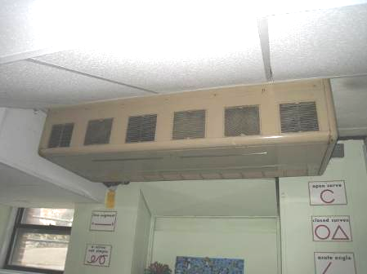

Vintage ceiling-mounted univent

Picture 2

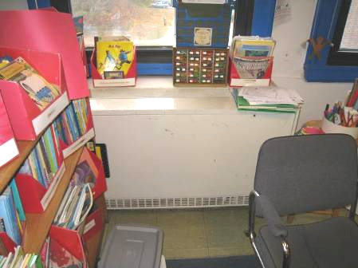

Typical classroom univent

Picture 3

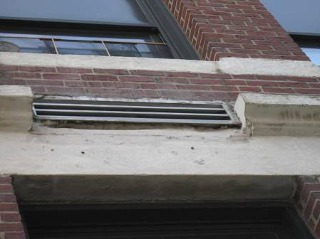

Univent fresh air intake

Picture 4

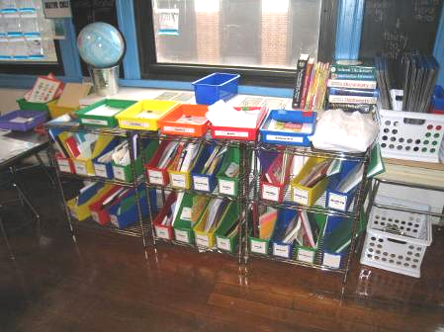

Univent (arrow) obstructed by classroom materials

Picture 5

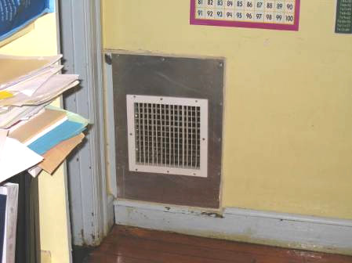

Wall-mounted exhaust vent

Picture 6

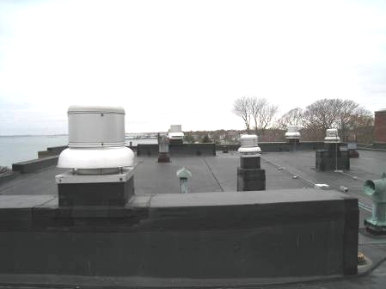

Rooftop exhaust motors

Picture 7

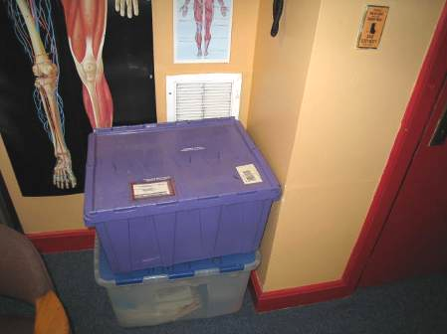

Wall-mounted exhaust vent (arrow) partially obstructed

Picture 8

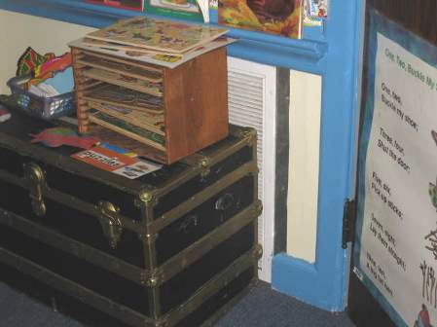

Wall-mounted exhaust vent (arrow) partially obstructed

Picture 9

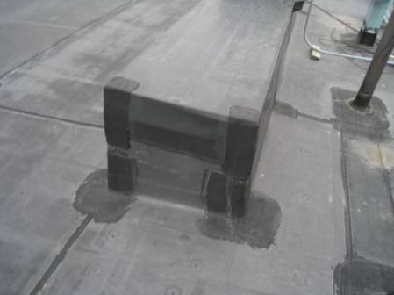

Roof patches

Picture 10

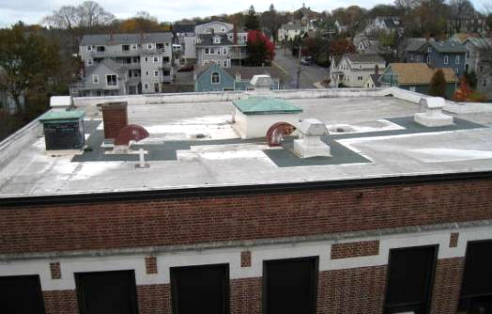

Patched roof areas (dark portions)

Picture 11

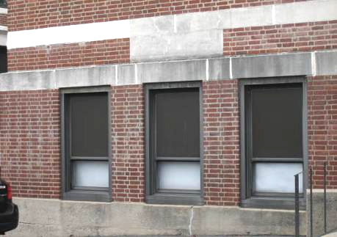

Exterior areas repointed/resealed to prevent water penetration
(indicated by light coloring)

Picture 12

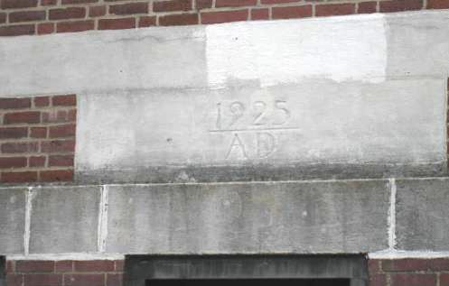

Exterior areas repointed/resealed to prevent water penetration
(indicated by light coloring)

Picture 13

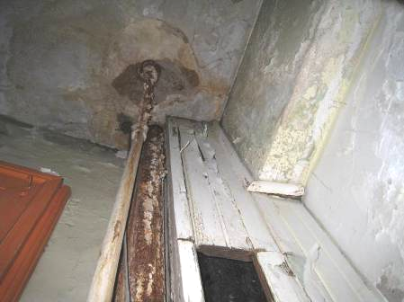

Water-damaged ceiling, walls, and wood in classroom 201 closet

Picture 14

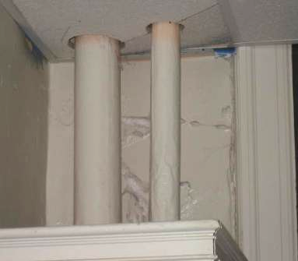

Efflorescence and peeling paint

Picture 15

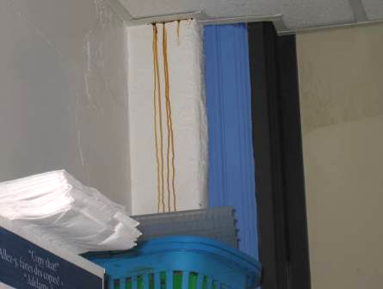

Staining of walls, evidence of water penetration

Picture 16

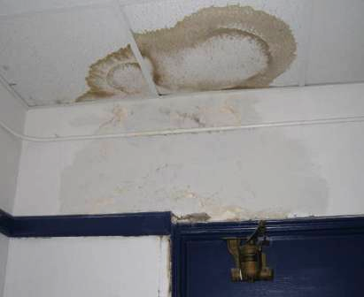

Water-damaged building materials on top floor of annex building

Picture 17

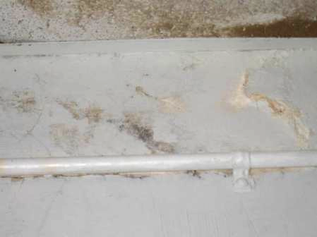

Close-up of visible mold growth (dark staining) from preceding picture on the surface of water-damaged paint in top floor of annex building

Picture 18

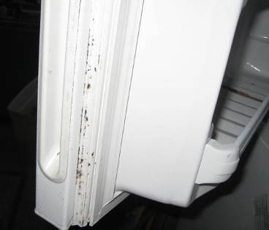

Mold growth on gasket of freezer in OT/PT room

Picture 19

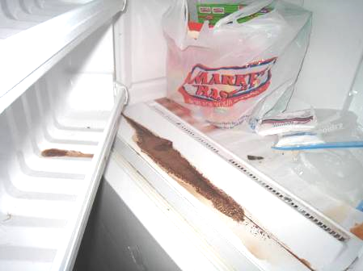

Mold growth and spilled food/residue in freezer in OT/PT room

Picture 20

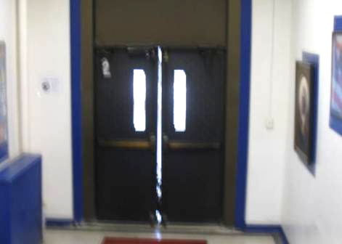

Light penetrating around exterior door

Picture 21

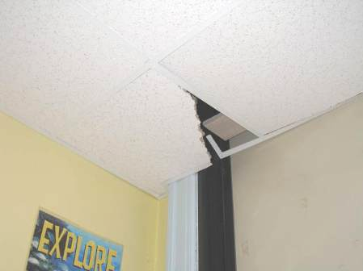

Broken ceiling tile

Picture 22

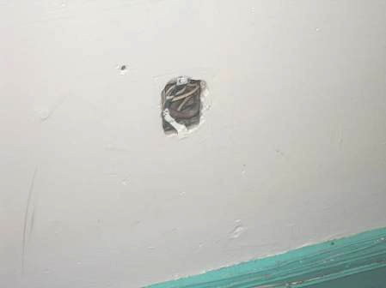

Missing outlet cover/hole in wall

Picture 23

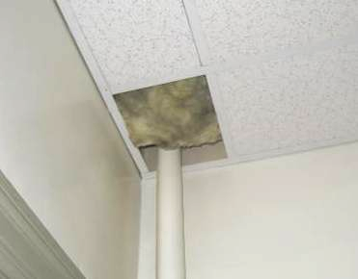

Missing ceiling tile exposing fiberglass insulation

Picture 24

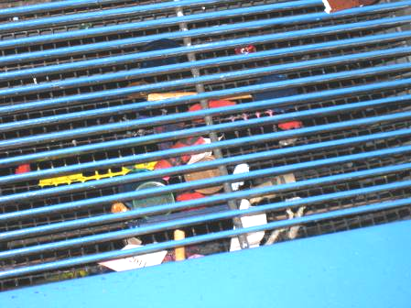

Various materials in univent air diffuser
Location | Carbon  Dioxide  (ppm) | Carbon Monoxide  (ppm) | Temp  (°F) | Relative  Humidity  (%) | PM2.5  (µg/m³) | Occupants  in Room | Windows  Openable | Ventilation |  | Remarks
 |  |  |  |  |  |  |  | Supply | Exhaust | Remarks
Background | 402 | ND | 49 | 40 | 6 |  |  |  |  | Cold, cloudy
101 | 685 | ND | 69 | 32 | 3 | 1 | Y | Y off | Y off
102 | 617 | ND | 69 | 33 | 4 | 0 | Y | Y
104-B nurse | 714 | ND | 68 | 34 | 6 | 3 | Y | N | N
105 | 974 | ND | 70 | 30 | 3 | 18 | Y | Y off | Y blocked | WD CT along windows
106 | 1060 | ND | 70 | 34 | 3 | 17 | Y | Y off | Y off | Exposed fiberglass WD plaster around CT, rusty/drip stains in closet
Gym | 750 | ND | 68 | 35 | 8 | 18 | Y | Y | Y | AHU
Copy area/gym storage | 658 | ND | 70 | 31 | 5 | 1 | Y | Y | Y off
Teachers lending library | 660 | ND | 68 | 31 | 4 | 0 | Y | Y | N | Carpet
201 | 1015 | ND | 68 | 34 | 6 | 15 | Y | Y off | Y | 1 damaged CT
201 closet |  |  |  |  |  |  |  |  |  | Current leak, WD CP , WP and wood
202 | 929 | ND | 69 | 35 | 3 | 19 | Y | Y | Y
204B library | 939 | ND | 69 | 34 | 5 | ~20 | Y | Y off | Y | Items on UV, carpet, 2 MT
205 | 802 | ND | 70 | 33 | 5 | 17 | Y | Y off | Y off | Efflorescence, peeling paint in closet/storage area
206 | 972 | ND | 69 | 35 | 3 | 18 | Y | Y | Y off | Fiberglass insulation, CT, peeling paint in closet
301 | 1223 | ND | 78 | 31 | 3 | 21 | Y | Y | Y | WD CT corners, periodic leaks
302 | 1070 | ND | 70 | 34 | 3 | 16 | Y | Y | Y | Active leaks above windows, WD CTs, UV return obstructed, carpet
302 closet |  |  |  |  |  |  |  |  |  | WD CT and paper
304 computer lab | 898 | ND | 70 | 33 | 3 | 0 | Y | Y off | Y off | Exhaust- backdrafting, 2 WD CT, air conditioner, WD wood stained, occupants at lunch
305B | 552 | ND | 68 | 31 | 1 | 0 | Y | Y off | Y off | Broken CT
306 | 1263 | ND | 68 | 42 | 2 | 21 | Y | Y off | Y off | Accumulated items
307 | 643 | ND | 68 | 30 | 2 | 1 | Y | Y | Y off | 4 occupants gone 15 minutes
Basement Cafeteria | 1188 | ND | 66 | 43 | 8 | ~35 | Y | N | N
Back cafeteria | 907 | ND | 66 | 38 | 7 | ~40 | Y | Y off | Y off
Front Cafeteria | 1100 | ND | 68 | 40 | 4 | ~50 | Y | Y | Y off | Noise from UV
Annex Building
3rd floor hallway |  |  |  |  |  |  |  |  |  | WD CT and WP, visible mold on paint-recommended cleaning
Gargan and Sheehan | 900 | ND | 66 | 37 | 4 | 0 | Y | N | N
Clain | 970 | ND | 60 | 37 | 8 | 21 | Y open | Y off | Y off blocked
Counselor’s office | 825 | ND | 67 | 38 | 2 | 1 | Y | N | N
Speech | 979 | ND | 66 | 39 | 3 | 2 | Y | Y | Y
Science room | 577 | ND | 67 | 34 | 2 | 0 | Y | Y off | Y partially blocked | 2 Air conditioners
Wheeler | 676 | ND | 69 | 34 | 3 | 4 | Y | Y off | Y off | UV blocked by file cabinet
Sanchez/Yasi | 857 | ND | 70 | 32 | 4 | 19 | Y open | Y off | Y off | UV blocked by bookcases, items
Music | 534 | ND | 67 | 32 | 3 | 0 | Y | Y off | Y off | Air conditioner
402 | 493 | ND | 68 | 33 | 2 | 0 | Y | N | N | Efflorescence/peeling paint
403 B OT/PT | 532 | ND | 67 | 30 | 2 | 0 | Y | Y off | Y | WD/MT, mold in freezer/fridge gaskets

The service life is the median time during which a particular system or component of …[an HVAC]… system remains in its original service application and then is replaced. Replacement may occur for any reason, including, but not limited to, failure, general obsolescence, reduced reliability, excessive maintenance cost, and changed system requirements due to such influences as building characteristics or energy prices (ASHRAE, 1991).

