Commonwealth of Massachusetts
Homeowner Assistance Fund (HAF)

Annual Report
November 2024

Table of Contents
Executive Summary 2
Community Engagement and Outreach 3
Performance Goals 4
Methods and Targeting 6
Best Practices and Coordination 7

Executive Summary
On March 11, 2021, the American Rescue Plan Act of 2021, H.R. 1319 (ARPA) became law. Section 3206 created the federal Homeowner Assistance Fund (HAF) to be administered by the U.S. Department of Treasury. HAF was established to help mitigate financial hardships associated with the COVID-19 pandemic by providing appropriated funds to eligible entities for the purpose of preventing homeowner mortgage delinquencies, defaults, foreclosures, loss of utilities or home energy services, and displacements of homeowners experiencing financial hardship after January 21, 2020. The Treasury provided a website announcement, including a Notice of Funds Request, on April 14, 2021 (and amended on August 2, 2021), publicizing the Housing Assistance Fund Guidance.
The Massachusetts HAF Program was administered by the Massachusetts Housing Partnership (MHP) and the Massachusetts Housing Finance Agency (MassHousing), in collaboration with the Massachusetts Executive Office for Administration and Finance (A&F), the Massachusetts Executive Office of Housing and Livable Communities (EOHLC), and the Massachusetts Division of Banks (the Division).
Homeowners were eligible to receive amounts assistance under the HAF if they experienced a COVID related financial hardship after January 21, 2020, had income equal to or less than 150% of the area median income (AMI) or 100% of the median income for the United States, whichever is greater, and were at least three payments delinquent on their mortgage. Financial assistance was provided to a homeowner only for qualified expenses related to the homeowner’s primary residence. Funds were provided to an eligible homeowner’s mortgage servicing company (the company that collects their mortgage payments) in order to apply it to the housing loan, and third-party payees for delinquent property charges.
Massachusetts implemented a $50,000 award cap per household, effective September 1, 2022, and participated in the P-Program (Loss Mitigation with State Contribution Program).
Entities participating in the HAF program were required to submit annual reports with information on the progress of their HAF program(s), including background information, outreach expenditures, performance on goals laid out in the HAF Participant Plan, and coordination efforts with community-based organizations, housing agencies, and servicers.
The Commonwealth stopped accepting applications on June 30, 2023, and final program awards have been distributed, thus concluding the program. Regardless of the program closure, Massachusetts continues to maintain a public website for HAF, which includes housing related resources for homeowners who are having difficulty paying their mortgage, as well as mental health resources.

Community Engagement and Outreach
The Commonwealth developed the Massachusetts HAF (MassHAF) Community Outreach Support Program to build awareness of the HAF fund at the local, neighborhood level and provide information regarding eligibility and program details. MassHAF focused its outreach on communities where homeowners are at high risk for foreclosure and for communities less likely to be reached with traditional advertising.
Massachusetts HAF began advertising and marketing efforts in January of 2022. There were two main components to the outreach strategy: an advertising campaign and a grant program to community-based organizations (CBOs) to promote HAF at the local and neighborhood level. Through September 2024, the total amount spent on outreach was $499,950, including 16 grants of up to $25,000 each to CBOs across the Commonwealth.
Grant recipients performed activities to raise awareness among homeowners in their service area about MassHAF and encourage homeowners who may be eligible to visit massmortgagehelp.org, and if necessary, refer them to the Housing Counseling Agency (HCA) for application assistance.
MassHousing and Massachusetts Housing Partnership (MHP) worked with more than 30 community organizations and providers, such as Citizens' Housing and Planning Association (CHAPA), Massachusetts Association of Community Development Corporations (MACDC), NeighborWorks Housing Solutions (NHS), Massachusetts Affordable Housing Alliance (MAHA), Way Finders, Massachusetts Communities Action Network (MCAN), Boston Home Center (City of Boston), Housing Assistance Corporation, Greater Boston Legal Services (GBLS), and others. Additionally, Massachusetts Housing Partnership (MHP) conducted outreach via a monthly newsletter that is distributed to over 400 housing organizations.
MassHAF did not have any significant difficulties in executing the outreach plan and has robust analytics showing measurable engagement with the target audience.

Performance Goals
The main goals for the MassHAF were to reduce mortgage delinquency among the targeted population and to disburse allocated funds timely and within Treasury guidelines.
Submitted goals that are identified in the MassHAF Participant Plan to measure program performance progress:
Title | Design Element | Status | Continue
Efficient Processing of Applications by Phase | Mortgage Reinstatement | Goal Met | X
Volume of Households Served | Mortgage Reinstatement | Goal Met | X
Serve All Households Eligible for the Program | Mortgage Reinstatement | Goal Met | X
Serve At Least 25% Socially Disadvantaged Households | Mortgage Reinstatement | Goal Met | X
Quick Response Time for Application Processing | Mortgage Reinstatement | Goal Met | X
Majority of Applications Processed in a Timely Manner | Mortgage Reinstatement | Goal Not Met | X
Distribute Funds Quickly Based on Demand | Mortgage Reinstatement | Goal Met | X
Fund at Least 60% of Households at or below 100% AMI | Mortgage Reinstatement | Goal Met | X
Category 2, Other Property Charges | Other measures | Goal Met | X
Category 2, Other Property Charges | Other measures | Goal Met | X
Serve Households by Gender Equitably | Mortgage Reinstatement | Goal Met | X
Serve Households by Race Equitably | Mortgage Reinstatement | Goal Met | X
Process Applications by Gender Equitably | Mortgage Reinstatement | Goal Met | X
Category 2, Other Property Charges | Other measures | Goal Met | X
Changes in foreclosure rate from pre-pandemic levels | Other measures | Goal Met | X
Serve Households by Gender in Amounts Paid Equitably | Mortgage Reinstatement | Goal Met | X
Process Applications by Race Equitably | Mortgage Reinstatement | Goal Met | X
Serve Households by Race in Amounts Paid Equitably | Mortgage Reinstatement | Goal Met | X

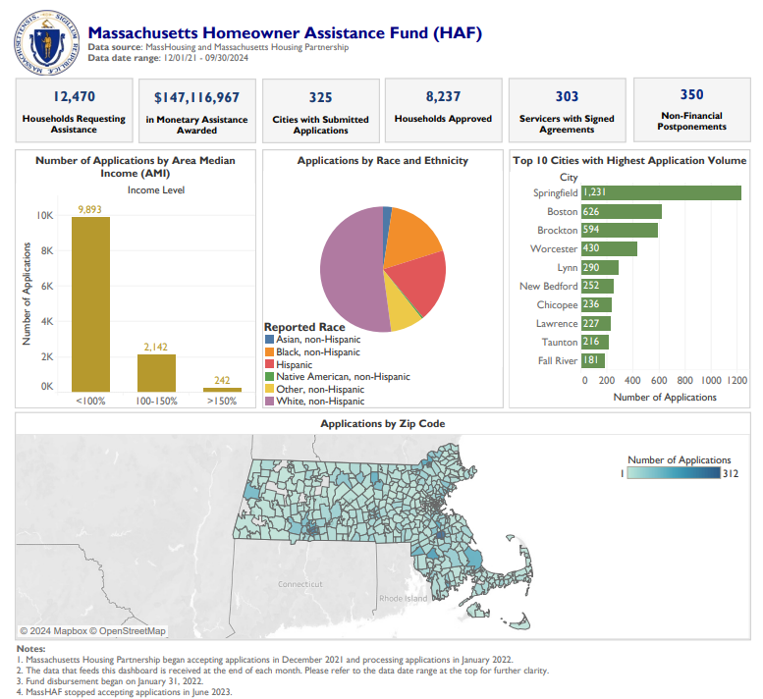
Annual metrics are comprised in an online dashboard that promotes a high-level view over the direction of HAF funding to municipalities and communities. Below includes the highlights from the most recent period of performance with program data through September 2024:

Methods and Targeting
HAF launched an advertising campaign in May 2022, which continued through the end of December 2022. The target markets were the 26 so-called Gateway Cities and the City of Boston, as well as communities surrounding these cities, which were categorized as disproportionately impacted by the pandemic.
The advertising campaign created ads in English, Cape Verdean Creole, Chinese, Haitian Creole, Khmer, Portuguese, Russian, Spanish, and Vietnamese. Ads were distributed via Google search, social media, radio, websites, public transit, TV, print, newspapers, video, and through several other channels such as posters and check cashing machines. Through September 2023, the digital components of the ad campaign have delivered more than 18 million impressions. Clicked ads resulted in more than 136,000 new unique HAF website users and a MassHAF video was viewed more than five million times.
The MassHAF Program continued to offer customer support via a call center until all applications were fully processed and all payments distributed.

Best Practices and Coordination
Massachusetts Housing Partnership (MHP) met with the Federal Housing Administration (FHA), Veteran Affairs (VA), and the U.S. Department of Agriculture (USDA) on individual cases. The USDA has a servicer agreement with MHP and is tailored to MHP's needs. MHP also met with Fannie Mae (Federal National Mortgage Association) on several occasions to discuss policy related to pausing foreclosures and to understand the loss mitigation waterfall. MassHAF staff previously met weekly with other states on the National Council of State Housing Agencies (NCSHA) meetings. MHP held a training conducted by the National Conference of State Legislatures (NCLS) for MA Housing Counseling Agencies on the loss mitigation waterfall and FHA loss mitigation plans.
Massachusetts Housing Partnership (MHP) had a dedicated servicer liaison team to handle any issues that arose for servicers and to recruit servicers for MassHAF participation. MHP staff hosted regular meetings with servicers and a monthly newsletter. MHP held weekly meetings and coordination calls with Mass Housing, Massachusetts’s other state housing finance agency, until the program ended. The MA Division of Banks initially reached out to servicers via email asking lenders overseen by the MA Division of Banks to participate in MassHAF. The Division followed up with two more letters to those who had not signed up in a timely manner. MassHAF also escalated to servicers any homeowner who had received a foreclosure notice/petition and worked with their team to pause the foreclosure. To date, MassHAF has successfully paused over 350 foreclosure sales. MassHAF staff has also worked closely with Attorney General Andrea Campbell’s office on constituent cases when a homeowner contacts them because the homeowner is having difficulty getting a response from their servicer on a foreclosure case.
Over the past year as the MassHAF program began to winddown, MHP conducted regular calls with servicers to discuss the status of outstanding cases and to quickly get answers on open items. They also worked closely with the Division of Banks to resolve major servicer issues and worked with the Attorney General’s Office to expedite resolutions on pending issues. MHP continues to maintain a centralized inbox to resolve servicer issues, including after program closure.

Homeowner Assistance Fund (HAF) | Mass.gov

