2019 Health Care Associated Infections: Acute Care Hospitals
Public Health Council
October 14, 2020
Christina Brandeburg, MPH, Epidemiologist
Katherine T. Fillo, Ph.D, MPH, RN-BC, Director of Clinical Quality Improvement
Eileen McHale, RN, BSN, Healthcare Associated Infection Coordinator

Introduction
Healthcare-associated infections (HAIs) are infections that patients acquire during the course of receiving treatment for other conditions within a healthcare setting.
HAIs are among the leading causes of preventable death in the United States, affecting 1 in 17 hospitalized patients, accounting for an estimated 1.7 million infections and an associated 98,000 deaths.*
The Massachusetts Department of Public Health (DPH) developed this data update as a component of the Statewide Infection Prevention and Control Program created pursuant to Chapter 58 of the Acts of 2006.
  - Massachusetts law provides DPH with the legal authority to conduct surveillance, and to investigate and control the spread of communicable and infectious diseases. (MGL c. 111,sections 6 & 7)
  - DPH implements this responsibility in hospitals through the hospital licensing regulation. (105 CMR 130.000)
  - Section 51H of chapter 111 of the Massachusetts General Laws authorizes the Department to collect HAI data and disseminate the information publicly to encourage quality improvement. (https://malegislature.gov/Laws/GeneralLaws/PartI/TitleXVI/Chapter111/Section51H)
*Haque M, Sartelli M, McKimm J, Abu Bakar M. Healthcare-associated Infections - an Overview. Infect Drug Resist. 2018;11:2321–2333.

Purpose
This HAI presentation is the 11th annual Public Health
Council update:
- It is an important component of larger efforts to reduce preventable infections in health care settings
- It presents an analysis of progress on infection prevention within Massachusetts acute care hospitals
- It is based upon work supported by state funds and the Centers for Disease Control and Prevention (CDC)
- It provides an overview of antibiotic resistance and stewardship activities

Methods
This data summary includes the following statewide measures for the 2019 calendar year (January 1, 2019 – December 31, 2019) as reported to the CDC’s National Healthcare Safety Network (NHSN).
The DPH required measures are consistent with the Centers for Medicare and Medicaid Services (CMS) quality reporting measures.
- Central line associated bloodstream infections (CLABSI) in intensive care units and wards (New this year)
- Catheter associated urinary tract infections (CAUTI) in intensive care units and wards (New this year)
- Specific surgical site infections (SSI)
- Specific facility wide laboratory identified events (LabID)
* National baseline data for each measure are based on a statistical risk model derived from 2015 national data
^ All data were extracted from NHSN on September 21, 2020

Measures
- Standardized Infection Ratio (SIR)
Standardized Infection Ratio (SIR) = Actual Number of Infections / Predicted Number of Infections
- Standard Utilization Ratio (SUR)
Standard Utilization Ratio = Number of Device Days / Predicted Number of Device Days
- If the SIR/SUR > 1.0, then more infections/device days were reported than predicted
- If the SIR/SUR = 1.0, then the number of infections/number of device days is equal to the predicted number
- If the SIR/SUR < 1.0, then fewer infections/device days were reported than predicted

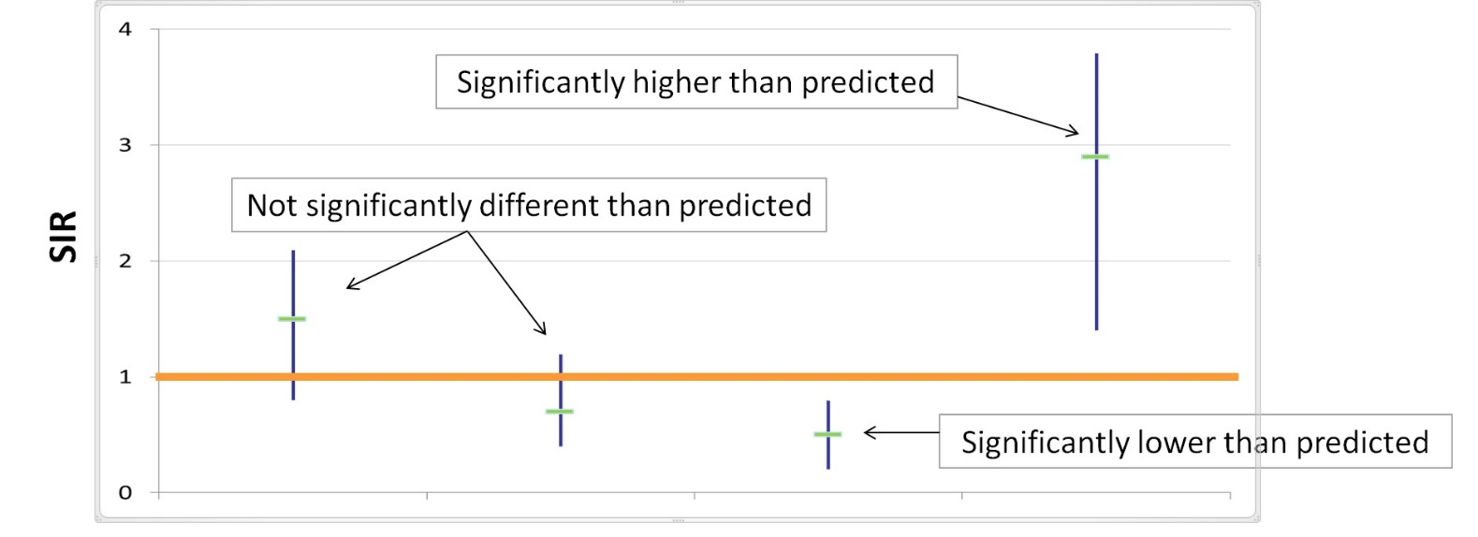
How to Interpret SIRs and 95% Confidence Intervals (CIs)

The green horizontal bar represents the SIR and the blue vertical bar represents the 95% confidence interval (CI). The 95% CI measures the probability that the true SIR falls between the two parameters.
- If the blue vertical bar crosses 1.0 (highlighted in orange), then the actual rate is not statistically significantly different from the predicted rate.
- If the blue vertical bar is completely above or below 1.0, then the actual is statistically significantly different from the predicted rate.

Central Line-Associated Bloodstream Infections (CLABSI): Standard Infection Ratio in Adult and Pediatric ICUs and Wards
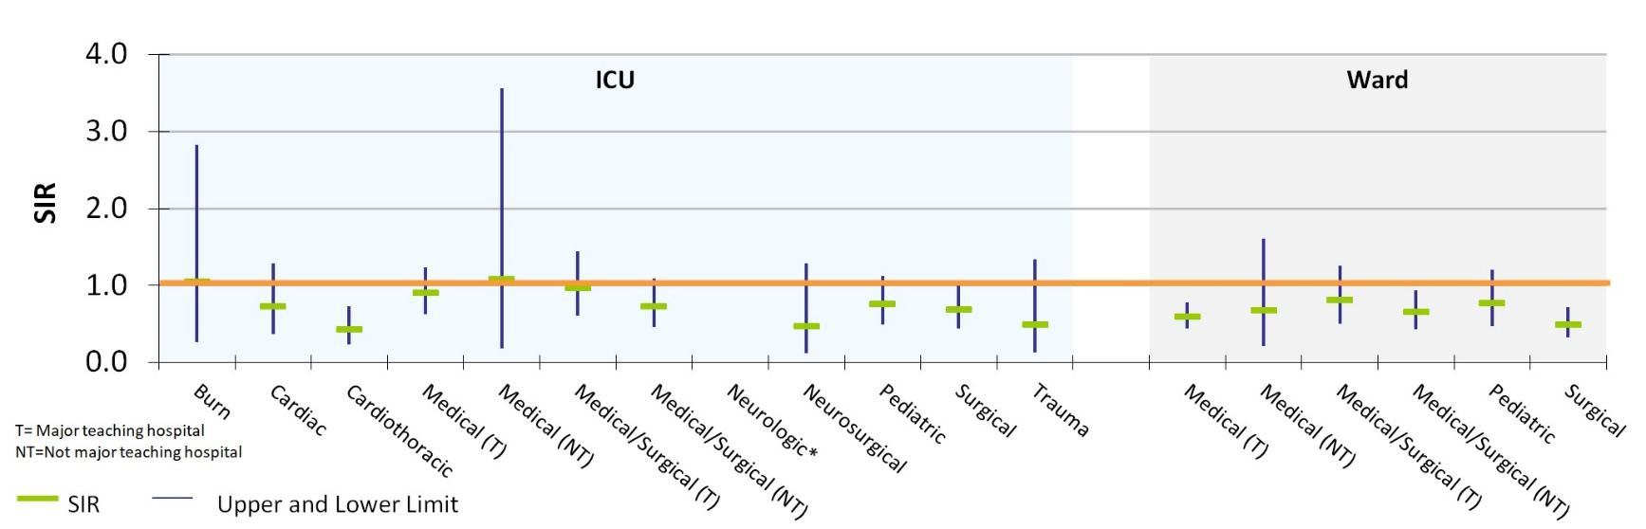
CLABSI Standard Infection Ratio (SIR) by Unit
Key:
Cardiothoracic ICU
Medical (T) Ward
Medical/Surgical (NT) Ward
Surgical Ward

Key Findings
Four unit types experienced a significantly lower number of infections than predicted, based on 2015 national aggregate data.
*SIRs and CIs are currently not calculated when the number of predicted infections is less than 0.5.

Central Line-Associated Bloodstream Infections (CLABSI): Standard Utilization Ratio in Adult and Pediatric ICUs and Wards
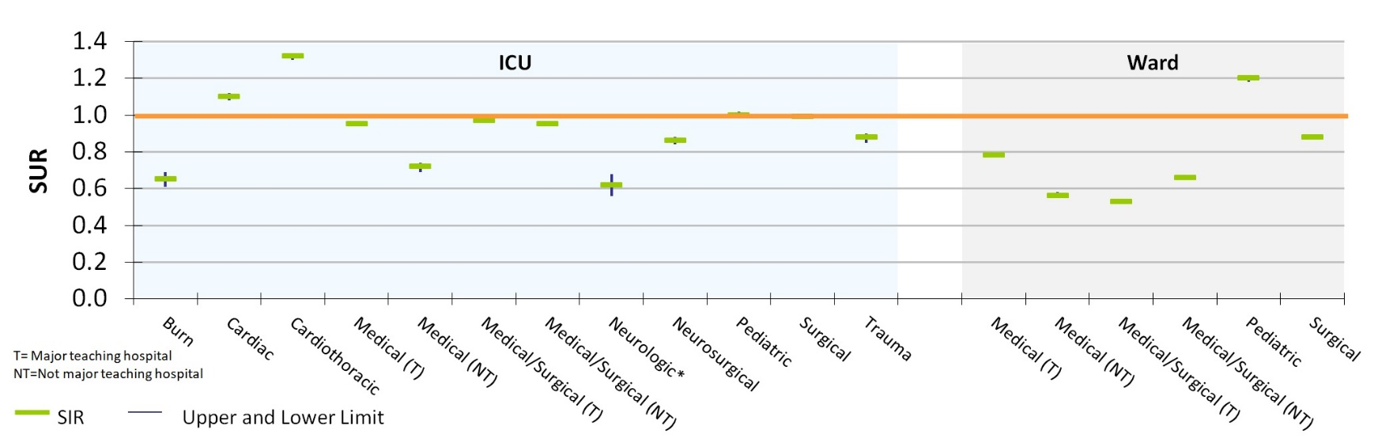
CLABSI Standard Utilization Ratio (SUR) by Unit

Key:
Cardiac ICU
Cardiothoracic ICU
Pediatric Ward

Key Findings
Three unit types experienced a significantly higher number of device days than predicted, based on 2015 national aggregate data.

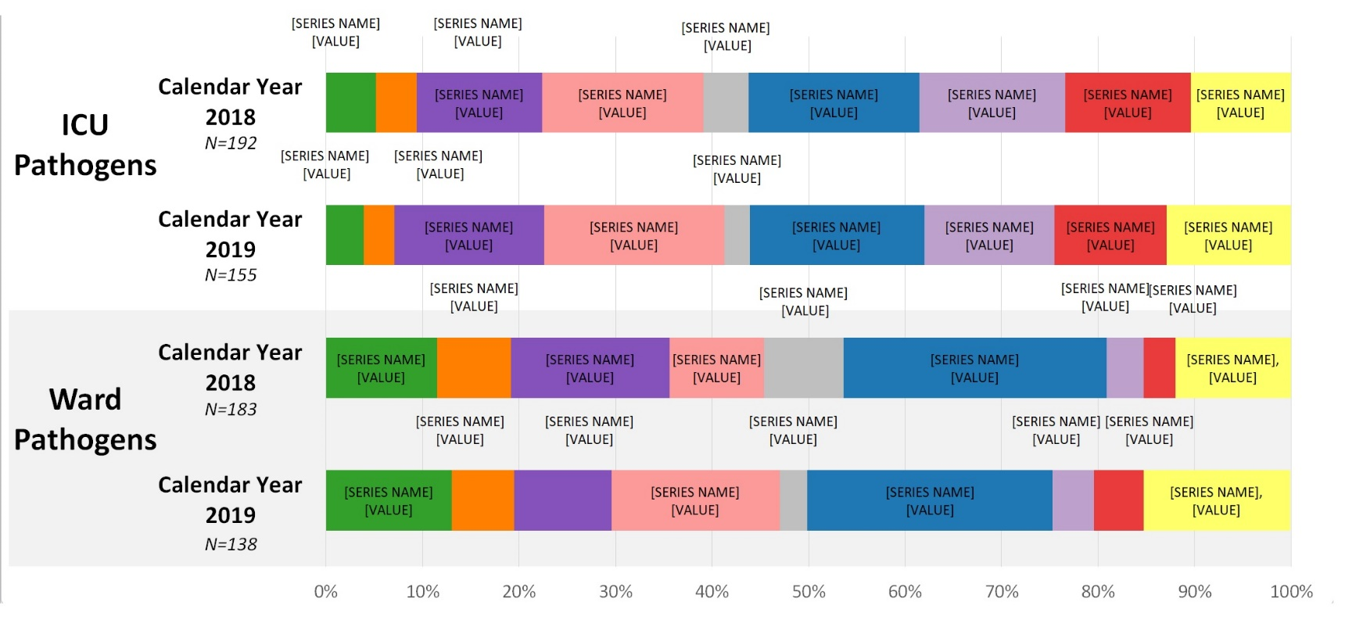
CLABSI Adult & Pediatric Pathogens for 2018 and 2019

Central Line-Associated Bloodstream Infections (CLABSI): Standard Infection Ratio in Neonatal ICUs
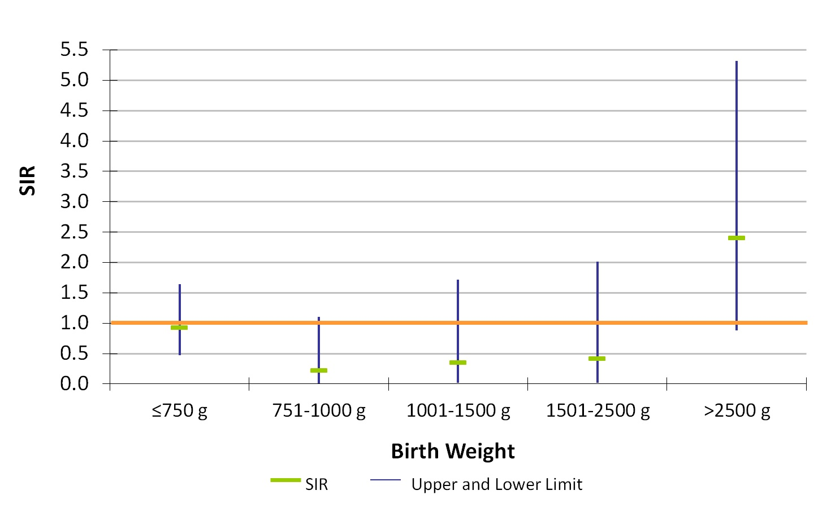
NICU CLABSI Standard Infection Ratio (SIR) by Birth Weight Category (grams)

Key Findings
There were no birthweight categories experiencing a significantly higher or lower number of infections than predicted, based on 2015 national aggregate data.
There were 18 CLABSIs reported in Neonatal ICUs in 2019.

Central Line-Associated Bloodstream Infections (CLABSI): Standard Utilization Ratio in Neonatal ICUs
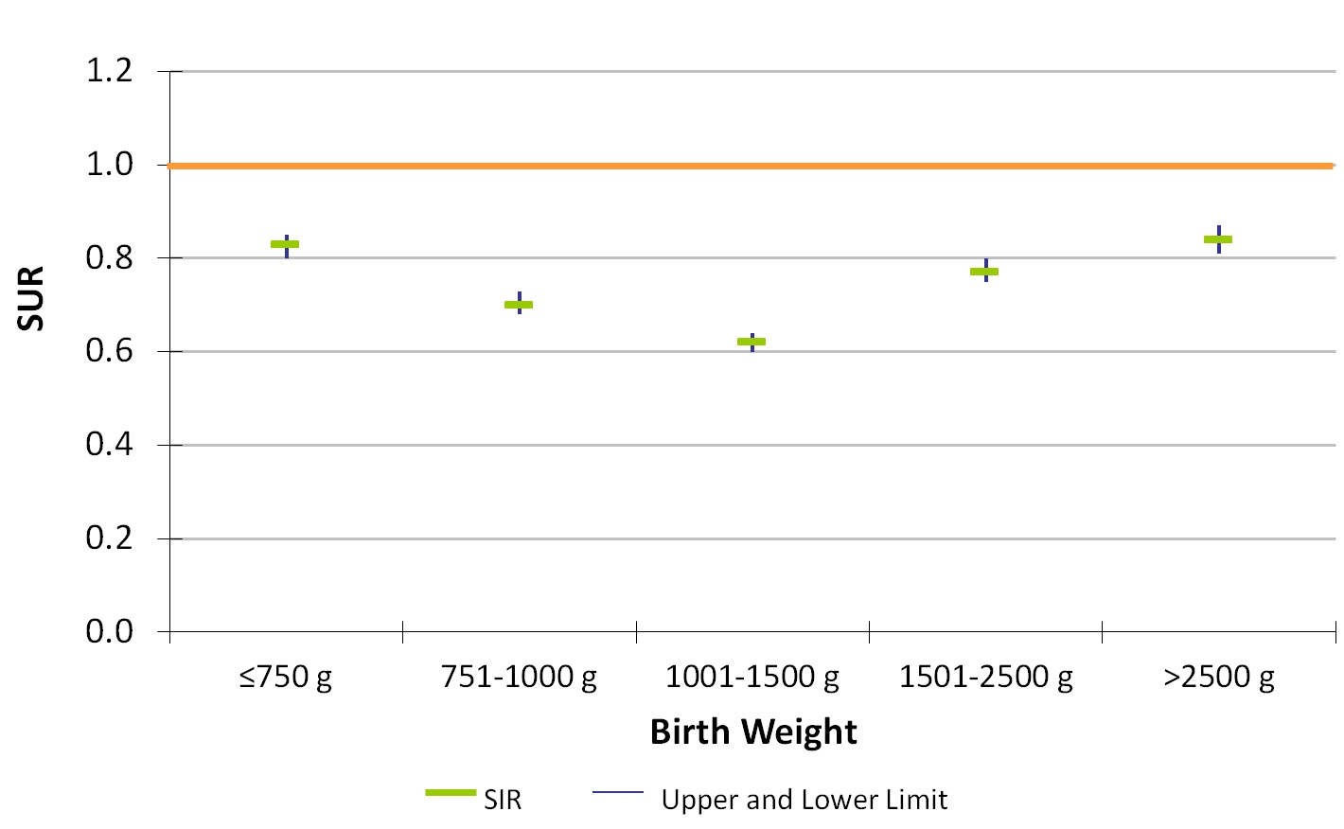
NICU CLABSI Standard Utilization Ratio (SUR) by Birth Weight Category (grams)

Key Findings
All five birthweight categories experienced a significantly lower number of device days than predicted, based on 2015 national aggregate data.

CLABSI NICU Pathogens for 2018 and 2019
Calendar Year 2018 (January 1, 2018 – December 31, 2018)
N=18
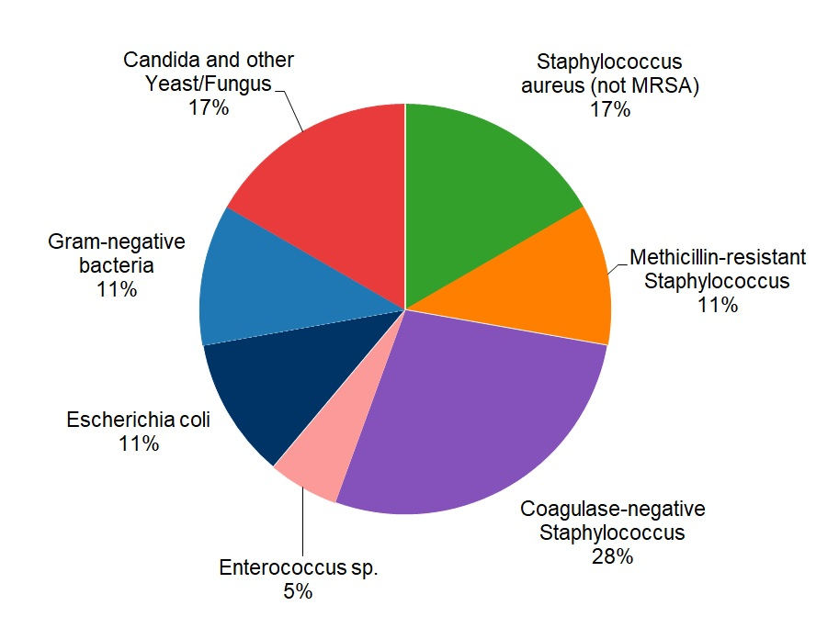

Calendar Year 2019 (January 1, 2019 – December 31, 2019)
N=18
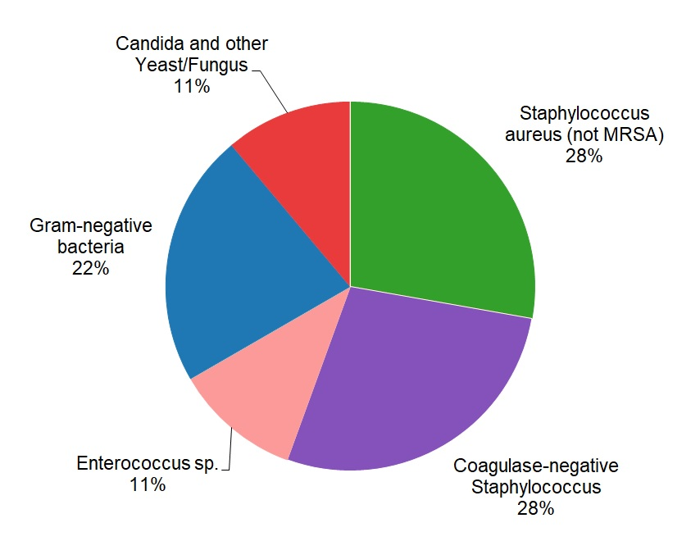
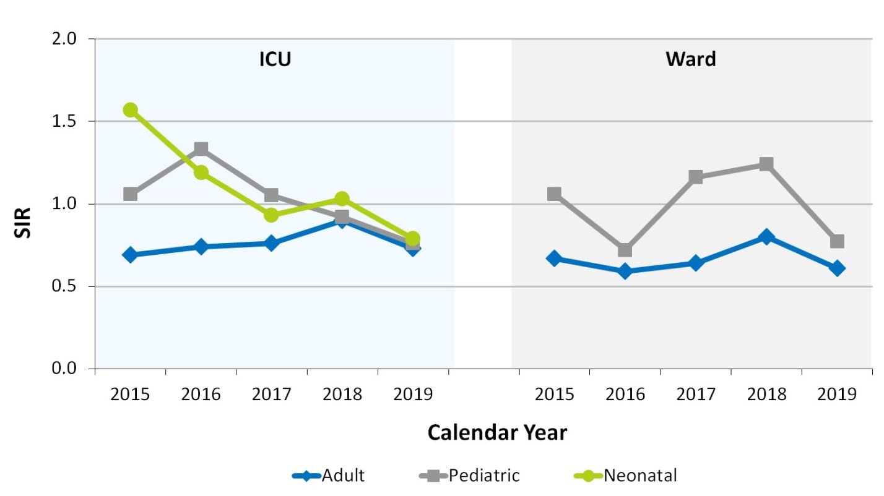
State CLABSI SIR in ICU and Wards
Key Findings
In 2019, adult ICUs experienced a significantly lower number of infections than predicted, based on 2015 national aggregate data.
Between 2015-2019, adult Wards experienced a significantly lower number of infections than predicted, based on 2015 national aggregate data.

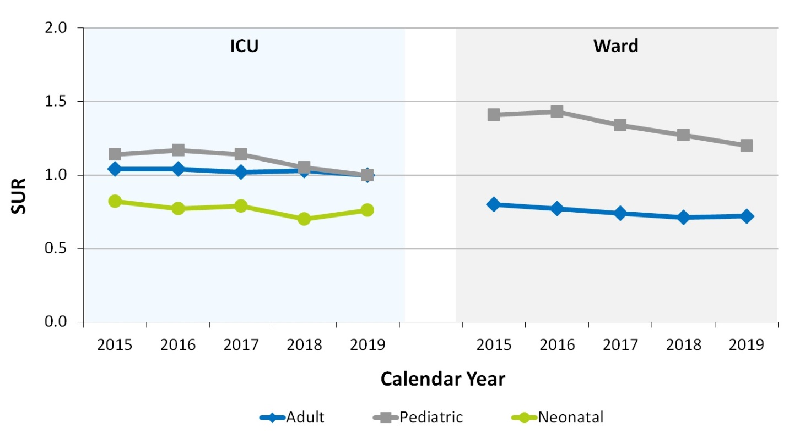
State CLABSI SUR in ICU and Wards
Key Findings
Between 2015-2019, neonatal ICUs and adult Wards experienced a significantly lower number of device days than predicted, based on 2015 national aggregate data.
Between 2015-2019, pediatric Wards experienced a significantly higher number of device days than predicted, based on 2015 national aggregate data.

Catheter-Associated Urinary Tract Infections (CAUTI): Standard Infection Ratio in Adult and Pediatric ICUs and Wards
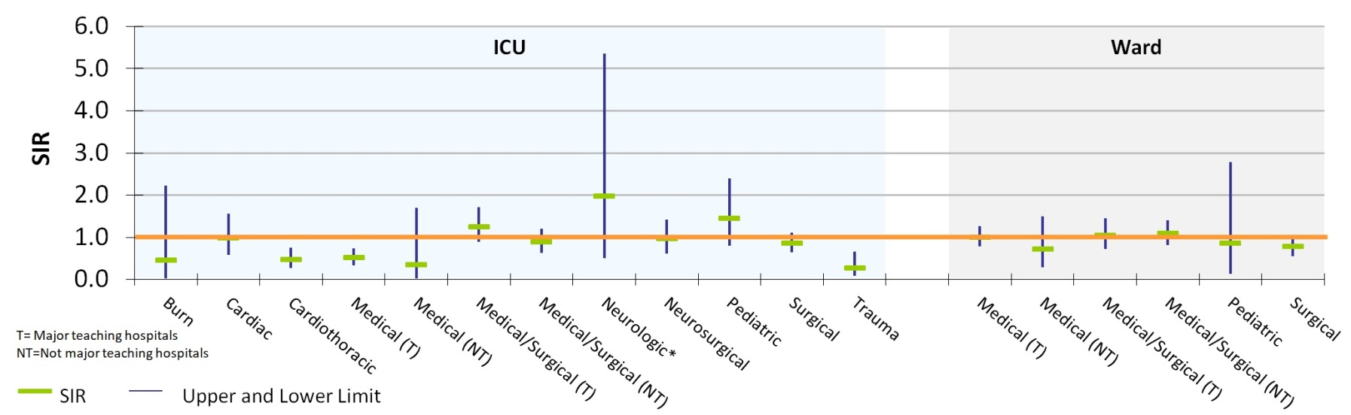
CAUTI Standard Infection Ratio (SIR) by Unit

Key:
Cardiothoracic ICU
Medical (T) ICU
Trauma ICU

Key Findings
Three unit types experienced a significantly lower number of infections than predicted, based on 2015 national aggregate data.

Catheter-Associated Urinary Tract Infections (CAUTI): Standard Utilization Ratio in Adult and Pediatric ICUs and Wards
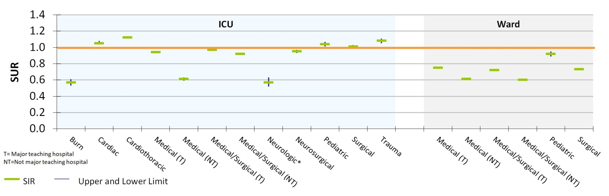
CAUTI Standard Utilization Ratio (SUR) by Unit

Key:
Cardiac ICU
Cardiothoracic ICU
Pediatric ICU
Surgical ICU
Trauma ICU
Key Findings
Five unit types experienced a significantly higher number of device days than predicted, based on 2015 national aggregate data.

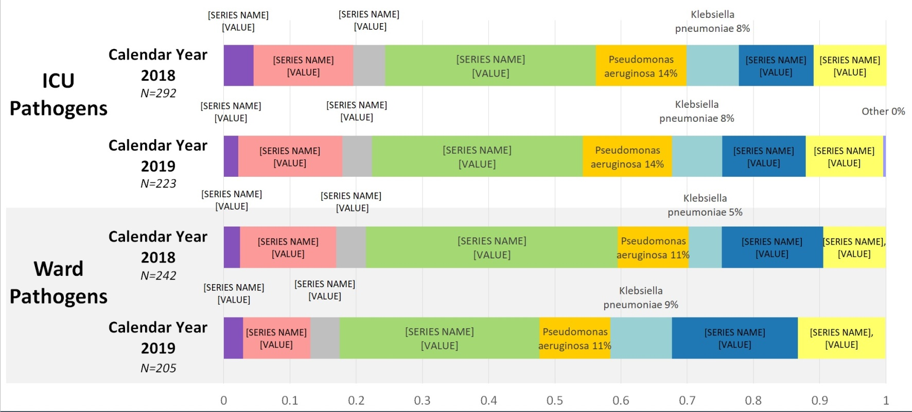
CAUTI Adult & Pediatric Pathogens for 2018 and 2019

State CAUTI SIR in ICU and Wards
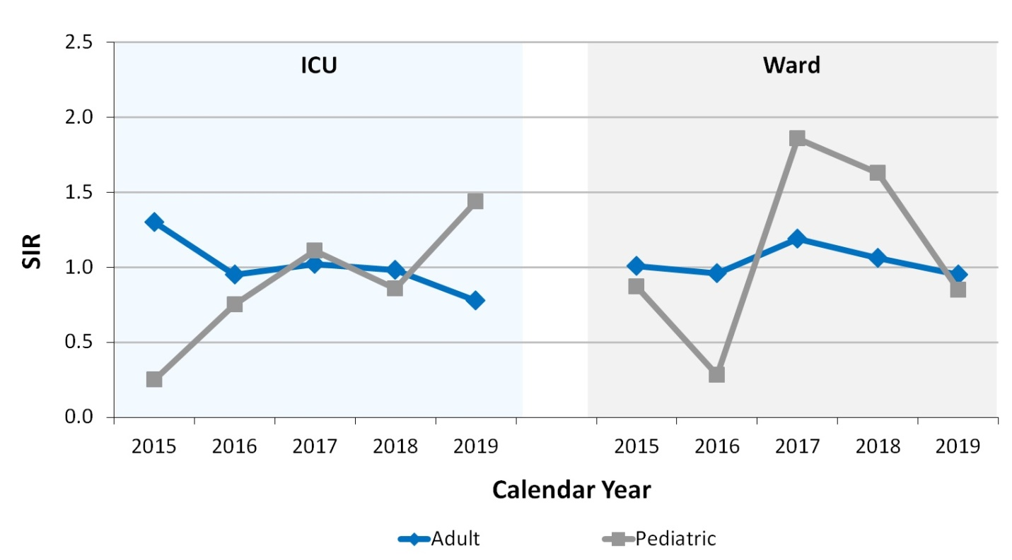
Key Findings
In 2019, adult ICUs experienced a significantly lower number of infections than predicted, based on 2015 national aggregate data.
Between 2017-2019, adult and pediatric Wards saw a decrease in the number of infections but in 2019 were no different than predicted, based on 2015 national aggregate data.

State CLABSI SUR in ICU and Wards
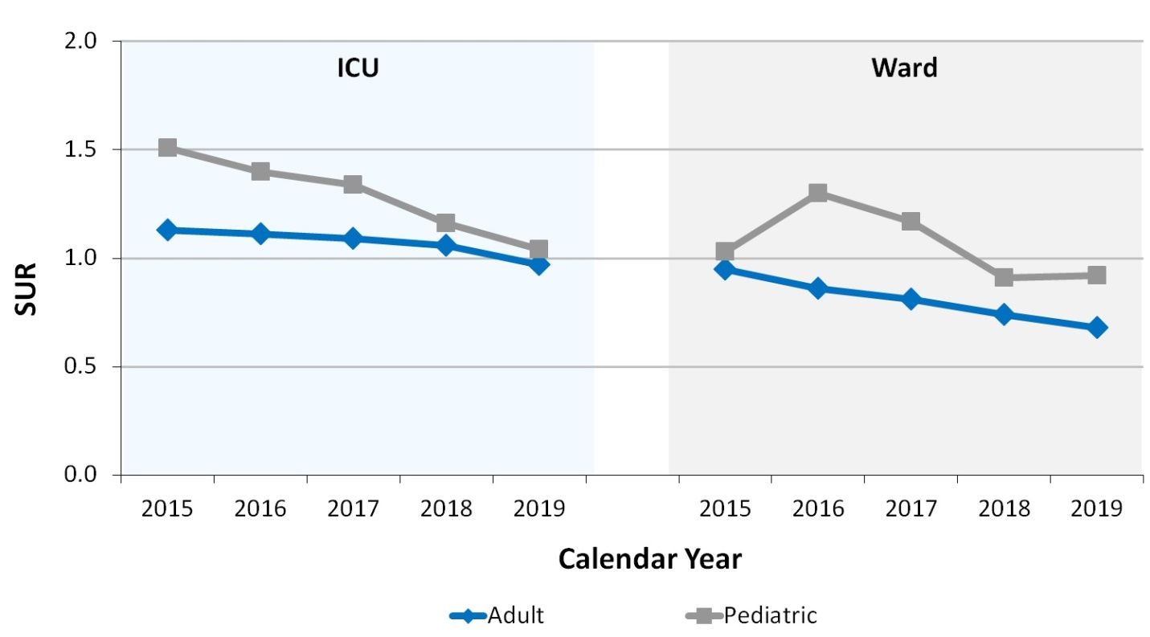
Key Findings
In 2019, adult ICUs experienced a significantly lower number of device days than predicted, based on 2015 national aggregate data.
For the past two years, adult and pediatric Wards experienced a significantly lower number of device days than predicted, based on 2015 national aggregate data.

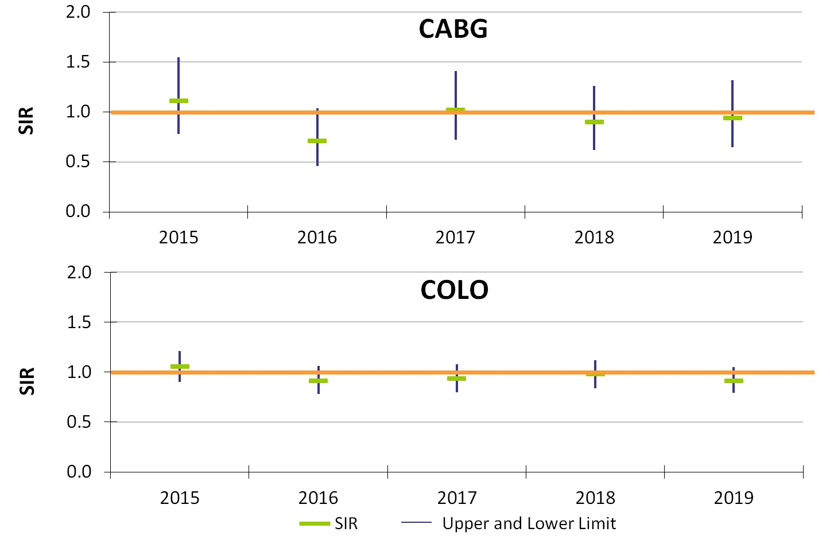
Surgical Site Infections (SSI)
Coronary Artery Bypass Graft (CABG) SIR and Colon Procedure (COLO) SIR

Key Findings
For the past five years, MA acute care hospitals performing coronary artery bypass graft procedures (CABG) and colon procedures (COLO) experienced the same number of infections as predicted, based on 2015 national aggregate data.
There were 31 CABG SSIs reported in 2019.
There were 182 COLO SSIs reported in 2019.

Surgical Site Infections (SSI)
Knee Prosthesis (KPRO) SIR and Hip Prosthesis (HPRO) SIR
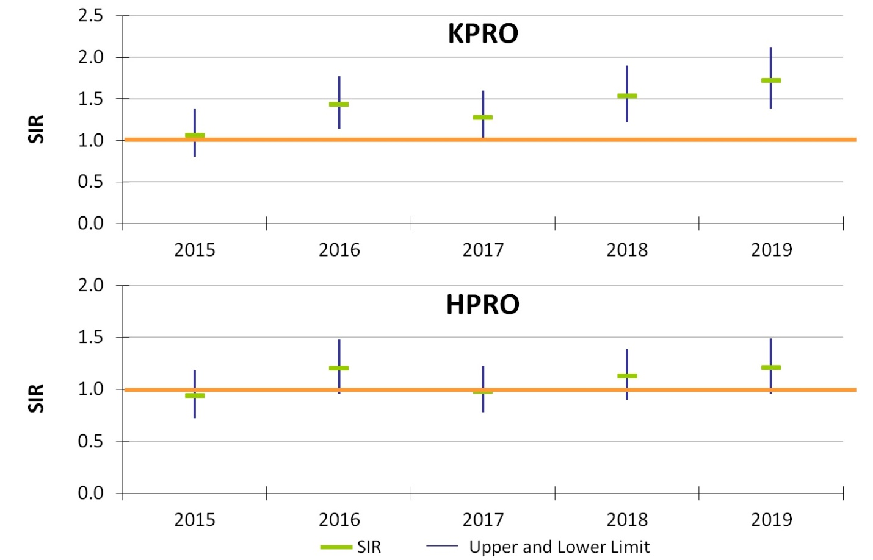
Key Findings
For the past two years, Massachusetts acute care hospitals performing knee prosthesis procedures (KPRO) experienced significantly higher number of infections than predicted, based on 2015 national aggregate data.
There were 83 KPRO SSIs reported in 2019.
There were 80 HPRO SSIs reported in 2019.

Surgical Site Infections (SSI)
Abdominal Hysterectomy (HYST) SIR and Vaginal Hysterectomy (VHYS) SIR
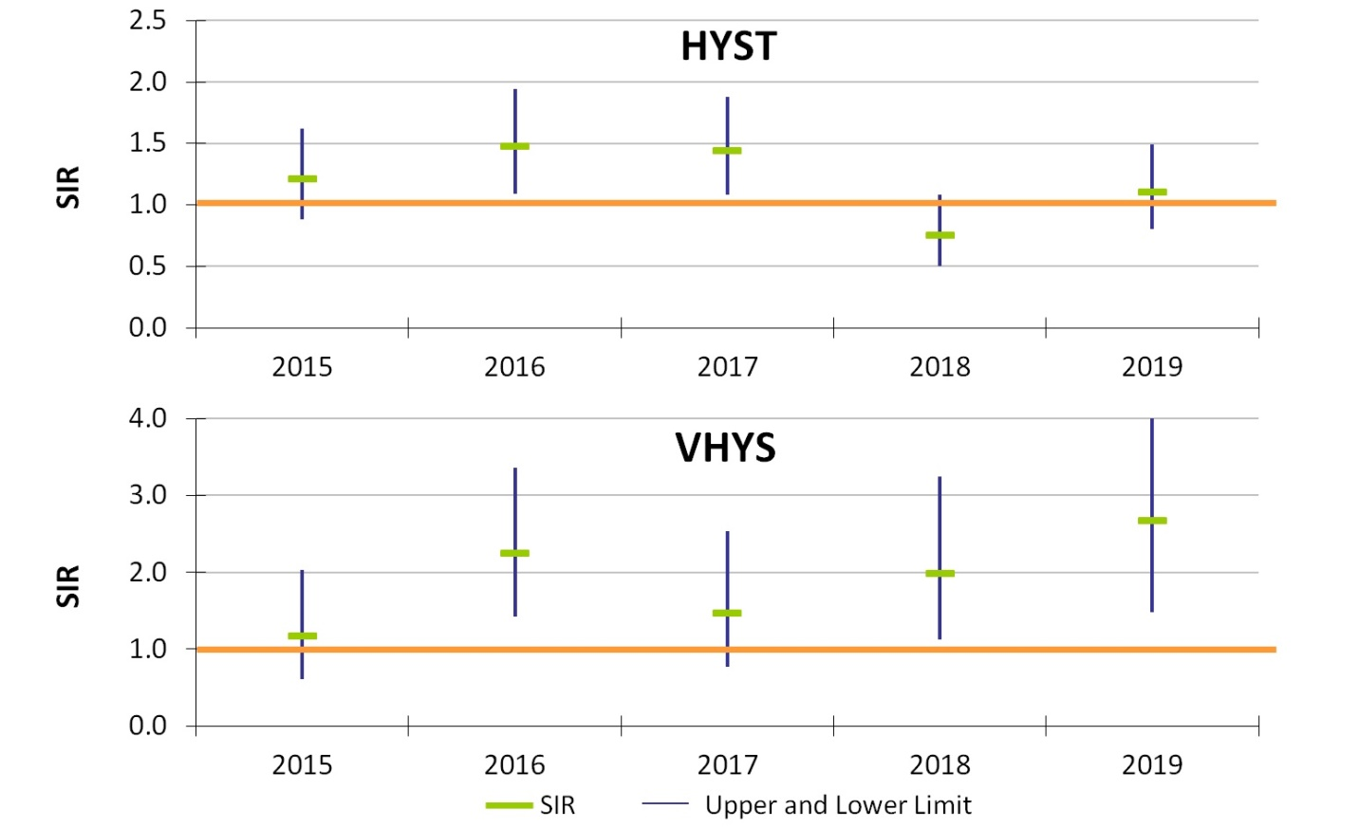

Key Findings
In 2019, Massachusetts acute care hospitals performing vaginal hysterectomy (VHYS) procedures experienced significantly higher number of infections than predicted, based on 2015 national aggregate data.
There were 40 HYST SSIs reported in 2019.
There were 13 VHYS SSIs reported in 2019.

SSI Pathogens for 2018-2019
CABG, KPRO, HPRO, HYST, VHYS, COLO
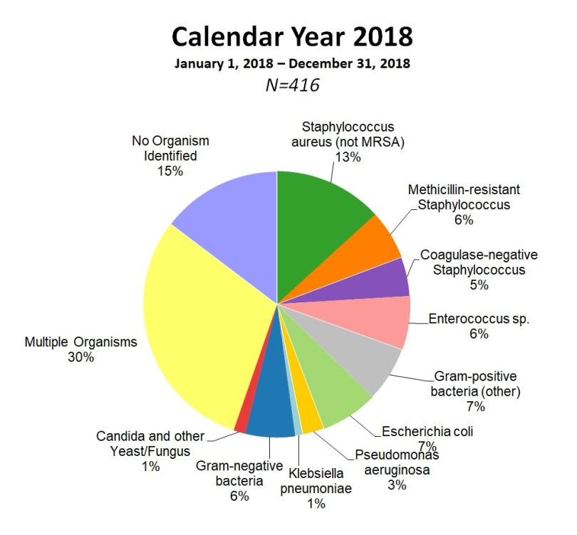

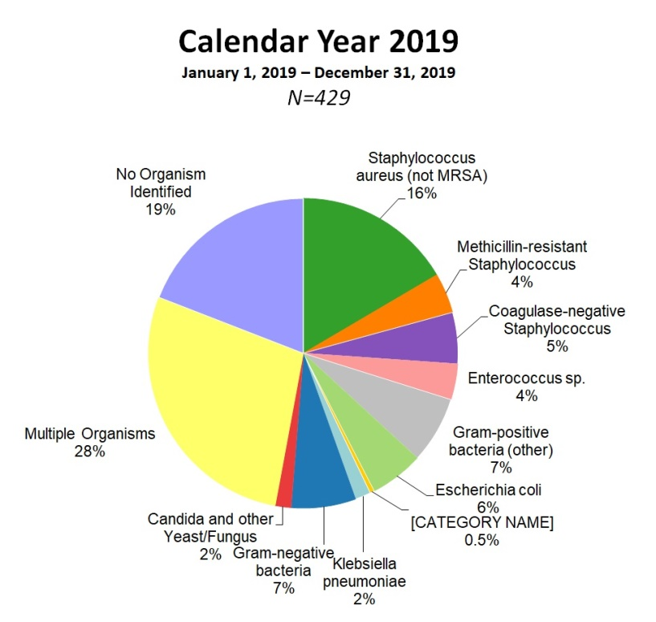

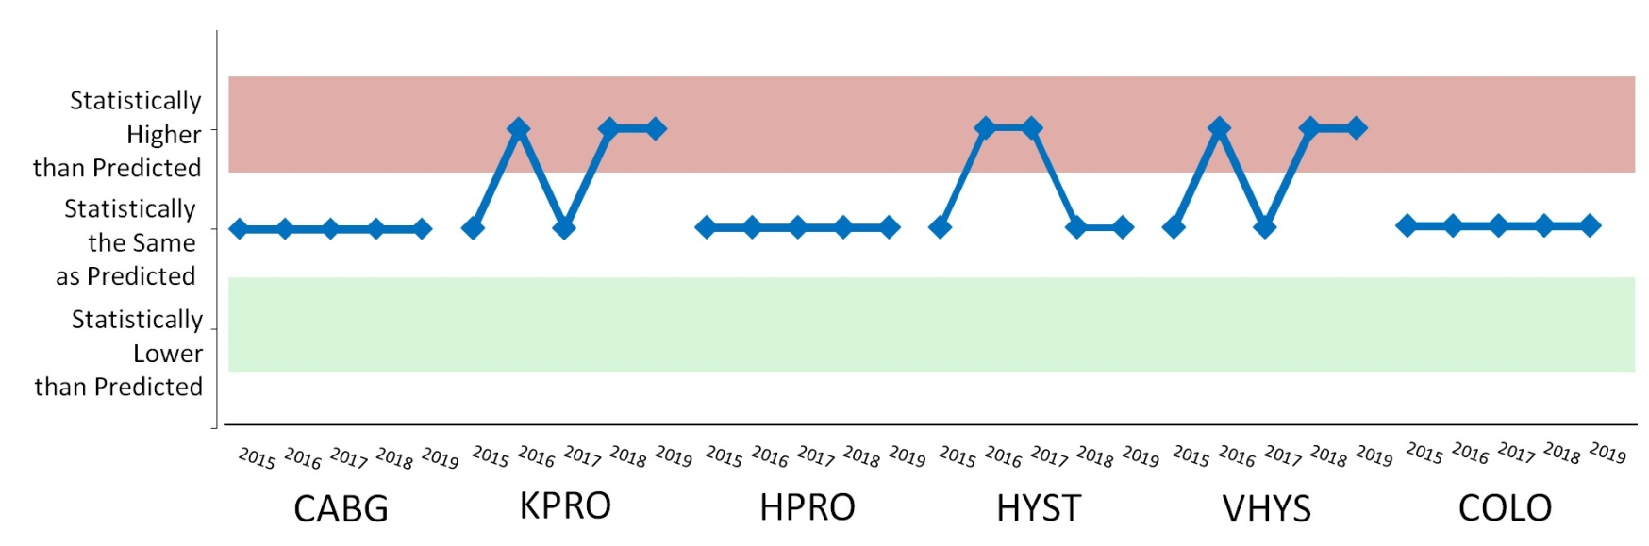
Statewide SSI Trends by Year
2015-2019

Laboratory Identified Events (LabID)
Clostridioides difficile (CDI) SIR
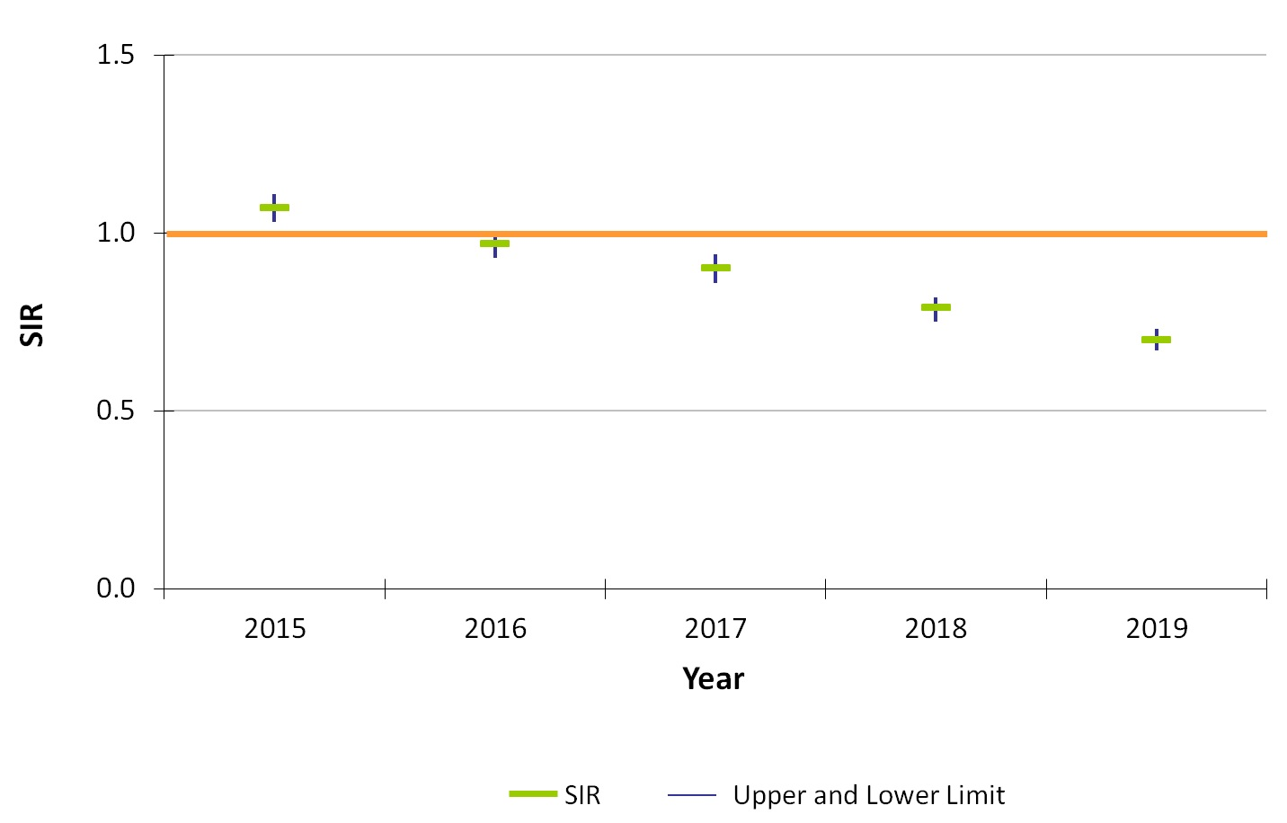
Key Findings
For the past three years, Massachusetts hospitals reporting CDI events experienced significantly lower number of infections than predicted, based on 2015 national aggregate data.
There were 1,605 CDI events reported in 2019.

Laboratory Identified Events (LabID)
Methicillin-resistant Staphylococcus aureus (MRSA) SIR
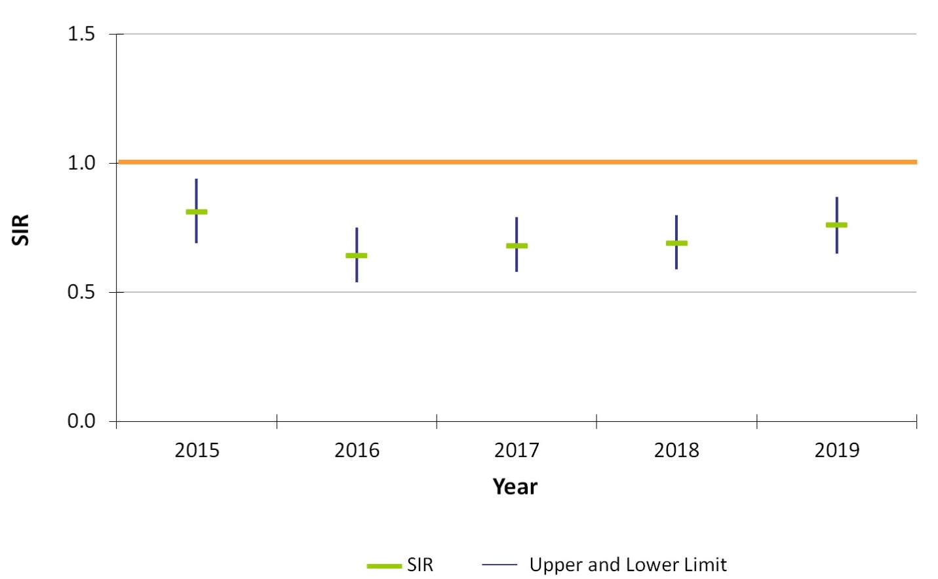

Key Findings
For the past five years, Massachusetts acute care hospitals reporting MRSA events experienced significantly lower number of infections than predicted, based on 2015 national aggregate data.
There were 181 MRSA events reported in 2019.

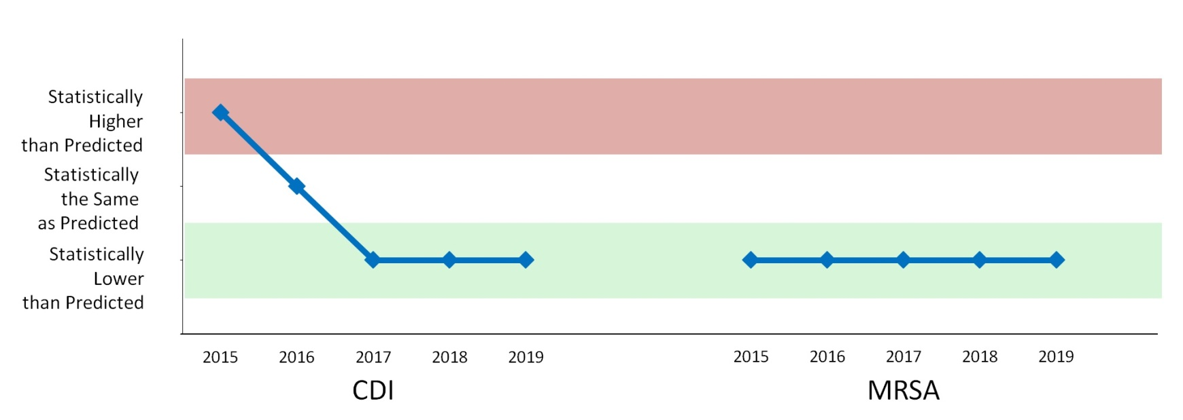
Statewide LabID Trends by Year
2015-2019

DPH HAI Prevention Activities
- Implemented new reporting requirements for CLABSI and CAUTI from non-acute care hospitals, public health hospitals, and out-of-hospital dialysis units.
- Began external data validation of methicillin resistant Staphylococcus aureus and Clostridioides difficile infections, at 13 non-acute care hospitals, and dialysis event data, at 20 outpatient-dialysis facilities.
- Three hemodialysis infection prevention simulation trainings were held for hemodialysis nurses and technicians.
- On-site Infection Control Assessment and Response (ICAR) visits were conducted at nursing homes, long-term acute care facilities, and community health centers.
- Ongoing data sharing with the Neonatal Quality Improvement Collaborative (NeoQIC) to address opportunities for improvement.
- DPH continues to monitor progress by providing quarterly Data Cleaning Reports to all hospitals and select long-term care facilities, voluntarily reporting Clostridioides difficile in NHSN, to identify areas where focused infection prevention efforts are needed.
- Continued outreach to hospitals with higher than expected SIRs to ensure the need for improvement.

Antibiotic Resistance: Urgent Threats in MA
CDC 2019 AR Threats Report
More than 2.8 million antibiotic-resistant infections occur in the U.S. each year, and more than 35,000 people die as a result.
Dedicated prevention and infection control efforts are working to reduce the number of infections and deaths caused by antibiotic-resistant germs, but the number of people facing antibiotic resistance is still too high.
- Urgent threats targeted in MA through surveillance, detection and containment
  - Carbapenem-resistant Acinetobacter
  - Candida auris
  - Clostridioides difficile
  - Carbapenem-resistant Enterobacteriaceae

Antibiotic Resistance: Targeting Carbapenemase-producing Organisms (CPO) in MA
- Carbapenems are a class of antibiotics often considered a “last resort” to treat infections caused by Enterobacteriaceae, Pseudomonas and Acinetobacter
- One way these organisms are resistant to carbapenems is by producing carbapenemases
- A carbapanemase is an enzyme that can break down (and thus resist) many classes of antibiotics, including carbapenems, making infections with these organisms harder to treat
- Genes that program the organism to produce a carbapenemase can be shared between bacteria
- Carbapenemase gene targets: KPC, NDM, VIM, OXA and IMP

Antibiotic Resistance Surveillance: Reporting and Laboratory Testing
- Electronic laboratory reporting (ELR) of mandatory MDROs of concern into the Massachusetts Virtual Epidemiologic Network (MAVEN)
- Mandatory submission of selected MDRO isolates to the Massachusetts State Public Health Laboratory (MA SPHL) for advanced testing here and at our partner ARLN laboratory, The Wadsworth Center in New York:
  - Identify novel resistance mechanisms such as genes that code for carbapenemase production or colistin resistance
  - Identify Candida auris
  - Test swabs to identify colonization with target organisms to detect transmission within a healthcare facility
  - Conduct whole-genome sequencing to determine relatedness of organisms to identify transmission pathways within and across healthcare facilities
Notes:
- Carbapenem-resistant Enterobacteriaceae (CRE), including carbapenemase-producing CRE
- Candida auris
- Organisms containing the mcr gene, conferring mobilized resistance to colistin, a last-resort antibiotic used for treating resistant infections

Antibiotic Resistance Surveillance: Carbapenemase-producing Organisms (CPOs) in MA
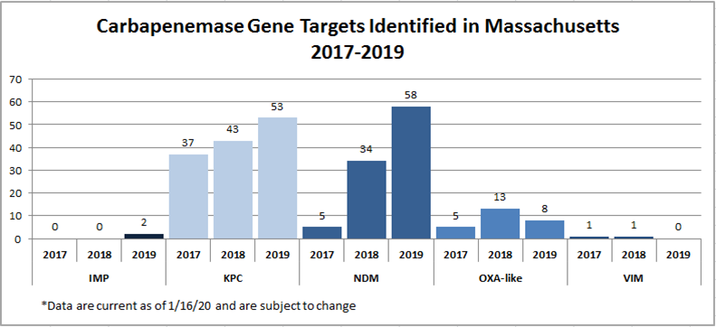

Antibiotic Stewardship
- Studies indicate that between 30-50% of antibiotics prescribed in hospitals and between 40-75% of antibiotics prescribed in nursing homes are unnecessary*
- Improved prescribing practices can help reduce rates of Clostridioides difficile and antibiotic resistance
- Appropriate antibiotic prescribing can improve patient outcomes and reduce healthcare costs
* https://www.cdc.gov/antibiotic-use/healthcare
https://www.cdc.gov/longtermcare/prevention/antibiotic-stewardship.html

Antibiotic Stewardship: Prevention and Educational Activities
- NEW: 18 new acute care hospitals participating in NHSN antibiotic use (AU) module to better understand
trends in antibiotic use and to monitor stewardship activities- will soon have access to antibiotic prescribing data for nearly 50% of all acute-care facilities in MA
- 2019 Component of Advanced Educational Series entitled “Navigating Infection Control and Antibiotic
Stewardship in Long-Term Care” with three “ask the experts” calls
- Collection, monitoring and benchmarking of facility-level antibiotic use data in long-term care facilities (n=70 participating facilities)
- Held a statewide webinar for long-term care facilities on MDROs and Infection Control (n=150 participants) in February, 2020
- NEW: Publication of 10-year trends in MA Hospital Antibiograms: https://doi.org/10.1017/ice.2020.395
- Engagement with subject matter experts and stakeholders during quarterly statewide HAI/AR Technical Advisory Group (TAG) meetings with formation of Antibiotic Use Subcommittee
- Partnered with the Northeast Branch of American Society of Microbiology (ASM) to host a regional conference on antibiotic resistance and stewardship in November, 2019

Antibiotic Resistance and Antibiotic Stewardship: DPH Antibiograms and NHSN AU Data
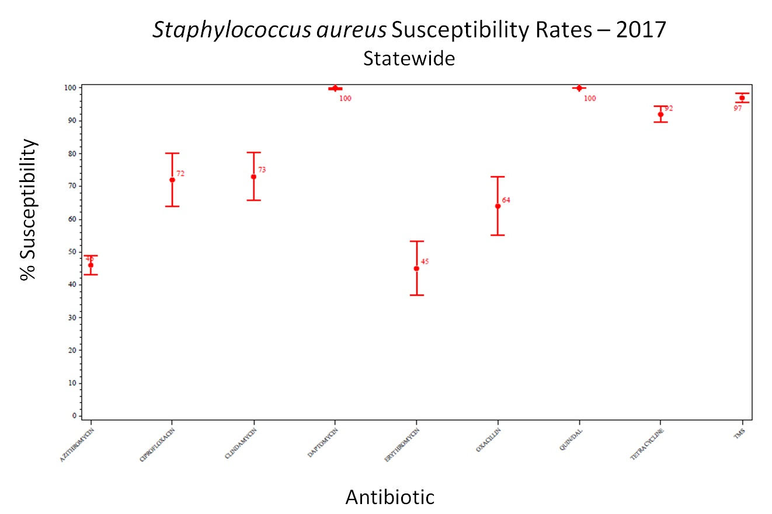

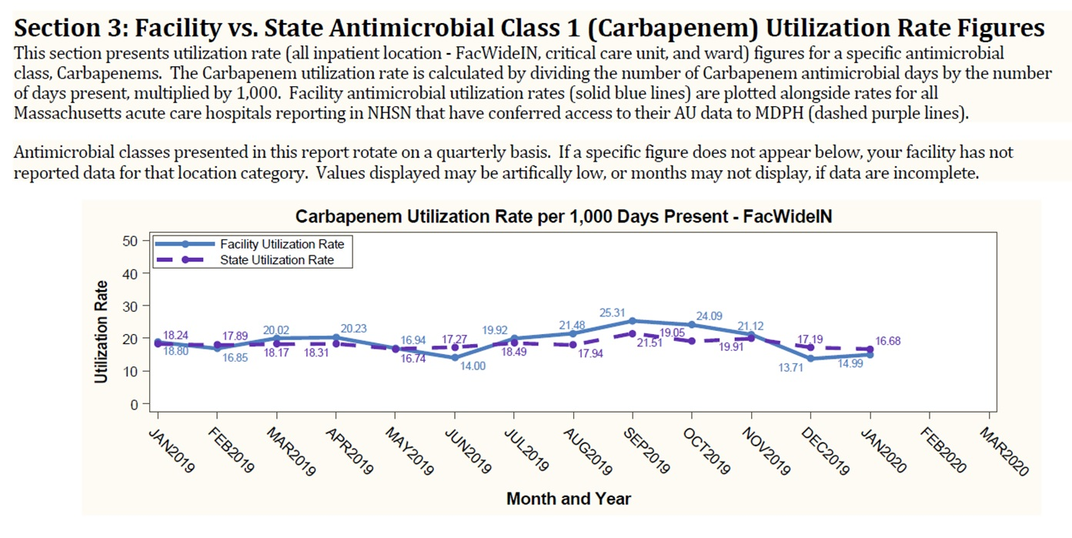

Contact Information
Thank you for the opportunity to present this information today. Please direct any questions to:
Eileen McHale, RN, BSN
Healthcare Associated Infection Coordinator
Bureau of Health Care Safety and Quality
eileen.mchale@state.ma.us

