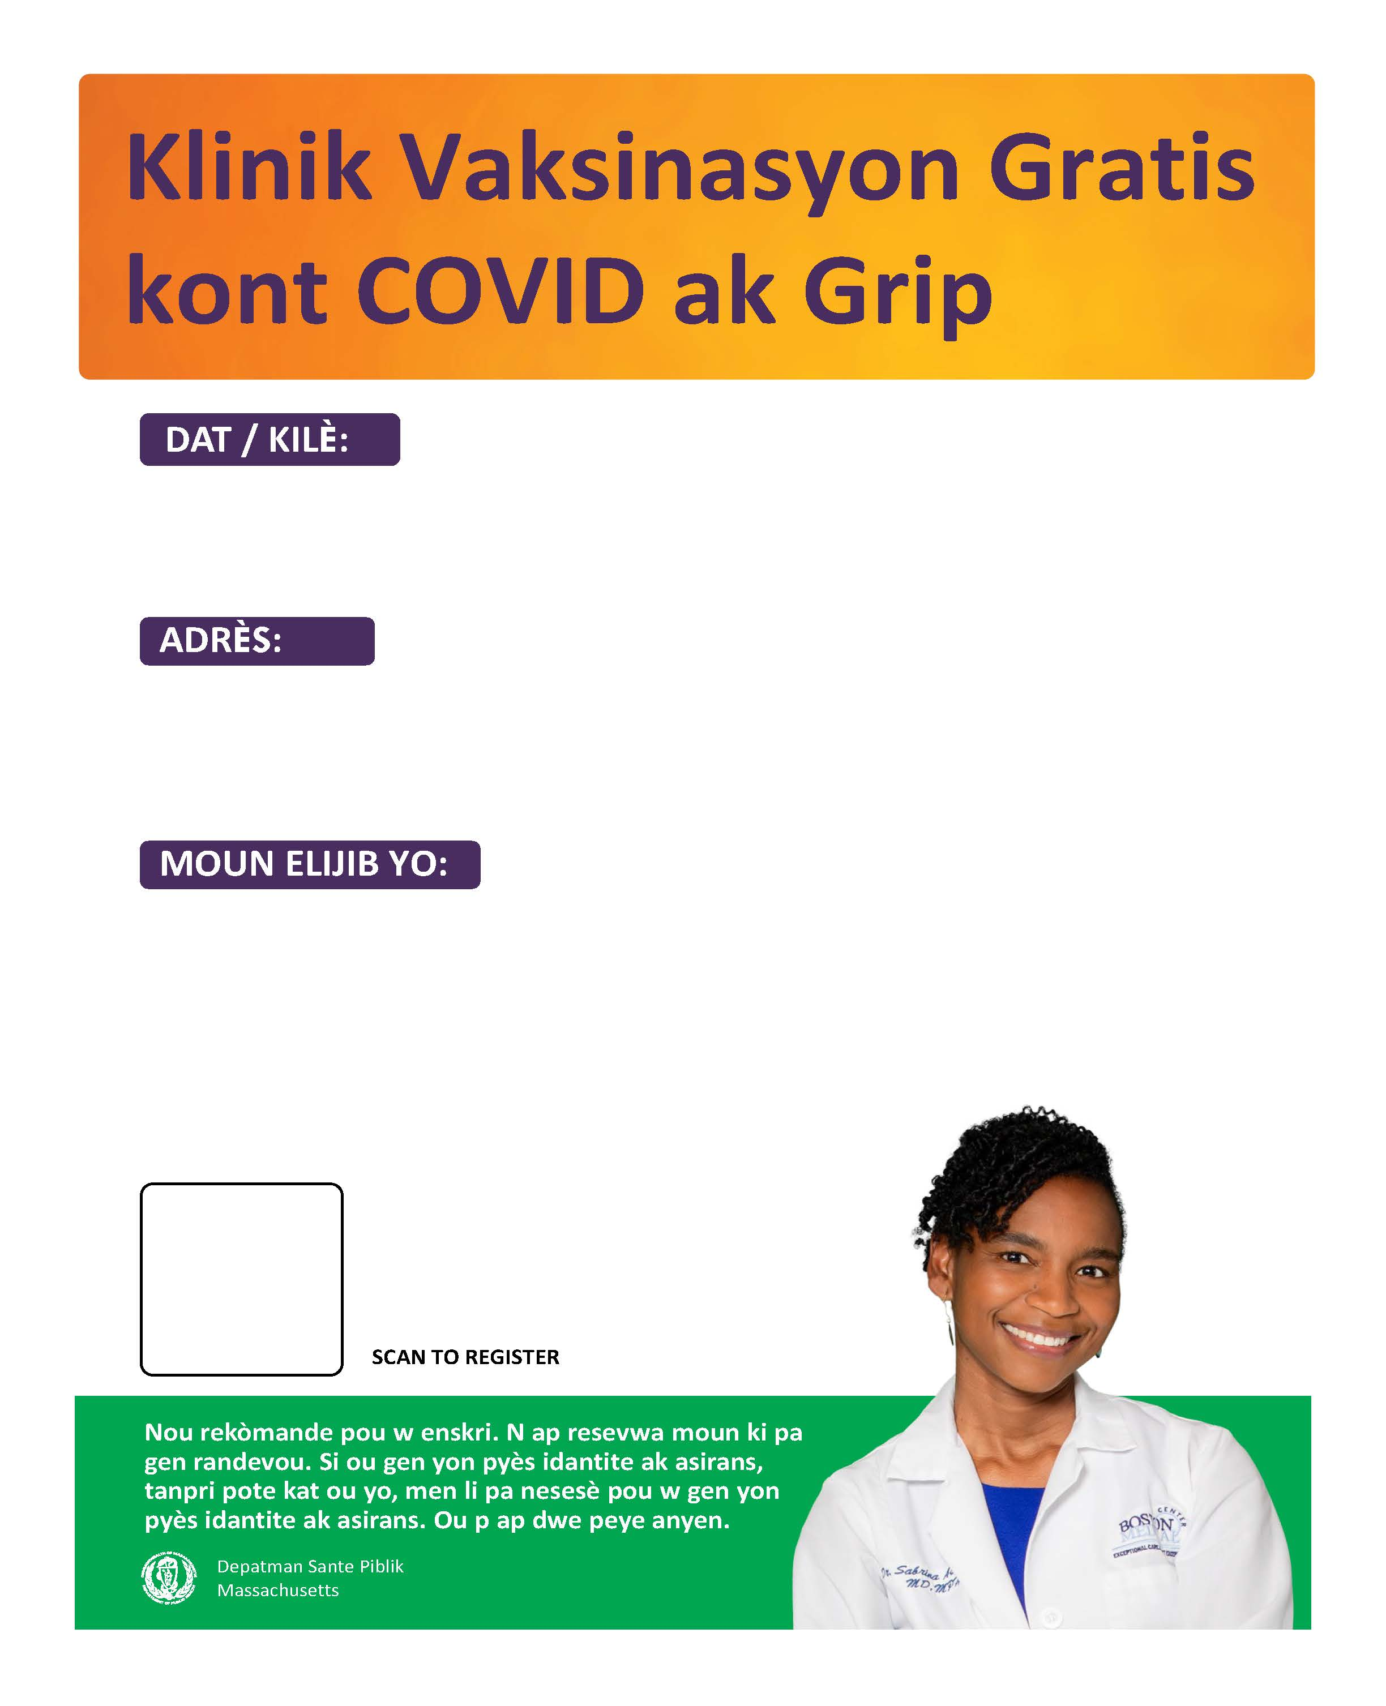

**Text here!**

**QR code here!**

**Text here!**

**Text here!**