Background/Introduction

ODOR ASSESSMENT

Hampden County Registry of Deeds
Hall of Justice
25 State Street
Springfield, MA

Prepared by:
Massachusetts Department of Public Health
Bureau for Environmental Health
Indoor Air Quality Program
February 2012

At the request of Administrative Offices of the Trial Court, the Massachusetts Department of Public Health (MDPH), Bureau of Environmental Health (BEH) provided assistance and consultation regarding indoor air quality concerns at The Registry of Deeds (ROD) Office on the fourth floor of the Hall of Justice (HOJ), located at 25 State Street, Springfield, MA. The request was prompted by reports of odors and the detection of refrigerant gas inside the ROD office.
On September 14, 2011, the ROD was visited by Michael Feeney, Director of BEH’s Indoor Air Quality (IAQ) Program, to assess the possible source of odors reported by ROD employees. Prior to this assessment, HOJ staff had conducted air sampling for refrigerant gas (RG), suspecting that a free-standing air conditioner was the source of odors.

Methods
Screening for refrigerant gases (RG) was conducted by HOJ staff using a Bachrach The Informant 2 Dual Purpose Refrigerant & Combustible Gas Leak Detector (RCD). The RCD can only indicate the presence of an RG and does not provide a quantitative air level.

Results
The ROD has a staff of approximately 20. The RG air samples were taken throughout the ROD space prior to the BEH visit.

Discussion

Odor Investigation
HOJ staff tested a portable air conditioner (AC) brand/model Movincool Office Pro 18, which used Genetron® AZ-20 (R-410A) as its refrigerant (Attachment 1). The portable AC was identified by HOJ staff as the source of RG. Prior to the visit by BEH staff, the portable AC had been deactivated and removed and the area was ventilated by HOJ staff.
The portable AC was installed with its exhaust hose configured to vent into the ceiling plenum above the ROD. The heating, ventilating and air-conditioning system (HVAC) in the HOJ has ducted supply and return vents and therefore does not use a ceiling plenum for return air (MPDH, 2006). “Ceiling plenum return” is an HVAC system configuration that uses the space between the suspended ceiling and floor/roof decking as a duct to return air to the AHU in place of hard ducts. The Movincool Office Pro 18 is designed to vent into a ceiling plenum return system, which would draw the heated air and water vapor to the main air handler unit servicing the area, making it a part of the HVAC system
Because the HOJ does not use the ceiling plenum as part of the HVAC system, the ducting of the portable AC would pressurize the ceiling plenum, forcing waste heat and water vapor, and leaking RG if present, through spaces in the ceiling. Gaps in the ceiling tile system in Room 403C (Picture 1) and at the front desk near the main entrance to the ROD (Picture 2) would provide such pathways. In addition, pressurization of the ceiling plenum can force any dirt, dust and loose debris that accumulates above the ceiling tiles into occupied areas, providing sources of eye and respiratory irritation.
Reportedly, once the portable AC was removed from the ROD, no further RG detections were measured in any other location during this assessment with the exception of Room 403C.
According to HOJ staff who had conducted the monitoring with the RCD, a number of anomalous readings, such as detections of refrigerant vapors in outside air, or detections and non-detections in the same location, occurred during the use of the RCD in the ROD. These detections are believed to be false positive readings caused by the behavior of the RCD when placed in moving air. According to product literature: “False refrigerant indications are usually caused by abnormal changes in sensor temperature. These temperature changes are typically due to a sudden change in air flow past the sensor. To avoid false refrigerant indications, [do not] ... use the detector in windy areas [or] move the probe tip back and forth faster than 2" per second.” (Bacharach, 2011)
The use of this type of a portable AC system in a building without an HVAC air return plenum system is not recommended. This type of system should be ducted directly to the outdoors through an exterior wall or window.

Conclusions/Recommendations
In view of the findings at the time of the visit, the following recommendations are made:
- Discontinue the use of the portable AC unit unless it is vented directly outdoors.
- ROD staff should consult with HOJ facilities staff on the most appropriate measures to provide additional supply and exhaust ventilation for the ROD offices and work areas.

References
Bacharach. 2011. Bacharach, Inc. Instruction 0019-9211 Operation and Maintenance (Rev. 8). New Kensington, Pennsylvania. June 2011. (http://www.bacharach-inc.com/PDF/Instructions/19-9211.pdf)
MDPH. 2006. Hall of Justice (HOJ), 50 State Street, Springfield, Massachusetts. Massachusetts Department of Public Health, Emergency Response/Indoor Air Quality Program, Boston, MA. May 2006.
Picture 1

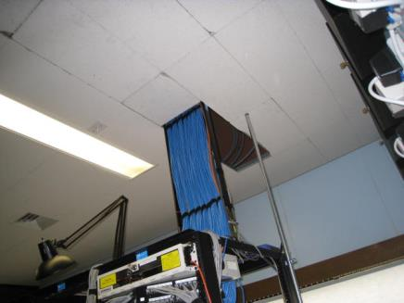

Space in Suspended Ceiling in Room 403C (arrow)

Picture 2

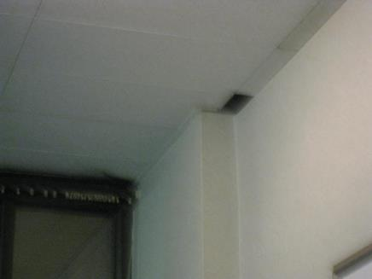

Space in Suspended Ceiling near the Front Desk near
Main Entrance to the ROD (arrow)
Picture 1

Space in Suspended Ceiling in Room 403C (arrow)

Picture 2

Space in Suspended Ceiling near the Front Desk near
Main Entrance to the ROD (arrow)

