INDOOR AIR QUALITY ASSESSMENT

Hampshire Family and Probate Court
33 King Street
Northampton, Massachusetts

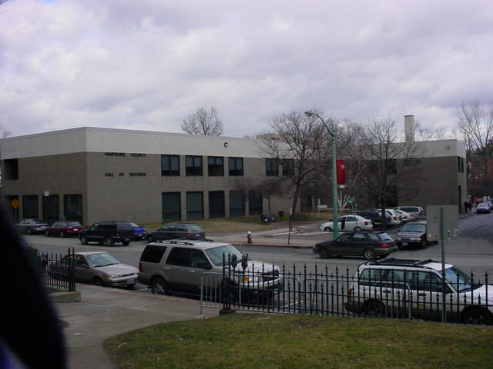

Prepared by:
Massachusetts Department of Public Health
Center for Environmental Health
Emergency Response/Indoor Air Quality Program
January 2007

Background/Introduction
In response to a request from John O’Donnell, Massachusetts Division of Capital Asset Management (DCAM), the Massachusetts Department of Public Health (MDPH), Center for Environmental Health (CEH) conducted an indoor air quality assessment at the Hampshire Family and Probate Court (HFPC), 33 King Street, Northampton, Massachusetts. Concerns about indoor air Quality, water damage and temperature control, as well as the former use of the site as a parking garage, prompted the request.
On January 19, 2007, Michael Feeney, Director of CEH’s Emergency Response/Indoor Air Quality (ER/IAQ) Program, made a visit to this building. The HFPC is a two-story cement building originally constructed in the 1950s as a parking garage. The building was reportedly converted into office space in 1976. The building contains the Hampshire Family Court, the Hampshire Probate Court, the Hampshire Registry of Deeds and probation offices. Windows are not openable in the building.

Methods
Air tests for carbon dioxide, temperature and relative humidity were taken with the TSI, Q-Trak, IAQ Monitor. Surface temperatures of computer equipment were taken with a Thermotrace Laser Thermometer.

Results
The HFPC has an employee population of over 30 with several hundred visitors on a daily basis. Tests were taken under normal operating conditions and results appear in Table 1.

Discussion
Ventilation
It can be seen from Table 1 that carbon dioxide levels were below 800 parts per million (ppm) in all areas surveyed, which generally indicates adequate fresh air supply in a building. Fresh air is supplied by ceiling or wall mounted fresh air supply vents connected to a rooftop air-handling unit (Picture 1). Exhaust ventilation is provided by ceiling mounted exhaust vents.
To maximize air exchange, the MDPH recommends that both supply and exhaust ventilation operate continuously during periods of occupancy. In order to have proper ventilation with a mechanical supply and exhaust system, the systems must be balanced to provide an adequate amount of fresh air to the interior of a room while removing stale air from the room. It is recommended that HVAC systems be re-balanced every five years to ensure adequate air systems function (SMACNA, 1994). The date of the last balancing of these systems was not available at the time of the assessment.
The Massachusetts Building Code requires a minimum ventilation rate of 20 cubic feet per minute (cfm) per occupant of fresh outside air or have openable windows in each room (SBBRS, 1997; BOCA, 1993). The ventilation must be on at all times that the room is occupied. Providing adequate fresh air ventilation with open windows and maintaining the temperature in the comfort range during the cold weather season is impractical. Mechanical ventilation is usually required to provide adequate fresh air ventilation.
Carbon dioxide is not a problem in and of itself. It is used as an indicator of the adequacy of the fresh air ventilation. As carbon dioxide levels rise, it indicates that the ventilating system is malfunctioning or the design occupancy of the room is being exceeded. When this happens a buildup of common indoor air pollutants can occur, leading to discomfort or health complaints. The Occupational Safety and Health Administration (OSHA) standard for carbon dioxide is 5,000 parts per million parts of air (ppm). Workers may be exposed to this level for 40 hours/week, based on a time-weighted average (OSHA, 1997).
The MDPH uses a guideline of 800 ppm for publicly occupied buildings. A guideline of 600 ppm or less is preferred in schools due to the fact that the majority of occupants are young and considered to be a more sensitive population in the evaluation of environmental health status. Inadequate ventilation and/or elevated temperatures are major causes of complaints such as respiratory, eye, nose and throat irritation, lethargy and headaches. For more information concerning carbon dioxide, please see Appendix A.
Temperature readings the day of the assessment ranged from 68ºF to 76ºF, which were within or close to the lower end of the MDPH recommended temperature range of 70ºF to 78ºF. Employees expressed concerns about the lack of temperature control in the building (e.g., not enough heat in winter/cooling in hot weather). There are a number of factors that likely contribute to these temperature control difficulties.
- The roof does not appear to be designed as an insulated roof. The decking appears to be comprised of wood with no apparent insulation (Picture 2). Without insulation, heat from the sun would heat the decking of the fourth floor, which would subsequently heat the ceiling plenum and the office space below the suspended ceiling.
- The window system consists of a single pane of glass installed in a metal frame. When exposed to direct sunlight the glass and metal of the windows can become a significant heat source. Conversely, windows that are not exposed to sunlight but rather northwesterly winds during frigid weather would be expected to result in significantly lower temperatures than the building’s interior. Therefore, the location of the room and weather conditions are likely to have significant influence on room temperature.
- The number of computers and related equipment (monitors, printers, etc.) in use are prevalent. The air temperature measured at a vent in the top of a monitor was 115 º F. Since the building was renovated prior to the advent of computers and other electronic equipment being present in the workplace, the HVAC system may not have the capacity to account for the heat generated by this equipment.
Therefore, a number of contributing factors inhibit temperature control and comfort maintenance in this building. Please note that even without these design and construction issues, fluctuations of temperature in occupied spaces are typically experienced, even in a building with an adequate fresh air supply.
The relative humidity measurements on the day of the assessment ranged from 23 to 32 percent, which were below the MDPH recommended range of 40 to 60 percent. Relative humidity levels in the building would be expected to drop during the winter months due to heating. The sensation of dryness and irritation is common in a low relative humidity environment. Low relative humidity is a very common problem during the heating season in the northeast part of the United States.

Microbial/Moisture Concerns
The roof is sloped inward from the exterior walls to enhance water drainage (Picture 3). Water damage ceiling tiles were seen in areas that roughly correspond to locations below roof drains (Table 1). In addition, debris was noted on the roof, which may clog drains. The freezing and thawing of water during winter months can lead to damage of the roof membrane and subsequent water penetration into the building. The American Conference of Governmental Industrial Hygienists (ACGIH) and the United States Environmental Protection Agency (US EPA) recommend that porous materials be dried with fans and heating within 24 to 48 hours of becoming wet (ACGIH, 1989; US EPA, 2001). If porous materials are not dried within this time frame, mold growth may occur. Water-damaged porous materials cannot be adequately cleaned to remove mold growth. The application of a mildewcide to moldy porous materials is not recommended.
The Registry of Deeds built a server room that requires air conditioning (AC) for computer equipment. A self-contained wall unit was installed in this room. As AC equipment operates, moisture accumulates in the cooling coils that require a drain to remove water from the unit. CEH staff could not locate the drain for this unit. If not connected to a building drainage system, water likely accumulates and pools within the AC unit, which can serve as a mold growth medium.
Plants were observed in a number of rooms. Moistened plant soil and drip pans can provide a source of mold growth. Plants are also a source of pollen. Plants should be located away from the air stream of ventilation sources to prevent the aerosolization of mold, pollen or particulate matter. Plants should have drip pans to prevent wetting of porous building materials and subsequent mold colonization. Over watering of plants should be avoided and drip pans should be inspected periodically for mold growth.

Other Concerns
A number of other conditions were noted during the assessment, which can affect indoor air quality. Of note is the location of the exhaust vents for the restrooms (Picture 4). These exhaust vents are located in close proximity to the fresh air intake for the rooftop AHU (Picture 5). Under certain wind conditions, air from these exhaust vents may be directed toward the fresh air intake hood of the AHU and distributed to office space.
A number of areas contained photocopiers, which can produce irritating odors during use. VOCs and ozone can be produced by photocopiers, particularly if the equipment is older and in frequent use. Ozone is a respiratory irritant (Schmidt Etkin, 1992). These areas are not equipped with local exhaust ventilation to help reduce excess heat and odors.
An ozone generator was observed in the Probate Court main office. At this time, the efficacy of ozone as an indoor air cleaner is being examined by several government agencies. While ozone may be effective in removing some odors of biological origin (e.g. skunk), its use as a universal air cleaner has not been established (US EPA, 2003). As mentioned, ozone is a respiratory irritant. Until more definitive information becomes available, the use of ozone generators in occupied areas should be done with caution.
Of note were break rooms that were equipped with stoves and/or microwave ovens. None of these areas appeared to have exhaust vents designed to remove cooking odors. Without proper exhaust ventilation, cooking odors can be drawn into the general ventilation system and subsequently distributed to other areas.
An unused floor drain was found in the Registry of Deeds Annex (Picture 6). The drain likely has a dry trap, which can allow sewer gases/odors to migrate from the drain system into occupied space. The drain should be filled regularly with water or sealed to prevent this contingency.
Missing/dislodged ceiling tiles were observed in a number of areas exposing a fiberglass insulation material. These breaches can serve as pathways for dirt, dusts and other particulates (i.e., fiberglass fibers), into occupied areas. In addition, fiberglass insulation can be a source of eye, skin and respiratory irritation to some individuals.
Of note is the use of humidifiers in the Registry of Deeds. Humidifiers contain a reservoir of standing water to provide moisture. Humidifiers should be cleaned frequently in a manner consistent with manufacturer’s instructions. Failure to do so can make a humidifier a source and distribution medium for microbial growth (US EPA, 1991).

Conclusions/Recommendations
The indoor air quality conditions at the HFPC are somewhat complex and interconnected. Decisions made concerning the design and construction of the building have made it prone to water leaks via drains around the roof. In addition, the configuration of the roof and the building’s type of window system make it difficult to control temperatures. While some problems can be addressed as soon as practicable, others will require planning and resources. For this reason, a two-phase approach consisting of short-term measures to improve air quality and long-term measures to address the overall indoor environmental concerns is recommended.

In view of the findings at the time of the visit, the following recommendations are made:

Short Term Recommendations
- Ensure leaks are repaired and replace any remaining water-damaged ceiling tiles. Examine the space above and around these areas for mold growth. Disinfect areas of water leaks with an appropriate antimicrobial.
- Use window shades/blinds as much as practical to reduce heat/cold transmission into offices.
- Remove debris from the roof, inspect regularly.
- Seal the drain shown in Picture 6 or pour water down on a regular basis.
- Consider either raising the exhaust vent and vent pipe for restroom (approximately 6-10 feet from the AHU air intake), or extending ductwork for AHU air intake away from exhaust and vent pipe to reduce/prevent entrainment of exhaust odors into the mechanical ventilation system.
- Consider discontinuing the use of the ozone generating air purifier.
- Examine the feasibility of installing exhaust ventilation for rooms with multiple photocopiers.
- Ensure proper drainage of AC unit in the Registry of Deeds to prevent mold growth and associated odors.
- Clean and maintain humidifiers as per the manufacturer’s instructions to prevent microbial growth.
- Consider balancing mechanical ventilation systems every 5 years, as recommended by ventilation industrial standards (SMACNA, 1994).
- For buildings in New England, periods of low relative humidity during the winter are often unavoidable. Therefore, scrupulous cleaning practices should be adopted to minimize common indoor air contaminants whose irritant effects can be enhanced when the relative humidity is low. To control for dusts, a high efficiency particulate arrestance (HEPA) filter equipped vacuum cleaner in conjunction with wet wiping of all non-porous surfaces is recommended. Drinking water during the day can help ease some symptoms associated with a dry environment (throat and sinus irritations).
- Replace missing ceiling tiles to prevent the egress of dirt, dust and particulate matter into occupied areas.
- Ensure all plants are equipped with drip pans. Examine drip pans for mold growth and disinfect areas of water leaks with an appropriate antimicrobial where necessary.

Long Term Recommendations
- Consult with a building engineer to examine the roof and make recommendations to establish a functional, insulated roof to eliminate water leaks and improve temperature control.
- Consideration should be given to replacing the existing window system with an energy efficient, double-paned type in order to eliminate heat/cold transmission into exterior walls.
- Examine the feasibility of installing dedicated exhaust vents for all areas with cooking equipment.
References
ACGIH. 1989. Guidelines for the Assessment of Bioaerosols in the Indoor Environment. American Conference of Governmental Industrial Hygienists, Cincinnati, OH.
BOCA. 1993. The BOCA National Mechanical Code/1993. 8th ed. Building Officials and Code Administrators International, Inc., Country Club Hill, IL. Section M-308.1.1.
Gold, D. 1992. Indoor Air Pollution. Occupational Lung Diseases. 13(2):224-225.

OSHA. 1997. Limits for Air Contaminants. Occupational Safety and Health Administration. Code of Federal Regulations. 29 C.F.R 1910.1000 Table Z-1-A.
SBBRS. 1997. Mechanical Ventilation. State Board of Building Regulations and Standards. Code of Massachusetts Regulations. 780 CMR 1209.0
Schmidt Etkin, D. 1992. Office Furnishings/Equipment & IAQ Health Impacts, Prevention & Mitigation. Cutter Information Corporation, Indoor Air Quality Update, Arlington, MA.
SMACNA. 1994. HVAC Systems Commissioning Manual. 1st ed. Sheet Metal and Air Conditioning Contractors’ National Association, Inc., Chantilly, VA
US EPA. 1991. Indoor Air Facts No. 8 Use and Care of Home Humidifiers. US Environmental Protection Agency, Office of Air and Radiation, Office of Research and Development, Washington, DC. February 1991.

US EPA. 2001. “Mold Remediation in Schools and Commercial Buildings”. Office of Air and Radiation, Indoor Environments Division, Washington, DC. EPA 402-K-01-001. March 2001. Available at: http://www.epa.gov/iaq/molds/mold_remediation.html
US EPA. 2003. “Ozone Generators That Are Sold As Air Cleaners. An assessment of Effectiveness and Health Consequences”. Indoor Environments Division, Office of Radiation and Indoor Air Programs, Office of Air and Radiation (6604j). Washington, DC. Available at http://www.epa.gov/iaq/pubs/ozonegen.html

Picture 1

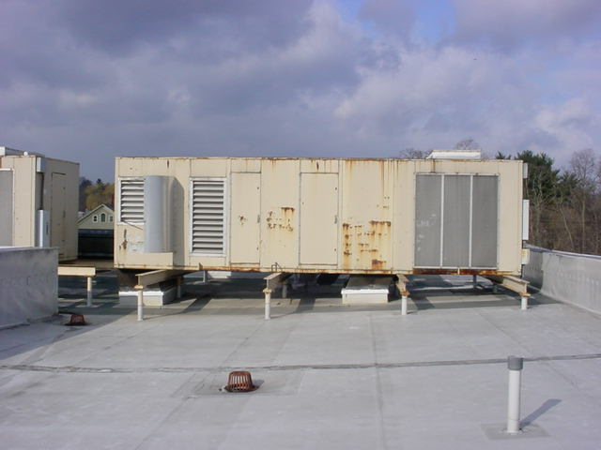

Rooftop Air Handling Unit

Picture 2

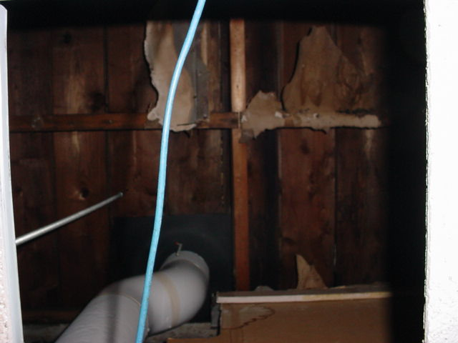

Wooden Roof Decking
Picture 3

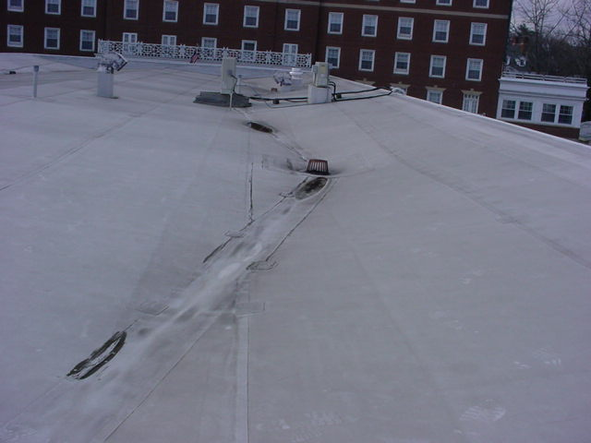

The Roof of the Building is Sloped Inward from the Exterior Walls

Picture 4

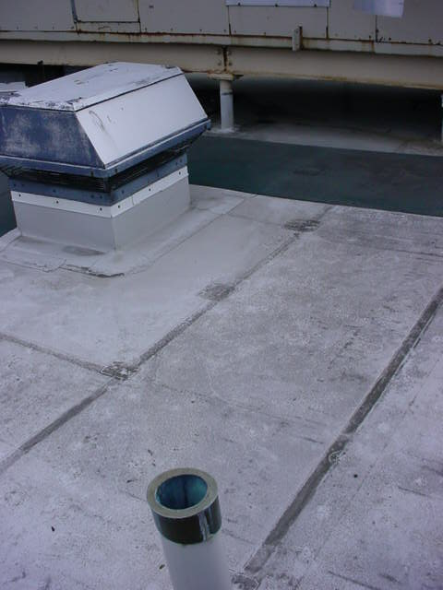

Exhaust Vent and Sewer Vent Pipe for the Restrooms

Picture 5

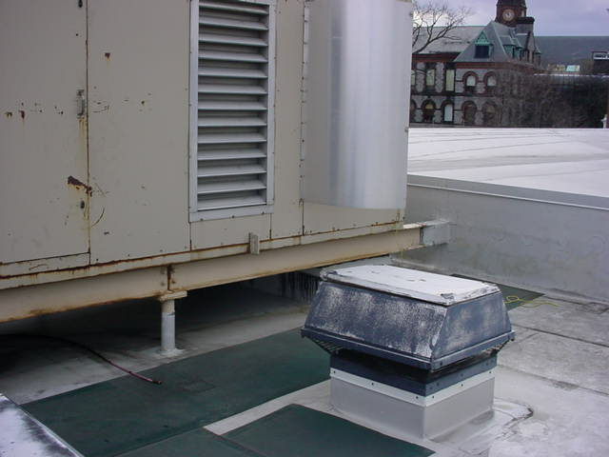

Exhaust Vents Are Located in Close Proximity to Fresh Air Intake
for the Rooftop AHU

Picture 6

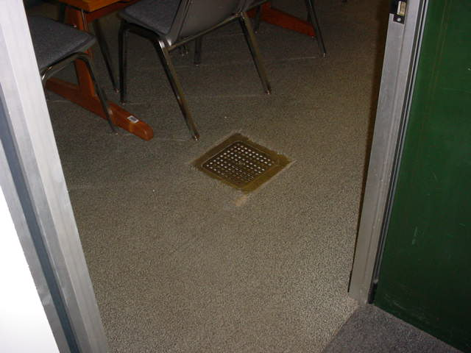

Unused Drain Was Found in the Floor of a Room in the Registry of Deeds Annex
Location | Carbon  Dioxide  (*ppm) | Temp  (°F) | Relative  Humidity  (%) | Occupants  in Room | Windows  Openable | Ventilation |  | Remarks
 |  |  |  |  |  | Supply | Exhaust | Remarks
Outside  (Background) | 379 | 75 | 24
Probate Court | 503 | 68 | 31 | 2 | N | Y | Y | Plants
Probate Court judge’s lobby | 646 | 70 | 32 | 0 | N | Y | Y
Probate Court main office | 617 | 71 | 31 | 11 | N | Y | Y | 3 water damaged ceiling tiles  Ozone generator  Humidifier  10+ computers
Probate Court break room | 643 | 73 | 25 | 0 | N | Y | Y | 1 water damage ceiling tile  Water cooler on carpet
Registrar of Probate Court office | 734 | 73 | 25 | 1 | N | Y | Y | Door open
Probate Court main office front desk | 667 | 73 | 25 | 4 | N | Y | Y
267 | 603 | 72 | 24 | 0 | N | Y | Y
Safe Plan office | 634 | 72 | 24 | 0 | N | Y | Y
2ND Assistant Registrar office | 605 | 72 | 24 | 1 | N | Y | Y
Assistant Registrar office | 703 | 73 | 25 | 1 | N | Y | Y | 2 missing ceiling tiles
251 | 606 | 73 | 25 | 3 | N | Y | Y
Probation hearing room | 589 | 70 | 26 | 0 | N | Y | Y | Plants  Door open
Probation judge’s lobby | 621 | 70 | 25 | 0 | N | Y | Y
Probation hallway | 680 | 71 | 27 | 4 | N | y | Y | 15 water damaged ceiling tiles  2 missing ceiling tiles  Plants
O’Riordan office | 615 | 73 | 26 | 0 | N | Y | Y | Door open
Aldridge office | 592 | 73 | 25 | 0 | N | Y | Y | Door open
Russell office | 615 | 74 | 25 | 0 | N | Y | Y | Door open
Registry of Deeds front desk | 615 | 74 | 25 | 1 | N | Y | Y
Plan room | 585 | 73 | 23 | 1 | N | Y | Y | Door open
Registrar of Deeds office | 615 | 74 | 23 | 0 | N | Y | Y | Plants  Door open
Registry of Deeds work area | 754 | 74 | 25 | 4 | N | Y | Y | 9 computers
Land court | 603 | 75 | 23 | 0 | N | Y | Y | Door open
Registry of Deeds computer mainframe room | 661 | 76 | 24 | 1 | N | Y | Y | Air condition without condensation drain  Door open
Registry of Deeds photocopier room | 655 | 75 | 23 | 1 | N | Y | Y | Photocopier odor  Door open
Registry of Deeds Annex | 623 | 75 | 24 | 0 | N | Y | Y | Abandoned drain  Door open

