Figuring it out together

Many families are worried about their child’s mental health, but they aren’t sure where to turn or how to get started. HandholdMA.org is here to help!

Who can help?
Should I be worried?

What can I do?

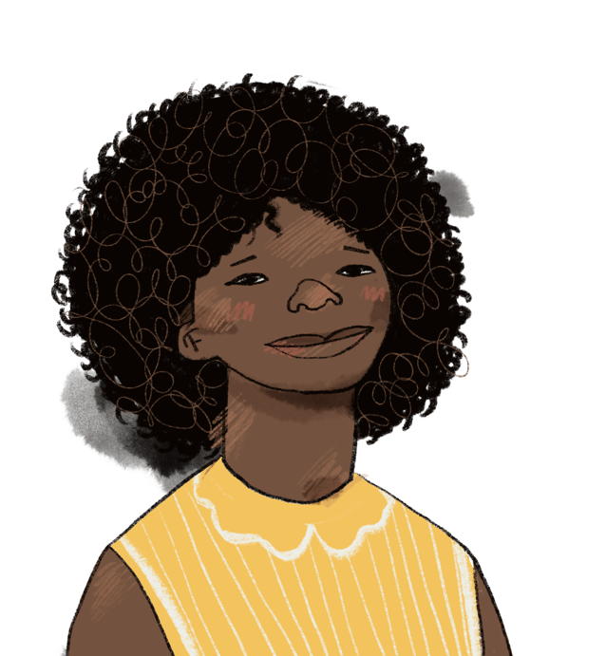

Scan the QR code to begin exploring HandholdMA.org today!

