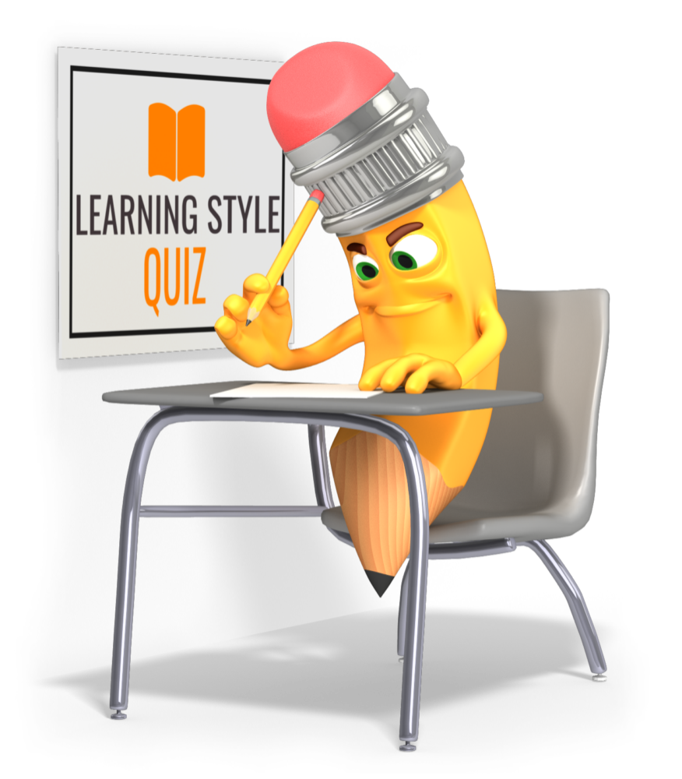
Read the following questions and circle the letter of the best answer in your opinion. There is no right or wrong answers to this quiz. Just circle what you usually prefer.

1. When learning how to use my computer, I prefer to:
A. Read the manual first
B. Have someone explain how to do it first
C. Just start using the computer and get help if I need it
2. When getting directions to a new location, it is easier to:
A. Look at a map
B. Have someone tell me how to get there
C. Follow someone or have them take me there
3. To remember a phone number, I:
A. Look at the number and dial it several times
B. Repeat it silently or out loud to myself several times
C. Remember the number by the pattern pressed on the keypad, the tones of
each number or by writing it down
4. For relaxation, I prefer to:
A. Read a book or magazine
B. Listen to or play music
C. Go for a walk or do something physical
5. I am better at:
A. Reading
B. Talking
C. Physical activities
6. In school, I learned best by:
A. Reading
B. Listening
C. Hands-on activities
7. I tend to be a:
A. Thinker
B. Talker
C. Doer
8. When I studied for a test, it worked best when I:
A. Read and pictured the information in my head
B. Read and said the ideas out loud or silently
C. Highlighted, wrote notes and outlines

9. It is easier for me to remember:
A. Faces
B. Names
C. Events
10. On a day off, I would prefer to:
A. See a movie
B. Go to a concert
C. Participate in athletics or be outside
11. In a college class, it was most important to have:
A. A good textbook with pictures, graphs and diagrams
B. A good teacher who had interesting lectures
C. Hands-on activities
12. It is easier to study by:
A. Reading and reviewing the material
B. Discussing the subject with others
C. Writing notes or outlines
13. When I get lost, I prefer to:
A. Look at the map
B. Call or ask for directions
C. Drive around the area until I recognize familiar landmarks
14. When cooking, I often:
A. Look for new recipes
B. Talk to others to get new ideas
C. Put it together and it generally comes out OK
15. When assembling an item such as a piece of furniture, I usually:
A. Read the instructions first
B. Talk myself through each step
C. Start putting it together and read the directions if I get stuck
16. When solving a problem, it is more useful to:
A. Read a best selling book on the topic
B. Talk over the options with a trusted friend
C. Do something about it
17. Which statement do you like the best:
A. A picture is worth a thousand words
B. Talk to me and I can understand
C. Just do it.
18. When I was a child, my parent said I:
A. Spent a lot of time reading, taking photos or drawing
B. Had lots of friends and was always talking to someone on the phone
C. Was always taking things apart to see how they worked

