|  |
| --- |
|  |
| Commonwealth of Massachusetts  Executive Office of Health and Human Services  **Virtual Gateway**  VG Logo 1_2009  Incident Management Module  Participant Guide  2014, Release 7.0 |

|  |
| --- |
|  |

Contents

[Introduction 3](#_Toc384651026)

[What is Virtual Gateway? 4](#_Toc384651027)

[How to Access Virtual Gateway 4](#_Toc384651028)

[What is HCSIS? 6](#_Toc384651029)

[HCSIS Modules 6](#_Toc384651030)

[History of HCSIS 7](#_Toc384651031)

[HCSIS Login and Navigation 7](#_Toc384651032)

[Access Overview 9](#_Toc384651033)

[Alerts Overview 9](#_Toc384651034)

## Introduction

Over the past several months, DDS, MRC and the University of Massachusetts Medical School (UMMS) have been working collaboratively towards transitioning case management responsibilities for the current Massachusetts Rehabilitation Commission (MRC) Acquired Brain Injury (ABI) and Money Follows the Person (MFP) community living waiver programs from UMMS to the Department of Developmental Services (DDS) & Massachusetts Rehabilitation Commission (MRC). In accordance with the Hutchinson Settlement Agreement, DDS is assuming responsibility for the oversight and monitoring activities for the residential ABI and MFP waivers, MRC will be responsible for the ABI & MFP non-residential waiver programs, and DDS will be responsible for the overall quality management and improvement system for all four waivers.

On April 14, 2014, the Home and Community-based Services Information System (HCSIS) will be available to newly assigned MRC and DDS staff and existing provider agencies to record incidents for individuals enrolled to the ABI and MFP waivers.

This Participant Guide is intended to supplement the HCSIS Incident Management (IM) module training sessions. The goal of the training is to provide users with an introduction to HCSIS and an opportunity to view the Incident Management processes within the system.

## What is Virtual Gateway?

Virtual Gateway provides a central portal for accessing programs and services offered by the Executive Office of Health and Human Services (EOHHS).

The Goal of Virtual Gateway is to streamline service access and coordinate service delivery. It serves three important groups:

* Consumers
* Service Providers
* Internal Health and Human Services (HHS) staff

### How to Access Virtual Gateway

* Obtain Virtual Gateway logins for new users in your organization. User Request Forms (URFs) are available through the HCSIS link under the “[Administration” section](http://www.mass.gov/eohhs/consumer/disability-services/services-by-type/intellectual-disability/provider-support/home-and-community-services-info/administration.html).” This URF contains the Incident Management (IM) roles to assign to new users.

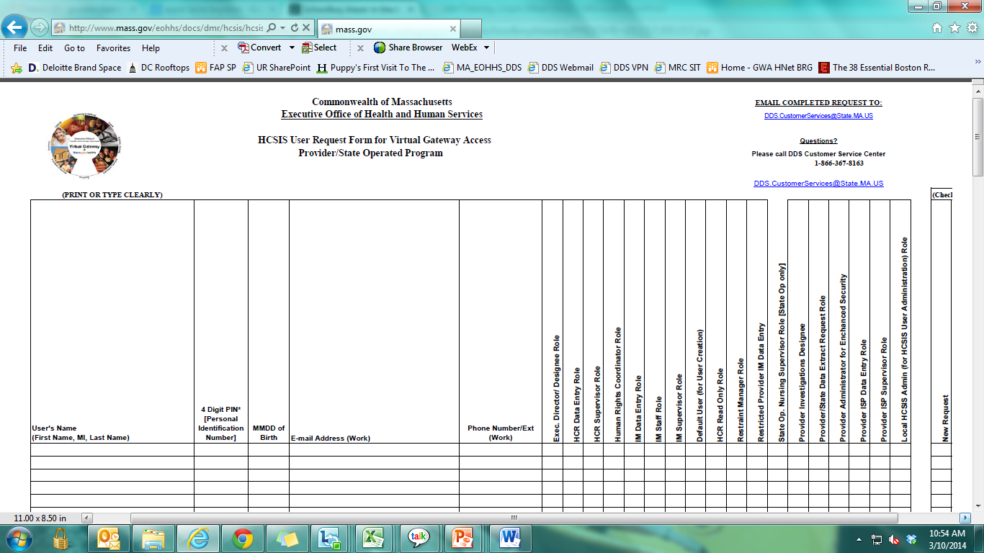

* Assign roles in HCSIS. You can assign roles to new users and change roles for existing users. Roles will be available in HCSIS on April 14, 2014. Roles must be assigned in order to start using the module.
  + For Provider Agencies, a HCSIS Administrator within your organization will be responsible for assigning roles in HCSIS once Virtual Gateway logins have been granted
  + For DDS and MRC staff, roles will be automatically assigned based on your current role within the organization
* Virtual Gateway is the entry point for HCSIS end users to log into the HCSIS application.

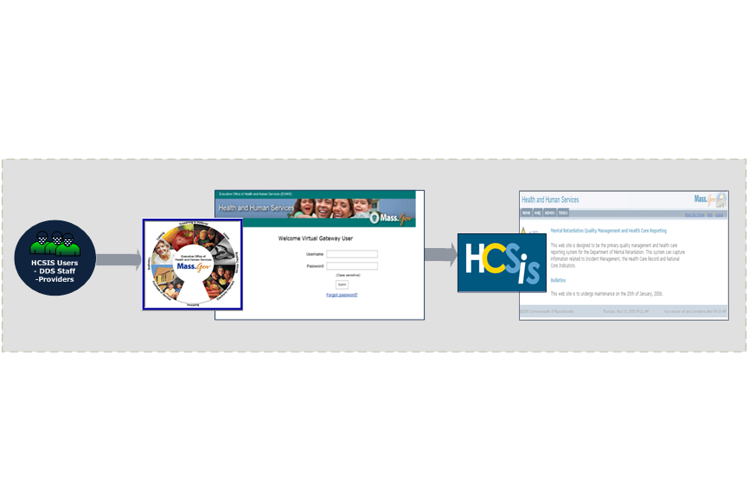

## What is HCSIS?

The Massachusetts Home and Community Services Information System (HCSIS) is a comprehensive system that allows the Department of Developmental Services (DDS) and provider agencies to more efficiently manage the reporting of incidents and other critical events, investigations of abuse and mistreatment, deaths, and health information for individuals they support. HCSIS provides a wide array of community-based and facility-based services to more than 34,000 individuals across the Commonwealth.

As of April 14, 2014, the Massachusetts Rehabilitation Commission (MRC) will begin using HCSIS for incident reporting.

Since its inception, HCSIS has provided several benefits for DDS:

* Enables the Department to achieve greater efficiency in its quality management efforts and to focus on follow up actions, trends and patterns
* Providers all users with access to a holistic view of an individual’s quality management and financial information in one place, rather than access to silos of information
* Allows Department and provider staff to have access to the same reports, leading to increased transparency
* Creates a greater sense of partnership, recognizing the shared goal of improving quality management for individuals with developmental disabilities within Massachusetts

### HCSIS Modules

There are several modules within HCSIS, as shown in the following graphic:

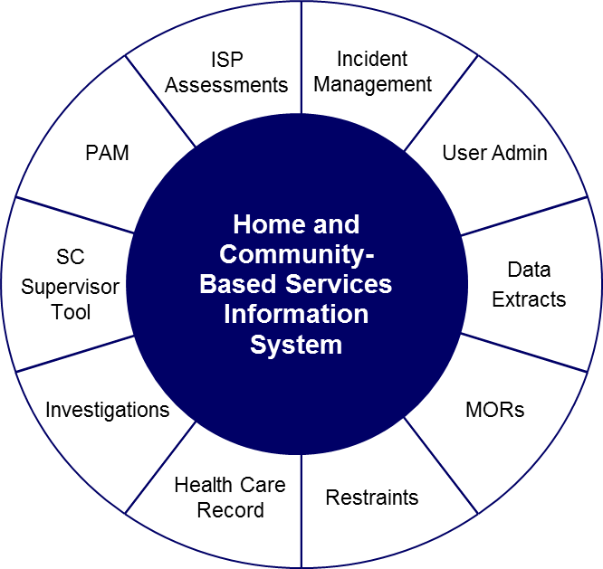

The mass.gov homepage provides detailed information about the HCSIS modules: <http://www.mass.gov/eohhs/consumer/disability-services/services-by-type/intellectual-disability/provider-support/home-and-community-services-info/>.

### History of HCSIS

HCSIS has been used by Department of Developmental Services’ staff and providers for the past seven years. The following timeline depicts some of the major milestones in the development of HCSIS since its inception.

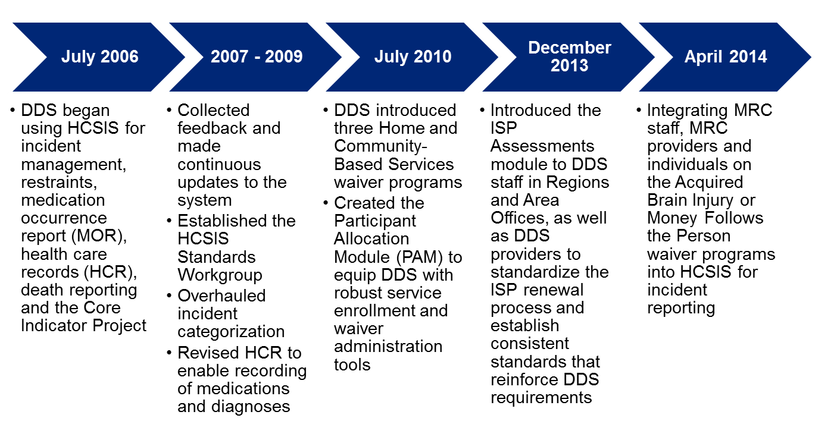

### HCSIS Login and Navigation

HCSIS can be access through the Virtual Gateway. Follow the steps below to access HCSIS.

1. Enter your Username and Password in Virtual Gateway.

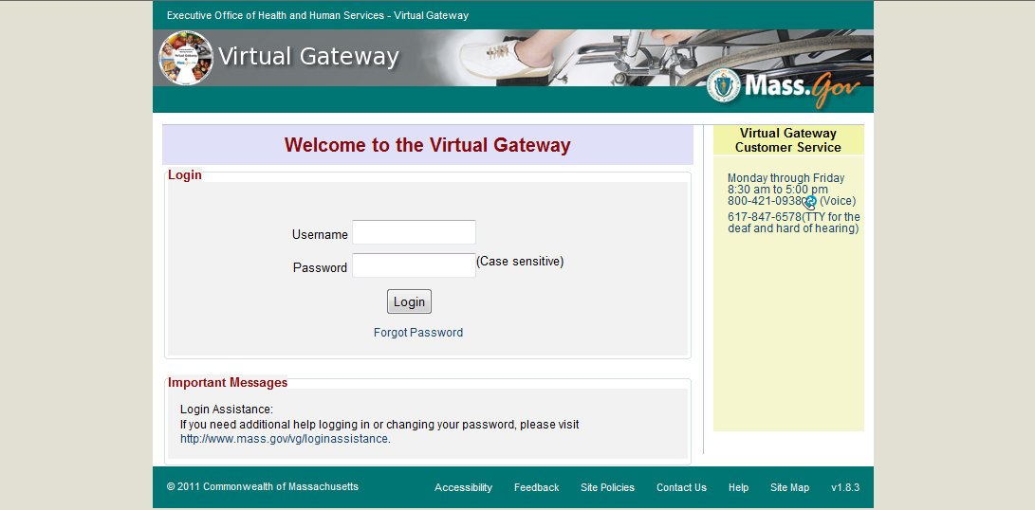

1. Select “Developmental Services Quality Management Reporting (HCSIS)”

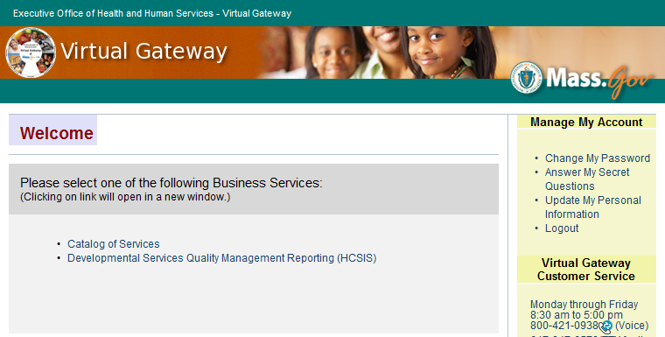

1. View the HCSIS Homepage

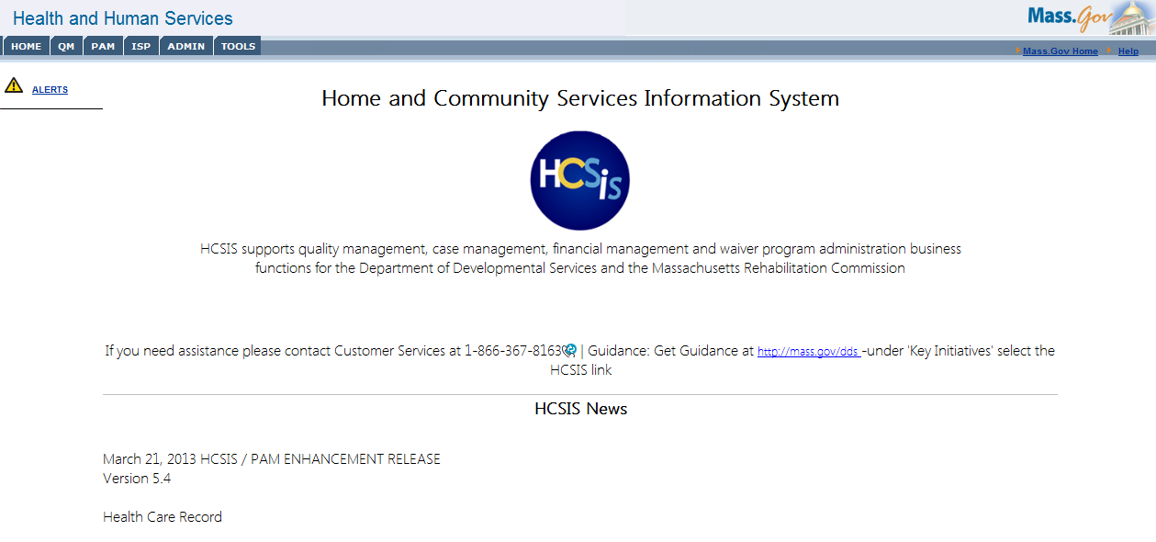

The HCSIS homepage has several features that will help you navigate the system:

* Home, QM, PAM, ISP, ADMIN and Tools tabs in the top left of the screen – these tabs will assist you in navigating to the different sections of the system
* Alerts hyperlink in the top left corner of the screen – this link will bring users to the alerts page, which we will cover in detail later in this participant guide
* Mass.gov link in the top right corner of the screen – this will bring you back to the Mass.gov website
* HCSIS Help Desk contact information in the middle of the screen – if you have any questions while using HCSIS, please feel free to call the Help Desk!
* HCSIS News is listed at the bottom portion of the screen – this section of the page will provide information on the latest updates to the system

### Access Overview

Access in HCSIS is determined by a combination of a user’s scope and role. **Scope** refers to what a user can see within the system (aka which individuals the user has access to), whereas **role** refers to the actions a user can perform within the system. For example, within the scope of “Provider Agency,” there are several roles available. Specific to Incident Management, one of the roles available within the “Provider Agency” scope is “IM Data Entry.” A user with the “Provider Agency” scope will be able to see all individuals within his or her agency and the “IM Data Entry” role limits the actions the user can perform to solely data entry actions. The graphic below depicts example scope and roles within provider agencies, DDS and MRC.

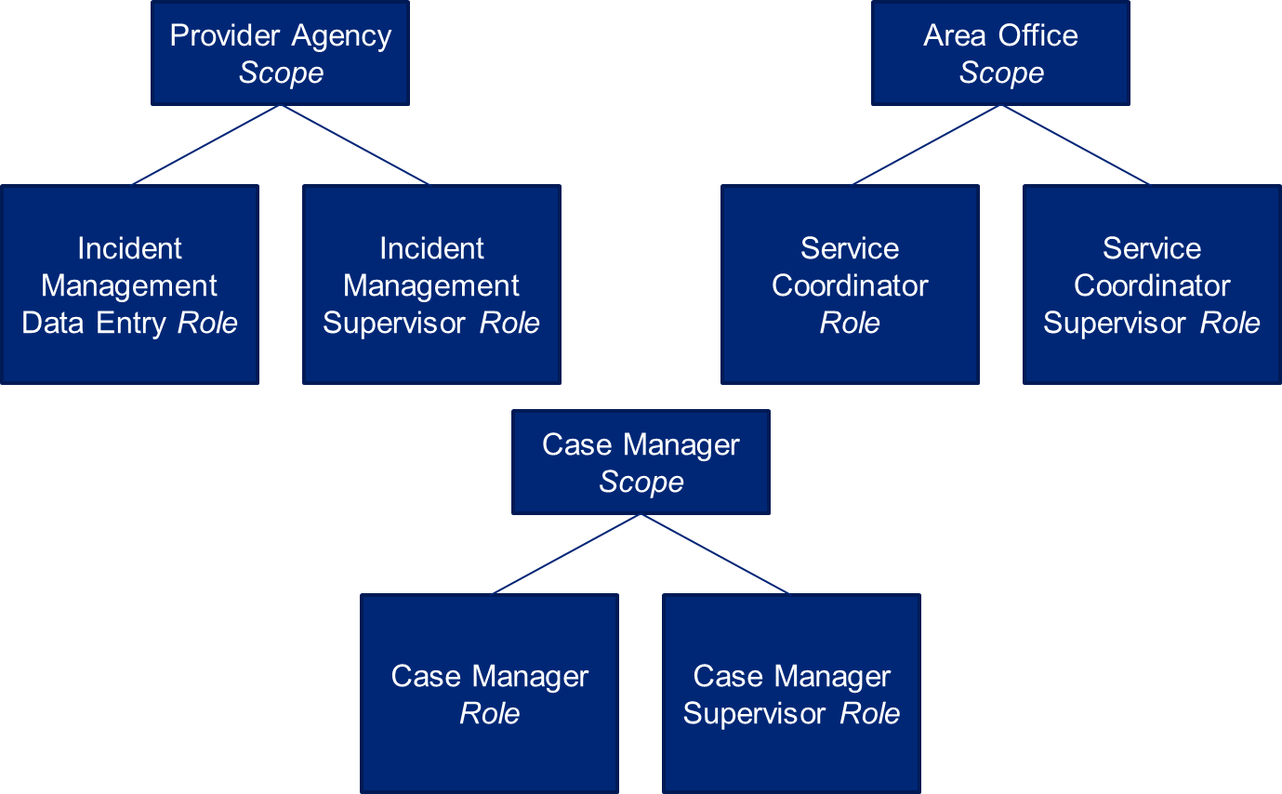

### Alerts Overview

An alert is a notification that is generated either by a module in HCSIS or as a result of an action taken by one or more users within a given module. The presence of alerts allows the HCSIS system to achieve its objective of enabling electronic submission and review of documents and reports and increase transparency between all service providers. The alerts are a valuable workload management tool to help users submit, review, and finalize materials on time and to eliminate duplication of effort.

Each module in HCSIS generates alerts for users depending on their role and scope in the system. There are 20 alerts that are specific to the Incident Management module. The number of alerts received depends on role, as well as whether or not the alert can be recurring based on an overdue action. The table below depicts all of the alerts for the Incident Management module by user.

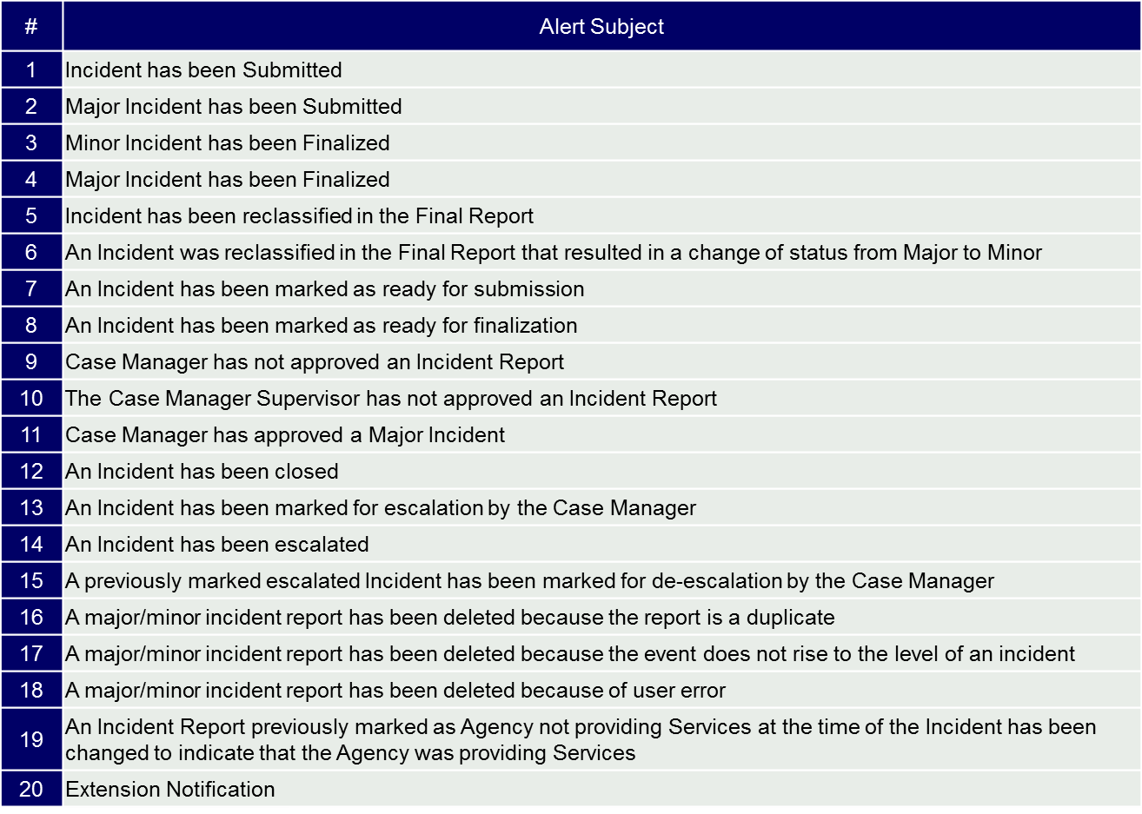

The process for viewing alerts will be discussed in this guide.