Contents
Incident Management Module Overview 1
What is the Incident Management module? 1
Events within Incident Management 2
Key Terms 2
Incident Management Responsibilities 3
Incident Reporting within the Incident Management Module 4
The Incident Report 4
Incident Categories 4
Incident Management Timeline 6
MRC versus DDS Incident Review Process 8
Incident Management Module Functionality 9
Scenario: Accessing the Incident Management Module 9
Functions of the Incident Management Module 11

Incident Management Module Overview

What is the Incident Management module?
The Incident Management (IM) module exists within the Home and Community Services Information System (HCSIS). This system performs 5 primary functions:

- Identify adverse events, potential jeopardy and factors related to risk.
- Notify key people involved in the planning and support of the involved individual.
- Trigger a response to protect the individual and minimize risk.
- Collect and analyze information about individuals, services, providers and the overall system.
- Identify patterns and trends to guide service improvement efforts.

In addition to these functions, the Incident Management system emphasizes closing the loop with agreed upon action steps to address causes for each incident and enhance the probability that the incident will not recur. It is a mechanism for documenting all activities related to an incident from initial observation or knowledge of an incident to follow-up and closure.

The Massachusetts Rehabilitation Commission (MRC) and the Department of Developmental Services (DDS) will use the Home and Community Services Information System (HCSIS) to achieve these five functions to support the safety and welfare of individuals on the ABI, MFP and adult DDS waivers. DDS staff and providers currently use the system for Incident Management and other functions. MRC staff and providers will begin using HCSIS on April 14, 2014.

Events within Incident Management
There are 5 types of events that can be reported within the Incident Management module, some of which can only be reported for individuals on certain waivers:

Event | Definition | Population
Individual Incident Report | An incident that pertains to one individual only | All DDS and MRC
Medication Occurrence Report (MOR) | A Medication Occurrence is defined as a breach of one of the five “R’s”, namely right individual, right medication, right time, right dose and right route | DDS and ABI/MFP Residential only
Optionally Reportable Event (ORE) | An event that does not meet the threshold of an incident, but that a provider agency would like to log nonetheless. These events will not be seen to MRC or DDS staff. | All DDS and MRC
Site Level Incident | An event that occurs at a site and impacts all individuals identically | DDS and ABI/MFP Residential only
Restraint | An event that requires the use of restraints on an individual | DDS only

Key Terms
The following terms will be used frequently throughout the Incident Management Module and related materials.
- In Progress: This term is used when a document has been created but is not finalized
- Submitted: This term is used when the initial report has been completed and sent to DDS or MRC
- Finalized: This term is used when the final version of a document has been completed and sent to DDS or MRC (Note: a finalized report is not necessarily approved)
- Closed: This term is used when the report has been approved at all necessary levels of review (Note: a closed report has been approved)
- Events: This term refers to Incident Reports, Medication Occurrence Reports and Optionally Reportable Events. Each event receives a unique Event ID when it is created.
- First Level Review: The First-Level Review is the first level review for all incidents. For incidents that require a minor level of review, this is the only review necessary
- Second Level Review: The Second-Level Review is the second level of review for incidents that require a major level of review

Incident Management Responsibilities

Role | Role Description
Provider | Responsible for:  - Submitting the intial and final incident report via HCSIS  - Revising and resubmitting the incident report if necessary
MRC Staff | Responsible for:  - Conducting the first and second level of review  - First-Level: Case Manager  - Second-Level: Case Manager Supervisor  - Revising incident categories if necessary  - Returning the incident report to providers if necessary  - Approving/ closing the incident
DDS Staff | Responsible for:  - Conducting the first and second level of review  - First-Level: Area Office  - Second-Level: Regional Office  - Revising incident categories if necessary  - Returning the incident report to providers if necessary  - Approving/ closing the incident

Incident Reporting within the Incident Management Module

The Incident Report
An incident report must be completed for any incident that can compromise the safety and well-being of an individual. The incident report has two sections, the Initial Incident Report and the Final Incident Report.

Initial Incident Report
The initial incident report is completed immediately after the incident is discovered and can be submitted without complete event details.
There are 7 sections of the initial report:
- Individual Information Screen- all information pertaining to the individual can be viewed as it is drawn in from MEDITECH
- Filing Agency Classification- all information pertaining to the filing agency can be viewed as it is drawn in from MEDITECH
- Incident Classification- a primary and secondary category for an incident are selected after providing details on the nature of the incident. For more information on the primary and secondary categories, please see the “Incident Categories” section of this guide.
- Incident Description- the event is fully described to include the date, time, involvement and status of the individual relative to the incident
- Actions Taken- the actions taken to protect the health, safety and rights of the individual are outlined
- Involved Parties- all involved parties and their contact information is listed
- Notifications- the filing agency notes who was notified about the event

Final Incident Report
The final incident report is completed within 7 days of the initial incident report and fills in any gaps and builds upon the information in the initial incident report.
There are 4 sections of the final incident report:
- Additional Information- any additional details of the event are reported
- Action Steps- allows the filing agency to input any information on action steps that have been taken to promote the health, safety and rights of the individual since the incident has occurred
- Involved Parties- the filing agency will update or add any information about parties other than the individual who were involved in the event
- Verification of Time and Categorization- allows the filing agency the opportunity to review the event information, make updates and even adjust the incident classification

Incident Categories
The selection of incident category on the incident classification screen defines the level of review that is necessary. The chart below shows the options for primary and secondary category of review; those categories in bold automatically require a major level of review. The exception to this rule is the Unexpected Hospital Visit incident category; additional details on this incident category can be found following the Incident Category table.

Primary | Secondary
Unexpected/Suspicious Death | Accidental, Suicide, Unusual Circumstances or Other Unexpected/Sudden Death
Suicide Attempt | First Known Attempt or Repeat Attempt
Unexpected Hospital Visit | Medical Hospitalization, Psychiatric Hospitalization, ER Visit or Emergency Psychiatric Services Evaluation
Inappropriate Sexual Behavior | Aggressive Sexual Behavior – Alleged Victim and/or Alleged Perpetrator or Sexual Misbehavior – Alleged Victim and/or Perpetrator
Victim of Physical Altercation | N/A
Significant Behavioral Incident | Involves a Physical Altercation or Does Not Involve a Physical Altercation
Missing Person | Law Enforcement Contacted or Law Enforcement Not Contacted
Medical or Psychiatric Intervention Not Requiring a Hospital Visit | Medical or Psychiatric
Fire | Alleged Started by Individual, Not Started by Individual – Fire of Known Origin or Fire of Unknown Origin
Suspected Mistreatment | Alleged Victim of Psychological Abuse, Alleged Victim of Verbal Abuse, Alleged Victim of Physical Abuse, Alleged Omission – Failure to Provide Needed Supports or Alleged Omission – Failure to Provide Needed Supervision
Property Damage | Alleged Victim or Alleged Perpetrator
Theft | Alleged Victim or Alleged Perpetrator
Other Criminal Activity | Alleged Victim or Alleged Perpetrator
Transportation Incident | Pedestrian, Motor Vehicle Accident or Other
Emergency Relocation | N/A
Unplanned Transportation Restraint | N/A
Other | N/A

Unexpected Hospital Visit Level of Review
An incident that is classified as an Unexpected Hospital Visit defaults to requiring a minor level of review. However, when a Reason for Hospital Visit is selected, the incident may require a major level of review based on the reason provided. The following table depicts which reasons would require a major level of review:
Reason for Hospital Visit – Requiring a Major Level of Review
Near Drowning
Inappropriate Sexual Behavior - Aggressive Sexual Behavior - Alleged Victim
Inappropriate Sexual Behavior - Aggressive Sexual Behavior - Alleged Perpetrator
Victim of Physical Altercation
Significant Behavioral Incident
Missing Person - Law Enforcement Contacted
Fire - Allegedly Started by Individual
Fire - Not Started by Individual
Fire - Source unknown
Suspected Mistreatment - Alleged Victim of Psychological Abuse
Suspected Mistreatment - Alleged Victim of Verbal Abuse
Suspected Mistreatment - Alleged Victim of Physical Abuse
Suspected Mistreatment - Alleged Omission - Failure To Provide Needed Supports
Suspected Mistreatment - Alleged Omission - Failure To Provide Needed Supervision
Other Criminal Activity - Alleged Victim
Other Criminal Activity - Alleged Perpetrator

Incident Management Timeline
The Incident Management Module has been designed to cover the process of incident reporting from the initial report through the required level(s) of review. This module has the features necessary to complete each step in the process as outlined in the timelines below.

Minor Level of Review
An incident requiring a minor level of review is one that can compromise the safety of an individual and as a result, requires timely notification to key people and a prompt and appropriate response to protect the individual and to minimize risk. An incident that requires a minor level of review only has one level of review. For an incident requiring a minor level of review, the initial incident report must be submitted within three business days of the date of incident discovery. The final report must then be completed within seven days of the initial report submission.

While the timelines are the same, the involved parties in the review processes differ for DDS and MRC. For incidents for individuals on the DDS waivers or programs, the first level of review is referred to as the Area Office Management Review (AOMR) and is conducted at the DDS Area Office Level. At MRC, the first level of review is called the Incident Report Review (IRR) and is conducted by a Case Manager, and in some cases, a Case Manager Supervisor. This review must be completed within 7 days of the submission of the final report.

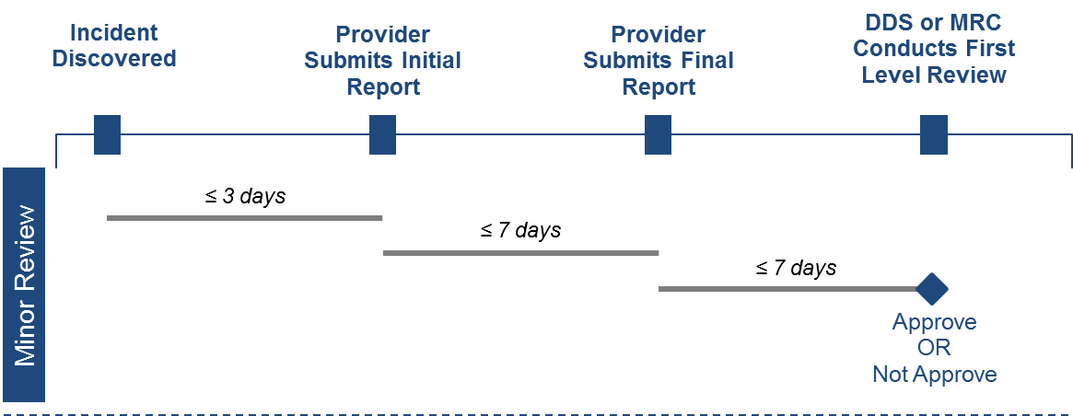

Major Level of Review
An incident requiring a major level of review is one that can compromise the safety of an individual and as a result, requires timely notification and a prompt response and meets one of the following criteria:
- Suspected mistreatment where there is a life threatening result
- Where staff action or failure to act exposes the individual to series personal or public safety risk
- Has the potential for broad, negative publicity in the media
- Law enforcement is involved in any capacity

The initial incident report for an incident that requires a major level of review must be submitted within one day of the incident discovery. The final incident report must be completed and finalized within seven days of the initial incident report submission. The incident will then undergo two levels of review. At DDS, this review is referred to as the Regional Office Management Review (ROMR) and occurs at the DDS Regional Office Level. At MRC, the second level of review is called the Secondary Incident Report Review (SIRR) and is conducted by a Case Manager Supervisor. This review must be completed within 7 days of the completion of the first level of review.

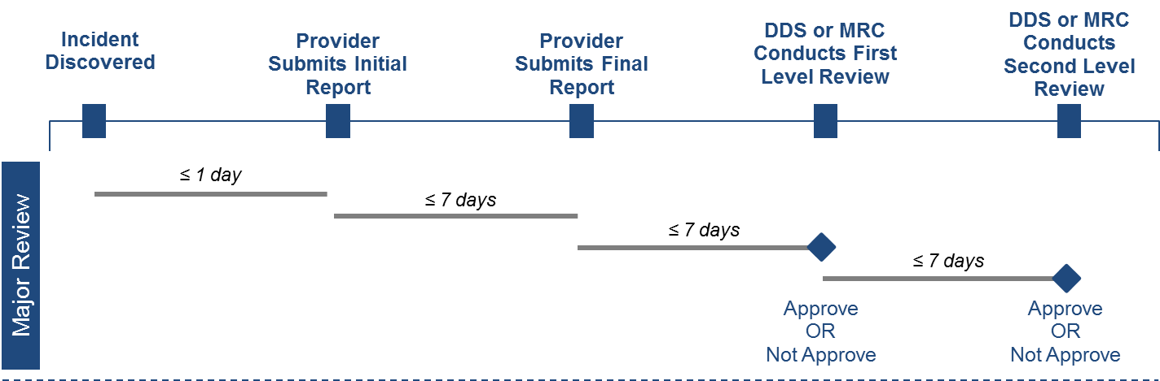

MRC versus DDS Incident Review Process
There are minor differences between the incident review process at DDS compared to the review process at MRC. The table below breaks down those differences:

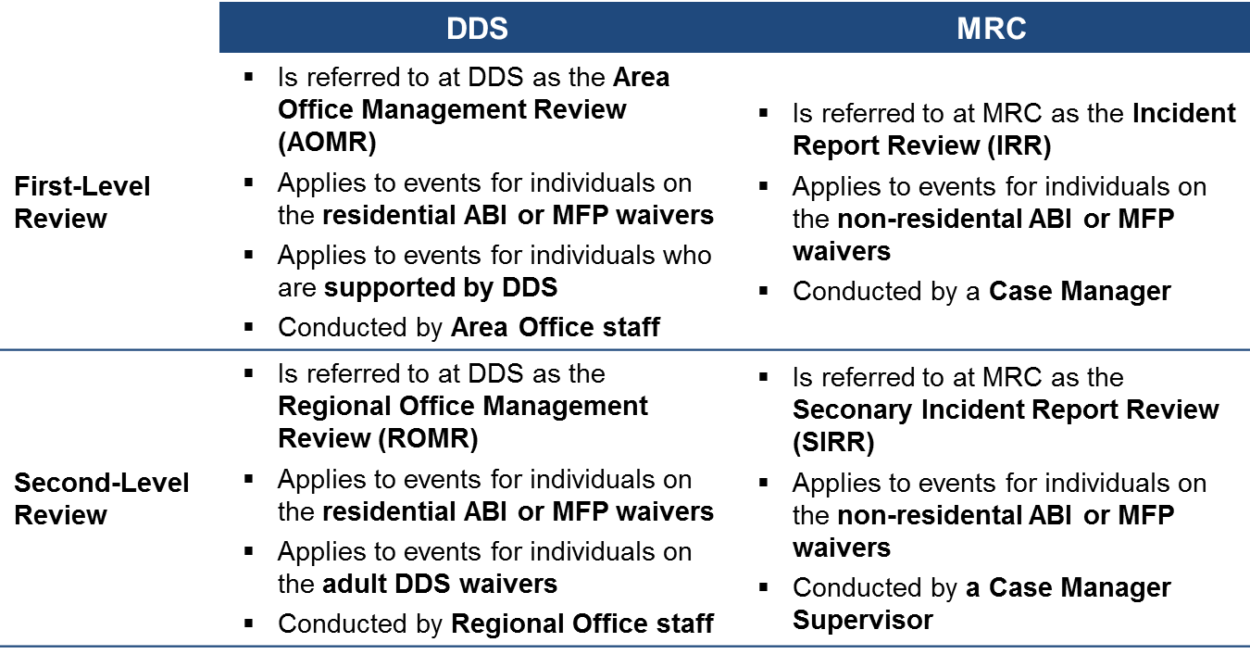

Incident Management Module Functionality

Scenario: Accessing the Incident Management Module
Access to HCSIS is obtained through the Virtual Gateway portal. All HCSIS users will have a Virtual Gateway login. Provider organizations will need to register new users in order to grant access to the system. Once logged in to Virtual Gateway, the user will select HCSIS and navigate to the Quality Management module, and the Incident Management module.
Steps
- Access the Virtual Gateway using this link: https://gateway.hhs.state.ma.us/authn/login.do.
- Login to the Virtual Gateway with username and password.

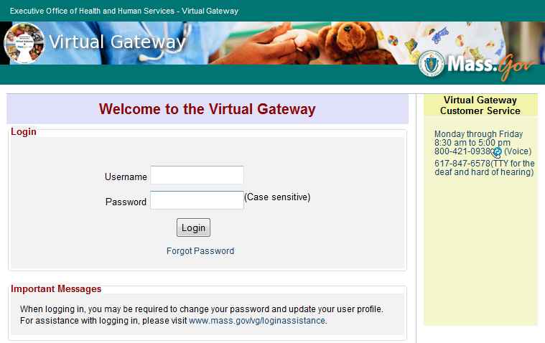

- Click the “Developmental Services Quality Management Reporting (HCSIS)” hyperlink to access HCSIS.

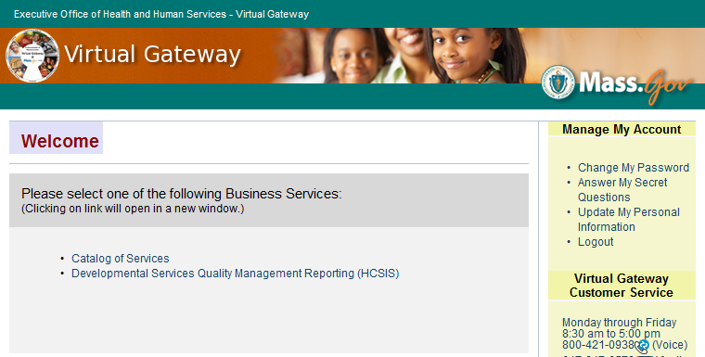

- This is the homepage for HCSIS. There are useful announcements and updates on this page that are consistently refreshed. From here, you can navigate to any of the modules using the tabs on the top left of the screen. Click the “QM” tab to access the QM module.
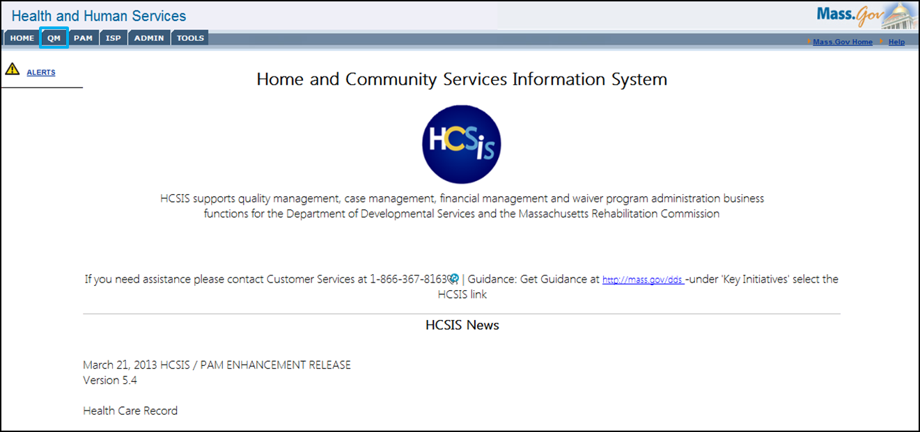
- After clicking the QM tab, the system returns the page shown below.

Within Quality Management, we can see that there are additional modules beyond Incident Management including:
  - Health Care Record (HCR): The Health Care Record (HC-5) is a form for gathering and organizing an individual’s medical history and records in a single document
  - Death Reporting: Where providers report the passing of an individual
  - National Core Indicators (NCI): Supports the National Core Indicator Surveys administrated by the National Association of State Directors of Developmental Disabilities Services (NASDDDS) and the Human Services Research Institute (HSRI)
  - Investigations: Track and maintain complaints of abuse or mistreatment reported to the Disabled Persons Protection Commission (DPPC)
  - Reports: Develop, request and review a management report on incidents within the QM module.
Note: The only modules available to MRC staff and MRC providers as of April 14, 2014 will be the Incident Management and Reports modules.

- Select the IM item from the sub-menu

- The following page will appear with the Incident Management sub-menu options

Functions of the Incident Management Module
The Incident Management Module has a variety of menu options to serve the needs of users and individuals in creating, finalizing and reviewing reports, managing workload, and accessing resources. These options, which will be detailed further below, are as follows:
- Event Data Entry
- Site Level Data Entry
- Restricted Access
- Report Extension
- Provider Filing Process Management
- State Agency Review Process Management
- Help

Event Data Entry
The Event Data Entry section is where Providers, DDS staff and MRC staff can search for an individual, view an individual’s event history, and create events for that individual
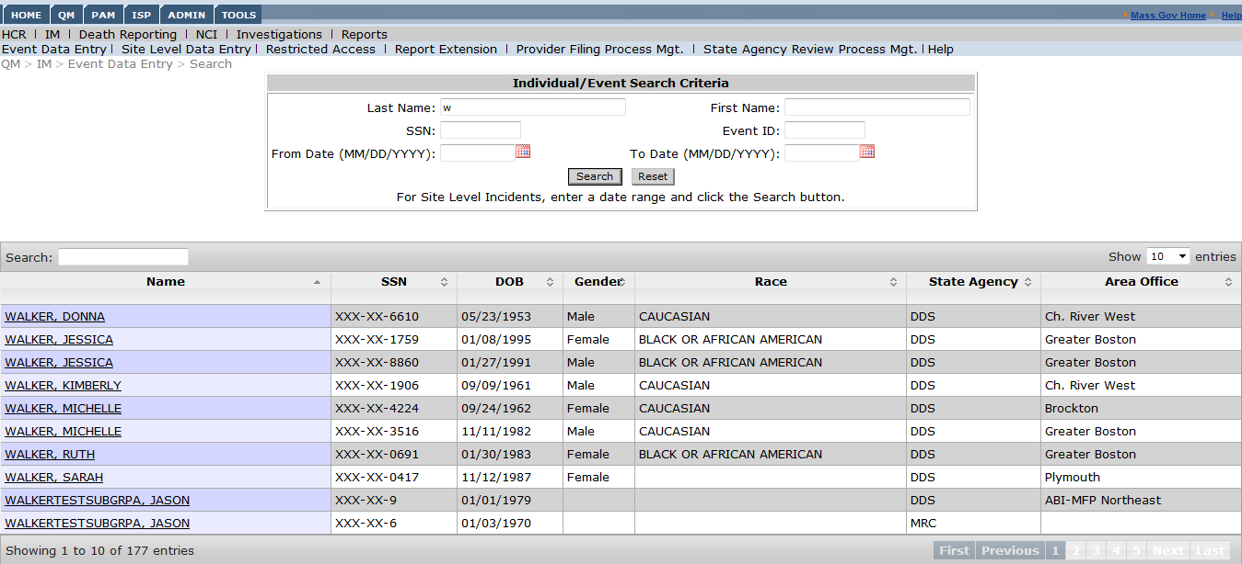

Site Level Data Entry
Site level incidents are those incidents where more than one individual is involved and the impact for all individuals is identical. If the incident results in an injury for one or more individual or if the follow up action is different for each individual, separate incidents must be recorded for each individual involved.
- Please note that providers who serve only individuals on the non-residential ABI/MFP waivers will not be able to create site-level incidents at this time.
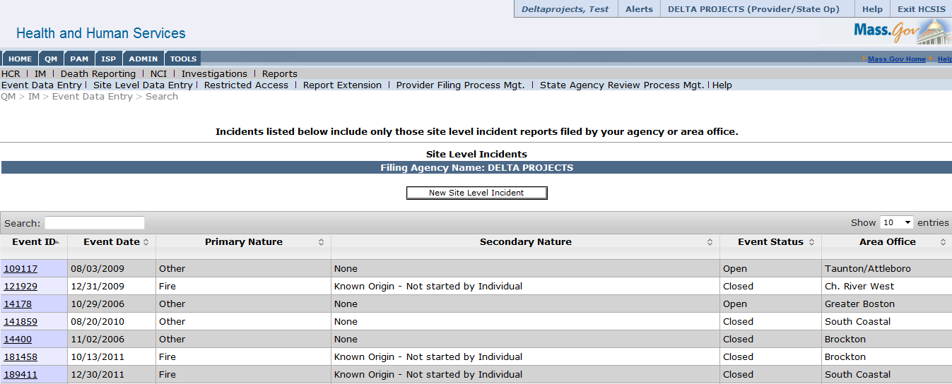

Restricted Access
The Restricted Access screen allows Incident Management Provider Supervisors, Case Managers, Case Manager Supervisors and Service Coordinator Supervisors to restrict access to certain events in an individual’s event history. This function is particularly useful for provider agencies who would like to restrict access to an individual to certain staff within their agency.
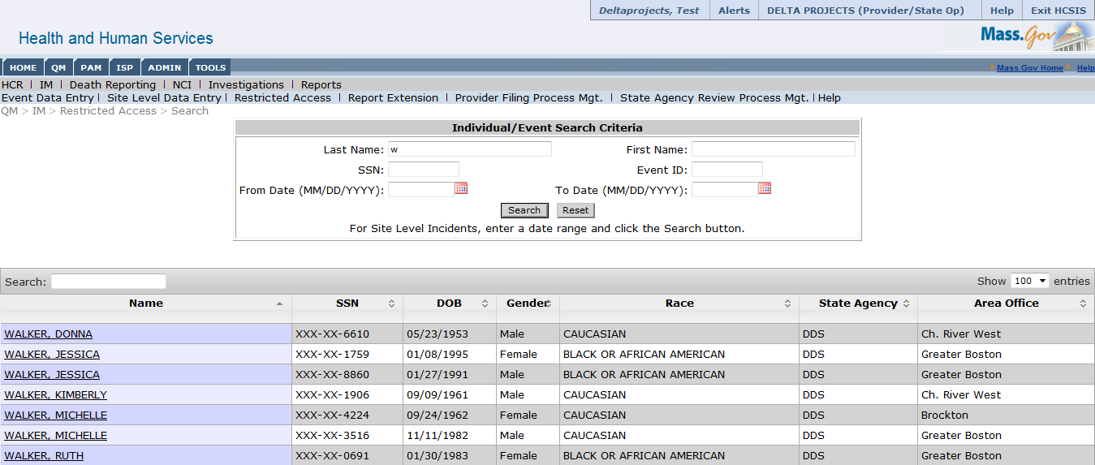

Report Extension
This screen can be used to input a report extension. Only Incident Management Supervisors, Case Managers, Case Manager Supervisors and Service Coordinator Supervisors can create an extension for a report.
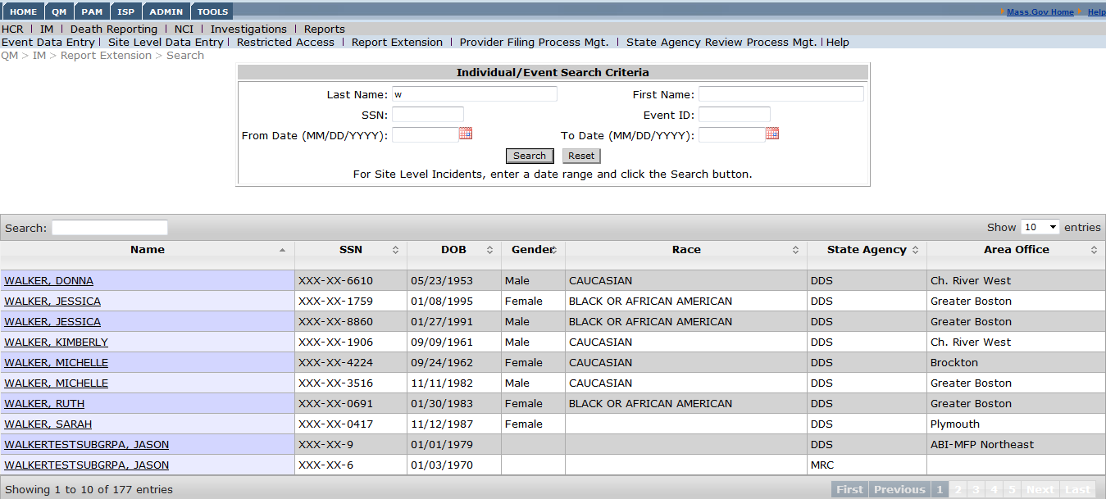

Provider Filing Process Management
This screen allows Incident Management Supervisors, Case Managers, Case Manager Supervisors and Service Coordinator Supervisors to view the latest milestone for each event from the perspective of the provider agency. The tool shows a summary of the next steps for an event from the perspective of the provider agency. The participant guide will cover how to use Provider Filing Process Management as a workload management tool in a later section.
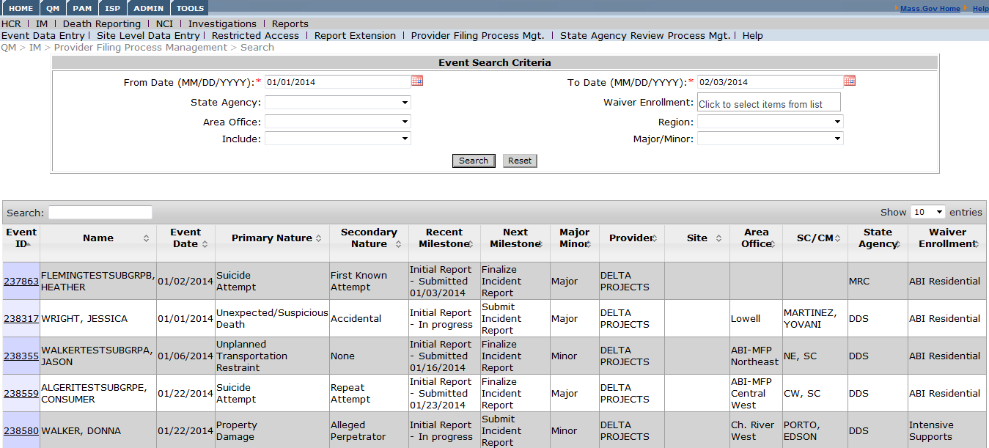

State Agency Review Process Management
This screen shows Incident Management Supervisors, Case Managers, Case Manager Supervisors and Service Coordinator Supervisors where each event is in regards to the review process conducted by DDS or MRC. The tool shows a summary of the next steps for an event from the perspective of the state agency that is responsible for reviewing the event. The participant guide will cover how to use the State Agency Review Process Management as a workload management tool in a later section.
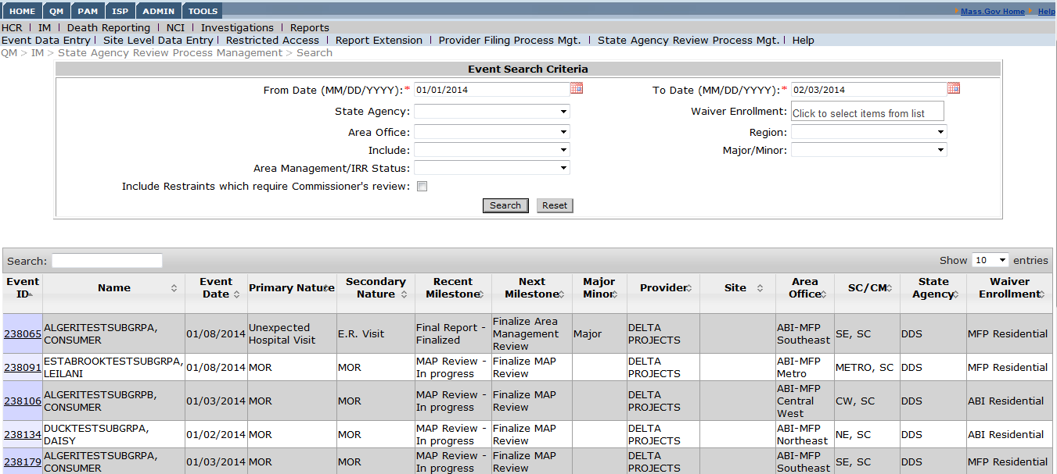

Help
This screen provides useful resources for the Incident Management module
