Contents
The Incident Report 1
Incident Report Overview 1
DDS Incident Report vs. ABI/MFP Incident Report 1
Scenario: Viewing an Individual’s Event History 2
Scenario: Create and Submit an Initial Report 5
Scenario: Review and Finalize an Incident Report 13
Scenario: Delete an Incident 21

The Incident Report
A reportable event is one that can compromise the safety and well-being of an individual, thus making it rise to the level of an incident. The incident requires timely notification to key people and a prompt and appropriate response to protect the individual and minimize risk. The Department of Developmental Services and the Massachusetts Rehabilitation Commission have reviewed their current incident reporting practices to develop a revised incident reporting process that meets the needs of all DDS and MRC consumers.

Incident Report Overview
The Incident Report provides a comprehensive overview of the incident that occurred, key details of the incident, individuals involved in the incident, follow up steps and additional information that is important to protect the individual, reduce risk of further incidents, and analyze trends.

When an Incident Report is created, the incident must be assigned a primary category. A secondary category should be assigned when available. These categories determine whether or not the incident necessitates a minor- or major- level of review. An initial incident report is submitted immediately after the event and is finalized within a week. The Incident Reporting timeline is shown below.

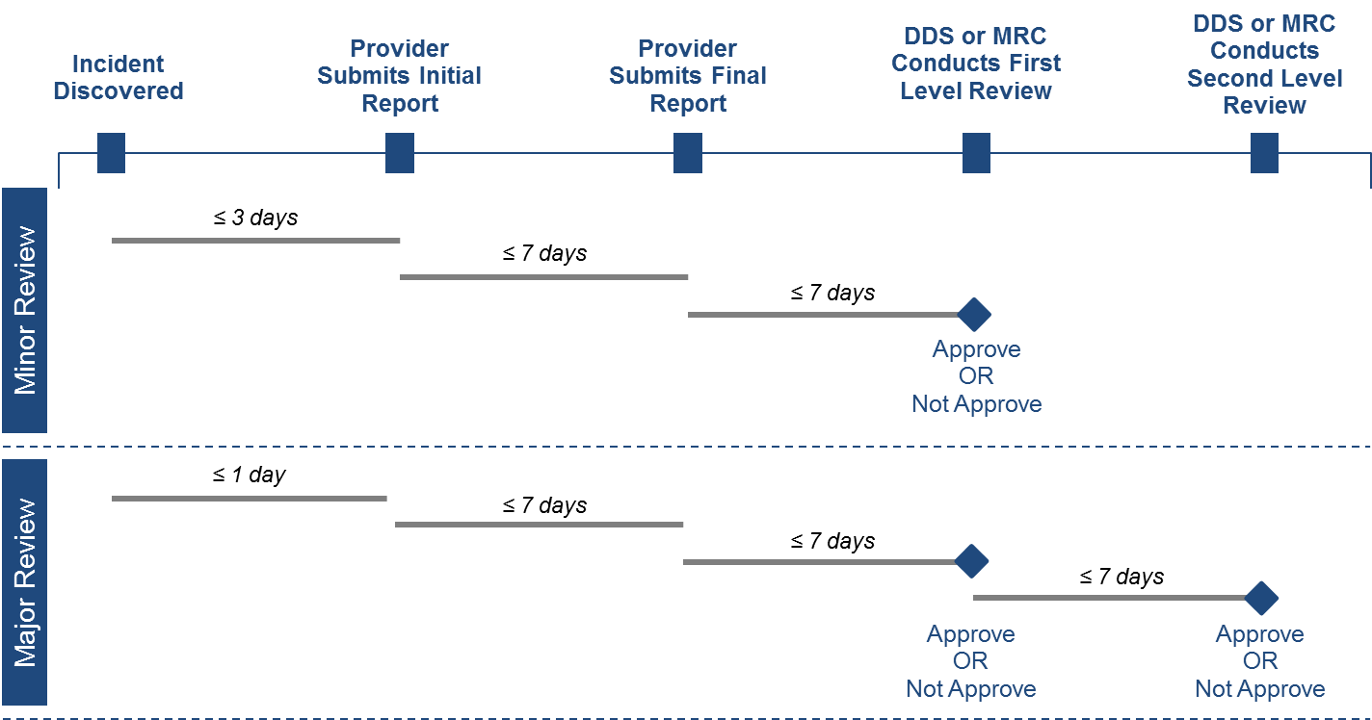

DDS Incident Report vs. ABI/MFP Incident Report
While the Department of Developmental Services and the Massachusetts Rehabilitation Commission have collaborated to develop an incident reporting process that meets the needs of all consumers, the varying characteristics of these individuals necessitate two slightly different versions of the incident report. The DDS version of the incident report will be used for all individuals enrolled to the adult DDS waivers whereas the ABI/MFP incident report will be used for all individuals enrolled to the ABI and MFP waivers. There are only three prompts which vary between the two reports, neither of which require action on the part of the user filling out the report in HCSIS as the responses to these prompts are automatically populated with information from MEDITECH. The different prompts can be found in the Individual Information section of the incident report, and are outlined in the table below:

Individual Information Section of the Incident Report
Prompt | On the DDS  Incident Report? | On the ABI/MFP Incident Report?
Level of Intellectual Disability
Does the individual have an acquired brain injury?
Class Status

Scenario: Viewing an Individual’s Event History
In order to view past reports, create new reports, and conduct first and second levels of review, a user must access an individual’s event history in HCSIS. Follow the steps below to view an individual’s event history screen.

Scenario Description:
- A user needs to view the event history of an individual
- This may occur at any time and is not restricted to the occurrence of a new event

Roles and Responsibilities:
- Providers (all roles): View event history for individuals in their caseload
- Provider Supervisor: View event history for individuals in their caseload
- MRC Case Manager: View event history for individuals in their caseload
- MRC Case Manager Supervisor: View event history for individuals in their caseload
- MRC Central Office Oversight: View event history for individuals in their caseload
- DDS ABI/MFP Service Coordinator: View event history for individuals in their caseload
- DDS ABI/MFP Service Coordinator Supervisor: View event history for individuals in their caseload
- DDS ABI/MFP Regional Staff: View event history for individuals in their region in read-only mode

First Steps:
- The user logs into HCSIS

Scenario Steps:

- Navigate to the Quality Management Module

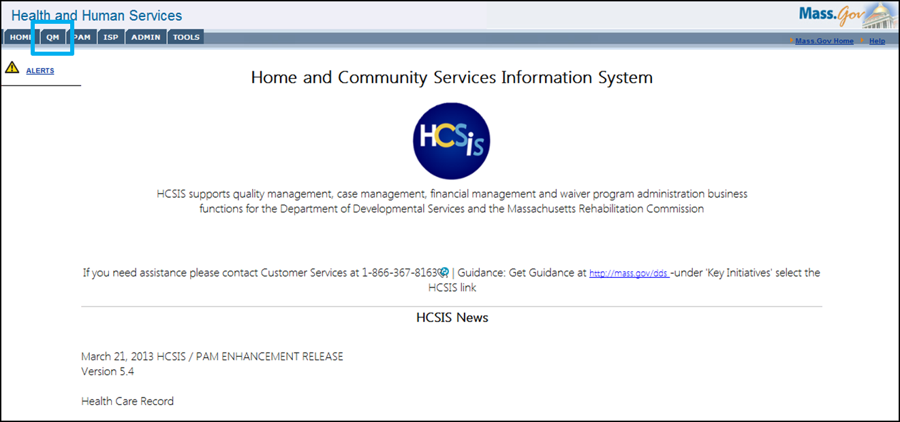

- Navigate to the Incident Management Sub-Module via the IM menu item

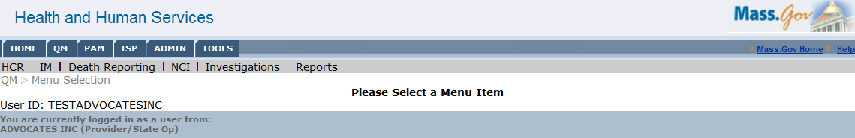

- Navigate to the Event Data Entry Screen
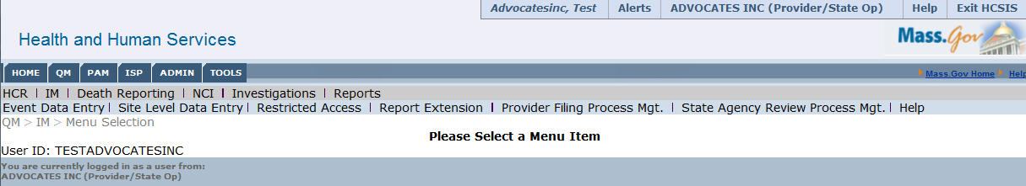

- Search for an Individual

This screen allows you to search for individuals by; Last Name, First Name, SSN, and Event ID. It is not necessary to know complete details of the individual; the results will include partial matches which contain the information entered in the search parameters.
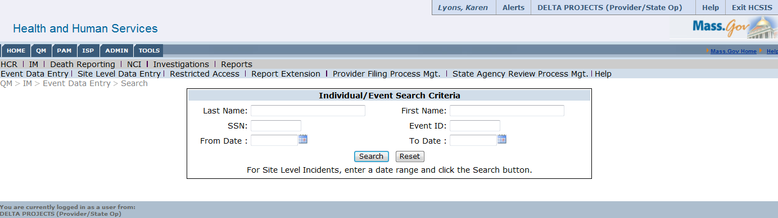

- Select an Individual from the Search Results Grid

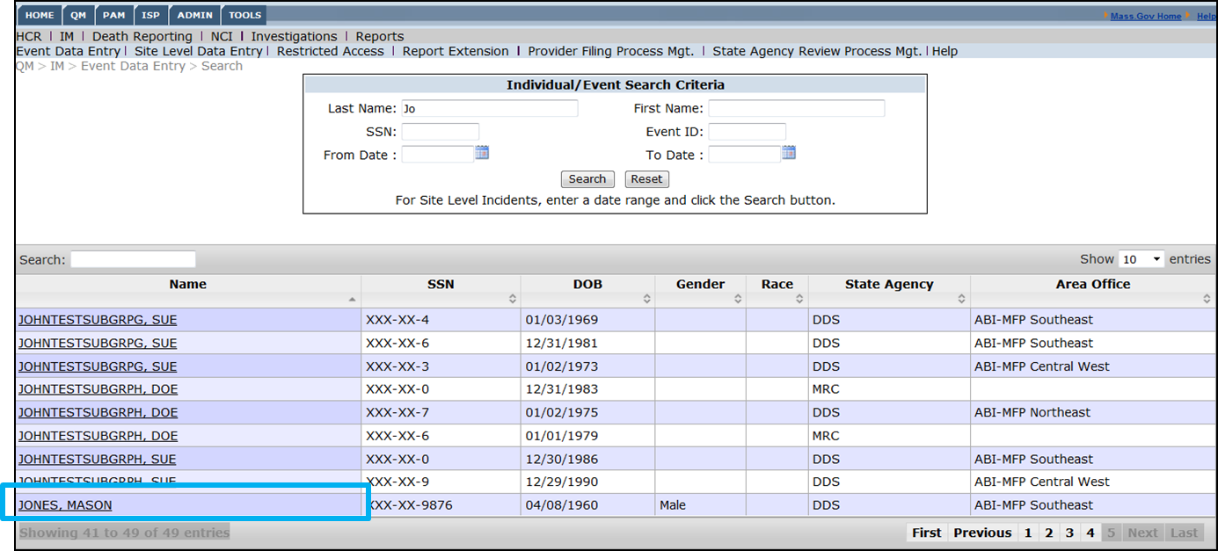

Once the user enters search criteria and clicks search, a grid will appear populated with the matching individuals, their SSN, Date of Birth, Gender, Race, State Agency and Area Office. The user will only see those individuals they have permission to access. There are a few features of this grid that will allow for easier navigation.
  - First, the grid contains a search box (see #1 in the screenshot below) which allows a secondary search of the results. All columns will be searchable by any text entered in this box.
  - Second, next to each of the column labels you will notice an up and down arrow (see #2 in the screenshot below). Clicking on these arrows will filter the results by that column in ascending or descending order.
  - Finally, should there be more search results than fit on one page, the bar at the bottom right of the grid allows easy navigation between pages (see #3 in the screenshot below).
  - Additionally, the drop down menu at the top lets the user change how many results are visible per page (see #4 in the screenshot below).

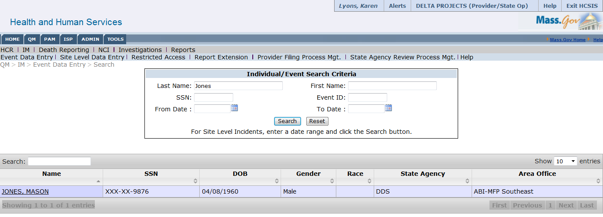

4

1
2

3

- Navigate the Event History Page

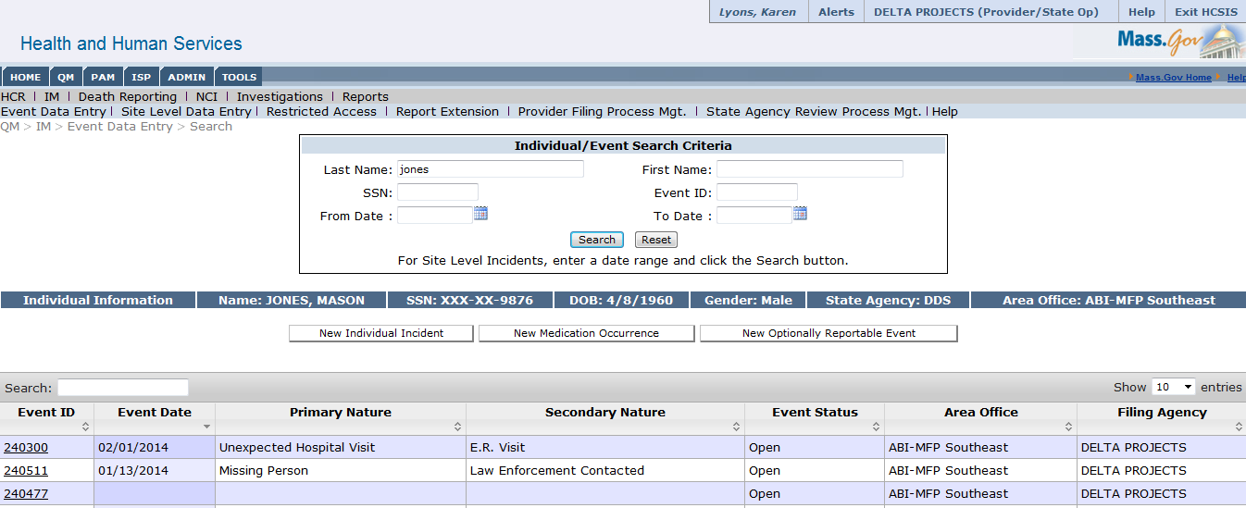

Scenario: Create and Submit an Initial Report
The following steps will outline how to create and submit an initial incident report. This report will need to be submitted according to the timeline shown below. For incidents that require a minor-level of review, the initial report must be submitted within 3 business days. For incidents that require a major level of review, the initial report must be submitted within 1 business day. Please note that this guide will follow the incident reporting and review process for an incident that requires a major-level of review.
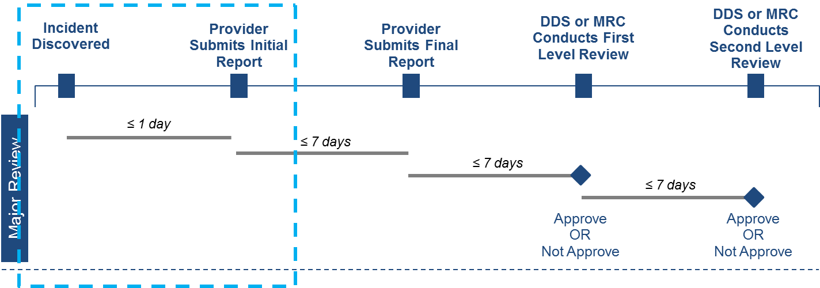

Roles and Responsibilities
- The following users can create and submit an initial report
  - Providers (all roles)
  - Case Managers
  - Case Manager Supervisors
  - Service Coordinators
  - Service Coordinator Supervisors
  - ABI/MFP Regional Staff

First Steps
- The user logs into HCSIS via the Virtual Gateway
- The user navigates to the Quality Management (QM) module

Scenario Steps
- Navigate to the IM Sub-Module

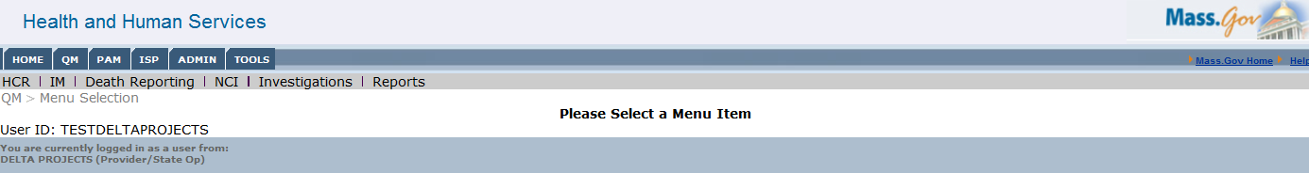

- Navigate to the Event Data Entry Screen

- Search for an Individual

- Select an Individual

- View Individual’s Event History
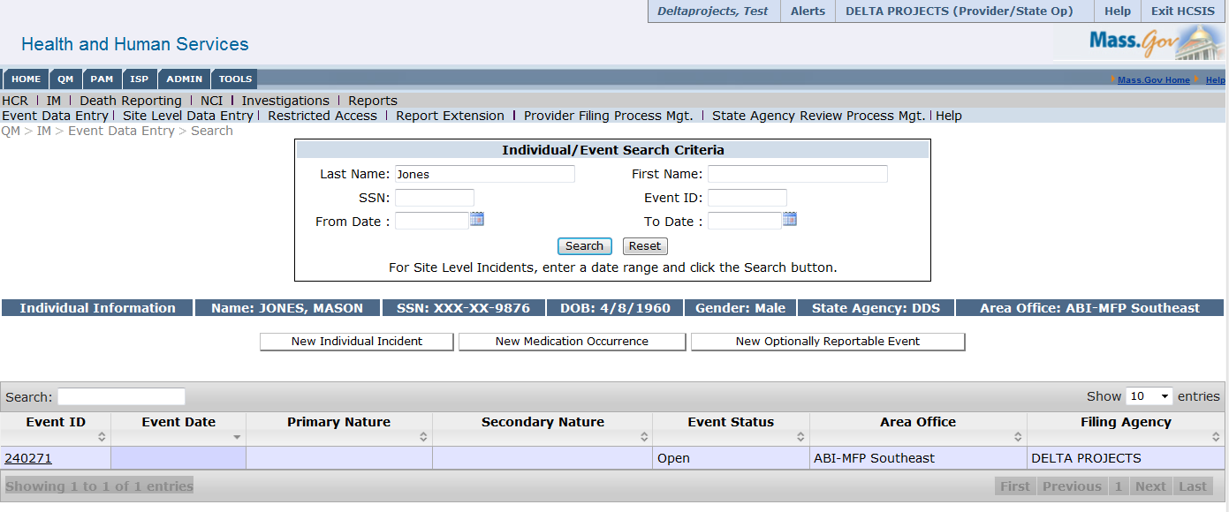

- Create New Report
  - Select New Individual Incident

The test individual used in this scenario is enrolled in an ABI/MFP residential waiver under DDS and the user entering the incident is a provider user, so the user is able to create individual incidents, medication occurrences and optionally reportable events. For individuals enrolled in DDS state and waiver programs, the user will additionally be able to create a new restraint. Since restraints are not permitted for the ABI/MFP population, this is not an option for the test individual. The types of reports that are able to be created will automatically adjust for the individual selected based on the role of the user creating the incident and the enrollment for the individual.

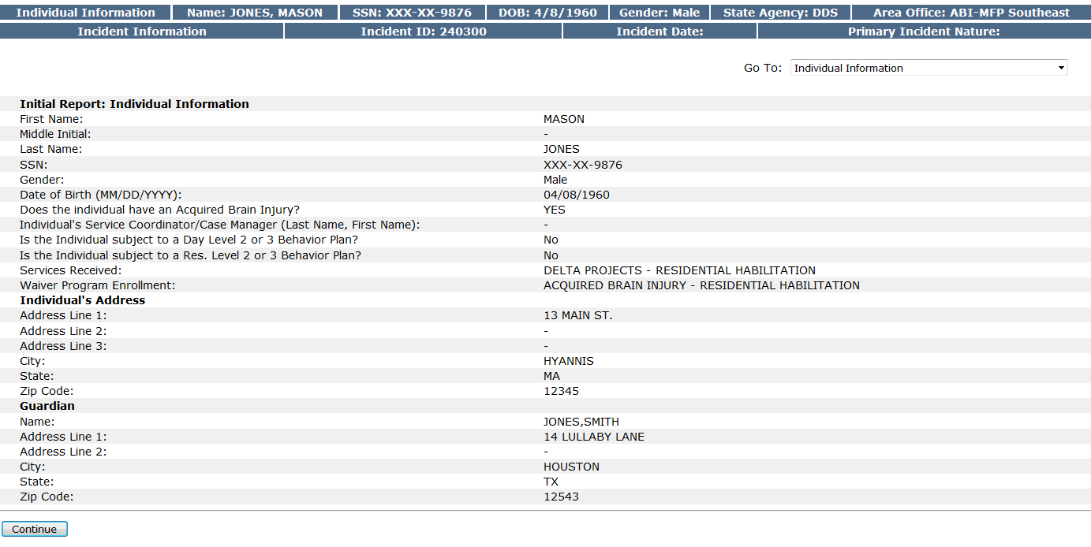
  - Review Individual Information Screen

This screen is automatically populated with information MEDITECH. While this screen requires no input from the user, review the information to ensure accuracy before continuing with the report.

To move to the next screen you can either select “Continue” on the bottom left of the screen, or jump to a specific screen with the “Go To” drop-down on the upper right of the incident report screen.

  - Complete Filing Agency Information
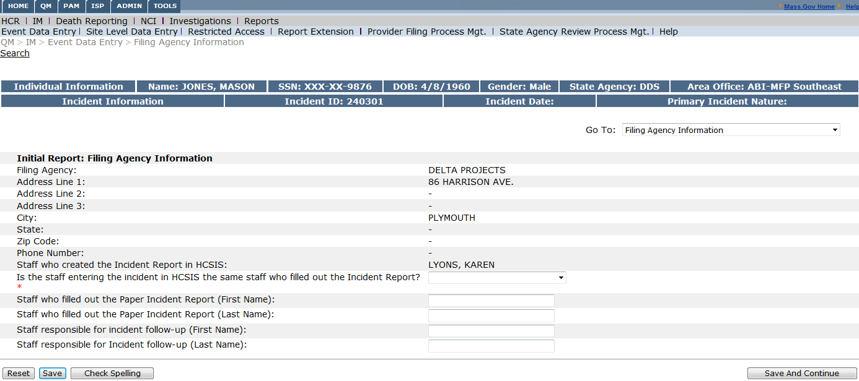
This screen is partially populated with information about the filing agency. The user is required to fill out whether or not the staff entering the incident in HCSIS is the same staff member who filled out the incident report, and details about these individuals.

  - Complete Incident Classification

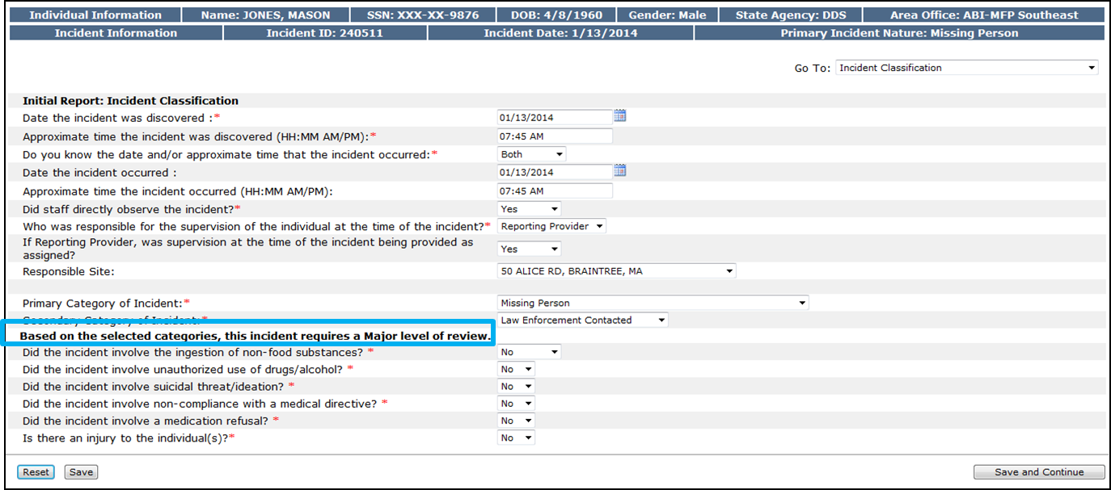

The Incident classification screen requires further detail input about the incident including:
    - Date and time of discovery and incident
    - Incident Observation
    - Responsible Individuals
    - Circumstances around the incident including use of unauthorized substances and medical non-compliances
Once a primary and secondary category of incident is selected, a prompt will appear classifying the incident as requiring a major or minor level of review. If the incident involves an injury to the individual, additional prompts will appear requiring detailed information about the injury type and severity, as well as treatment.

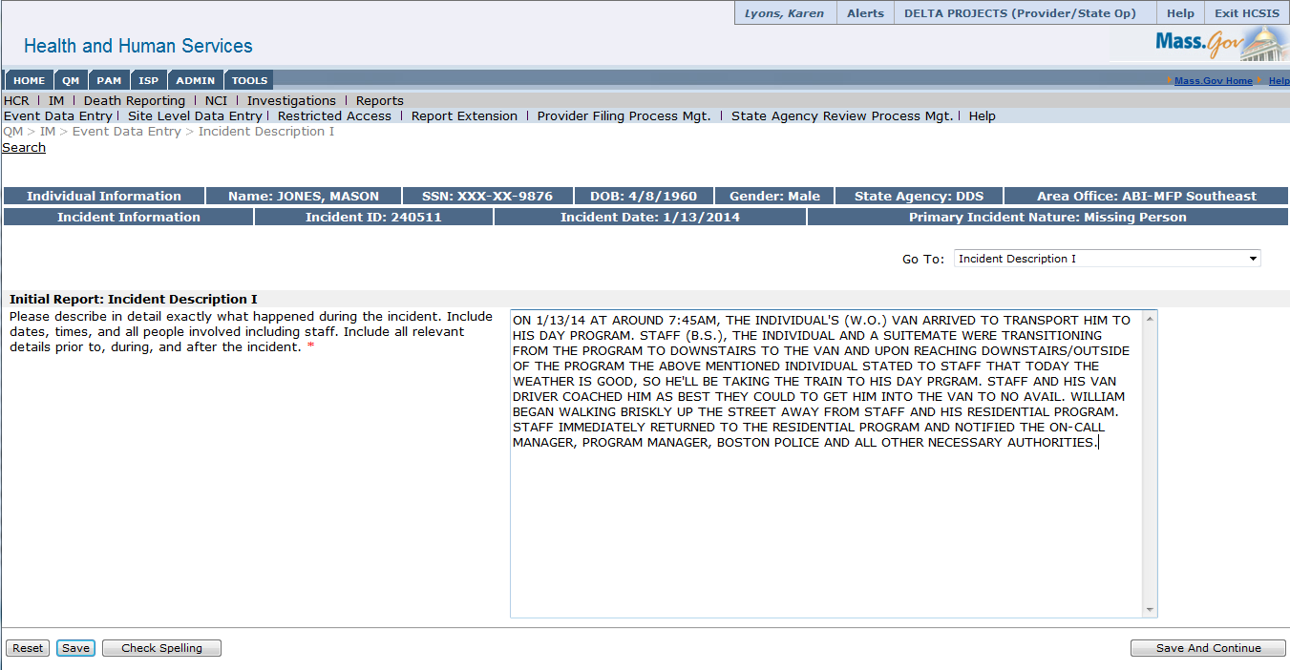
  - Complete Incident Description I

This section of the report contains a text box that allows the user to provide a detailed description of the incident that may not be captured in other sections. This includes dates, times, and involved individuals relevant prior to, during, and following the incident. Input is mandatory, and it is necessary to provide adequate detail.

  - Complete Incident Description II
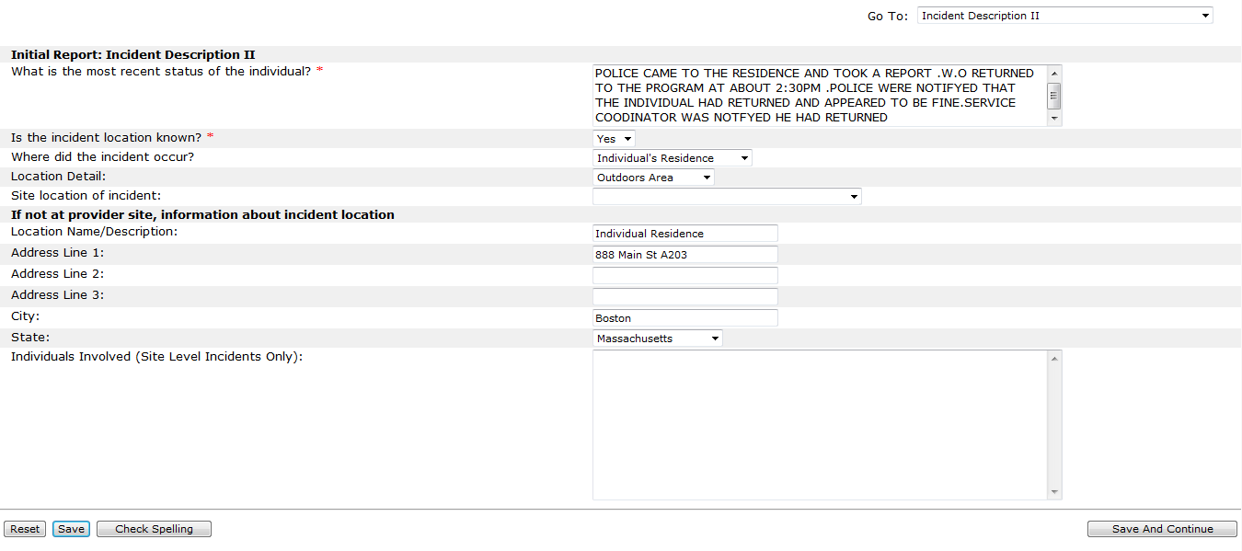
This section requires input regarding the most recent status of the individual, as well as further details about the incident location details.

  - Fill out Actions Taken to Protect Health, Safety and Rights

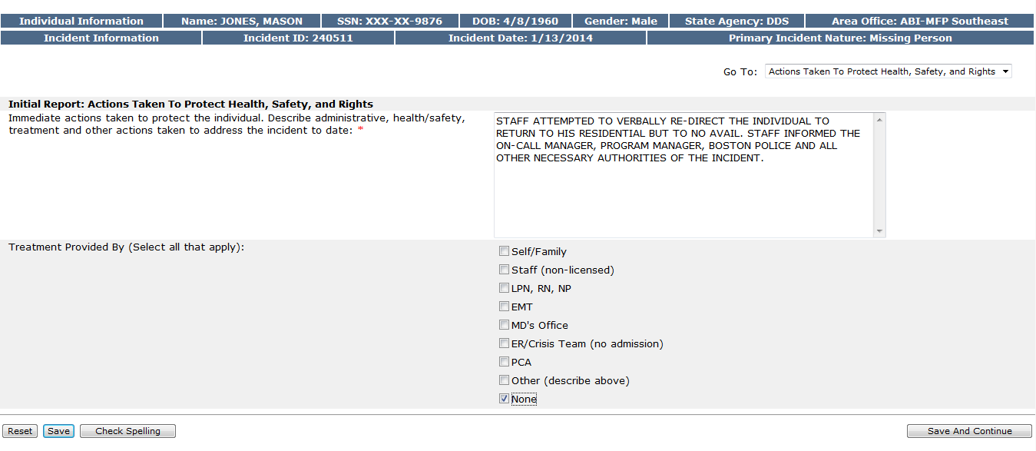
This section requires input regarding actions taken and treatment administered as a result of the incident.

  - Complete Involved Parties

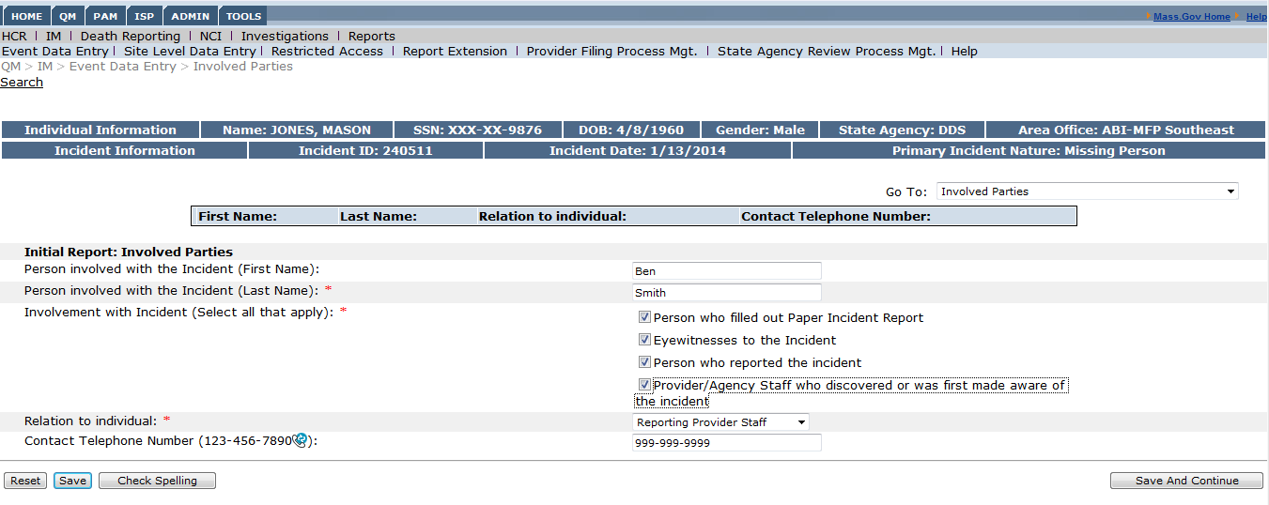
On this screen you may add all involved parties in the incident. Once an individual is added, they will appear in the search box above the form and are able to be edited or removed if necessary.

  - Complete Notification Screen

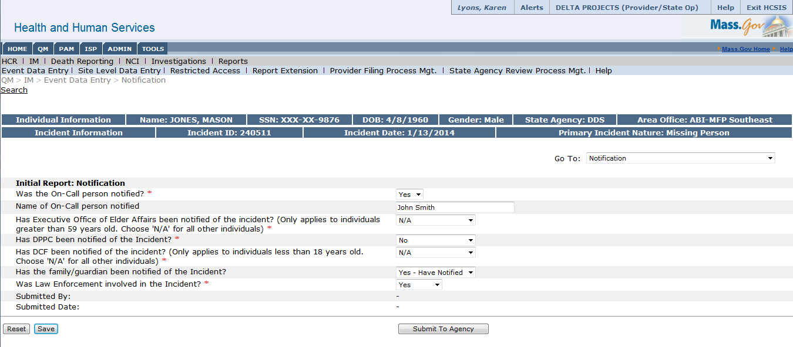
This screen requires information about those individuals notified of the incident. Some of the fields are conditionally mandatory, for example responding “Yes” to “Was the On-Call person notified” will make the “Name of On-Call Person Notified” field mandatory.

  - Submit Report
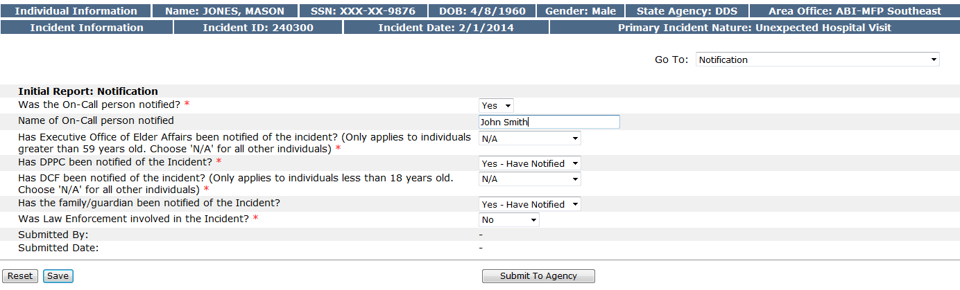

Next steps:

Now that the initial report has been submitted, the user will be able to review and finalize the final report. The final report must be completed within seven days of the submission of the initial report. Additional incidents may be created simultaneously; therefore because this incident is not yet finalized it does not limit the user’s ability to begin creating a new incident for that individual or any other individual.

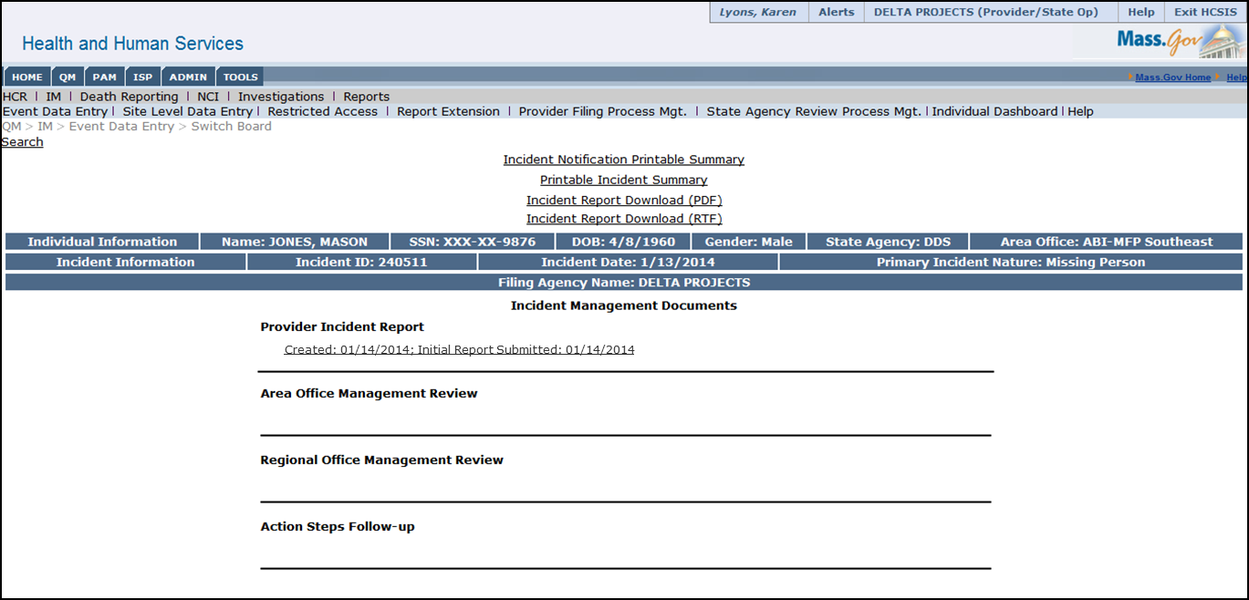

On the individual event switchboard, as shown above, this event will appear as “Initial Report: Submitted” with the date of submission. This screen will update automatically as the report is finalized and reviews occur.

Scenario: Review and Finalize an Incident Report
The following steps will outline how to review and finalize an initial incident report. This occurs after an initial incident report has been submitted and will need to be completed within seven days of submitting the initial incident report. Finalizing the report allows the user to add more detail and information than was known at the time of the initial report, including changes that have occurred during the time period between the initial and final report. These may lead the user to change the category of an incident, add action steps follow up, or record details that become known after completion of the initial report.
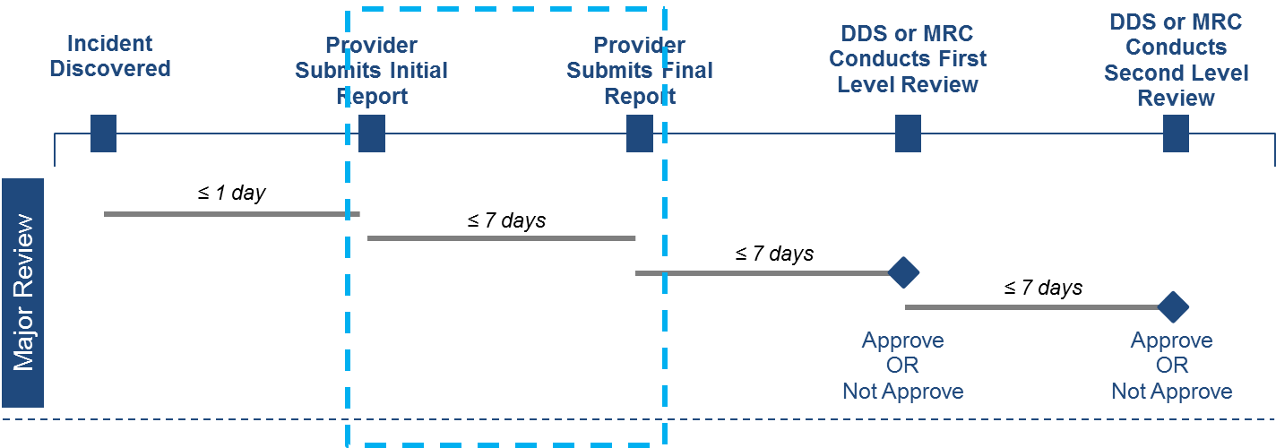

Roles and Responsibilities
- The following users can finalize an initial report
  - Provider Supervisor
  - Case Manager
  - Case Manager Supervisor
  - MRC Central Office Oversight
  - DDS ABI/MFP Service Coordinator
  - DDS ABI/MFP Service Coordinator Supervisor

First Steps
- The user logs into HCSIS via the Virtual Gateway
- The user navigates to the Quality Management (QM) module
- The user navigates to the Incident Management (IM) sub-module

Scenario Steps
- Search for an Individual

- Input search criteria

- Select an Individual

- View the Individual’s Event History

- Select an Event

- View the Event Switchboard

On the individual event switchboard, the user can see the status of the incident report; at this point the incident will appear as submitted but not yet finalized.

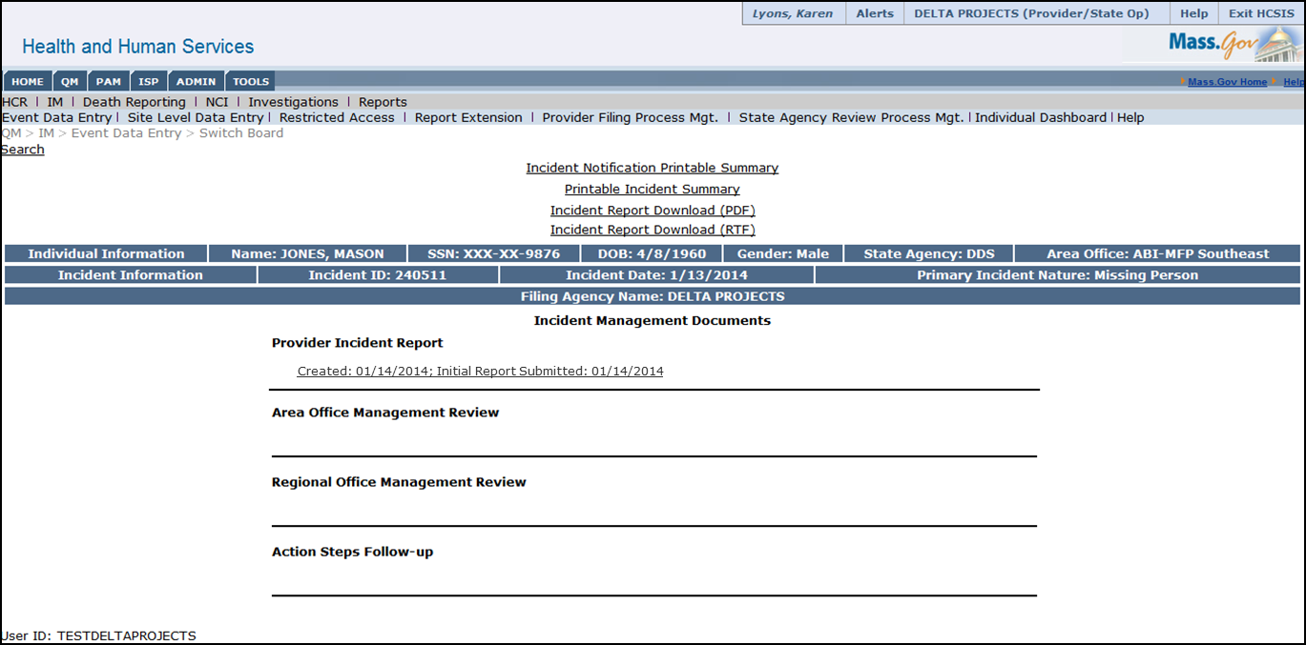

- Finalize the Incident Report
  - Click the Provider Incident Report status hyperlink to open the Initial Incident Report

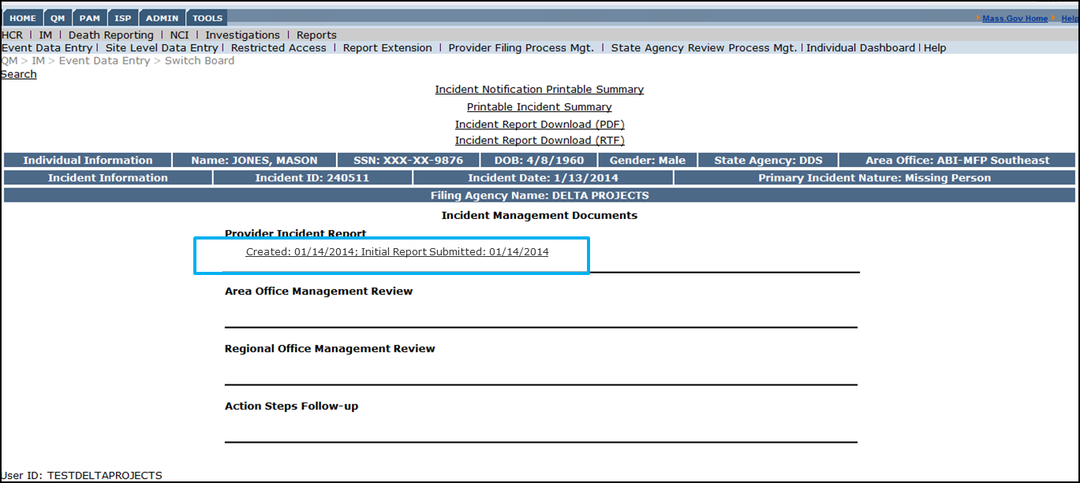

  - Input any additional information related to the incident

On this screen the user can input any additional information that has surfaced since logging the incident and submitting the initial report.
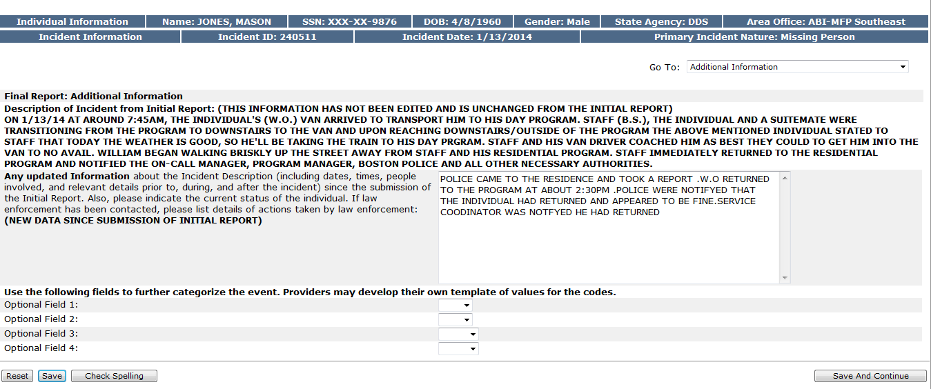

  - Add, edit or delete any Action Steps related to the incident

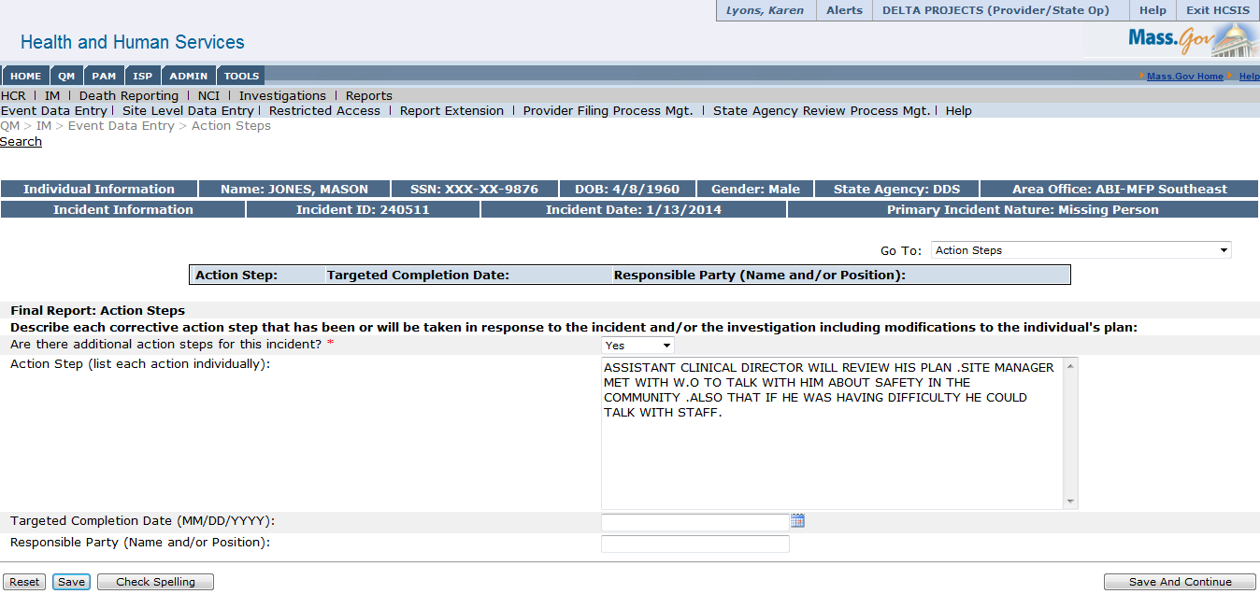

  - Add, edit or delete the Involved Parties fields

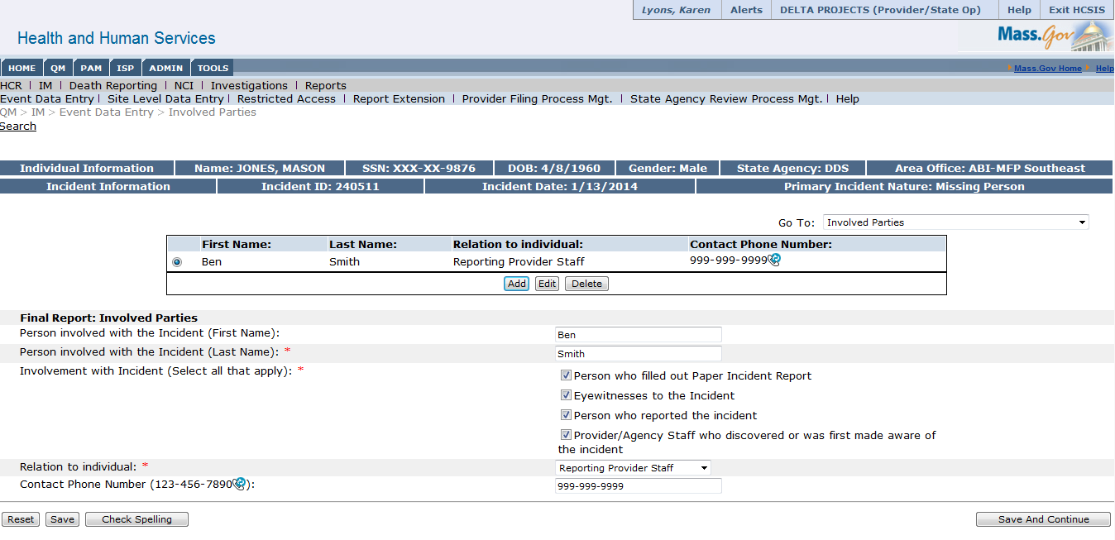

  - Verify time and category of incident

The last screen of the final report requires the user to review and verify the time and categorization information that was input during the initial submission of the report.

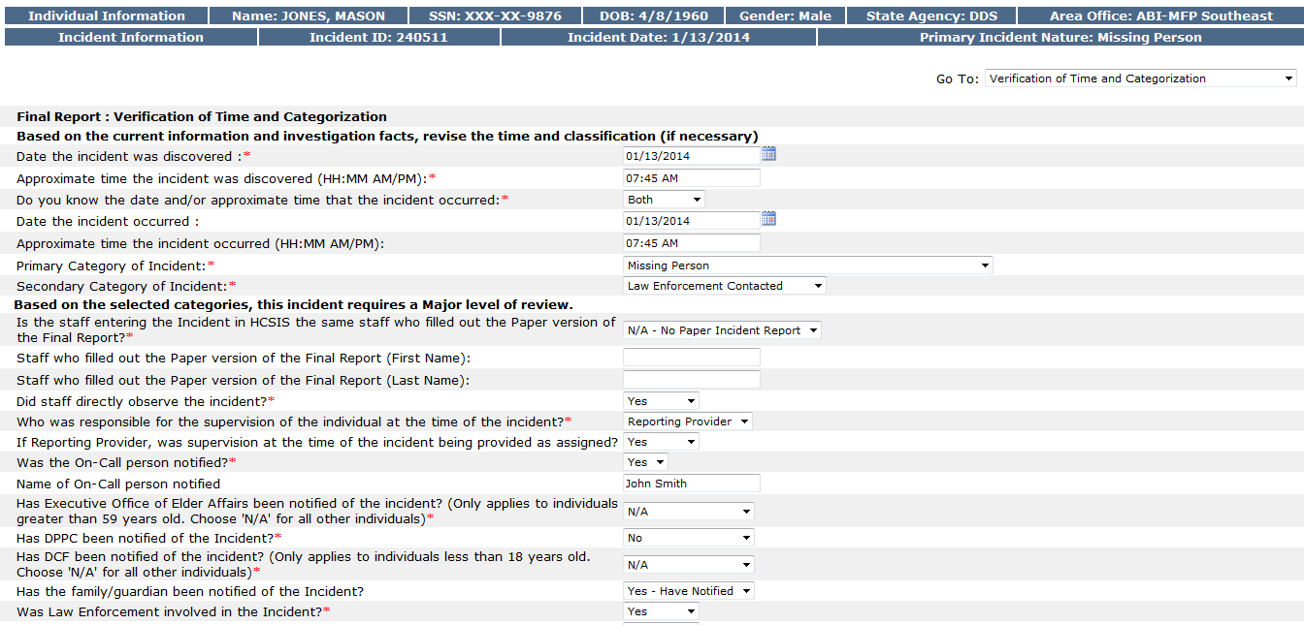

  - Finalize

After completing the Verification of Time and Categorization Screen the user can finalize the incident report by clicking the Finalize button

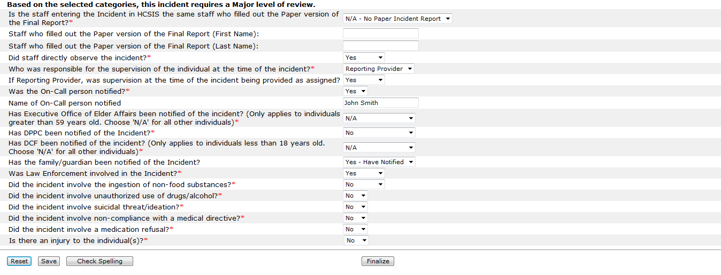

Finalize an Unexpected Hospital Visit Incident Report
If the initial incident was designated as an Unexpected Hospital Visit, there is an additional screen in the Final Incident Report that addresses the details of the hospital visit. This additional screen appears before the remaining Final Incident Report screens. The following screenshots depict the additional information required related to the hospital visit.

In the screenshot below, the selection of the Reason for ER/Hospital Visit will determine the level of review required for the incident, as opposed to the primary and secondary incident categories.

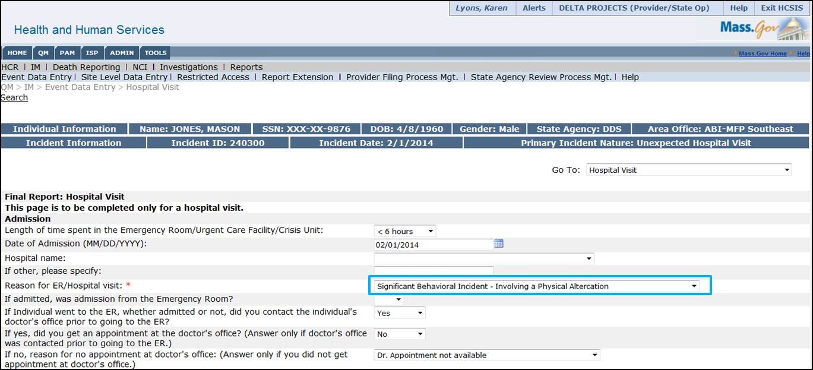

After providing details about the Admission information, the user would be requested to provide information on the Hospital Course, Discharge and Diagnosis.

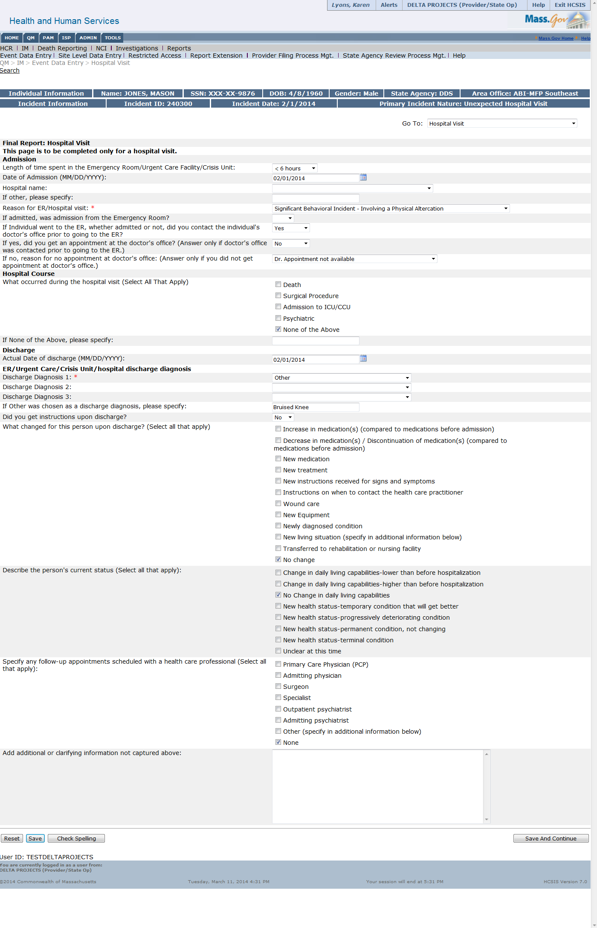

There are additional prompts on the diagnosis, as shown below:

Once all of the Hospital Visit information is saved in the Final Incident Report, the user would move through the additional screens of the Final Incident Report. On the last screen of the Final Incident Report, there is one key difference between an Unexpected Hospital Visit incident and any other incident type. Instead of stating that based on the incident categories selected, the incident will require a major/minor level of review, the system will state that based on the reason for ER/Hospital Visit, the incident is a major/minor incident.

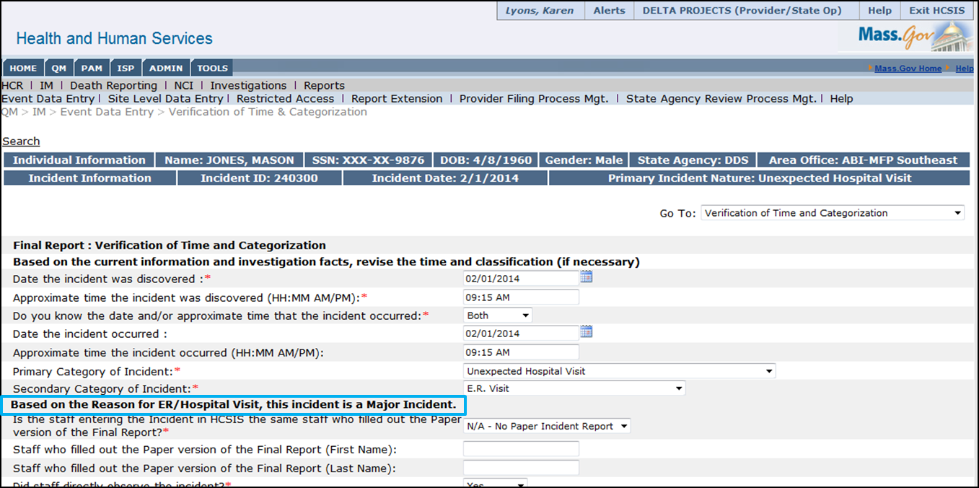

Scenario: Delete an Incident
There are situations that will necessitate the deletion of a created incident. This may occur for one of three reasons:
- It does not rise to the level of an incident
- There is a duplicate entry
- There is a user error

An event may be deleted during the review process following the submission of the final report by the provider. Please note you must know the event ID of the event you are deleting.

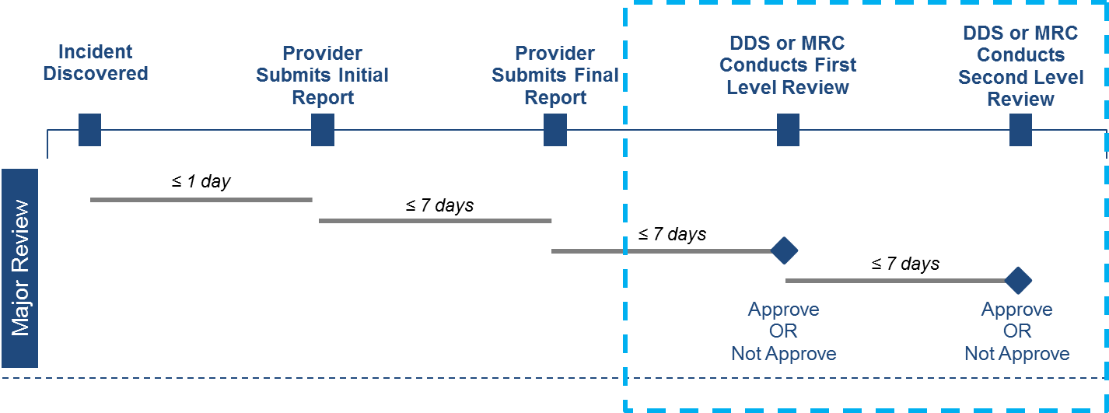

Roles and Responsibilities
- The following users can delete an incident
  - MRC Case Manager Supervisor
  - MRC Central Office Oversight
  - DDS ABI/MFP Regional Staff

First Steps
- The user logs into HCSIS via the Virtual Gateway
- The incident has been created in the system by a Provider, Service Coordinator or Case Manager

Scenario Steps
- Select Tools

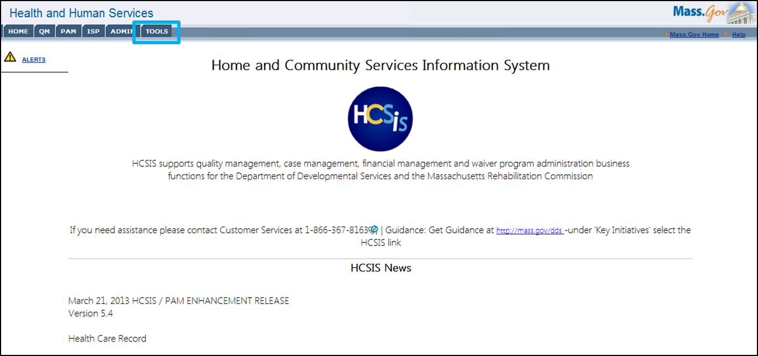

- Select the IM Utilities Menu Item
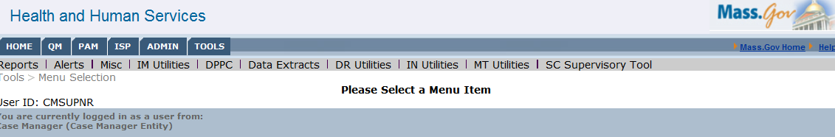

- Select the Delete Event Menu Item

- Search for an Event using the Event ID

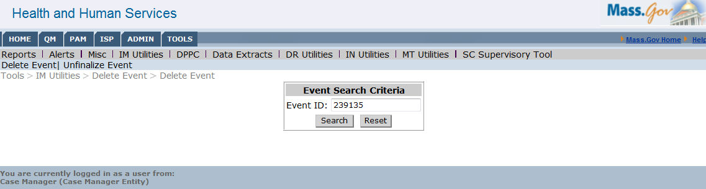

- Delete Event
  - Select “Delete”

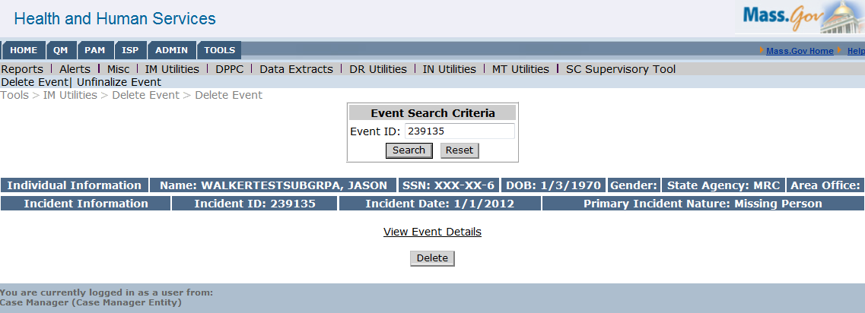

Note: the user could also view the event details before clicking “Delete” to confirm that the event is the event they would like to delete.

  - Enter a reason for deletion

  - Confirm deletion
